Supplementary Materials

Investigating the added value of incorporating mammographic density to an integrated breast cancer risk model with questionnaire-based risk factors and polygenic risk score

Table of Contents |  | Page
1.0 | Risk model development using the iCARE tool | 2
2.0 | Methods for risk model validation | 3
3.0 | Adjustment for selection into nested case-control studies | 3
4.0 | Derivation of the reference populations | 4
Table S1 | Characteristics of prospective cohort studies used for model validation | 5
Table S2 | Breast cancer risk factor distribution by cohort | 6
Table S3 | Sources of information for model inputs for each country | 8
Table S4 | Breast cancer risk factor distribution in each reference population dataset | 9
Table S5 | Model calibration measured by expected-to-observed ratios of various iCARE-Lit models in women younger than 50 and 50 years and older. | 11
Table S6A | Risk discrimination measured by the model area under the curve of various iCARE-Lit models in women younger than 50 | 12
Table S6B | Risk discrimination measured by the model area under the curve of various iCARE-Lit models in women 50 years and older | 13
Table S7 | Proportion of women reclassified at the high-risk thresholds based on risk estimated from the integrated model with questionnaire-based risk factors, 313-SNP PRS and BI-RADS, as opposed to the model with questionnaire-based risk factors and 313-SNP PRS only | 14
Table S8 | Reclassification at high-risk thresholds after incorporating BI-RADS density to questionnaire-based risk factors and 313-SNP PRS | 15
Table S9 | Overview of validation studies of breast cancer risk models including polygenic-risk-score and mammographic breast density | 16
Figure S1A | Absolute risk and relative risk calibration in KARMA for women younger than 50 years | 17
Figure S1B | Absolute risk and relative risk calibration in NHS II for women younger than 50 years | 18
Figure S1C | Absolute risk and relative risk calibration in KARMA for women 50 years and older | 19
Figure S1D | Absolute risk and relative risk calibration in NHS I for women 50 years and older | 20
Figure S1E | Absolute risk and relative risk calibration in MMHS for women 50 years and older | 21

- Risk model development using the iCARE tool

We used iCARE to build a model to predict a woman’s 5-year absolute risk of developing breast cancer integrating classical risk factors, PRS and MBD for women 50 years or older. iCARE implements a flexible approach of estimating absolute risk by combining information on relative risks of the risk factors, age-specific incidence and competing mortality rates from multiple data sources, and an individual level reference dataset of risk factors representing the underlying population. Age was used as a timescale used for disease incidence modeling. The conditional relationship between age-specific incidence rates and the risk factors were assumed to follow a Cox proportional hazards model of the form
$Pr(T ∈ \left[t, t+ \left.Δt\right) \left| T ≥t, Z\right)= \right.λ_{0}\left(u\right)\exp\left(β^{T}Z\right)$,
where T represents the time to onset of breast cancer, and risk factors Z have a multiplicative effect on the baseline hazard $λ_{0}(t)$. With this model the absolute risk of a woman at age a over the time interval a + $τ$ can be estimated using the formula:
$\int_{a}^{a+τ}{λ_{0}\left(t\right)\exp\left(β^{T}Z\right)\exp{ (-\int_{a}^{t}{\left[λ_{0}\left(u\right)\exp\left(β^{T}Z\right)+m(u)\right]du)dt}}}$,
where $β$ represents the log relative risk (or log hazard ratio) of risk factors Z and m(t) is the age-specific mortality rate function (1).

iCARE implements a flexible approach of estimating absolute risk by combining information on relative risk estimates, age-specific disease incidence and competing mortality rates and risk factor distributions from multiple data sources. Age was used as the timescale for disease risk modeling. The conditional age-specific incidence rates given the risk factors were assumed to follow a Cox proportional hazards model.

Incidence and mortality rates
The marginal age-specific disease incidence rates are provided by the United States’ Surveillance Epidemiology and End Results (SEER) cancer registry 2008-2012. Competing mortality rates due to causes other than breast cancer was obtained from the CDC WONDER database 2008-2012.

Relative risk estimates
The classical risk factors included in the iCARE-Lit model were ages at menarche, first birth and menopause, parity, height, BMI, alcohol intake, history of benign breast disease, presence/absence of breast cancer in first degree relatives, use of oral contraceptives and hormone replacement therapy (HRT). The relative risks for these factors were previously obtained from a literature review as described by Pal Choudhury et al., supplementary Table 1 (2).

The 313-SNP PRS was recently developed by Mavaddat et al. using data from 94,075 cases and 75,017 controls of European ancestry from 69 case-control studies in the Breast Cancer Association Consortium (BCAC) (3). A per-standard deviation odds ratio of the PRS is used in the model. The PRS was integrated into the iCARE-Lit model assuming a multiplicative joint association with disease risk, with the exception of family history. Due to its correlation with PRS, the model automatically accounts for attenuation of the odds ratio for family history (1). The 313 SNPs and their per-allele log-odds ratio included in the polygenic risk score can be found in supplementary Table 5. by Pal Choudhury et al. (2).

To obtain relative risk estimates for the 4-level BI-RADS variable, an extensive literature search was carried out. Once multiple sources were explored (4–9), the decision to use the relative risk estimates were based on the sample characteristics, i.e. study design, study population, sample size, and the risk factors that were adjusted for in the model. The relative risk
estimates ultimately chosen were provided by Barlow et al. and were adjusted for age, BMI, menopausal status, surgical menopause, family history, age at childbirth, HRT use, prior breast procedures, race, Hispanic ethnicity and previous mammographic outcome. (4).

2.0 Methods for model validation

We considered models with questionnaire-based risk factors and MBD, a model with MBD and PRS, and lastly, a fully integrated model with questionnaire-based risk factors, PRS and MBD. To assess calibration, the individual subjects were stratified in low to high-risk categories based on deciles of both predicted 5-year absolute risk and their relative risk score. For each category, the average predicted absolute risk and relative risk scores were computed. The E/O ratio was calculated overall (and within each category), first using the predicted absolute risk. The expected-to-observed ratio is defined as the ratio of the average expected absolute risk and the proportion of observed cases, overall and by category. We assessed model calibration using the Hosmer-Lemeshow (HL) goodness-of-fit test, where the HL statistic approximately follows a chi-square distribution. We also estimated a calibration slope and intercept from a linear regression of the observed and expected proportion of cases within risk deciles.

Within each category we also computed the observed and expected relative risks. The observed relative risk of a category was defined as the ratio of the proportion of observed cases in the category and the proportion of cases in the validation cohort. The expected relative risk of each category was defined as the ratio of the average 5-year absolute risk in the category and the average 5-year absolute risk in the validation cohort. For both expected-to-observed number of cases and expected-to-observed relative risk, 95% Wald-based confidence intervals were computed using an influence function-based variance estimator described by Pal Choudhury et al. (1). The calibration of relative risk was assessed using chi-square goodness-of-fit tests. All statistical tests were two-sided and P value less than 0.05 was considered statistically significant.

The discriminatory accuracy of the model was assessed using the Area Under the Curve (AUC) based on the 5-year absolute risk and relative risk scores. AUC is defined as the probability that the risk for a randomly selected case is higher than the risk for a randomly selected control, or AUC = δ = P[S₁ > S₀], where the probability that the risk-score for a case (S₁) is higher than the risk-score for a control (S₀). The AUC was estimated empirically as the proportion of case-control pairs in which the risk of the case is higher than that of the control. The 95% Wald-based confidence intervals for AUC using the asymptotic variance formula were computed (10).

3.0 Adjustment for selection into the nested case-cohort

The fully integrated model incorporated a 313-SNP PRS and BI-RADS breast density. In all validation cohorts, BI-RADS density and the genotype data on SNPs used to calculate the PRS was available for a nested case-control study. To reflect the underlying full cohort, all calculations are adjusted using sampling weights using the inverse-probability weighted (IPW) approach. Weights are defined by the probability of selection of subjects to the nested case-control sample from the full cohort. The probability of selection is estimated by fitting a logistic regression model with age of study entry, follow-up time, the matching factors, and interactions of case/control status with age of study entry and follow-up time to the entire underlying cohort, where the outcome is defined as whether the individual is included or not. All standard errors and 95% Wald-based confidence intervals were calculated using influence function-based variance estimators that account for sampling weights.

4.0 Derivation of the reference datasets

For estimating the risk factor distribution and projecting the absolute risk in the US and Swedish population, two individual reference datasets containing individual level data on the questionnaire-based risk factors was needed. For the US, the risk factor distribution was estimated from an individual level reference dataset representing women from European ancestry in the United States. The majority of the risk factors in the reference dataset were derived from the National Health Interview Survey and the National Health and Nutrition Examination Survey as previously described by Maas et al. (11). To generate a unique PRS for each person, the log-odds ratio for each SNP was multiplied by the number of minor alleles, assuming an independent relationship with the classical risk factors and MBD (7) with the exception of family history (1).

To estimate the joint distribution of classical risk factors and mammographic density, the relationship between BI-RADS and the questionnaire-based risk factors was studied through proportional odds regression methods for ordinal data. Analyses were performed in the Breast Cancer Surveillance Consortium (BCSC) dataset and data were collected from six participating registries: KP Washington, New Hampshire, North Carolina, San Francisco, Vermont and Chicago. Our dataset included 565,927 US women of European ancestry aged 50 - 70 with screening mammograms and diagnostic mammograms, collected from 2005 through 2017. For each woman, the first record and corresponding covariates collected at that visit were used and only records with complete covariate information were included in the analysis. The majority of the risk factors in the BCSC dataset were obtained through a questionnaire filled out by patients (available from www.bcsc-research.org). The variable on benign breast disease was derived from pathology reports and included the diagnosis with the highest severity. Finally, 63,756 women were included, from which we simulated the BIRADS variable for the reference dataset.

The reference dataset for Sweden was generated using data on subjects with no diagnosis of breast cancer and with no missing information for the risk factor variables from the prospective cohort KARMA. Table S4 provides the sources for building the reference dataset for each country.

Table S1. Characteristics of prospective cohort studies used for model validation

Study | Country |  | Full cohort ^{b} |  |  |  |  |  | Nested cohort ^{b, c}
Study | Country |  | Year(s) at DNA collection | Age at DNA collection ª | Years of follow-up ª | Cases | Total |  | Cases | Controls
NHS II | US |  | 1996 | 43 (33-49) | 13 (7-15) | 390 | 57 695 |  | 142 | 941
KARMA | Sweden |  | 2011-2013 | 45 (27-49) | 5 (3-7) | 179 | 24 018 |  | 138 | 4096
KARMA | Sweden |  | 2011-2013 | 60 (50-72) | 5 (3-7) | 683 | 42 280 |  | 557 | 10616
MMHS | US |  | 2003-2006 | 61 (50-75) | 9 (0-10) | 269 | 11 996 |  | 242 | 1040
NHS I | US |  | 1989 | 64 (50-75) | 14 (9-21) | 1245 | 58 163 |  | 389 | 2411
ª Mean (range)
^{b} Defined as women of European ancestry, with no history of breast cancer, who provided a sample of DNA
^{c} Includes subjects with genotype data and BI-RADS data
Table S2. Breast cancer risk factor distribution by cohort
Breast cancer risk factors | MMHS  N=11,996 | NHS I  N=65,926 | NHS II  N=58,940 | KARMA  N=65,436
Age at baseline, years
Median (IQR) | 60 (54, 66) | 65 (59,71) | 44 (41,47)
Age at menarche, N (%)
≤11 | 2,114 (18) | 13,156 (22) | 8328 (22) | 13,049 (20)
12 – 13 | 6,422 (57) | 33,169 (57) | 21 103 (58) | 29,774 (46)
14 – 15 | 2,302 (20) | 9,812 (16) | 5591 (15) | 19,692 (31)
≥16 | 366 (3.3) | 2,026 (3.5) | 1301 (3.6) | 2,921 (4.5)
Missing | 792 | 0 | 0 | 0
Parity, N (%)
Nulliparous | 1,428 (12) | 3,181 (5.6) | 6533 (23) | 7,762 (13)
1 birth | 998 (8.4) | 3,740 (6.5) | 4593 (17) | 8,916 (15)
2 births | 3,678 (31) | 15,290 (27) | 14 061 (51) | 29,305 (48)
3 + births | 5,742 (49) | 35,098 (61) | 2681 (9.6) | 15,163 (25)
Missing | 150 | 854 | 8455 | 4290
Age at first birth, years (among parous women), N (%)
<20 | 2,221 (21) | 411 (0.8) | 1041 (5.8) | 3,108 (5.8)
20 – 24 | 5,208 (50) | 27,919 (52) | 3568 (20) | 14,915 (30)
25 – 29 | 2,231 (21) | 20,526 (38) | 7298 (41) | 18,847 (35)
≥30 | 748 (7.2) | 52,58 (9.7) | 6054 (34) | 16,625 (31)
Missing | 10 | 14 | 3374 | 22
OC use (among subjects age <50), N (%)
Never | --- | --- | 4729 (13) | ---
Former | --- | --- | 29 472 (82) | ---
Current | --- | --- | 1834 (5.1) | ---
Missing | --- | --- | 288 | ---
OC use (among subjects age ≥50), N (%)
Never | 3,075 (26) | 29,752 (52) | --- | 13689 (21)
Ever | 8,843 (72) | 27,294 (48) | --- | 51747 (79)
Missing | 78 | 1,117 | --- | 0
HRT use (among subjects age ≥50), N (%)
Never | 4,056 (38) | 14,650 (29) | --- | 46106 (81)
Former | 3,829 (36) | 15,624 (30) | --- | 8921 (16)
Current | 2,803 (26) | 21,105 (41) | --- | 1741 (3)
Missing | 1,308 | 6,784 | --- | 8668
Type of HRT use (among current users age ≥50), N (%)
Current E-type | 518 (27) | 7,373 (40) | --- | 815 (47)
Current C-type | 1,418 (73) | 11,232 (60) | --- | 926 (53)
Missing | 867 | 39,558 | --- | 8668
Age at menopause, years (among subjects age ≥50), N (%)
< 40 | 702 (10) | 2,234 (4.2) | --- | 717 (4)
40 – 44 | 847 (13) | 3,748 (7.0) | --- | 1460 (9)
45 – 49 | 1,838 (27) | 13,449 (25) | --- | 4106 (25)
50 – 54 | 2,597 (38) | 30,486 (57) | --- | 7684 (46)
≥55 | 771 (11) | 3,914 (7.3) | --- | 2624 (16)
Missing | 5,241 | 4,332 | --- | 48845
Breast cancer risk factors | MMHS n (%)  N=11,996 | NHS I n (%)  N=58,163 | NHS II  N=36,323 | KARMA  N=65,436
Height, cm
Median (IQR) | 163  (IQR: (159, 168)) | 163  (160, 168) | 165  (160, 170) | 166  (160, 172)
Body mass index (kg/m²), N (%)
<25 | 3,843 (32) | 26,436 (48) | 19,510 (55) | 38,113 (58)
≥25 - <30 | 4,009 (34) | 18,001 (33) | 9,107 (26) | 19,402 (30)
≥30 | 4,131 (35) | 10,383 (19) | 7,138 (20) | 7,921 (12)
Missing | 13 | 3,343 | 568 | 0
Alcohol (g/day), N (%)
None | 3,975 (33) | 22,346 (40) | 13,321 (37) | 11,708 (19)
<5 | 6,283 (53) | 19,531 (35) | 15,004 (42) | 15,726 (26)
5 – 14 | 1,160 (9.7) | 9,111 (16) | 5,753 (16) | 24,673 (41)
15 – 24 | 353 (3.0) | 3,188 (5.7) | 1,087 (3.0) | 5,900 (10)
25 – 34 | 126 (1.1) | 939 (1.7) | 427 (1.2) | 1,209 (2)
35 – 44 | 19 (0.2) | 1 (0.0) | 196 (0.5) | 1,195 (2)
≥45 | 2 (0.0) | 548 (0.1) | 137 (0.4) | 218 (0.4)
Missing | 78 | 2,499 | 398 | 4,807
History of BBD, N (%)
No | 8,931 (74) | 37,310 (64) | 10,837 (64) | 46399 (78)
Yes | 3,065 (26) | 20,852 (36) | 6,109 (36) | 13296 (22)
Missing | 0 | 1 | 19,377 | 5741
Family history of breast cancer in first degree relatives, N (%)
No | 9,666 (81) | 50,191 (86) | 33 064 (91) | 57975 (89)
Yes | 2,330 (19) | 7,972 (14) | 3259 (9) | 7461 (11)
Missing | 0 | 0 | 0 | 0
BI-RADS density ª, N (%)
a | 2,984 (25) | 491 (20) | 50 (5) | 8,191 (13)
b | 5,120 (43) | 873 (36) | 169 (18) | 24,493 (37)
c | 3,333 (28) | 783 (32) | 397 (42) | 25,915 (40)
d | 546 (5) | 264 (11) | 325 (35) | 6,837 (10)
Missing | 0 | 0 | 0 | 0
Abbreviations: BBD = benign breast disease, C-type = estrogen and progestogen combined, E-type = estrogen-only, HRT = hormone replacement therapy, IQR = interquartile range, OC = oral contraceptive.
ª For NHSI and NHSII, there is no full-cohort information on BI-RADS density. Controls-only data from the nested case-control study is reported.

Table S3. Sources of information for model inputs for each country
Country | Breast Cancer Incidence | Competing Mortality | Reference Risk Factor Distribution
Sweden | The National Board of Health and Welfare, 2016 | The National Board of Health and Welfare, 2016 | Controls of KARMA cohort
United States | US National Cancer Institute-Surveillance, Epidemiology, and End Results Program, 2008-2012 | Center for Disease Control WONDER database, 2008-2012 | Questionnaire-based risk factors, as previously described(2):  - National Health and Nutrition Examination Survey, 2008, 2010, 2012  - Women’s Health Initiative, 2010  - National Health Interview Survey, 2010  - PLCO cohort  BI-RADS:  - Breast Cancer Surveillance Consortium, 2005-2017

Table S4. Breast cancer risk factor distribution in each reference population dataset
Risk Factors | United States | Sweden
Age at first birth, years (among parous women)
<20 | 26.8% | 4.7%
20 – 24 | 38.9% | 22.7%
25 – 29 | 21.7% | 28.7%
≥30 | 12.6% | 25.3%
OC use
Never | 19.1 | 20.9%
Ever | 80.9 | 79.1%
Height, cm
Mean | 162.3  (SD: 6.4) | 166.6  (SD: 6.0)
Alcohol, g/day
None | 45% | 17.9%
<5 | 39.7% | 24.0%
5 – 14 | 12.1% | 37.7%
15 – 24 | 2.3% | 9.0%
25 – 34 | 0.6% | 1.8%
35 – 44 | 0.2% | 1.8%
≥45 | 0.2% | 0.3%
History of BBD
No | 83.3% | 74.3%
Yes | 16.8% | 25.7%
Family history of breast cancer in first degree relatives
No | 86.4% | 88.6%
Yes | 13.6% | 11.4%
Age at menarche, years
≤11 | 33.3% | 19.9%
12 – 13 | 43.8% | 45.5%
14 – 15 | 20.1% | 30.1%
≥16 | 2.6% | 4.5%
Age at menopause, years
< 40 | 21.3% | 1.6%
40 – 44 | 13.3% | 2.9%
45 – 49 | 22.7% | 10.2%
50 – 54 | 30.3% | 78.5%
≥55 | 12.4% | 6.8%
Parity
Nulliparous | 17.6 | 11.9%
1 birth | 15.1 | 13.6%
2 births | 33.7 | 44.8%
3 + births | 33.6 | 23.2%

Risk Factors | United States | Sweden
Body mass index, kg/m²
<25 | 35.1% | 58.3%
≥25 - <30 | 31.9% | 29.7%
≥30 | 33.1% | 12.1%
BMI and use of HRT
BMI <25: Never HRT use | 20.4% | 32.2%
BMI 25-29: Never HRT use | 18.4% | 20.4%
BMI ≥30: Never HRT use | 19.5% | 8.5%
BMI <25: Former HRT use | 10.5% | 17.9%
BMI 25-29: Former HRT use | 10.2% | 11.5%
BMI ≥30: Former HRT use | 11.1% | 4.0%
BMI <25: Current use of C-type HRT | 1.8% | 3.0%
BMI 25-29: Current use of C-type HRT | 1.4% | 2.0%
BMI ≥30: Current use of C-type HRT | 1.1% | 0.6%
BMI <25: Current use of E-type HRT | 2.3% | 2.2%
BMI 25-29: Current use of E-type HRT | 1.8% | 1.5%
BMI ≥30: Current use of E-type HRT | 1.3% | 0.5%
BI-RADS
a | 11.9% | 12.5%
b | 54.7% | 37.4%
c | 28.3% | 39.6%
d | 5.2% | 10.4%

Table S5. Model calibration measured by expected-to-observed ratios of various iCARE-Lit models in women younger than 50 and 50 years and older.
Population and model |  |  | Number of controls / cases | Overall E/O  (95 %CI)
Women younger than 50 years | KARMA | QRF only | 4,096/  138 | 1.34 (1.13-1.58)
Women younger than 50 years | KARMA | PRS only | 4,096/  138 | 1.10 (0.93-1.31)
Women younger than 50 years | KARMA | QRF + MBD | 4,096/  138 | 1.11 (0.93-1.31)
Women younger than 50 years | KARMA | PRS + MBD | 4,096/  138 | 1.10 (0.93-1.30)
Women younger than 50 years | KARMA | QRF+ PRS | 4,096/  138 | 1.12 (0.95-1.33)
Women younger than 50 years | KARMA | QRF + PRS + MBD | 4,096/  138 | 1.12 (0.95-1.33)
Women younger than 50 years | NHS II | QRF only | 941/  142 | 0.80 (0.64-1.00)
Women younger than 50 years | NHS II | PRS only | 941/  142 | 0.68 (54.3-0.71)
Women younger than 50 years | NHS II | QRF + MBD | 941/  142 | 0.80 (0.64-1.00)
Women younger than 50 years | NHS II | PRS + MBD | 941/  142 | 0.68 (0.55-0.85)
Women younger than 50 years | NHS II | QRF+ PRS | 941/  142 | 0.83 (0.67-1.04)
Women younger than 50 years | NHS II | QRF + PRS + MBD | 941/  142 | 0.85 (0.68-1.06)
Women 50 years and older | KARMA | QRF only | 10,616/  557 | 0.89 (0.82-0.96)
Women 50 years and older | KARMA | PRS only | 10,616/  557 | 0.83 (0.76-0.90)
Women 50 years and older | KARMA | QRF + MBD | 10,616/  557 | 0.83 (0.76-0.90)
Women 50 years and older | KARMA | PRS + MBD | 10,616/  557 | 0.87 (0.80-0.95)
Women 50 years and older | KARMA | QRF+ PRS | 10,616/  557 | 0.86 (0.77-0.97)
Women 50 years and older | KARMA | QRF + PRS + MBD | 10,616/  557 | 0.87 (0.79-0.98)
Women 50 years and older | NHS I | QRF only | 2,411/  389 | 0.82 (0.74-0.93)
Women 50 years and older | NHS I | PRS only | 2,411/  389 | 0.78 (0.70-0.88)
Women 50 years and older | NHS I | QRF + MBD | 2,411/  389 | 0.82 (0.73-0.92)
Women 50 years and older | NHS I | PRS + MBD | 2,411/  389 | 0.77 (0.69-0.87)
Women 50 years and older | NHS I | QRF+ PRS | 2,411/  389 | 0.86 (0.77-0.97)
Women 50 years and older | NHS I | QRF + PRS + MBD | 2,411/  389 | 0.87 (0.78-0.98)
Women 50 years and older | MMHS | QRF only | 1,040 /  242 | 0.95 (0.77-1.18)
Women 50 years and older | MMHS | PRS only | 1,040 /  242 | 0.78 (0.63-0.97)
Women 50 years and older | MMHS | QRF + MBD | 1,040 /  242 | 0.89 (0.77-1.02)
Women 50 years and older | MMHS | PRS + MBD | 1,040 /  242 | 0.77 (0.67-0.89)
Women 50 years and older | MMHS | QRF+ PRS | 1,040 /  242 | 0.89 (0.77-1.10)
Women 50 years and older | MMHS | QRF + PRS + MBD | 1,040 /  242 | 0.89 (0.77-1.02)

The iCARE-Lit models risk-factor combinations are: (i) questionnaire-based risk factors and BI-RADS breast density, (ii) BI-RADS breast density with the 313-SNP PRS, (iii) the 313-SNP PRS and questionnaire-based risk factors, and (iv) the fully integrated model incorporating questionnaire-based risk factors, the 313-SNP PRS and BI-RADS breast density. Abbreviations: AUC = area under the curve; CI = confidence interval; E/O = ratio of expected to observed absolute risk; MBD = Mammographic Breast Density; MMHS = Mayo Mammography Health Study; PRS = Polygenic Risk Score; QRF = questionnaire-based risk factors
Table S6A. Risk discrimination measured by the model area under the curve of various iCARE-Lit models in women younger than 50 and risk discrimination measured by the model area under the curve based on a meta-analysis across both studies.
Population and model |  | Number of controls / cases | AUC (95% CI)
KARMA | QRF only | 4,096/  138 | 58.8 (54.2-63.3)
KARMA | PRS only | 4,096/  138 | 62.7 (57.9-67.6)
KARMA | QRF + MBD | 4,096/  138 | 63.2 (58.8-67.7)
KARMA | PRS + MBD | 4,096/  138 | 65.3 (60.6-70.0)
KARMA | QRF+ PRS | 4,096/  138 | 64.2 (59.6-68.9)
KARMA | QRF + PRS + MBD | 4,096/  138 | 66.4 (61.9-70.9)
NHS II | QRF only | 941/  142 | 62.2 (55.7-68.7)
NHS II | PRS only | 941/  142 | 64.9 (59.2-70.6)
NHS II | QRF + MBD | 941/  142 | 63.4 (57.5-69.4)
NHS II | PRS + MBD | 941/  142 | 66.4 (60.7-72.0)
NHS II | QRF+ PRS | 941/  142 | 67.5 (61.4-73.7)
NHS II | QRF + PRS + MBD | 941/  142 | 68.2 (62.3-74.0)
Overall | QRF only | 5,037/  280 | 59.9 (56.2-63.6)
Overall | PRS only | 5,037/  280 | 63.6 (59.9, 67.3)
Overall | QRF + MBD | 5,037/  280 | 63.3 (59.7- 66.8)
Overall | PRS + MBD | 5,037/  280 | 65.7 (62.1, 69.4)
Overall | QRF+ PRS | 5,037/  280 | 65.4 (61.7, 69.1)
Overall | QRF + PRS + MBD | 5,037/  280 | 67.1 (63.5, 70.6)

The iCARE-Lit models risk-factor combinations are: (i) questionnaire-based risk factors and BI-RADS breast density, (ii) BI-RADS breast density with the 313-SNP PRS, (iii) the 313-SNP PRS and questionnaire-based risk factors, and (iv) the fully integrated model incorporating questionnaire-based risk factors, the 313-SNP PRS and BI-RADS breast density. Abbreviations: AUC = area under the curve; CI = confidence interval; E/O = ratio of expected to observed absolute risk; MBD = Mammographic Breast Density; MMHS = Mayo Mammography Health Study; PRS = Polygenic Risk Score; QRF = questionnaire-based risk factors
Table S6B. Risk discrimination measured by the model area under the curve of various iCARE-Lit models in women 50 years and older and risk discrimination measured by the model area under the curve based on a meta-analysis across all studies.
Population and model |  | Number of controls / cases | AUC (95% CI)
KARMA | QRF only | 10,616/  557 | 61.0 (58.7-63.4)
KARMA | PRS only | 10,616/  557 | 64.0 (61.7-66.3)
KARMA | QRF + MBD | 10,616/  557 | 61.8 (59.4-64.1)
KARMA | PRS + MBD | 10,616/  557 | 64.7 (62.5-67.0)
KARMA | QRF+ PRS | 10,616/  557 | 65.5 (63.2-67.8)
KARMA | QRF + PRS + MBD | 10,616/  557 | 66.1 (63.9-68.4)
NHS I | QRF only | 2,411/  389 | 58.8 (55.5-62.0)
NHS I | PRS only | 2,411/  389 | 62.1 (58.8-65.4)
NHS I | QRF + MBD | 2,411/  389 | 62.4 (59.1-65.6)
NHS I | PRS + MBD | 2,411/  389 | 65.1 (61.7-68.4)
NHS I | QRF+ PRS | 2,411/  389 | 65.3 (62.1-68.5)
NHS I | QRF + PRS + MBD | 2,411/  389 | 67.2 (63.9-70.5)
MMHS | QRF only | 1,040 /  242 | 56.5 (52.0-61.1)
MMHS | PRS only | 1,040 /  242 | 65.6 (61.4-69.8)
MMHS | QRF + MBD | 1,040 /  242 | 57.5 (52.9-62.1)
MMHS | PRS + MBD | 1,040 /  242 | 63.4 (59.0-67.9)
MMHS | QRF+ PRS | 1,040 /  242 | 65.9 (61.7-70.0)
MMHS | QRF + PRS + MBD | 1,040 /  242 | 63.9 (59.5-68.3)
Overall | QRF only | 14,067/  1,188 | 59.7 (57.9-61.4)
Overall | PRS only | 14,067/  1,188 | 63.8 (62.0-65.5)
Overall | QRF + MBD | 14,067/  1,188 | 61.3 (59.6-63.1)
Overall | PRS + MBD | 14,067/  1,188 | 64.6 (62.9, 66.3)
Overall | QRF+ PRS | 14,067/  1,188 | 65.5 (63.8-67.2)
Overall | QRF + PRS + MBD | 14,067/  1,188 | 66.1 (64.4-67.8)

The iCARE-Lit models risk-factor combinations are: (i) questionnaire-based risk factors and BI-RADS breast density, (ii) BI-RADS breast density with the 313-SNP PRS, (iii) the 313-SNP PRS and questionnaire-based risk factors, and (iv) the fully integrated model incorporating questionnaire-based risk factors, the 313-SNP PRS and BI-RADS breast density. Abbreviations: AUC = area under the curve; CI = confidence interval; E/O = ratio of expected to observed absolute risk; MBD = Mammographic Breast Density; MMHS = Mayo Mammography Health Study; PRS = Polygenic Risk Score; QRF = questionnaire-based risk factors
Table S7. Proportion of women reclassified at the high-risk thresholds based on risk estimated from the integrated model with questionnaire-based risk factors, 313-SNP PRS and density, as opposed to the model with questionnaire-based risk factors and 313-SNP PRS only
 |  |  | US Population |  |  |  |  | SE Population
 |  |  | Total women |  | Future Cases |  |  | Total women |  | Future Cases
QRF + PRS | QRF + PRS + MBD |  | n | % | n | % |  | n | % | n | %
AR<3% | AR<3% |  | 34,043,694 | 77.9% | 478,201 | 53.4% |  | 1,095,322 | 87.6% | 13,207 | 67.8%
AR≥3% | AR≥3% |  | 6,230,381 | 14.3% | 316,688 | 35.4% |  | 88,032 | 7.0% | 4,312 | 22.1%
AR<3% | AR≥3% |  | 1,802,715 | 4.1% | 62,325 | 7.0% |  | 40,972 | 3.3% | 1,404 | 7.2%
AR≥3% | AR<3% |  | 1,641,370 | 3.8% | 37,684 | 4.2% |  | 25,369 | 2.0% | 546 | 2.8%
AR<6% | AR<6% |  | 42,135,743 | 96.4% | 773,818 | 86.5% |  | 1,230,034 | 98.4% | 18,043 | 92.7%
AR≥6% | AR≥6% |  | 822,237 | 1.9% | 74,815 | 8.3% |  | 8,118 | 0.65% | 698 | 3.6%
AR<6% | AR≥6% |  | 477,828 | 1.1% | 32,986 | 3.7% |  | 9,133 | 0.73% | 611 | 3.1%
AR≥6% | AR<6% |  | 282,353 | 0.6% | 13,277 | 1.5% |  | 2,410 | 0.2% | 117 | 0.6%
Questionnaire-based risk factors correspond to the iCARE-Lit model and include age at menarche, age at first live birth, parity, oral contraceptive use, age at menopause, hormone replacement therapy use, type of hormone replacement therapy, alcohol intake, height, BMI, breast cancer family history (i.e., presence or absence of breast cancer in at least one first degree relative), benign breast disease. The 3% cutoff corresponds to the US Preventive Services Task Force recommendation for risk-lowering drugs and the 6% cutoff corresponds to a cutoff for very high risk used in the WISDOM trial. Abbreviations: AR = absolute risk, MBD = Mammographic Breast Density, PRS = polygenic risk score, SNP = single nucleotide polymorphism.

Table S8. Reclassification at high-risk thresholds after incorporating density to questionnaire-based risk factors and 313-SNP PRS.
 | US Population |  |  |  | Sweden population
 | 3% risk |  | 6% risk |  | 3% risk |  |  | 6% risk
 | Total women,  n (%) | Future cases,  n (%) | Total women,  n (%) | Future cases,  n (%) | Total women, n (%) |  | Future cases, n (%) | Total women,  n (%) | Future cases, n (%)
Based on questionnaire-based risk factors + PRS
Below threshold, n (%) | 35 846 408 (81.9) | 540 525  (60.4) | 42 613 571 (97.5) | 806 804  (90.2) | 1 136 294  (90.9) | 14 611  (75.0) |  | 1 239 167  (99.1) | 18.654  (95.8)
Above threshold, n (%) | 7 871 752 (18.1) | 354 372  (39.6) | 1 104 590  (2.5) | 88 092  (9.8) | 113 401  (9.1) | 4 858  (25.0) |  | 10 528  (0.9) | 815  (4.2)
Total, N | 43 718 160 | 894 897 | 43 718 161 | 894 896 | 1 249 695 | 19 469 |  | 1 249 695 | 19 469
Based on questionnaire-based risk factors + PRS + MBD
Reclassified,  n (%) | 3 444 085  (7.9) | 100 008  (11.2) | 760 181  (1.7) | 46 263  (5.2) | 66 341  (5.3) | 1 950  (10.0) |  | 11 543  (0.9) | 729  (3.7)
Moving down,  n (%) | 1 641 370  (3.8) | 37 986  (4.2) | 282 353  (0.6) | 13 277  (1.5) | 25 369  (2.0) | 546  (2.8) |  | 2 410  (0.2) | 117  (0.6)
Moving up,  n (%) | 1 802 715  (4.1) | 62 325  (7.0) | 477 828  (1.1) | 32 986  (3.7) | 40 972  (3.3) | 1 404  (7.2) |  | 9 133  (0.7) | 611  (3.1)
We report the number of women and future cases (i.e., women expected to develop breast cancer within 5 years) above or below the risk threshold based on questionnaire-based risk factors and PRS, and the number and percentage of these women moving below the threshold (down), above the threshold (up) and a total number and percentage of reclassified women. Questionnaire-based risk factors correspond to the iCARE- Lit model and includes age at menarche, age at first live birth, parity, oral-contraceptive use, age at menopause, hormone-replacement-therapy use, type of hormone replacement therapy, alcohol intake, height, BMI, breast-cancer family history (i.e., presence or absence of breast cancer in at least one first-degree relative), benign breast disease and the 313-SNP PRS. The 3% cut-off corresponds to the US Preventive Services Task Force recommendation for risk-lowering drugs and the 6% cut-off corresponds to a cut-off for very high risk used in the WISDOM trial. Abbreviations: MBD = Mammographic Breast Density, PRS = polygenic risk score, SNP = single nucleotide polymorphism.

Table S9: Overview of validation studies of breast cancer risk models including polygenic-risk-score and mammographic breast density
Model | Reference | Risk factors included | PRS | Breast density | Validation population | Sample size (cases/controls)
BCSC | Vachon 2015 (7) | Age, race/ethnicity, family history, biopsy history | 76-variant PRS | BI-RADS density | MMHS  MCBCS  BBCC | ﻿1643 / 2397
BOADICEA | Yang 2022 (12) | Age, age at menarche, number of births, age at first live birth, OC, MHT, BMI, alcohol, smoking, personal BBD, family history of BC | 313-variant PRS | BI-RADS density | KARMA | 676 / 14826 (with PRS)  280 / 5413 (with PRS + PV)
IBIS/Tyrer-Cuzick | Van Veen 2018 (13) | Family history, age, weight, height, parity, age at first child, menopausal status, age at menopause, age at menarche, BBD, LCIS, prior ATP, ovarian cancer | 18-variant PRS | Percentage mammographic density | PROCAS | ﻿8897/ 466
IBIS/Tyrer-Cuzick | Brentnall 2020 (14) | Family history, age, weight, height, parity, age at first child, menopausal status, age at menopause, age at menarche, BBD, LCIS, prior ATP, ovarian cancer | 143-variant PRS | Percentage mammographic density | PROCAS | ﻿405 / 1668
iCARE-Lit | Current study | Age, age at menarche, parity, age at first birth, OC ª, HRT ^{b}, type of HRT ^{b}, age at menopause ^{b}, BMI, height, alcohol, BBD, family history of breast cancer | 313-variant PRS | BI-RADS density | MMHS  NHS I & II  KARMA | 1468 /  19104
ATP: atypical hyperplasia, BBD: benign breast disease, BBCC: ﻿Bavarian Breast Cancer Cases and Control Study, BCSC: Breast Cancer Surveillance Consortium, iCARE: ﻿Individualized Coherent Absolute Risk Estimator, LCIS: lobular carcinoma in situ, MCBCS: ﻿Mayo Clinic Breast Cancer Study, MMHS: Mayo Mammography Health Study, MHT: Menopausal hormonal therapy, PRS: polygenic risk score, PV: pathogenic variants
ª OC current use is only included in the iCARE Lit model for women younger than 50 years.
^{b} Information on HRT and menopause is only included in the iCARE Lit model for women aged 50 years and older.
Figure S1A. Absolute risk and relative risk calibration in KARMA for women younger than 50 years

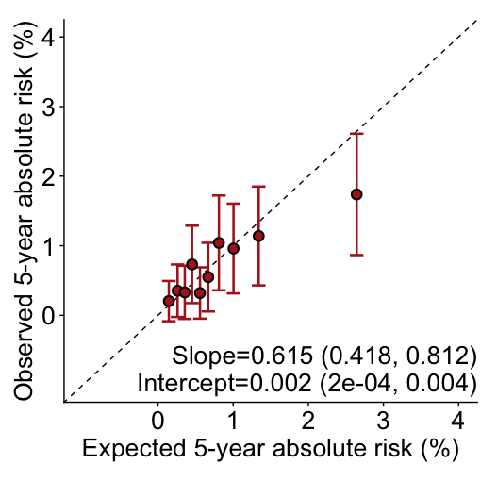
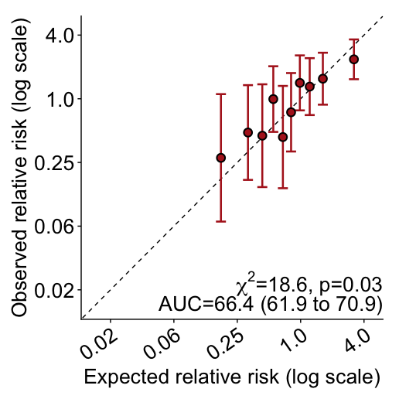
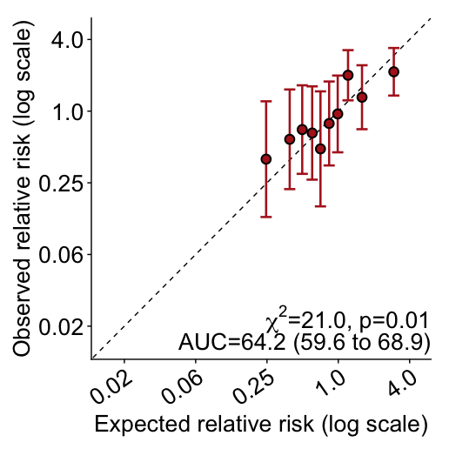
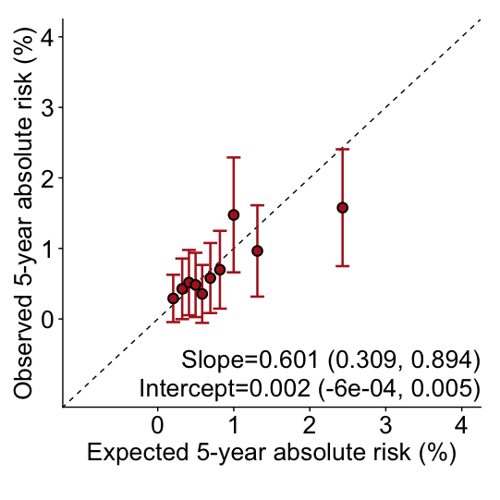
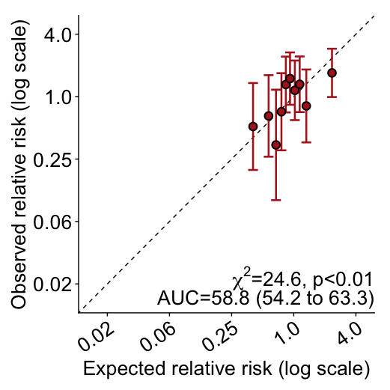
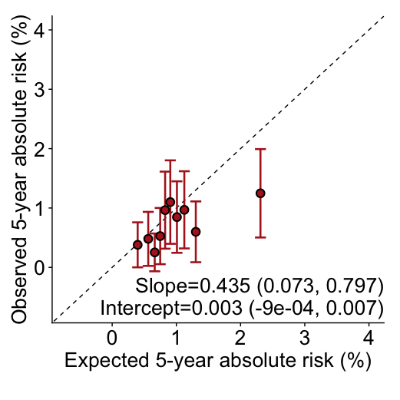
QRF + PRS + MBD
QRF + PRS
QRF only

Calibration and discrimination of 5-year risk predictions of breast cancer for women aged younger than 50 years in the nested case-control sample of the Karolinska Mammography Project for Risk Prediction of Breast Cancer cohort with risk categories based on deciles of predicted 5-year absolute risk. Validation results are shown for the extended iCARE model that incorporates (i) questionnaire-based risk factors with a PRS based on 313 common germline variants without questionnaire-based risk factors, (ii) the fully integrated model incorporating questionnaire-based risk factors, the 313-variant PRS and BI-RADS breast density. Estimates and 95% CI of the calibration slope and intercept are reported based on a linear regression of the decile-specific observed proportion of cases within 5 years and the average of the predicted 5-year absolute risk. AUC = area under the curve, c² =chi-square goodness-of-fit test, CI = confidence interval, E/O = expected to observed number of cases, KARMA = Karolinska Mammography Project for Risk Prediction of Breast Cancer II, PRS = polygenic risk score, QRF = Questionnaire-based risk factors.

Figure S1B. Absolute risk and relative risk calibration in NHS II for women younger than 50 years
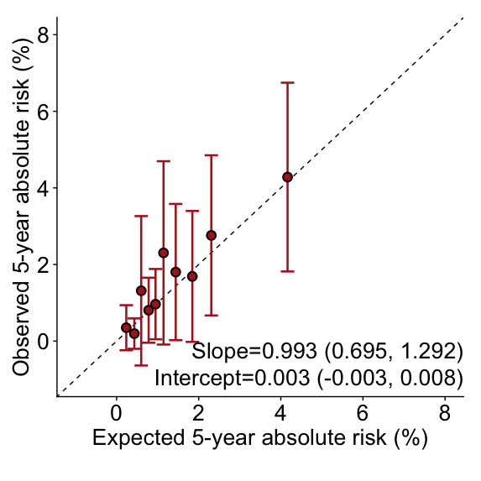
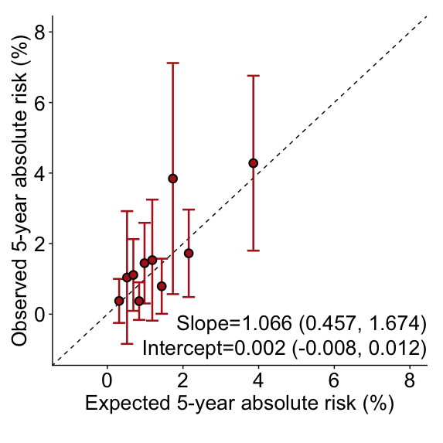
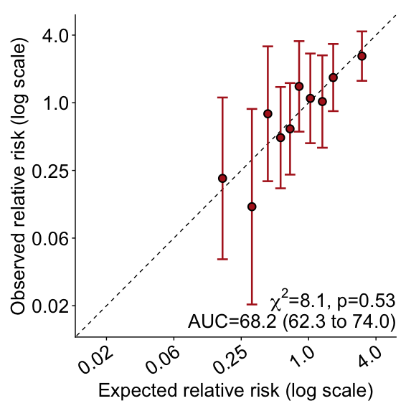
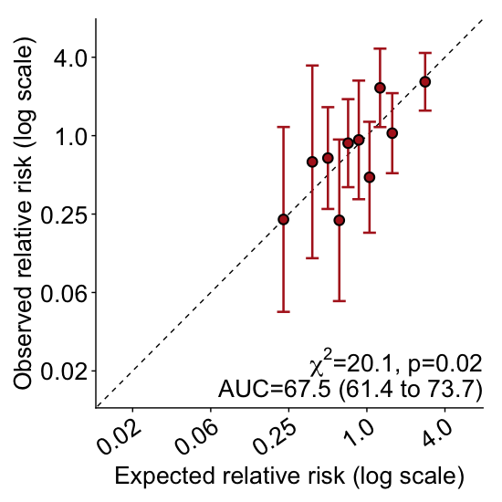
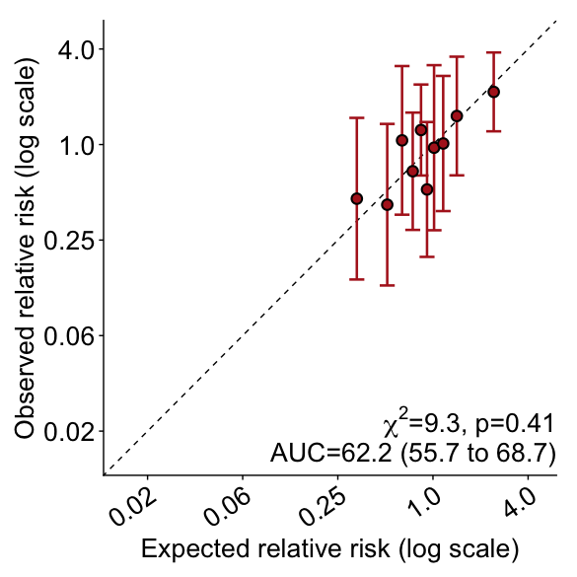
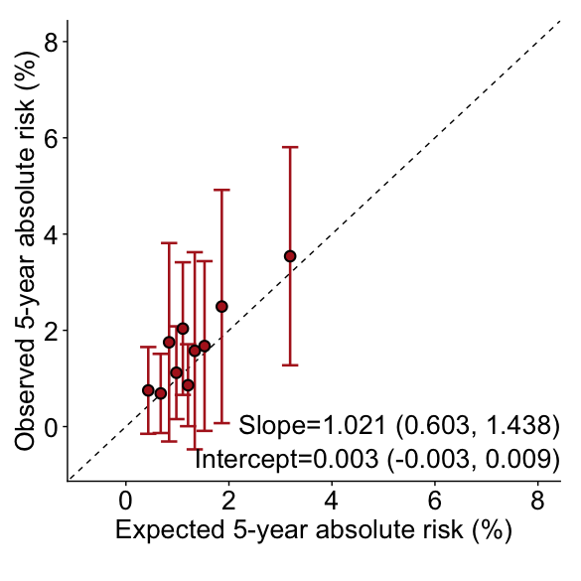
QRF + PRS + MBD
QRF + PRS

QRF only

Calibration and discrimination of 5-year risk predictions of breast cancer for women aged younger than 50 years in the nested case-control sample of the Nurses’ Health Study II with risk categories based on deciles of predicted 5-year absolute risk. Validation results are shown for the extended iCARE model that incorporates (i) questionnaire-based risk factors with a PRS based on 313 common germline variants without questionnaire-based risk factors, (ii) the fully integrated model incorporating questionnaire-based risk factors, the 313-variant PRS and BI-RADS breast density. Estimates and 95% CI of the calibration slope and intercept are reported based on a linear regression of the decile-specific observed proportion of cases within 5 years and the average of the predicted 5-year absolute risk. AUC = area under the curve, c² =chi-square goodness-of-fit test, CI = confidence interval, E/O = expected to observed number of cases, NHS II = Nurses’ Health Study II, PRS = polygenic risk score, QRF = Questionnaire-based risk factors.
Figure S1C. Absolute risk and relative risk calibration in KARMA for women 50 years and older

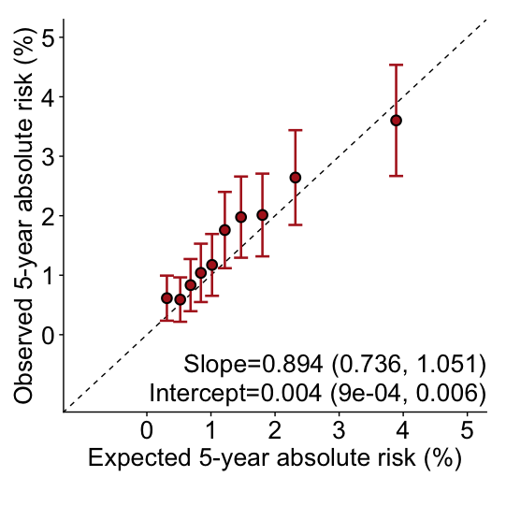
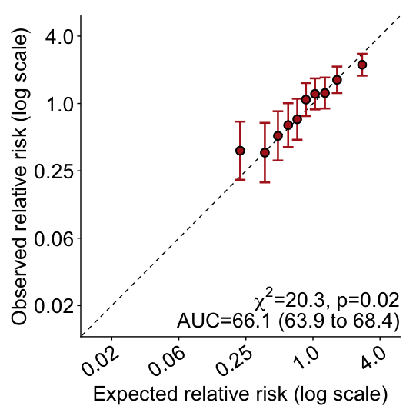
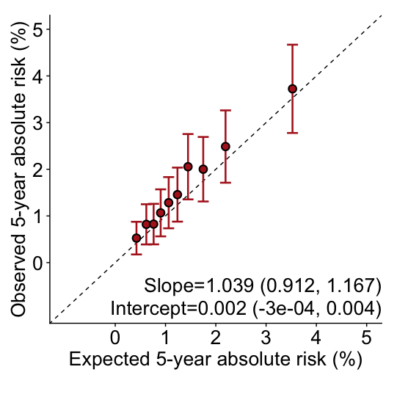
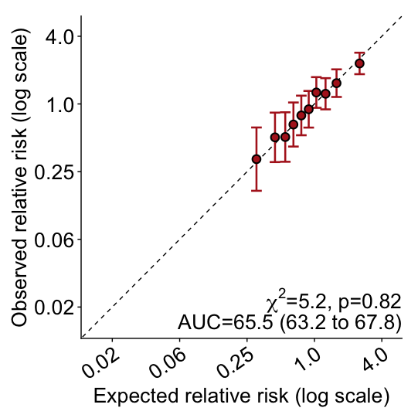
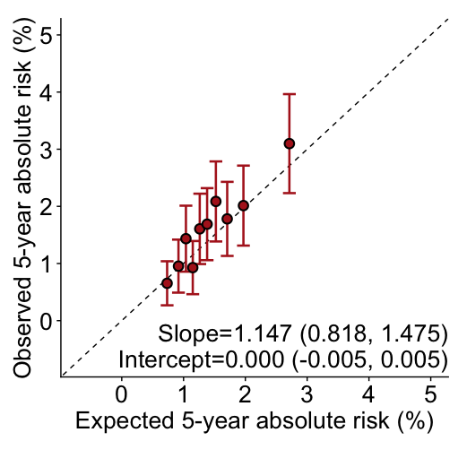
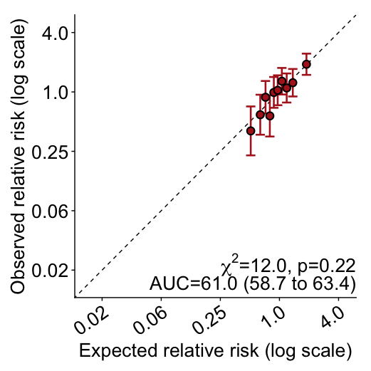
QRF + PRS + MBD
QRF + PRS
QRF only

Calibration and discrimination of 5-year risk predictions of breast cancer for women aged 50 years and over in the nested case-control sample of the Karolinska Mammography Project for Risk Prediction of Breast Cancer cohort with risk categories based on deciles of predicted 5-year absolute risk. Validation results are shown for the extended iCARE model that incorporates (i) questionnaire-based risk factors with a PRS based on 313 common germline variants without questionnaire-based risk factors, (ii) the fully integrated model incorporating questionnaire-based risk factors, the 313-variant PRS and BI-RADS breast density. Estimates and 95% CI of the calibration slope and intercept are reported based on a linear regression of the decile-specific observed proportion of cases within 5 years and the average of the predicted 5-year absolute risk. AUC = area under the curve, c² =chi-square goodness-of-fit test, CI = confidence interval, E/O = expected to observed number of cases, KARMA = Karolinska Mammography Project for Risk Prediction of Breast Cancer, PRS = polygenic risk score, QRF = Questionnaire-based risk factors.
Figure S1D. Absolute risk and relative risk calibration in NHS I for women 50 years and older

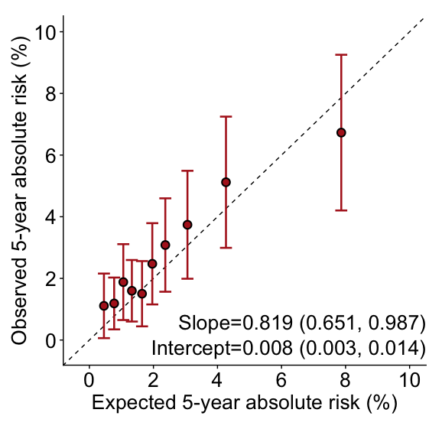
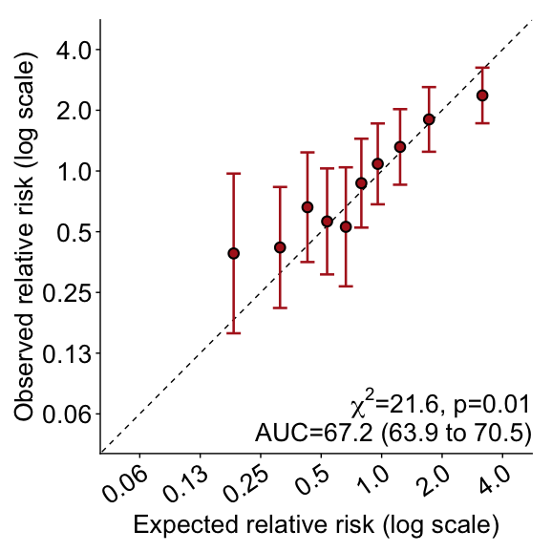
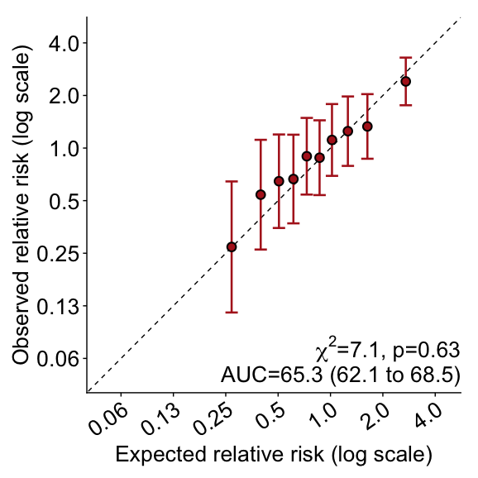
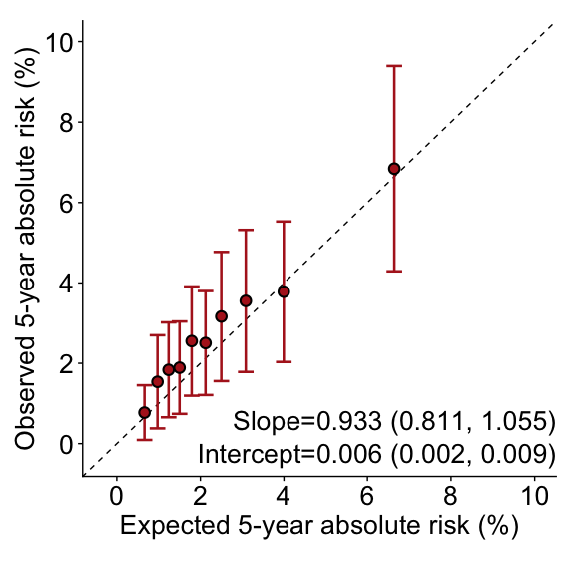
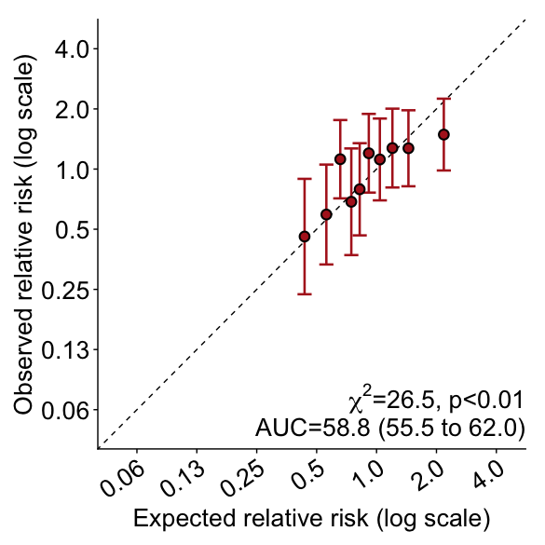
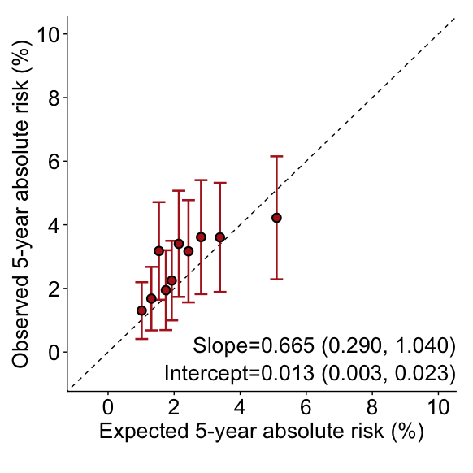
QRF + PRS + MBD
QRF + PRS
QRF only

Calibration and discrimination of 5-year risk predictions of breast cancer for women aged 50 years and over in the nested case-control sample of the Nurses’ Health Study I with risk categories based on deciles of predicted 5-year absolute risk. Validation results are shown for the extended iCARE model that incorporates (i) questionnaire-based risk factors with a PRS based on 313 common germline variants without questionnaire-based risk factors, (ii) the fully integrated model incorporating questionnaire-based risk factors, the 313-variant PRS and BI-RADS breast density. Estimates and 95% CI of the calibration slope and intercept are reported based on a linear regression of the decile-specific observed proportion of cases within 5 years and the average of the predicted 5-year absolute risk. AUC = area under the curve, c² =chi-square goodness-of-fit test, CI = confidence interval, E/O = expected to observed number of cases, NHS II = Nurses’ Health Study I, PRS = polygenic risk score, QRF = Questionnaire-based risk factors.
Figure S1E. Absolute risk and relative risk calibration in MMHS for women 50 years and older

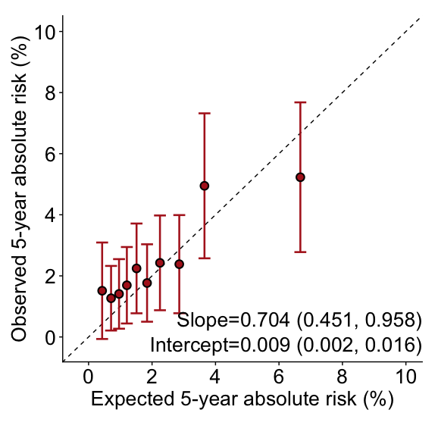
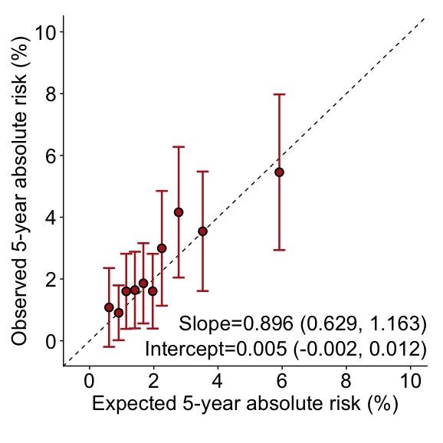
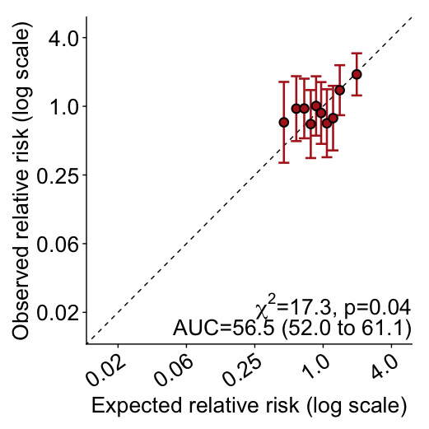
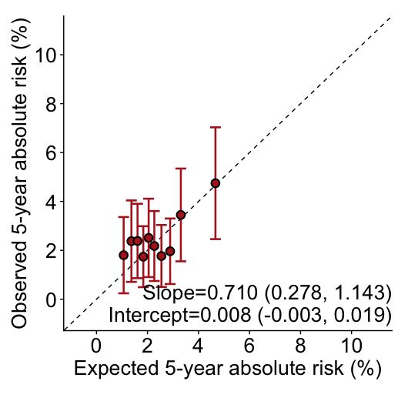
QRF + PRS + MBD
QRF + PRS
QRF only

Calibration and discrimination of 5-year risk predictions of breast cancer for women aged 50 years and over in the nested case-control sample of the Mayo Mammography Health Study with risk categories based on deciles of predicted 5-year absolute risk. Validation results are shown for the extended iCARE model that incorporates (i) questionnaire-based risk factors with a PRS based on 313 common germline variants without questionnaire-based risk factors, (ii) the fully integrated model incorporating questionnaire-based risk factors, the 313-variant PRS and BI-RADS breast density. Estimates and 95% CI of the calibration slope and intercept are reported based on a linear regression of the decile-specific observed proportion of cases within 5 years and the average of the predicted 5-year absolute risk. AUC = area under the curve, c² =chi-square goodness-of-fit test, CI = confidence interval, E/O = expected to observed number of cases, MMHS = Mayo Mammography Health Study, PRS = polygenic risk score, QRF = Questionnaire-based risk factors.
References

1. Pal Choudhury P, Maas P, Wilcox A, Wheeler W, Brook M, Check D, et al. iCARE: An R package to build, validate and apply absolute risk models. Meyre D, editor. PLoS One [Internet]. 2020 Feb 5 [cited 2020 Jun 17];15(2):e0228198. Available from: https://dx.plos.org/10.1371/journal.pone.0228198
2. Choudhury PP, Wilcox AN, Brook MN, Zhang Y, Ahearn T, Orr N, et al. Comparative validation of breast cancer risk prediction models and projections for future risk stratification. J Natl Cancer Inst. 2020;112(3):278–85.
3. Mavaddat N, Michailidou K, Dennis J, Lush M, Fachal L, Lee A, et al. Polygenic Risk Scores for Prediction of Breast Cancer and Breast Cancer Subtypes. Am J Hum Genet. 2019 Jan 3;104(1):21–34.
4. Barlow, W.E.; White, E.; Ballard-Barbash, R.; Vacek, P.M.; Titus-Ernstoff, L.; Carney, P.A.; Tice, J.A.; Buist, D.S.; Geller, B.M.; Rosenberg R et al. Prospective Breast Cancer Risk Prediction Model for Women Undergoing Screening Mammography. J Natl Cancer Inst [Internet]. 2006;98:1204–1663. Available from: https://academic.oup.com/jnci/article-abstract/98/17/1204/2521747
5. McCormack VA, Dos Santos Silva I. Breast density and parenchymal patterns as markers of breast cancer risk: A meta-analysis. Cancer Epidemiol Biomarkers Prev. 2006 Jun;15(6):1159–69.
6. Tice JA, Miglioretti DL, Li CS, Vachon CM, Gard CC, Kerlikowske K. Breast density and benign breast disease: Risk assessment to identify women at high risk of breast cancer. J Clin Oncol. 2015 Oct 1;33(28):3137–43.
7. Vachon CM, Pankratz VS, Scott CG, Haeberle L, Ziv E, Jensen MR, et al. The contributions of breast density and common genetic variation to breast cancer risk. J Natl Cancer Inst [Internet]. 2015 [cited 2020 May 4];107(5). Available from: https://www.ncbi.nlm.nih.gov/pmc/articles/PMC4598340/
8. Engmann NJ, Golmakani MK, Miglioretti DL, Sprague BL, Kerlikowske K. Population-attributable risk proportion of clinical risk factors for breast cancer. JAMA Oncol [Internet]. 2017 Sep 1 [cited 2020 Jul 6];3(9):1228–36. Available from: https://jamanetwork.com/journals/jamaoncology/article-abstract/2599991
9. Destounis S, Arieno A, Morgan R, Roberts C, Chan A. Qualitative Versus Quantitative Mammographic Breast Density Assessment: Applications for the US and Abroad. Diagnostics. 2017 May 31;7(2):30.
10. DeLong ER, DeLong DM, Clarke-Pearson DL. Comparing the Areas under Two or More Correlated Receiver Operating Characteristic Curves: A Nonparametric Approach. Biometrics [Internet]. 1988 Sep [cited 2020 Jul 7];44(3):837. Available from: https://www.jstor.org/stable/2531595
11. Maas P, Barrdahl M, Joshi AD, Auer PL, Gaudet MM, Milne RL, et al. Breast Cancer Risk From Modifiable and Nonmodifiable Risk Factors Among White Women in the United States. JAMA Oncol [Internet]. 2016 Oct 1 [cited 2020 Jun 29];2(10):1295–302. Available from: /pmc/articles/PMC5719876/?report=abstract
12. Yang X, Eriksson M, Czene K, Lee A, Leslie G, Lush M, et al. Prospective validation of the BOADICEA multifactorial breast cancer risk prediction model in a large prospective cohort study. J Med Genet. 2022;59(12):1196–205.
13. Van Veen EM, Brentnall AR, Byers H, Harkness EF, Astley SM, Sampson S, et al. Use of single-nucleotide polymorphisms and mammographic density plus classic risk factors for breast cancer risk prediction. JAMA Oncol. 2018 Apr 1;4(4):476–82.
14. Brentnall AR, Van Veen EM, Harkness EF, Rafiq S, Byers H, Astley SM, et al. A case-control evaluation of 143 single nucleotide polymorphisms for breast cancer risk stratification with classical factors and mammographic density. Cancer Epidemiol Int J Cancer [Internet]. 2020;146:2122–9. Available from: http://epi.grants.cancer.gov/oncoarray

