A practical measure of health facility efficiency: An innovation in the application of routine health information to determine health worker productivity in Ethiopia

Additional File 1: Supplemental Materials
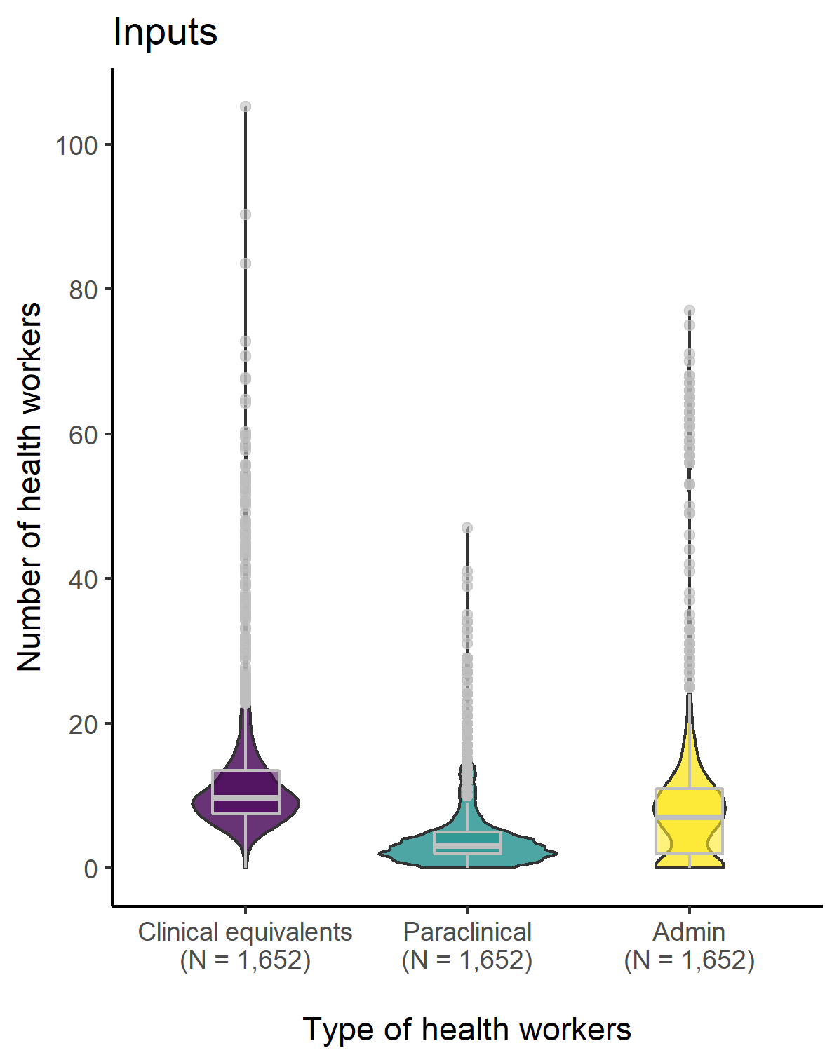
Supplementary Material 1: Distribution of the output and input measures with outliers:

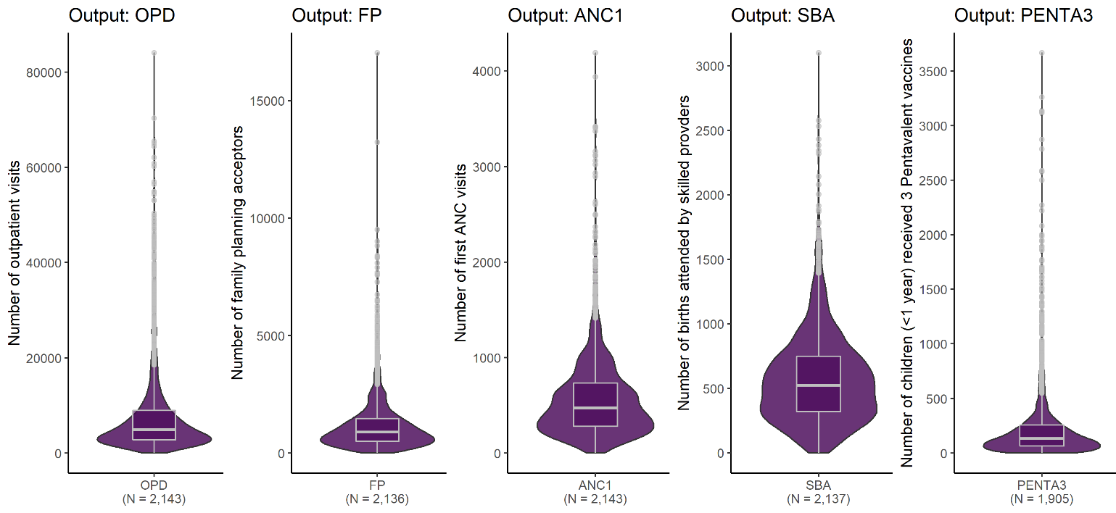
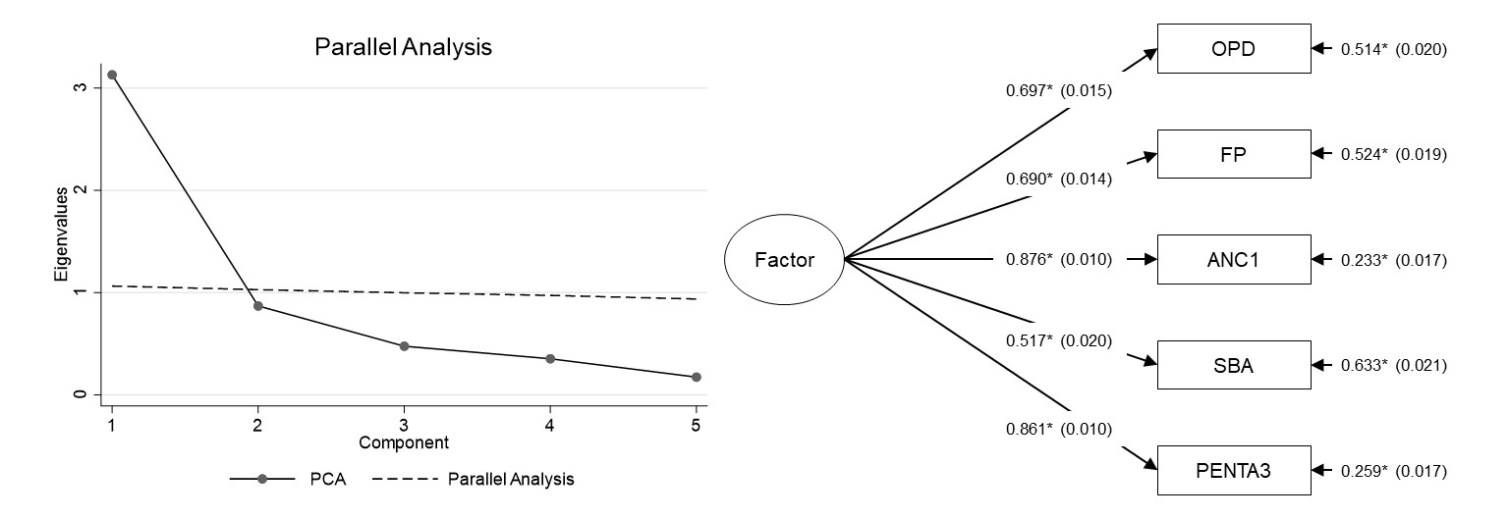
Supplementary Material 2: Result of Horn’s parallel analysis and factor analysis (N = 1,128).
Note: * = P < 0.001; The factor analysis is implemented using the Maximum Likelihood (ML) estimation; Goodness of fit indices: root mean square error of approximation (RMSEA) = 0.073, comparative fit index (CFI) = 0.920, Tucker-Lewis index (TLI) = 0.890, standardized root mean square residual (SRMR) = 0.056, λ² value = 652.105, df = 5, p < 0.001.

