Supplementary Materials

PART A: System Hardware
I. Graphene Transparent Photodetector Device Fabrication:
We first transferred a layer of graphene onto a commercial glass substrate. The graphene layer was grown on copper foil with chemical vapor deposition (CVD), and a standard wet transfer process produced a decent coverage of the monolayer graphene on the centimeter scale. We patterned the graphene layer into isolated squares (as the floating gate) using photolithography. Then we etched away the exposed graphene with oxygen plasma. A 6-nm layer of sputtered silicon was sputtered on top of the graphene layer as the tunneling barrier. Another layer of graphene was transferred on top of the barrier immediately after silicon sputtering to minimize surface oxidation. We annealed the sample in Ar at 300 C for 15 mins to enhance graphene’s adhesion with the substrate, so that there is less stripping-off in the subsequent process. This graphene layer was lithographically patterned into the channel of the phototransistor as well as interconnects. The individual device pixels were spaced 0.3 mm away from each other. Cr/Au metal contacts were then deposited and connected to the graphene interconnects, leaving a 2.5 mm by 2.5 mm transparent window for light to pass through. The Cr/Au pads were then wire bonded to a sample holder in the readout circuit. The readout circuit was a scanning line that selectively applies bias to different pixels and collects the photocurrent in the target pixel.

II. Graphene Photodetector Characterization:
The fabricated all-graphene devices in general showed good coverage over the entire die. To check the uniformity and device yield, we applied a 0.5 V bias voltage across every pixel and measured the current across the graphene channel (see Fig. 1S(b)). Of all 192 devices tested, only 2 devices showed open circuit. This DC conductance test result shows 99% graphene device yield and negligible graphene peeling-off during the nanofabrication process.
The detector photoresponse is characterized using a 532 nm Verdi V10 CW laser under 0.22 $μ$W illumination on a single pixel. The responsivity is 3 A/W under 0.5 V source-drain bias. It is slightly smaller than previously reported values due to a relatively small bias voltage applied, lower doping level of graphene, and the geometry of the device. The DC photocurrent shows both a “fast” response on the scale of seconds and a “slow” response in hundreds of seconds, which is due to the charge trapping effect of the highly defective silicon barrier. By changing the dielectric material, the response time of such a structure can be decreased to the sub-millisecond level.To increase the speed of measurement and remove effects from drifting dark currents, we adopted an AC photocurrent measurement scheme to measure the smaller but fast component, as discussed in the main text. Fig. 1S(d) shows a linear dependence of AC photocurrent with respect to illumination power. A linear power dependence of the AC photocurrent was observed.
We also characterize the transparency of the graphene detector array with a light focused on the detector plane. Transmission of a 532 nm laser beam through the array is measured to be 81%, while the reflection of the uncoated glass substrate contributes to a transmission of 86%, as measured in the graphene-free area of the device. The graphene detector array contributes to only 5% of decrease in transmission. If the application requires, the transparency can be significantly improved to >95% using an antireflection coating, and by replacing the silicon layer with ALD-grown Al₂O₃ of the same thickness.
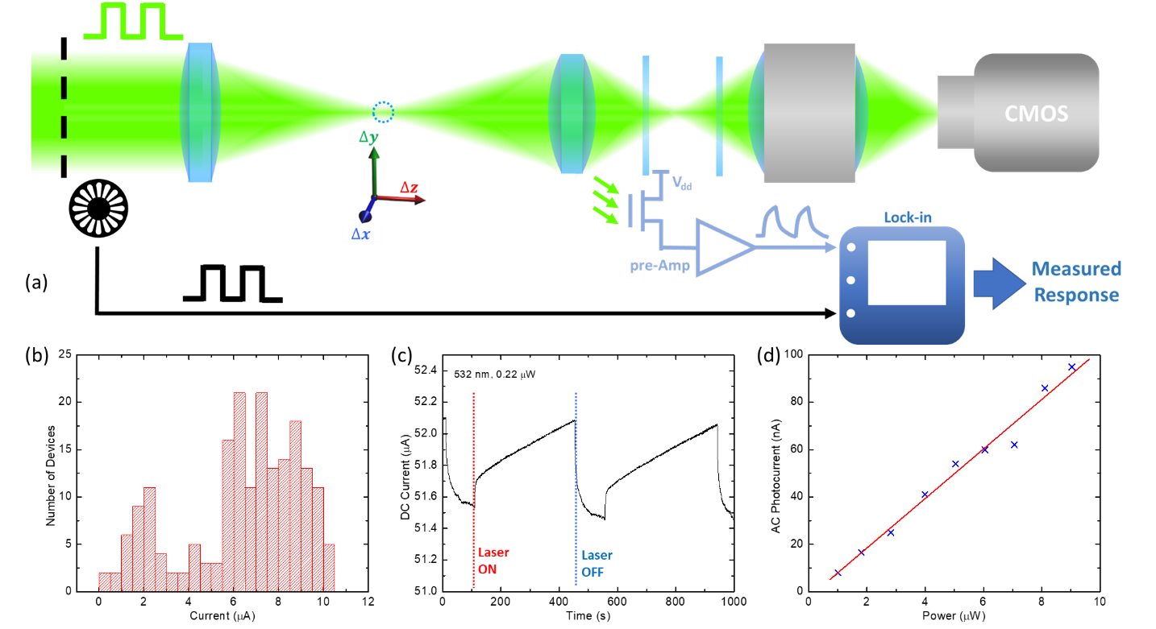
Figure 1S. Optical and electrical measurements on the all-graphene transparent photodetector. (a) measurement setup. A point object (dotted circle) is generated by focusing a green laser beam (532 nm) with the lens. Its position is controlled by a 3D motorized stage. Two detector arrays (blue sheets) are placed behind the lens. An objective and CCD camera are placed behind the detector array for sample alignment. A chopper modulates the light at 500 Hz and a lock-in amplifier records the AC current at the chopper frequency. (b) Histogram of the DC currents across graphene channels for individual detector devices. Bias voltage applied is 0.5 V. (c) DC temporal photoresponse of a typical graphene detector following light illumination. Both a fast and a slow component were observed, while the background current also showed drifting over time. (d) Power dependence of AC photocurrent, which measures the fast component and suppress the background drift. A linear power dependence (red line) is observed.

III. Use of Graphene for Interconnects
In our transparent detector array design, graphene is used not only as the active pixel material but also as the passive interconnect. Compared with other transparent electrode materials, such as indium-tin oxide (ITO), graphene is atomically thin while maintaining similar conductivity. This ultimate thin-ness minimizes optical interference patterns generated from the interconnect patterning, and also suppresses edge scatterings from normal metal wires. Fig. 2S compares the optical transmission images of detector arrays fabricated using graphene interconnects versus ITO interconnects under 532 nm laser illumination. Even though the interference and scattering effect from ITO interconnects can be reduced with a refractive index compensation layer, this would add more complexity to the sensor array.
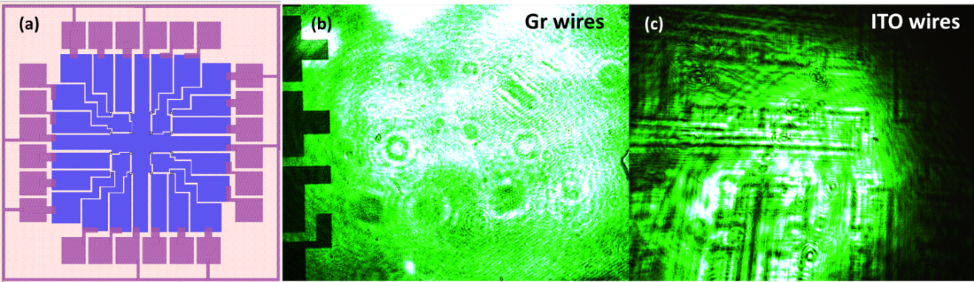
Figure 2S. Array design (a) and optical images of photodetector arrays captured by CMOS camera. Samples using graphene interconnects (b) showed significantly weaker effects of interference and scattering than samples with ITO interconnects (c).

IV. Readout of Single Pixel in 3D Ranging
Before using the graphene devices as an imaging array, an imaging hardware reliability test is performed (Fig. S3). The single-pixel photocurrent is measured while the light source moves both in-plane and along the optical axis. For each pixel tested, the photocurrent always shows a single peak when the object is translated in 3 dimensions. The peak positions and FWHMs of peaks match the relative positions of pixels tested, confirming that the graphene detector array can indeed accurately “image” the focus of a point light source.

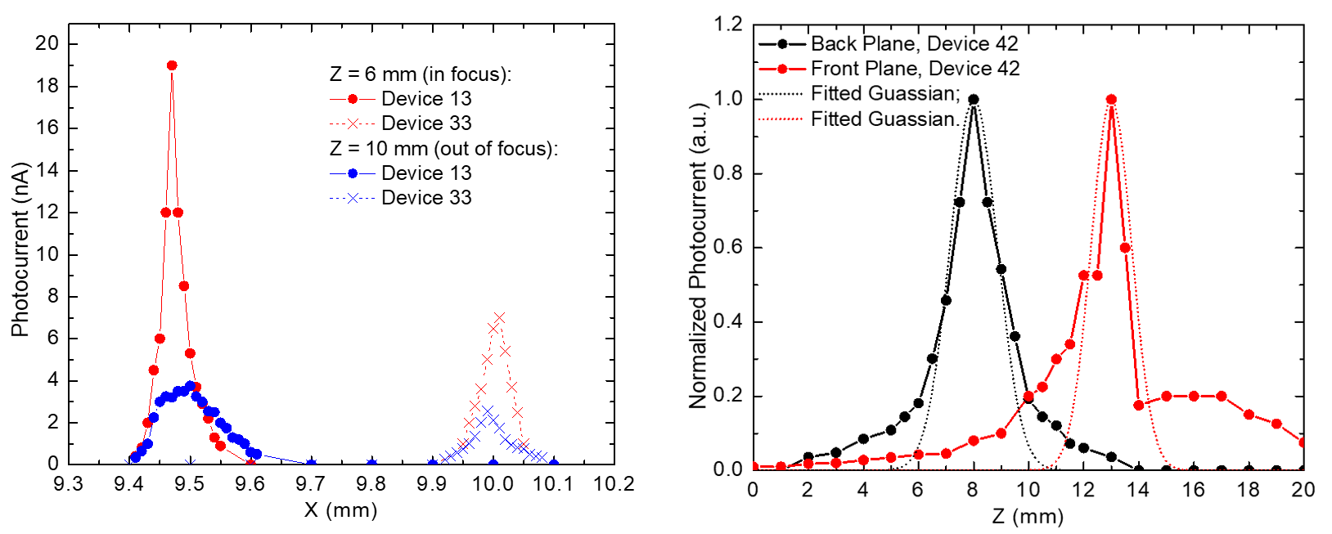
Figure 3S. 3D ranging test of single detector pixels. Left: Photocurrents from two pixels (Device 13 and 33) spaced laterally in the X direction. When the point light source moves in X direction, the devices are illuminated sequentially and give peaks at two different X positions. When the point source is off focus on the device plane, a broader peak is observed corresponding to de-focusing. Right: Photocurrents from two pixels at front and back planes along the optical path (Z direction), respectively. As the point source moves from front to back along Z direction, the focus shifts from front to back detector plane accordingly, resulting in the observed photocurrent peaks at different Z positions. Deviation from the Gaussian fit stems from imperfect beam quality and possible off-axis alignment.

PART B: Data Processing and Machine Learning
- Single-point object focal stack from CMOS camera
We recorded the 1,331 single-point object focal stacks using the transparent graphene transistor array and separately using a CMOS sensor (Thorlab DCC1645C); see the right part of the Fig. 2(a) in the main text. By moving the CMOS sensor along $z$ to focus at either the transparent detector array closer to or farther away from the lens, we captured focal stacks from CMOS camera. This data allows us to test how the image resolution and image quality of the graphene sensors affect the 3D ranging performance of a machine-learning algorithm.

We applied the following procedure to each high-resolution (1280 $×$ 1024) color image captured by the CMOS camera: we convert the captured color image to gray image and optionally smooth it by spatial averaging and generate low resolution single-point object focal stacks of spatial size 4 $×$ 4, 9 $×$ 9 or 32 $×$ 32. We used the processed images in either single-point tracking (to investigate the effects of imaging resolution to the tracking performance) or synthesizing multi-point object focal stacks.

- Synthesizing multi-point object focal stack
We synthesized the multi-point object focal stack using focal stacks from the scanned single point object (either from transparent graphene transistor array or from CMOS camera). The synthesis is based on the assumption that the detector’s response is linear, i.e., suppose $I_{i}$ is the sensor image of the single point object at location $\left(x_{i},y_{i},z_{i}\right)$. Then the sensor image $I_{multi}$ consisting of multiple points can be synthesized as $I_{multi}=\sum_{i=1}^{N}{I_{i}}$, where $N$ is the number of point objects.
We constructed the $M$-point object focal stack dataset, where the dataset consists of multiple subsets, and each subset consists of $K$ possible shapes (relative position between points), by synthesizing each shape independently and then combining them. We translated an object to all possible (i.e., no point of $M$-point object is off the 3D grid) locations in the 3D $11×11×11$ scanning grid; at each location, we synthesize the corresponding focal stack according to the summation above. The number of synthesized datasets with (M = 2, K = 2), (M = 2, K = 3), (M = 3, K = 2), (M = 3, K = 3) were 1600, 2320, 1232, and 1880, respectively.

We constructed the rotating 2-point object focal stack dataset by selecting focal stacks from the M-point focal stack with K possible shapes dataset, with $M=2,K=4$. Four shapes of a 2-point object (i.e., $M=2,K=4$) are chosen to have same inter-point distance but rotated by different angles (26.5$°$, 63.5$°$, 116.5$°$, and 153.5$°$) about $z$ axis (e.g., (1,0,0) means 0$°$ rotation about $z$axis and (0,1,0) means 90$°$ rotation about $z$axis). To form the helical trajectory in the $M=2,K=4$ setup, we selected an angle from the set {26.5$°$, 63.5$°$, 116.5$°$, and 153.5$°$} at each $z$ position in the following sequence: 63.5$°$, 26.5$°$,153.5$°$, 116.5$°$, 63.5$°$, 26.5$°$, 153.5$°$,116.5$°$, 63.5$°$, 26.5$°$, 153.5$°$, for $z=$-10 mm, -8 mm, $…$, 10 mm. See graphical illustration in Fig. 3(e) of the main paper.

- Extended object focal stack
We captured extended object focal stacks using the CMOS sensor. The experimental setup is shown in Fig. 4S. We used a ladybug as the extended object and moved it in a 3D spatial grid of size 8.5 mm $×$ 8.5 mm $×$45 mm. The grid spacing is 0.85 mm along both $x$ and $y$, 3 mm along $z$. At each grid point, the object has 8 possible orientations in the x-z plane, with 45$°$ angular separation between neighboring orientations. This leads to in total 1,5488 focal stacks, where each focal stack consists of two images captured by the CMOS sensor positioned at different $z$ positions. Similar to Part B-III, all images are converted to gray images before feeding to the neural networks.
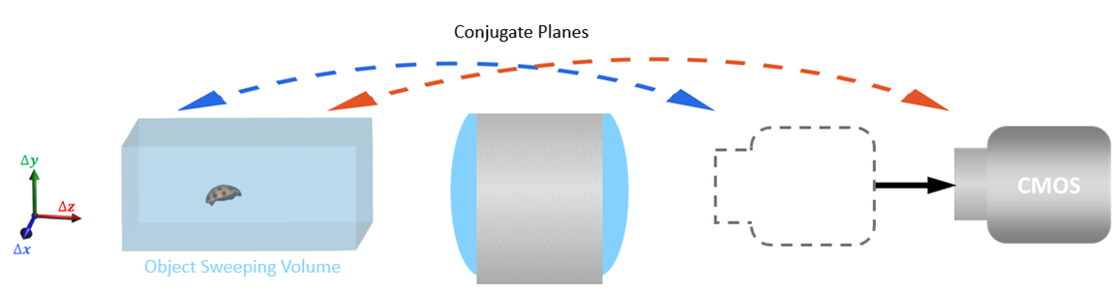
Fig. 4S. Experimental set-up for capturing the extended object (ladybug) focal stack, using CMOS sensor.

- Neural network architectures and training
We implemented all neural networks in Pytorch (ver. 1.0). The network architectures and training details are described below.

For single-point object tracking, separate neural networks were trained for estimating the three spatial coordinates $x$, $y$ and $z$, respectively. Fig. 5S(a) shows the network architecture used for estimating coordinates $x$ and $y$, and Fig. 5S(b) shows the network architecture used for estimating $z$. For multi-point object tracking, a single neural network (Fig. 5S(c)) is trained to estimate all points’ coordinates.
In point object tracking cases (Fig.5S (a-c)), the focal stack data is flattened into a one-dimensional vector and subsequently passed through multilayer perceptron (MLP) using Rectified Linear Unit (ReLU) as the activation function.

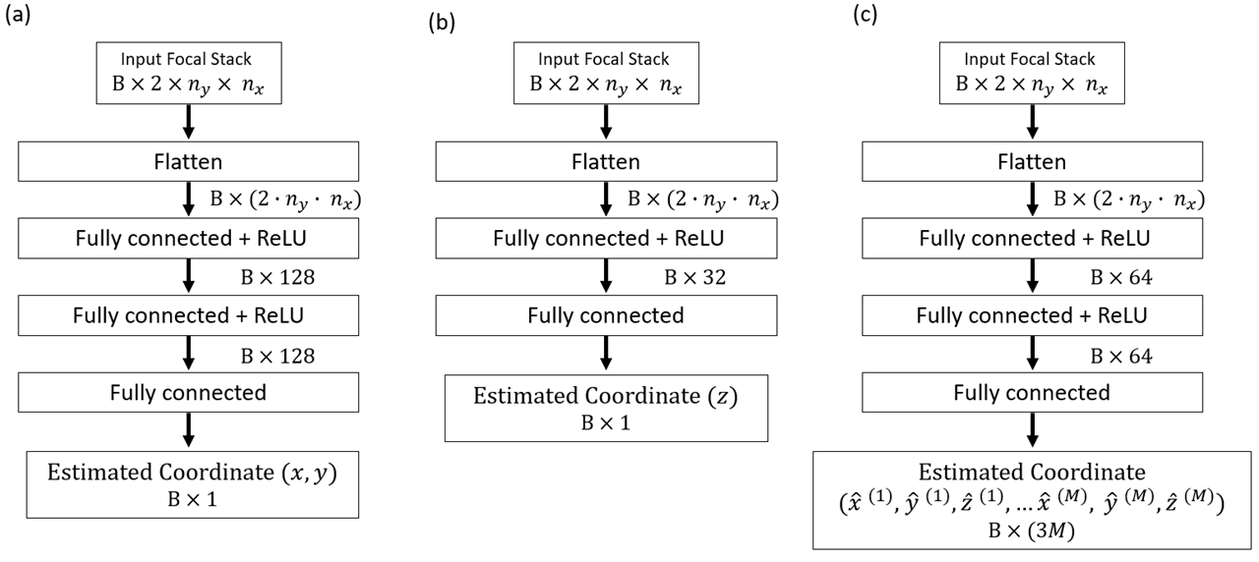
Fig. 5S. Neural network architectures for 3D ranging. $B$ is the general batch size of the data (e.g., in training, $B$ is the training batch size; in testing with a single sample, $B=1$). (a) Network for estimating single point object’s $x$ or $y$ coordinate. (b) Network for estimating single point object’s $z$ coordinate. (c) Network for estimating M-point object’s $\left(x_{i},y_{i},z_{i}\right)$ coordinates tuple.

For single-point object tracking, the network outputs a single coordinate value for each focal stack, and the networks are trained by minimizing the following mean-square error (MSE) loss
$$\frac{1}{N}\sum_{i=1}^{N}{{\left({\overset{^}{s}}_{i}-s_{i}\right)}^{2},}$$
where $N$ is the number of training samples, $s_{i}$ is the true spatial coordinate ($x_{i},y_{i}$, or $z_{i}$) and ${\overset{^}{s}}_{i}$ is the estimated spatial coordinate from a neural network. We trained networks using the Adam optimizer with the learning rate of 10⁻², the training batch size of 50, and 2000 epochs.

For training multi-point object tracking neural networks, we defined the following MSE loss that considers the ordering ambiguity of the network outputs in training:
$$\frac{1}{N}\sum_{i=1}^{N}{\min_{{(p}_{1},...,p_{M})∈P}}\sum_{j=1}^{M}{{\left({\overset{^}{x}}_{i}^{(j)}-x_{i}^{(p_{j})}\right)}^{2}+{\left({\overset{^}{y}}_{i}^{(j)}-y_{i}^{(p_{j})}\right)}^{2}+{\left({\overset{^}{z}}_{i}^{(j)}-z_{i}^{(p_{j})}\right)}^{2}},$$ | (1)

where $M$ is the number of points of the object, $P$ is the set containing all possible permutations of the tuple $(1,2,...M)$, $x_{i}^{(j)}$ and ${\overset{^}{x}}_{i}^{(j)}$ are the true and estimated coordinate of the $i^{th}$ data sample, $j^{th}$ point. The network outputs a coordinates tuple for all the points of the object as $\{{(\overset{^}{x}}^{\left(1\right)},{\overset{^}{y}}^{\left(1\right)},{\overset{^}{z}}^{\left(1\right)}),…,{(\overset{^}{x}}^{\left(M\right)},{\overset{^}{y}}^{\left(M\right)},{\overset{^}{z}}^{\left(M\right)})\}$. To consider the ordering ambiguity of the network outputs in training, e.g., for $(x^{\left(1\right)},y^{\left(1\right)},z^{\left(1\right)})$, the network cannot determine which estimate gives lower MSE, between $({\overset{^}{x}}^{\left(1\right)},{\overset{^}{y}}^{\left(1\right)},{\overset{^}{z}}^{\left(1\right)})$ and $({\overset{^}{x}}^{\left(2\right)},{\overset{^}{y}}^{\left(2\right)},{\overset{^}{z}}^{\left(2\right)})$, we found proper orders by minimizing MSE over the permutation set $P$ in (1) . With the help of minimization over $P$, the loss will be low as long as a trained network predicts the overall shape of the object, regardless of the order of the network estimates. In the training, we scaled down the true $z$ coordinate values by 33.3 so that it is in the same range as coordinates $x$ and $y$. This avoids the loss (1) from being dominated by $z$ component of MSE loss, i.e., avoids training from being biased to $z$-coordinate estimation. We trained the network using Adam optimizer with the learning rate of 10⁻³, the training batch size of 100, and 2000 epochs.

For tracking the two-point rotating object, we also trained the network by (1) and scaled the z coordinate values by 33.3. For training the network, we used Adam optimizer with the learning rate of 10⁻³, the training batch size of 100, and 2000 epochs.

For extended object tracking and orientation estimation, we use two convolutional neural networks (CNNs) (Fig. 6S) similar to VGG-16. The CNN shown in Fig. 6S(a) is used for the tracking. For each focal image, we first extract high-level feature maps with multiple convolution-batch normalization (BN)-ReLU-pooling layers. Then we apply the following procedure to extracted feature maps from all focal images: 1) concatenation of all feature maps along channel dimension, 2) average pooling, 3) flattening, and 4) feeding the output into fully connected layers (FC) that lead to final coordinates. The network is trained by minimizing the following MSE loss:
$$\frac{1}{3N}\sum_{i=1}^{N}{{\left({\overset{^}{x}}_{i}-x_{i}\right)}^{2}+{\left({\overset{^}{y}}_{i}-y_{i}\right)}^{2}+{\left({\overset{^}{z}}_{i}-z_{i}\right)}^{2}},$$
where $N$ is the number of training samples. In the training, we scaled the true $z$ coordinate values to have the same range as x and y coordinates, for the same reason as in the multi-point object tracking. The CNN shown in Fig. 6S(b) is used for object orientation estimation. We consider the problem as a multi-class classification problem: the CNN takes focal stack as input and output scores that are used to classify the object orientations with eight different orientations. The network is trained by minimizing the cross-entropy loss.
We trained both CNNs with 13,188 training samples, using Adam optimizer with the initial learning rate of 10⁻⁴ (with learning rate decay by 0.3 at epoch 3, 5, 10, 20), the training batch size of 20, and 60 epochs and tested trained CNNs with 2,300 test samples. Due to the nondeterministic behavior of PyTorch, the training/testing is repeated three times for the orientation classification network and the best model is used. The orientation classification accuracies of the three runs are 95.35%, 96.61% and 99.35%.
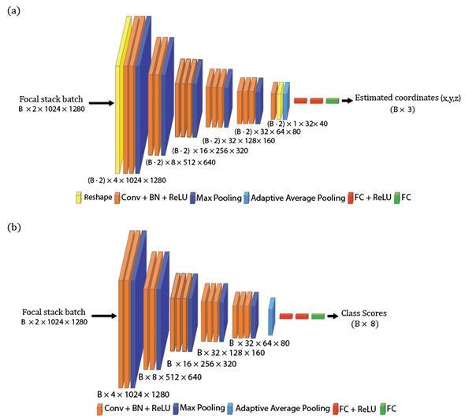
Fig. 6S. Convolutional neural network architectures for extended object tracking and orientation estimation. $B$ is the general batch size of the data (e.g., in training, $B$ is the training batch size; in testing with a single sample, $B=1$). (a) Network for estimating extended object’s spatial coordinates $\left(x,y,z\right).$(b) Network for estimating extended object’s orientation.

- Ranging performance comparison
We studied the effect of the detector resolution and spatial smoothing on the single-point object 3D ranging performance. Table 1 summarizes the results. The resolution of the CMOS focal stack is varied to see its effect on the ranging performance: it can be seen by comparing horizontally the root mean square error (RMSE) in the 2nd, 3rd and 4th columns or in the 5th and 6th columns that higher resolution focal stack gives lower loss. Besides, note that spatially averaged results have lower loss, compared to those without averaging. This is because the noise from interference fringes is suppressed after applying spatial averaging.
 | $4×4$ Graphene | $4×4$ CMOS | $9×9$ CMOS | $32×32$ CMOS | $4×4$ (Avg. 20) CMOS | $9×9$ (Avg. 20) CMOS
RMSE x | $$0.012$$ | $$0.031$$ | $$0.020$$ | $$0.021$$ | $$0.014$$ | $$0.009$$
RMSE y | $$0.014$$ | $$0.028$$ | $$0.017$$ | $$0.012$$ | $$0.012$$ | $$0.010$$
RMSE $z$ | 1.196 | 1.304 | 1.192 | 0.480 | 0.616 | 0.458

Table 1. Single-point object 3D ranging RMSE (unit: mm) table on testing set. Avg. 20 means spatial averaging with window size 20 is performed on the raw high-resolution focal stack.
 | $4×4$ Graphene | $4×4$ CMOS | $9×9$ CMOS | $32×32$ CMOS | $4×4$ (Avg. 20) CMOS | $9×9$ (Avg. 20) CMOS
2p2s | 0.017 | 0.036 | 0.025 | 0.013 | 0.020 | 0.013
2p3s | 0.019 | 0.033 | 0.022 | 0.013 | 0.019 | 0.012
3p2s | 0.019 | 0.042 | 0.027 | 0.025 | 0.021 | 0.016
3p3s | 0.021 | 0.041 | 0.029 | 0.028 | 0.022 | 0.017

Table 2. Multi-point object 3D ranging RMSE (unit: mm) table of $x$ on testing set. Avg. 20 means spatial averaging with window size 20 is performed on the raw high-resolution focal stack. First column encodes different object configurations, e.g., 2p3s means 2-point object with 3 possible shapes.

 | $4×4$ Graphene | $4×4$ CMOS | $9×9$ CMOS | $32×32$ CMOS | $4×4$ (Avg. 20) CMOS | $9×9$ (Avg. 20) CMOS
2p2s | 0.022 | 0.045 | 0.033 | 0.019 | 0.026 | 0.017
2p3s | 0.025 | 0.039 | 0.028 | 0.018 | 0.025 | 0.015
3p2s | 0.010 | 0.019 | 0.013 | 0.016 | 0.011 | 0.007
3p3s | 0.019 | 0.035 | 0.026 | 0.027 | 0.021 | 0.016

Table 3. Multi-point object 3D ranging RMSE (unit: mm) table of $y$ on testing set. Avg. 20 means spatial averaging with window size 20 is performed on the raw high-resolution focal stack. First column encodes different object configurations, e.g., 2p3s means 2-point object with 3 possible shapes.
 | $4×4$ Graphene | $4×4$ CMOS | $9×9$ CMOS | $32×32$ CMOS | $4×4$ (Avg. 20) CMOS | $9×9$ (Avg. 20) CMOS
2p2s | 0.685 | 1.073 | 0.759 | 0.349 | 0.557 | 0.371
2p3s | 1.164 | 1.573 | 1.142 | 0.788 | 0.983 | 0.641
3p2s | 0.793 | 1.328 | 0.876 | 0.715 | 0.750 | 0.470
3p3s | 0.894 | 1.444 | 1.004 | 0.895 | 0.850 | 0.594

Table 4. Multi-point object 3D ranging RMSE (unit: mm) table of $z$ on a testing set. Avg. 20 means spatial averaging with window size 20 is performed on the raw high-resolution focal stack. First column encodes different object configurations, e.g., 2p3s means 2-point object with 3 possible shapes.
Tables 2, 3, 4 summarize the study of the effect of the detector resolution and spatial smoothing on the multi-point object 3D ranging performance. Similar to the single-point object case, more pixels are useful in reducing the ranging error, as can be seen by comparing horizontally the RMSE in 2nd, 3rd and 4th columns or in the 5th and 6th columns. The spatial averaging is again helpful, as in the single object case, in reducing the estimation error.
The numerical results summarized in Table 1-4 above are also illustrated graphically in Fig. 7S-11S below.
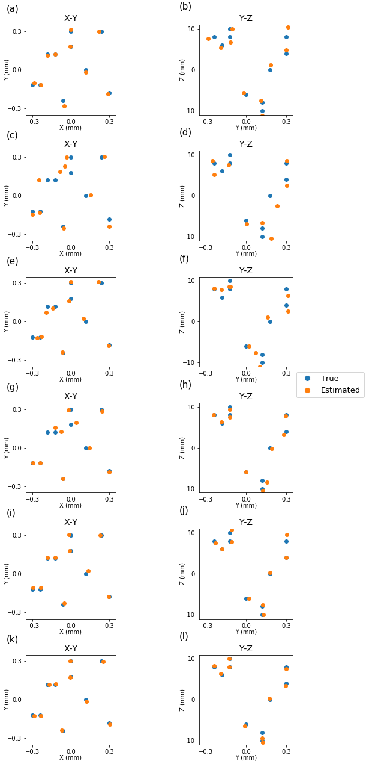
Fig. 7S. Single-point object tracking performance (only 10 test samples are shown). Focal stack data from: (a-b) 4$×$4 transparent graphene detector. (c-d) 4$×$4 CMOS sensor. (e-f) 9$×$9 CMOS sensor. (g-h) 32$×$32 CMOS sensor. (i-j) 4$×$4 Avg. 20 CMOS sensor. (k-l) 9$×$9 Avg. 20 CMOS sensor.
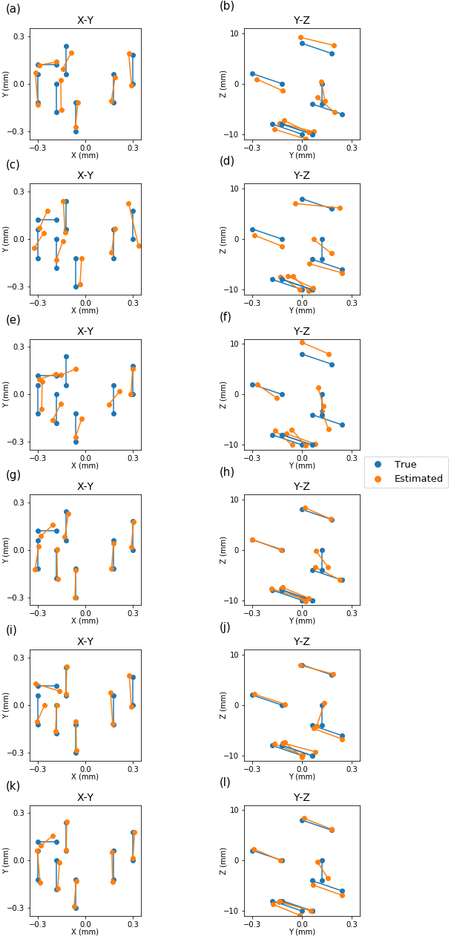
Fig. 8S. 2-point object with 2 possible shapes tracking performance (only 7 test samples are shown). Focal stack data from: (a-b) 4$×$4 transparent graphene detector. (c-d) 4$×$4 CMOS sensor. (e-f) 9$×$9 CMOS sensor. (g-h) 32$×$32 CMOS sensor. (i-j) 4$×$4 Avg. 20 CMOS sensor. (k-l) 9$×$9 Avg. 20 CMOS sensor.
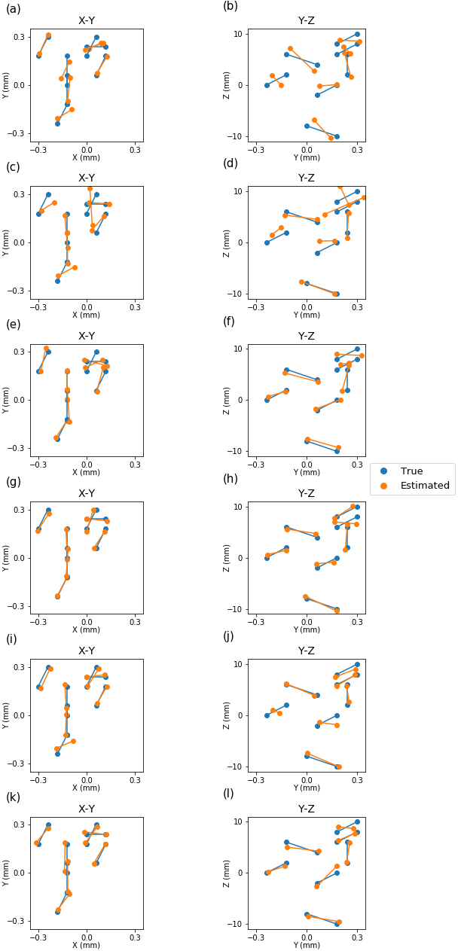
Fig. 9S. 2-point object with 3 possible shapes tracking performance (only 7 test samples are shown). Focal stack data from: (a-b) $4×4$transparent graphene detector. (c-d) $4×4$ CMOS sensor. (e-f) $9×9$ CMOS sensor. (g-h) $32×32$ CMOS sensor. (i-j) $4×4$ Avg. 20 CMOS sensor. (k-l) $9×9$ Avg. 20 CMOS sensor.
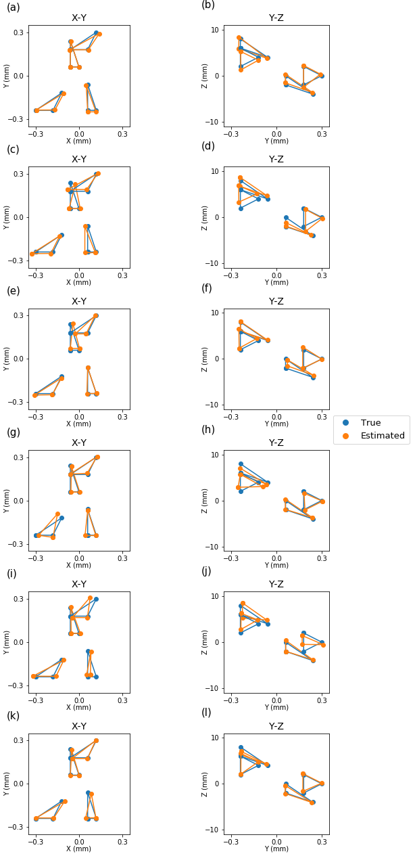
Fig. 10S. 3-point object with 2 possible shapes tracking performance (only 4 test samples are shown). Focal stack data from: (a-b) $4×4$ transparent graphene detector. (c-d) $4×4$ CMOS sensor. (e-f) $9×9$ CMOS sensor. (g-h) $32×32$ CMOS sensor. (i-j) $4×4$ Avg. 20 CMOS sensor. (k-l) $9×9$ Avg. 20 CMOS sensor.
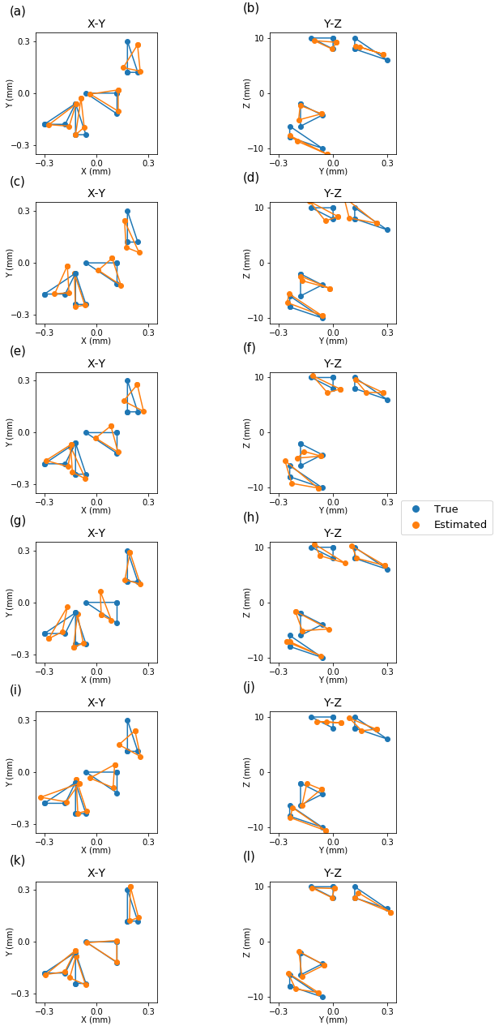
Fig. 11S. 3-point object with 3 possible shapes tracking performance (only 4 test samples are shown). Focal stack data from: (a-b) $4×4$ transparent graphene detector. (c-d) $4×4$ CMOS sensor. (e-f) $9×9$ CMOS sensor. (g-h) $32×32$ CMOS sensor. (i-j) $4×4$ Avg. 20 CMOS sensor. (k-l) $9×9$ Avg. 20 CMOS sensor.
- Inference time
Table 4 shows the network inference time for point object tracking. The inference times for extended object position tracking and orientation estimation are 9.538 ms and 6.001 ms, respectively. We measured the inference time using a 1531 MHz Nvidia GeForce 1080 Ti GPU with 11G RAM.
 | $4×4$ | $9×9$ | $32×32$
Single-point object | 0.503 ms | 0.512 ms | 0.539 ms
2-point object | 0.187 ms | 0.190 ms | 0.192 ms
3-point object | 0.190 ms | 0.189 ms | 0.189 ms

Table 4. Point object tracking inference time for different input focal stack resolutions.
Reference:

Lee, Seunghyun, et al. "Homogeneous bilayer graphene film based flexible transparent conductor." Nanoscale 4.2 (2012): 639-644.
Zhang D, Cheng G, Xu Z, et al. Electrically tunable photoresponse in a graphene heterostructure photodetector[C]//2017 Conference on Lasers and Electro-Optics (CLEO). IEEE, 2017: 1-2.
F. Rosenblatt, Psychol. Rev. 65, 386 (1958).
Kingma, Diederik P., and Jimmy Ba. "Adam (2014), A method for stochastic optimization." Proceedings of the 3rd International Conference on Learning Representations (ICLR), arXiv preprint arXiv. Vol. 1412.
S. Karen and A. Zisserman, ArXiv:1409.1556v6 (2014).
https://pytorch.org/docs/stable/notes/randomness.html

