Indirect methanol synthesis from CO₂ through high-efficient dimethyl carbonate hydrogenation as a bridge below 100°C
You Wang^{1,2,#}, Jiyun Ren^{1,#}, Yunxia Liu¹, Qing Guo¹, Xin Zhou¹, Wenjie Guo¹, Yongquan Qu^{1,}* and Sai Zhang^{1,2,}*
¹ School of Chemistry and Chemical Engineering, Northwestern Polytechnical University, Xi’an, 710072, China
² Research & Development Institute of Northwestern Polytechnical University in Shenzhen, Shenzhen, 518057, China
# These authors contributed equally to this work.
Correspondence and requests for materials should be addressed to Zhang S. and Qu Y. Q. (Email: zhangsai1112@nwpu.edu.cn and yongquan@nwpu.edu.cn)

1. Characterization methods
The structure and crystallinity of the catalysts were characterized by an X-ray diffraction analysis (XRD, Rigaku Mini Flex 600 with Cu Kα radiation) with Cu Kα radiation operating at 45 kV between 5° and 90°. The microstructures and compositions were examined using transmission electron microscopy (TEM, FEI Talos F200X) operating at an acceleration voltage of 200 kV. The chemical states and oxygen vacancies were investigated using X-ray photoelectron spectroscopy (XPS, Kratos AXIS Ultra DLD). Electron paramagnetic resonance (EPR) spectroscopic measurements were performed at room temperature using Bruker A2009. 5/12 spectrometer (Germany). The Micrometrics Autochem II 2920 apparatus was employed to conduct Temperature-programmed desorption (TPD) and temperature-programmed reduction (TPR) experiments.
In situ diffuse reflectance Fourier transform infrared spectroscopy (DRIFTS) was performed on an INVENIO S (BRUKER) equipped with a MCT detector by the following procedures. Before the tests, 20 mg of catalysts were placed in the dry pot and heated to 200 °C and maintained at this temperature for 30 min under a flow of argon. All of the background spectra were collected at 30 or 100 °C before the measurements.
2. Catalytic production of dimethyl carbonate (DMC) from CH₃OH with CO₂
For synthesis of DMC, a mixture containing 10 mL of CH₃OH and 20 mg of catalysts was added into a 55 mL autoclave equipped with a pressure detector. Subsequently, the autoclave was purged with CO₂ for three times and then pressurized to 1.0 MPa of CO₂ before catalytic reactions. The autoclave was then heated to 100 ºC and maintained at this temperature under the stirring with a rate of 400 rpm for 1 h. After the reaction, the gas mixture was collected using a gas sampling bag and then analyzed using gas chromatography equipped with TCD and FID. The liquid products were analyzed using gas chromatography equipped with a flame ionization detector.
The generated amount (n, in mmol) of the DMC and CH₃OH is calculated using eqs S1. The generation rate of r (mmol g_{cat}⁻¹ h⁻¹) is calculated using eqs S2. The eqs S3 is used to calculate the generation rate of methanol through two-step synthesis of methanol carbonylation and subsequent DMC hydrogenation.
(S1)
(S2)
(S3)
Where is the integral area of GC for DMC or MeOH; $K$ is the rate of the curve obtained by the GC test standard solution of DMC or MeOH (as illustrated in following figure); $n$ is calculated by eqs S1; m_{cat.} is the mass of catalysts; $t_{h}$ is the reaction time; $r$ is calculated from eqs S2.
The proportion of oxygen vacancies (O_{V}) is calculated by using eqs S4.
(4)
Where , andrepresent the O1s of XPS peak area, respectively.
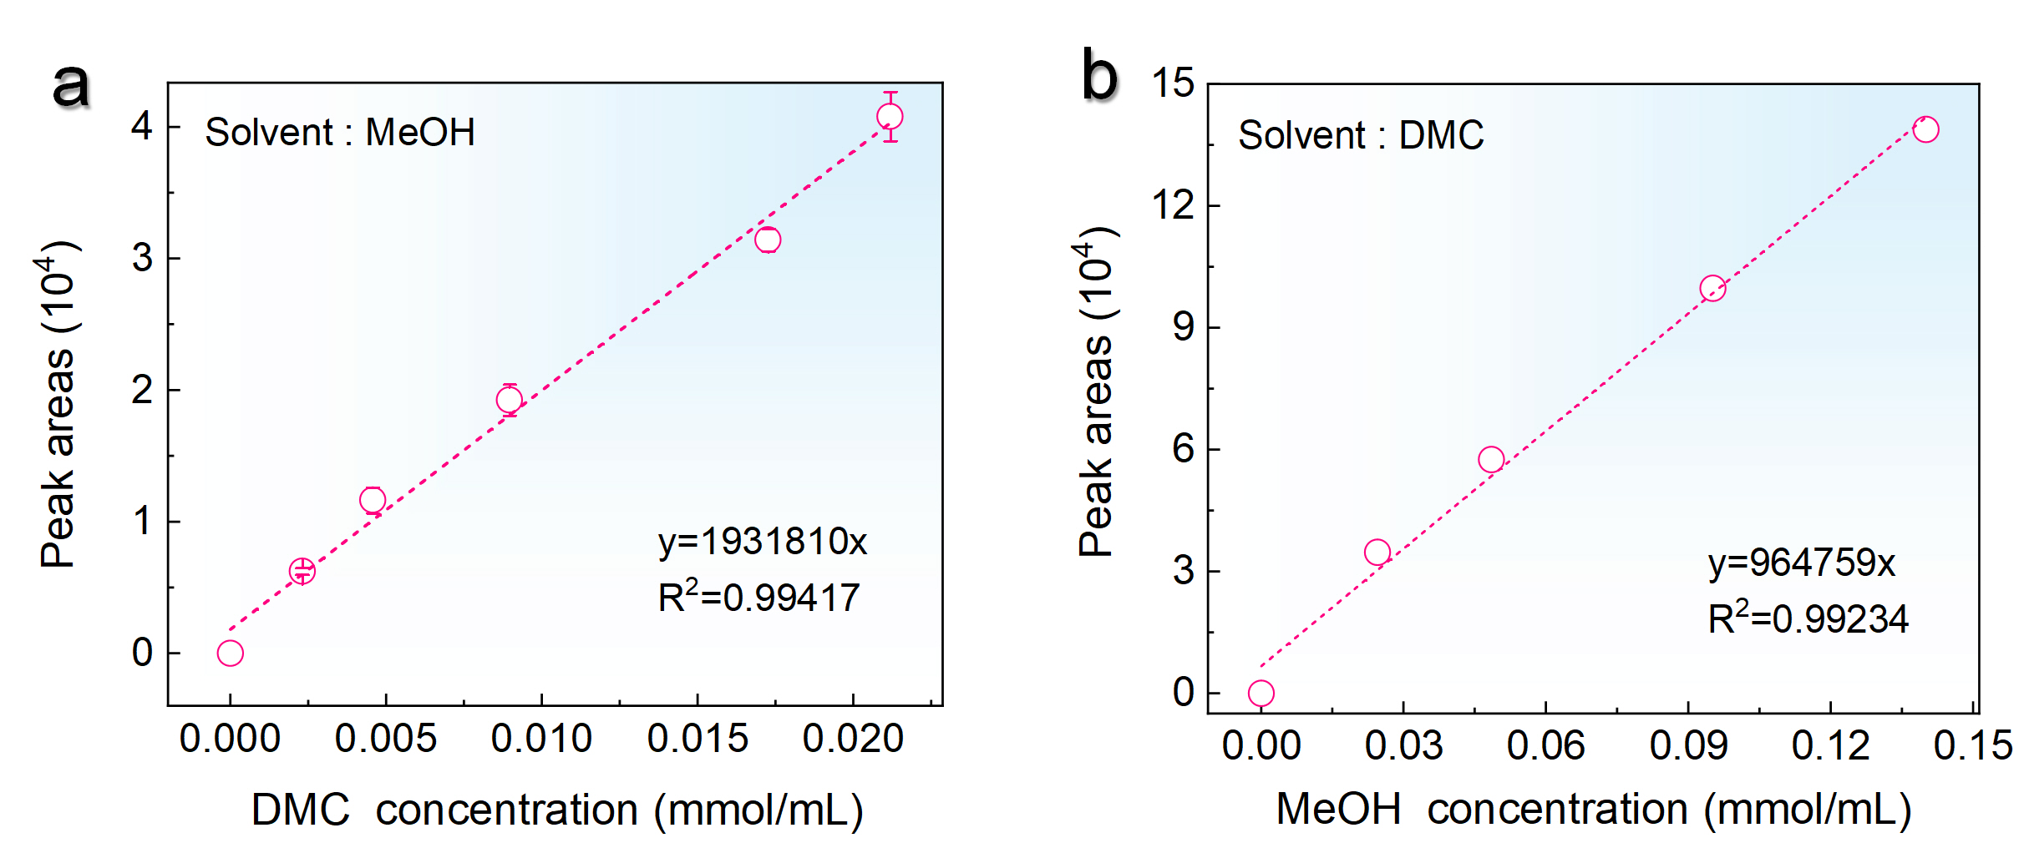
Standard curve. (a) Relationship between the concentrations of DMC and integrated peak areas of GC (Solvent: MeOH). (b) Relationship between the concentrations of MeOH and integrated peak areas of GC (Solvent: DMC).
3. DFT calculations
All periodic DFT calculations were performed using the Vienna Ab Initio Simulation Package (VASP).¹⁻³ The projector augmented wave (PAW)⁴ method was used for the interaction between the core and valence electrons. The valence electron density was described by a plane wave basis set with an energy cut-off of 400 eV.²
Previous studies have demonstrated that the In₂O₃(111) facet was more stable than other low-index facets.⁵ The In₂O₃(111) crystal plane has a four-layer O-In-O three-layer facet simulation with (1x1) unit cells. In a unit cell, there are 12 oxygen atoms in each In-O layer, containing a total of 96 O and 64 In atoms, which are denoted as In₂O₃(111). The surface slab was separated by a vacuum height of 15 Å in the z-direction to eliminate unphysical interactions between periodic surface plates. Brillouin-zone integrations were performed using a Γ-centered (2 × 2 × 1) k-point mesh.
The calculated lattice constant (a=b=c=10.2886 Å) and In-O bond length (2.164 Å) of the In₂O₃ block are consistent with the experimental results. During the optimization process, the atoms in the bottom three layers of the surface facet are fixed, while the remaining atoms are allowed to relax. The thresholds for converging the electronic wavefunctions and atomic structures are 10⁻⁴ eV for the energy and 0.02 eV/Å for the maximal force, respectively.
Adsorption energy (*E_{ads}) is defined as, *E_{ads}=E_{total}-E_{slab}-(a_{EH}+b_{ED}), where E_{total} and E_{slab} are the total energies of a surface with an adsorbate and a clean surface, respectively. The elemental energies of H and D refer to the gas phases H₂ and DMC, respectively. a and b represent the number of H₂ and DMC, respectively.

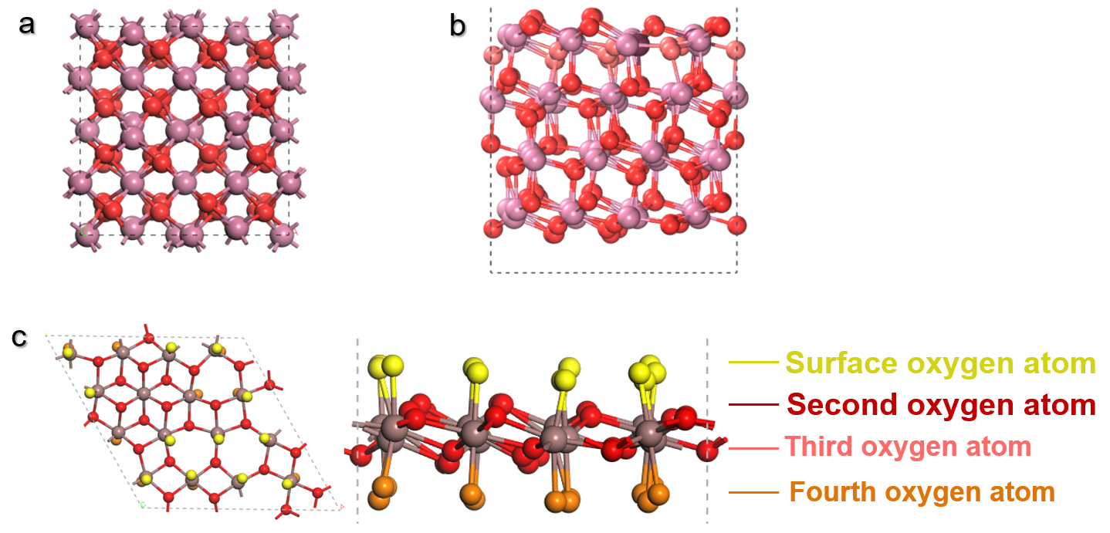
Figure S1. Optimized In₂O₃(111) crystal face. (a) Unit cell and (b) side view of the optimized In₂O₃(111) crystal face. (c) One layer of In atoms with four different layers of oxygen atoms of In₂O₃(111) crystal face.

Figure S2. Optimized adsorption configuration of H₂. H₂ adsorption behaviors on In₆, In₅, In₄₊₁ and In₄···In₄ sites on the In₂O₃(111) surface.

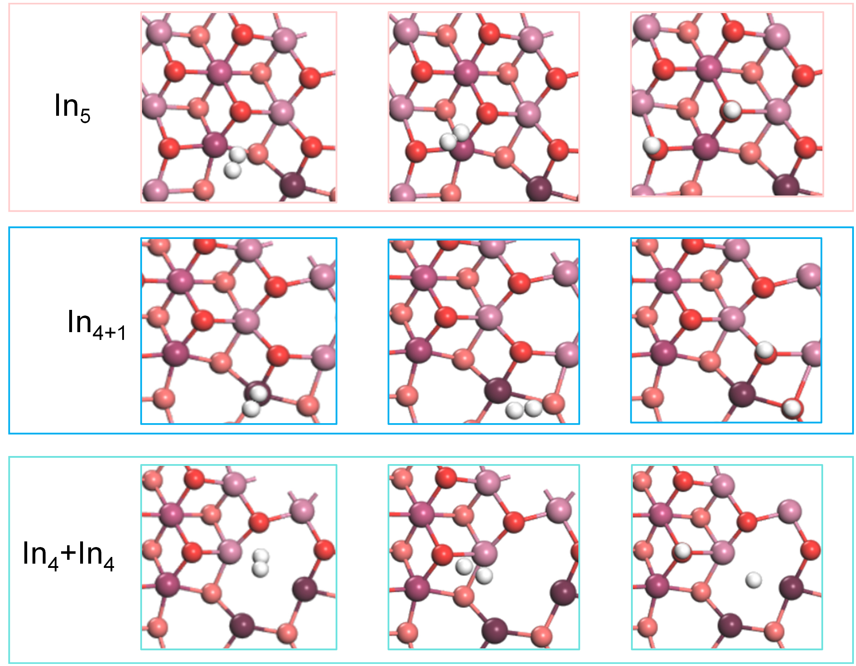
Figure S3. Optimized adsorption configurations of the active hydrogen species. The optimized adsorption structures of the reaction intermediates of H₂ dissociation on In₅, In₄₊₁ and In₄···In₄ sites of the In₂O₃(111) surface.
Figure S4. Optimized adsorption configurations of DMC. DMC adsorption behaviors on In₆, In₅, In₄₊₁ and In₄···In₄ sites on the optimized In₂O₃(111) surface.

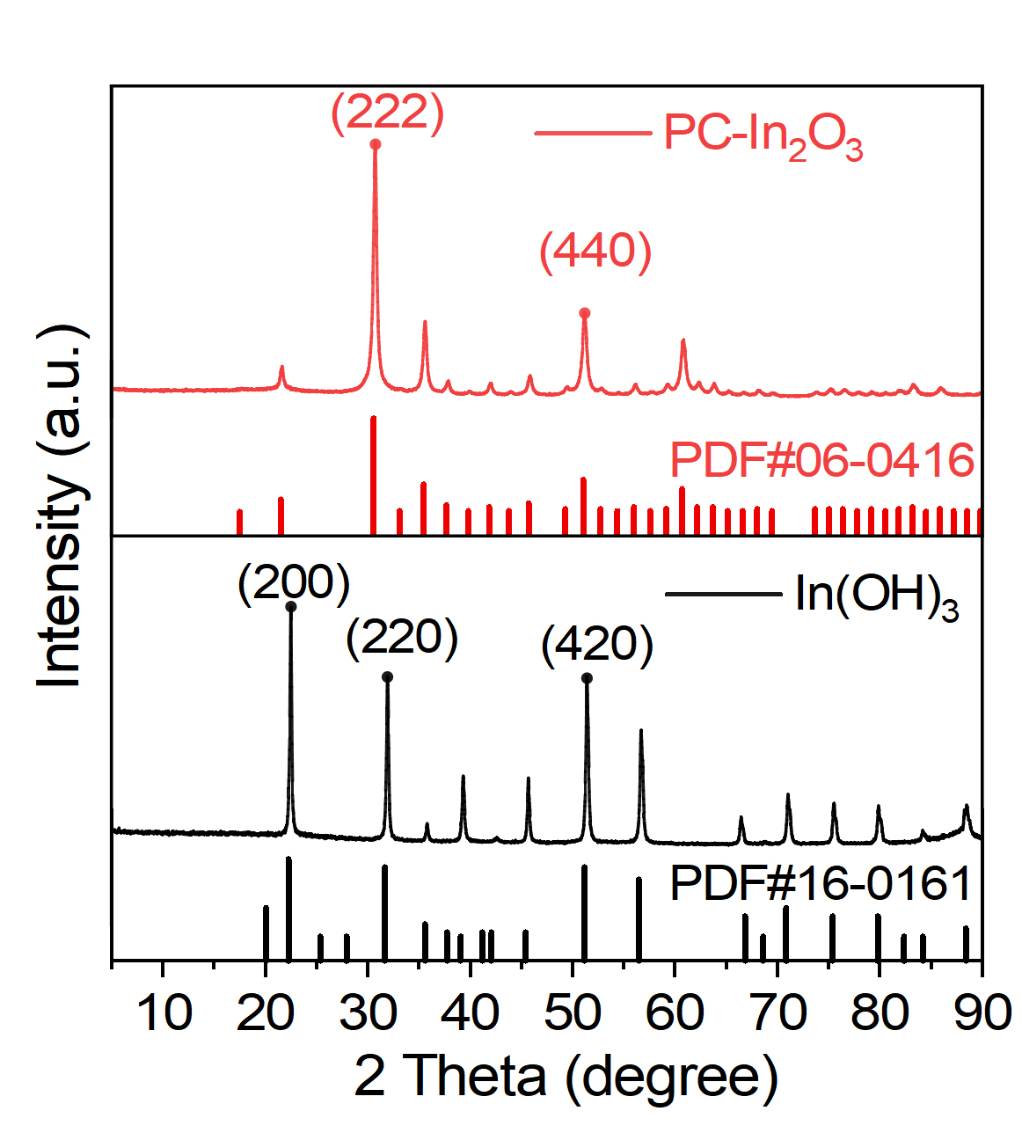
Figure S5. XRD patterns of the In(OH)₃ precursors and PC-In₂O₃ catalysts.

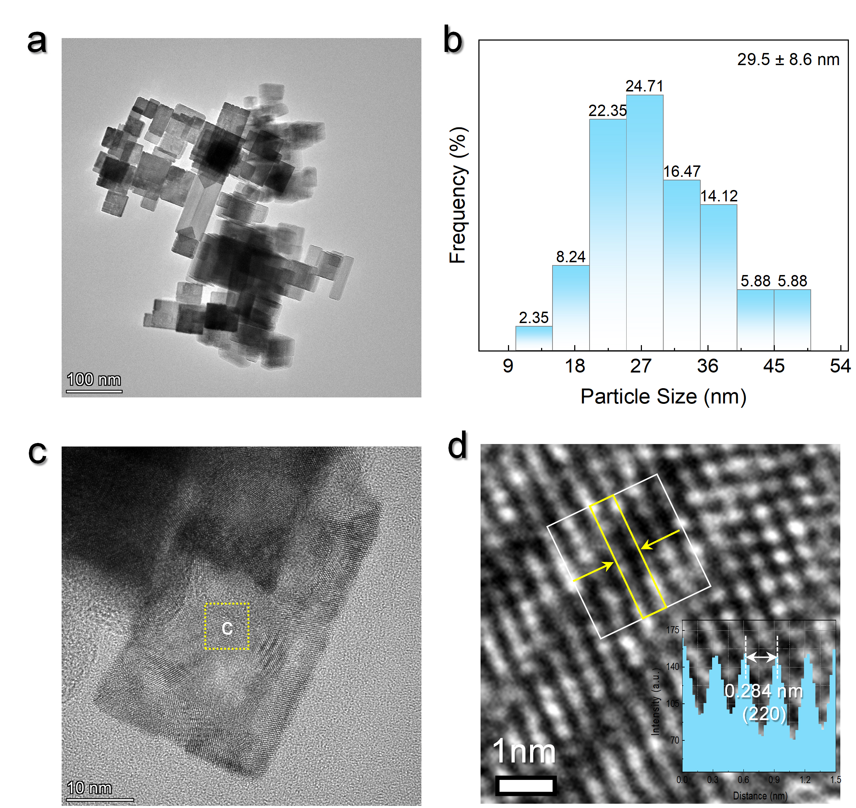
Figure S6. Structural characterizations of the In(OH)₃ precursors. (a) TEM images and (b) size distribution of the In(OH)₃ precursors. (c) High-resolution TEM image and (d) Intensity profiles crystal plane spacing of the In(OH)₃ precursors.
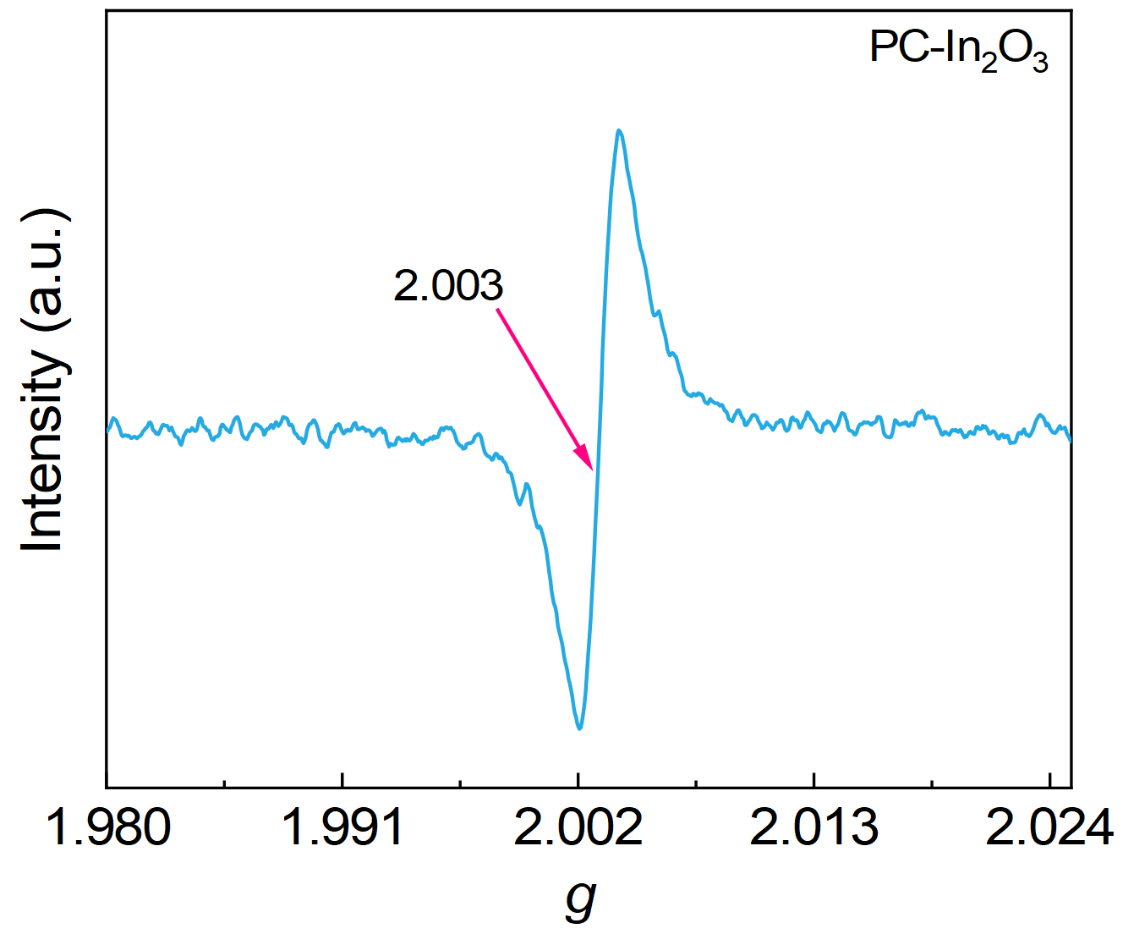
Figure S7. The EPR spectrum of the PC-In₂O₃ catalysts

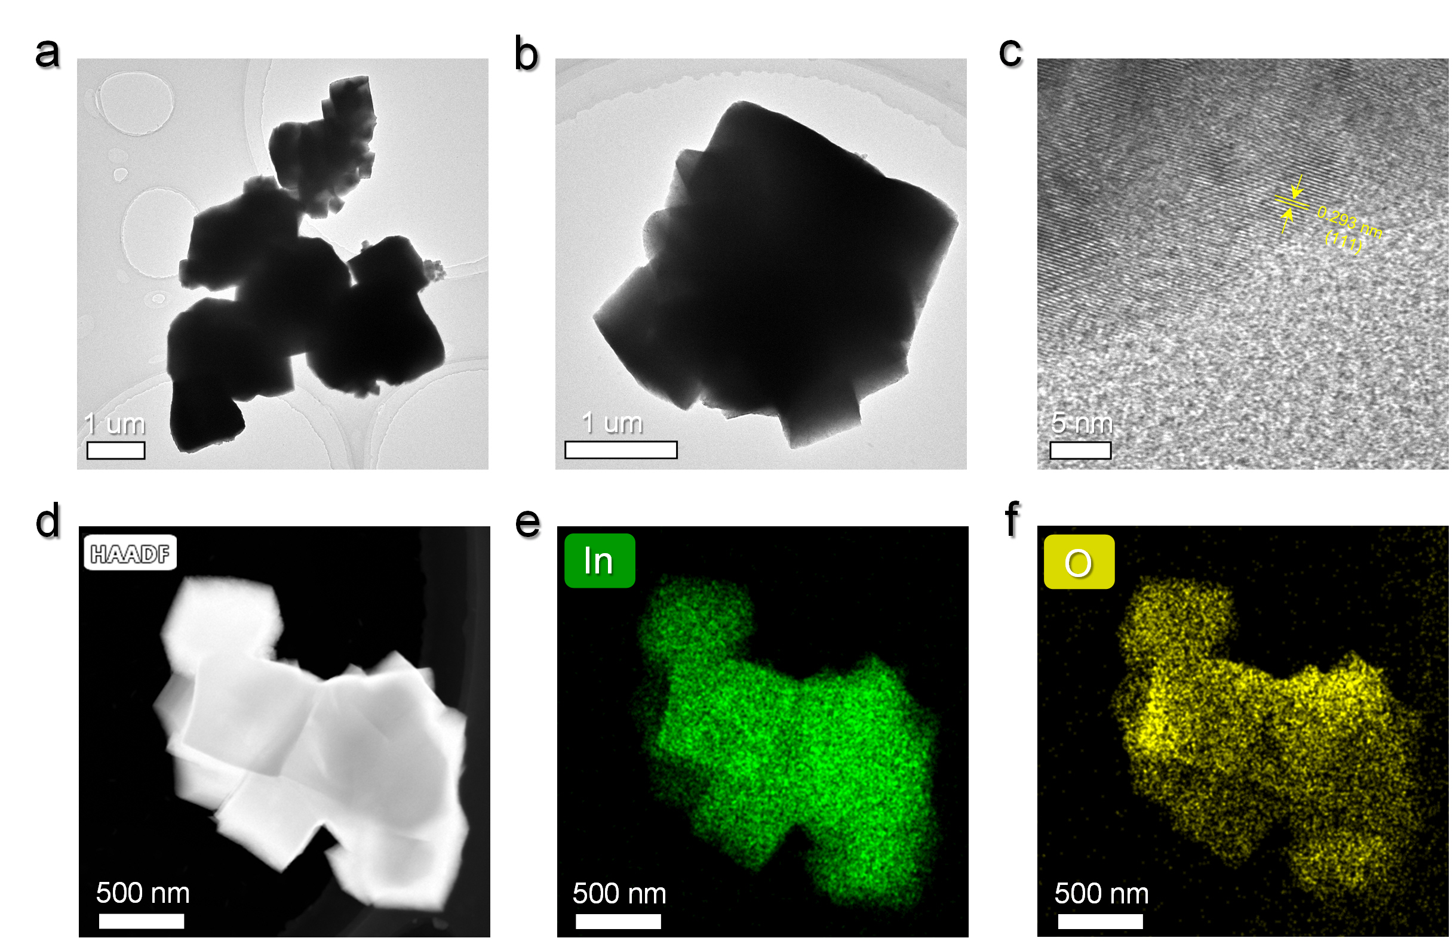
Figure S8. Structural characterizations of NP-In₂O₃. (a, b) TEM and (c) HRTEM images of NP-In₂O₃. (d) HAADF-STEM image and corresponding EDS elemental mappings of (e) In and (f) O elements for NP-In₂O₃.

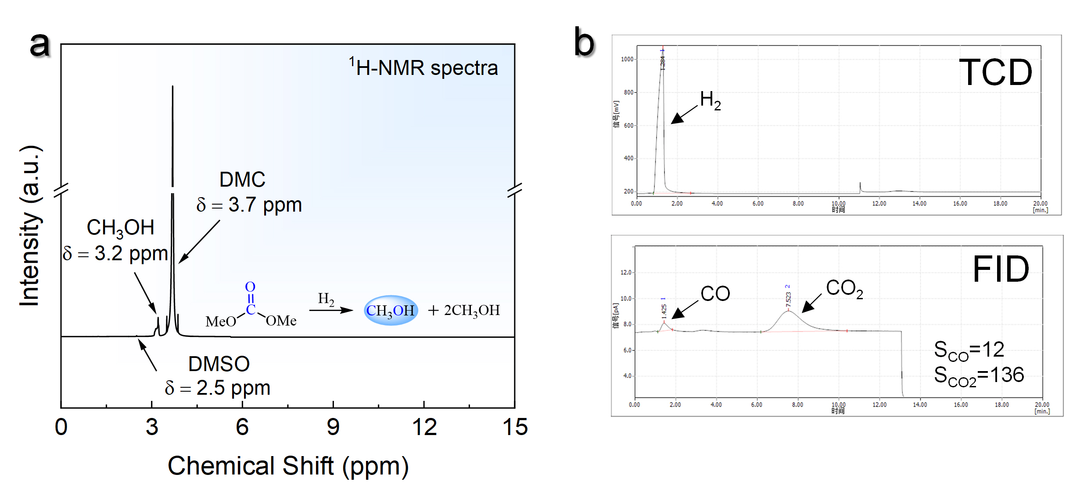
Figure S9. Product analysis. (a) The ¹H-NMR spectra of the liquid phase products. (b) Gas chromatography analysis of gas phase products.

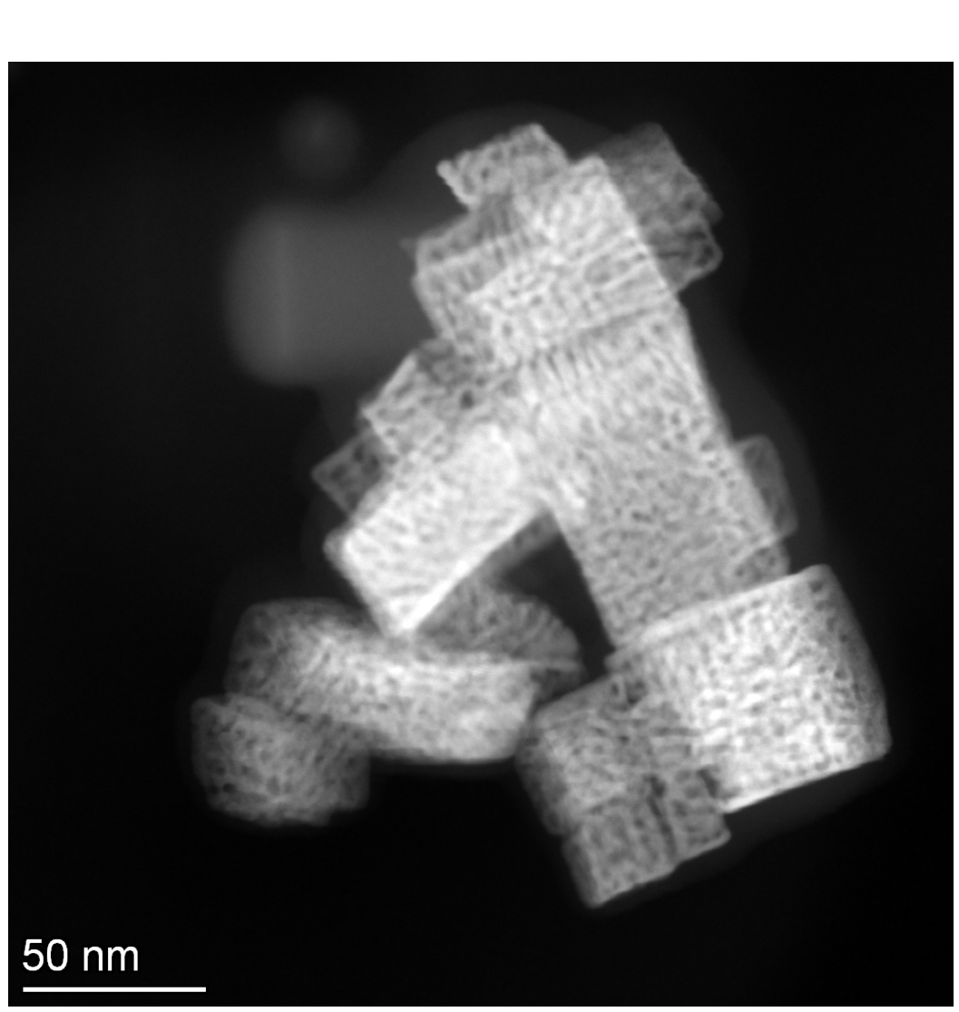
Figure S10. Structural characterizations of the spent PC-In₂O₃ catalysts.

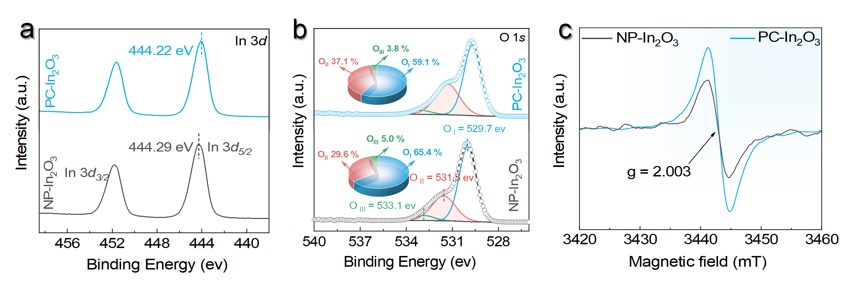
Figure S11. Electronic structures and oxygen vacancy characterizations of NP-In₂O₃ and PC-In₂O₃. (a) In 3d and (b) O1s XPS spectra of the NP-In₂O₃ and PC-In₂O₃ catalysts. (c) EPR spectra of the NP-In₂O₃ and PC-In₂O₃ catalysts at room temperature.

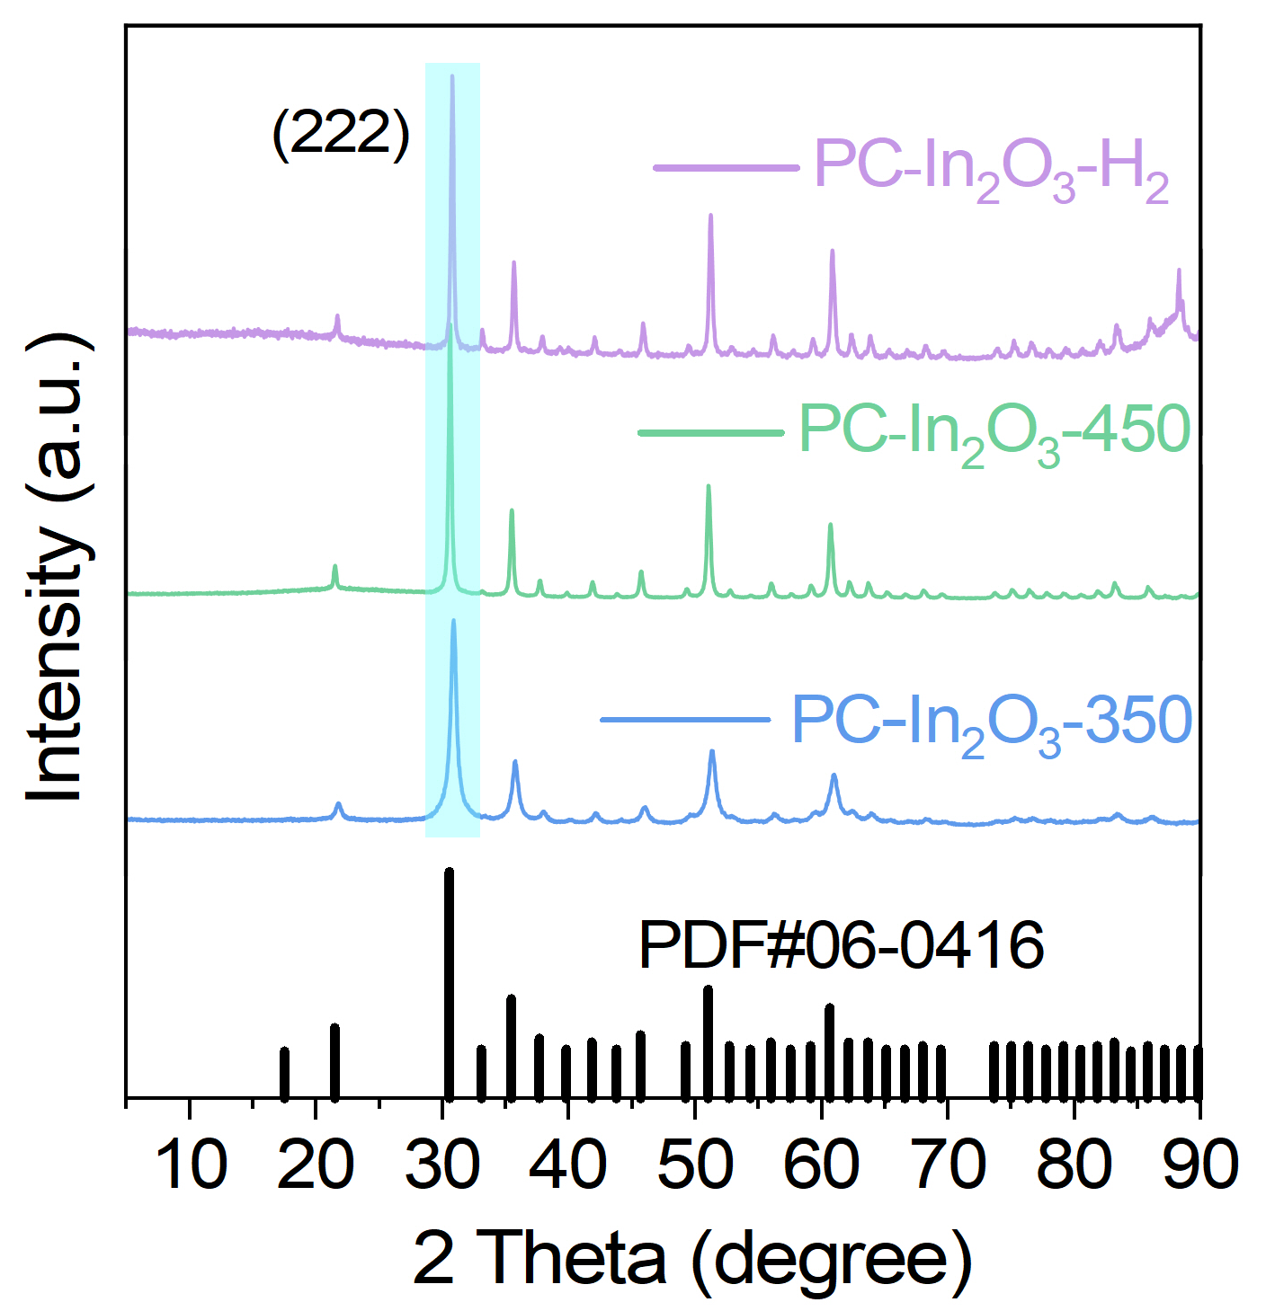
Figure S12. XRD patterns of the PC-In₂O₃-350, PC-In₂O₃-450 and PC-In₂O₃-H₂ catalysts.

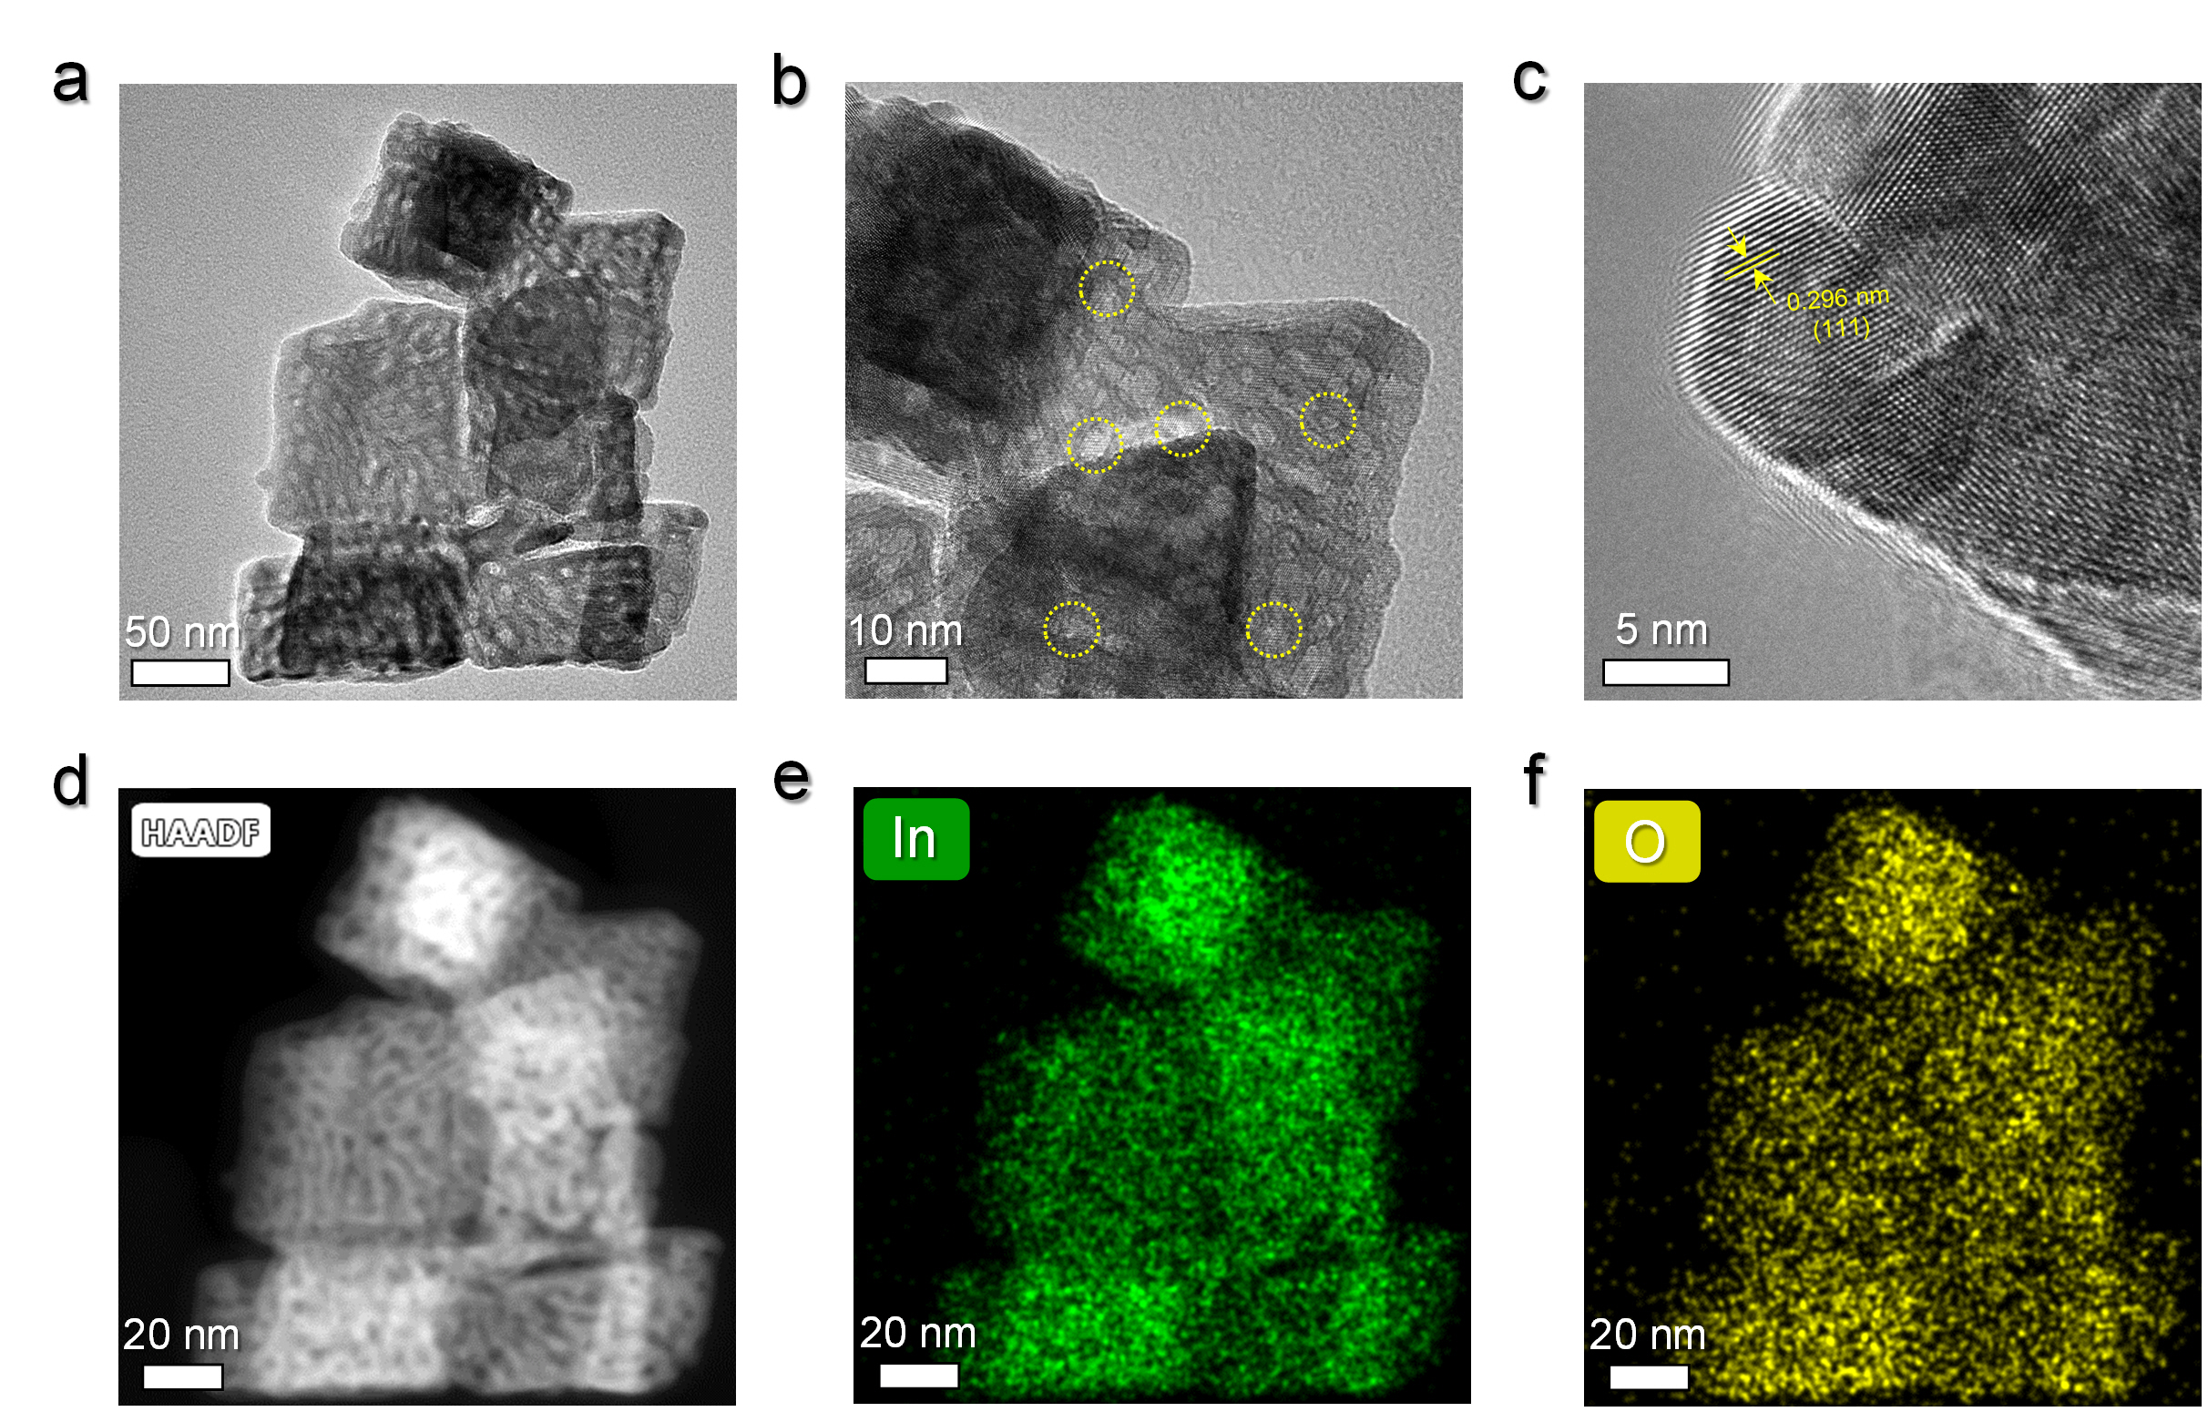
Figure S13. Structural characterizations of PC-In₂O₃-350. (a, b) TEM and (c) HRTEM images of the PC-In₂O₃-350 catalysts. (d) HAADF-STEM image and EDS elemental mappings of (e) In and (f) O elements for the PC-In₂O₃-350 catalysts.

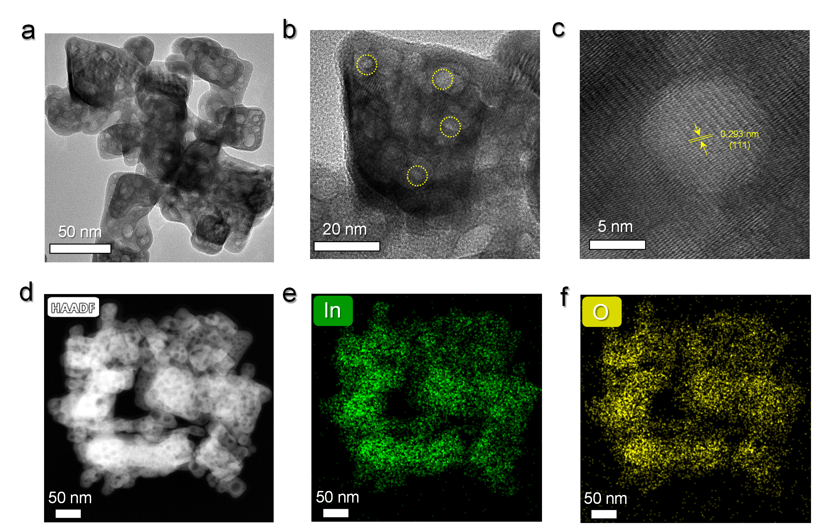
Figure S14. Structural characterizations of PC-In₂O₃-450. (a, b) TEM and (c) HRTEM images of the PC-In₂O₃-450 catalysts. (d) HAADF-STEM image and EDS elemental mappings of (e) In and (f) O elements for the PC-In₂O₃-450 catalysts.

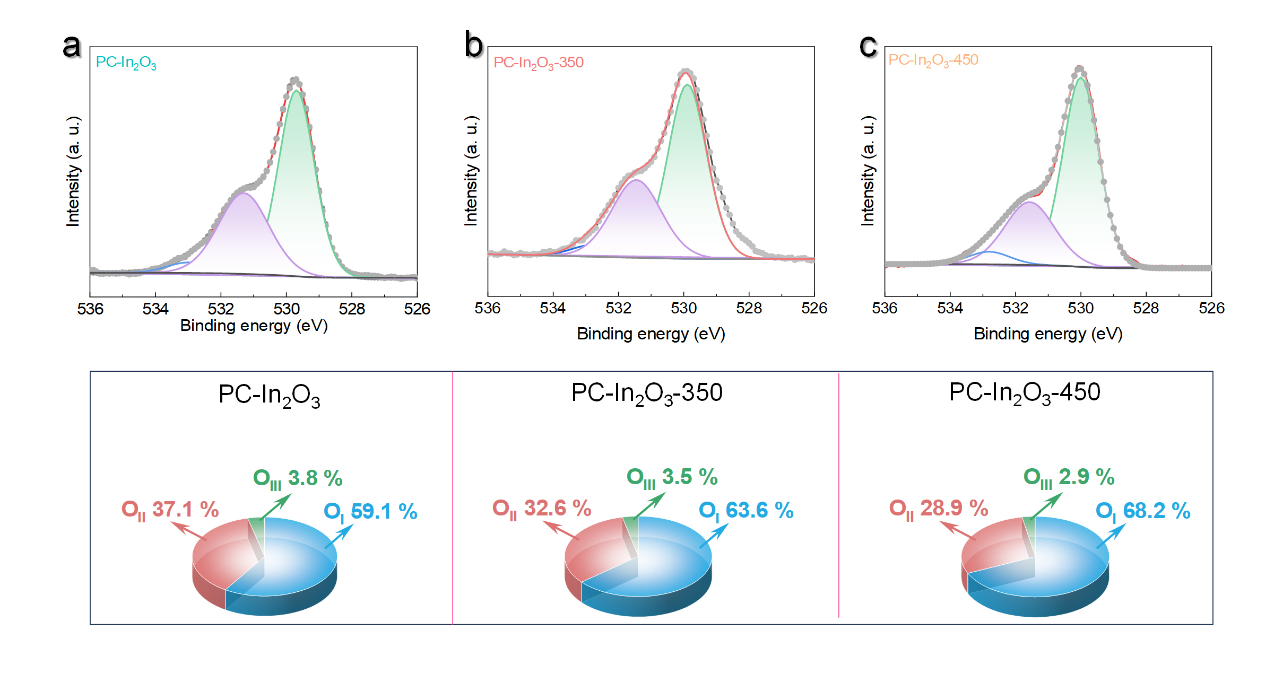
Figure S15. Oxygen vacancy characterizations. XPS analysis of O 1s profiles of the (a) PC-In₂O₃, (b) PC-In₂O₃-350 and (c)PC-In₂O₃-450 catalysts.

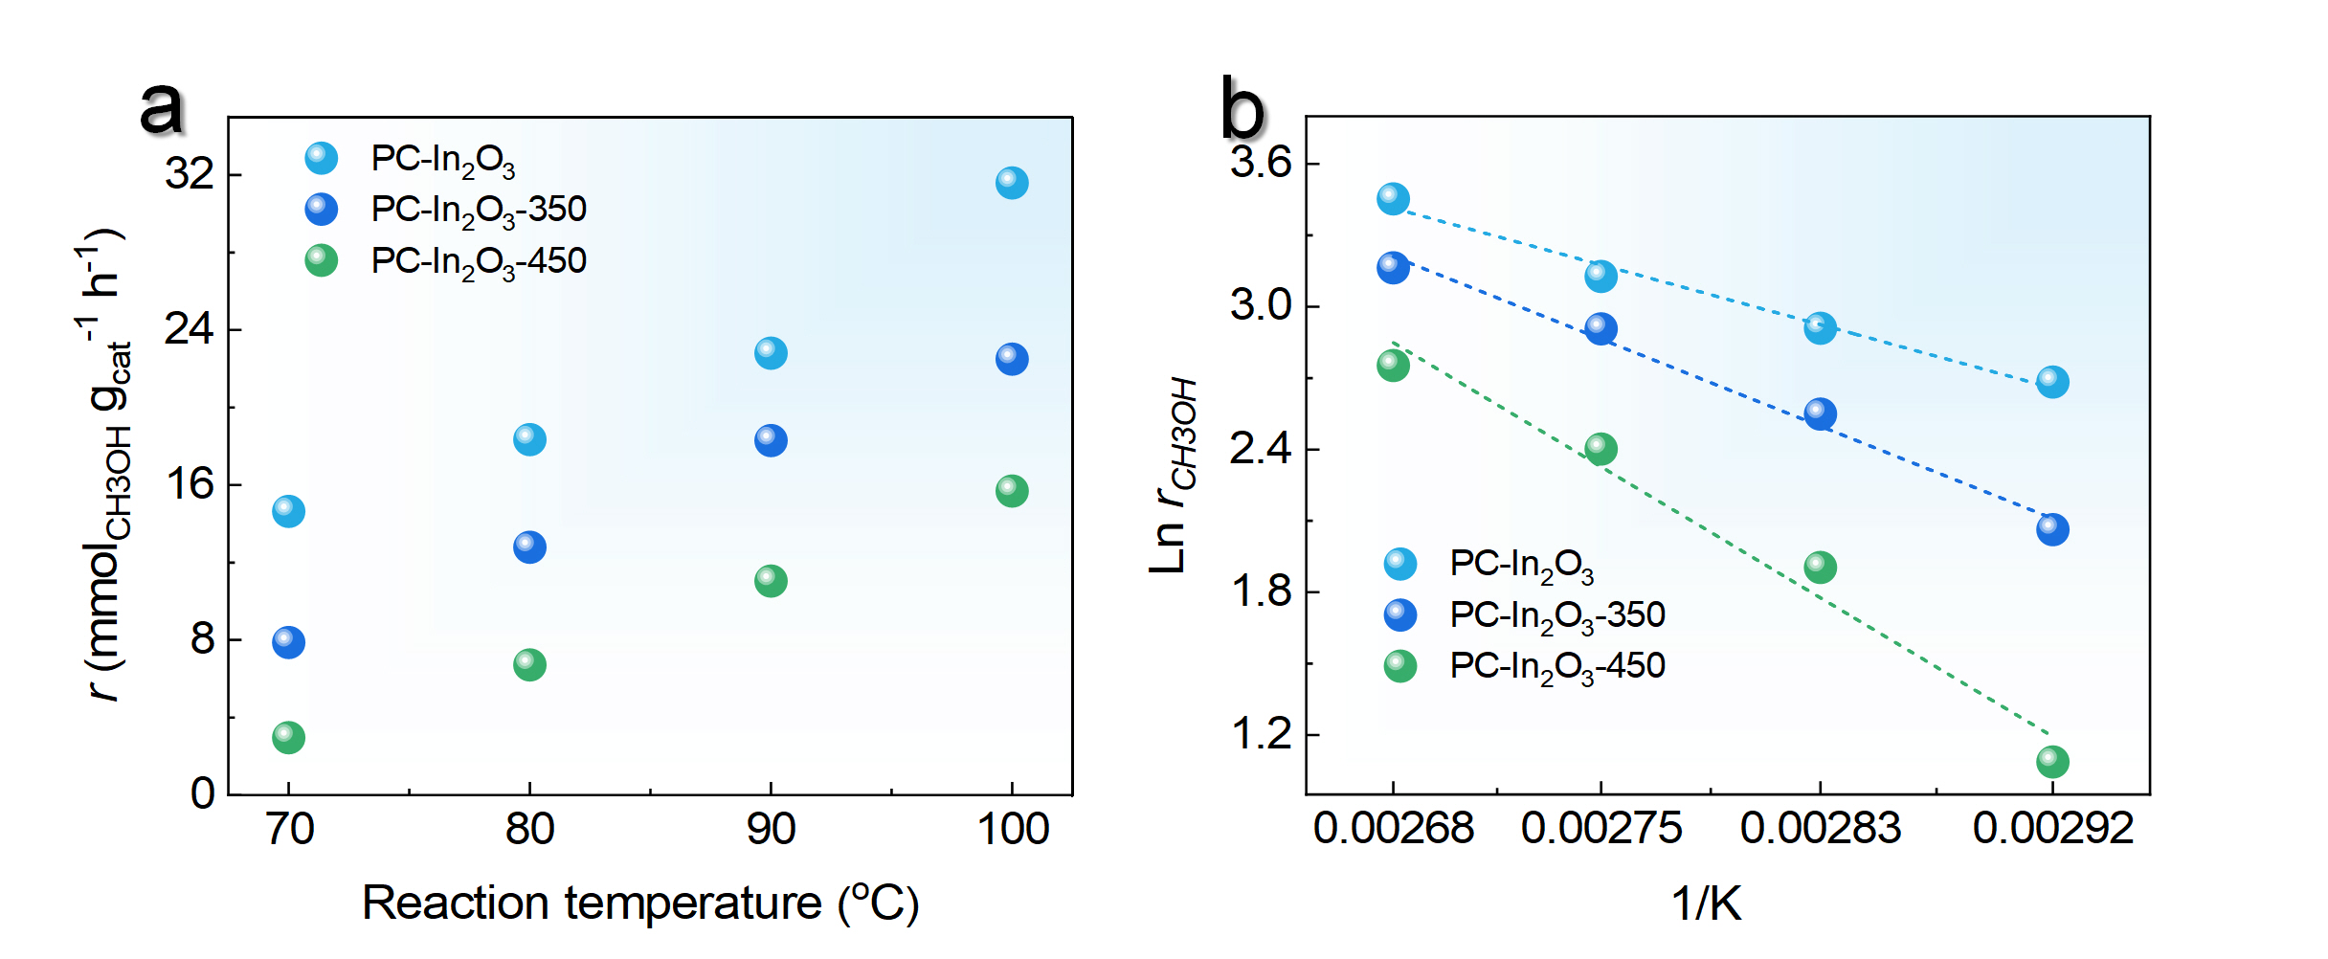
Figure S16. Kinetics analysis of In₂O₃ for the DMC hydrogenation. (a) MeOH production rates at various temperatures. (b) Corresponding Arrhenius curves. Reaction conditions: catalysts (20 mg), DMC (5 mL), 1 h, 100 ℃ and 2 MPa H₂.

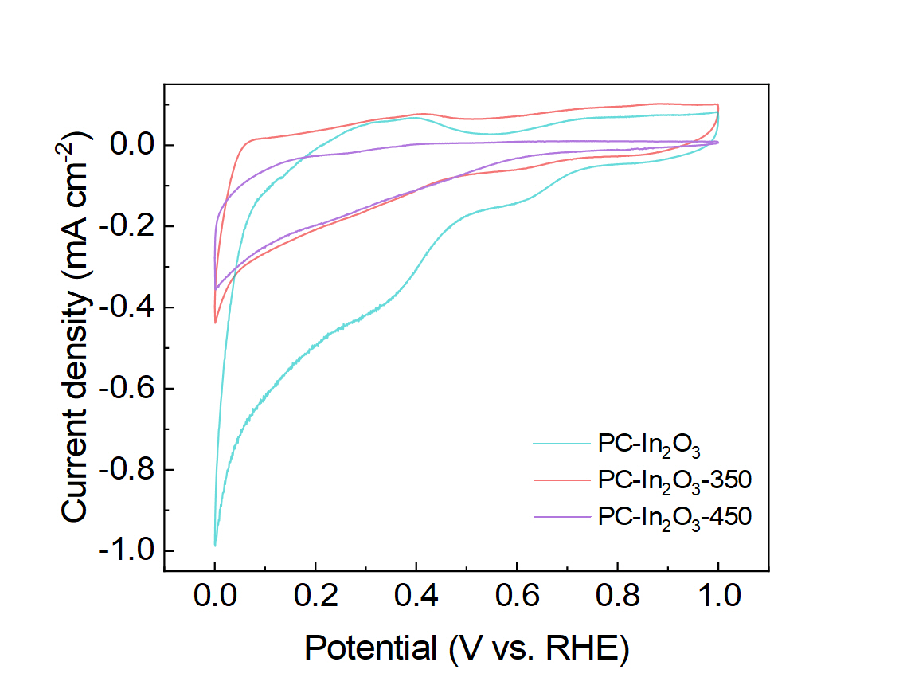
Figure S17. CV plots of PC-In₂O₃, PC-In₂O₃-350, and PC-In₂O₃-450. All CVs plots were collected in an H₂-saturated 0.1 M KOH electrolyte at a scan rate of 20 mV s⁻¹ at room temperature.

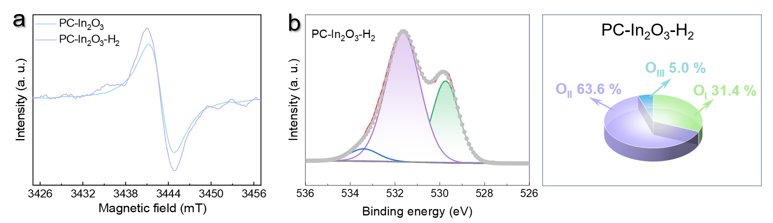
Figure S18. Characterizations of PC-In₂O₃-H₂. (a) EPR spectra of the PC-In₂O₃ and PC-In₂O₃-H₂ catalysts. (b) XPS of O1s spectum for the PC-In₂O₃-H₂ catalysts.

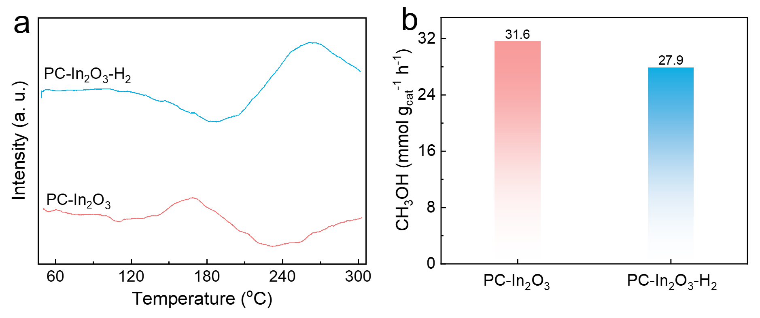
Figure S19. Catalytic performance of PC-In₂O₃-H₂. (a) H₂-TPR curves of the PC-In₂O₃ and PC-In₂O₃-H₂ catalysts. (b) The CH₃OH generation rates of PC-In₂O₃ and PC-In₂O₃-H₂ for the DMC hydrogenation.
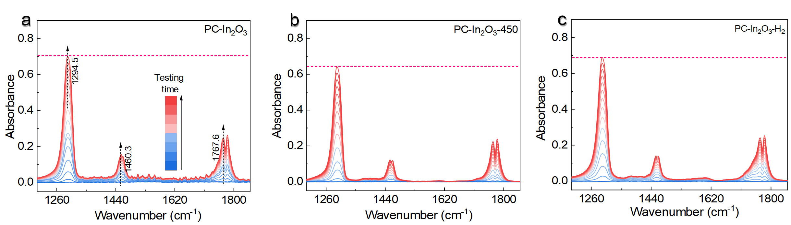
Figure S20. In situ DRIFTS measurements. In situ DRIFTS spectra of various catalysts of (a) PC-In₂O₃, (b) PC-In₂O₃-450, (c) PC-In₂O₃-H₂ under a flowing of DMC. Experiment condition: The catalysts were pretreated by a flow of Ar at 100 ℃ for 1 h. Subsequently, a flow of Ar was passed through a DMC solution at room temperature and then introduced into the in situ cell. The DRIFTS signals were recorded every 30 s.

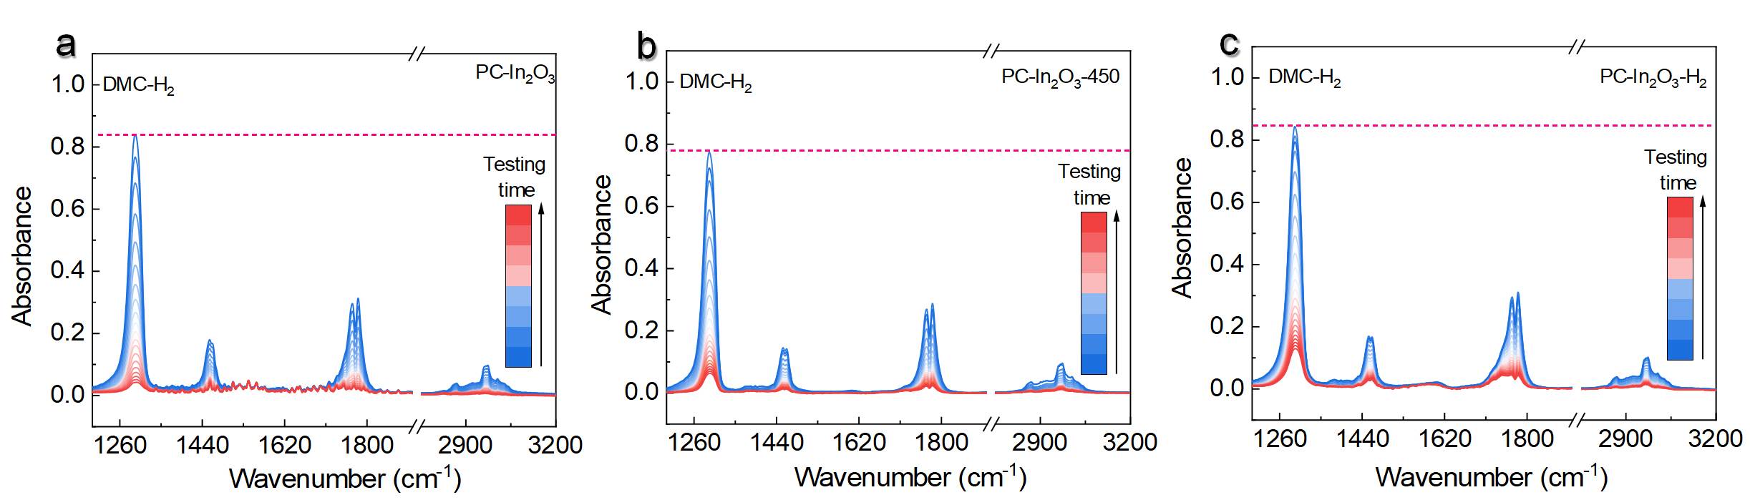
Figure S21. In situ DRIFTS measurements. In situ DRIFTS spectra of various catalysts of (a) PC-In₂O₃, (b) PC-In₂O₃-450, (c) PC-In₂O₃-H₂ with the saturated adsorption of DMC under a flowing of H₂. Experiment condition: After the saturation adsorption of DMC, a pure Ar flow was switched to remove the physically adsorbed DMC. Then, a flow of 50 vol.% H₂/Ar gas was introduced and maintained for another 30 min to collect the DRIFTS signal every 30 s.

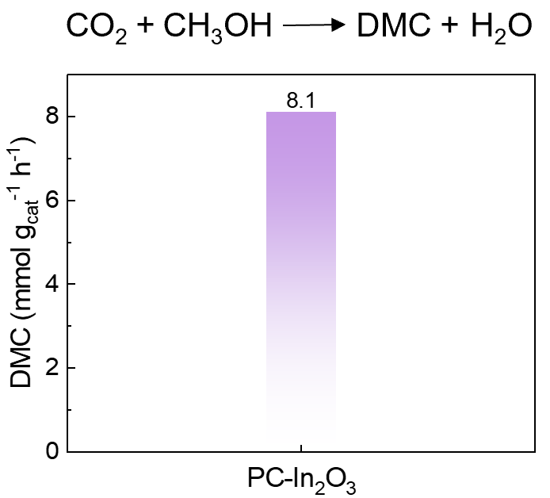
Figure S22. The catalytic performance of PC-In₂O₃ for DMC synthesis through CH₃OH carbonylation. Reaction conditions: catalysts (20 mg), MeOH (10 mL), 1 h, 100 ℃ and 1 MPa CO₂.

Table S1. XPS of O 1s of various In₂O₃ catalysts.
Sample | PC-In₂O₃ |  | PC-In₂O₃-350 |  | PC-In₂O₃-450 |  | PC-In₂O₃-H₂ |  | NP-In₂O₃ |  | Used PC-In₂O₃
Sample | B.E. (eV) | Peak area | B.E. (eV) | Peak area | B.E. (eV) | Peak area | B.E. (eV) | Peak area | B.E. (eV) | Peak area | B.E. (eV) | Peak area
Lattice Oxygen (O_{I})
O_{I} | 529.7 | 38943 | 529.8 | 65633 | 529.9 | 74889 | 529.6 | 95008 | 529.7 | 23513 | 529.4 | 45044
Oxygen Vacancy (O_{II})
O_{II} | 531.3 | 24415 | 531.5 | 33493 | 531.6 | 31680 | 531.6 | 192275 | 531.3 | 10626 | 531.0 | 27604
Hydroxide Groups (O_{III})
O_{III} | 532.8 | 2504 | 532.9 | 3551 | 533.0 | 3191 | 533.2 | 14853 | 533.1 | 1812 | 532.6 | 2314

Table S2. Summary of catalytic performance of recents heterogeneous catalysts for CO₂ hydrogenation to methanol.
Entry | Catalyst | GHSV  (mL g_{cat}⁻¹ h-1) | H₂:CO₂  (MPa) | Temperature  (°C) | r_{MeOH}  (mmol g_{cat}⁻¹ h⁻¹) | Ref.
1 | Cu-N₃ | H₂O | 3:1  (4 MPa) | 70  150 | 0.19  0.45 | [6]
2 | FL-MoS₂ | 1500 | 3:1  (5 MPa) | 60, 80, 100, 120 | 0.03, 0.06, 0.13, 0.28 | [7]
3 | N-In₂O₃ | 21000 | 4:1  (5 MPa) | 200 | 1.56 | [8]
4 | Cu-In-Zr-O | 18000 | 4:1  (2.5 MPa) | 210, 230, 250 | 0.09, 1.56, 2.5 | [9]
5 | Cu/ZnO_{x}@MOF | 18000 | 3:1  (4 MPa) | 250 | 0.081 | [10]
6 | h-In₂O₃-R | 9000 | H₂:CO₂:N₂  72:24:4 | 240 | 3.2 | [11]
7 | Cu/Zn/Ga-LDH | 18000 | 4:1  (4.5 MPa) | 210 | 0.84 | [12]
8 | h-MoS₂/ZnS | H₂O | 4:1  (5 MPa) | 160, 260 | 0.003, 0.029 | [13]
9 | In₂O₃/ZrO₂ | 21000 | 4:1  (4 MPa) | 200, 230 | 0.03, 1.25 | [14]
10 | Cu/BaTiO_{2.8}H_{0.2} | 20 mL/min | 24 %/72 %/4 % CO₂/H₂/Ar  (3 MPa) | 250 | 4.7 mmol g_{Cu}⁻¹ h⁻¹ | [15]
11 | h-PdMo/Mo₂N |  |  | 60, 80, 100, 120, 140, 160 | 0.005, 0.01, 0.015, 0.02, 0.035, 0.05 | [16]
12 | MOF-808-Zn | 9000 | 3:1  (4 MPa) | 250 | 5.96 | [17]
13 | Cu/Zr-UiO66-COOH (Zr⁴⁺) | 140 sccm | 5:1  (0.2 MPa) | 220 | 0.4 | [18]
14 | ZnZrO_{x} | 24000 | 4:1  (5 MPa) | 320 | 14.1 | [19]
15 | Cu-ZnO/amUiO-66 | 120 sccm | 5:1  (0.2 MPa) | 220 | 0.7 | [20]
16 | c-In₂O₃-S | 9000 | H₂/CO₂/N₂ = 73/24/3 | 240, 260, 280, 300, 320, 340, 360 | 4.2, 5, 5.9, 7.8, 8.9, 6.8, 4.3 | [21]
17 | Cu/ZrO₂-SiO₂ | 4000 | 3:1  (3 MPa) | 190, 210, 230 | 0.025, 0.053, 0.042  mmol m⁻² h⁻¹ | [22]
18 | Pt/H_{x}MoO_{3−y} | 1,4-dioxane  15 mL | 3:1  (3 MPa) | 200 | 1.53 | [23]
19 | 95In₂O₃-5Al₂O₃ | 30000 | H₂/CO₂/N₂ = 30/10/10  (3 MPa) | 260 | 2.8 | [24]
20 | 5%Ni/In₂O₃ | - | CO₂/H₂/N₂ = 10:30:10 mL/min.  (3 MPa) | 250 | 7.8 | [25]
21 | Co@Si_{0.95} | 6000 | 3:1  (2 MPa) | 260, 280, 300, 320, 340, 360, 380 | 0.9, 1.5, 2.5, 3.0, 2.8, 2.6, 2.5 | [26]
22 | Re(1)/TiO₂ | 1,4-dioxane (1 mL) | 5:1  (6 MPa) | 150 | 1.8 | [27]
23 | ZnO-ZrO₂ | 24000 | 3:1  (5 MPa) | 340 | 0.5 mmol m⁻² h⁻¹ | [28]
24 | Cu/MoS₂@SiO₂ | 24000 | 4:1  (5 MPa) | 260 | 6.11 mol_{MeOH} mol_{Mo}^{–1} h^{–1} | [29]
25 | 2Pd/CeO₂-R | 2000 | 3:1  (3 MPa) | 240 | 1.4 | [30]
26 | UiO-67-Pt | 0.01 g_{cat} min mL^{–1} | 3:1  (0.8 MPa) | 170 | 2.16 | [31]
27 | PtGa-GaO_{x} | 6-100 mL/min | 2.5 MPa | 230 | 7.2 mol_{CH3OH} h^{–1} mol_{Pt}^{–1} | [32]
28 | Cu/ZnO₂/Al₂O₃ | - | CO₂ (1 MPa)  H₂ (2 MPa) | 100 | 1.4 | This work
29 | NP-In₂O₃ | - | CO₂ (1 MPa)  H₂ (2 MPa) | 100 | 1.1 | This work
30 | PC-In₂O₃ | - | CO₂ (1 MPa)  H₂ (2 MPa) | 70, 80, 90, 100 | 0.76, 1.80, 3.9, 6.5 | This work

References:
1. G. Kresse & Furthmiiller, J. Efficiency of ab-initio total energy calculations for metals and semiconductors using a plane-wave basis set. Comput. Mater. Sci 6, 15-50 (1996).
2. Furthmüller, J. Efficient iterative schemes for ab initio total-energy calculations using a plane-wave basis set. Phys. Rev. B 54, 11169-11186 (1996).
3. Kresse, G. Ab initio molecular dynamics for liquid metals. Phys. Rev. B 47, 222-229 (1995).
4. G. Kresse & Joubert, D. From ultrasoft pseudopotentials to the projector augmented-wave method. Phys. Rev. B 59, 1758-1775 (1999).
5. Dang, S. et al. Rationally designed indium oxide catalysts for CO₂ hydrogenation to methanol with high activity and selectivity. Sci. Adv. 6, 1-11 (2020).
6. Yang, T. et al. Coordination tailoring of Cu single sites on C₃N₄ realizes selective CO₂ hydrogenation at low temperature. Nat. Commun. 12, 6022 (2021).
7. Hu, J. et al. Sulfur vacancy-rich MoS₂ as a catalyst for the hydrogenation of CO₂ to methanol. Nat. Catal. 4, 242-250 (2021).
8. Yang, Y., Shen, C., Sun, K., Mei, D. & Liu, C.-j. Enhanced surface charge localization over nitrogen-doped In₂O₃ for CO₂ hydrogenation to methanol with improved stability. ACS Catal. 13, 6154-6168 (2023).
9. Yao, L., Shen, X., Pan, Y. & Peng, Z. Synergy between active sites of Cu-In-Zr-O catalyst in CO₂ hydrogenation to methanol. J. Catal. 372, 74-85 (2019).
10. An, B. et al. Confinement of ultrasmall Cu/ZnO_{x} nanoparticles in metal-organic frameworks for selective methanol synthesis from catalytic hydrogenation of CO₂. J. Am. Chem. Soc. 139, 3834-3840 (2017).
11. Dang, S. S., et al. Rationally designed indium oxide catalysts for CO₂ hydrogenation to methanol with high activity and selectivity. Sci. Adv. 6, 1-11 (2020).
12. Li, M. M.-J. et al. CO₂ hydrogenation to methanol over catalysts derived from single cationic layer CuZnGa LDH precursors. ACS Catal 8, 4390-4401 (2018).
13. Zhou, S. & Zeng, H. C. Boxlike assemblages of few-layer MoS₂ nanosheets with edge blockage for high-efficiency hydrogenation of CO₂ to methanol. ACS Catal., 9872-9886 (2022).
14. Martin, O. et al. Indium oxide as a superior catalyst for methanol synthesis by CO₂ hydrogenation. Angew. Chem. Int. Ed. 55, 6261-6265 (2016).
15. He, Y. et al. Significant roles of surface hydrides in enhancing the performance of Cu/BaTiO_{2.8}H_{0.2} catalyst for CO₂ hydrogenation to methanol. Angew. Chem. Int. Ed. 63, 1-9 (2023).
16. Araújo, T. P. et al. Reaction‐induced metal‐metal oxide interactions in Pd‐In₂O₃/ZrO₂ catalysts drive selective and stable CO₂ hydrogenation to methanol. Angew. Chem. Int. Ed. 62, 1-11 (2023).
17. Zhang, J. et al. Neighboring Zn–Zr sites in a metal–organic framework for CO₂ hydrogenation. J. Am. Chem. Soc. 143, 8829-8837 (2021).
18. Zhu, Y. et al. Copper-zirconia interfaces in UiO-66 enable selective catalytic hydrogenation of CO₂ to methanol. Nat. Commun. 11, 1-11 (2020).
19. Araújo, T. P. et al. Design of flame‐made ZnZrO_{x} catalysts for sustainable methanol synthesis from CO₂. Adv. Energy Mater. 13, 1-17 (2023).
20. Mitsuka, Y. et al. Fabrication of integrated copper‐based nanoparticles/amorphous metal–organic framework by a facile spray‐drying method: Highly enhanced CO₂ hydrogenation activity for methanol synthesis. Angew. Chem. Int. Ed. 60, 22283-22288 (2021).
21. Dang, S. et al. Rationally designed indium oxide catalysts for CO₂ hydrogenation to methanol with high activity and selectivity. Sci. Adv. 6 1-11 (2020).
22. Yang, M. et al. Unlocking a dual‐channel pathway in CO₂ hydrogenation to methanol over single‐site zirconium on amorphous silica. Angew. Chem. Int. Ed. 63, e202312292 (2023).
23. Kuwahara, Y. et al. A quasi-stable molybdenum sub-oxide with abundant oxygen vacancies that promotes CO₂ hydrogenation to methanol. Chem. Sci. 12, 9902-9915 (2021).
24. Liu, L., Mezari, B., Kosinov, N. & Hensen, E. J. M. Al promotion of In₂O₃ for CO₂ hydrogenation to methanol. ACS Catal. 13, 15730-15745 (2023).
25. Zhu, J. et al. Ni–In synergy in CO₂ hydrogenation to methanol. ACS Catal. 11, 11371-11384 (2021).
26. Wang, L. et al. Silica accelerates the selective hydrogenation of CO₂ to methanol on cobalt catalysts. Nat. Commun 11, 1-9 (2020).
27. Ting, K. W., Toyao, T., Siddiki, S. M. A. H. & Shimizu, K.-i. Low-temperature hydrogenation of CO₂ to methanol over heterogeneous TiO₂-supported Re catalysts. ACS Catal. 9, 3685-3693 (2019).
28. Wang, J. et al. A highly selective and stable ZnO-ZrO₂ solid solution catalyst for CO₂ hydrogenation to methanol. Sci. Adv. 3, 1701290 (2017).
29. Zhou, S. et al. Strained few-layer MoS₂ with atomic copper and selectively exposed in-plane sulfur vacancies for CO₂ hydrogenation to methanol. Nat. Commun 14, 1-15 (2023).
30. Jiang, F. et al. Insights into the influence of CeO₂ crystal facet on CO₂ hydrogenation to methanol over Pd/CeO₂ catalysts. ACS Catal. 10, 11493-11509 (2020).
31. Gutterød, E. S. et al. Influence of defects and H₂O on the hydrogenation of CO₂ to methanol over Pt nanoparticles in UiO-67 metal–organic framework. J. Am. Chem. Soc. 142, 17105-17118 (2020).
32. Zhou, W. et al. Reactivity switch of platinum with gallium: from reverse water gas shift to methanol synthesis. J. Am. Chem. Soc. 146, 10806-10811 (2024).

