Additional File 1
Impact of Differentiated Service Delivery Models on Quality of Life among People living with HIV in Uganda
Nasasira et.al
Figure S1: Description of facility and community DSD models implemented in Uganda (13)

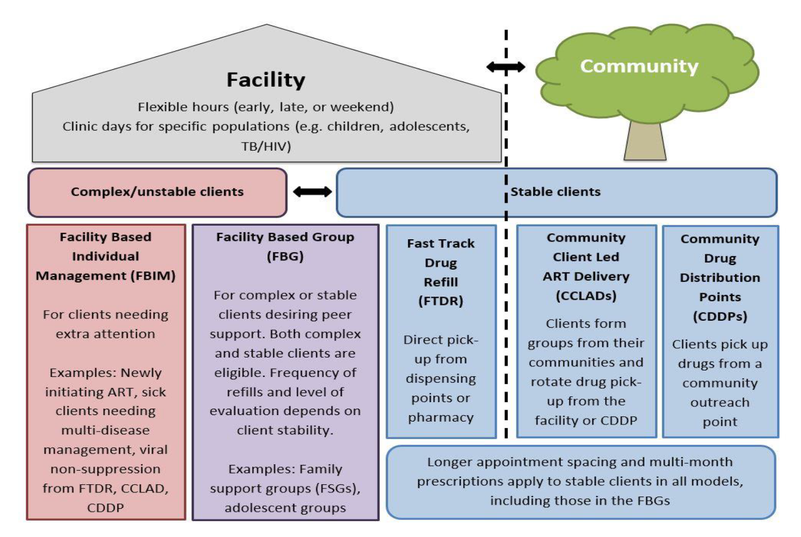

Figure S2: Stability criteria for DSD models (13)
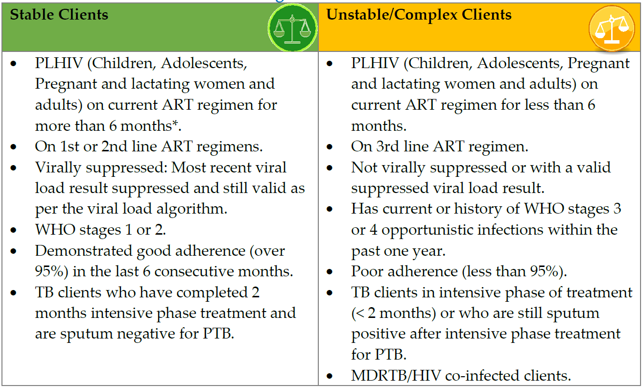

Figure S3: Facility and community DSD models according to patient characterization of stability (13)
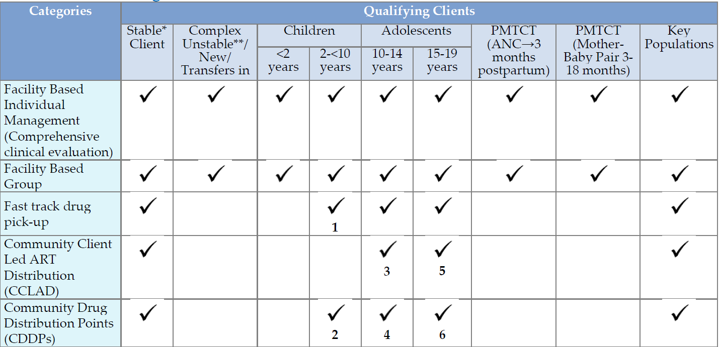

Table S1: Standardized differences before and after IPTW weighting showing balance in distribution of covariates between intervention (Any DSD model) and Standard of Care group (SOC)
Characteristic | Before IPTW weighting |  | SMD | After IPTW weighting |  | SMD
 | Control (SOC) | Intervention (DSD) |  | Control (SOC) | Intervention (DSD)
 | Mean (SD) | Mean (SD) |  | Mean (SD) | Mean (SD)
Male gender | 0.36 (0.48) | 0.39 (0.49) | 0.07 | 0.37 (0.48) | 0.40 (0.49) | 0.06
Baseline QoL score | 89.5 (7.50) | 90.3 (6.37) | 0.10 | 89.7 (7.41) | 90.3 (6.37) | 0.08
Baseline age 45 to 54 years | 0.37 (0.48) | 0.43 (0.50) | 0.13 | 0.38 (0.49) | 0.43 (0.50) | 0.11
Baseline age ≥55 years | 0.16 (0.36) | 0.12 (0.33) | 0.10 | 0.15 (0.36) | 0.12 (0.33) | 0.09
Baseline BMI <18.5 Kgs/m² | 0.12 (0.33) | 0.12 (0.33) | 0.01 | 0.12 (0.33) | 0.12 (0.33) | 0.08
Baseline WHO stage 3 or 4 | 0.88 (0.33) | 0.87 (0.33) | 0.01 | 0.88 (0.33) | 0.87 (0.34) | 0.03
Baseline VL<200 cells/m² | 0.05 (0.23) | 0.03 (0.18) | 0.10 | 0.05 (0.23) | 0.03 (0.18) | 0.10
Had partner | 0.52 (0.50) | 0.55 (0.50) | 0.07 | 0.52 (0.50) | 0.55 (0.50) | 0.07
Employed | 0.81 (0.39) | 0.83 (0.38) | 0.04 | 0.84 (0.37) | 0.85 (0.35) | 0.05
Household income ≥100000 UGX | 0.53 (0.50) | 0.58 (0.49) | 0.11 | 0.53 (0.50) | 0.58 (0.49) | 0.12
History of tobacco use at baseline | 0.19 (0.39) | 0.21 (0.40) | 0.05 | 0.19 (0.39) | 0.21 (0.41) | 0.04
Current tobacco use at baseline | 0.02 (0.15) | 0.02 (0.13) | 0.05 | 0.03 (0.16) | 0.02 (0.13) | 0.06
History of alcohol use at baseline | 0.49 (0.50) | 0.48 (0.50) | 0.03 | 0.49 (0.50) | 0.47 (0.50) | 0.04
Current alcohol use at baseline | 0.24 (0.43) | 0.25 (0.43) | 0.01 | 0.24 (0.43) | 0.25 (0.44) | 0.02
Log transformed baseline CD4 (cells/mL) | 6.26 (0.44) | 6.28 (0.46) | 0.03 | 6.27 (0.44) | 6.27 (0.46) | 0.01
Table S2: Unweighted Mixed effect model comparing change in QoL between SOC model and any other DSD models, adjusting for participants characteristics (conventional model)
Characteristic | exp(Beta) | 95% CI¹ | p-value
factor(DSD_status2)
0 | — | —
1 | 2.742 | 1.621, 4.637 | 0.000
Sex
Female | — | —
Male | 2.251 | 1.099, 4.612 | 0.027
Baseline QoL score | 1.242 | 1.195, 1.292 | 0.000
Baseline age (Yrs), categorized)
25-44 | — | —
45-54 | 0.359 | 0.200, 0.644 | 0.001
>=55 | 0.032 | 0.014, 0.076 | 0.000
Baseline BMI (Kgs/m2), categorized
<18.5 | — | —
18.5-24.9 | 2.683 | 1.171, 6.149 | 0.020
>=25 | 2.782 | 1.132, 6.835 | 0.026
Baseline WHO stage
I-II | — | —
III-IV | 1.286 | 0.589, 2.808 | 0.527
Baseline viral load (copies/mL)
<200 | — | —
>=200 | 0.312 | 0.086, 1.128 | 0.076
Currently have partner
No | — | —
Yes | 1.351 | 0.756, 2.415 | 0.310
Employed
No | — | —
Yes | 2.666 | 1.221, 5.822 | 0.014
Household monthly income
< 100000 | — | —
>=100000/= | 1.284 | 0.729, 2.259 | 0.386
Tobacco use
Never | — | —
Past | 0.944 | 0.454, 1.965 | 0.878
Present | 0.301 | 0.050, 1.808 | 0.189
Alcohol use
Never | — | —
Past | 0.875 | 0.460, 1.664 | 0.684
Present | 1.336 | 0.635, 2.811 | 0.445
Log transformed baseline CD4 (cells/mL) | 0.694 | 0.378, 1.274 | 0.238
¹ CI = Confidence Interval
UGX denotes Uganda shillings (1 US dollar = 3,238 UGX as average exchange rate in 2015)

Table S3: Comparing proportions of Sustained viral suppression, mortality, and Loss to follow-up among DSD models versus standard of care.
Comparisons | Sustained viral suppression (<200)  N=745(%) | Sustained viral suppression (<1000)  N=819(%) | Mortality  N=85(%) | Lost to follow-up  N=32(%)
Primary comparison
SOC | 374(71.9) | 421(80.9) | 72(13.9) | 29(5.6)
DSD | 371(80.7) | 398(86.5) | 13(2.8) | 3(0.7)
Subgroup‡
Females
SOC | 229(69.4) | 259(78.5) | 40(12.1) | 20(6.1)
DSD | 225(81.5) | 242(87.7) | 6(2.2) | 2(0.7)
Males
SOC | 145(76.3) | 162(85.3) | 32(16.8) | 9(4.7)
DSD | 146(79.4) | 156(84.8) | 7(3.8) | 1(0.5)
Age 25 – 44 years
SOC | 163(67.1) | 187(77.0) | 20(8.2) | 14(5.8)
DSD | 165(81.7) | 173(85.6) | 6(3.0) | 2(1.0)
Age 45+ years
SOC | 211(76.2) | 234(84.5) | 52(18.8) | 15(5.4)
DSD | 206(79.8) | 225(87.2) | 7(2.7) | 1(0.4)
TB Negative
SOC | 365(72.4) | 410(81.4) | 70(13.9) | 28(5.6)
DSD | 363(80.5) | 390(86.5) | 13(2.9) | 2(0.4)
TB positive
SOC | 9(56.3) | 11(68.8) | 2(12.5) | 1(6.3)
DSD | 8(88.9) | 8(88.9) | 0(0.0) | 1(11.1)

SOC – denote standard of care, DSD – denotes Differentiated Service Delivery model

