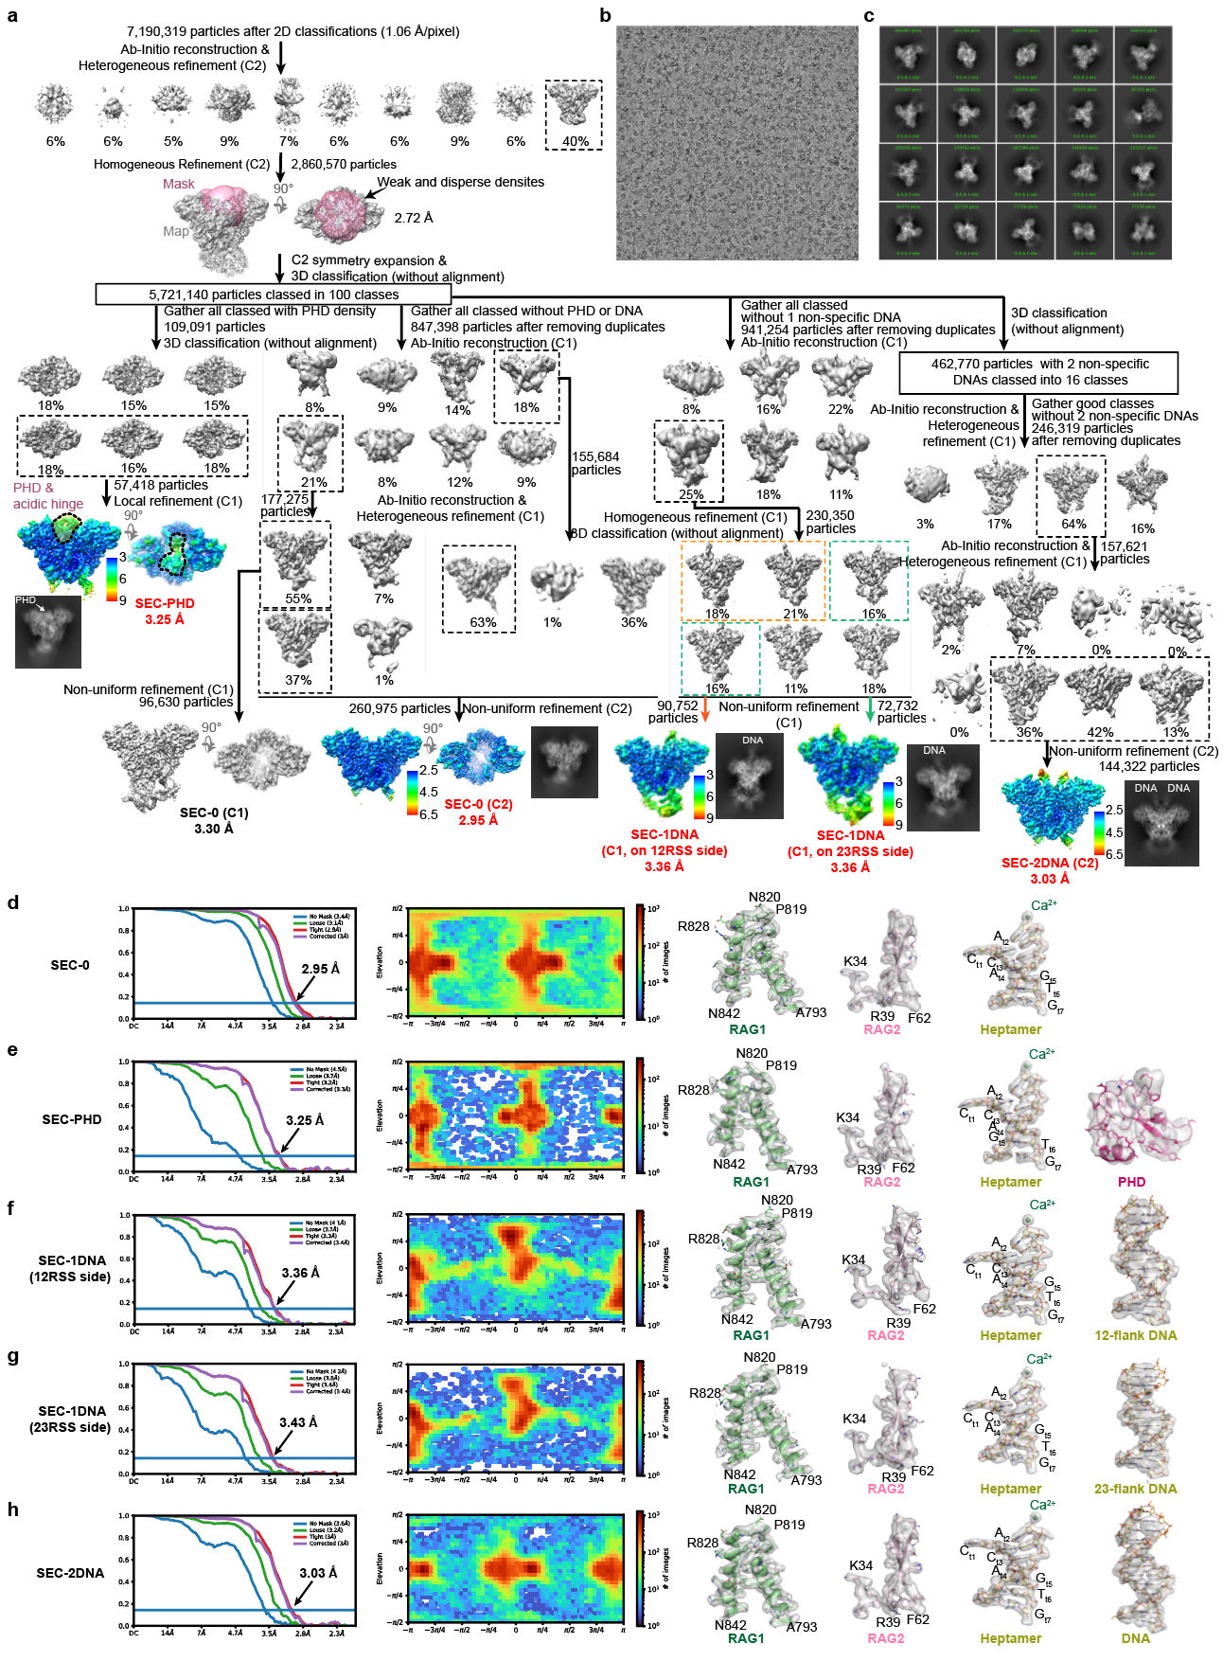
Extended Data Fig. 1: Structure determination of RAG SEC by cryo-EM. a, Flow chart for the cryo-EM data processing. The maps showing local resolution estimations and marked with red bold letters are used for final model building of STC structures. b, c, A representative cryo-EM micrograph and 2D classes of different views. d-h, FSC curves, angular distributions and representative densities of SEC maps.
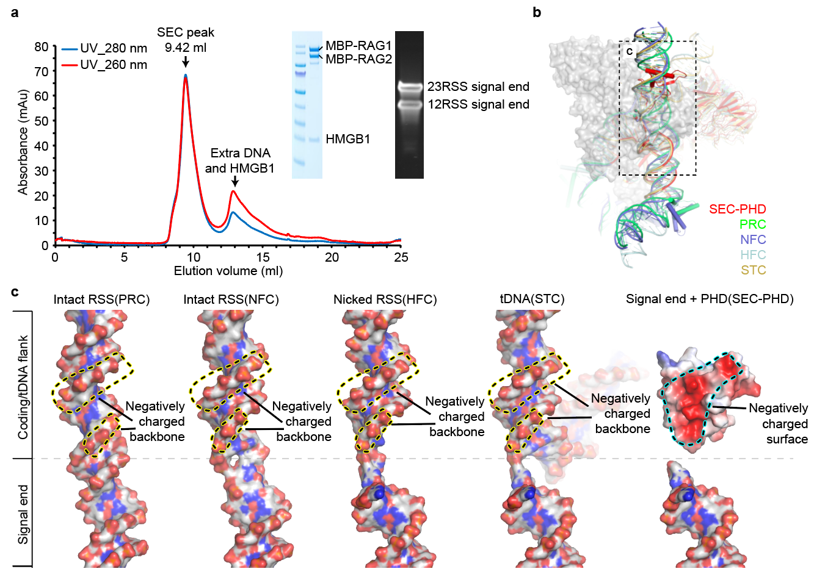
Extended Data Fig. 2: RAG SEC purification and PHD mimics DNA to compete binding to core RAG. a, The SEC complex was purified with MBP tags. The eluted peak contains MBP-tagged RAG proteins, HMGB and pre-cleaved RSS DNAs, as shown in the protein and DNA denaturing gels respectively. b, Superimposition of SEC-PHD with PRC (PDB: 6OEM), NFC (PDB: 6OEO), HFC (PDB: 6CG0) and STC (PDB: 6OES) show PHD mimics DNA binding at coding/tDNA flank binding site. c, Zoom-in views of PHD and DNAs. The negatively charged PHD surface and DNA backbone are indicated and marked using dashed lines.

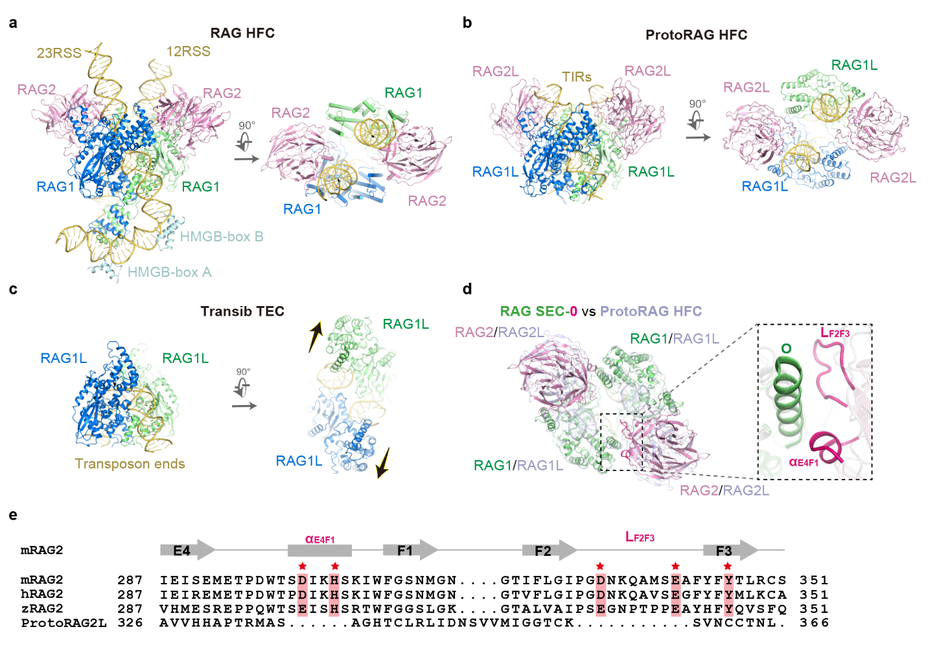
Extended Data Fig. 3: Comparison of RAG HFC, RAG SEC-0, ProtoRAG HFC and Transib TEC. a, RAG HFC appears in a closed form with RSS flanks. b, ProtoRAG HFC is also in a closed form with TIR flanks. c, Transib TEC exhibits an opened form without RAG2L subunits and additional DNA binding at tDNA binding site. The opening directions are indicated with arrows. d, Superimposition of RAG SEC-0 and ProtoRAG HFC showing non-conserved trans RAG1(L)-RAG2(L) interactions. e, Sequence alignment of RAG2s and ProtoRAG2L’s α_{E4F1} and L_{F2F3.} The conserved residues (marked with red stars), which are critical for the trans RAG1-RAG2 interaction, are absent in ProtoRAG2L.
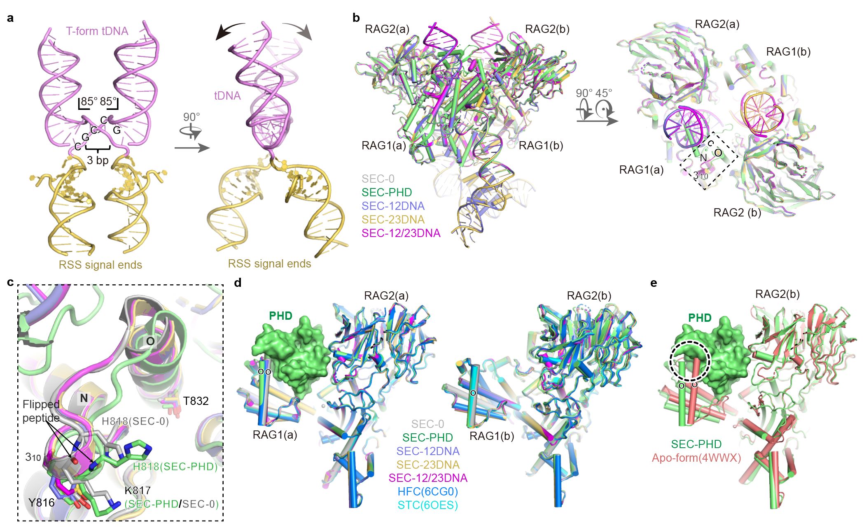
Extended Data Fig. 4: Comparisons of SEC, HFC and STC. a, The extremely 170° bent (2 × 85°) tDNA in RAG STC. Two 85° kinks are separated apart by 3 bp. The twisting directions are indicated with black arrows. b, Orthogonal views of superimposition of all SEC states. The RMSD values of comparing SEC-PHD, SEC-12DNA, SEC-23DNA and SEC-12/23DNAs with SEC-0 are 0.275, 0.482, 0.549 and 0.409 Å (C_{α} atoms of RAG1 aa 461-1008 and RAG2 aa 1-350 are compared). c, Zoom-in view of loop L_{NO} shows structural changes upon PHD docking. The flipping peptide bonds between K817 and H818 are marked with black arrows. Helices N, O and 3₁₀ (aa 816-818 of RAG1) are labeled. d, Superimpositions of RAG1/2(a) and RAG1/2(b) dimers of all SEC states, HFC (PDB:6CG0) and STC (PDB:6OES). The RMSD values of comparing RAG1/2(a) of SEC-PHD, SEC-12DNA, SEC-23DNA, SEC-12/23DNAs, HFC and STC with SEC-0 are 0.257, 0.392, 0.420, 0.323, 0.539 and 0.366 Å, and the ones of RAG1/2(b) are 0.244, 0.410, 0.457, 0.345, 0.532 and 0.374 Å (C_{α} atoms of RAG1 aa 461-1008 and RAG2 aa 1-350 are compared). e, Superimpositions of RAG1/2(a) of SEC-PHD with an apo-form RAG1/2 dimer. The RMSD value is 0.833 Å (the same C_{α} atoms are compared as in panel d). The clash between ZnH2 and PHD is indicated with dashed cycle. Helix O is marked to show local conformational differences in panel d and e.

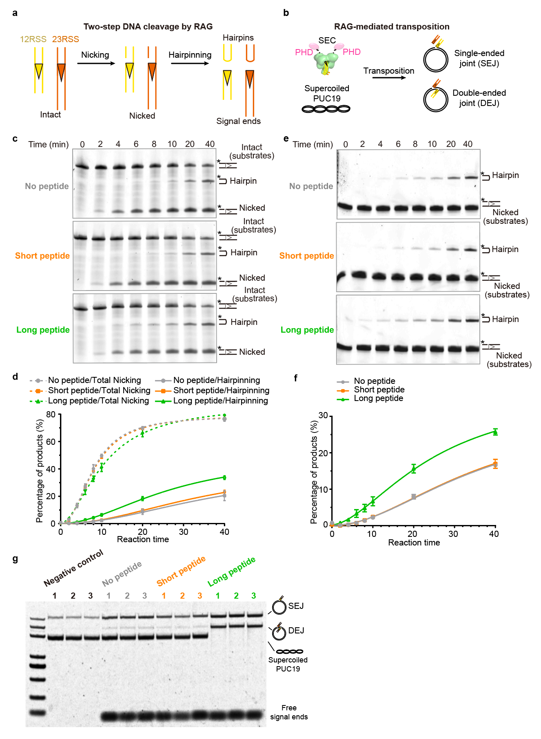
Extended Data Fig. 5. DNA cleavage and transposition assays. a,b, Schematic diagrams of RAG-mediated DNA cleavage and transposition. c,d, Representative DNA gels and quantified results of RAG cleaving intact RSS DNA substrates with addition of no H3K4me3 peptides or different length of H3K4me3 peptides. Total nicking (nicked and hairpin) was indicated using dashed lines, and solid lines for hairpinning. e,f, Representative DNA gels and quantified results of RAG cleaving pre-nicked RSS DNA substrates with addition of no H3K4me3 peptides or different length of H3K4me3 peptides. g, DNA gel of RAG-mediated transposition using supercoiled PUC19 plasmid as substrates with addition of no H3K4me3 peptides or different length of H3K4me3 peptides (related to Fig. 4d). All the assays were performed in triplicate.
Supplementary Table 1 | Oligos and peptides used in structural and biochemical studies.

Name | Sequence | Length (nt) | Purification Method
Oligos used in structural and biochemical assays
I46 (FAM) | 5'-FAM-GATCTGGCCTGTCTTACACAGTGATACAGCCCTTA  ACAAAAACCCG-3' | 46 | HPLC
F46 | 5'- CGGGTTTTTGTTAAGGGCTGTATCACTGTGTAAGACAGGCCAG  ATC-3' | 46 | PAGE
J57 | 5'-GATCTGGCCTGTCTTACACAGTGATGCAAATCAAGTGTGAAGC  CAGACAAAAACCCG-3' | 57 | PAGE
G57 | 5'-CGGGTTTTTGTCTGGCTTCACACTTGATTTGCATCACTGTG  TAAGACAGGCCAGATC-3' | 57 | PAGE
I16 (FAM) | 5'-FAM-GATCTGGCCTGTCTTA-3' | 16 | HPLC
I30 | 5'-CACAGTGATACAGCCCTTAACAAAAACCCG-3' | 30 | PAGE
I16 | 5'-GATCTGGCCTGTCTTA-3' | 16 | PAGE
M41 | 5'-CACAGTGATGCAAATCAAGTGTGAAGCCAGACAAAAACCCG-3' | 41 | PAGE
F30 | 5'-CGGGTTTTTGTTAAGGGCTGTATCACTGTG-3' | 30 | PAGE
M41 | 5'-CACAGTGATGCAAATCAAGTGTGAAGCCAGACAAAAACCCG-3' | 41 | PAGE
G41 | 5'-CGGGTTTTTGTCTGGCTTCACACTTGATTTGCATCACTGTG-3' | 41 | PAGE
Peptides used in biochemical assays
6-aa peptide | ARTK(Me3)QT | 6 | HPLC
21-aa peptide | ART K(Me3)QTARKSTGGKAPRKQLA | 21 | HPLC
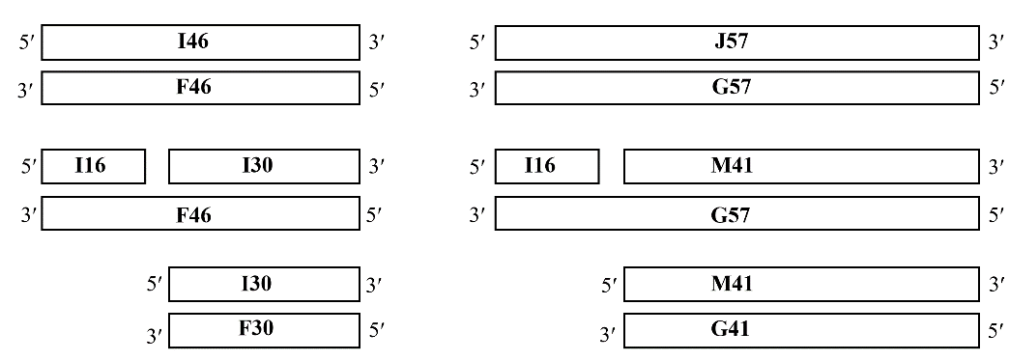
Signal end DNAs
Intact DNAs
12 RSS
23 RSS
Pre-nicked DNAs
HFC DNA
HFC DNA

Supplementary Video 1
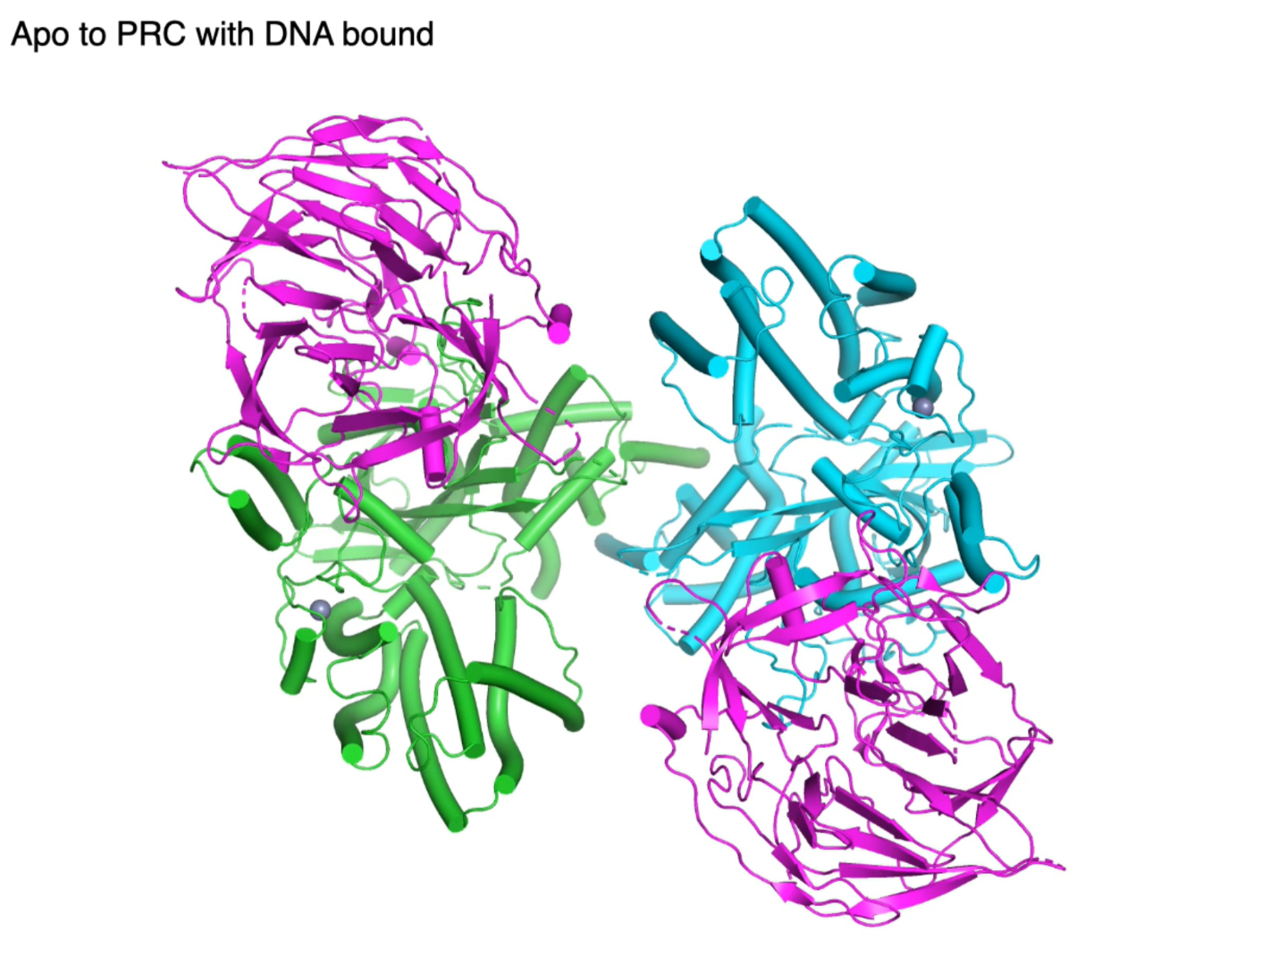
The “spring-loaded” mechanism of RAG-mediated RSS cleavage. The “spring-loading” is at the initial RSS and coding flank binding by apo-RAG, to become PRC, then the high energy step-wisely releases when becomes NFC, HFC and SEC during the DNA nicking and hairpinning reactions. The closed-form of HFC, SEC and STC indicate the lowest energy state.

