Supplementary S3. Sanger sequencing electropherograms of SNP rs41524547 (G or C allele).

Example 1
Heterozygous; Genotype: C/G
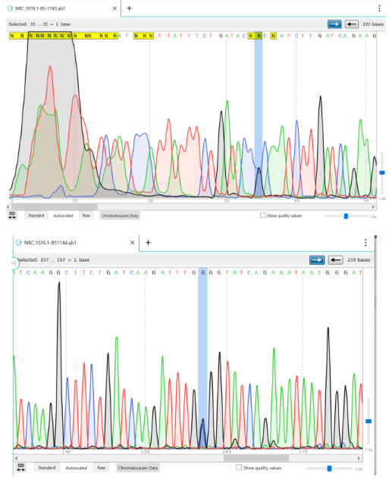

Example 2
Homozygous; Genotype: G/G
