Supplementary S2. RP-PCR electropherograms of ATTCT-ATXN10. We used four fluorophores (Blue: 6-FAM, Red: PET, Green: VIC, Black: NED). X-axis: length (in pair of bases); Y-axis: RFU (Relative Fluorescence Units); orange lane: limit of 32 ATTCT repeats. Last example displays a sample with a possible interruption within the ATTCT microsatellite.
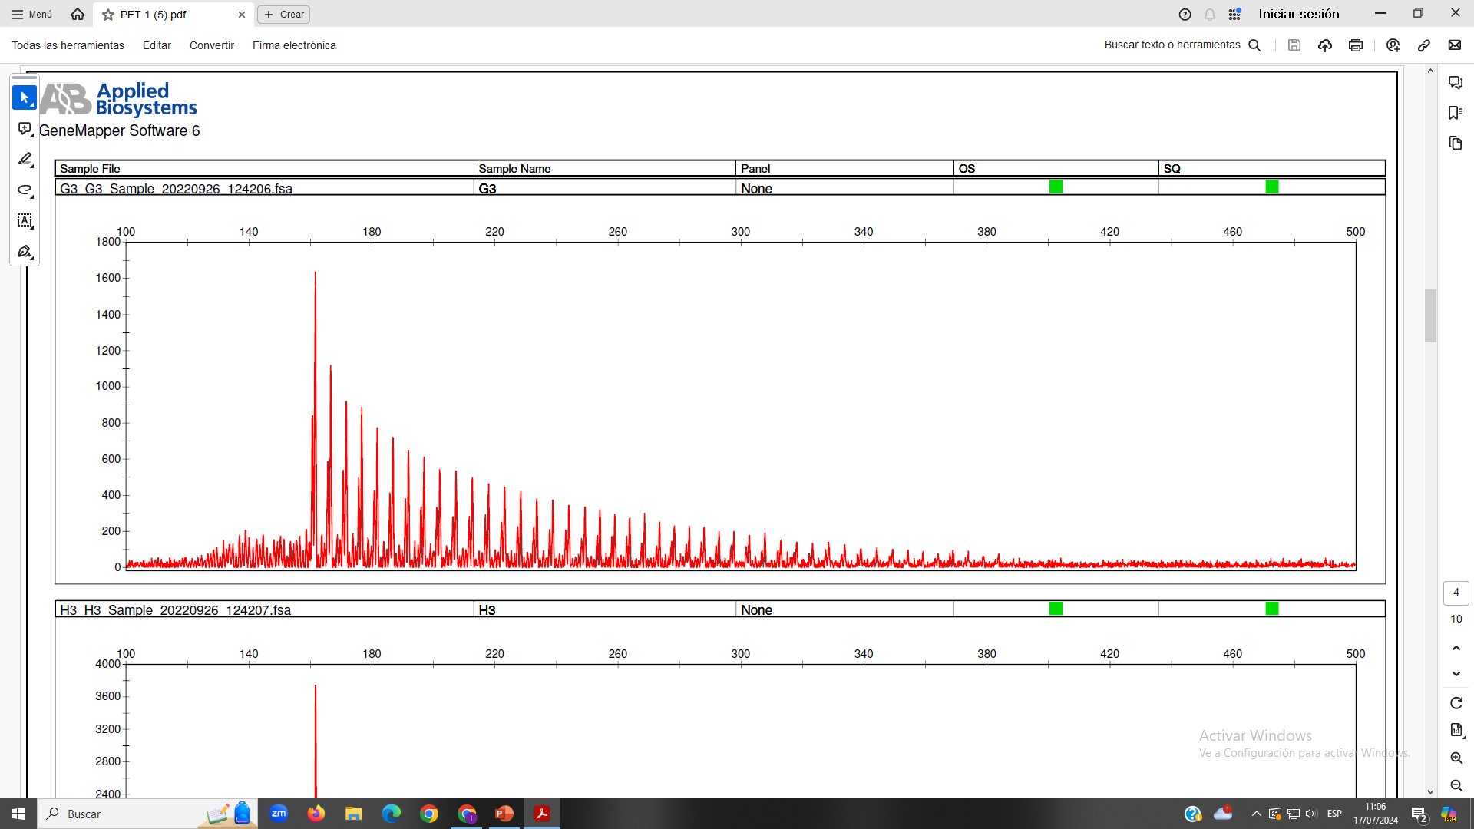
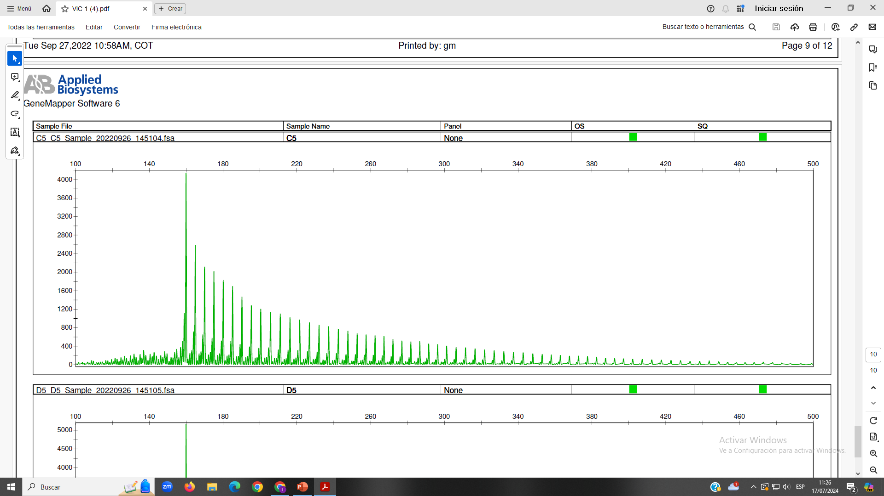
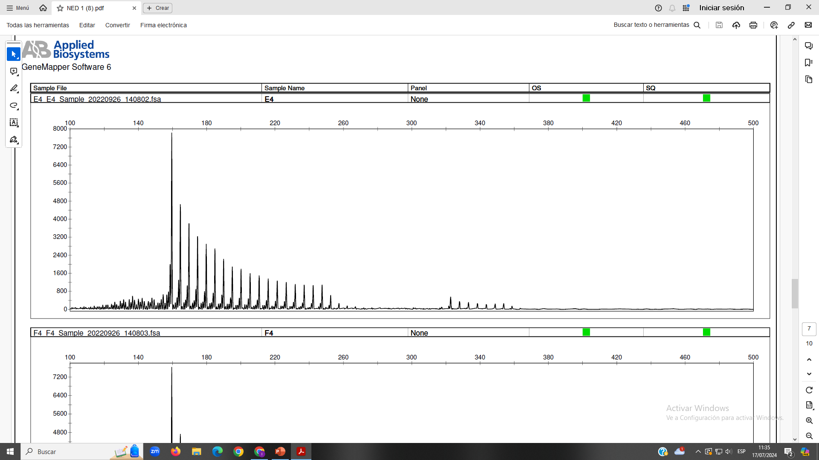
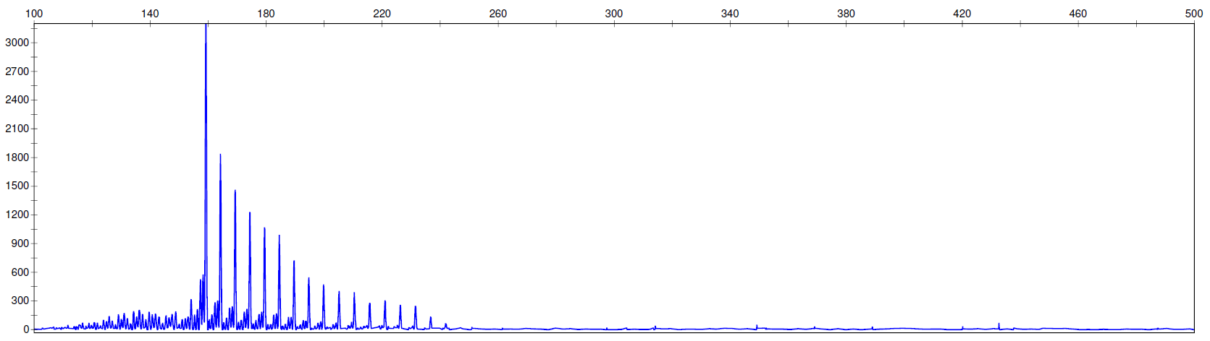
Gap
Example 4 (NED)
RP-PCR positive
Example 1 (6-FAM)
RP-PCR negative
Example 1 (VIC)
RP-PCR positive
Example 2 (PET)
RP-PCR positive

