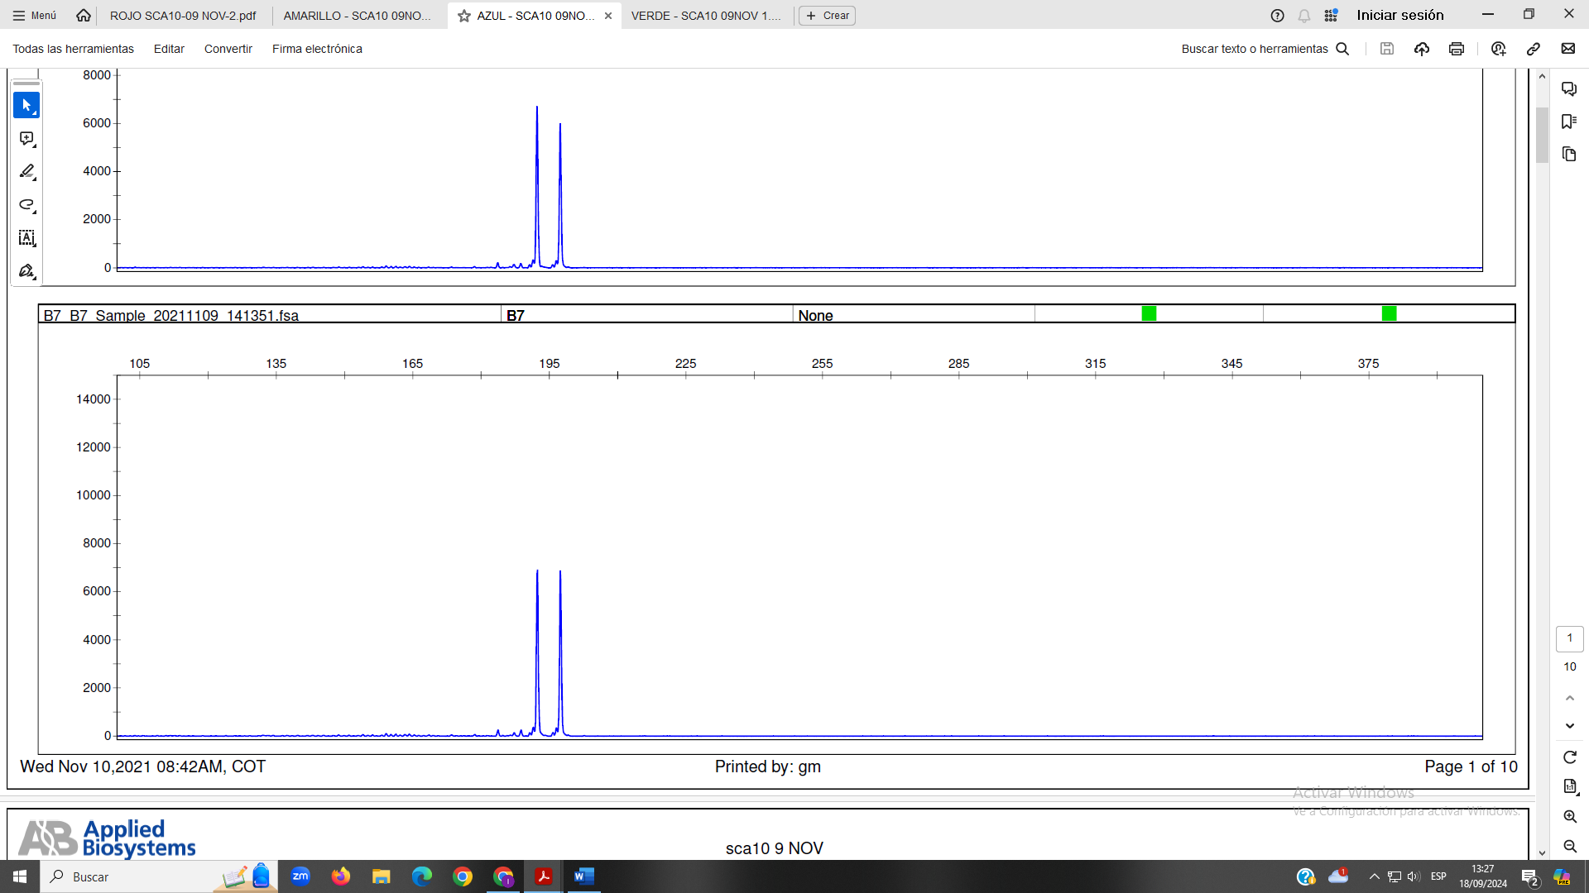
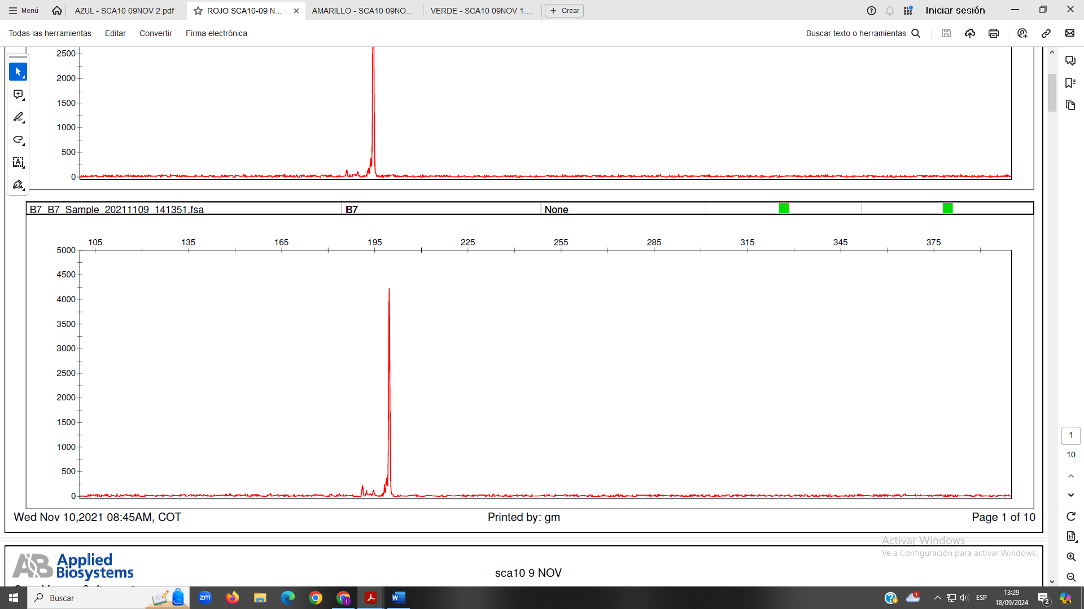
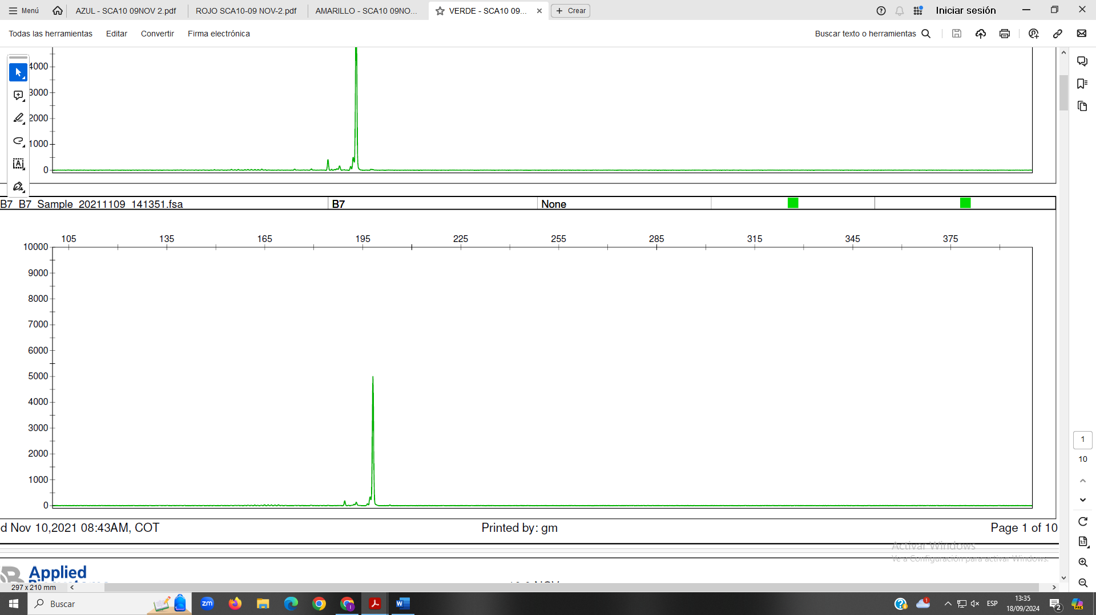
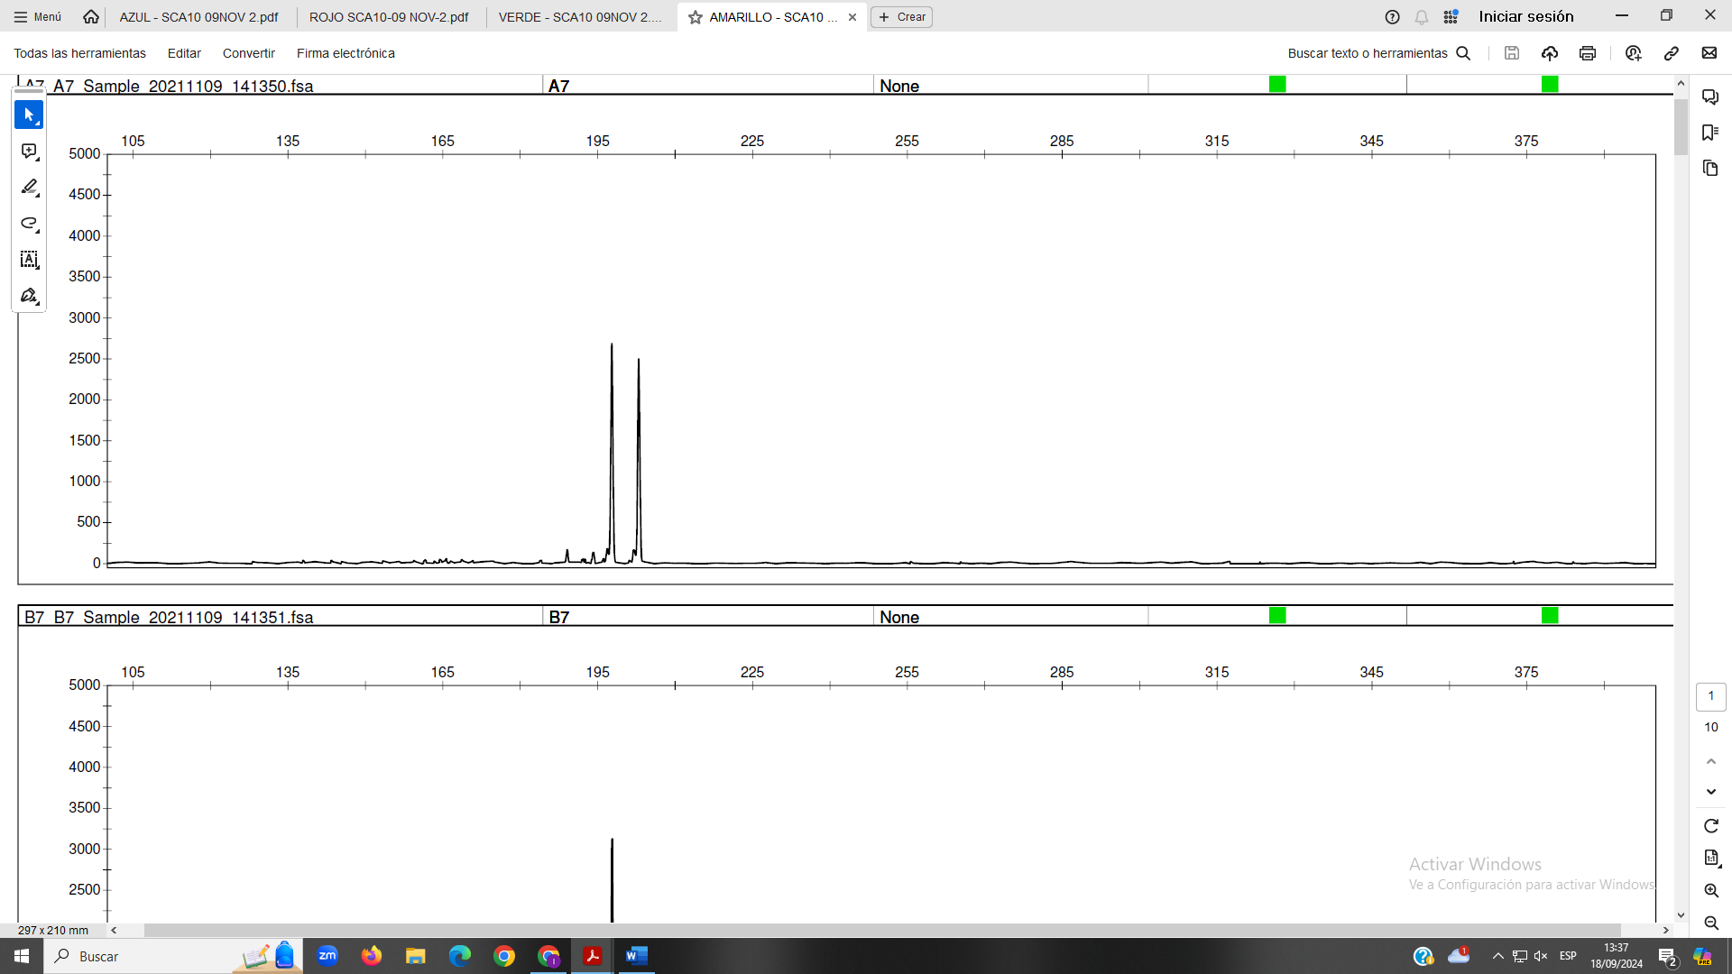
Supplementary S1. PCR electropherograms of ATTCT-ATXN10. We used four fluorophores (Blue: 6-FAM, Red: PET, Green: VIC, Black: NED). X-axis: length (in pair of bases); Y-axis: RFU (Relative Fluorescence Units).
15
14
14
14
14
13
Example 1 (6-FAM)
Genotype: 13/14
Example 2 (PET)
Genotype: 14/?
Example 3 (VIC)
Genotype: 14/?
Example 4 (NED)
Genotype: 14/15

