Supplementary Material
Gene syntax modulates gene expression and genetic circuit behavior on plasmids
Yijie Deng¹, Hannah E. Maurais¹, Kai Etheridge¹, Rahul Sarpeshkar^{1,2*}
1. Thayer School of Engineering, Dartmouth College, Hanover, NH 03755, USA
2. Departments of Engineering, Microbiology & Immunology, Physics, and
Molecular and Systems Biology, Dartmouth College, Hanover, NH 03755, USA
* Correspondence: rahul.sarpeshkar@dartmouth.edu

Figure S1. Transcription read-through from the AmpR gene is negligible. (A)The promoter activity of the AmpR gene on ColE1 plasmid is low. (B) Two terminators were identified upstream of the GFP gene.

Figure S2 Gene orientation relative to the pSC101 Ori affects gene expression profiles. (A) The design of plasmid pairs where each plasmid carries two reporter genes facing the same direction, either codirectional to or opposite to the plasmid Ori (pSC101). (B) The mean expression levels of GFP and RFP are compared between the codirectional and head-on orientations. (C) The ratios of GFP to RFP are compared between the codirectional and head-on orientations. (D, E) Contribution of upstream DNA sequences to transcription of GFP (D) and RFP (E) on plasmids pDA466 and pDA467. Fluorescence signals were collected in the same way as mentioned in the Method section but with gain setting of 2500x. Values are presented as mean ± SD (n = 8). **** p< 0.0001; *p < 0.05; ns, not significant.

Figure S3. The comparison of upstream transcription activity among the divergent, convergent, and tandem-oriented reporter genes. The contribution of upstream DNA sequences to the transcription of GFP (A) and RFP (B) are compared. The highest transcription rate (at distance 0) indicates the transcription start site of the promoter of the GFP or RFP gene.

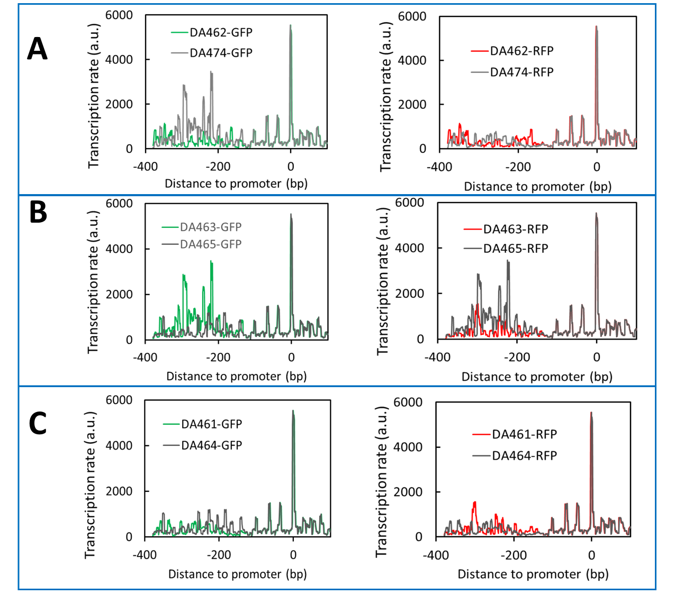
Figure S4. The comparison of upstream transcription activity of GFP or RFP placed at different orders. The contribution of upstream DNA sequences to the transcription of GFP and RFP are compared within each pair; each pair of plasmids carries GFP and RFP genes with the same orientation but in different order. The highest transcription rate (at distance 0) indicates the transcription start site of the promoter of the GFP or RFP gene. (A) DA462 and pDA474 pair. (B) DA463 and DA465 pair. (C) DA461 and DA464 pair.

