Genomic Blueprint of Novel Slow-Growing Bacteria with Insights into their Potential Adaptation Mechanisms in Soil Ecosystems
Osiel Silva Gonçalves1*, Mateus Ferreira Santana2*
¹Department of Biological Science, Universidade Estadual do Centro-Oeste (Unicentro), Paraná, Brazil.
2Grupo de Genômica Eco-evolutiva Microbiana, Laboratório de Genética Molecular de Microrganismos, Departamento de Microbiologia, Instituto de Biotecnologia Aplicada à Agropecuária, Universidade Federal de Viçosa, Minas Gerais, Brazil.

Correspondence authors: osiel.goncalves@outlook.com.br, mateus.santana@ufv.br

Supplementary Figures

Figure S1: Comparison of Genome Quality Metrics Across Four Cerrado Strains. GC Content, BUSCO Completeness, and Contamination Rates.

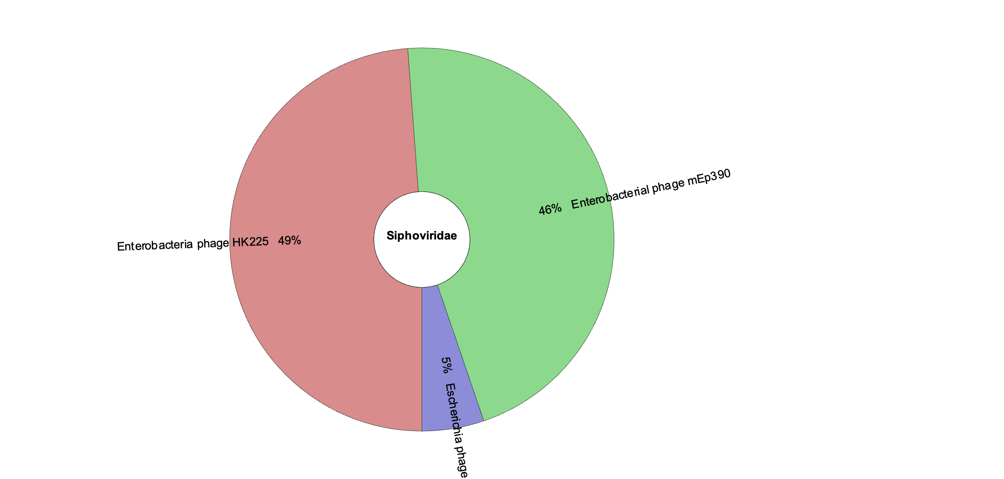

Figure S2. Taxonomic classification of phage sequences from the CER55 genome using Kaiju v1.9.0. The donut chart shows the percentage of reads mapped to different taxa within the phage sequences. Specifically, 49% of the reads are mapped to HK225, 46% to Enterobacteriaceae, and 5% to Escherichia. This distribution highlights the taxonomic composition of phage-related reads within the CER55 genome based on Kaiju's classification.

Figure S3. Heatmap of Transporter Abundance and Diversity in Cerrado Lineages. The rows and columns have been clustered using correlation distance and average linkage methods.

