Supporting Information
Development of a coumarin-based Schiff base fluorescent probe and its application in detection of Cu²⁺

Xinli Yang ¹,Qiurui Ma ¹,Yingying Zhao ¹

¹ College of Chemistry and Chemical Engineering, Henan University of Technology, Zhengzhou 450001, China

*Corresponding author: Yingying Zhao, zhaoyy@haut.edu.cn

Calculation of detection limit
The detection limits of M for Cu²⁺ was calculated by the following formula (1):
$$LOD=\frac{3σ}{s}$$
（1）

where σ is the standard deviation of 10 times the intensity of free M, and S is the slope of the emission intensity of M as a function of the Cu²⁺ concentration.
Calculation of association constant
The association constant between M and Cu²⁺ was calculated by the following formula (2):
$\frac{1}{∆F}=\frac{1}{∆F_{max}}+\frac{1}{K∆F_{max}}·\frac{1}{[{Cu}^{2+}]}$
（2）

where ΔF =F - F₀ and ΔF_{max} = F₀ – F_{max}. With F₀, F and F_{max} being the fluorescence intensities of the free M, at various concentration of Cu²⁺ and at the maximum concentration of Cu²⁺ respectively.
Theoretical calculation
The molecular structures of M and M+Cu²⁺ were optimized using the B3LYP functional and the mixed basis sets 3-21G* in Gaussian 09 program, employing density functional theory (DFT) combined with time-dependent density functional theory (TD-DFT) for structure optimization and energy calculation.
Through frequency calculation, it was ensured that no virtual frequency exists in all optimized structures.

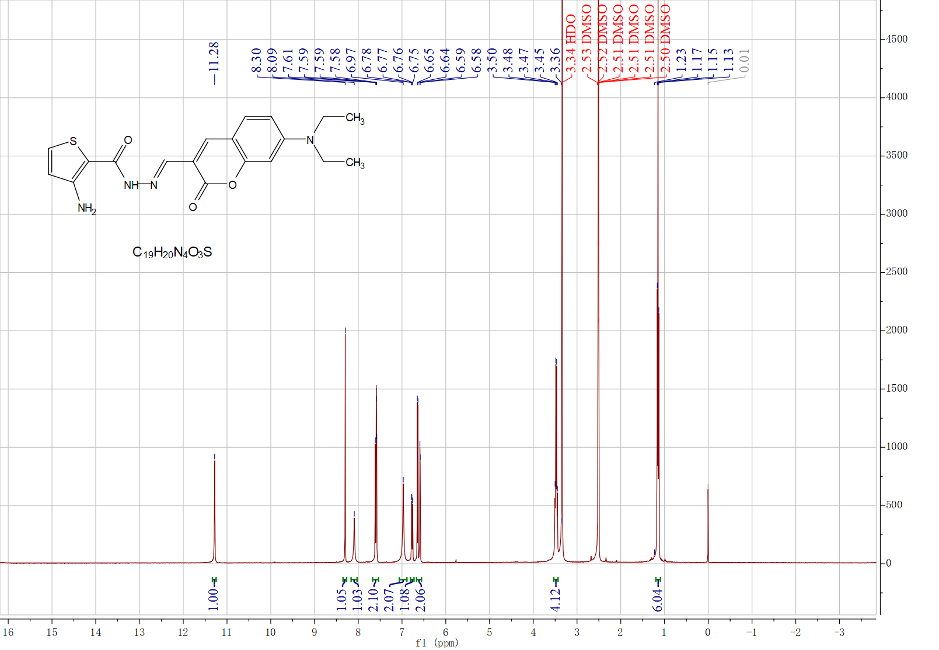
Figure S1. ¹H NMR in DMSO-d₆ spectrum of M.
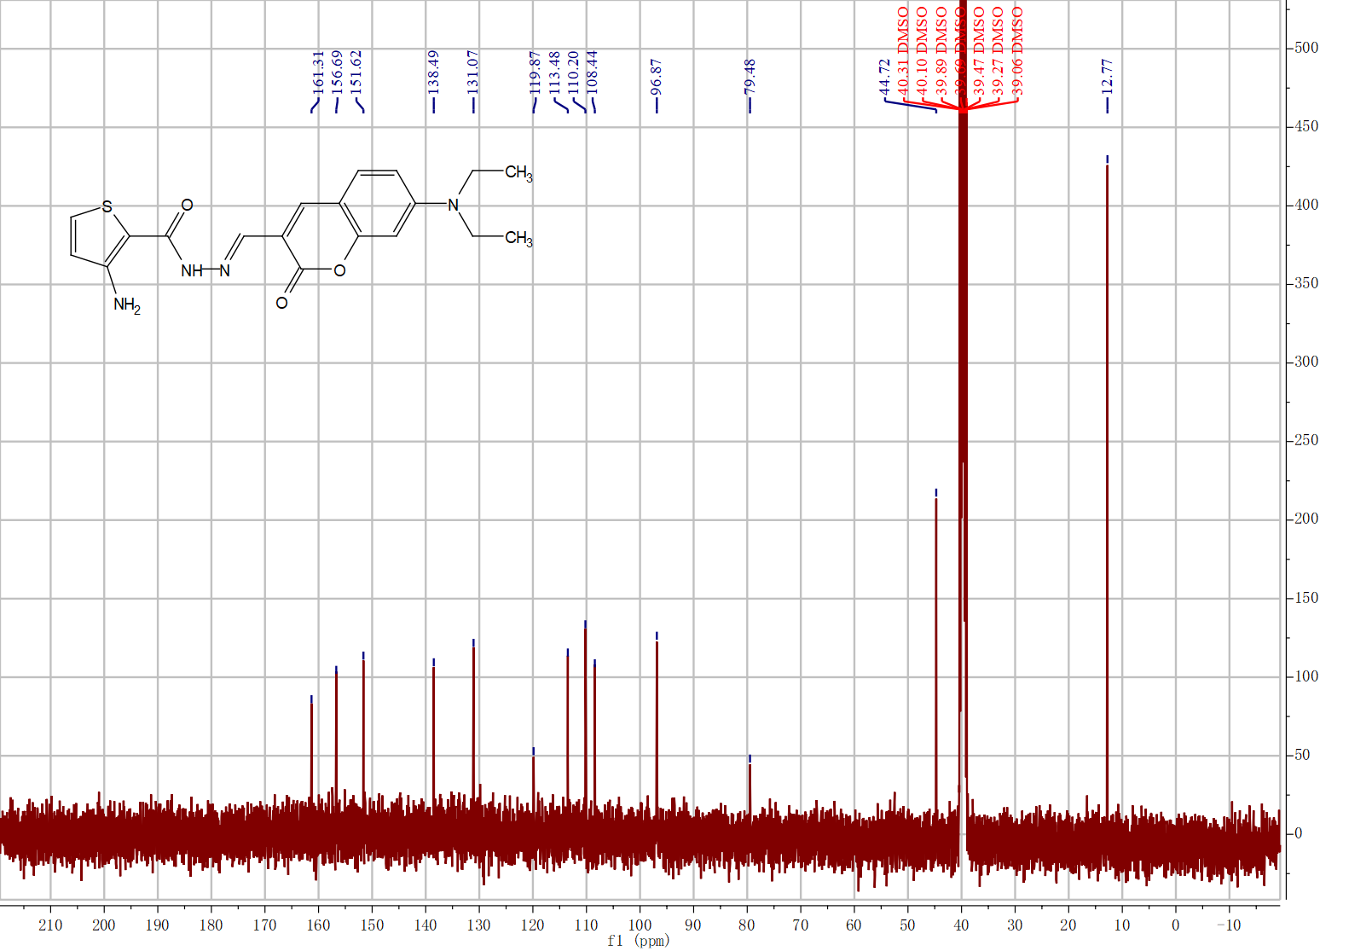
Figure S2. ¹³C NMR in DMSO-d₆ spectrum of M.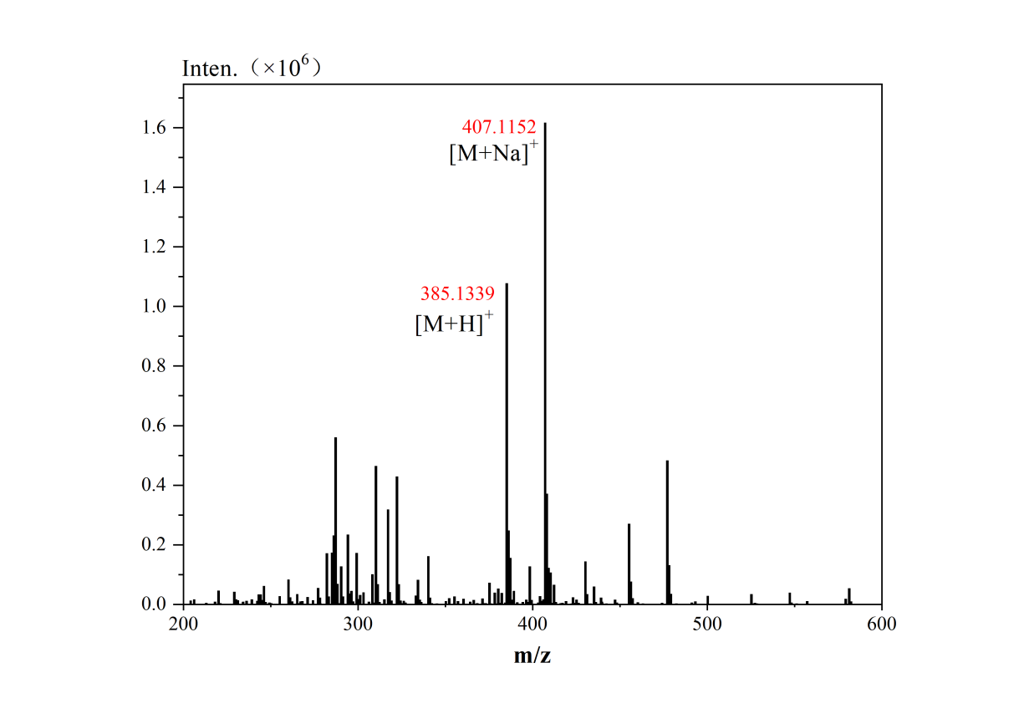
Figure S3. ESI-MS spectrum of probe M.
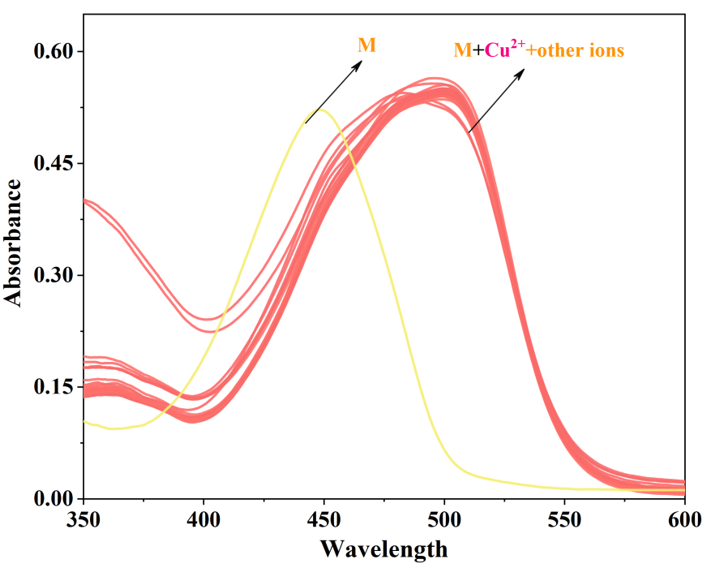
Figure S4. UV-vis absorption spectra of M mixed with various metal ions in THF/H₂O Tris buffer (v/v=9:1, 0.01 M, pH=7.4) were recorded in the presence of Cu²⁺.
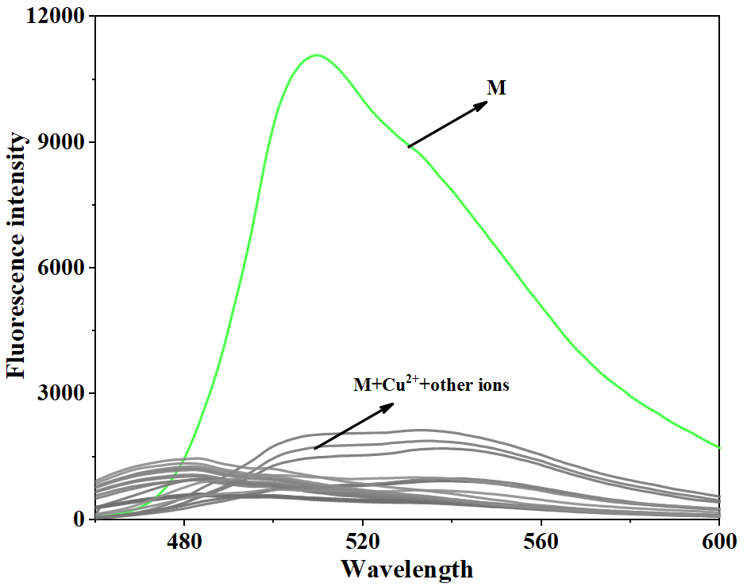
Figure S5. Fluorescence emission spectra of M in the presence of various metal ions were recorded in THF/H₂O Tris buffer (v/v=9:1, 0.01 M, pH=7.4), with a particular focus on Cu²⁺.
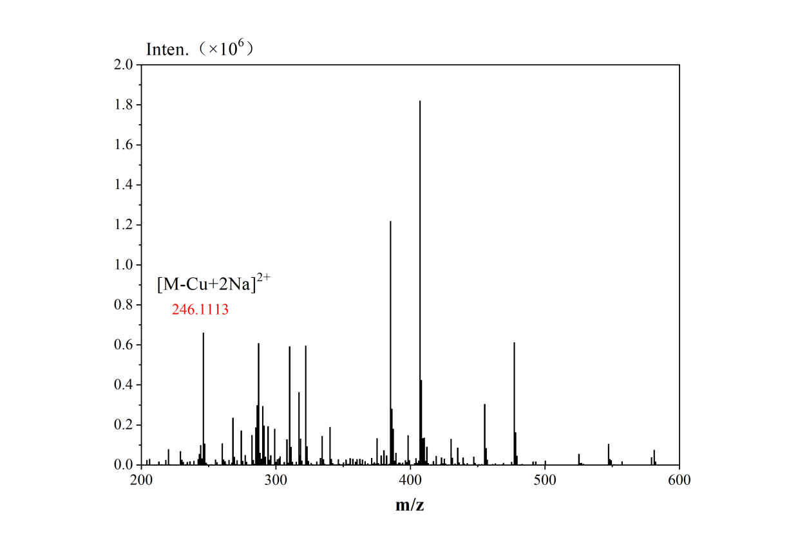
Figure S6. ESI-MS spectrum of probe M with addition of Cu²⁺.

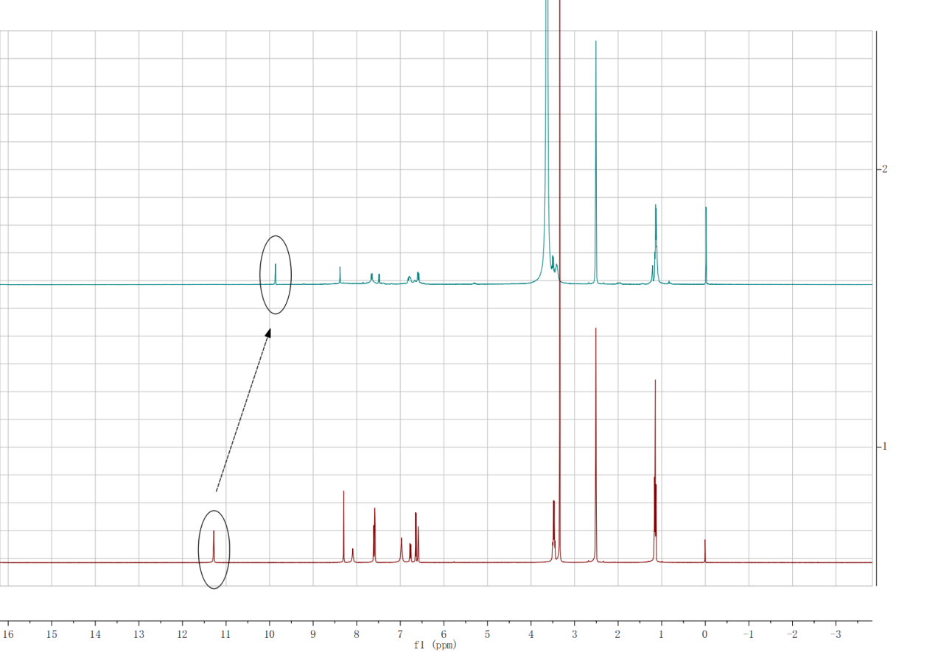
Figure S7. ¹H NMR of compound M after adding Cu²⁺ to DMSO-d₆.

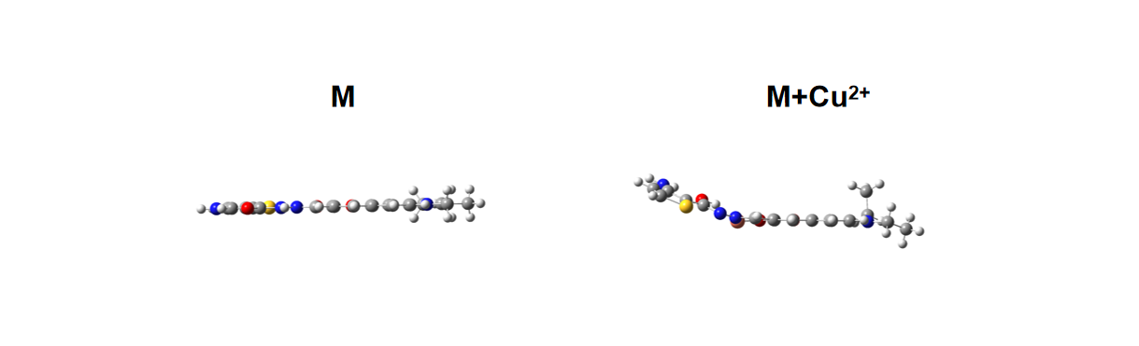
Figure S8. The planar structure of M and M complexed with Cu²⁺.

