Supplementary Materials
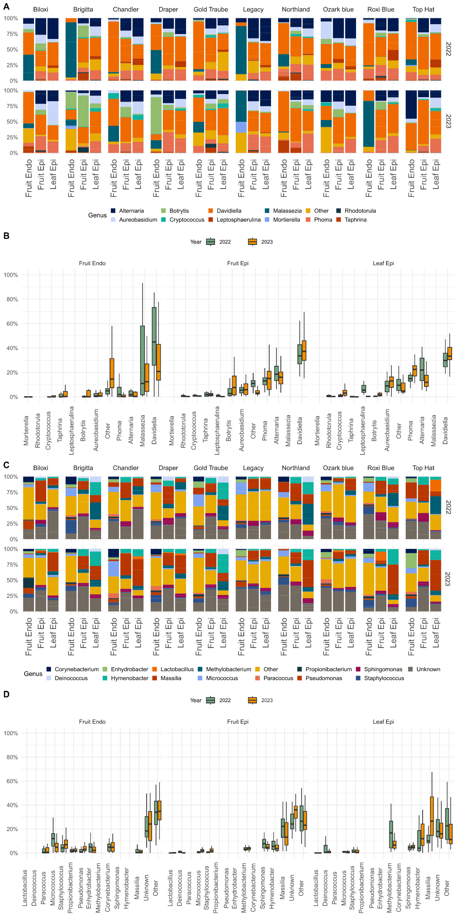
Supp_fig_ 1 : The figure shows the genus-level composition and diversity of fungal and bacterial communities in blueberry cultivars across different tissues and years: A) Stacked bar charts indicate the relative abundance of fungal genera across different blueberry cultivars and tissue types (Fruit Endo, Fruit Epi, Leaf Epi) for two years. Davidiella is notably abundant in endophytic niches; B: Box plots compare the relative abundance of various fungal genera in different tissues over two years, highlighting differences in genera like Davidiella and Malassezia; C: Stacked bar charts show the relative abundance of bacterial genera across blueberry cultivars and tissue types for two years. There is a notable presence of genera such as Corynebacterium and Hymenobacter; D: Box plots compare the relative abundance of various bacterial genera in different tissues over two years, showing distinct patterns in genera like Lactobacillus and Sphingomonas.

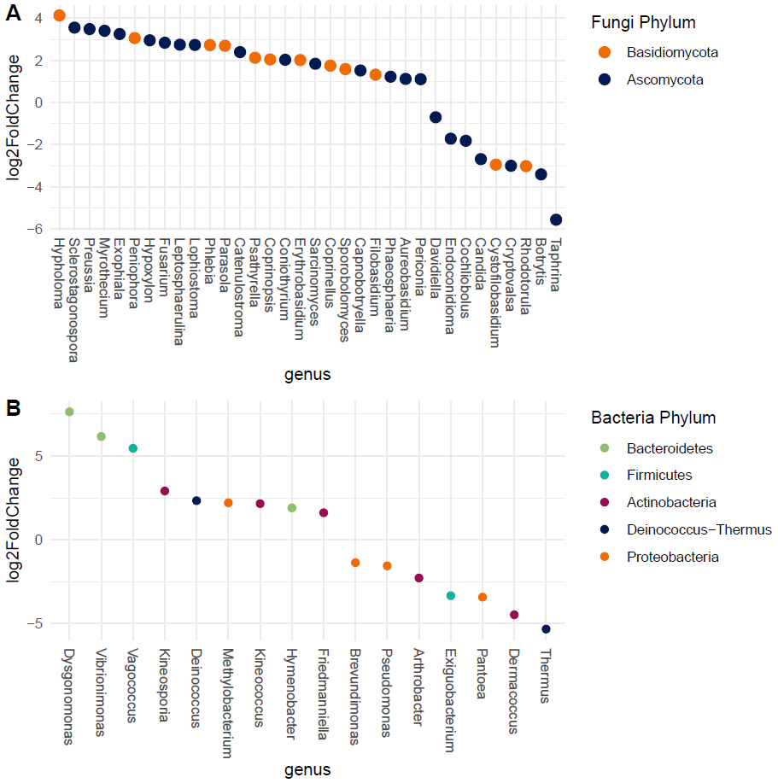
Supp_fig_2: A) differential abundance between fruit carposphere and leaf surface analyzed with DESeq2 for fungal kingdom; B) differential abundance between fruit carposphere and leaf surface analyzed with DESeq2 for bacteria kingdom.

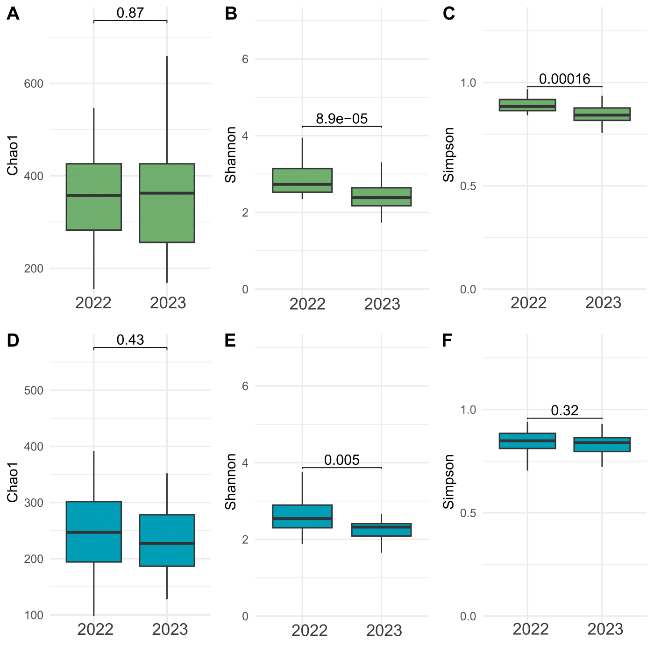

Supp_fig_3: Alpha diversity index of fungi comparing the two years: A) Chao1 Richness; B) Shannon’s Diversity; C) Simpson’s Dominance indices for leaf epiphytes; D) Chao1 Richness; E) Shannon’s Diversity; F) Simpson’s Dominance indices for fruits epiphytes.
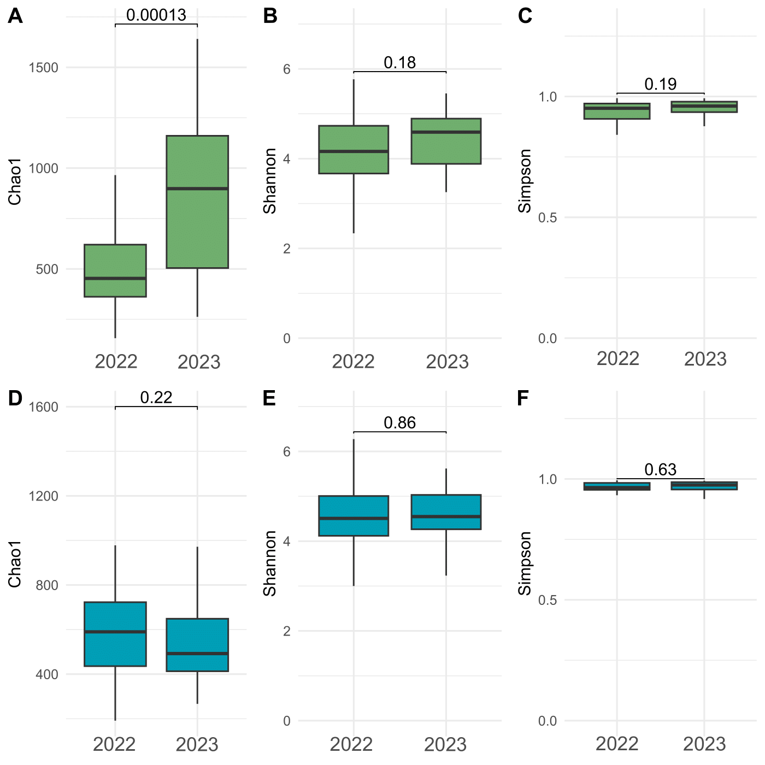

Supp_fig_4 : Alpha diversity index of bacteria comparing the two years: A) Chao1 Richness; B) Shannon’s Diversity; C) Simpson’s Dominance indices for leaf epiphytes; D) Chao1 Richness; E) Shannon’s Diversity; F) Simpson’s Dominance indices for fruits epiphytes.

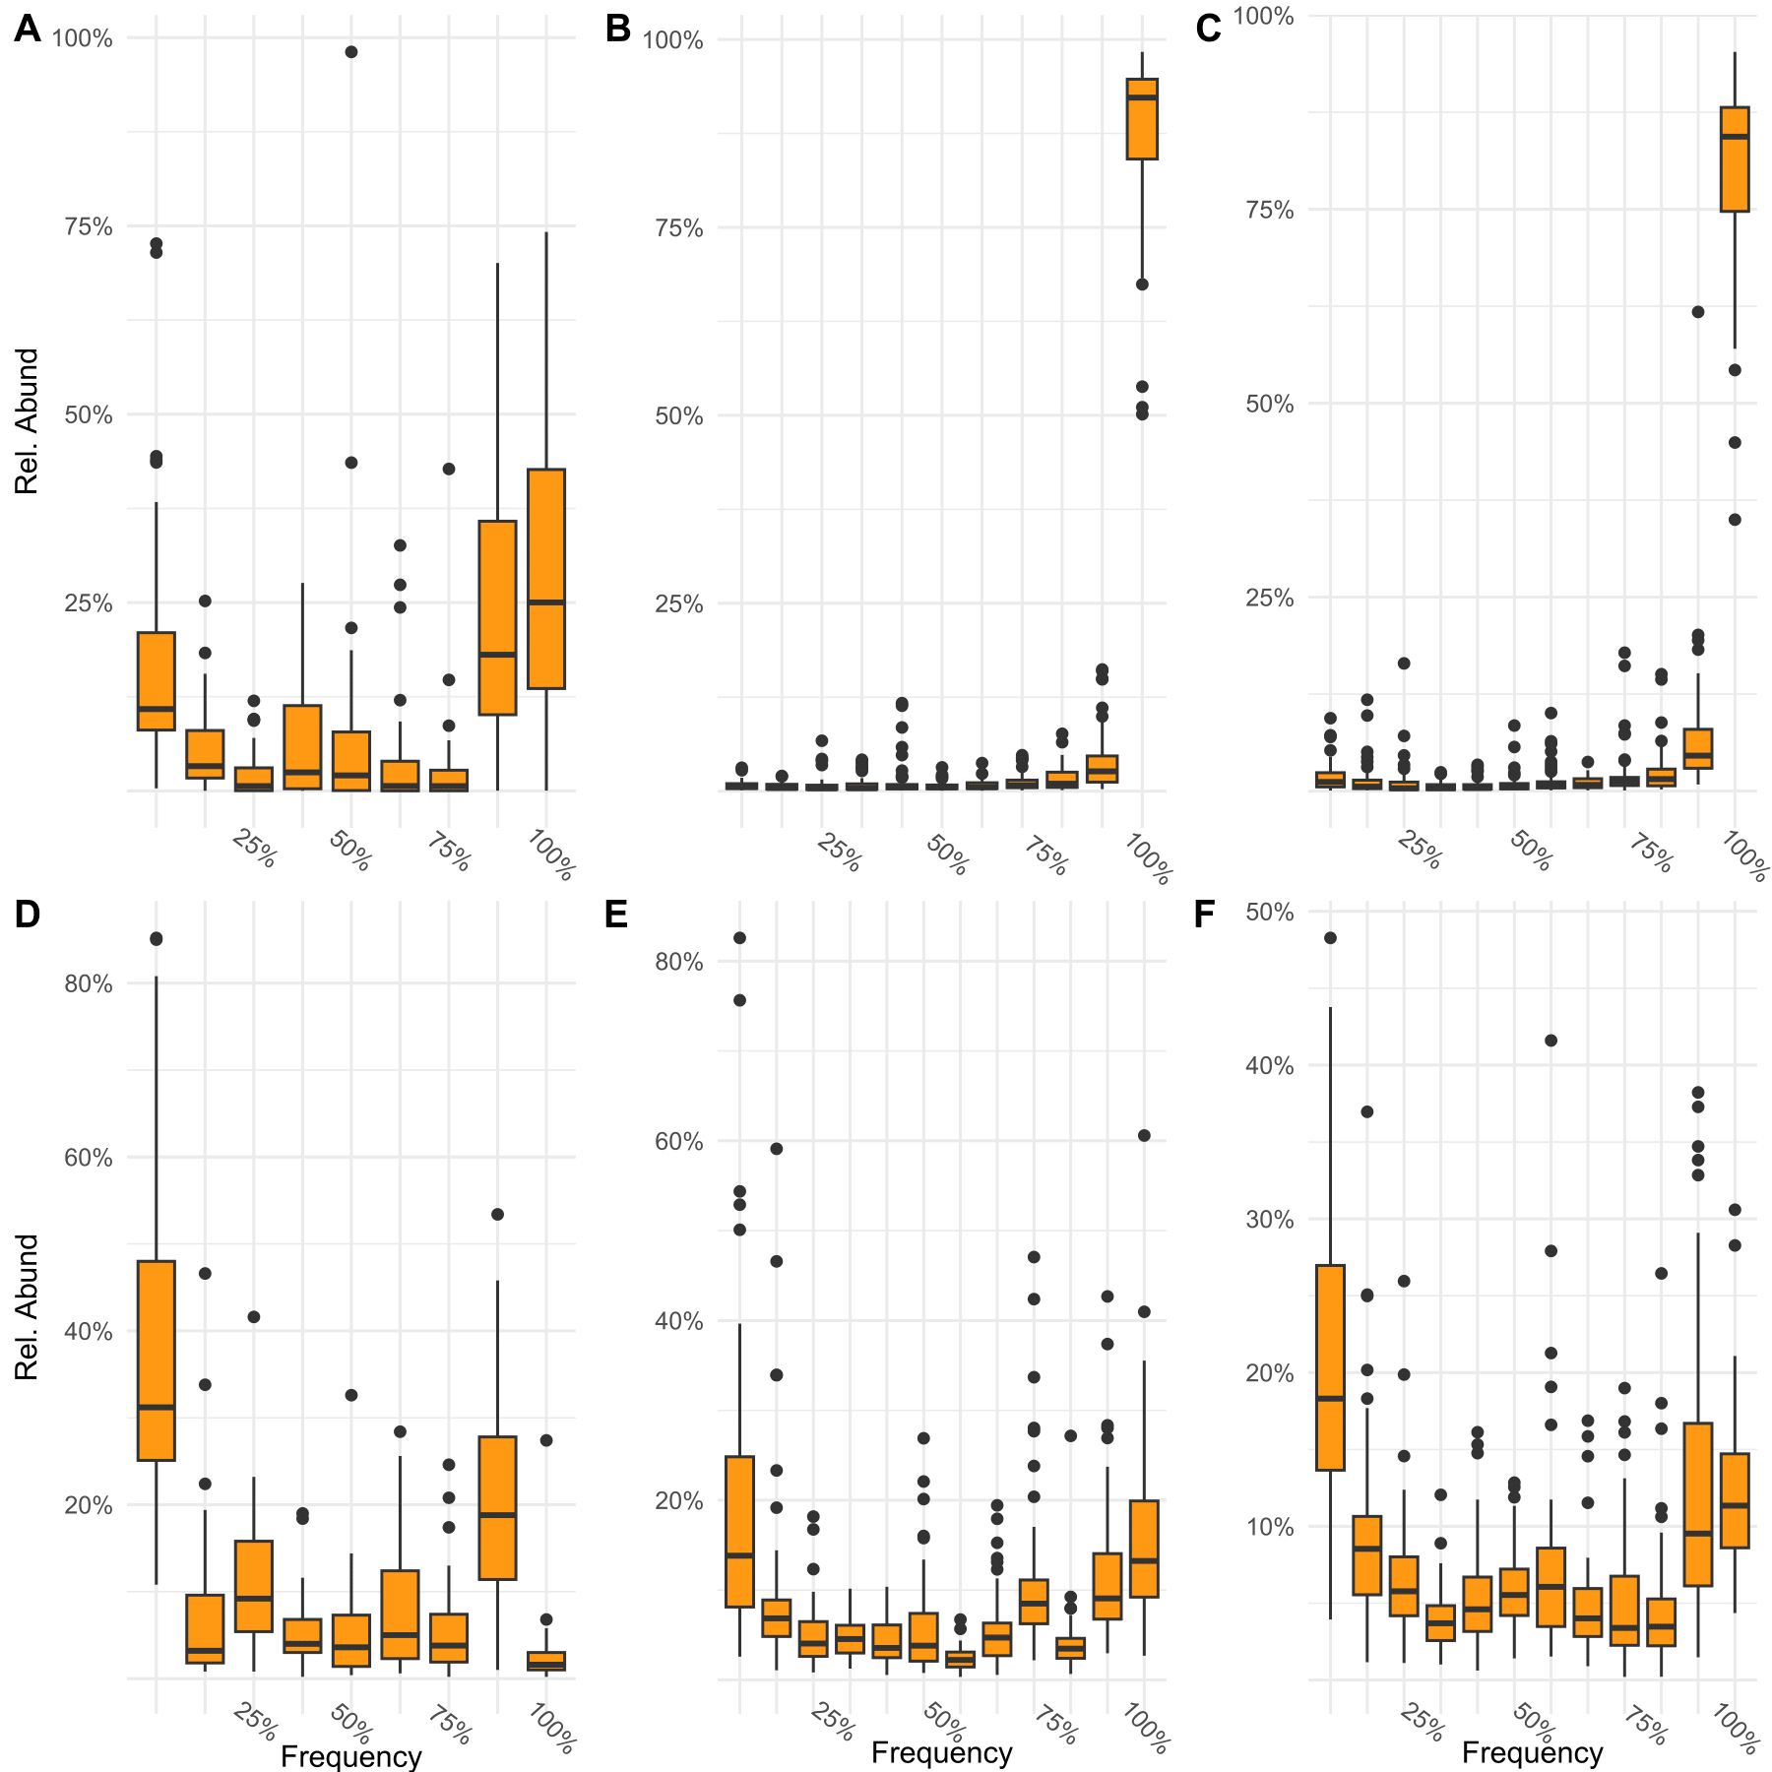

Supp_fig_5: Box plots of relative abundance of ASVs in blueberry endophytic and epiphytic niches, summarized by their frequency of occurrence across samples; each panel represents a specific niche: A) Endophytic Fungi in Fruits B) Epiphytic Fungi on Leaves C) Epiphytic Fungi on Fruits D) Endophytic Bacteria in Fruits E) Epiphytic Bacteria on Leaves F) Epiphytic Bacteria on Fruits.

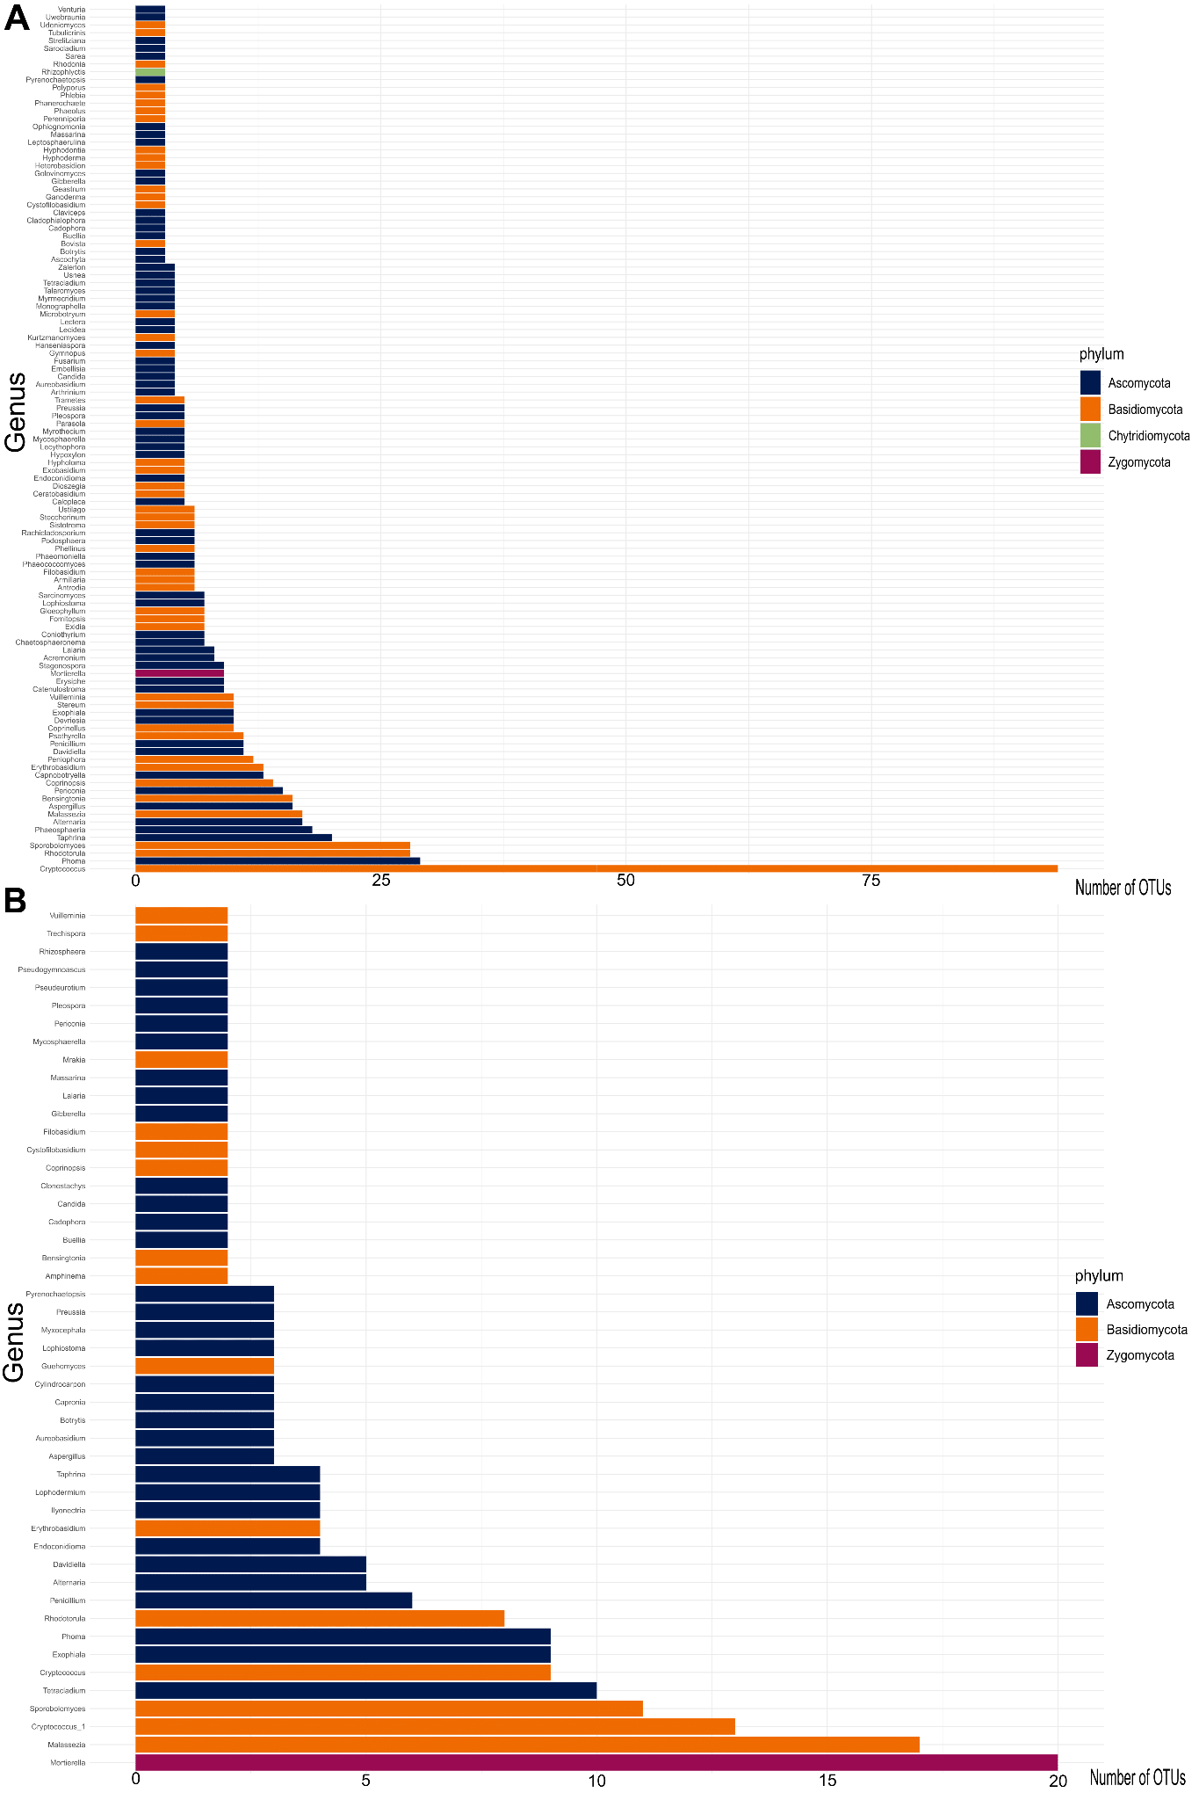

Supp_fig_ 6 : A) number of ASVs for each genus in fungi epiphytes B) number of ASVs for each genus in fungi endophytes

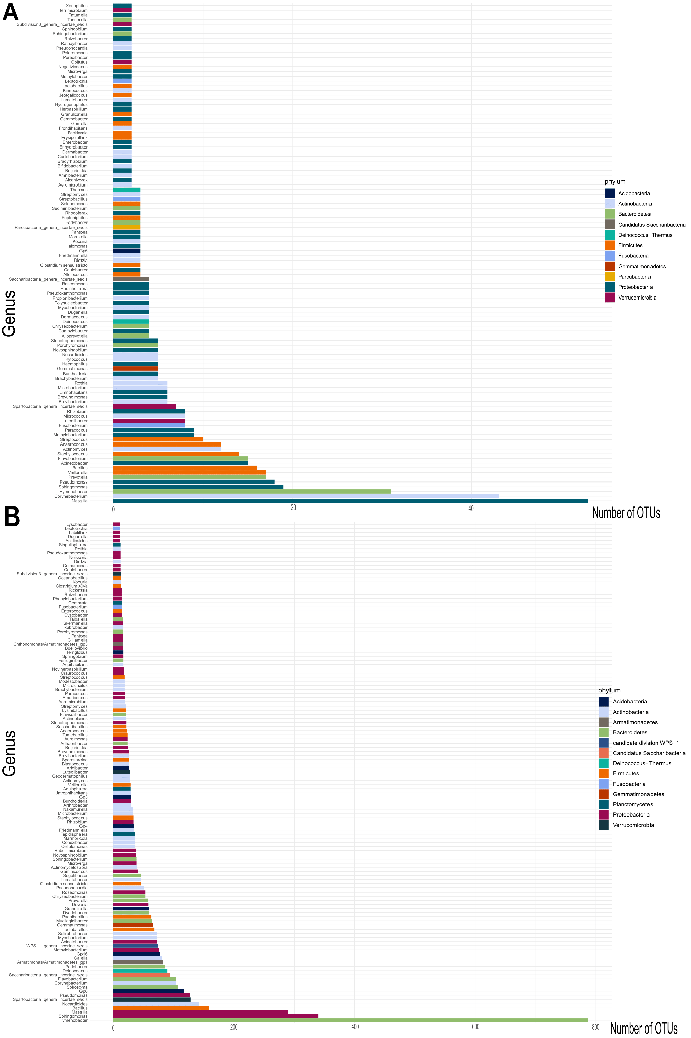Supp_fig_ 7:A) number of ASVs for each genus in bacteria epiphytes B) number of ASVs for each genus in bacteria endophytes.
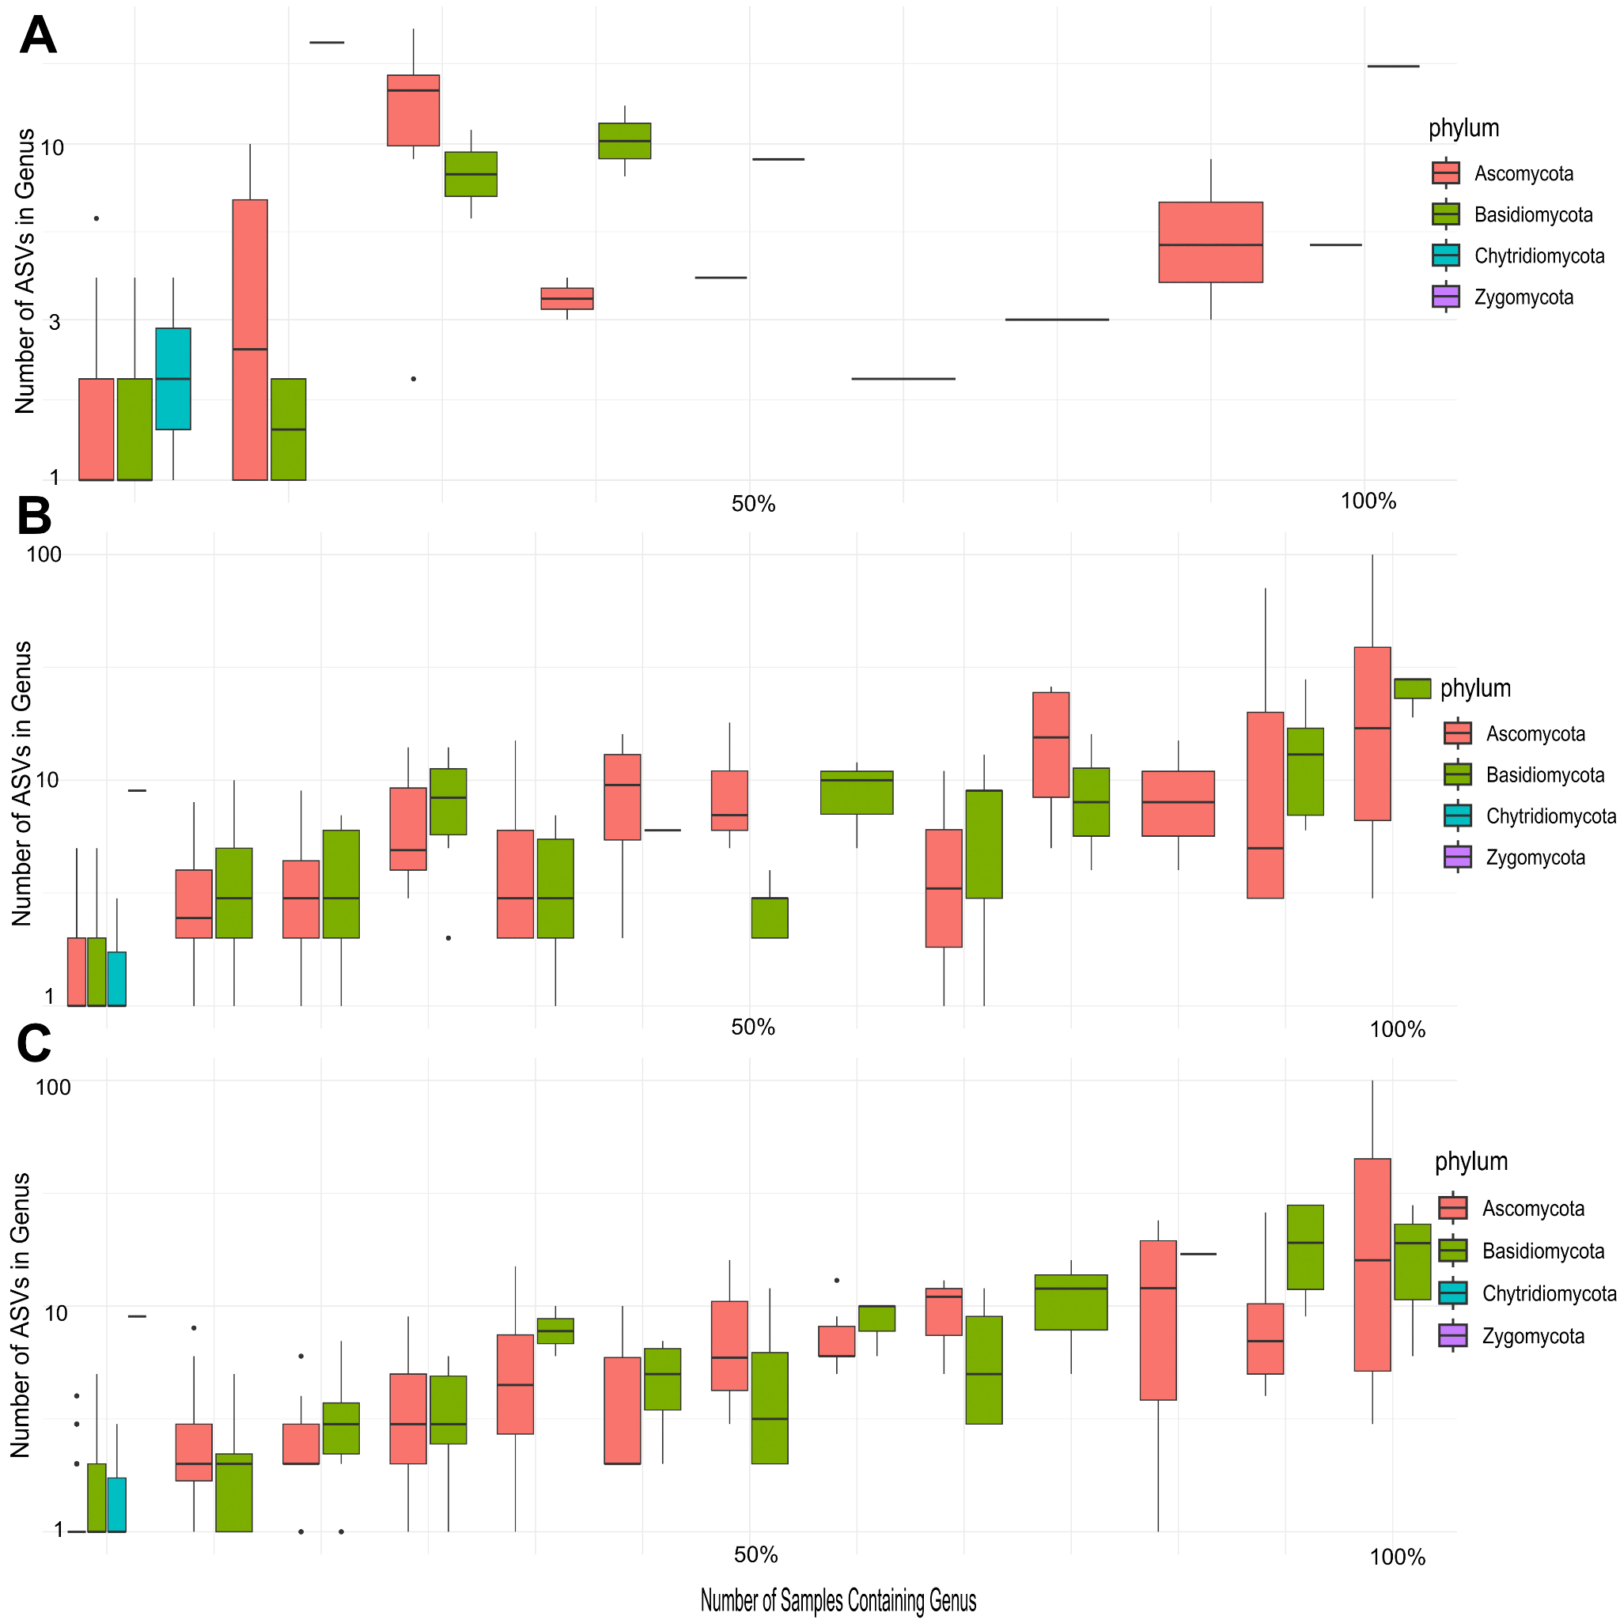

Supp_fig_8: Genus diversity (number of different ASVs belonging to a genus) against genus prevalence (number of samples in which the genus appears) of the fungal kingdom: A) Fruit endophytes; B) Fruit epiphytes; C) Leaf epiphytes.

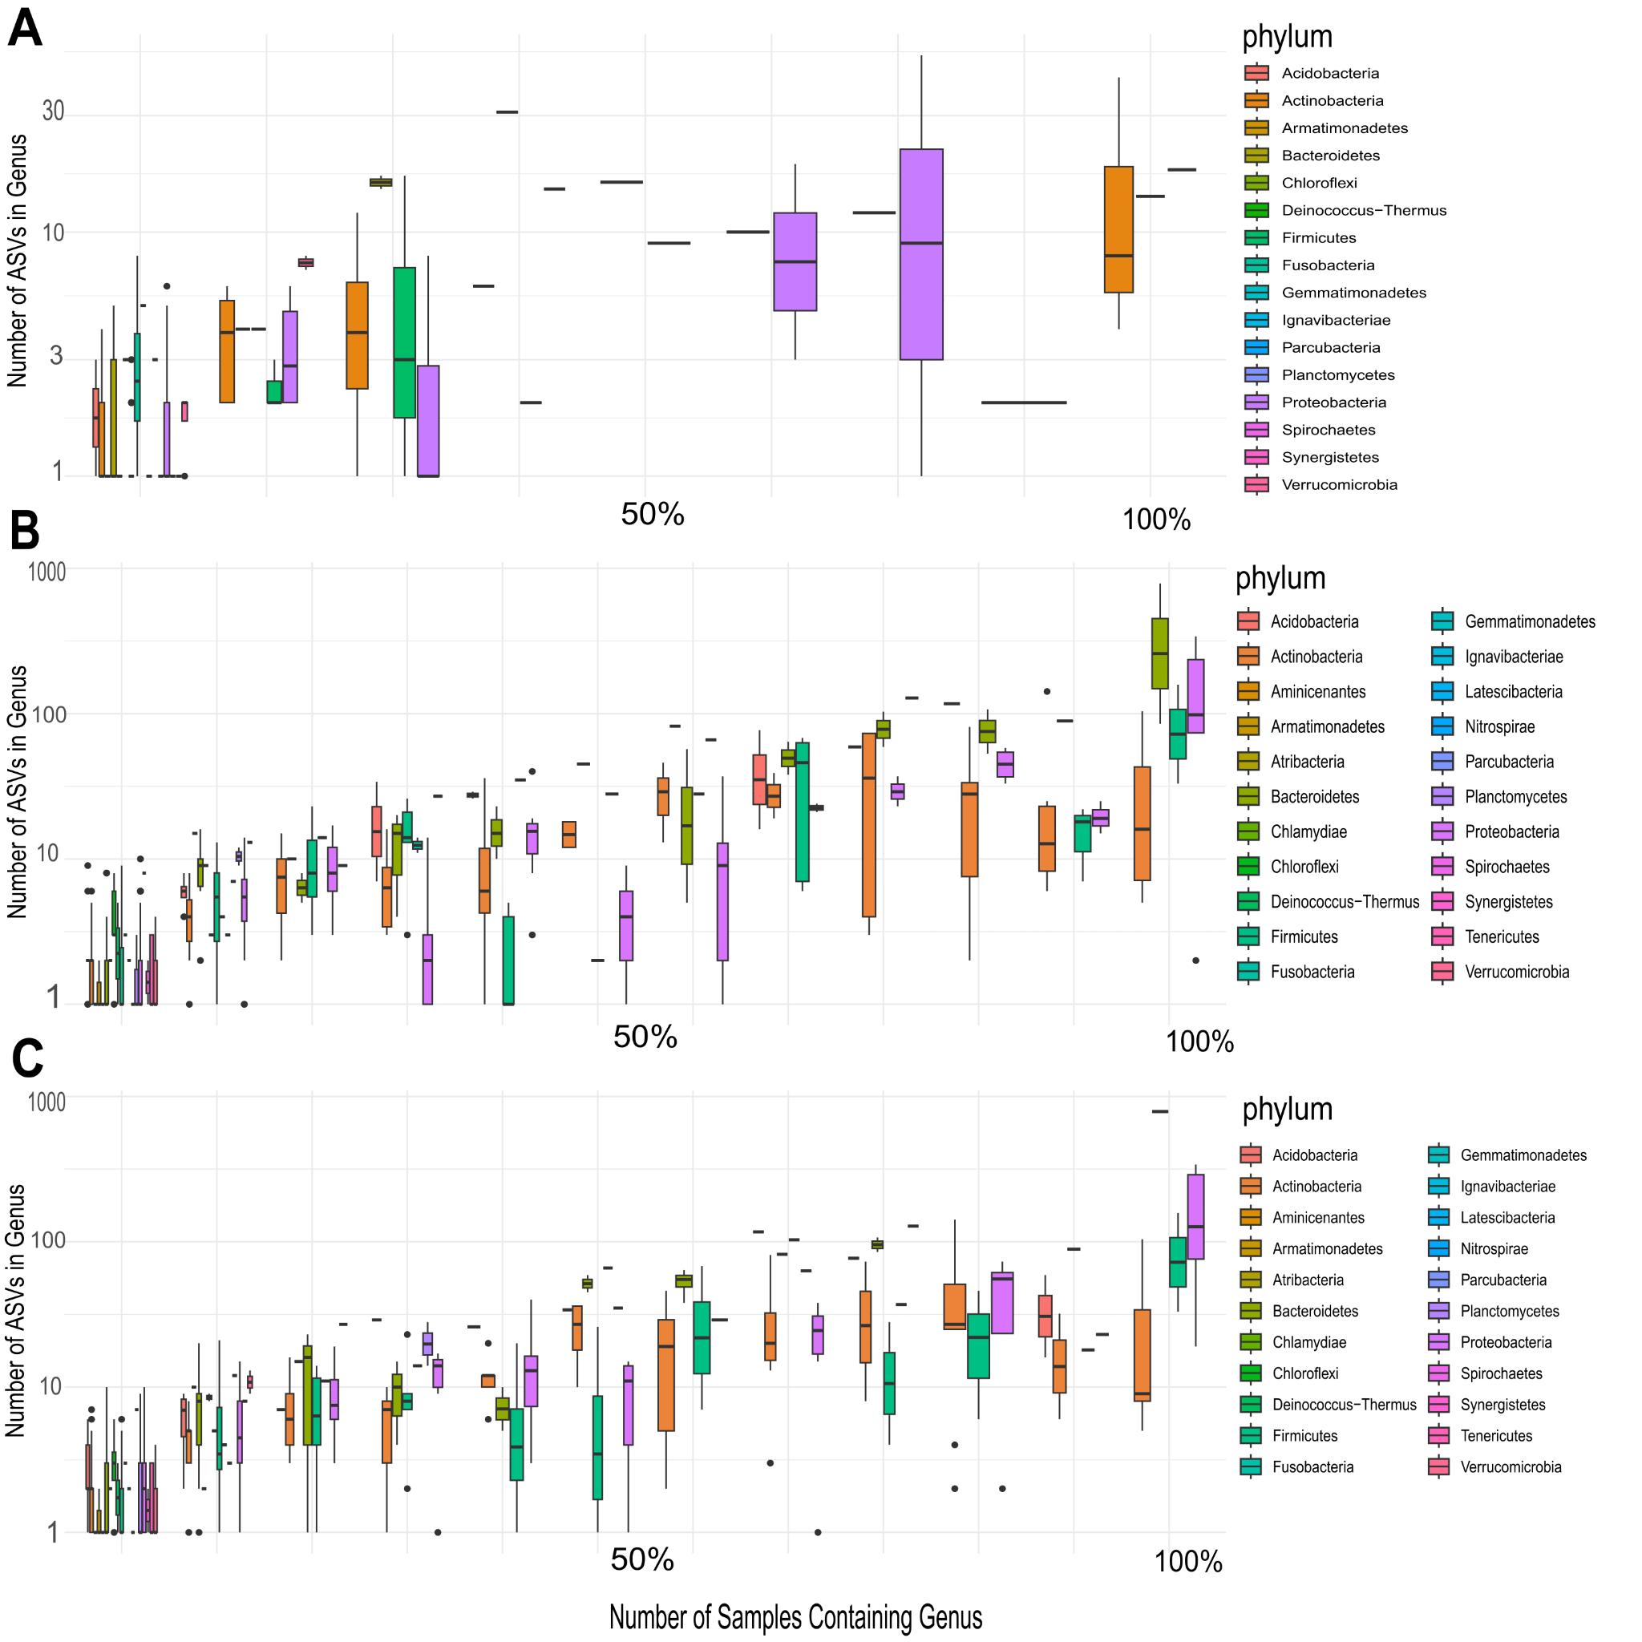
Supp_fig_9: Genus diversity (number of different ASVs belonging to a genus) against genus prevalence (number of samples in which the genus appears) of the bacterial kingdom: A) Fruit endophytes; B) Fruit epiphytes; C) Leaf epiphytes.

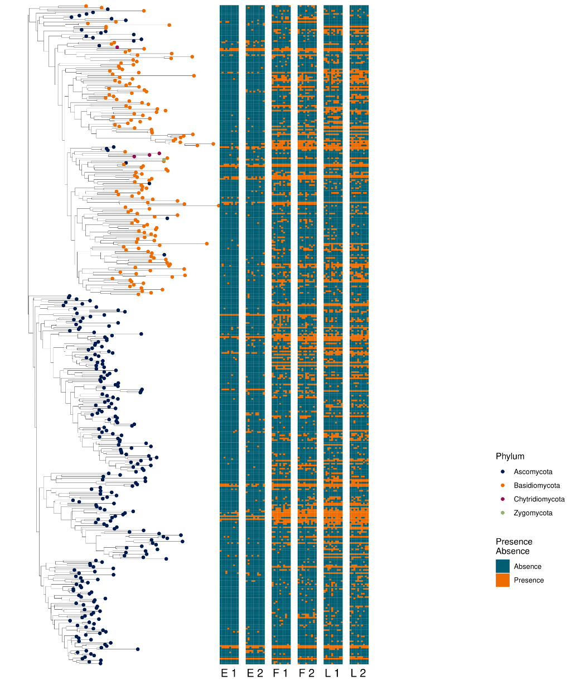
Supp_fig_10: Tree of fungal microbial core at the genus level, the labels are at the Phylum level, surrounded by six matrices: E1 first year fruit endophytes, E2 second year fruit endophytes, F1 first year fruit epiphytes, F2 second year fruit epiphytes, L1 first year leaf epiphytes, L2 second year leaf epiphytes that indicate the presence/absence of the genus in cultivars analyzed.

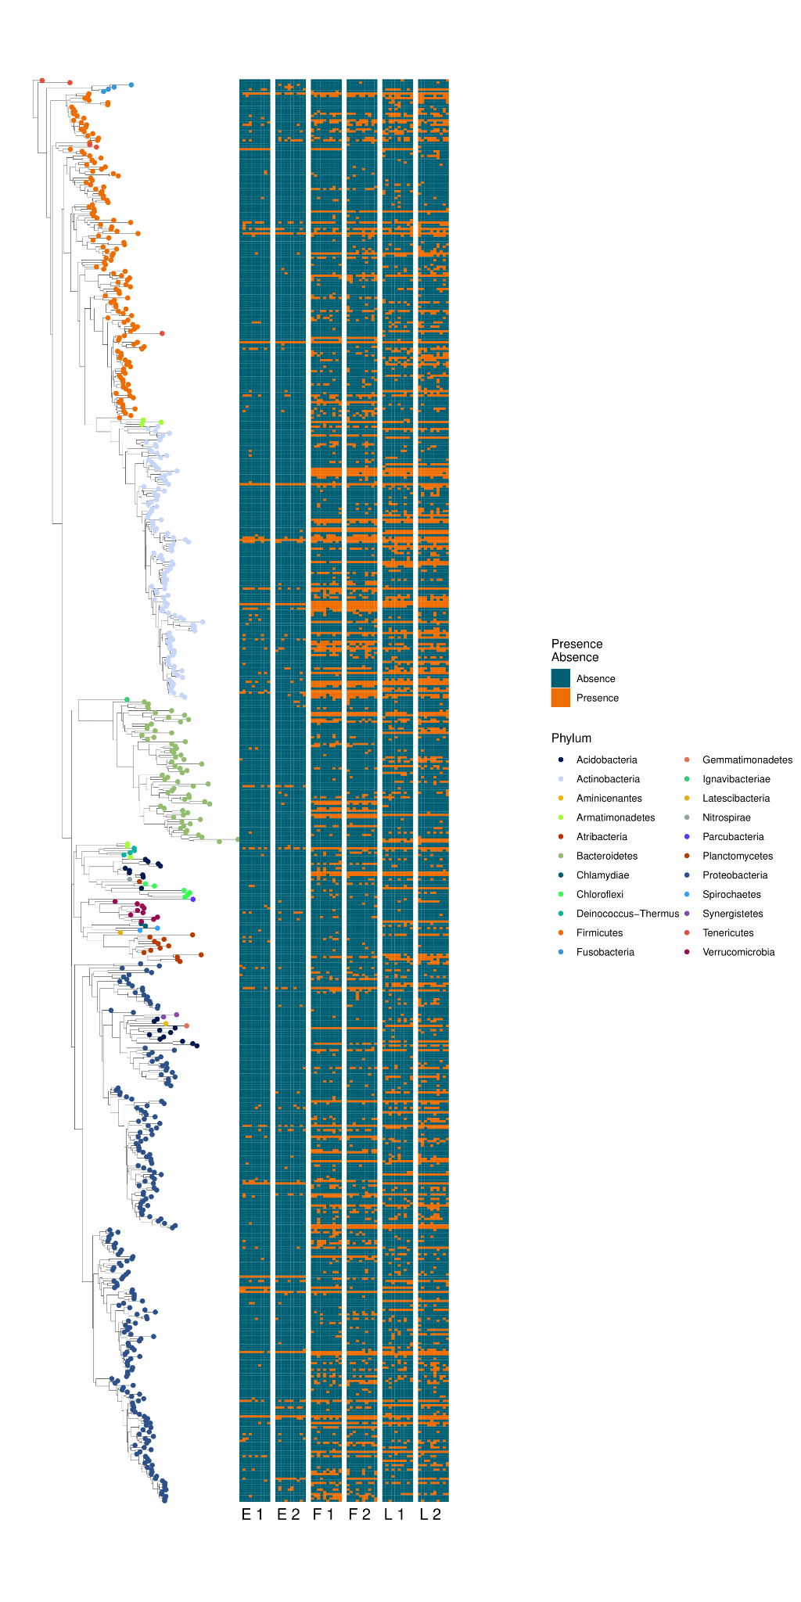
Supp_fig_11: Tree of bacteria microbial core at the genus level, the labels are at the Phylum level, surrounded by six three matrices: E1 first year fruit endophytes, E2 second year fruit endophytes, F1 first year fruit epiphytes, F2 second year fruit epiphytes, L1 first year leaf epiphytes, L2 second year leaf epiphytes, that indicate the presence/absence of the genus in each one plant in cultivars variety analyzed

