Supplementary material

Assessing the temporal clustering of coastal storm tide hazards under natural variability in a near 500-year model run

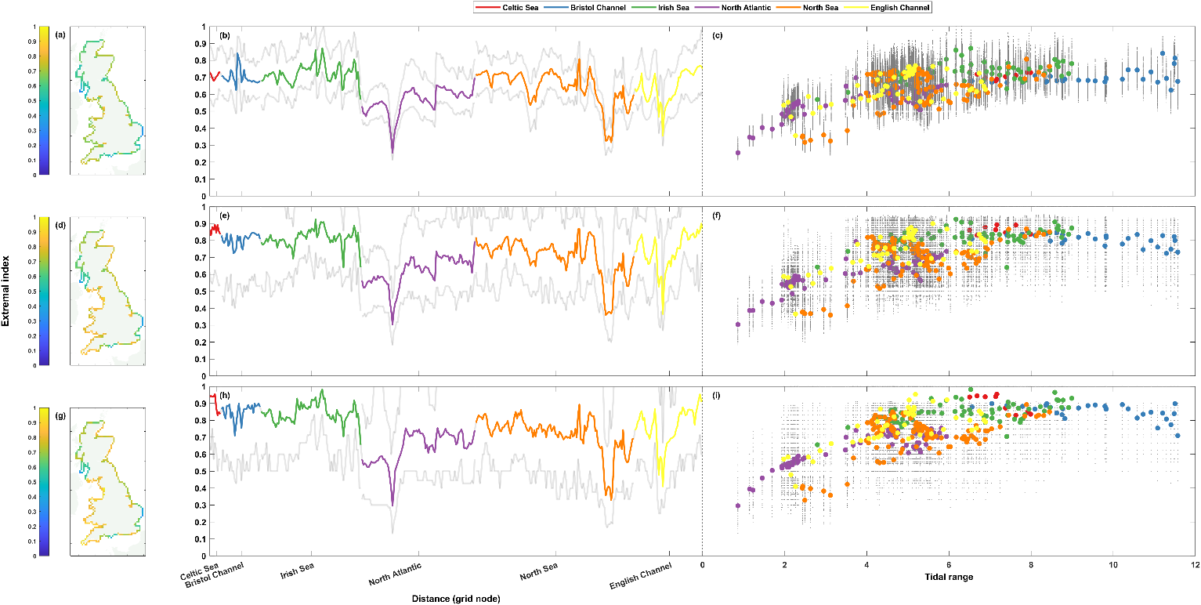
Fig. S1: Extremal index (K-gaps) for non-tidal residual timeseries. The top row (a-c) shows results at the 1 in 1-year return level, the middle row (d-f) the 1 in 5-year return level, and the bottom row (g-i) the 1 in 10-year return level. Percentages are shown spatially in panels a, d, and g (left column), clockwise around the coast from the Southwest tip of England ending back at Newlyn in panels b, e, and h (middle column), and finally shown as a scatter plot against maximum non-tidal residual at that grid node in panels c, f, and i (right column). The grey lines (dots) in panels b, e, and h (c, f, and i) show the range of (all) results from the 50-year rolling window analysis.

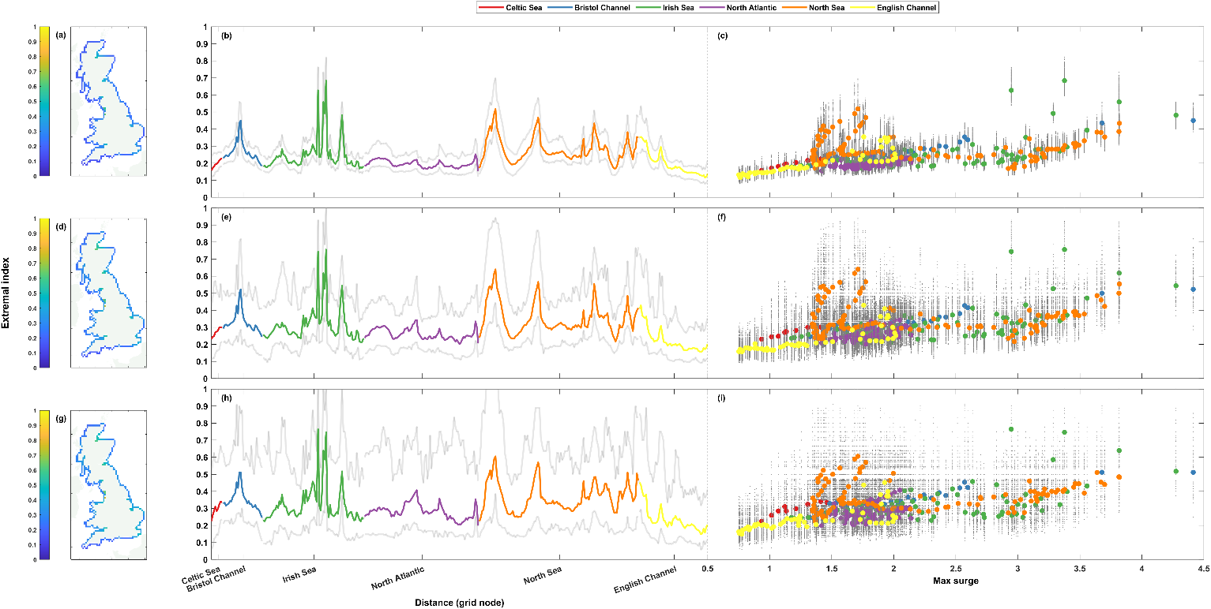
Fig. S2: Extremal index (K-gaps) for sea level timeseries. The top row (a-c) shows results at the 1 in 1-year return level, the middle row (d-f) the 1 in 5-year return level, and the bottom row (g-i) the 1 in 10-year return level. Percentages are shown spatially in panels a, d, and g (left column), clockwise around the coast from the Southwest tip of England ending back at Newlyn in panels b, e, and h (middle column), and finally shown as a scatter plot against tidal range at that grid node in panels c, f, and i (right column). The grey lines (dots) in panels b, e, and h (c, f, and i) show the range of (all) results from the 50-year rolling window analysis.

