Exploration of Refined Humane Endpoints for Melioidosis in BALB/c Mice

Supplementary Material

Table A1. Treatment group comparisons for each of the four studies. In each case, a comparison is made between the mice receiving the named treatment listed in group A versus the mice receiving the named treatment listed in group B.
Study | Treatment Group A | Treatment Group B
Study 1 | Finafloxacin | Diluent Control
Study 1 | Co-trimoxazole | Diluent Control
Study 1 | Co-trimoxazole | Finafloxacin
Study 2 | Finafloxacin | Diluent Control
Study 3 | Finafloxacin | Diluent Control
Study 3 | Doxycycline | Diluent Control
Study 3 | Doxycycline | Finafloxacin
Study 3 | Finafloxacin & doxycycline | Diluent Control
Study 3 | Finafloxacin & doxycycline | Finafloxacin
Study 3 | Finafloxacin & doxycycline | Doxycycline
Study 4 | Finafloxacin (36h) | Finafloxacin (48h)
Study 4 | Finafloxacin (36h) | Diluent Control
Study 4 | Finafloxacin (48h) | Diluent Control

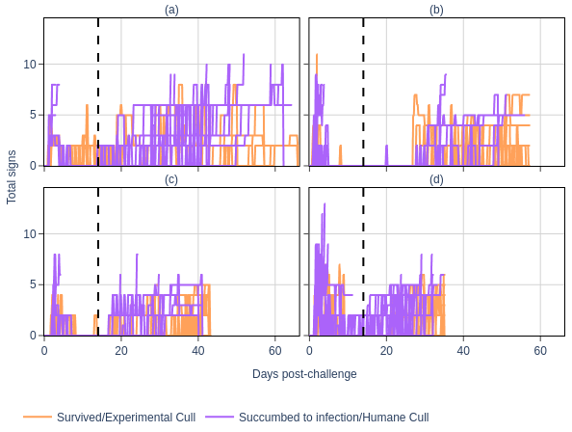
Figure A1. Total clinical signs scores over time per mouse, by survival outcome for (a) Study 1, (b) Study 2, (c) Study 3, and (d) Study 4. The vertical dashed lines are drawn at 14 days post-challenge to indicate when the analyses was initiated.

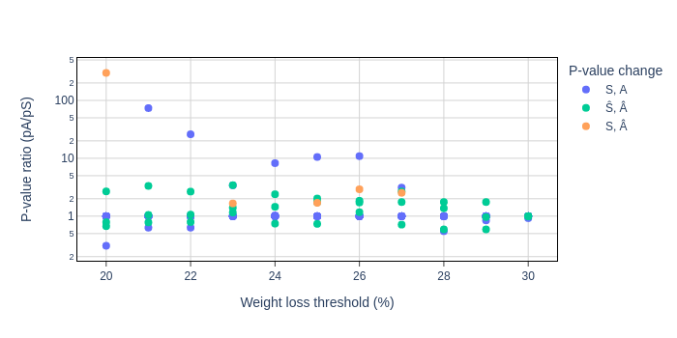
Figure A2. P-value ratios of treatment group comparisons for different weight loss thresholds (without signs-based thresholds applied). The blue points show instances where both the original study comparison (S) and the alternative comparison (A) were significant (S, A). The green points show instances where both the original study comparison and the alternative comparison were not significant (Ŝ, Â).The orange points show instances where the original study comparison was significant but the alternative comparison was not significant (S, Â).
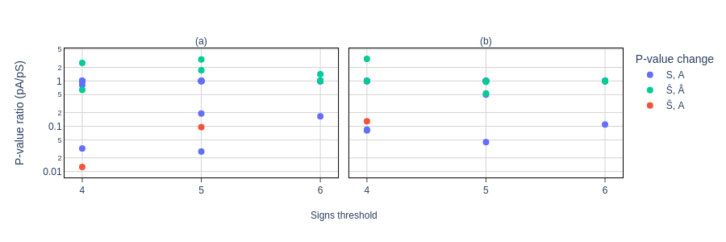
Figure A3. P-value ratios of treatment group comparisons for different sign-based thresholds (without weight loss thresholds applied), for (a) ‘total signs’ and (b) ‘average total signs’ (the mean of ‘total signs’ over the preceding 48h period). The blue points show instances where both the original study comparison (S) and the alternative comparison (A) were significant (S, A). The green points show instances where both the original study comparison and the alternative comparison were not significant (Ŝ, Â).The red points show instances where the original study comparison was not significant but the alternative comparison was significant (Ŝ, A).
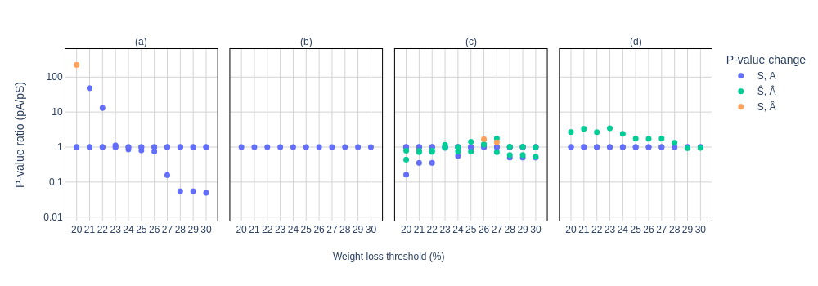
Figure A4. P-value ratios of treatment group comparisons for (a) Study 1, (b) Study 2, (c) Study 3, and (d) Study 4. An average total clinical signs threshold of ≥5 is combined with different weight thresholds. The blue points show instances where both the original study comparison (S) and the alternative comparison (A) were significant (S, A). The green points show instances where both the original study comparison and the alternative comparison were not significant (Ŝ, Â). The orange points show instances where the original study comparison was significant but the alternative comparison was not significant (S, Â).
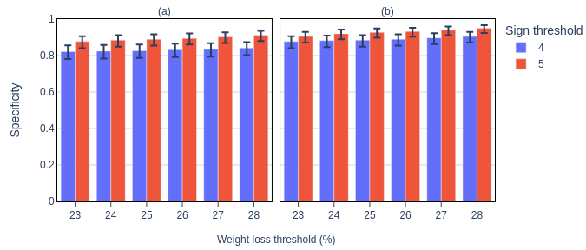
Figure A5. Specificity across refined humane endpoints derived according to weight loss threshold (x-axes), sign threshold (color), and (a) ‘total signs’ metric, and (b) ‘average total signs’ metric. The error bars represent the 95% confidence interval for the specificity.
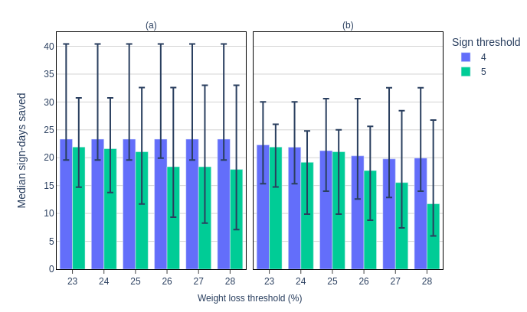
Figure A6. ‘Median sign-days saved’ per mouse across refined humane endpoints derived according to weight loss threshold (x-axes), sign threshold (color), and (a) ‘total signs’ metric, and (b) ‘average total signs’ metric. The error bars represent the 95% confidence interval for the ‘median sign-days saved’.

Copyright: © Crown copyright (2024), Dstl. This material is licensed under the terms of the Open Government Licence except where otherwise stated. To view this licence, visit http://www.nationalarchives.gov.uk/doc/open-government-licence/version/3 or write to the Information Policy Team, The National Archives, Kew, London TW9 4DU, or email: psi@nationalarchives.gov.uk.

