Supporting Information

Stabilizing Excited-State of Organic Phosphorescent Photosensitizers via Self-Assembly for Boosting Photoreduction of CO₂-to-CO

Chenchen Xiong^{a,+}, Ping Wang^{b,+}, Yao Ma^{c}, Yongfeng Zhangª, Xin Chengª, Cong Chao^{e}, Lingling Kangª, Gengchen Liª, Peng Sun^{d}, Jianbing Shiª, Bin Tongª, Xiangfeng Shao^{c,}*, Zhi-Ming Zhang^{b,}*, Zhengxu Cai^{a,}*, and Yuping Dongª

Synthesis and characterization of guest compounds
Polycyclic aromatic hydrocarbons (PAHs) 2,3,5,6,8,9-hexabutoxytriphenyleno-trithiophene-hexaoxide (TP), 2,3,5,6,9,10-hexabutoxy-8-phenyldithieno-triphenyleno-pyridine (TPy), 1,2,4,5-tetrabutoxy-8-phenyltrithieno-triphenyleno[2,3-d]oxazole-hexaoxide (TH), and 1,2,4,5-tetrabutoxy-9,10-dimethyltrithieno-triphenyleno[2,3-b]quinoxaline (TQ) were synthesized according to our previous work¹⁻⁴.

Table S1. UV-vis absorption wavelength (at room temperature) of PAHs in THF (1 × 10⁻⁵ M).
PAHs | UV-vis absorption
TP | sharp absorption band (λ= 311 nm) and weak broad band (370-450 nm)
TPy | sharp absorption band (λ= 296, 325, 340 nm) and weak broad band (360-470 nm)
TH | sharp absorption band (λ= 262, 318 nm) and weak broad band (340-387 nm, 387-475 nm)
TQ | sharp absorption band (λ= 262, 318 nm), absorption band extends to 580 nm

Table S2. Emission properties (at room temperature) of PAHs. ^{[a]}
PAHs | Fluorescence emission | Fluorescence quantum yield (%) | τ (ns)
TP | 463 nm | 5.8 | 2.0
TPy | 493 nm | 3.5 | 4.2
TH | 531 nm | 3.2 | 6.5
TQ | 702 nm | 1.6 | 2.6
^{[a]} Measurement conditions: solvent, CH₂Cl₂; concentration, 10^{–5} M; temperature, 293 K.

Measurements of materials
UV-vis absorption spectra were performed with a UV-2600 Shimadzu spectrophotometer. Prompt and delayed spectra were measured by using Edinburgh FLS 1000 fluorescence spectrophotometer equipped with a Xenon lamp (450 W), or a microsecond flash-lamp (100 W). The photoluminescence quantum efficiency was determined on Edinburgh FLS 1000 fluorescence spectrophotometer equipped with an integrating sphere. Transient absorption spectra were measured on the LP980 laser flash photolysis instrument (Edinburgh, UK). Cyclic voltammetry (CV) measurements were carried out on a CHI 760E electrochemical workstation at room temperature. 300 W Xenon lamp (CEL-HXF300, CEAULICHT) with 400 nm ﬁlter was used as a visible light source. The amount of CO product was analyzed by gas chromatography (Shimadzu GC-2014 ATF, MolSieve 5A column, FID, argon carrier). Isotope labeling experiments with ¹³CO₂ as the carbon source were performed by gas chromatography-mass spectrometry (GC-MS, agilent 7890B/5977B, 30 m×0.25 mm×0.25 μm capillary column). The particle size and size distribution of nanoparticles suspension in deionized (DI) water were measured by using dynamic light scattering (DLS) (Nicomp 380 Z3000, USA), and three measurements for every nanoparticle sample were conducted. Nanoparticles placed in an Amicon ® ultra-4 centrifugal filters (30 kDa) were centrifuged at 3000 rpm for 20 min in a HC-3016R high speed refrigerated centrifuge. Subsequently, the concentration of nanoparticles was calibrated by UV-vis absorption. The morphology and size of nanoparticles were characterized by the transmission electron microscope (TEM) (Tecnai Spirit, USA) with an acceleration voltage of 120 kV.

Regents and solvents
Polystyrene (PS, average M_{w} 35000), tetrabutylammonium hexafluorophosphate (Bu₄NPF₆), and ferrocene (Fc) were purchased from Adamas-beta®. Tetrahydrofuran (THF) was purchased from Jingdongtianzheng (Tianjin) chemical reagent factory. Acetonitrile (CH₃CN) and triethylamine (TEA) were purchased from Adamas-beta®. Catalyst (CAT) and BIH were easily synthesized according to literature methods.^{5,6}

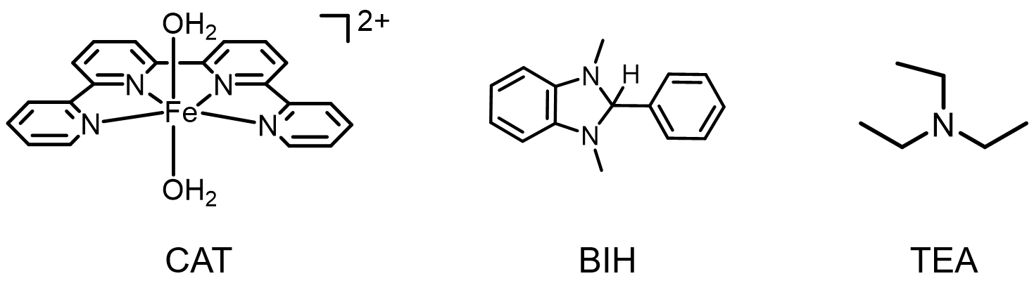

Theoretical calculations.
The density functional theory (DFT) and the time-dependent density functional theory (TD-DFT) calculations were performed using the Gaussian 09 program (Revision D. 01).⁷ The ground-state (S₀) geometries were optimized with PBE0 by using def2-TZVP basis sets for frontier orbital energy analysis. Further, based on the optimized S₀ molecular structure, the first singlet excited state (S₁) was optimized to obtain the lowest excited singlet state (S₁, the exciton decays from the Frank-Condon point to the lowest excited singlet state). Finally, the excitation energies in singlet states (S_{n}) and triplet states (T_{n}) were obtained by the TD-DFT method based on the optimized S₁ molecular structure. The transition orbital compositions analysis can evaluate the possible singlet-triplet intersystem crossings (ISC) channels from S₁ to T_{n}. The transition from S₁ to T_{n} is considered as ISC channel when T_{n} and S₁ have the same transition component, and the energy difference between S₁ and T_{n} (ΔE_{ST}) is defined by the equation: ΔE_{ST}=E(S₁)-E(T_{n}). The spin-orbit coupling (SOC) matrix elements of TP, TPy, TH, and TQ monomer were calculated by ORCA 4.2.1 program ⁸ using the SOMF method based on the excited-state wave functions obtained from TD-DFT calculations. Wave function analysis was conducted using Multiwfn 3.8 package.⁹

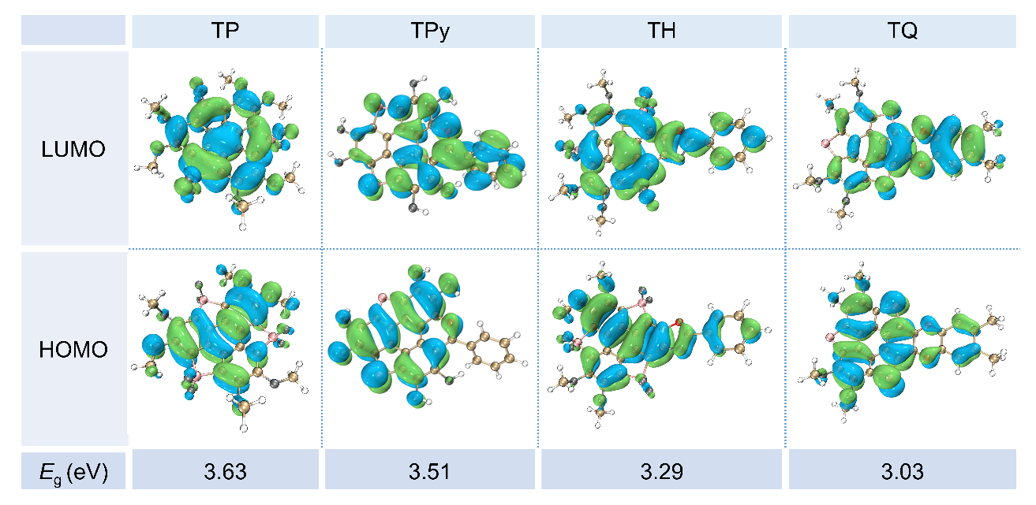
Figure S1. HOMO and LUMO electron cloud distribution of PAHs and corresponding energy gap (E_{g}).
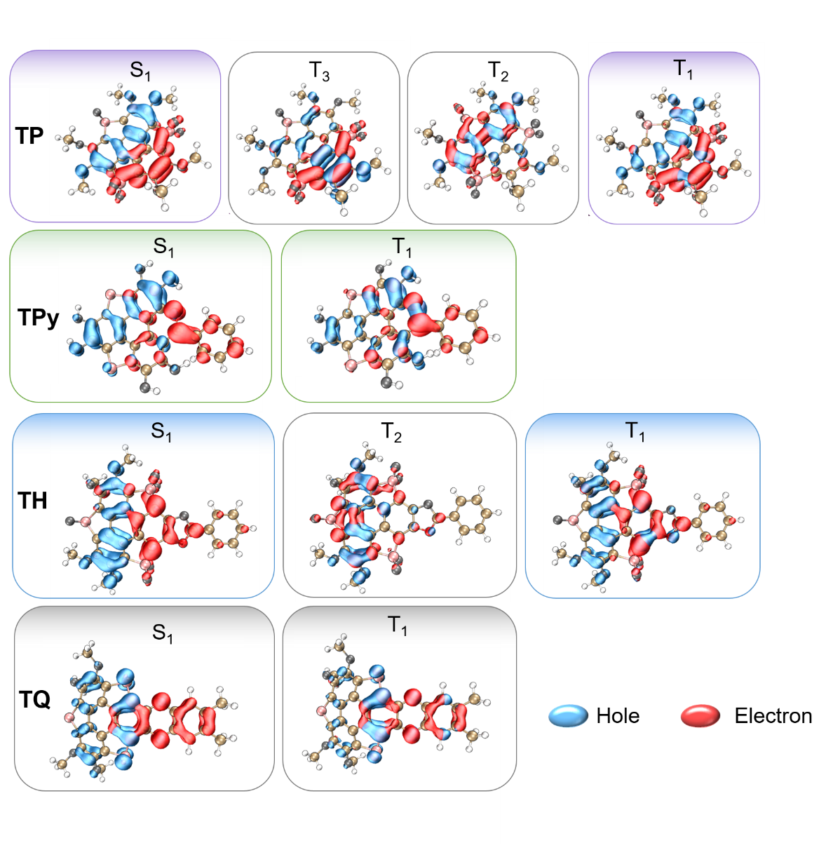
Figure S2. Electronic configuration calculated through electron-hole population of PAHs at the lowest excited singlet state (S₁).

Table S3. The singlet and triplet excited state transition configurations of TP monomer based on PBE0/def2-TZVP.
States | Energy (eV) | Oscillator Strength | Transition configuration (%)
S₁ | 2.5846 | 0.00370 | H→L (99.0)
S₂ | 3.0897 | 0.07300 | H-1→L (96.1)
S₃ | 3.4208 | 0.13950 | H→L+1 (91.1)
T₁ | 2.0898 | 0.00000 | H→L (84.7)
T₂ | 2.3066 | 0.00000 | H→L+1 (57.7), H-2→L (10.6), H-1→L+2 (6.9)
T₃ | 2.4305 | 0.00000 | H-1→L (83.7), H→L+1 (6.8)
T₄ | 2.7925 | 0.00000 | H→L+2 (68.4), H-2→L (8.5), H-3→L (7.2),  H-1→L+1 (6.1)
T₅ | 3.0434 | 0.00000 | H→L+1 (22.4), H-1→L+2 (18.0),  H-2→L (17.6), H-3→L (15.6), H→L (7.3)
H: highest occupied molecular orbital, HOMO; L: lowest unoccupied molecular orbital, LUMO.

Table S4. The singlet and triplet excited state transition configurations of TPy monomer based on PBE0/def2-TZVP.
States | Energy (eV) | Oscillator Strength | Transition configuration (%)
S₁ | 2.1984 | 0.05160 | H→L (96.3)
S₂ | 2.4818 | 0.15860 | H-1→L (95.8)
S₃ | 3.5140 | 0.06680 | H→L+1 (54.1), H→L+3 (12.3),  H-1→L+1 (10.4), H-2 → L (7.8)
T₁ | 1.9968 | 0.00000 | H→L (77.5), H-1→L (9.4)
T₂ | 2.4291 | 0.00000 | H-1→L (83.7), H→L (11.4)
T₃ | 2.6972 | 0.00000 | H→L+1 (45.5), H-1→L+3 (13.5),  H→L+4 (12.6)
T₄ | 2.8797 | 0.00000 | H-3→L (23.2), H-4→L (15.8), H-2→L (14.6)  H-1→L+1 (12.1), H→L+3 (7.7), H→L (5.0)
T₅ | 3.1065 | 0.00000 | H→L+3 (34.1), H→L+1 (17.3), H-1→L+1 (16.1), H-1→L+3 (9.1), H-2→L (5.7)
Table S5. The singlet and triplet excited state transition configurations of TH monomer based on PBE0/def2-TZVP.
States | Energy (eV) | Oscillator Strength | Transition configuration (%)
S₁ | 2.3834 | 0.00540 | H→L (98.5)
S₂ | 3.0131 | 0.35450 | H-1→L (95.6)
S₃ | 3.2887 | 0.16470 | H→L+1 (94.1)
T₁ | 1.9052 | 0.00000 | H→L (74.3), H-1→L (7.6), H-2→L (6.7)
T₂ | 2.2168 | 0.00000 | H→L+1 (46.2), H-1→L (20.7), H→L (10.3),  H-2→L (8.3)
T₃ | 2.3954 | 0.00000 | H-1→L (56.9), H→L+1 (20.4)
T₄ | 2.7329 | 0.00000 | H→L+2 (38.7), H-2→L (26.2), H-1→L+1 (7.8)  H→L+3 (5.7), H→L+1 (5.4)

Table S6. The singlet and triplet excited state transition configurations of TQ monomer based on PBE0/def2-TZVP.
States | Energy (eV) | Oscillator Strength | Transition configuration (%)
S₁ | 2.0294 | 0.03650 | H→L (99.2)
S₂ | 2.7474 | 0.24850 | H-1→L (90.9), H→L+1 (8.0)
S₃ | 3.2021 | 0.38720 | H-6→L (65.2), H-5→L (27.9)
T₁ | 1.2433 | 0.00000 | H→L (88.0), H-2→L (9.0)
T₂ | 2.2560 | 0.00000 | H-1→L (90.6)
T₃ | 2.3071 | 0.00000 | H-2→L (62.0), H→L+2 (16.1), H-7→L (5.2)
T₄ | 2.6909 | 0.00000 | H-6→L (60.8), H-5→L (25.7)

Supplementary photophysical properties of doped films
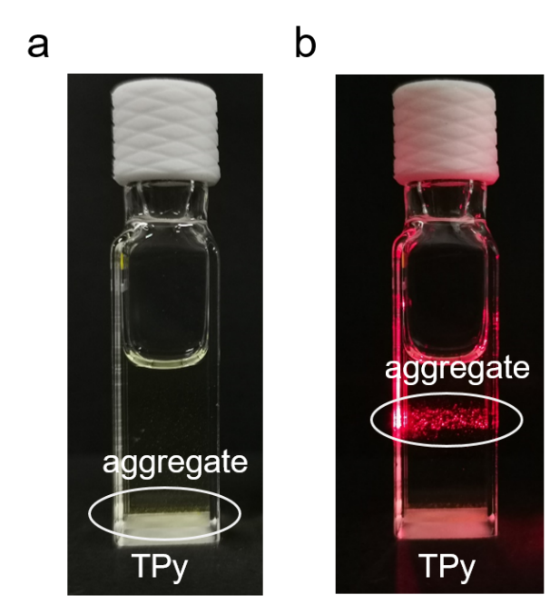
Figure S3. (a) TPy in CH₃CN / H₂O (v/v = 4/1) solution under natural light. (b) TPy in CH₃CN / H₂O (v/v = 4/1) solution irradiated by laser.

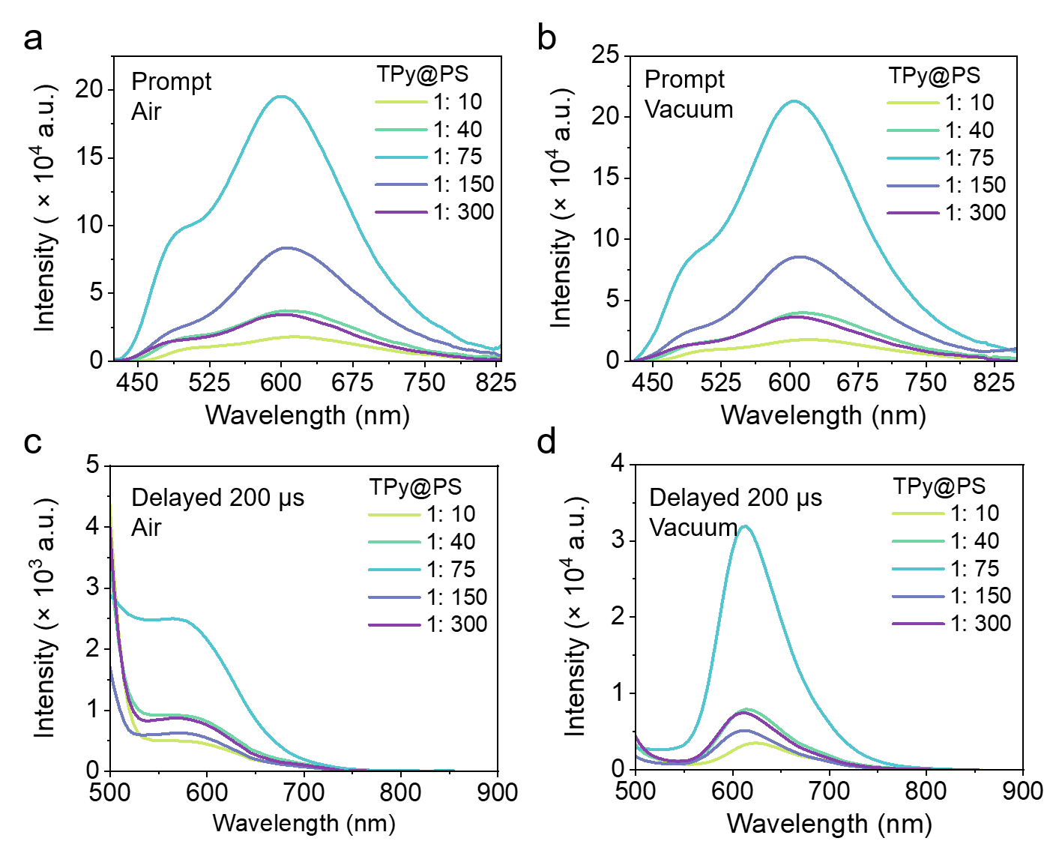
Figure S4. (a) Prompt and (c) delayed spectra of TPy@PS with different mass ratios in air. (b) Prompt and (d) delayed spectra of TPy@PS with different mass ratios in vacuum. (Delayed time: 200 μs).

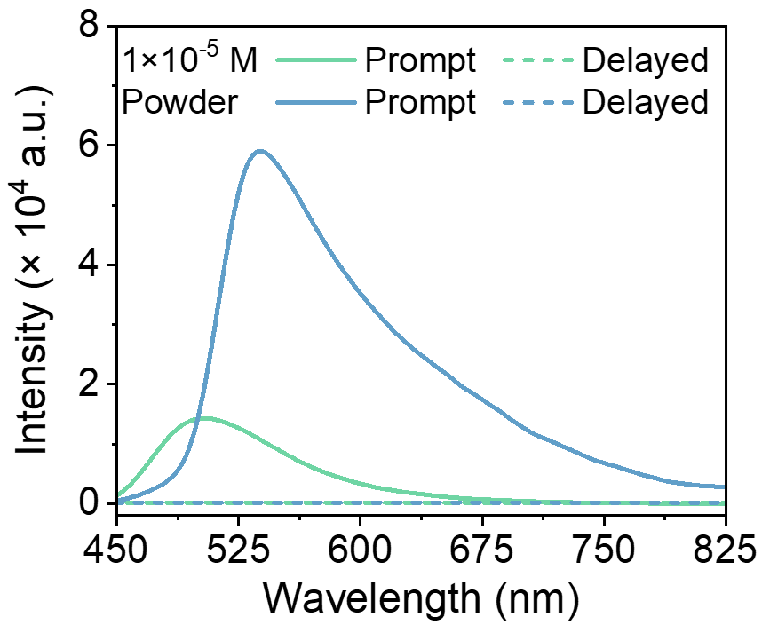
Figure S5. Prompt and delayed spectra of TPy in monomer and powder states. No phosphorescence of TPy in monomer and powder states was observed. (Delayed time: 50 μs)

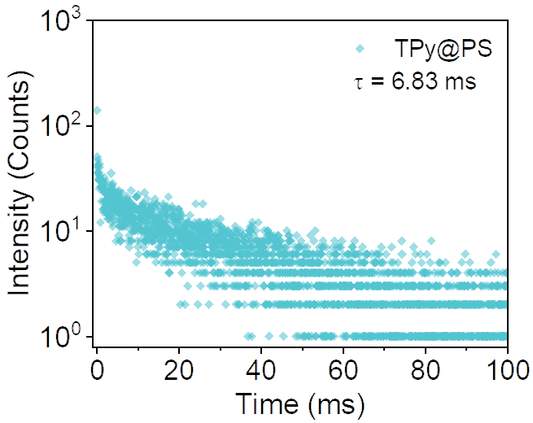
Figure S6. The decay curve of the corresponding phosphorescence of TPy@PS at 620 nm in vacuum.

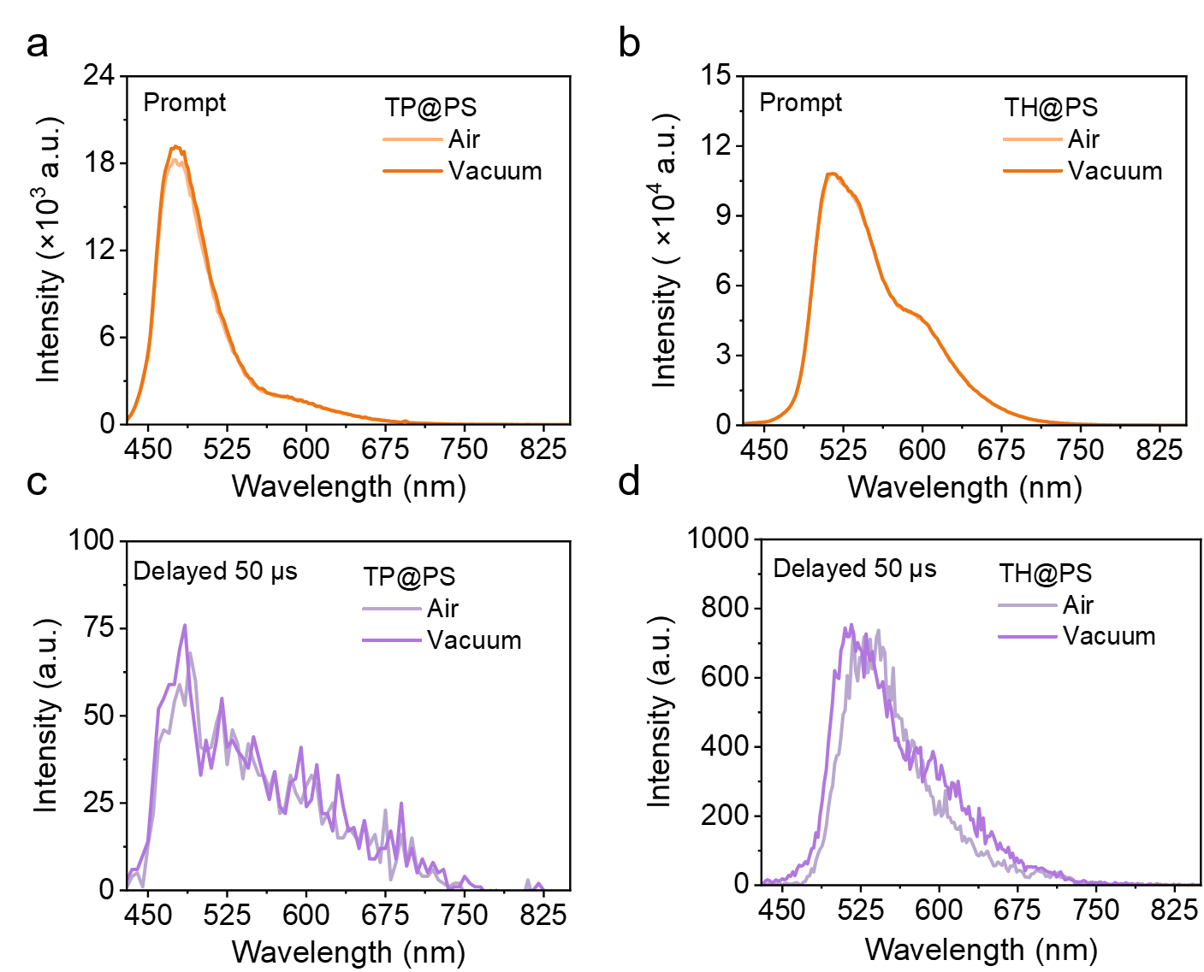
Figure S7. (a) Prompt and (c) delayed emission spectra of TP@PS in air and vacuum. (b) Prompt and (d) delayed emission spectra of TH@PS in air and vacuum. (Delayed time: 50 μs). The mass ratio of PAHs@PS is 1:75.

Supplementary properties of nanoparticles

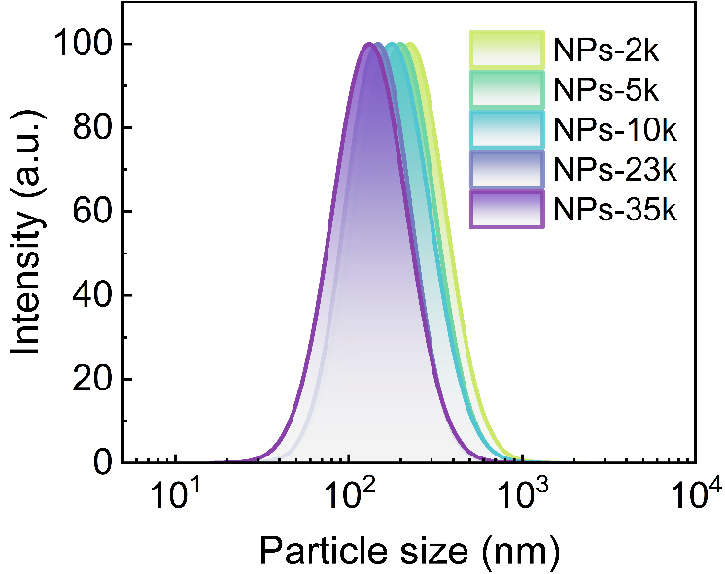
Figure S8. DLS measurement of NPs-xk (x=2, 5, 10, 23, 35) in DI water. The particle sizes are 252 nm, 221 nm, 201 nm, 162 nm, and 149 nm, respectively. The polydispersity index (PI) values are 0.22, 0.21, 0.25, 0.19, and 0.24, respectively.

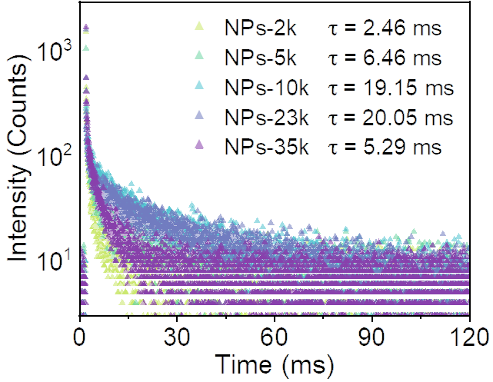
Figure S9. Lifetime decay curves for the delayed emission (recorded at 620 nm) of NPs-xk in DI water.

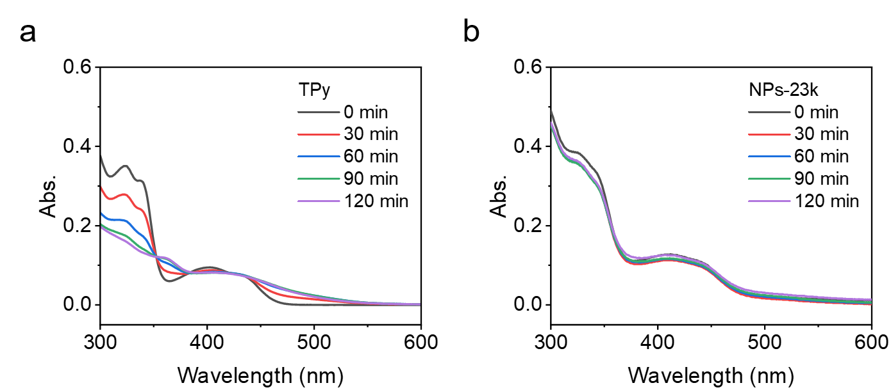
Figure S10. UV-vis absorption of (a) TPy and (b) NPs-23k in deaerated CH₃CN under the illumination of a 300 W xenon lamp (50 mw·cm⁻², λ > 400 nm, irradiation time: 2 h), c_{TPy} = c_{NPs-23k} = 1 × 10⁻⁵ M.

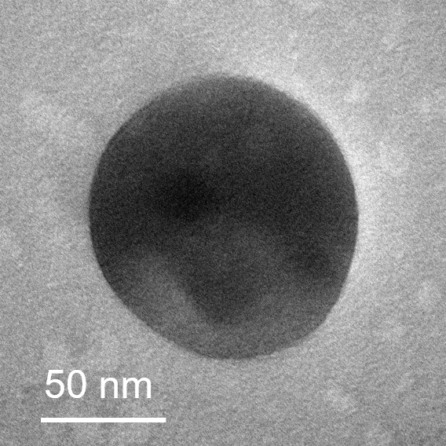
Figure S11. TEM images of NPs-23k.

Optimization of photocatalytic CO₂ reduction
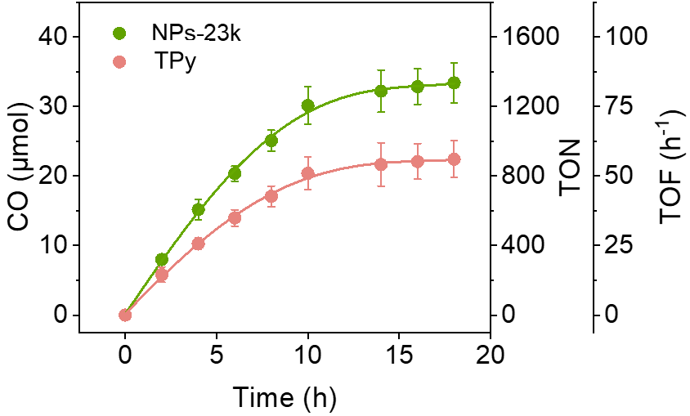
Figure S12. Photocatalytic CO₂ reduction with photosensitizers (NPs-23k and TPy) under the illumination of a 300 W xenon lamp (50 mw·cm⁻², λ > 400 nm, irradiation time: 18 h) in the presence of photosensitizers (10 μM), CAT (5 μM), BIH (18 mM), and TEA (0.3 mM) in 5 mL CO₂-saturated CH₃CN/H₂O (v/v = 4/1) solution.

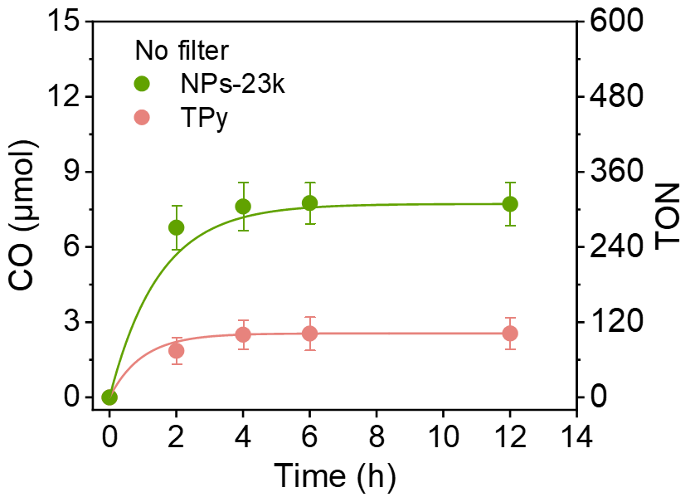
Figure S13. Photocatalytic CO₂ reduction with photosensitizers (NPs-23k and TPy) under the illumination of a 300 W xenon lamp (50 mw·cm⁻², no filter, irradiation time: 12 h) in the presence of photosensitizers (10 μM), CAT (5 μM), BIH (18 mM), and TEA (0.3 mM) in 5 mL CO₂-saturated CH₃CN/H₂O (v/v = 4/1) solution.

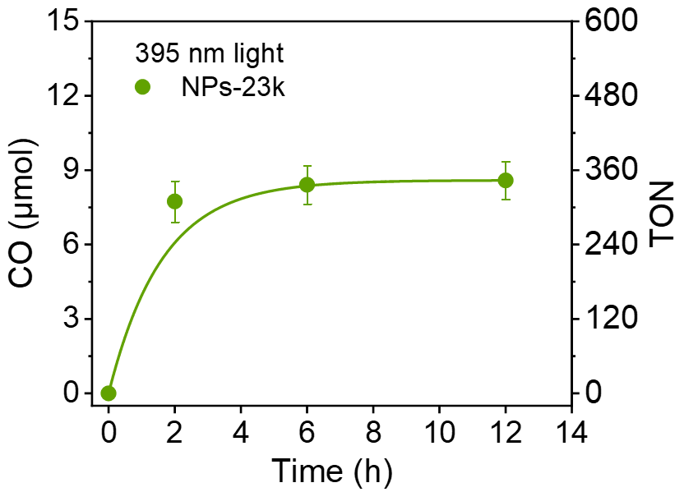
Figure S14. Photocatalytic CO₂ reduction with photosensitizers (NPs-23k) under the illumination of 395 nm light-emitting diode (50 mw·cm⁻², irradiation time: 12 h) in the presence of photosensitizers (10 μM), CAT (5 μM), BIH (18 mM), and TEA (0.3 mM) in 5 mL CO₂-saturated CH₃CN/H₂O (v/v = 4/1) solution.

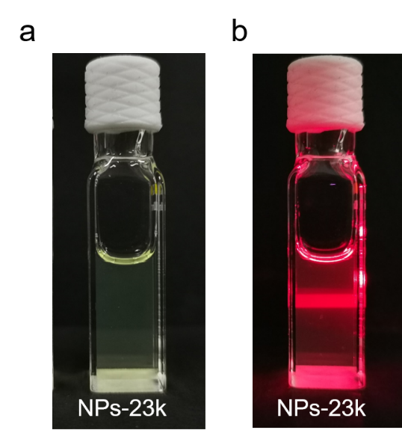
Figure S15. (a) NPs-23k in CH₃CN / H₂O (v/v = 4/1) solution under natural light. (b) NPs-23k in CH₃CN / H₂O (v/v = 4/1) solution irradiated by laser: NPs-23k are uniformly dispersed micelles.

Photocatalytic CO2 reduction mechanism analysis
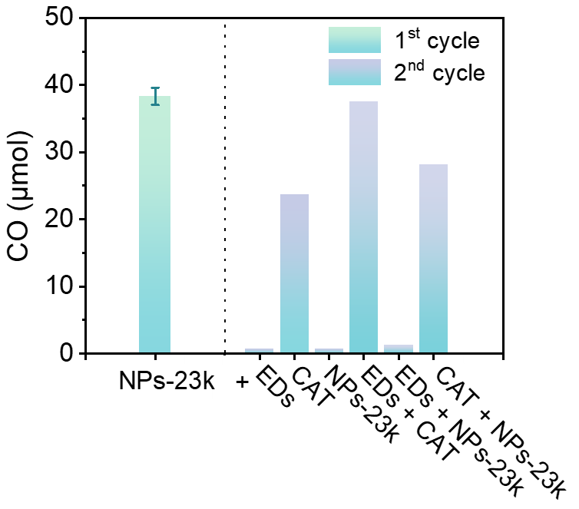
Figure S16. CO₂ photoreduction in the presence of NPs-23k. CAT, and EDs (1st cycle) under the irradiation of a 300 w Xenon lamp (100 mw·cm⁻², λ > 400 nm); then followed by the addition of EDs, NPs-23k, EDs + CAT, EDs + NPs-23k, CAT + NPs-23k (2nd cycle). The irradiation time of each cycle was 6 h. NPs-23k: 20 μM, CAT: 5 μM, EDs: 18 mM BIH + 0.3 mM TEA.

Table S7. The results of control experiments for photoreduction of CO₂ to CO.
Entryª | CO (μmol) | H₂ (μmol) | TON
1 | 0 | 0 | 0
2 | trace | 0 | trace
3 | 0 | 0 | 0
4 | 0 | 0 | 0
5 | trace | 0 | trace
6 | 0 | 0.21 | 0
ªEntry 1: without TPy/NPs-23k; Entry 2: without CAT; Entry 3: without BIH; Entry 4: without light; Entry 5: PS_{15k}-b-PEG_{23k}; Entry 6: Ar. Reaction conditions: TPy/NPs-23k (10 μM), CAT (5 μM), BIH (18 mM), in 5 mL CO₂-saturated CH₃CN/H₂O (v/v = 4/1) solution, Xenon lamp (100 mw·cm⁻², λ > 400 nm), irradiation time: 6 h.

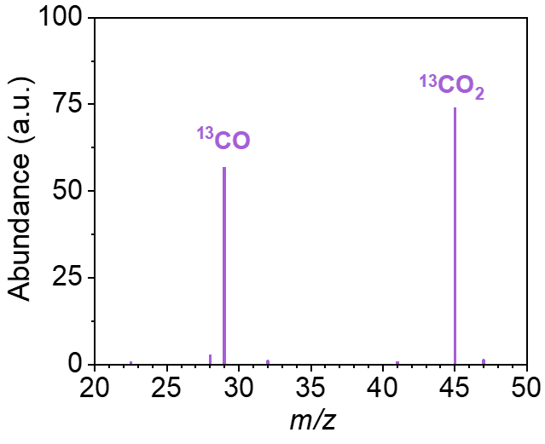
Figure S17. GC-MS analysis of ¹³CO generated under ¹³CO₂ atmosphere.

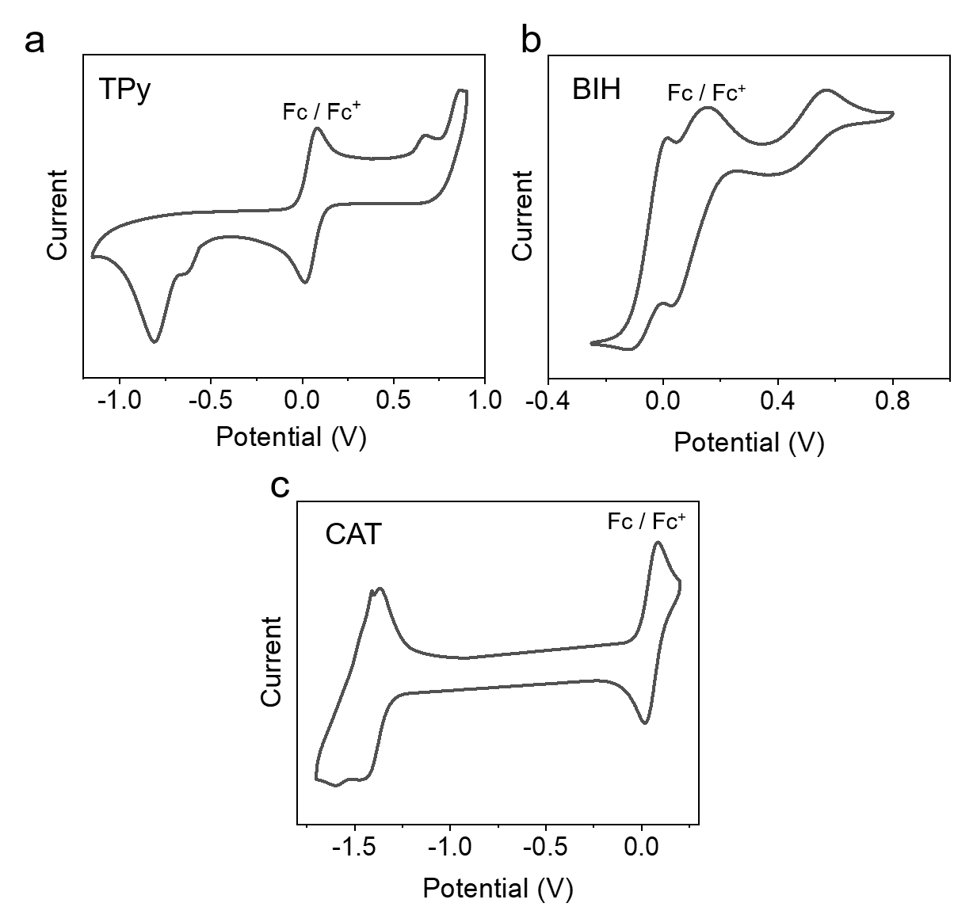
Figure S18. CV of (a) TPy, (b) BIH, (c) CAT. The CVs were determined in the deaerated CH₃CN solution, containing 0.5 mM photosensitizer, Fc, and 0.10 M Bu₄NPF₆ as the supporting electrolyte, with a scan rate of 0.05 V·s⁻¹ and a positive initial scan direction. Glassy carbon electrode, Ag/AgNO₃ and Pt silk was used as the working electrode, reference electrode and counter electrode, respectively.

Table S8. Redox potentials of TPy, BIH, and CAT. Fc was used as an internal reference (E_{1/2} = + 0.40 V (Fc⁺/Fc) vs. SCE).
 | E_{ox} | E_{red} | E_{0,0} | *Ox | *Red
TPy | 1.02 | -0.28 | 2.33 | -1.21 | 1.95
BIH | 0.52, 0.26 |  | - | - | -
CAT |  | -1.05 | - | - | -
The excited state oxidation potential *Ox = E_{ox} – E₀₀ (where E_{ox} is the ground state oxidation potential)
The excited state reduction potential *Red = E_{red} + E₀₀ (where E_{red} is the ground state reduction potential)
The value of E_{0,0} estimated from the onset (5% relative intensity) of the room-temperature emission spectrum

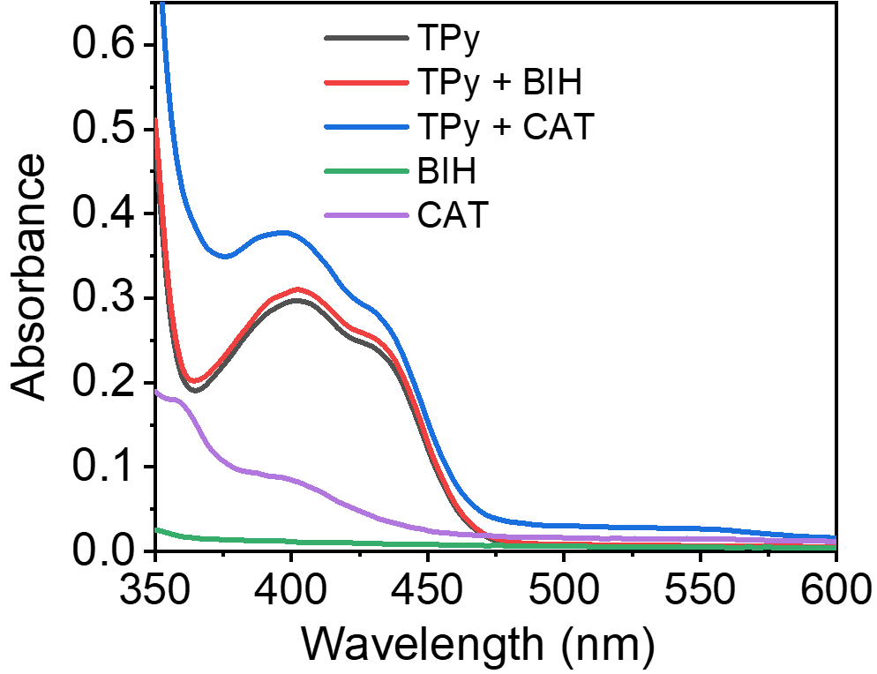
Figure S19. UV−vis absorption spectra of a 10 μM solution of TPy in the presence of CAT (10 μM), BIH (100 μM) in deaerated CH₃CN.

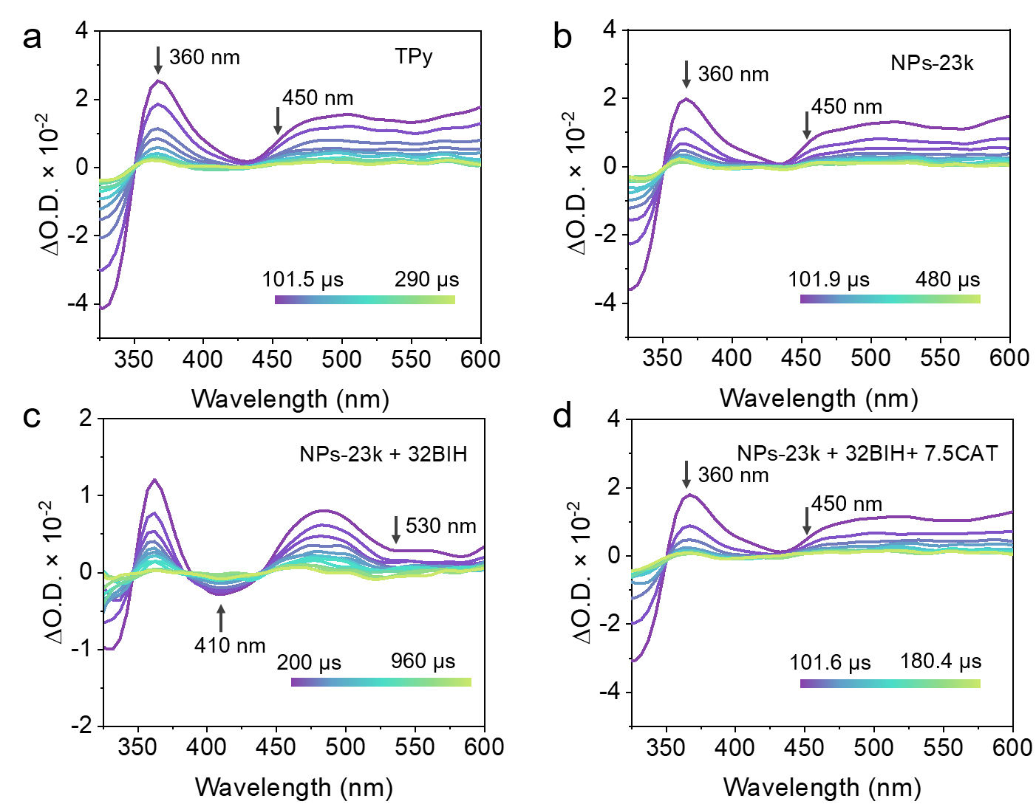
Figure S20. Transient absorption spectra of 10 μM (a) TPy, 10 μM (b) NPs-23k, (c) NPs-23k in the presence of 320 μM BIH, (d) reduced NPs-23k in the presence of 75 μM of CAT. These spectra were recorded in CH₃CN/H₂O (v/v = 4/1) solution after pulsed excitation at 430 nm under argon atmosphere at room temperature

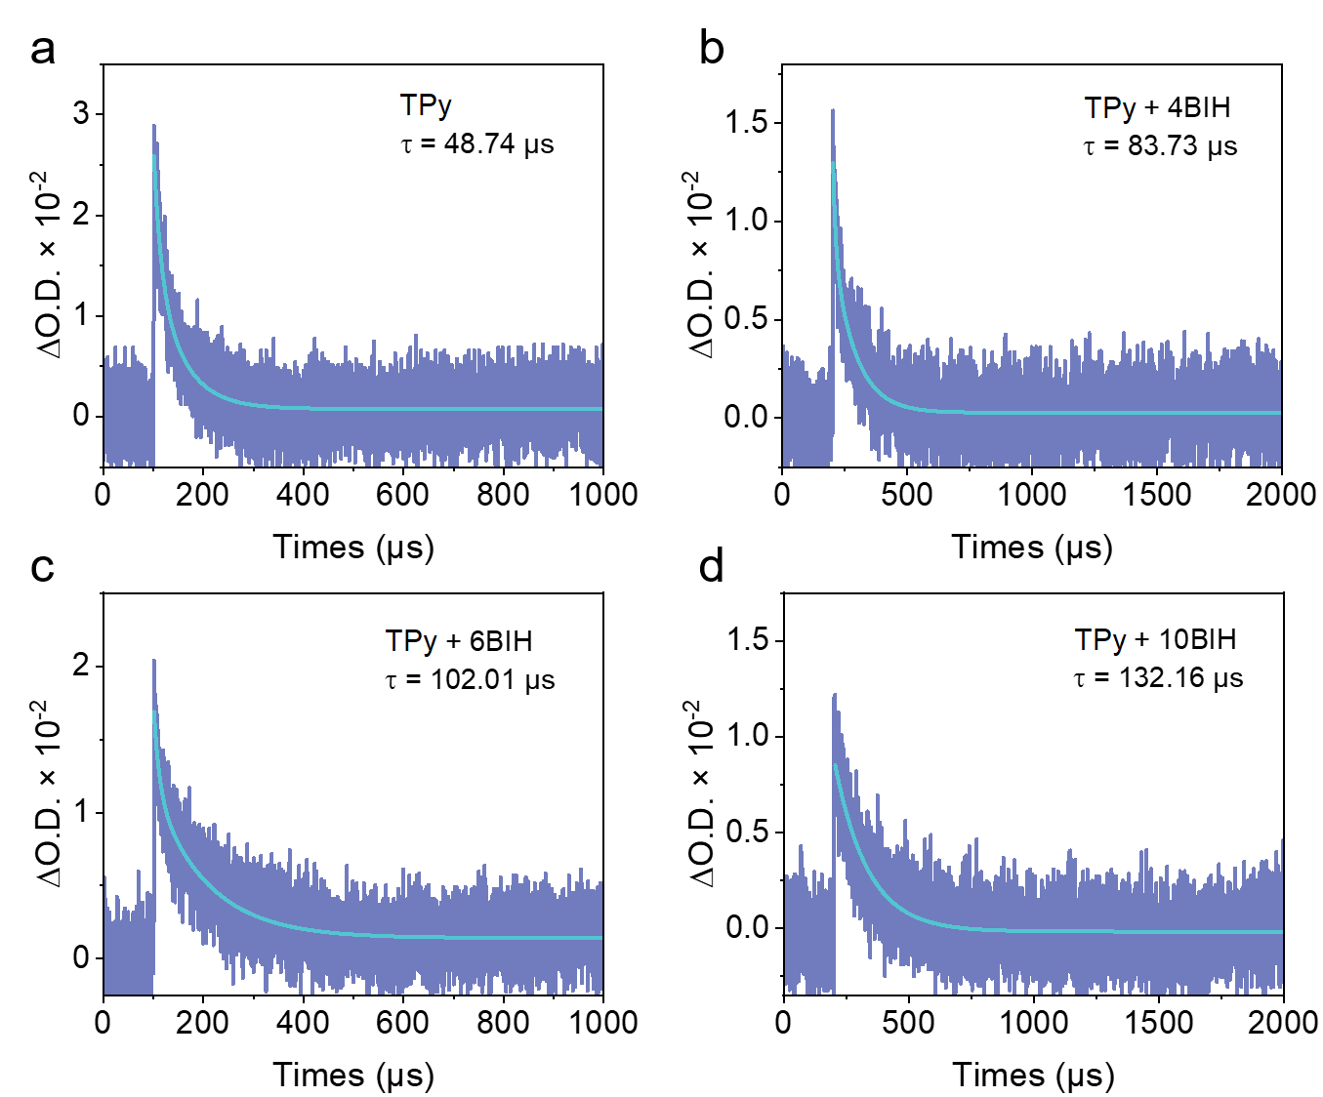
Figure S21. (a) The decay of 10 μM TPy at 500 nm. Kinetic traces of (b) TPy in the presence of 40 μM of BIH, (c) TPy in the presence of 60 μM of BIH, (d) TPy in the presence of 100 μM of BIH at 500 nm. These spectra were recorded in CH₃CN/H₂O (v/v = 4/1) solution after pulsed excitation at 430 nm under argon atmosphere at room temperature

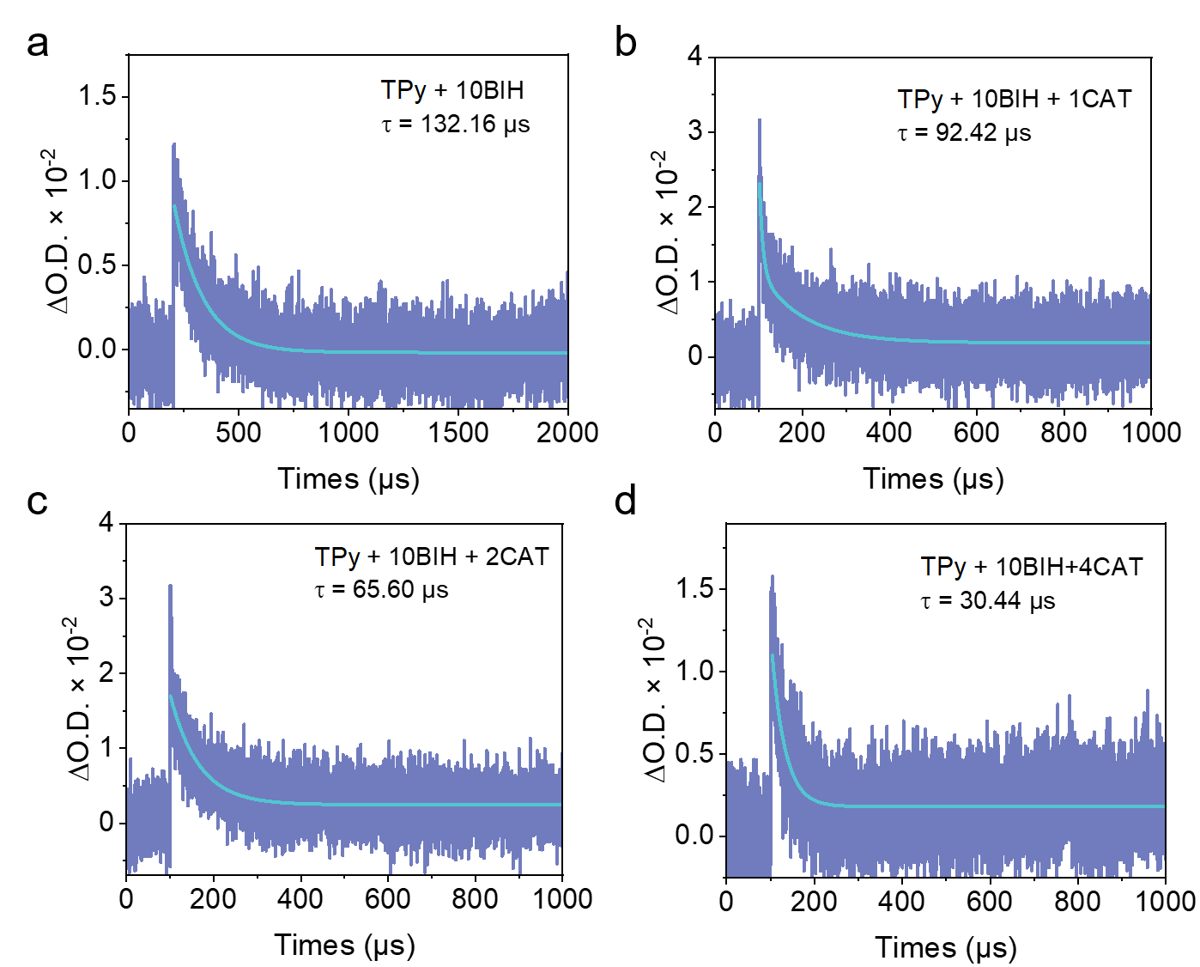
Figure S22. Kinetic decay trace of (a) reduced TPy, (b) reduced TPy in the presence of 10 μM of CAT, (c) reduced TPy in the presence of 20 μM of CAT, (d) reduced TPy in the presence of 40 μM of CAT at 500 nm. These spectra were recorded in CH₃CN/H₂O (v/v = 4/1) solution after pulsed excitation at 430 nm under argon atmosphere at room temperature

SI References

1 Hou, X. et al. Tris(S,S-dioxide)-trithiasumanene: Strong fluorescence and cocrystal with 1,2,6,7,10,11-hexabutoxytriphenylene. Chem. Commun. 53, 1546-1549 (2017).
2 Geng, R. et al. Driving π-plane to π-bowl through lateral coordination at room temperature. Mater. Chem. Front. 2, 1456-1461 (2018).
3 Wang, W., Feng, L., Hua, X., Yuan, C. & Shao, X. Stimuli-responsive polycycles based on hetero-buckybowl trithiasumanene. Chin. J. Chem. 39, 3413-3420 (2021).
4 Sun, Y. et al. Trichalcogenasumanene ortho-quinones: Synthesis, properties, and transformation into various heteropolycycles. Angew. Chem. Int. Ed. 56, 13470-13474 (2017).
5 Guo, Z. et al. Highly efficient and selective photocatalytic CO₂ reduction by iron and cobalt quaterpyridine complexes. J. Am. Chem. Soc. 138, 9413-9416 (2016).
6 Wei, Y. et al. Highly efficient photocatalytic reduction of CO₂ to CO by in situ formation of a hybrid catalytic system based on molecular iron quaterpyridine covalently linked to carbon nitride. Angew. Chem. Int. Ed. 61, e202116832 (2022).
7 Frisch, M. J. et al. Gaussian 09, revision d.01. Gaussian, Inc., Wallingford CT, 2009.
8 Neese, F. The orca program system. WIREs Comput. Mol. Sci. 2, 73-78 (2012).
9 Lu, T. & Chen, F. Multiwfn: A multifunctional wavefunction analyzer. Journal of Computational Chemistry 33, 580-592 (2012).

