Supplementary material: Pilot trial to determine dose for intraperitoneal injection of S. iniae into juvenile Asian sea bass (Lates calcarifer) held at 37°C.
Streptococcus iniae is an economically significant, gram-positive bacterium affecting several species of teleost but is detected mostly in warm water farmed fish causing septicaemia and meningitis (Agnew and Barnes 2007; Harvie et al. 2012). Both adult and juvenile Asian sea bass reared in marine and freshwater are affected (Creeper and Buller 2006; Bromage and Owens 2009; Siddik et al. 2018) and clinical signs include but are not limited to loss or orientation, lethargy, swimming erratically, vertebral deformity, melanosis, exophthalmia and emaciation (Agnew and Barnes 2007). On Asian sea bass farms, S. iniae-associated mortality is highest between 25 – 28 ᵒC but infections have been experimentally induced in fish held as high as 33ᵒC (Bromage and Owens 2009). In controlled in vivo trials, fish have been shown to be susceptible to infection through a variety of routes such as oral, bath exposure, cohabitation and intra-peritoneal (IP) injection (Shoemaker et al. 2000; Bromage and Owens 2002). In IP injection trials, it is simple to control a standard dose between fish and mortality generally occurs within 48 hours making this a relevant, reliable and fast disease challenge model to overlay on feeding trials (Bromage and Owens 2002).
A pilot trial was conducted to determine the optimal dose of S. iniae for juvenile Asian sea bass held at 37°C. A subset of Asian sea bass (n = 20/treatment, mass = 82 ± 12.7 g ) from the same cohort as those in the experiment underwent a thermal ramp at 1°C a day until 37°C and held there for a minimum of 1 week until the bacterial challenge. Fish were dip-netted out of their holding tank, intraperitoneally injected with either PBS to serve as negative controls or one of 3 doses of S. iniae (10³, 10⁴, or 10⁵ CFU/fish). Additionally, fish were tagged with visible implantable elastomer tags to identify their treatment group. Then fish were placed in a 400 L tank at 37°C with a recirculation biological filter attached. Mortality checks occurred twice a day for 6 days. From the pilot trial, a target challenge dose of 10² CFU/fish was chosen because we wanted mortality less then ~25% so that there were enough fish remaining to sample after 48 h.
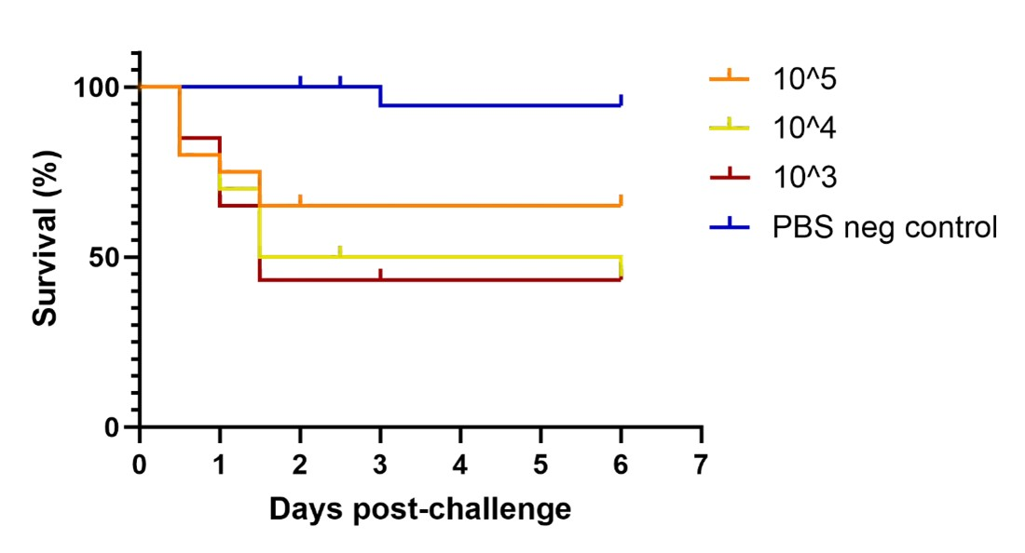
Fig. S1 Survival curve for juvenile Asian sea bass challenged through IP injection with Streptococcus iniae with either PBS as a negative control or one of 3 doses of S. iniae (10³, 10⁴, 10⁵ CFU/fish)
References
Agnew W, Barnes AC (2007) Streptococcus iniae: An aquatic pathogen of global veterinary significance and a challenging candidate for reliable vaccination. Vet Microbiol 122:1–15. https://doi.org/10.1016/j.vetmic.2007.03.002
Bromage E, Owens L (2009) Environmental factors affecting the susceptibility of barramundi to Streptococcus iniae. Aquaculture 290:224–228. https://doi.org/10.1016/j.aquaculture.2009.02.038
Bromage E, Owens L (2002) Infection of barramundi Lates calcarifer with Streptococcus iniae: effects of different routes of exposure. Dis Aquat Org 52:199–205. https://doi.org/10.3354/dao052199
Creeper J, Buller N (2006) An outbreak of Streptococcus iniae in barramundi (Lates calcarifer) in freshwater cage culture. Aust Vet J 84:408–411. https://doi.org/10.1111/j.1751-0813.2006.00058.x
Harvie EA, Green JM, Neely MN, Huttenlocher A (2012) Innate Immune Response to Streptococcus iniae Infection in Zebrafish Larvae. Infect Immun 81:110–121. https://doi.org/10.1128/iai.00642-12
Shoemaker CA, Evans JJ, Klesius PH (2000) Density and dose: factors affecting mortality of Streptococcus iniae infected tilapia (Oreochromis niloticus). Aquaculture 188:229–235. https://doi.org/10.1016/S0044-8486(00)00346-X
Siddik MAB, Howieson J, Partridge GJ, et al (2018) Dietary tuna hydrolysate modulates growth performance, immune response, intestinal morphology and resistance to Streptococcus iniae in juvenile barramundi, Lates calcarifer. Sci Rep 8:15942. https://doi.org/10.1038/s41598-018-34182-4

