Supplemental figure 1. All embryos in the test dataset (red) and independent dataset (blue) were assigned an AI score and classified into ascending score brackets (G1-G4) (X-axis). The fetal heartbeat (FH) rate (Y-axis) was calculated for each score bracket to show ascending rates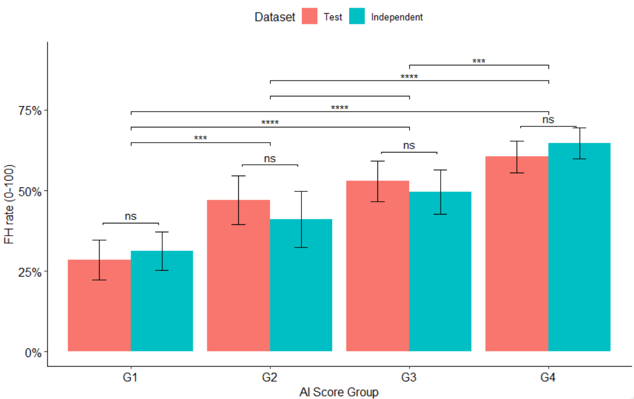

Supplemental Table 1. Characteristics of the full dataset used for AI model training and validation
Characteristics | Train and validation dataset
Total embryo count (n=embryos) | 16,935
known transfer outcomes (n=embryos) | 9,810
FH+ embryos (n=embryos) | 4,812
FH- embryos (n=embryos) | 4,998
FH rate (%) | 49
Discarded (n=embryos) | 7,125
Fresh transferred (n=embryos) | 5,577
Cryopreserved-thawed transferred (n=embryos) | 4,233
Maternal (uterus) age (mean ± SD, years) | 38.09 ± 5.26
Oocyte age (mean ± SD, years) | 30.82 ± 6.75

Supplemental Table 2. Distribution of data characteristics across the test and independent datasets
Characteristics | Test dataset | Independent dataset
Total embryo count (n=embryos) | 1,708 | 7,445
After data exclusion (n=embryos) | 1,708 | 6,246
Transferred (n=embryos) | 1,070 | 1,493
Single embryo transferred (n=embryos) | 997 | 1,168
Double embryo transferred (n=embryos) | 64 | 316
Triple embryo transferred (n=embryos) | 9 | -
Cryopreserved (n=embryos) | 25 | 2,985
Discarded (n=embryos) | 596 | 992
Unknown clinical fate (n=embryos) | 17 | 776
Unknown outcome after transfer (n=embryos) | - | 9
Annotated (n=embryos) | 1,358 | 5,734
Maternal (uterus) age (mean ± SD, years) | 38.76 ± 5.21 | 37.00 ± 4.88
Oocyte age (mean ± SD, years) | 30.20 ± 6.96 | 35.79 ± 4.12

Supplemental Table 3. Single embryo transfer (SET) characteristics across the test and independent datasets
Characteristics | Test dataset |  | Independent Dataset
Characteristics | Autologous | Donor oocyte recipient | Autologous | Donor oocyte recipient
Single transferred embryos (n= embryos) | 582 | 415 | 936 | 232
Known transfer outcomes (n= embryos) | 582 | 415 | 791 | 171
Positive FH outcome (n=embryos) | 240 | 256 | 368 | 111
Maternal (uterus) age  (mean ± SD, years) | 35.2 ± 4.56 | 41.2 ± 4.26 | 35.4 ± 3.85 | 41.8 ± 4.40
Oocyte age  (mean ± SD, years) | 35.2 ± 4.56 | 25.4 ± 4.34 | 35.4 ± 3.85 | 25.4 ± 4.47
FH rate (%)  [95% CI] | 41.23 [37.20-45.20] | 61.68 [57.00-66.40] | 46.52 [43.00-50.00] | 64.91 [57.70-72.10]

Supplemental Table 4. Distribution of annotations and mean AI scores are shown for three evaluated parameters of embryo morphology quality: ASEBIR grade, inner cell mass (ICM), and trophectoderm (TE)
Morphology parameter |  | Test Dataset |  | Independent Dataset |  | Combined Data
Morphology parameter | Annotation | Embryo count (n) | AI score (mean ± SD) | Embryo count | AI score (mean ± SD) | Embryo count (n) | AI score (mean ± SD)
ASEBIR | A | 221 | 7.72 ± 1.20 | 882 | 7.67 ± 1.23 | 1103 | 7.68 ± 1.22
ASEBIR | B | 523 | 6.50 ± 1.81 | 2190 | 6.65 ± 1.78 | 2713 | 6.63 ± 1.79
ASEBIR | C | 445 | 3.92 ± 1.94 | 2496 | 4.81 ± 2.30 | 2941 | 4.68 ± 2.27
ASEBIR | D | 49 | 2.01 ± 1.53 | 166 | 4.10 ± 1.94 | 215 | 3.62 ± 2.05
ASEBIR | E | 120 | 2.04 ± +1.81 | - | - | 120 | 2.04 ± +1.81
ICM | A | 317 | 7.45 ± 1.42 | 1299 | 7.21 ± 1.56 | 1616 | 7.25 ± 1.53
ICM | B | 534 | 6.00 ± 2.08 | 2674 | 6.06 ± 2.16 | 3208 | 6.05 ± 2.15
ICM | C | 221 | 4.51 ± 2.01 | 1475 | 4.71 ± 2.36 | 1696 | 4.68 ± 2.32
ICM | D | 4 | 3.60 ± 2.46 | 73 | 3.98 ± 2.10 | 77 | 3.97 ± 2.10
TE | A | 235 | 7.68 ± 1.32 | 882 | 7.67 ± 1.23 | 1117 | 7.67 ± 1.25
TE | B | 552 | 6.45 ± 1.87 | 2191 | 6.66 ± 1.78 | 2743 | 6.61 ± 1.80
TE | C | 296 | 4.30 ± 1.94 | 2504 | 4.82 ± 2.29 | 2800 | 4.76 ± 2.27
TE | D | 17 | 3.47 ± 1.86 | 157 | 4.01 ± 1.91 | 174 | 3.96 ± 1.91

Supplemental Table 5. Distribution of annotations and fetal heartbeat (FH) data are shown for three evaluated parameters of embryo morphology quality: ASEBIR grade, inner cell mass (ICM), and trophectoderm (TE). Annotations for transferred embryos ranged from A (top quality) to C (fair quality). All annotated embryos in the test dataset had known FH outcomes
 |  | Test Dataset |  |  | Independent Dataset
Morphology parameter | Annotation | Embryo count (n) | FH+ embryos (n) | FH rate (%)  [95% CI] | Embryo count (n) | Embryos with known FH outcomes | FH+ embryos (n) | FH rate (%) [95% CI]
ASEBIR | A | 207 | 133 | 64.25 [57.70-70.80] | 180 | 134 | 92 | 68.65 [60.70-76.60]
ASEBIR | B | 407 | 231 | 56.75 [51.90-61.60] | 566 | 470 | 264 | 56.17 [51.70-60.70]
ASEBIR | C | 124 | 50 | 40.32 [31.60-49.10] | 205 | 170 | 61 | 35.88 [28.60-43.20]
ICM | A | 290 | 181 | 62.41 [56.80-68.00] | 289 | 216 | 136 | 62.96 [56.50-69.50]
ICM | B | 381 | 207 | 54.33 [49.30-59.40] | 611 | 530 | 271 | 51.13 [46.90-55.40]
ICM | C | 57 | 25 | 43.85 [30.60-57.10] | 43 | 27 | 7 | 25.92 [8.26-43.60]
TE | A | 215 | 139 | 64.65 [58.20-71.10] | 180 | 134 | 92 | 68.65 [60.70-76.60]
TE | B | 430 | 241 | 56.04 [51.30-60.80] | 566 | 470 | 264 | 56.17 [51.70-60.70]
TE | C | 86 | 35 | 40.69 [30.10-51.30] | 205 | 170 | 61 | 35.88 [28.60-43.20]

Supplemental Table 6. Stratification of fetal heartbeat (FH) outcomes by AI score bracket (G1-G4). Odds ratio (OR) and P-values for the associations between AI scores and fetal heartbeat (FH) rate is shown

 | Test Dataset |  |  |  |  | Independent dataset
AI score  bracket | Embryo count  (n) | FH+ embryos  (n) | FH rate (%)  [95% CI] | OR  [95% CI] | P-  value | Embryo count (n) | FH+ embryos (n) | FH rate (%)  [95% CI] | OR  [95% CI] | P-  value
G4  (score>=7.5) | 382 | 231 | 60.47 [55.40-64.90] | 3.84  [2.66-5.53] | <0.01 | 381 | 246 | 64.56  [59.70-69.40] | 4.01  [2.84-5.66] | <0.01
G3  (>=6 score <7.5) | 240 | 127 | 52.91 [46.80-59.10] | 2.82  [1.90-4.18] | <0.01 | 208 | 103 | 49.51  [42.70-56.40] | 2.16  [1.47-3.17] | 0.05
G2  (>=4 score <6) | 168 | 79 | 47.02  [39.10-53.70] | 2.23  [1.45-3.42] | <0.01 | 129 | 53 | 41.08  [32.50-49.70] | 1.53  [0.98-2.39] | <0.01
G1  (score<4) | 207 | 59 | 28.50  [22.30-34.20] | 0.40  [0.30-0.54] | <0.01 | 240 | 75 | 31.25  [25.30-37.20] | 0.46  [0.35- 0.60] | <0.01

