Supplementary material
Role of organic/sulfide ratios on DNRA cultivation and the microbial community structure of a co-driven sequencing biofilm batch reactor
Xiaoling Li¹, Jianqiang Zhao^{2*}, Yuhao Zhang², Jiaojie He¹, Kaili Ma³, Chun Shuang Liu⁴
1. School of Civil Engineering, Key Laboratory of Water supply ＆ Sewage Engineering Ministry of Housing and Urban-Rural Development, Chang’an University, Xi’an, 710054, China.
2. School of Water and Environment, Chang’an University, Xi’an 710055, China.
3. School of Environment, Henan Normal University, Xinxiang 453000, China
4. College of Chemical Engineering, China University of Petroleum, Qingdao 266580, China.

Fig. S1 The fitting curve of S²⁻- S and NH₄⁺-N.
Fig. S2 Shannon index and Rarefaction curves in different systems.
Fig. S3 Microbial community composition of the SBBR sludge based on high-throughput 16S rRNA gene sequencing. The 100% stacked column showing community composition at the phylum level.

Table S1 Bacterial taxa identified using the closest relatives inferred from 16S rRNA gene sequence similarity.

Fig.S1 The fitting curve of S²⁻- S and NH₄⁺-N.

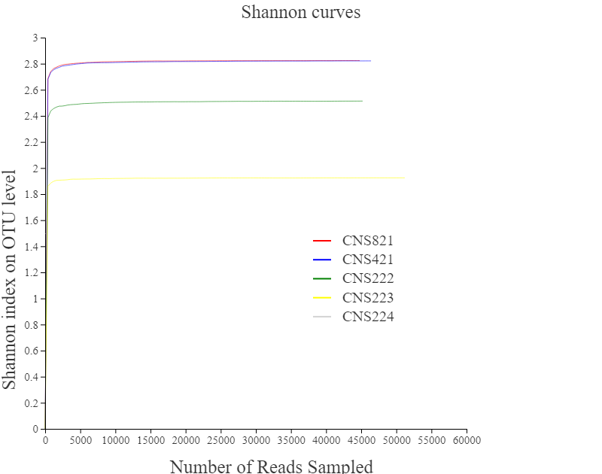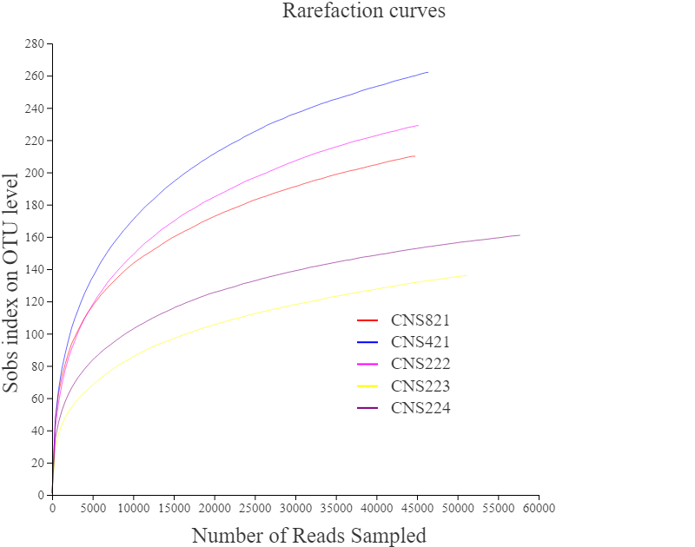
Fig.S2 Shannon index and Rarefaction curves in different systems.

Fig.S3 Microbial community composition of the SBBR sludge based on high-throughput 16S rRNA gene sequencing. The 100% stacked column showing community composition at the phylum level.

Table S1 Bacterial taxa identified using the closest relatives inferred from 16S rRNA gene sequence similarity.

Band No. | Closest relative | Identity | Access no. | Genus | Class | Phylum
1 | Veillonella ratti strain | 100% | NR 113377.1 | Veillonella | Negativicutes | Firmicutes
2 | Proteiniclasticum ruminis DSM 24773 strain | 100% | NR 115875.1 | Proteiniclasticum | Clostridia | Firmicutes
3 | Fusibacter fontis strain | 100% | NR 137378.1 | Fusibacter | Clostridia | Firmicutes
4 | Aminivibrio pyruvatiphilus strain | 100% | NR 113331.1 | Aminivibrio | Synergistia | Synergistetes
5 | Holophaga foetida strain | 100% | NR 036891.1 | Holophaga | Holophagae | Acidobacteria
6 | Desulfovibrio desulfuricans strain | 100% | NR 104990.1 | Desulfovibrio | Deltaproteobacteria | Acidobacteria
7 | Geobacter lovleyi | 99.53% | NR 074979.1 | Geobacter | Deltaproteobacteria | Proteobacteria
8 | Desulfobacterium catecholicum strain | 100% | NR 028895.1 | Desulfobacterium | Deltaproteobacteria | Proteobacteria
9 | Thermomonas koreensis strain | 100% | NR 043584.1 | Thermomonas | Gammaproteobacteria | Proteobacteria
10 | Hydrogenophaga caeni strain | 100% | NR 043769.1 | Hydrogenophaga | Gammaproteobacteria | Proteobacteria
11 | Thauera phenylacetica strain | 100% | NR 027224.1 | Thauera | Gammaproteobacteria | Proteobacteria
12 | Sulfuritalea hydrogenivorans | 100% | NR 113147.1 | Sulfuritalea | Gammaproteobacteria | Proteobacteria
13 | Thiobacillus thioparus strai | 100% | NR 117864. | Thiobacillus | Gammaproteobacteria | Proteobacteria
14 | Thiobacillus sajanensis strain | 100% | NR 115758.1 | Thiobacillus | Gammaproteobacteria | Proteobacteria
15 | Flavobacterium lacus strain | 100% | NR 133745.1 | Flavobacterium | Bacteroidia | Bacteroidetes
16 | Geofilum rhodophaeum strain | 100% | NR 158091.1 | Geofilum | Bacteroidia | Bacteroidetes
17 | Lentimicrobium saccharophilum strain | 100% | NR 149795.1 | Lentimicrobium | Bacteroidia | Bacteroidetes

