Supplementary Information

A bioinspired stretchable sensory-neuromorphic system
Sun Hong Kim^{1†}, Geun Woo Baek^{1†}, Jiyong Yoon^{2†}, Seunghwan Seo², Donghyo Hahm³, Jun Hyuk Chang³, Duhwan Seong², Hyunseon Seo⁴, Seyong Oh², Kyunghwan Kim¹, Heeyoung Jung¹, Youngsu Oh⁴, Hyoung Won Baac², Batyrbek Alimkhanuly⁵, Wan Ki Bae³, Seunghyun Lee⁵, Jeonghun Kwak¹*, Jin-Hong Park²* and Donghee Son²*

†These authors contributed equally to this work
*To whom correspondence should be addressed.
E-mail: daniel3600@g.skku.edu, jhpark9@skku.edu, jkwak@snu.ac.kr

Table of Contents

1. Supplementary Notes 1-6 S2
2. Supplementary Figures 1-30 S7
3. Supplementary Tables 1-4 S37
4. Supplementary References S41

Supplementary Notes

Supplementary Note 1: Experiment set up for stretching and cyclic test of printed sinter-free conductor
Stretching and cyclic test of printed conductor were performed by auto stretching machine (PMC-1HS, Autonics Inc., Korea) and Programmable motion controller system. A digital multi-source meter (2400, Keithley Instruments Inc., USA) was used for real-time recording of sheet resistance in four-wire mode.

Supplementary Note 2: Characterization of sinter-free conductors in different solvents
To observe the resistance curves of printed conductors, sheet resistances of printed conductors were measured by four-probes-method using a digital multi-source meter (2400, Keithley Instruments Inc., USA) soon after screen-printing. Sample preparation for cross-sectional SEM imaging is performed by freezing samples in liquid N₂ followed by slicing process. Three kinds of ink (prepared by chloroform, methyl-isobutyl ketone, hexyl acetate) were printed on elastomer by screen-printing method. For micro-scale visualization of distribution of Ag flakes in the polymer matrix as shown in Fig. 2c, FE-SEM (Field emission scanning electron microscopy, Inspect F50, FEI Co., USA) is used.

Supplementary Note 3: Electrical measurement of intrinsically stretchable RRAM and capacitance sensor.
Capacitance was measured by the Probe Station (MST 5500B, MSTECH Inc., Korea) using a Precision LCR Meter (4284A, Agilent Technology Inc., USA), 1 kHz frequency, 0.1 V DC voltage bias, under ambient conditions. In dual detection modes of stretching and pressure, strain was applied by stretching on manual stretcher stage and pressure was applied by loading various weights on each cell. Electrical characteristics of RRAM were measured using a Semiconductor Parameter Analyzer (4155C, Agilent Technology Inc., USA). We obtained the LTP/LTD characteristics of the artificial synapse using semiconductor characterization system (4200-SCS, Keithley Instruments Inc., USA). We applied a series of 100 excitatory/inhibitory pulses using pulse function generator (81150A, Keysight Technologies Inc., USA) and switch matrix (707B, Keithley Instruments Inc., USA). Stretching tests of each devices were conducted by manual stretching stage and cyclic tests of each devices were measured by using auto stretching machine.

Supplementary Note 4: Fabrication of intrinsically stretchable QLEDs
PI was spin-coated at 3000 rpm for 60 s to fabricate the detach layer, subjected to thermal annealing for full cross-linking and photolithographically patterned by dry-etching for 7 min to define the 5 × 5 islands (O₂ flow rate = 20 sccm, pressure = 50 mTorr, RF power = 150 W). An Ag/Au (85 nm/50 nm) bottom contact electrode was thermally deposited using a metal mask. Then, ZnO NPs (20 mg/ml) and red-emitting CdSe/CdZnS QDs (25 mg/ml) were successively spin-coated as an electron injection/transport layer (EIL/ETL) and an emissive layer (EML), respectively. We peeled off the multiple layers from PI layer to QD layer using thermal release tape (Semiconductor Equipment Corp.). The thermal release tape was laminated on PDMS substrate for the transfer technique. After that, thermal release tape was softly detached by heat (~140 °C). On the devices, CBP (60 nm) and MoO_{x} (10 nm) were used as a hole transport layer (HTL) and a hole injection layer (HIL). As an anode, a thin Ag (20 nm) layer was deposited followed by passivation with a silicon oxide (SiO₂ ~20 nm) layer. To interconnect the 5 × 5 array of the QLED islands, sinter-free printable ink was screen printed. Finally, the device was encapsulated with PDMS for enhancing the packing effect.

Supplementary Note 5: Characterization of intrinsically stretchable QLEDs
The J−V−L characteristics of the devices were measured using a source-measure unit, multimeter (236 and 2000, Keithley Instruments Inc., USA), a calibrated Si photodiode (Hamamatsu S5227-1010BQ), and a photomultiplier tube (PMT) detector. The EL spectra were measured using a spectroradiometer (Konica–Minolta CS-1000). For compensating photon counting depending on angular distribution of emission, QLEDs were mounted onto the revolving stage. EL intensities were recorded using a PMT equipped with a monochromator via optical fibers. Stretching of device was performed by manual stretching stage and cyclic test of stretchable QLEDs was performed by auto stretching machine.

Supplementary Note 6: LabVIEW code (Capacitance sensor to RRAM)
The capacitance values of image patterns were measured using peripheral component interconnect (PCI) extensions for instrumentation (PXI) system and LabVIEW code. First, open session of switch module was activated while determining topology, trigger input, and scan advanced output. After the scan list was specified, scanning configuration was performed on the hardware. Second, after triggering the session of digital multimeter (DMM) module, measurement type, range, resolution, trigger source, trigger slope, continuous acquisition, and sample trigger slope were applicable to what determined before. Third, we can determine how many samples are available when backlog status was confirmed. And then, all available samples were returned to 5 × 5 table after DMM and switch module are initiated. The normalized capacitance values were converted to voltage ones. Finally, the resulting voltage values were rescaled.

Supplementary Note 7: Synapse weight update for the artificial synapse
Based on the delta value (δ), which is difference between the output neuron signals and the label values (k) for input patterns (δ = k − f), the synaptic weight was determined to be potentiated or depressed. If δ > 0 (potentiation phase), then G is increased. In the depression phase (δ < 0), G is decreased. These conductance changes (∆G) were determined by the following Equations:
$G_{n+1}=G_{n}+ΔG_{P}=G_{n}+α_{P}e^{-β_{P}\frac{G_{n}-G_{min}}{G_{max}-G_{min}}}$ (∆G > 0, G↑),
$G_{n+1}=G_{n}+ΔG_{D}=G_{n}-α_{D}e^{-β_{D}\frac{G_{max}-G_{n}}{G_{max}-G_{min}}}$ (∆G < 0, G↓).
In these equations, G_{n+1} and G_{n} denote the synaptic conductance when the n+1th and n^{th} pulses are applied, and parameters α and β are the conductance change amount and the nonlinearity, respectively. Fitting results are provided in Supplementary Table 3, 4. The above pattern recognition processing was implemented with MATLAB.

Supplementary Note 8: LabVIEW code (RRAM to QLEDs feedback actuation)
The processed voltage values are transmitted by PXI system and LabVIEW code. 5 × 5 processed voltage values which are imported from excel file are applied to input array. 5 × 5 bottom gate voltage values which are used to prevent unintended simultaneous light emitting by applied 0 s diagonally. 5 × 5 processed voltage values and 5 × 5 bottom gate voltage values consist 5 × 10 array. Each 0 ~ 4 row of 5 × 10 array is selected by iteration loop and selected row is multiplied to scale. And then, data acquisition (DAQ) assistant block sends analog signals to QLEDs by analog output module.

Supplementary Figures

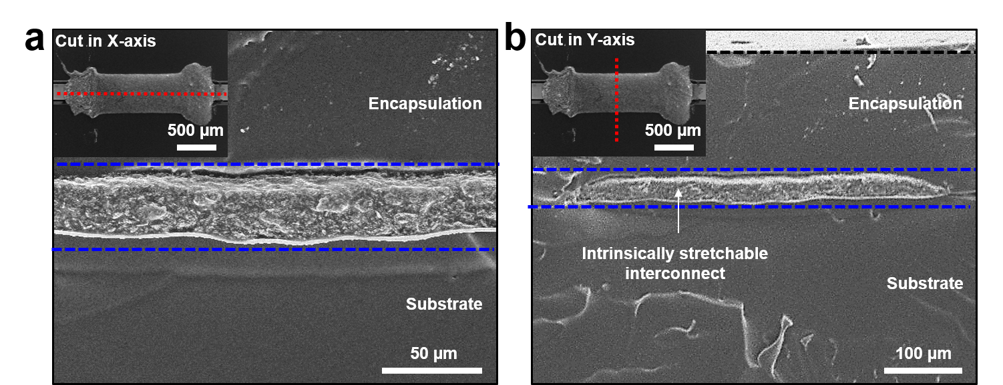
Supplementary Figure 1 | Cross-sectional SEM images of an intrinsically stretchable interconnects encapsulated by elastomer. Cross-sectional SEM image of an intrinsically stretchable interconnects ^{S1} cut in (a) X-axis and (b) Y-axis.

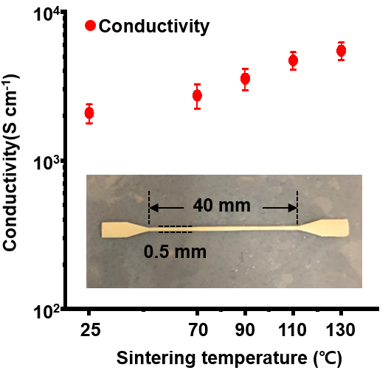
Supplementary Figure 2 | The conductivity variation of sinter-free printable conductor in different sintering temperature. The conductivity of sinter-free printable conductor is in a range of 1750-2300 S/cm without sintering and increases as the sintering temperature increases.

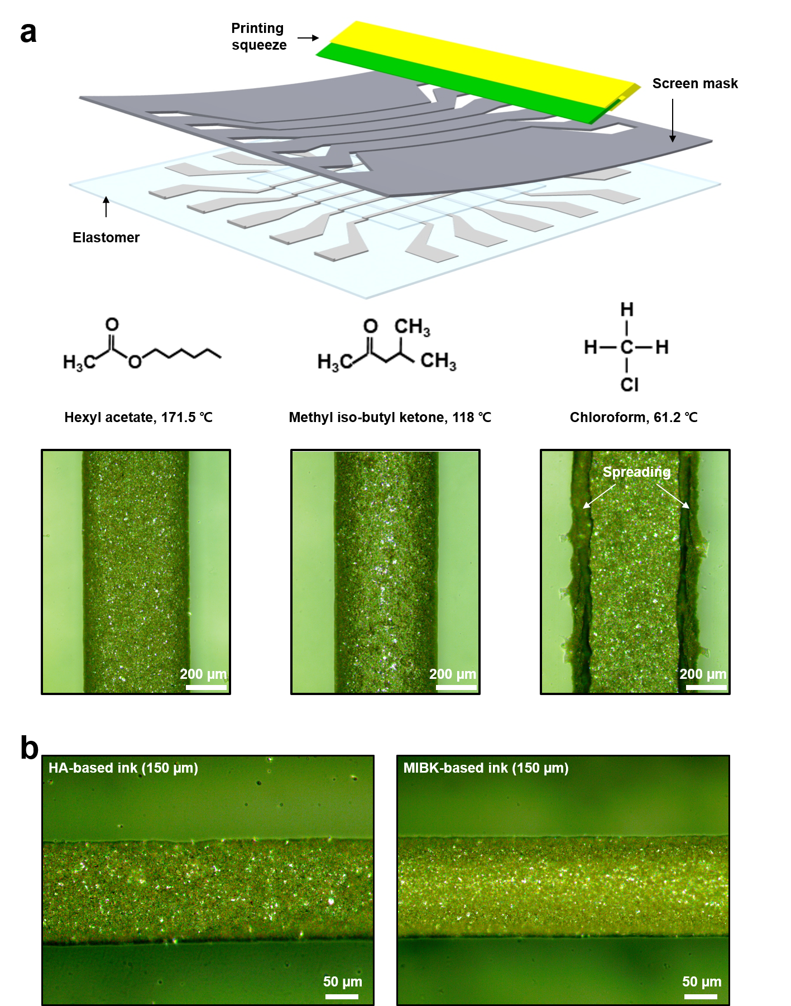
Supplementary Figure 3 | The printing resolution of sinter-free printable ink with different organic solvents. a, A schematic of screen-printing process and optical microscopic images of printed conductor formulated by different organic solvents. Chloroform ink (right) shows poor resolution compared to HA (left) and MIBK (middle) ink. b, Optical microscopic images of HA-, MIBK-based ink printed in 150 um width.
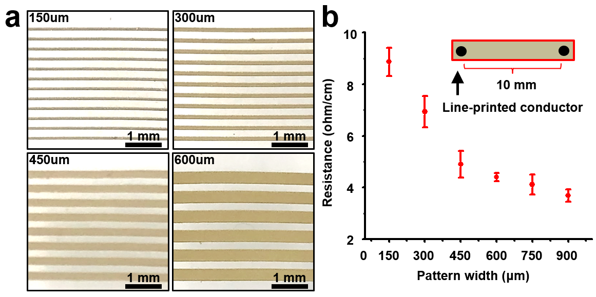
Supplementary Figure 4 | The printing resolution of MIBK-based ink on PDMS and corresponding resistance. a, Screen-printed conductive lines of sinter-free conductor on PDMS substrate (150 µm-600 µm width). b, Resistance values of printed conductor in various printing resolutions.

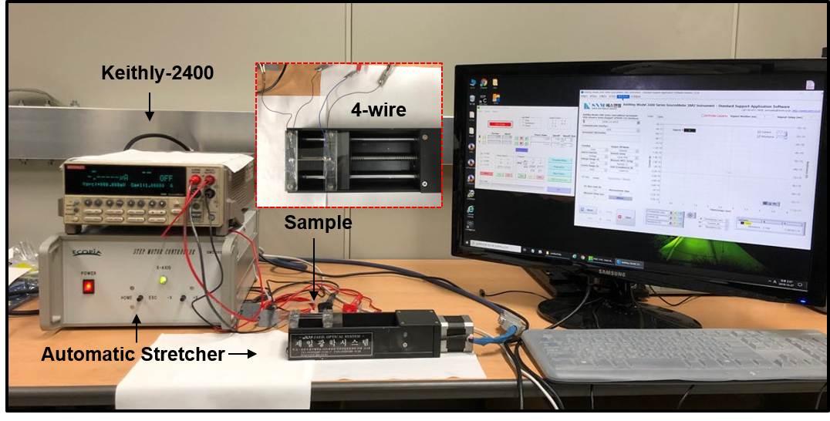
Supplementary Figure 5 | Measurement set up for characterization of conductor. The printed conductor is stretched by automatic stretcher and measured by 4-probe point method by using Keithly-2400^{S2}.

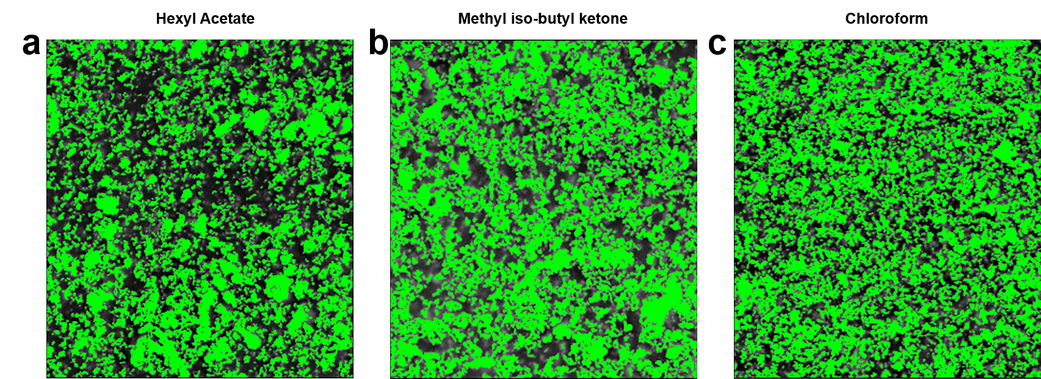
Supplementary Figure 6 | Colored SEM image of three different printed conductors. Ag flakes are labelled with green color for clearly comparing the distributions of Ag flakes among printed conductors based on (a) HA, (b) MIBK and (c) Chloroform.

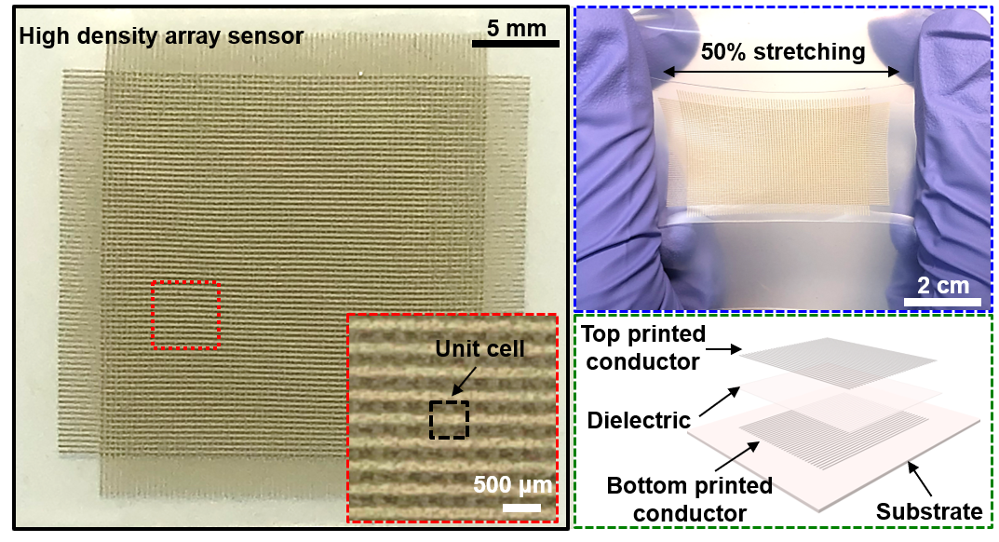
Supplementary Figure 7 | Fabrication of high-density (80×80 array) capacitive sensor. A photograph (left, red dot square) of high-density capacitive sensor (6,400 cells) fabricated by printing of sinter-free printable ink on elastomer and stretched to 50 % (right, blue dot square). At last, schematic layer of device is illustrated (right, green dot square).

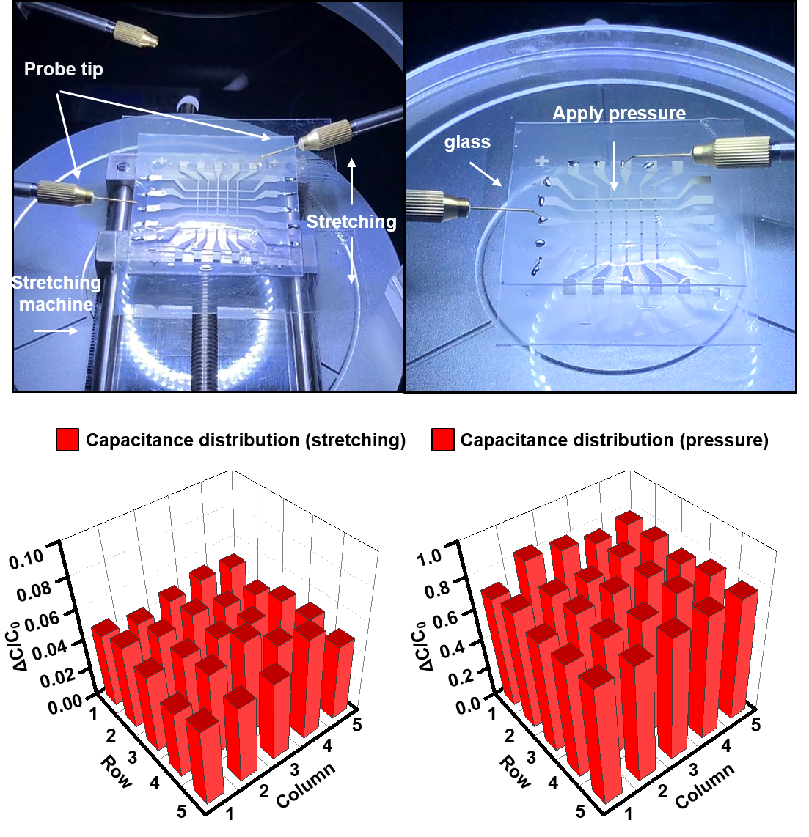
Supplementary Figure 8 | Measurement of capacitive sensor. A photograph (top) of measurement method of capacitive sensor in stretching mode by LCR meter. 3D graph (bottom) showing cell variations of 5×5 capacitive sensor array before and after stretching.

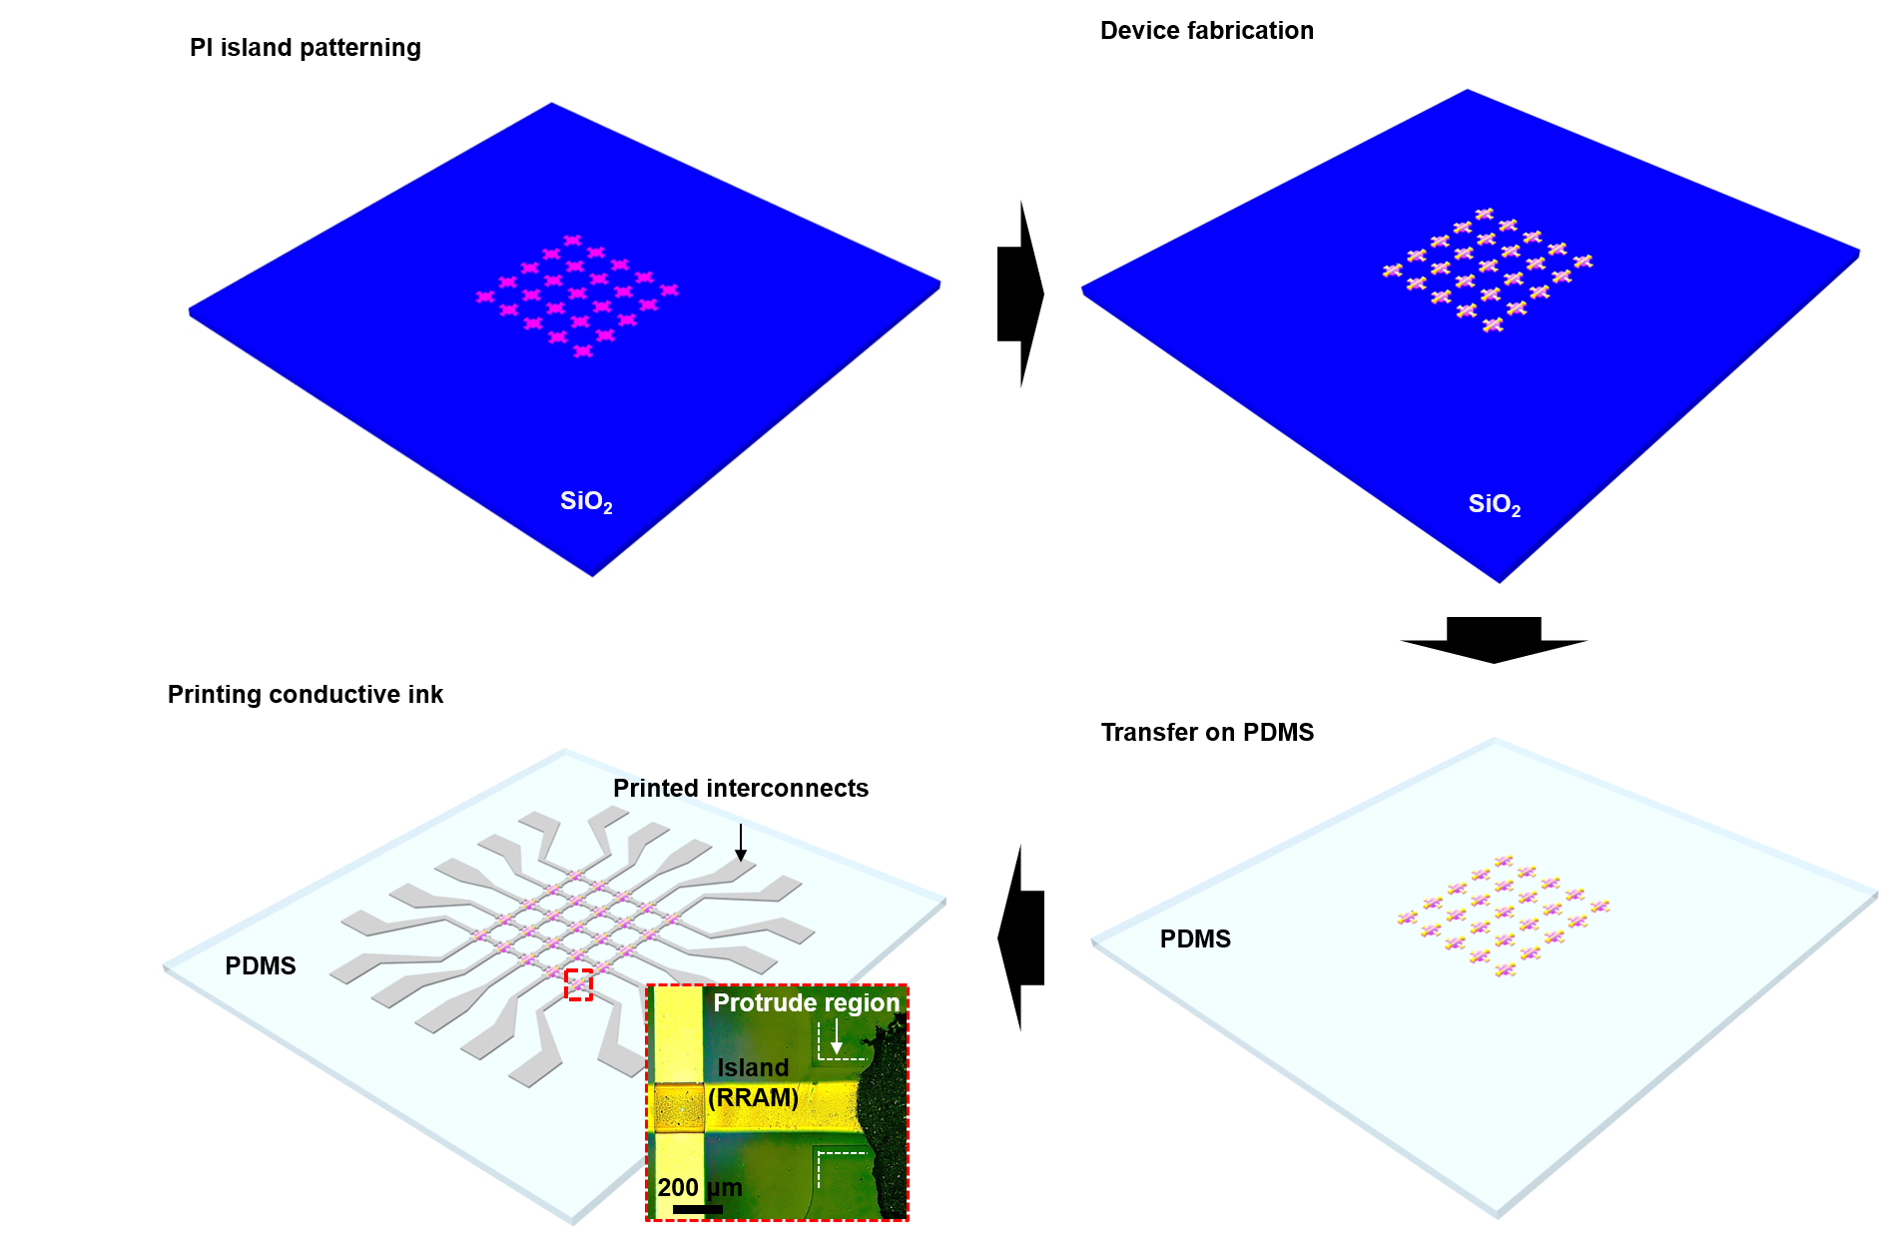
Supplementary Figure 9 | Fabrication process of RRAM. A schematic illustration of fabrication steps for RRAM array, comprising PI island patterning, device fabrication, transfer-printing by thermal release tape and forming stretchable interconnects by screen-printing of ink.

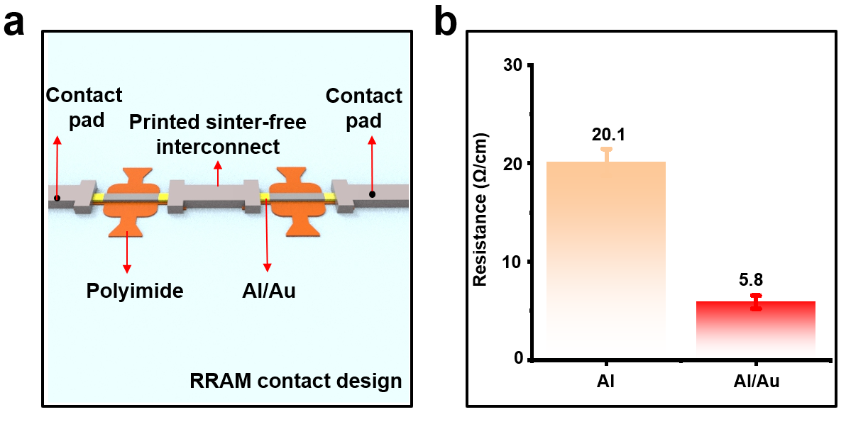
Supplementary Figure 10 | Al/Au layer for reducing the contact resistance. a, A schematic illustration of strategy for reducing contact resistance between electrode of RRAM and printed stretchable interconnect by Au inter-layer. b, Line-resistance between electrodes (Al, Al/Au) and printed stretchable interconnect.

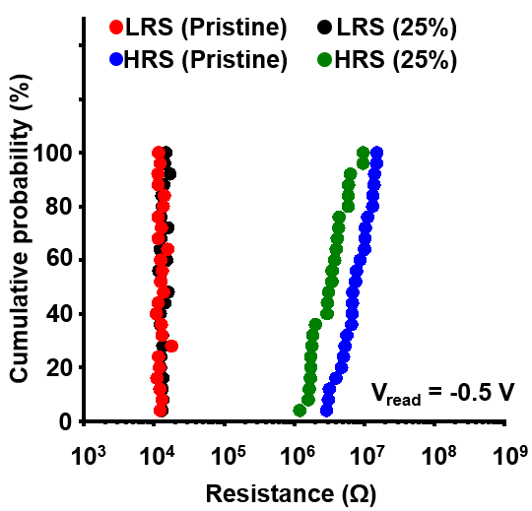
Supplementary Figure 11 | Cumulative probability of intrinsically stretchable RRAM array. Cumulative probability plot of intrinsically stretchable RRAM in pristine and 25 %-stretched state, showing the uniformity within the array.

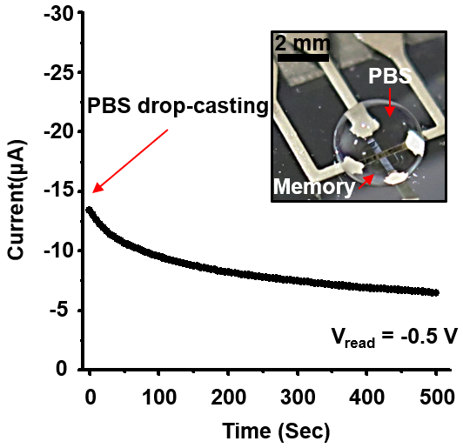
Supplementary Figure 12 | Waterproof test in phosphate buffered solution. Plot of read current in time under droplet of PBS and photograph of device exposed to PBS^{S3}.

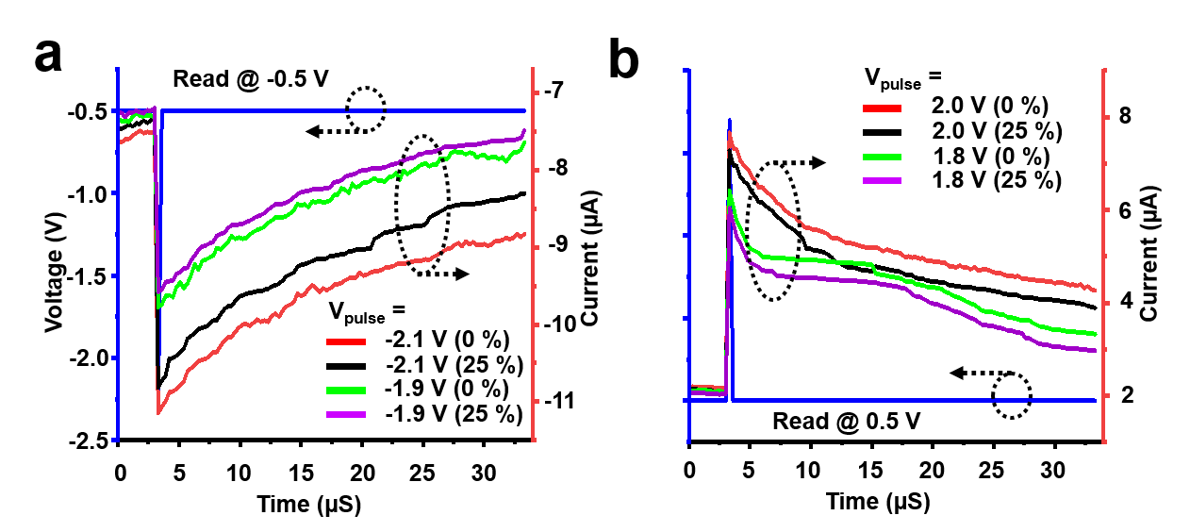
Supplementary Figure 13 | Characterization of postsynaptic current change (ΔPSC) at 0 % and 25 % strain. a, EPSC, and b, IPSC responses of intrinsically stretchable RRAM induced by excitatory/inhibitory voltage pulses with an amplitude range from -1.9 V to -2.1 V in EPSC and from 1.8 V to 2.0 V in IPSC^{S4}.

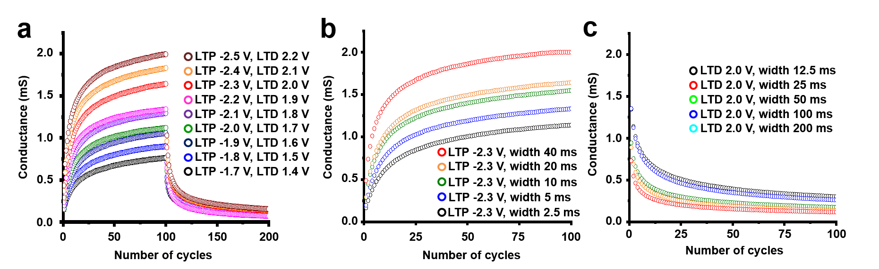
Supplementary Figure 14 | Long-term potentiation and depression (LTP/LTD) characteristic in various condition. a, LTP/LTD characteristics by different input pulses with an amplitude range from -1.7 V to -2.5 V in LTP and from 1.4 V to 2.2 V in LTD. b, LTP and (c) LTD plots by different width of input pulses.

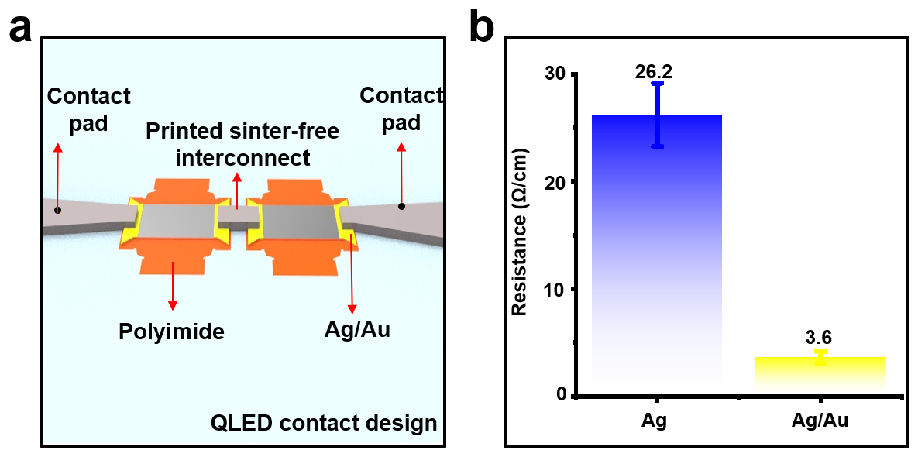
Supplementary Figure 15 | Characterization of contact resistance dependent on Au auxiliary electrodes. a, A schematic view of Ag/Au electrodes on PI rigid island interconnected by sinter-free conductor. b, Line-resistance between electrodes (Ag, Ag/Au) and printed sinter-free interconnect.

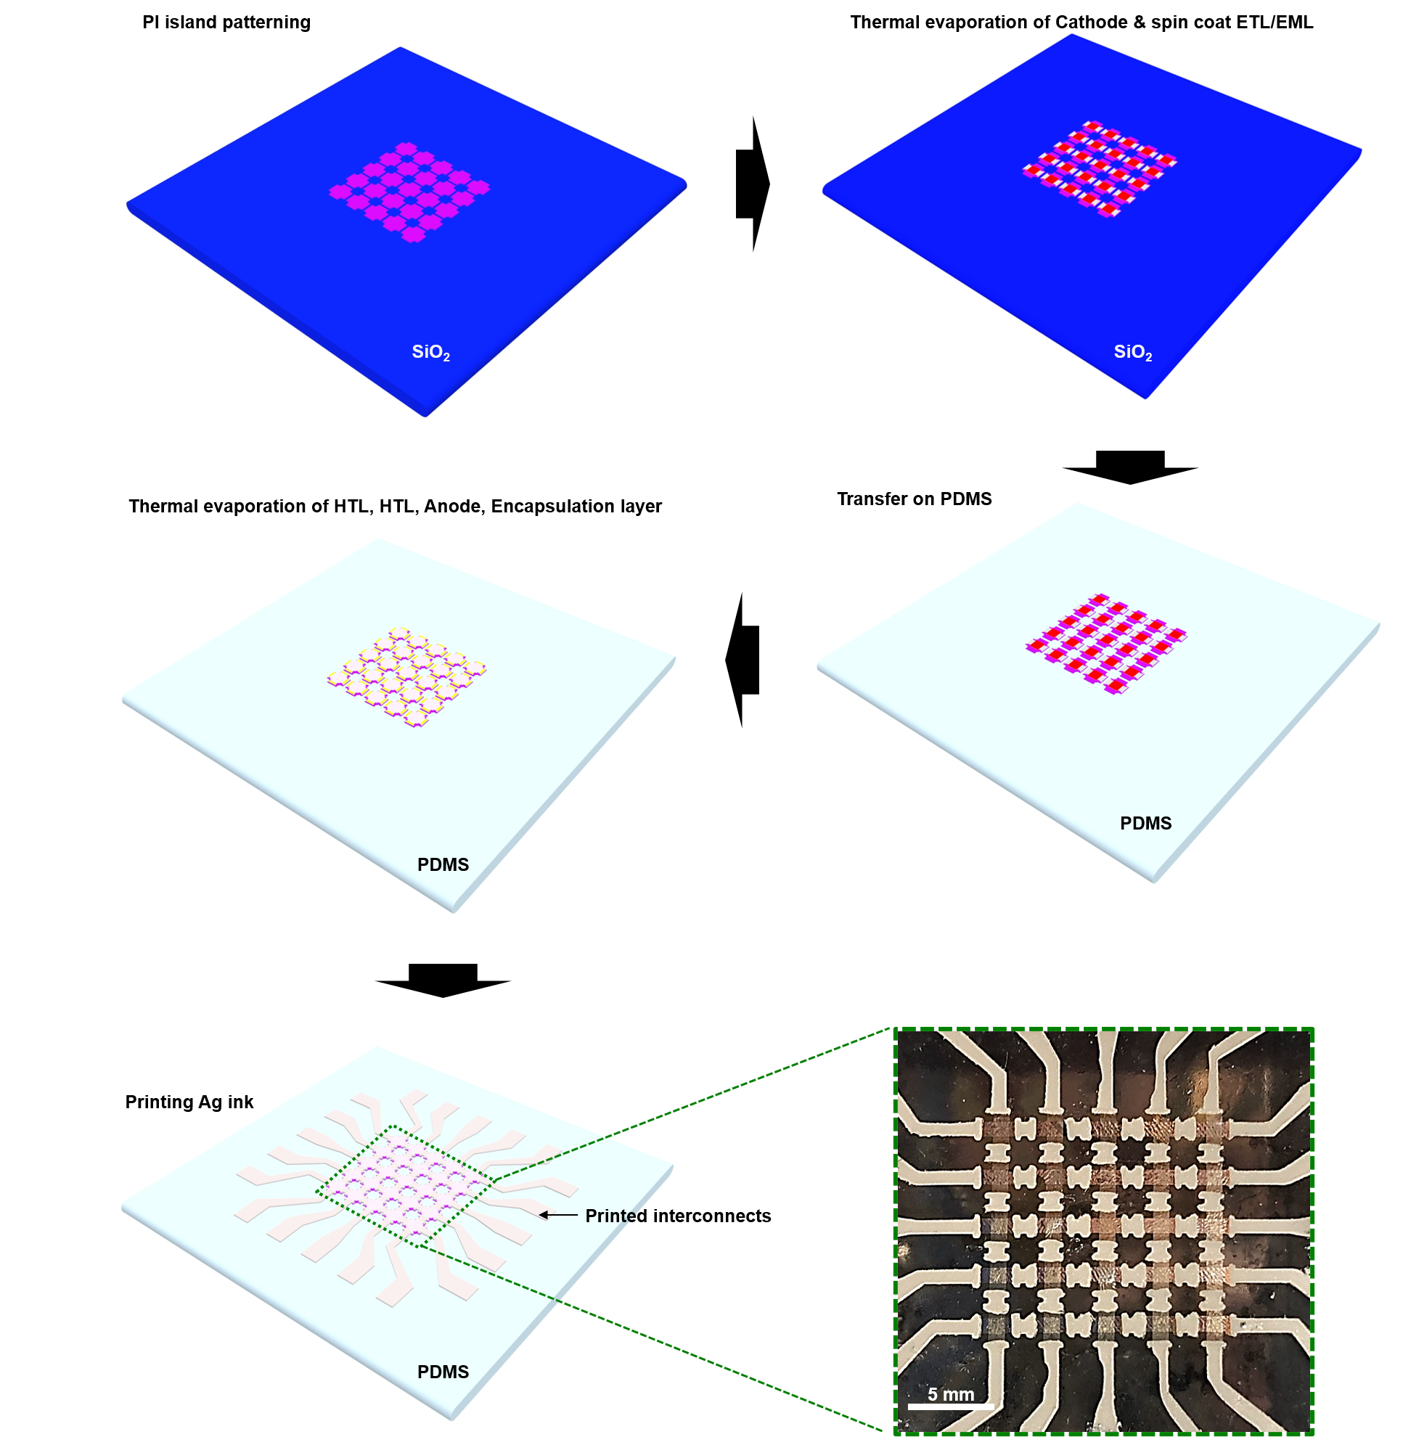
Supplementary Figure 16 | Process schemes for fabrication of the epidermal photonic actuator. A schematic illustration of fabrication process for QLED array consists of PI island patterning, thermal evaporation of cathode/spin-coating of ETL/EML, transfer-printing of layers by thermal release tape, thermal evaporation of HTL/anode and screen-printing of ink^{S5}.
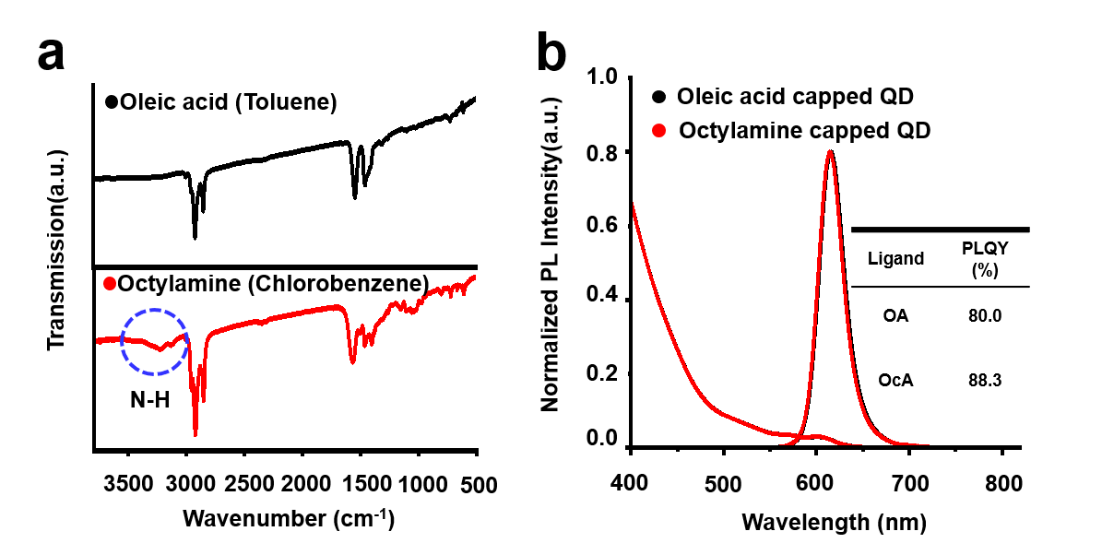
Supplementary Figure 17 | Analysis of as-synthesized QDs with OA ligands and ligand exchanged QDs with OcA ligands. a, FTIR spectra, and b, optical properties of absorption and PL intensity with OA- and OcA-capped QDs before/after ligand modification. The inset shows PLQY of QDs^{S6}.

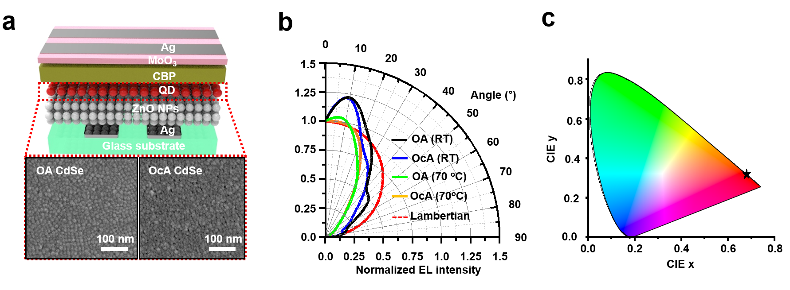
Supplementary Figure 18 | Optical properties of top-emitting red CdSe QLEDs. a, The device illustration and SEM image of emissive layer (QDs) dependent on ligand modification b, The normalized angle-dependent EL intensity of top-emitting QLEDs with OA and OcA-capped QDs before/after 1 h annealing at 70 ° C. c, CIE coordination diagram of the red QLEDs^{S7}.

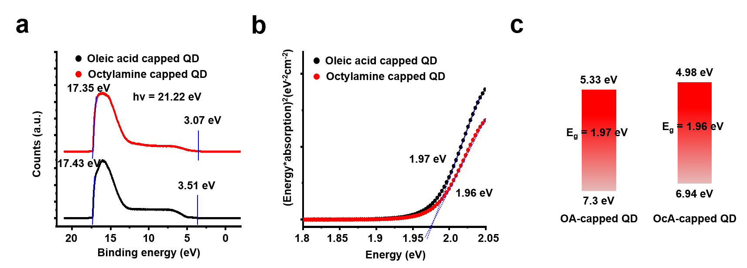
Supplementary Figure 19 | UPS measurement of OA- and OcA-capped red CdSe QDs. a, One set and cut-off region of QDs via ligand modification. b, Tauc plot of red CdSe QDs with OA and OcA ligands for measuring bandgap. c, Energy band alignment of OA- and OcA-capped QDs^{S8}.

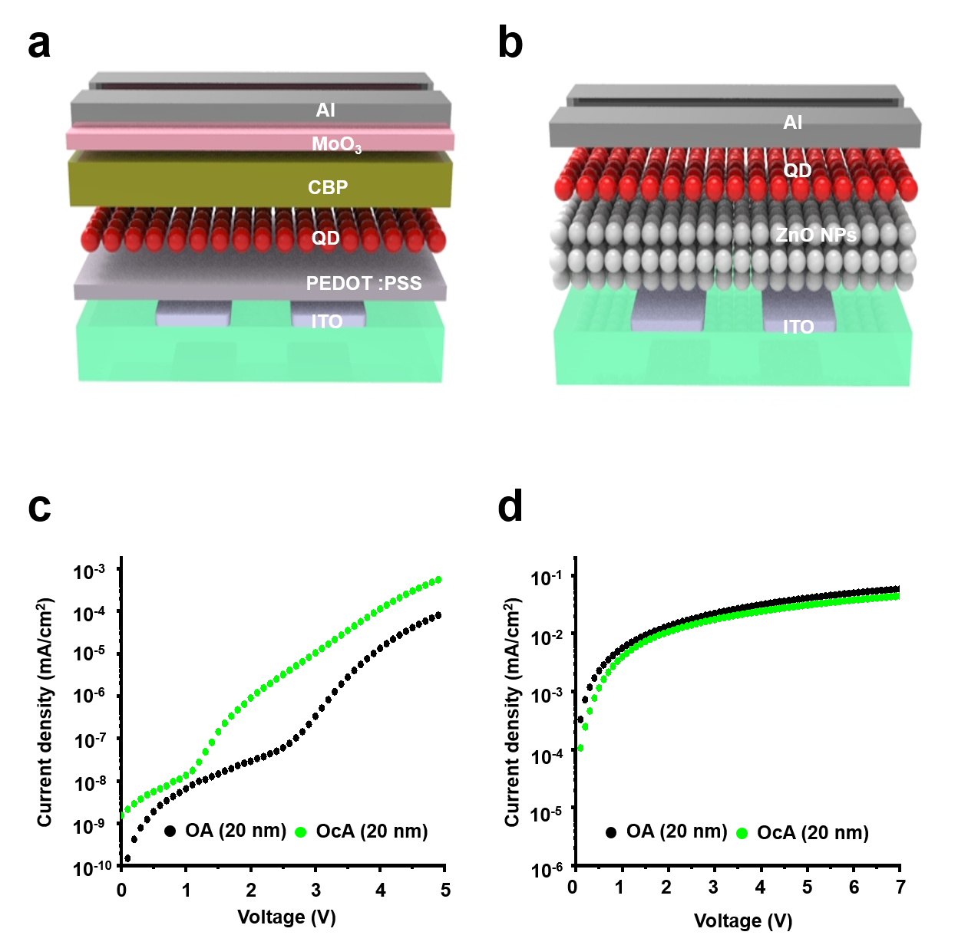
Supplementary Figure 20 | Characterization of HODs/EODs dependent on QDs with OA and OcA ligands. a, Device structure of HODs (ITO/PEDOT:PSS/QDs/CBP/MoO_{x}/Al) and, b, EODs (ITO/ZnO NPs/QDs/Al). c, Current density and voltage of HODs and EODs via ligand modification.

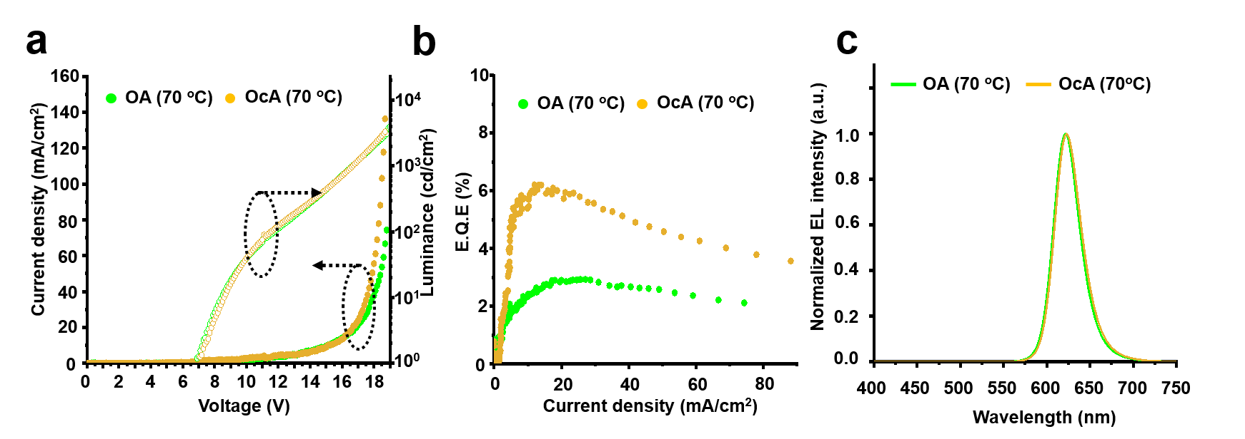
Supplementary Figure 21 | Characterization of OA- and OcA-capped QLEDs after thermal annealing (70 °C for 1 h). a, J-V-L characteristics, b, E.Q.E-current density, and c, the normalized EL spectra of top-emitting red CdSe QLEDs with OA and OcA ligands on glass substrate.

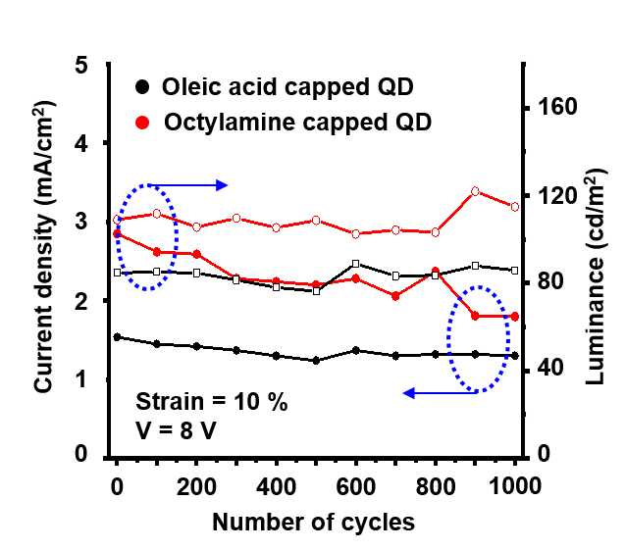
Supplementary Figure 22 | Endurance test of epidermal photonic actuator. plot of current density and luminance depending on number of cycles at 10 % strain applied at 8 V^{S9}.

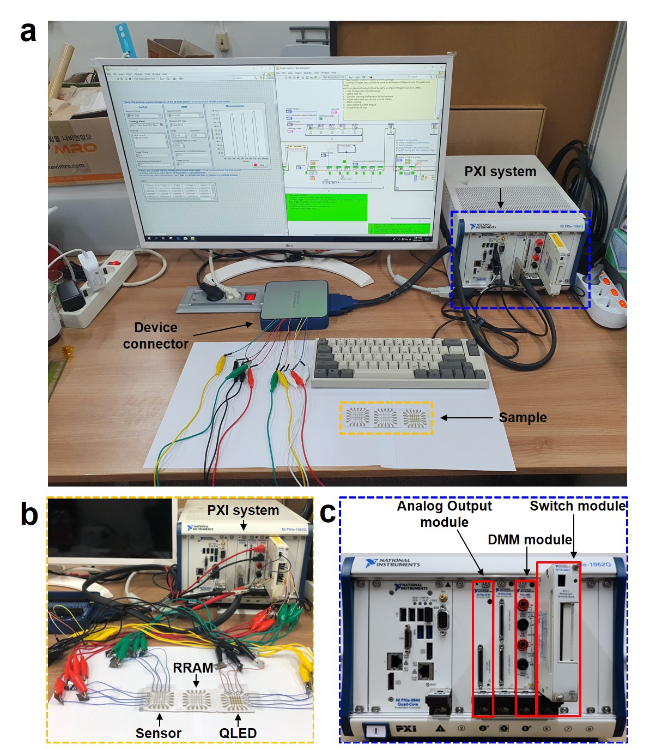
Supplementary Figure 23 | Experimental set up for demonstration of G-SSNS. a, The G-SSNS is demonstrated by PXI system and LabVIEW based program. b, A photogragh of the line connections between G-SSNS and PXI system. c, PXI system modules used for demonstration.
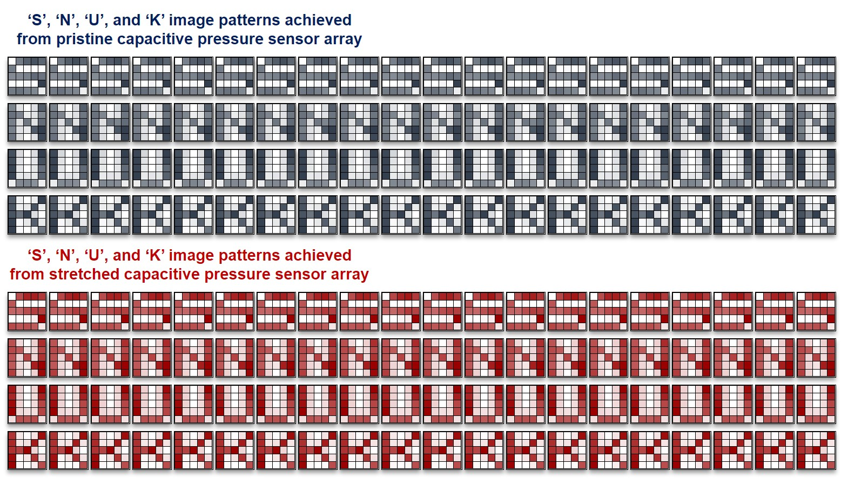
Supplementary Figure 24 | Image patterns detected from mechanoreceptor. 20 sets of image patterns (‘S’, ‘N’, ‘U’, and ‘K’) obtained from the pristine mechanoreceptor (top) and the 25 %-stretched mechanoreceptor (bottom).

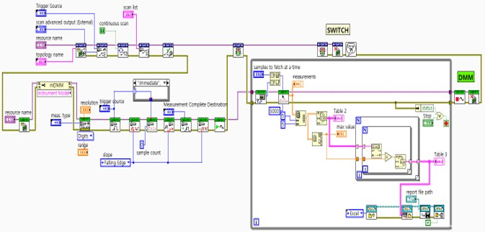
Supplementary Figure 25 | Capacitance measurement from mechanoreceptor by using LabVIEW-based software. Block diagram of LabVIEW-based software for measuring capacitance values and transforming to voltage values.

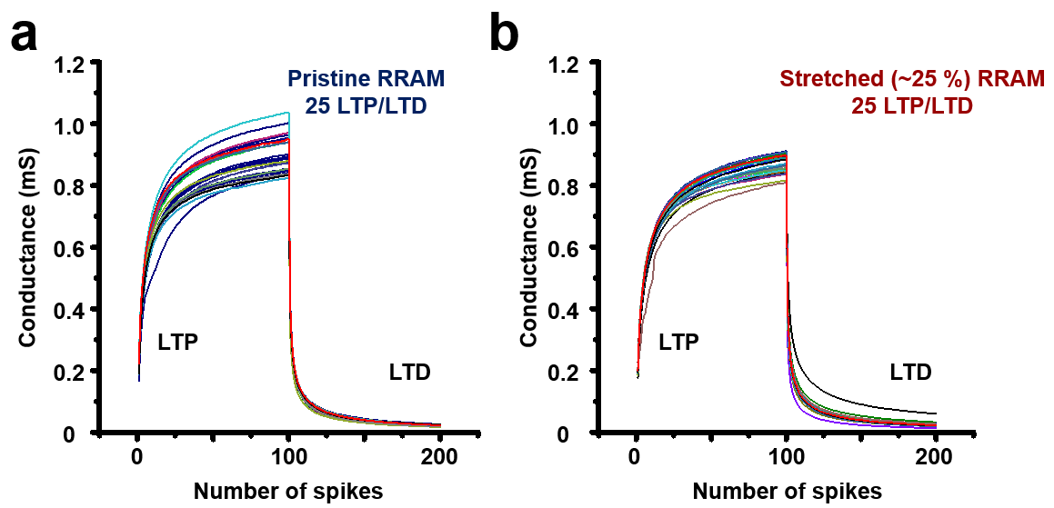
Supplementary Figure 26 | Synapse weights (conductance values) of pristine and 25 %- stretched state as a function of number of spikes. 25 LTP/LTD plots of each pixel in (a) pristine and (b) 25 %-stretched state of artificial synapse represented by conductance values^{S10}.

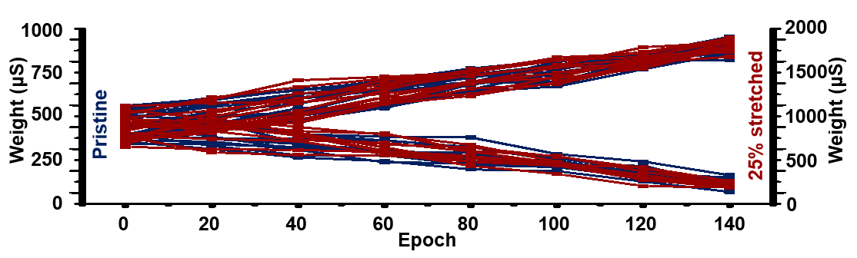
Supplementary Figure 27 | Synaptic weight values with respect to the training epoch. The weight values of the pristine and 25 %-stretched, which are gradually potentiated up to 180 μS and 944 μS or depressed down to 42 μS and 1.72 mS^{S11}.

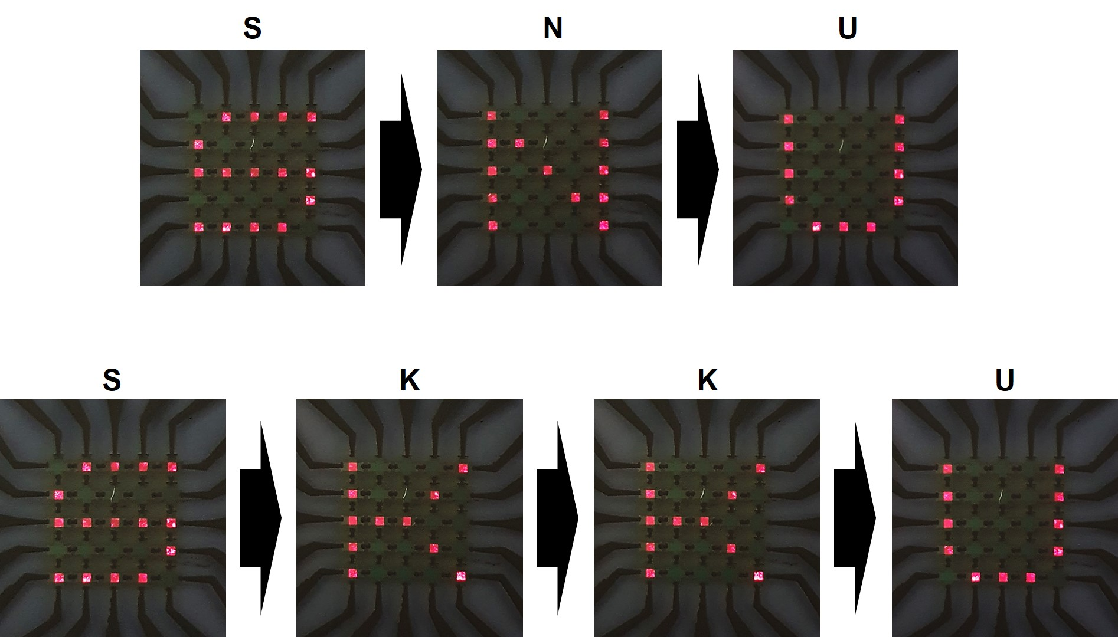
Supplementary Figure 28 | Demonstration images of epidermal photonic actuator array. Photographs of epidermal photonic actuator array, visualizing the trained/inferenced patterns of ‘S’, ‘K’, ‘U’ (top) and ‘S’, ‘K’, ‘K’, ‘U’ (bottom).

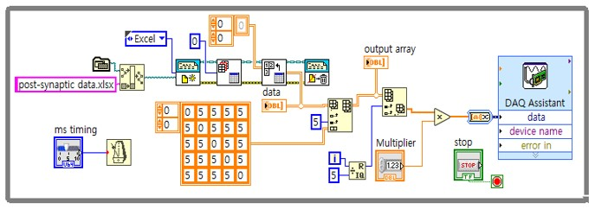
Supplementary Figure 29 | LabVIEW-based block diagram for operating epidermal photonic actuator. Block diagram of LabVIEW-based software for visualizing feedback actuation of the epidermal photonic actuator array^{S12}.

Supplementary Tables

Supplementary Table 1: Synaptic dynamic properties

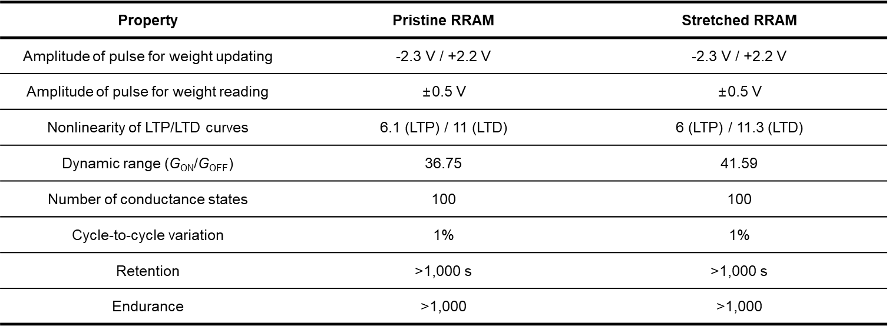

Supplementary Table 2: Performance of top emissive CdSe QLEDs

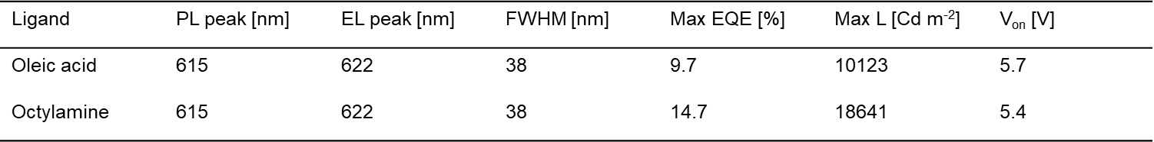

Supplementary Table 3: Extracted fitting parameters from pristine RRAM for pattern recognition tasks

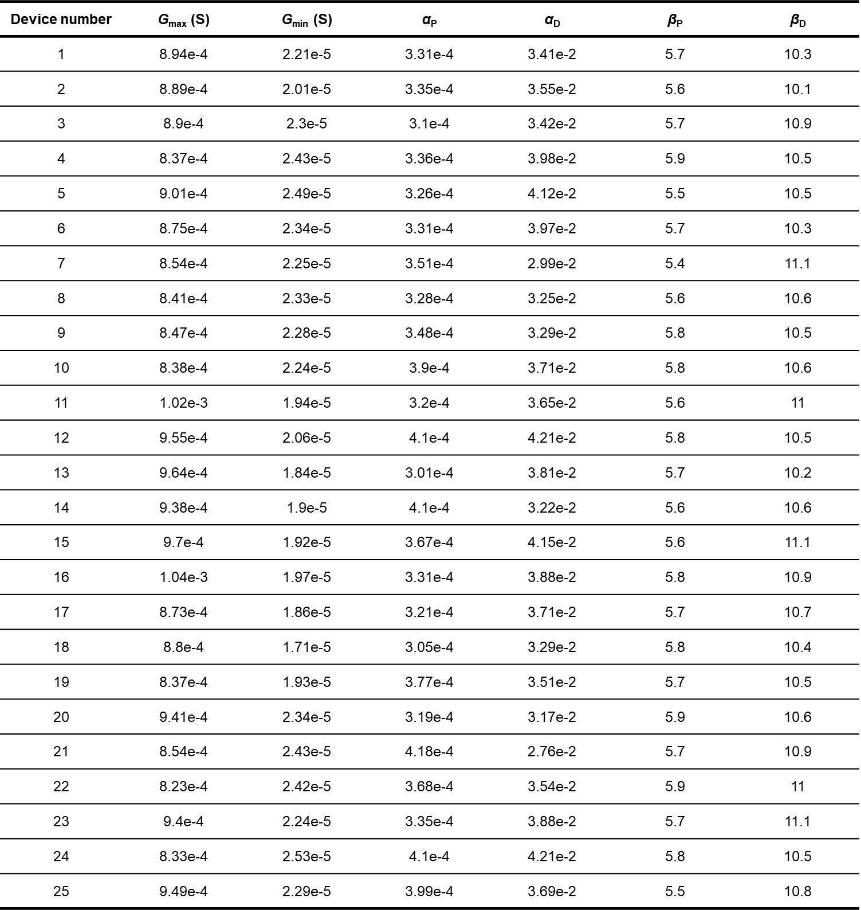

Supplementary Table 4: Extracted fitting parameters from 25 %-stretched RRAM for pattern recognition tasks

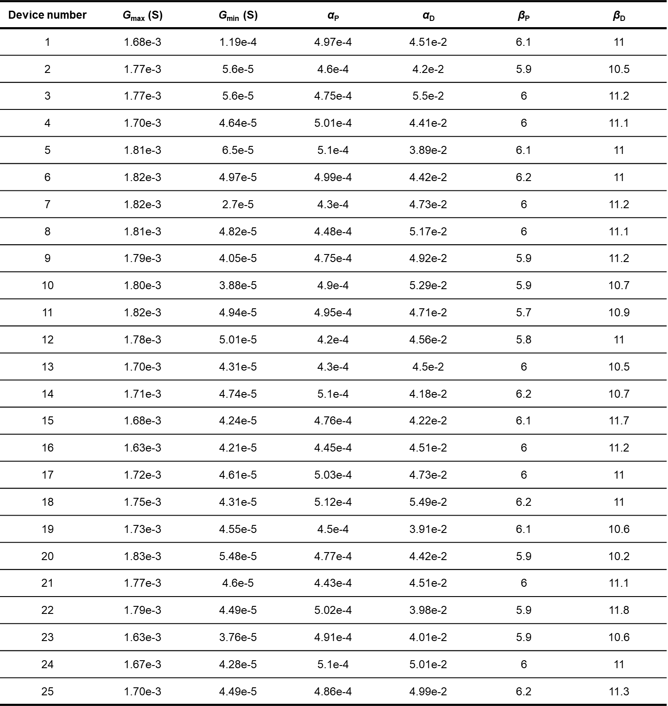

Supplementary References
- Kang, J. et al. Tough and water‐insensitive self‐healing elastomer for robust electronic skin. Adv. Mater. 30, 1706846 (2018).
- Kim, S.H. et al. An ultrastretchable and self-healable nanocomposite conductor enabled by autonomously percolative electrical pathways. ACS Nano 13, 6531-6539 (2019).
- Son, D. et al. Multifunctional wearable devices for diagnosis and therapy of movement disorders. Nat. Nanotech. 9, 397–404 (2014).
- Tang, J. et al. Bridging biological and artificial neural networks with emerging neuromorphic devices: fundamentals, progress, and challenges. Adv. Mater. 31, 1902761 (2019).
- Kim, T.-H. et al. Fully stretchable optoelectronic sensors based on colloidal quantum dots for sensing photoplethysmographic signals. ACS Nano 11, 5992–6003 (2017).
- Cho, I. et al. Multifunctional Dendrimer Ligands for High-Efficiency, Solution-Processed Quantum Dot Light-Emitting Diodes. ACS Nano 11, 684-692 (2016).
- Lee, T. et al. Highly Efficient and Bright Inverted Top-Emitting InP Quantum Dot Light-Emitting Diodes Introducing a Hole-Suppressing Interlayer. Small 15, 1905162 (2019).
- Cho, K.-S. et al. High-performance crosslinked colloidal quantum-dot light-emitting diodes. Nat Photon. 3, 341-345 (2009).
- Li, Y.‐F. et al. Stretchable organometal‐halide‐perovskite quantum‐dot light‐emitting diodes. Adv. Mater. 31, 1807516 (2019).
- Seo, S. et al. Artificial optic-neural synapse for colored and color-mixed pattern recognition. Nat. Commun. 9, 5106 (2018).
- Prezioso, M. et al. Training and operation of an integrated neuromorphic network based on metal-oxide memristors. Nature 521, 61–64 (2015).
- Kim, J. et al. Ultrathin quantum dot display integrated with wearable electronics. Adv. Mater. 29, 1700217 (2017).

