Supplimentry Information
Synthesis and Characterization of Thiazolidinone Derivatives by Using Novel 1,3-dibutyl-1H-benzo[d]imidazol-3-ium Tetrafluroborate Ionic Liquid
Nadeem Ahmad Ayyub Ahmadª, Sainath Babaji Aher^{b}, Pundlik Rambhau Bhagat^{c}, Prashant Narayan Muskawarª*
ªDepartment of Chemistry, Amolakchand Mahavidyalaya, Yavatmal 445001, INDIA
^{b}K K Wagh College of Pharmacy, Nashik, India 422003, INDIA
^{c}Chemistry Department, School of Advanced Sciences, VIT University, Vellore 632014, INDIA
*E-mail: p.muskawar@gmail.com
Table of contents
Content | Page No.
1H-NMR, 13C-NMR, FT-IR & HRMS spectra of [DBBim] Br (3a) | 3-6
1H-NMR, 13C-NMR, FT-IR & HRMS spectra of [DBBim] BF₄ (3b) | 7-10
Spectral Data of synthesised Thiazolidinone derivatives. | 11-14
1H-NMR, 13C-NMR & FT-IR spectra of 2-(4-nitrophenyl)-2-(P- tolyl) thiazolidin-4-one) (2a) | 15-17
1H-NMR, 13C-NMR & FT-IR spectra of 2-(4-chlorophenyl)-3-(p-tolyl) thiazolidin-4-one (2b) | 18-21
1H-NMR, 13C-NMR & FT-IR spectra of 2-(2,3 -dichlorophenyl)-3-(p-tolyl)thiazolidin-4-one (2c) | 22-25
1H-NMR, 13C-NMR & FT-IR spectra of 2-(3-bromophenyl)-3-(p-tolyl)thiazolidin-4-one (2d) | 26-28
1H-NMR, 13C-NMR & FT-IR spectra of 2-(3-fluorophenyl)-3-(6.47p-tolyl) thiazolidin-4-one. (2e) | 29-31
1H-NMR, 13C-NMR & FT-IR spectra of 2-(4-fluorophenyl)-3-(p-tolyl) thiazolidin-4-one. (2f) | 32-34
FT-IR & Mass spectrum of 2-(3,4-dimethoxyphenyl)-3-(p-tolyl)thiazolidin-4-one (2g) | 35-36
FT-IR spectra of 2-(2-hydroxyphenyl)-3-(p-tolyl)thiazolidin-4-one (2h) | 37-37
1H-NMR, 13C-NMR & FT-IR spectra of 2-(2,4-dichlorophenyl)-3-(p-tolyl)thiazolidin-4-one (2i) | 38-40
1H-NMR, 13C-NMR & FT-IR spectra of 2-(2-chlorophenyl)-3-(p-tolyl)thiazolidin-4-one (2j) | 41-43

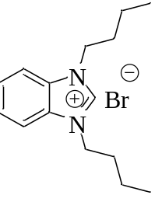
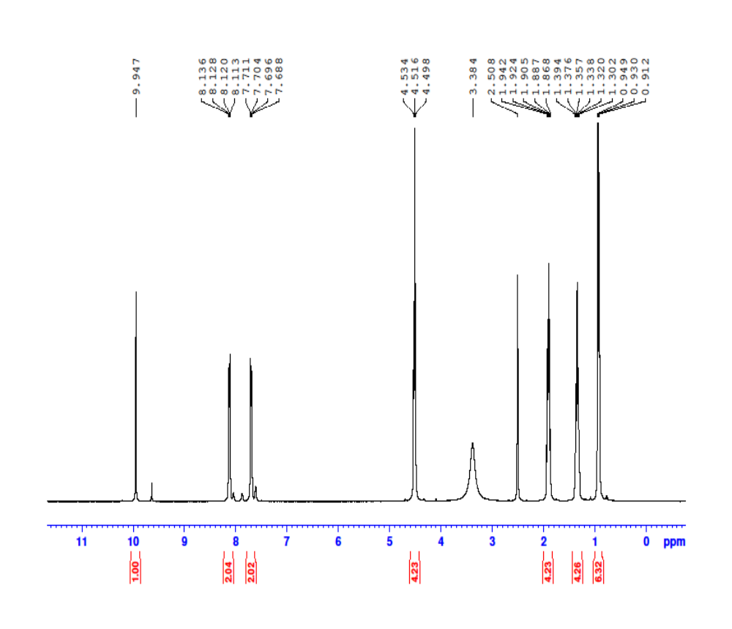Figure 1 ¹H NMR of 1,3-dibutyl-1H-benzo[d]imidazole-3-ium Bromide (3a)
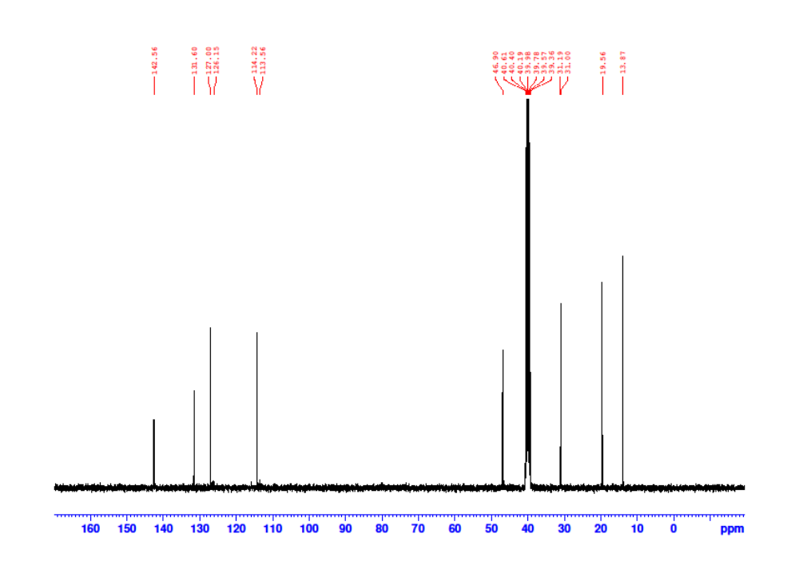
Figure 2 ¹³C NMR of 1,3-dibutyl-1H-benzo[d]imidazole-3-ium Bromide (3a)
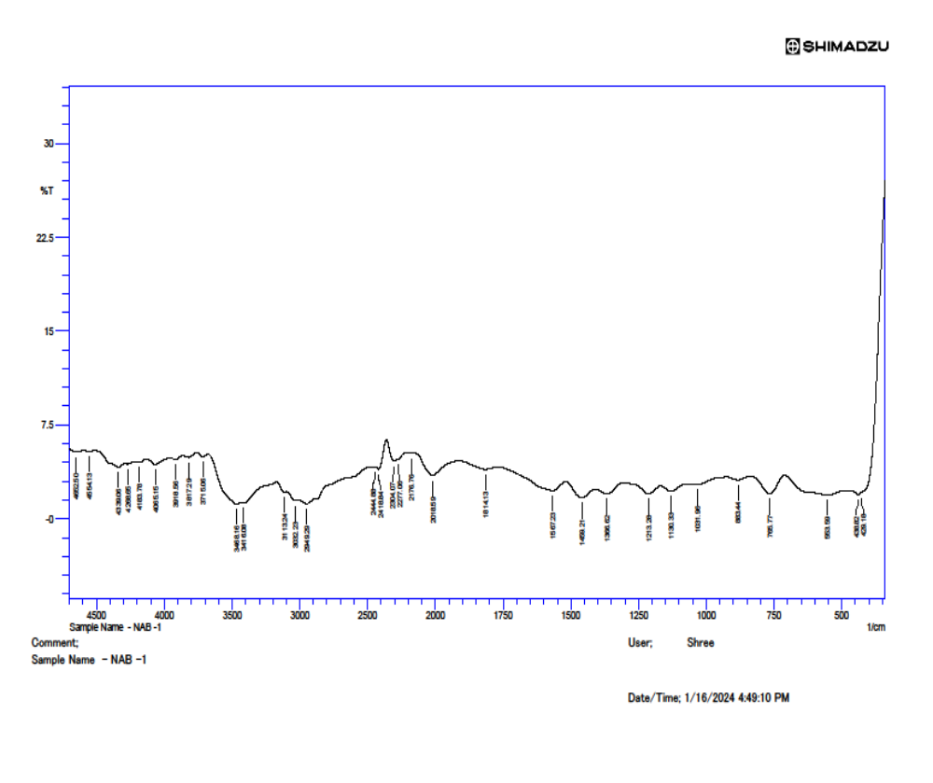Figure 3 FT-IR Spectrum of 1,3-dibutyl-1H-benzo[d]imidazole-3-ium Bromide (3a)
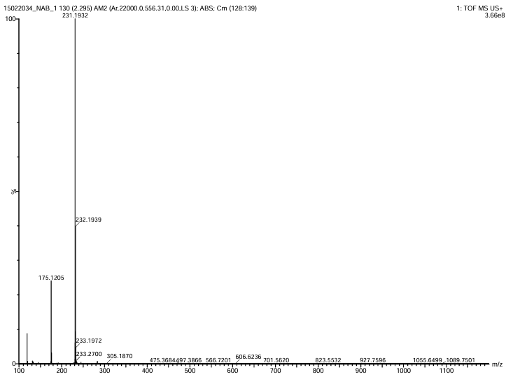Figure 4 HR-MS of 1,3-dibutyl-1H-benzo[d]imidazole-3-ium Bromide (3a)

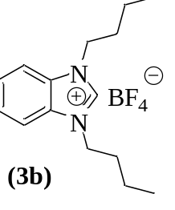
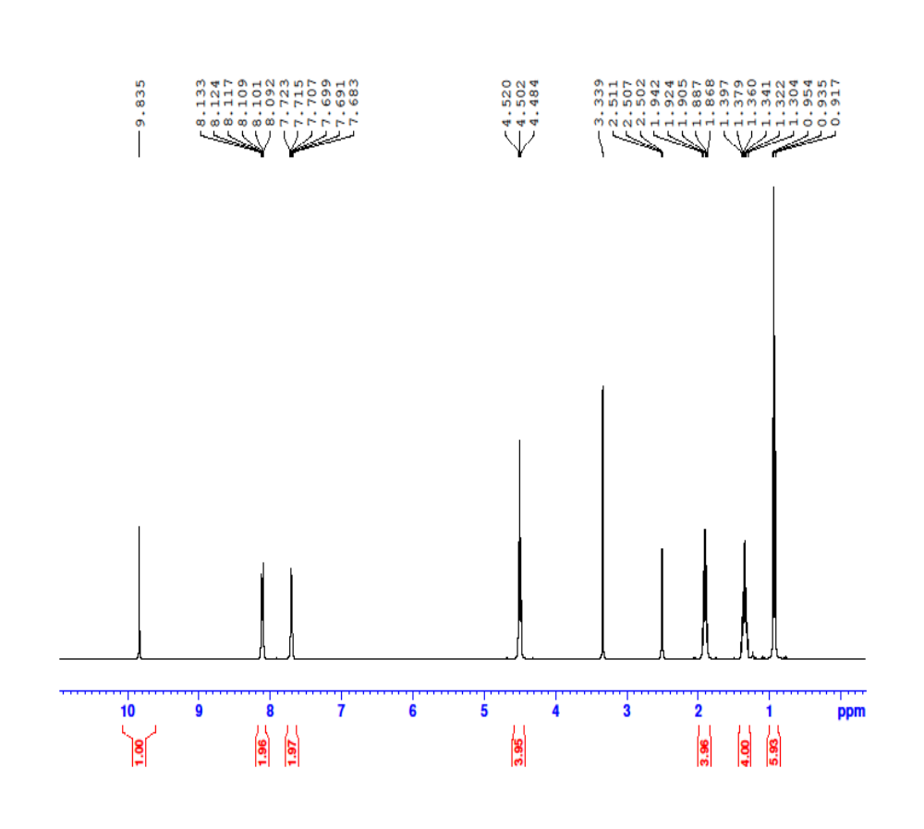Figure 5 ¹H NMR of 1,3-dibutyl-1H-benzo[d]imidazole-3-ium tetrafluoroborate (3b)
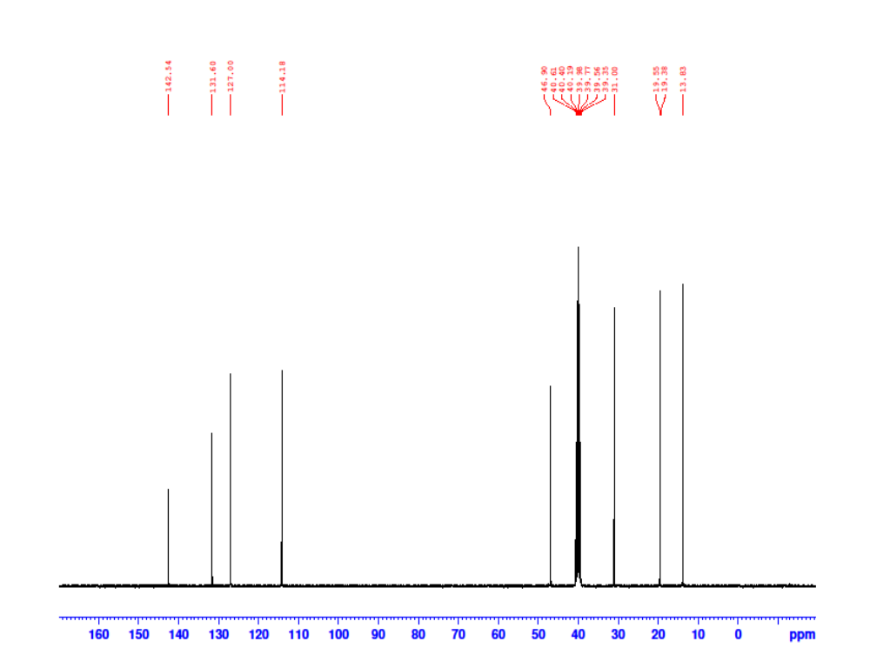Figure 6 13C NMR of 1,3-dibutyl-1H-benzo[d]imidazole-3-ium tetrafluoroborate (3b)
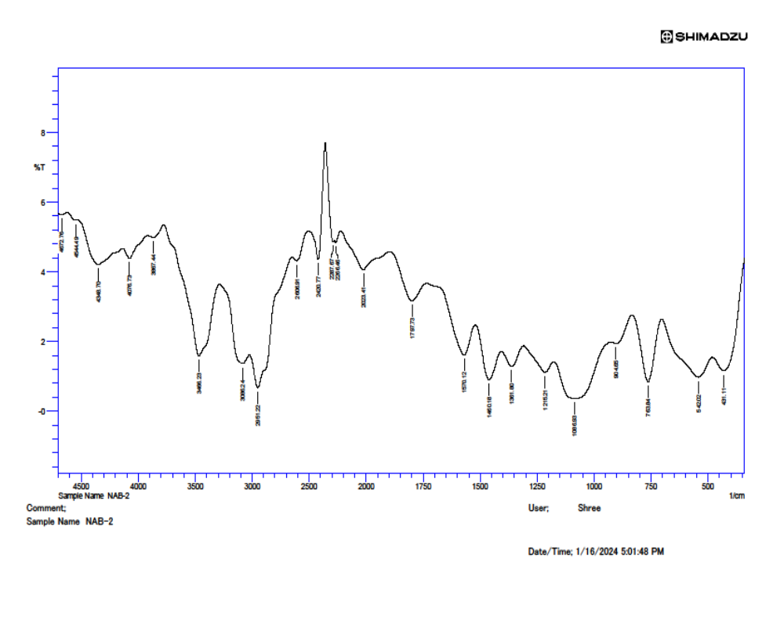Figure 7 FT-IR Spectrum of 1,3-dibutyl-1H-benzo[d]imidazole-3-ium tetrafluoro borate. (3b)
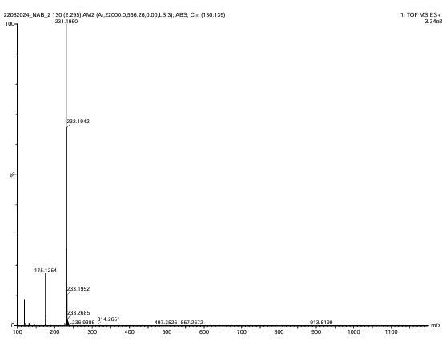
Figure 8 HR-MS spectrum of 1,3-dibutyl-1H-benzo[d]imidazole-3-ium tetrafluoroborate (3b)

Spectral Data of synthesised Thiazolidinone derivatives.
2-(4-nitrophenyl)-2-(P- tolyl) thiazolidin-4-one) (2a)
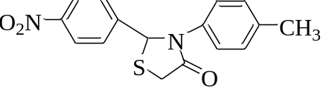
` Yield: 95%; Yellow solid; m.p 151ºC; ¹H-NMR (400MHz. DMSO-d₆/ TMS): δ= 8.12-8.15 (d, J = 8.53Hz, 2H), 7.67-7.69 (d, J = 8.50 Hz, 2H), 7.21-7.24 ( d, J = 8.17 Hz, 2H ), 7.09-7.11 (d, J = 8.07 Hz, 2H ), 6.65 ( s, J = 1H), 3.89- 4.1 (dd, J = 8.54 Hz, 2H), 2.20 (s, 3H). ¹³C-NMR (100MHz. DMSO-d₆/ TMS) δ = 170.00, 148.43, 147.78, 136.53, 135.21, 129.85, 128.68, 125.72, 124.38, 62.76, 33.00, .20.91. FT-IR (KBr, v/cm⁻¹): 3602, 3331, 3057, 2940, 2739, 2608, 2443, 2291, 2200, 1920, 1684, 1606, 1605,1521, 1360,831,618.
2-(4-chlorophenyl)-3-(p-tolyl) thiazolidin-4-one (2b)
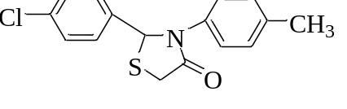
Yield: 93%, Yellow solid, m.p 168ºC; Yield: 93%, Yellow solid, m.p 168ºC; ¹H-NMR (400MHz. DMSO-d₆/ TMS): δ = 7.40-7.42 (d, J = 8.58 Hz, 2H), 7.32-7.34 (d, J = 8.55 Hz, 2H), 7.16-7.18 (d, J = 8.35 Hz, 2H), 7.08-7.10 (d, J = 8.20 Hz, 2H), 6.48 (s, 1H), 4.045–4.050 (dd, J =1.61Hz, 1H), 3.84-4.04 (dd, J = 15.51 Hz, 2H), 2.21 (t, 3H). ¹³C-NMR (100MHz. DMSO-d₆/TMS) δ = 170.75,.139.77, 136.37, 135.37, 133.39, 129.73, 129.49, 129.12, 125.93, 63.21, 33.10, 20.94. FT-IR (KBr, v/cm⁻¹): 3606, 3405, 3320, 3178, 3052, 2931, 2594, 2443, 2417, 2294, 2278, 2171, 1995, 1904, 1904, 1678, 1605, 1500, 1365, 828, 621. GC-MS (EI+); Calculated Mass: 303.05, Found: 303.06
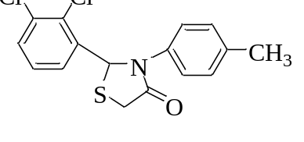
2-(2,3 -dichlorophenyl)-3-(p-tolyl)thiazolidin-4-one (2c)
Yield: 89%, Yellow solid; m.p 135ºC; ¹H-NMR (400MHz. DMSO-d₆/ TMS): δ = 7.54-7.56 (dd, J = 6.58 Hz, 1H), 7.45-7.47 (dd, J = 6.63 Hz, 1H), 7.29-7.34 (m, J = 7.96 Hz, 3 H), 7.12-7.14 (d, J = 8.26 Hz, 2H), 6.67 (s, 1H), 3.86-4.01 (q, J = 15.82 Hz, 2H), 2.22 (s, 3H). ¹³C-NMR (100MHz. DMSO-d₆/TMS) δ = 170.95,.136.49, 135.24, 132.82, 130.80, 129.98, 129.88, 129.13, 125.17, 61.69, 32.79, 20.93. FT-IR (KBr, v/cm⁻¹): 3531, 3350, 3277, 3059, 2916, 2745, 2606, 2446, 2418, 2298, 2277, 2180, 2011, 1906, 1685, 1517, 1391, 1312, 1246, 1135, 811, 758, 625. GC-MS (EI+); Calculated Mass: 337.01, Found: 336.85

2-(3-bromophenyl)-3-(p-tolyl)thiazolidin-4-one (2d)
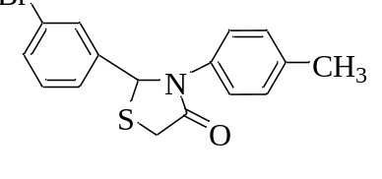
Yield: 94%, Yellow solid; m.p 135ºC; ¹H NMR (400 MHz. DMSO-d₆/ TMS) δ = 7.50 (s, 1H), 7.39-7.44 (t, J = 9.87 Hz, 2H), 7.23-7.27 (t, J = 7.84 Hz, 1H), 7.18-7.20 (d, J = 8.39 Hz, 2H) 7.10-7.12 (d, J = 8.3 Hz, 2H), 6.47 (s, 2H), 3.84-4.048 (dd, J = 15.61 Hz, 2H), 2.21 (s, 3H) ¹³C-NMR (100MHz. DMSO-d₆/ TMS) δ = 170.77, 143.61, 136.40, 135.32, 131.80, 131.35, 130.21, 130, 129.78, 126.52, 125.79, 122.18, 63.03, 33.05, 20.94. FT-IR (KBr, v/cm⁻¹): 3606, 3343, 3053, 2933, 2741, 2587, 2455, 2421, 2291, 2265, 2158, 2064, 1891, 1680, 1591, 1513, 1363, 1219, 1117, 886, 802, 674, 603.
2-(3-fluorophenyl)-3-(6.47p-tolyl) thiazolidin-4-one (2e)
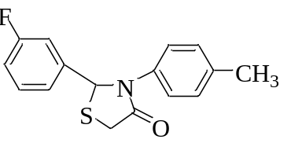
Yield: 94%, Yellow solid, m.p 120º C, ¹H-NMR (400MHz. DMSO-d₆/TMS) δ = 7.29-7.35 (qt, J = 7.77 Hz, 1H), 7.18-7.26 (m, J = 8.22 Hz, 4H) 7.03-7.11 (m, J = 8.20 Hz, 3H ), 6.49 (s, 1H), 4.04-4.08 (d, J = 15.58 Hz, 1H), 3.84-3.88 (d, J = 15.73 Hz, 1H), 2.21 (s, 3H). ¹³C-NMR (100MHz. DMSO-d₆/TMS) δ = 170.79, 163.81, 161.38, 143.82, 143.75, 136.37, 135.34, 131.19, 131.11, 123.60, 115.93, 114.15, 63.16, 33.02, 20.95. FT-IR (KBr, v/cm⁻¹): 3603, 3336, 3242, 3051, 2936, 2726, 2590, 2511, 2456, 2420, 2293, 2267, 2165, 2062, 1878, 1677, 1612, 1487, 1378, 1338, 1240, 1135, 1031, 949, 896, 873, 798, 603.
2-(4-fluorophenyl)-3-(p-tolyl) thiazolidin-4-one (2f)
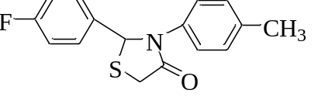
Yield: 95%, Yellow solid; m.p 155 ºC, ¹H-NMR (400MHz. DMSO-d₆/TMS) δ = 7.41-7.52 (t, J = 7.75 Hz, 2H), 7.082-7.168 (m, J = 9.19 Hz, 6H), 6.47 ( s, 1H), 3.85-4.04 (dd, J = 15.68 Hz, 2H), 3.85-3.89 (d, J = Hz, 1H), 2.20 (s, 3H). ¹³C-NMR (100MHz, DMSO-d₆) δ = 170.74, 163.50, 161.06, 136.83, 136.81, 136.35, 135.38, 129.90, 129.81, 129.71, 126.06, 116.05, 115.84, 63.25, 33.14, 20.95. FT-IR (KBr, v/cm⁻¹):3596, 3418, 3330, 3037, 3037, 2935, 2590, 2443, 2339, 2154, 2007, 1903, 1676, 1509, 1367, 1222, 1122, 1133, 1036, 829, 623.
2-(3,4-dimethoxyphenyl)-3-(p-tolyl)thiazolidin-4-one (2g)
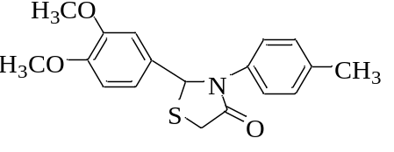
Yield: 76%, Creamish white solid; m.p 125ºC; ¹H NMR (400 MHz. DMSO-d₆/ TMS) δ = 7.45-7.47 (d, J = 7.46 Hz, 2H), 7.01-7.12 (m, J = 6.87 Hz, 3H), 6.95 (s, 1H), 6.78 (s, 1H), 5.12 (s, 1H), 3.68-3.78 (m, 8H), 2.25 (s, 3H). ¹³C-NMR (100MHz. DMSO-d₆/ TMS) δ = 169.11, 149.00, 148.82, 135.27, 132.98, 130.00, 129.62, 129.18, 128.60, 124.36, 121.92, 119.73, 113.37, 55.91, 31.70, 20.92, FT-IR (KBr, v/cm⁻¹): 1673, 1506, 1256, 1137, 1030, 816, 507
2-(2-hydroxyphenyl)-3-(p-tolyl)thiazolidin-4-one (2h)
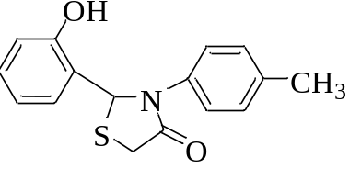
Yield: 79%, Yellow solid; m.p 142ºC; ¹H NMR (400 MHz. DMSO-d₆/ TMS) δ = 8.96 (s, 1H), 7.65 (s, 1H), 7.26-7.63 (m, 6H), 6.95-6.99 (m, 2H), 3.74-3.87 (dd, 2H), 3.41 (s, 1H), 2.34 (s, 3H), ¹³C-NMR (100MHz. DMSO-d₆/ TMS) δ = 163.74, 145.86, 136.98, 133.53, 132.95, 130.42, 121.70, 119.78, 119.55, 117.02, 64.15, 33.04. FT-IR (KBr, v/cm⁻¹): 1649, 1601, 1554, 1506, 1328, 1244, 816, 507.
2-(2,4-dichlorophenyl)-3-(p-tolyl)thiazolidin-4-one (2i)
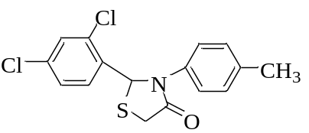
Yield: 88 %, Creamish Yellow solid; m.p 152ºC; ¹H NMR (400 MHz. DMSO-d₆/ TMS) δ = 7.63 (s, 1H), 7.56-7.58 (d, J = 8.35 Hz, 1H), 7.41-7.43 (d, J = 8.10 Hz, 1H), 7.30-7.32 (d, J = 8.10 Hz, 2H), 7.17-7.19 (d, J = 7.97 Hz, 2H), 6.77 (s, 1H), 3.92-4.04 (dd, J = 15.63 Hz, 2H), 2.27 (s, 3H). ¹³C-NMR (100MHz. DMSO-d₆/ TMS) δ = 170.87, 136.58, 135.15, 134.13, 133.05, 129.87, 128.43, 125.39, 60.75, 20.95. FT-IR (KBr, v/cm⁻¹): 1677, 1508, 1331, 1098, 1042, 864, 809, 495
2-(2-chlorophenyl)-3-(p-tolyl)thiazolidin-4-one (2k)
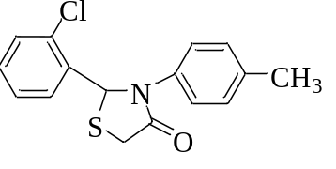
Yield: 91 %, Creamish Yellow solid; m.p 164ºC; ¹H NMR (400 MHz. DMSO-d₆/ TMS) δ = 7.46-7.48 (d, J = 6.27 Hz, 1H), 7.39-7.41 (d, J = 8.18 Hz, 1H) 7.26-7.28 (d, J = 7.85 Hz, 4H), 7.11-7.13 (d, J = 8.03 Hz, 2H), 6.72 (s, 1H), 3.86-4.00 (dd, J = 15.73 Hz, 2H), 2.21 (s, 3H). ¹³C-NMR (100MHz. DMSO-d₆/ TMS) δ = 170.96, 136.41, 135.33, 132.01, 130.46, 129.81, 128.22, 125.34, 61.24, 20.95. FT-IR (KBr, v/cm⁻¹): 1679, 1518, 1373, 1320, 1037, 739, 525, 495.

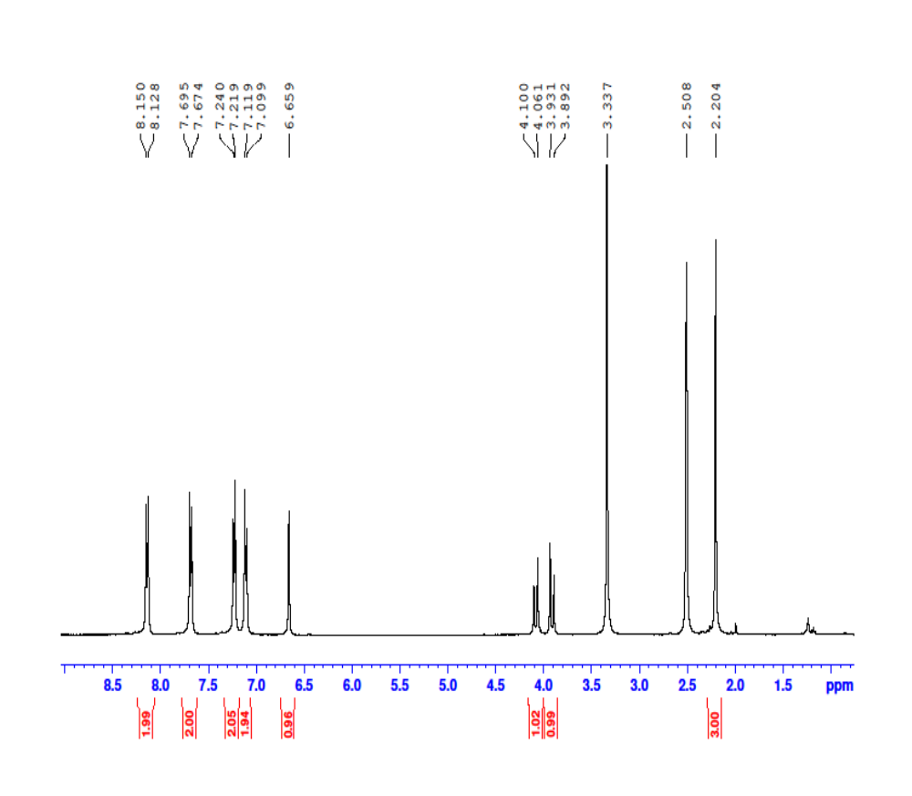Figure 9 ¹H NMR of 2-(4-nitrophenyl)-2-(P- tolyl) thiazolidin-4-one) (2a)
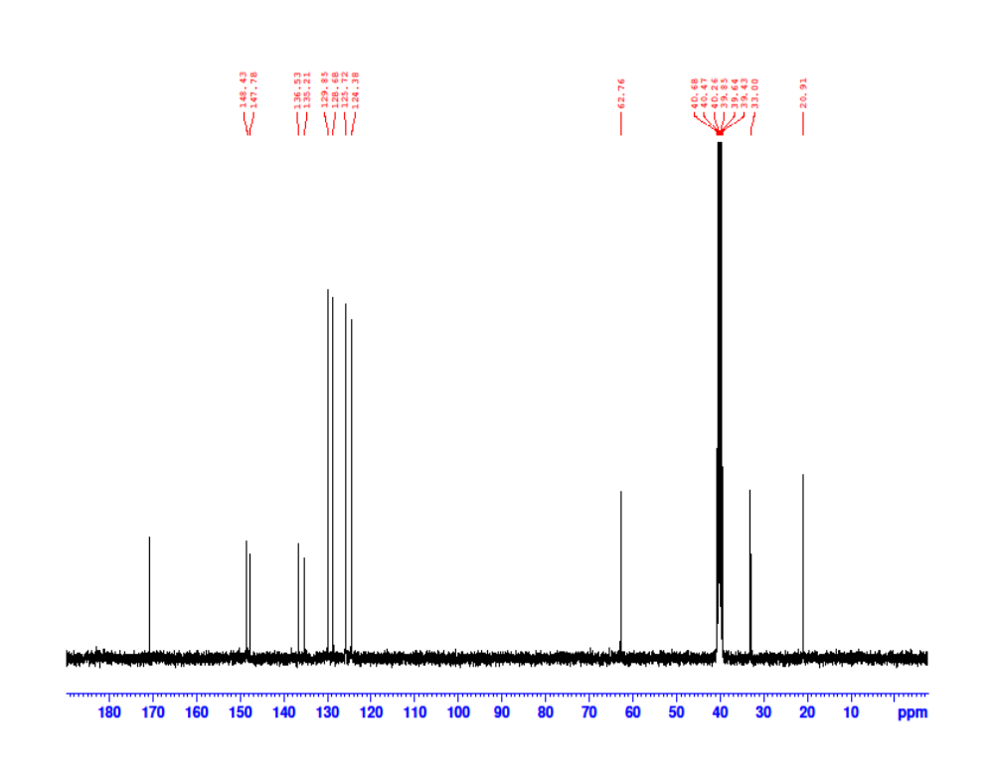
Figure 10 ¹³C NMR of 2-(4-nitrophenyl)-2-(P- tolyl) thiazolidin-4-one) (2a)
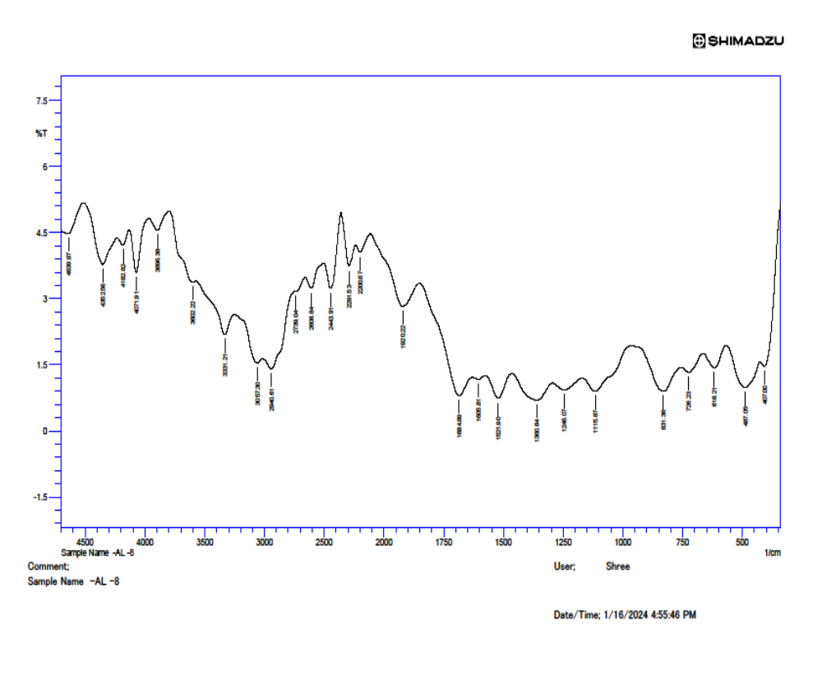
Figure 11 FT-IR Spectrum of 2-(4-nitrophenyl)-2-(P- tolyl) thiazolidin-4-one) (2a)
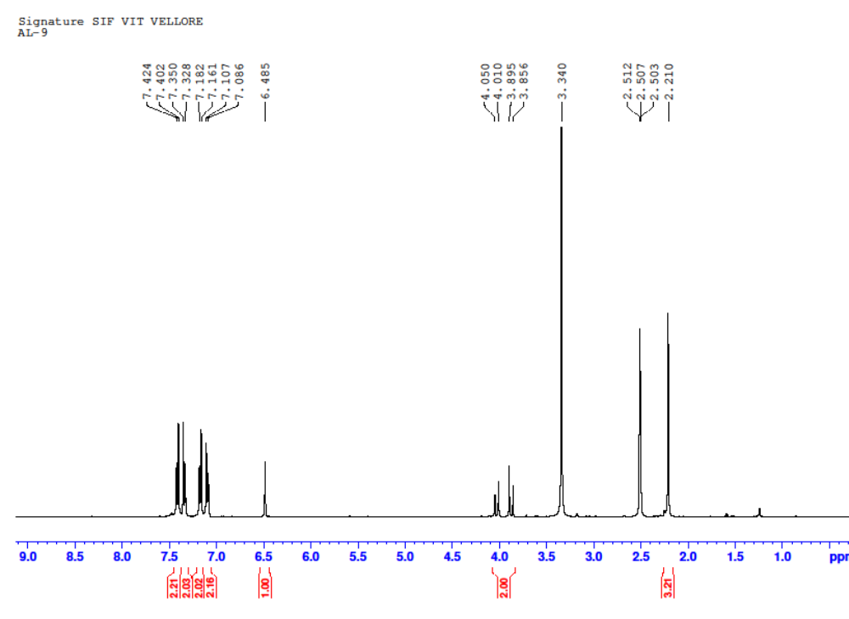
Figure 12 ¹H-NMR of 2-(4-chlorophenyl)-3-(p-tolyl) thiazolidin-4-one. (2b)
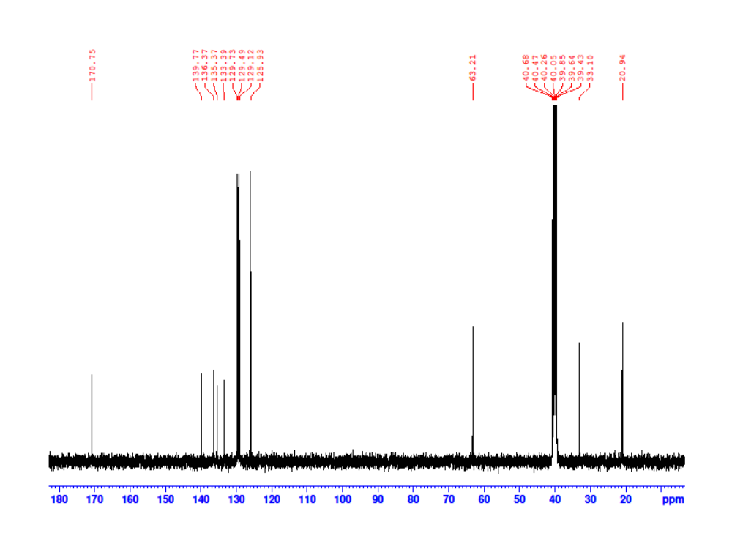
Figure 13 ¹³C-NMR of 2-(4-chlorophenyl)-3-(p-tolyl) thiazolidin-4-one. (2b)
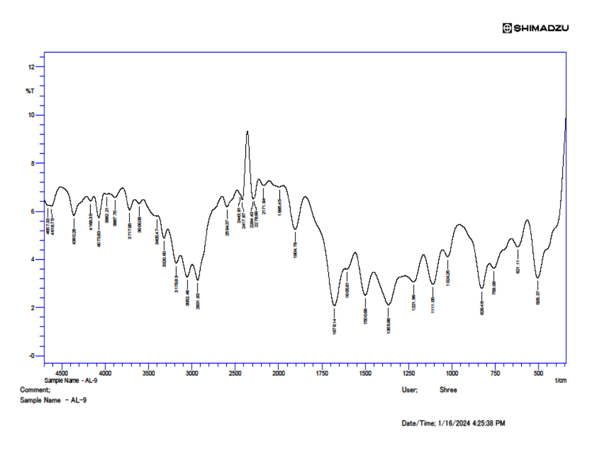Figure 14 FT-IR Spectrum of 2-(4-chlorophenyl)-3-(p-tolyl) thiazolidin-4-one. (2b)
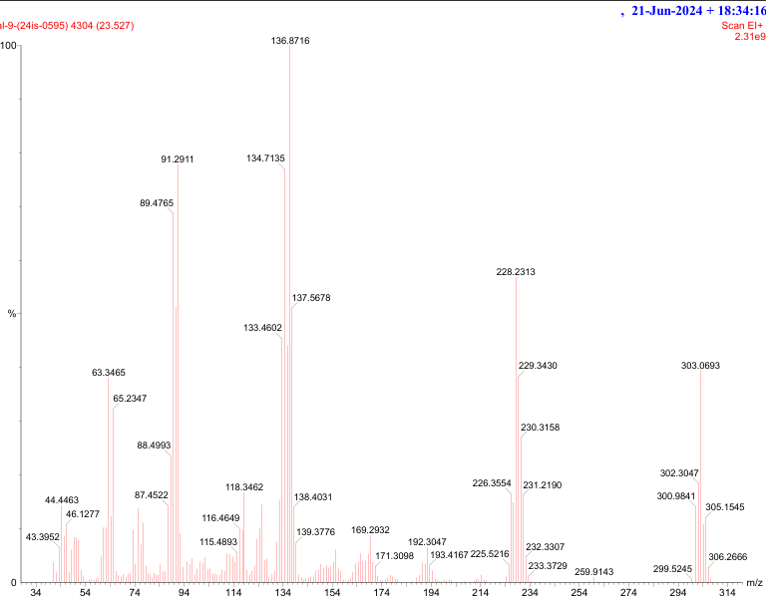
Figure 15 GC-MS (EI+) Spectrum of 2-(4-chlorophenyl)-3-(p-tolyl) thiazolidin-4-one (2b).
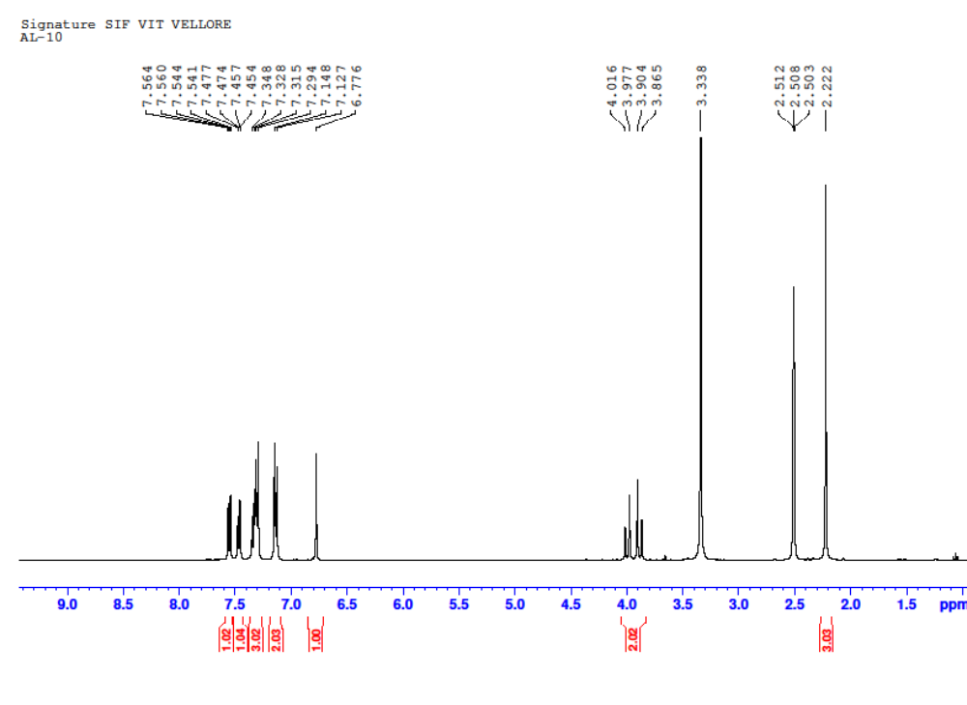Figure 16 1H NMR of 2-(2, 3-dichlorophenyl)-3-(p-tolyl) thiazolidin-4-one (2c)
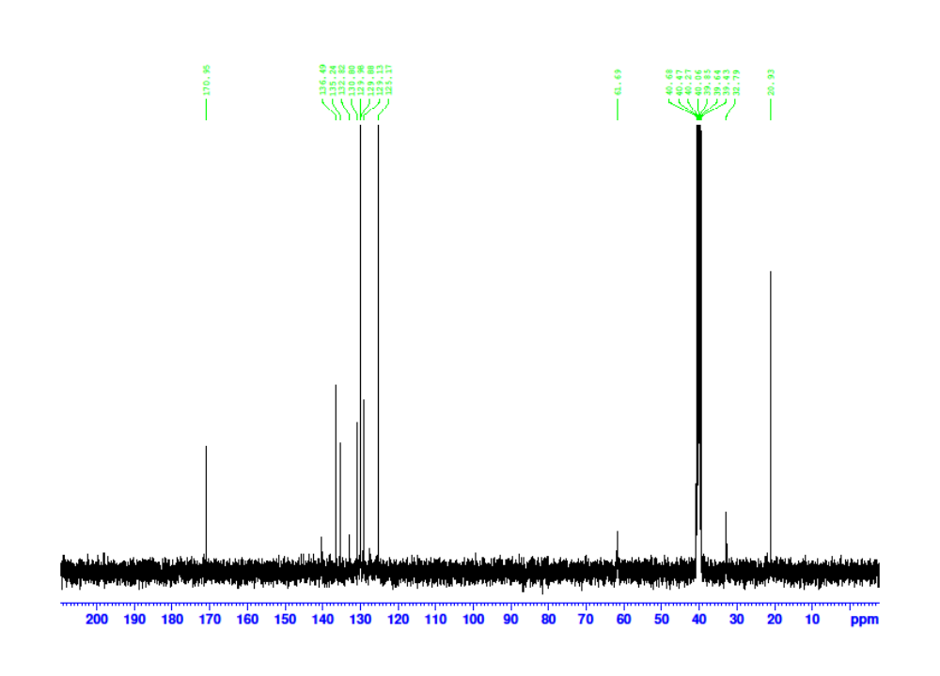Figure 17 13C NMR of 2-(2, 3-dichlorophenyl)-3-(p-tolyl) thiazolidin-4-one. (2c)
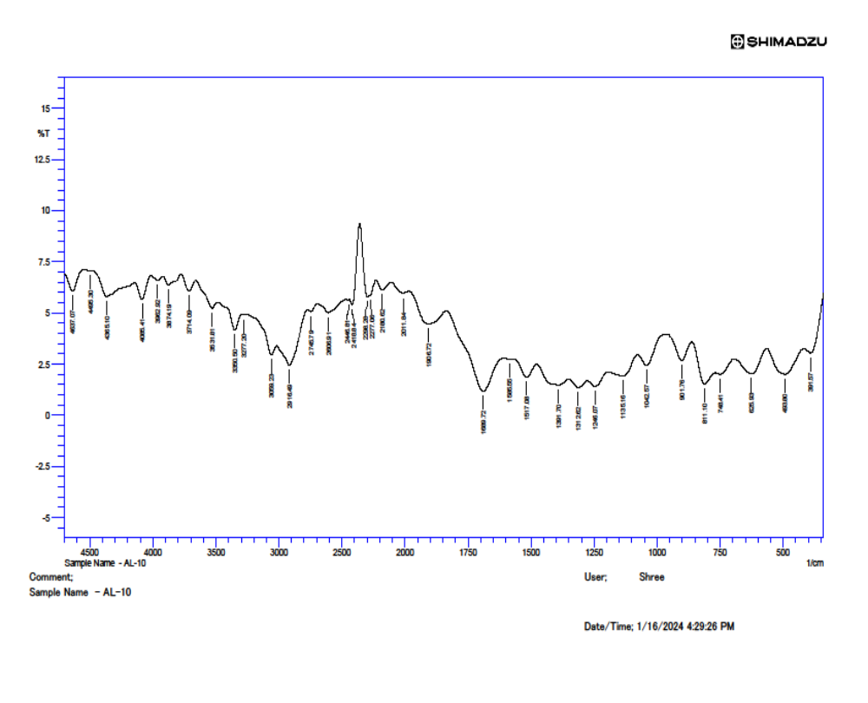Figure 18 FT-IR Spectrum of 2-(2, 3-dichlorophenyl)-3-(p-tolyl) thiazolidin-4-one. (2c)
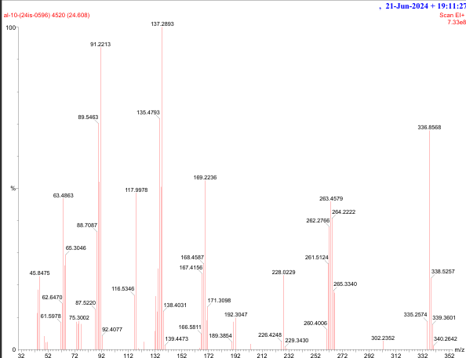Figure 19 GC-MS (EI+) Spectrum of 2-(2, 3-dichlorophenyl)-3-(p-tolyl) thiazolidin-4-one. (2c)
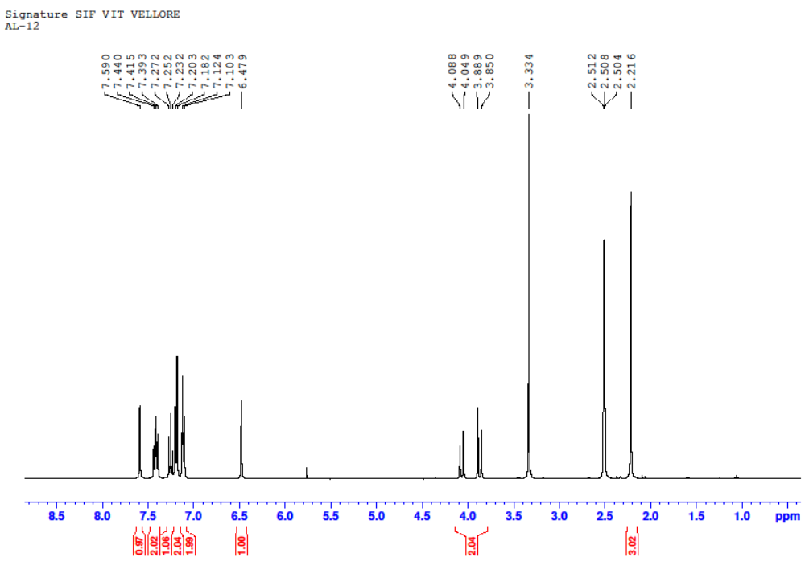Figure 20. Figure 20 ¹H-NMR data of 2-(3-bromophenyl)-3-(p-tolyl)thiazolidin-4-one (2d)
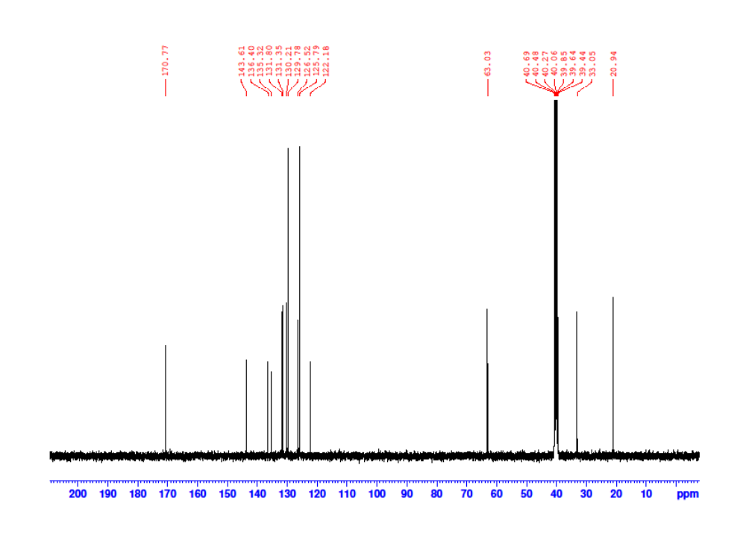Figure 21. Figure 21 13C NMR data of 2-(3-bromophenyl)-3-(p-tolyl)thiazolidin-4-one (2d)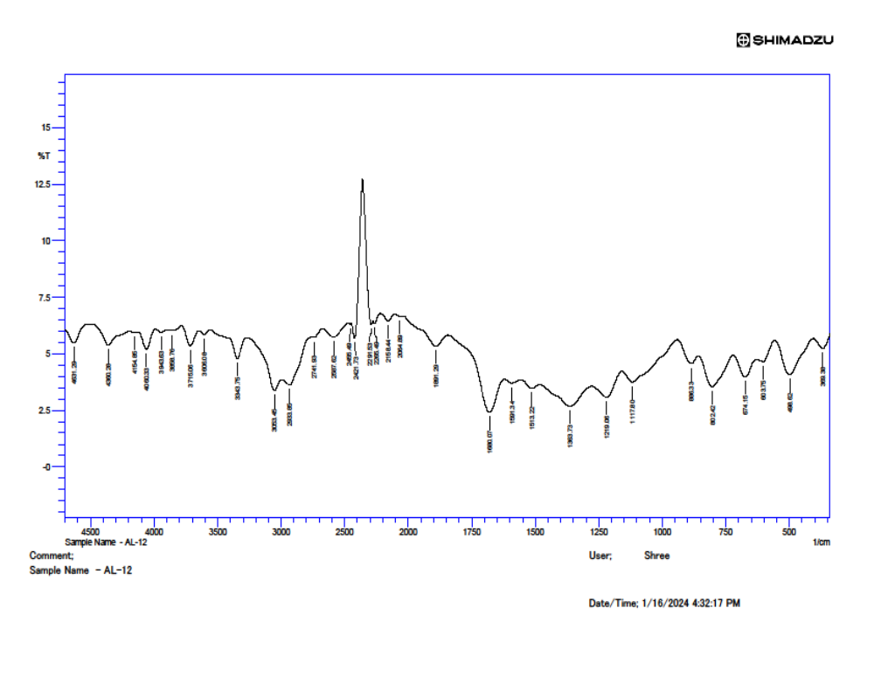Figure 22 FT-IR Spectrum of 2-(3-bromophenyl)-3-(p-tolyl)thiazolidin-4-one (2d)
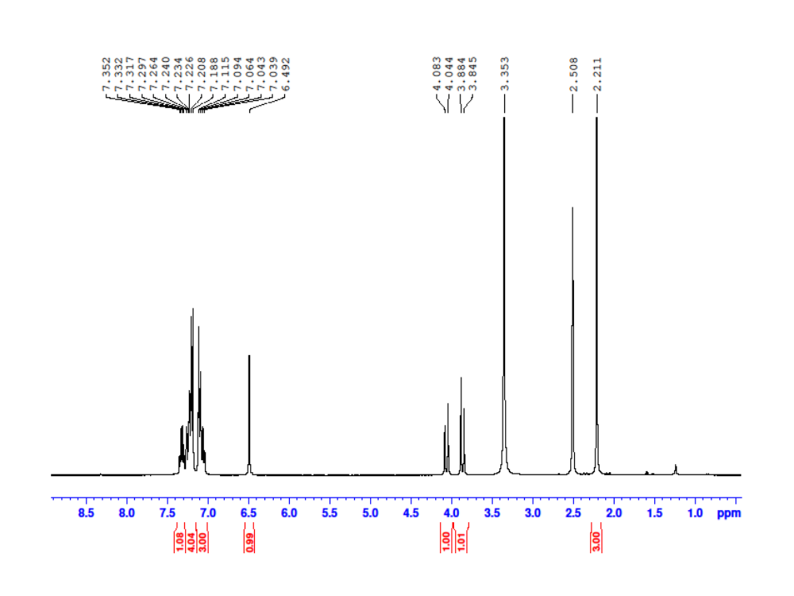Figure 23 ¹H NMR data of 2-(3-fluorophenyl)-3-(p-tolyl) thiazolidin-4-one. (2e)
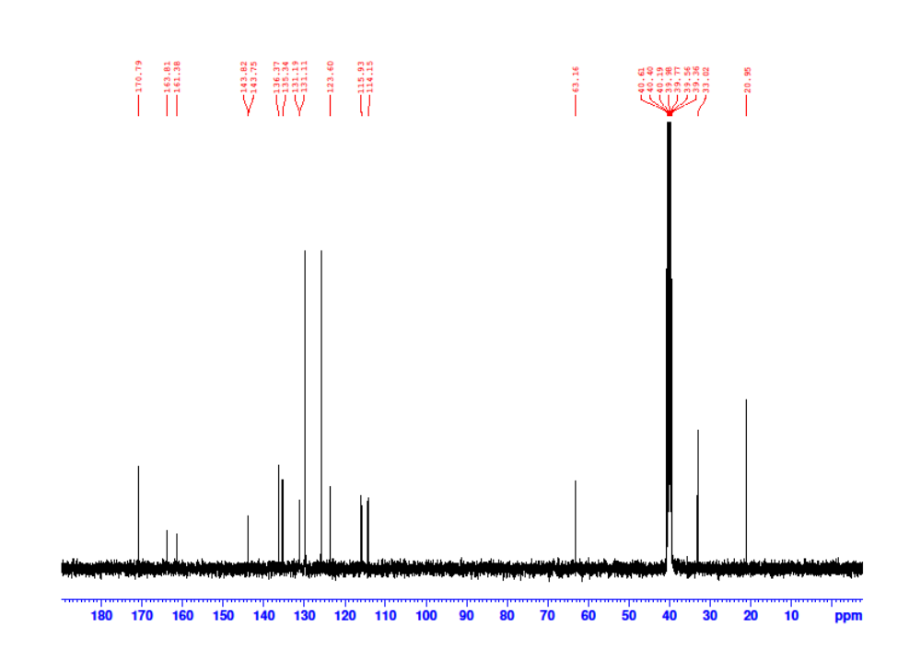
Figure 24 ¹³C NMR data of 2-(3-fluorophenyl)-3-(p-tolyl) thiazolidin-4-one. (2e)

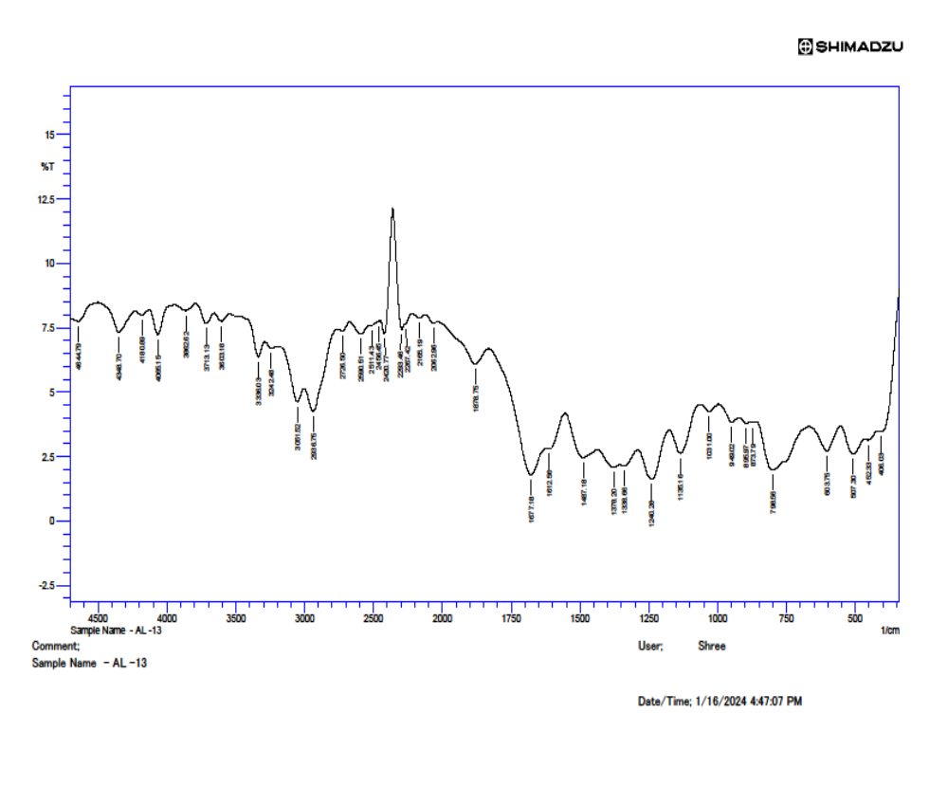Figure 25 FT-IR Spectrum of 2-(3-fluorophenyl)-3-(p-tolyl) thiazolidin-4-one. (2e)
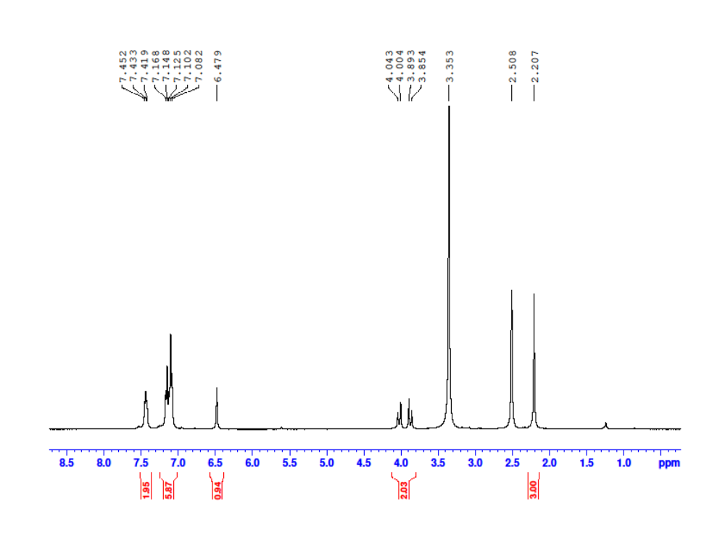
Figure 26 ¹H-NMR data of 2-(4-fluorophenyl)-3-(p-tolyl) thiazolidin-4-one (2f)

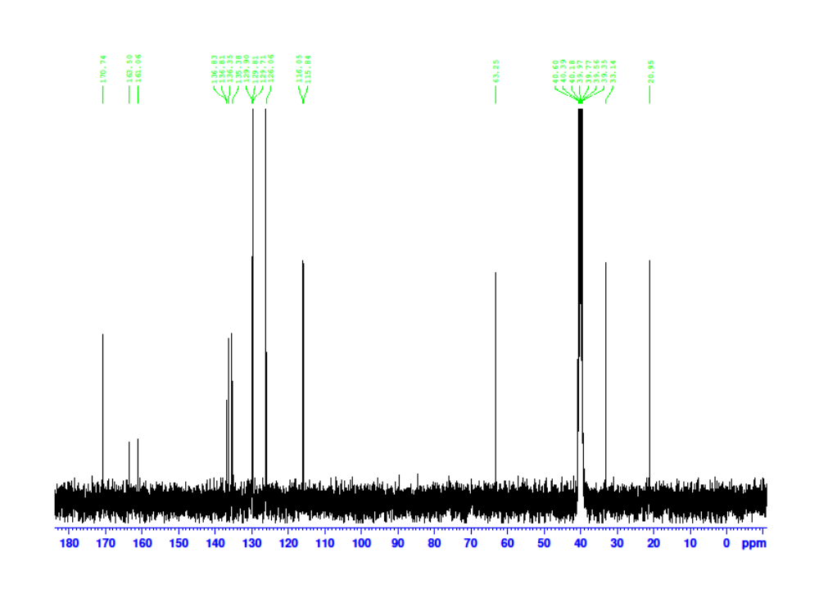Figure 27 ¹³C NMR data of 2-(4-fluorophenyl)-3-(p-tolyl) thiazolidin-4-one (2f)
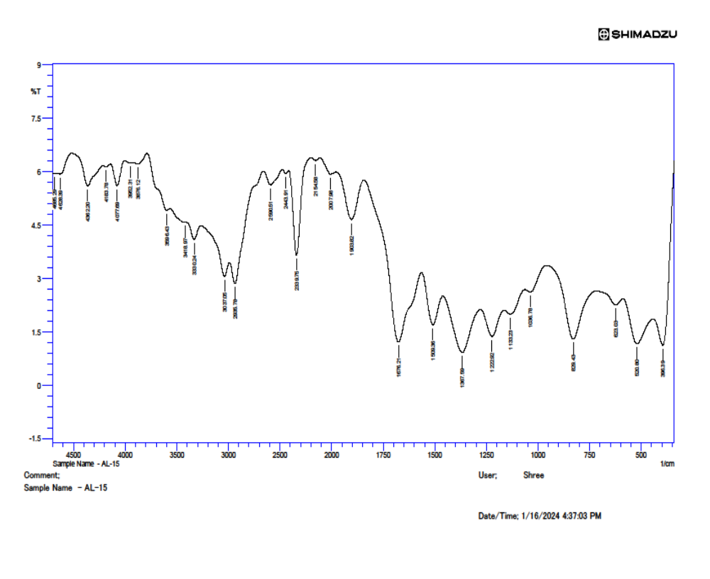Figure 28 FT-IR Spectrum of 2-(4-fluorophenyl)-3-(p-tolyl) thiazolidin-4-one (2f)
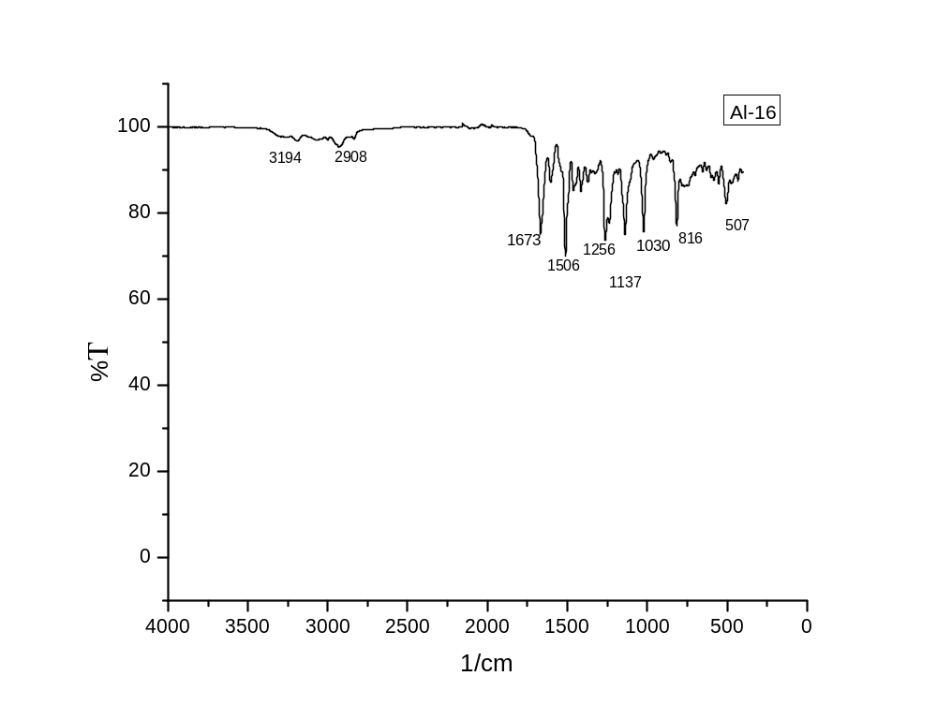
Figure 29 FT-IR Spectrum of 2-(3,4-dimethoxyphenyl)-3-(p-tolyl)thiazolidin-4-one (2g)
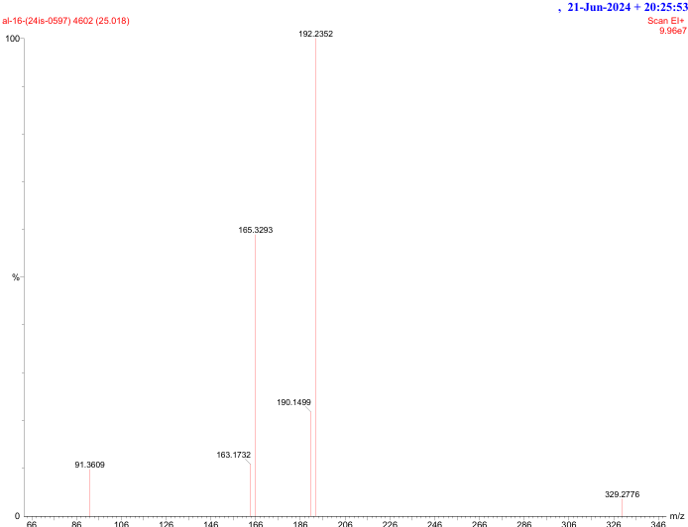
Figure 30 GC-MS (EI+) Spectrum of 2-(3,4-dimethoxyphenyl)-3-(p-tolyl)thiazolidin-4-one (2g)
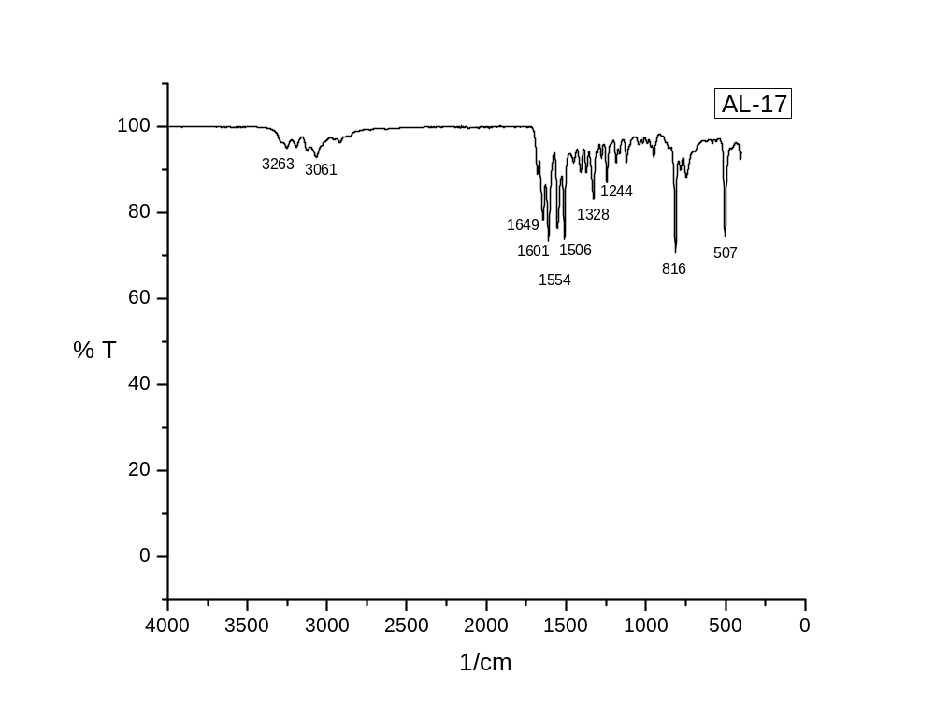Figure 31 FT-IR Spectrum of 2-(2-hydroxyphenyl)-3-(p-tolyl)thiazolidin-4-one (2h)
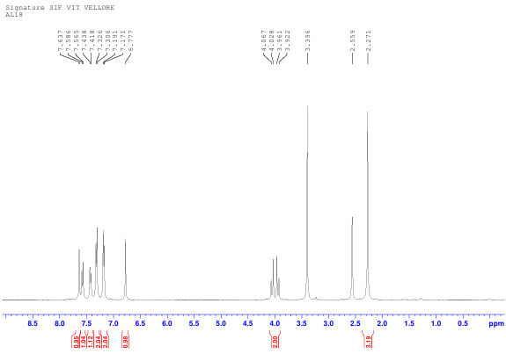
Figure 32 ¹H-NMR Spectrum of 2-(2,4-dichlorophenyl)-3-(p-tolyl)thiazolidin-4-one (2i)
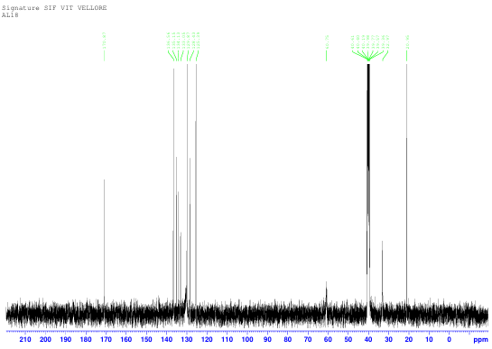
Figure 33 ¹³C-NMR Spectrum of of 2-(2,4-dichlorophenyl)-3-(p-tolyl)thiazolidin-4-one (2i)
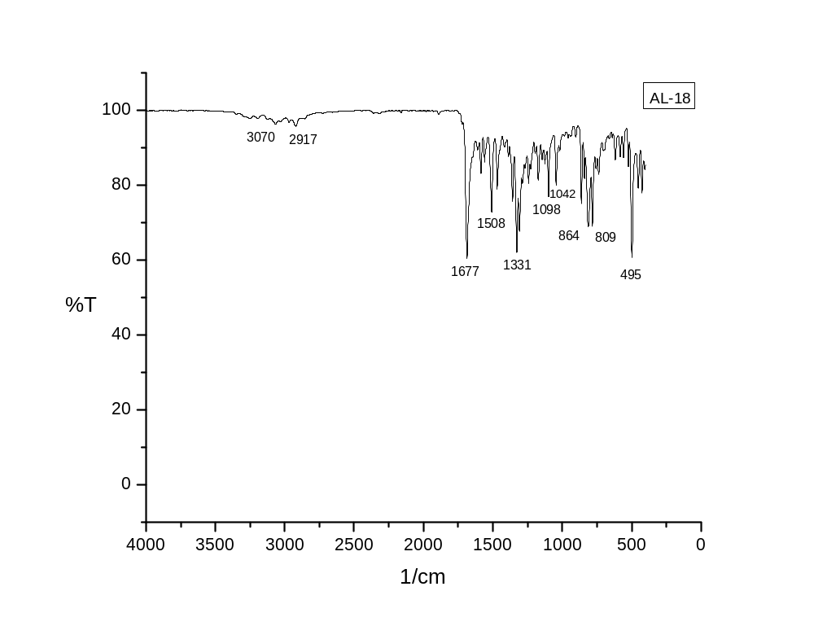Figure 34 FT-IR Spectrum of 2-(2,4-dichlorophenyl)-3-(p-tolyl)thiazolidin-4-one (2i)
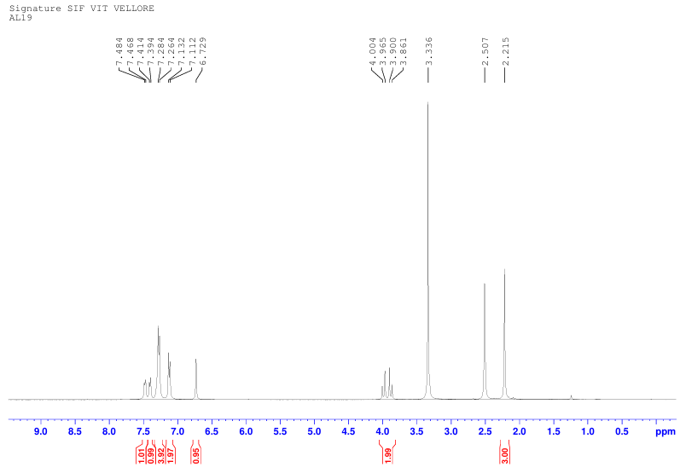Figure 35 1H-NMR Spectrum of 2-(2-chlorophenyl)-3-(p-tolyl)thiazolidin-4-one (2j)
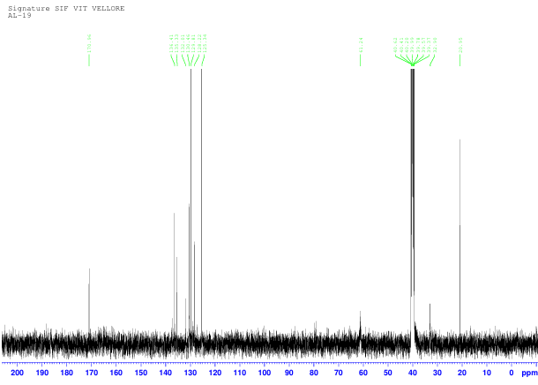Figure 36 13C-NMR Spectrum of 2-(2-chlorophenyl)-3-(p-tolyl)thiazolidin-4-one (2j)

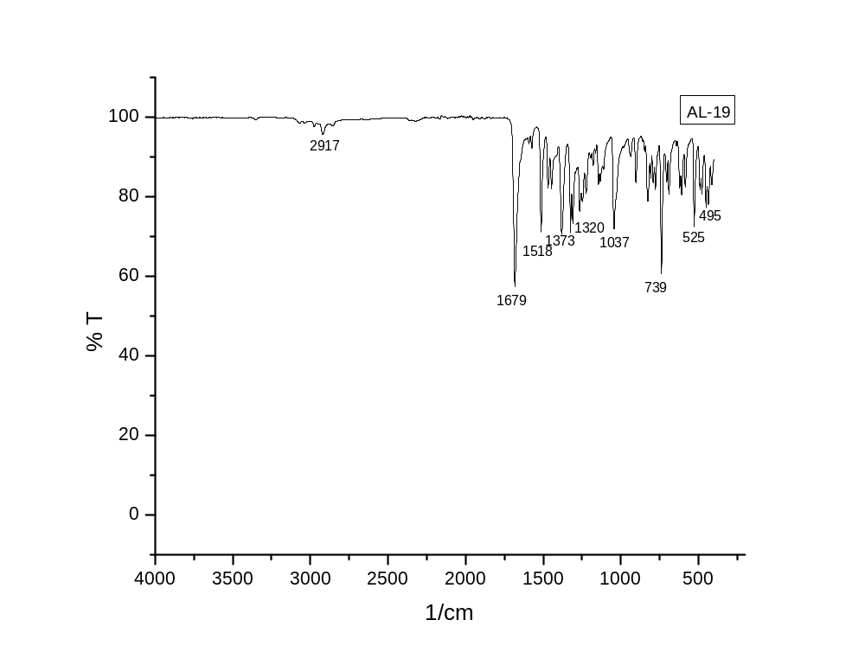Figure 37 FT-IR Spectrum of 2-(2-chlorophenyl)-3-(p-tolyl)thiazolidin-4-one (2j)

