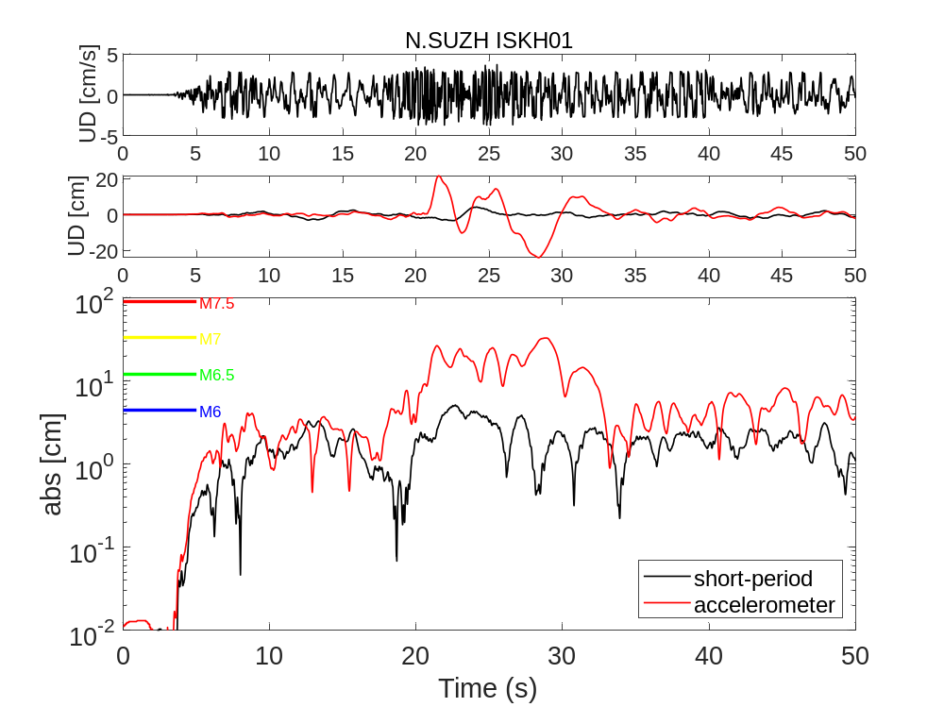
(a)
(b)
(c)
Supporting Figure S1: Comparison between the Hi-net short-period sensor (N.SUZH) and KiK-net borehole accelerometer (ISKH01). They are at the same location. (a) Raw velocity record in UD component. (b) Displacement of the short-period sensor (black) and acceleration sensor (red) in the UD component. (c) Absolute amplitude of displacement of the short-period sensor (black) and acceleration sensor (red). The associated magnitude was shown at the left top.
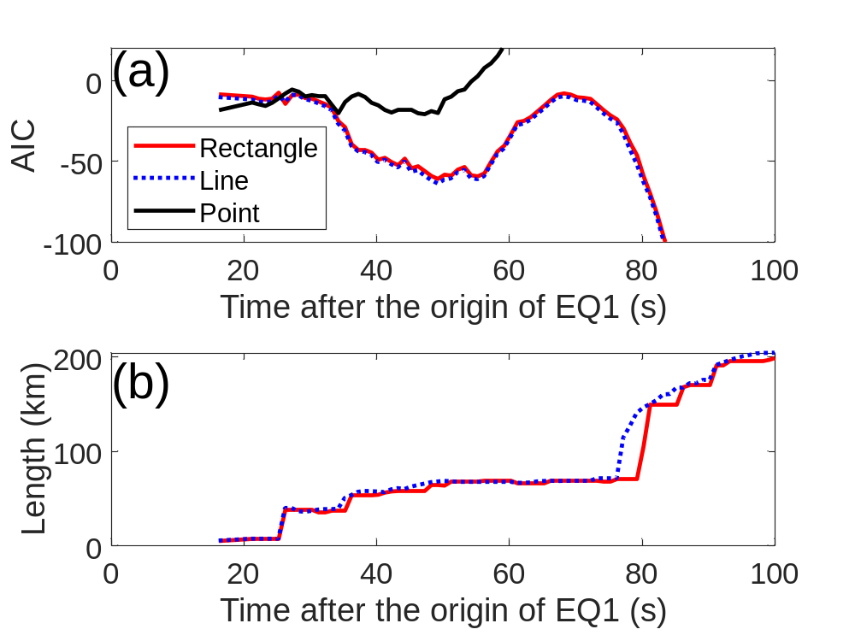
Supporting Figure S2: Time history of (a) the AIC of the three models in the XYtracker method and (b) the rupture length of the rectangle and line source models. The red, blue, and black lines show the rectangle, line, and point-source models, respectively. In the upper panel, the point-source model is the minimum up to 25 s, and the line-source model is the minimum after 28 s.

