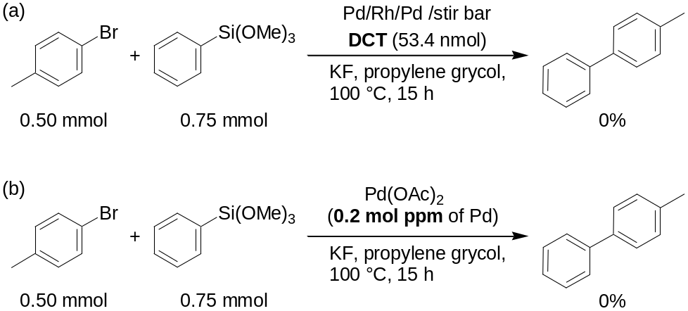
Scheme 1. (a) The Hiyama coupling reaction in the presence of DCT. (b) The Hiyama coupling reaction using 0.2 mol ppm of Pd.

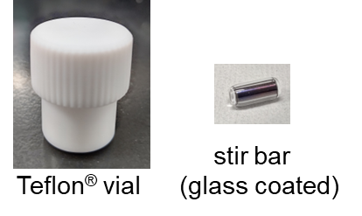
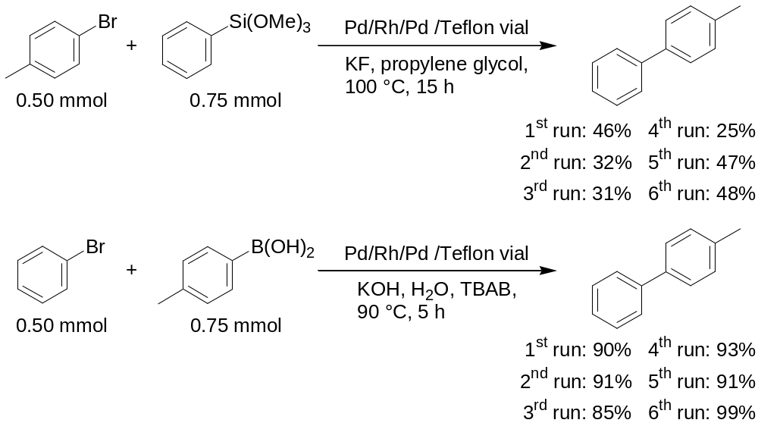
Scheme 2. The reusability of the Pd/Rh/Pd-immobilized Teflon® vial.

