Supporting Information for
A Method for Recycling the Pd Catalyst at Molar ppm Level

Shohei Masuu,ª Misaki Goto,^{s} Saki Miyamoto,ª Tomoya Kiguchi,ª Tsutomu Shinagawa,^{b} Yoshimasa Matsumura,ª Osamu Shimomuraª and Atsushi Ohtaka,^{a,*}

ªDepartment of Applied Chemistry, Faculty of Engineering, Osaka Institute of Technology, 5-16-1 Ohmiya, Asahi, Osaka 535-8585, Japan. ^{b}Electronic Materials Research Division, Morinomiya Center, Osaka Research Institute of Industrial Science and Technology (ORIST), 1-6-50 Morinomiya, Joto, Osaka, 536-8553, Japan.

General comments
¹H NMR spectra in CDCl₃ were recorded with a 400 MHz NMR spectrometer (ECZ400S, JEOL Ltd.) using tetramethylsilane (δ = 0) as an internal standard. Inductively coupled plasma optical emission spectrometry (ICP-OES) was performed using iCAP-7400 (Thermo Fisher Scientific Inc.). Field Emission Scanning electron microscope (FE-SEM) images of the deposits on the FTO substrates were obtained using an electron microscope (JEOL JSM-7800F, JSM-6700F) with an acceleration voltage of 5.0 kV.

Typical procedures for the Hiyama coupling reaction with mol ppm level of Pd loading.
Trimethoxyphenylsilane (148 mg, 0.75 mmol), 4-bromotoluene (85.5 mg, 0.5 mmol), potassium fluoride (87.1 mg, 1.5 mmol), propylene glycol (1 mL), and 1.0 mmol/L of THF solution of Pd(OAc)₂ (10 μL, 2 mol ppm relative to 4-bromotoluene) were added to a screw-capped vial (no. 02, Maruemu Co., Osaka, Japan) with stir bar. After stirring vigorously (1350 rpm) at 100 °C for 1 h under air, the vial was immersed in water (∼20 °C) for about 10 min to cool the reaction mixture to room temperature. The recovered stir bar was washed with H₂O (1.0 mL × 3) and diethyl ether (1.0 mL × 3), then dried in vacuo, and reused. The aqueous solution was extracted five times with diethyl ether. The combined organic extracts were dried over anhydrous MgSO₄ and evaporation of the solvent afforded the desired product. Characterization of the product was established by comparison of their ¹H NMR spectra with those of authentic samples.

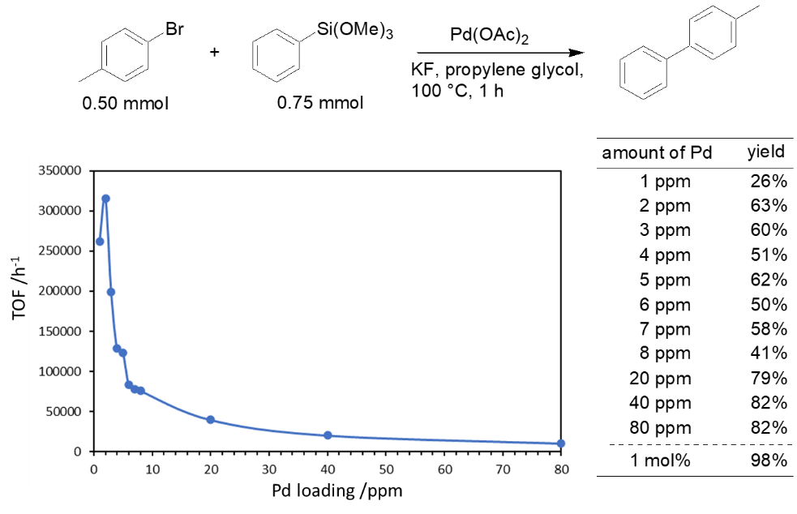
Scheme S1. Hiyama coupling reaction with various Pd loading.

Typical procedures for the Suzuki coupling reaction with mol ppm level of Pd loading..
4-Methylphenylboronic acid (102 mg, 0.75 mmol), bromobenzene (78.5 mg, 0.5 mmol), 1.5 mol/L aqueous KOH solution (1 mL), and 1.0 mmol/L of THF solution of Pd(OAc)₂ (10 μL, 2 mol ppm relative to bromobenzene) were added to a screw-capped vial (no. 02, Maruemu Co., Osaka, Japan) with stir bar. After stirring vigorously (1350 rpm) at 90 °C for 1 h under air, the vial was immersed in water (∼20 °C) for about 10 min to cool the reaction mixture to room temperature. The recovered stir bar was washed with H₂O (1.0 mL × 3) and diethyl ether (1.0 mL × 3), then dried in vacuo, and reused. The aqueous solution was extracted five times with diethyl ether. The combined organic extracts were dried over anhydrous MgSO₄ and evaporation of the solvent afforded the desired product. Characterization of the product was established by comparison of their ¹H NMR spectra with those of authentic samples.

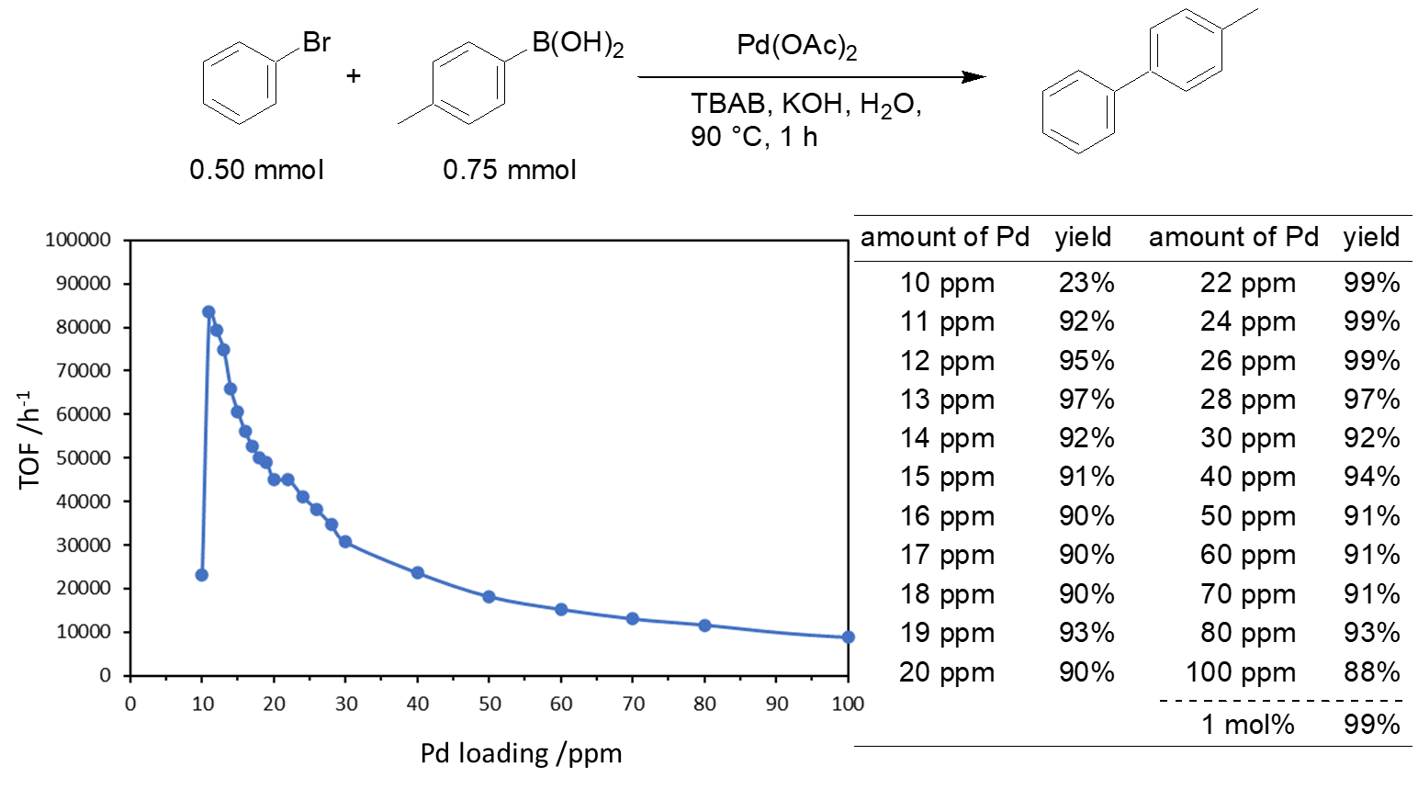
Scheme S2. Suzuki coupling reaction with various Pd loading.

