APPENDIX
for “Greater effort, greater pain: Givers’ feelings of social exclusion in gift failures across close and distant relationships”

APPENDIX A. Instruction and supplementary results for Study 1

Instruction for the social distance self-representation task
The following experiment asks you to imagine that you have made a list of the 100 people closest to you in the world, ranging from your dearest friend or relative at position #1 to a most distant one at #100. The person at #1 would be someone you know best and is your closest friend or relative. The person at #100 might be someone you recognize and encounter, but perhaps you may not even know their name (strangers, etc.). You do not have to physically create the list-just imagine you have done so.
After reading the instructions above, participants were asked to indicate their perceived social distance from the ten roles in their social environment with numbers between 1 to 100. We also informed them if any one of the roles did not exist in their lives, they could imagine his / her existence or skip the role.

Rating results for Study 1
The results of the two rating tasks in Study 1 are shown in Figure A1.
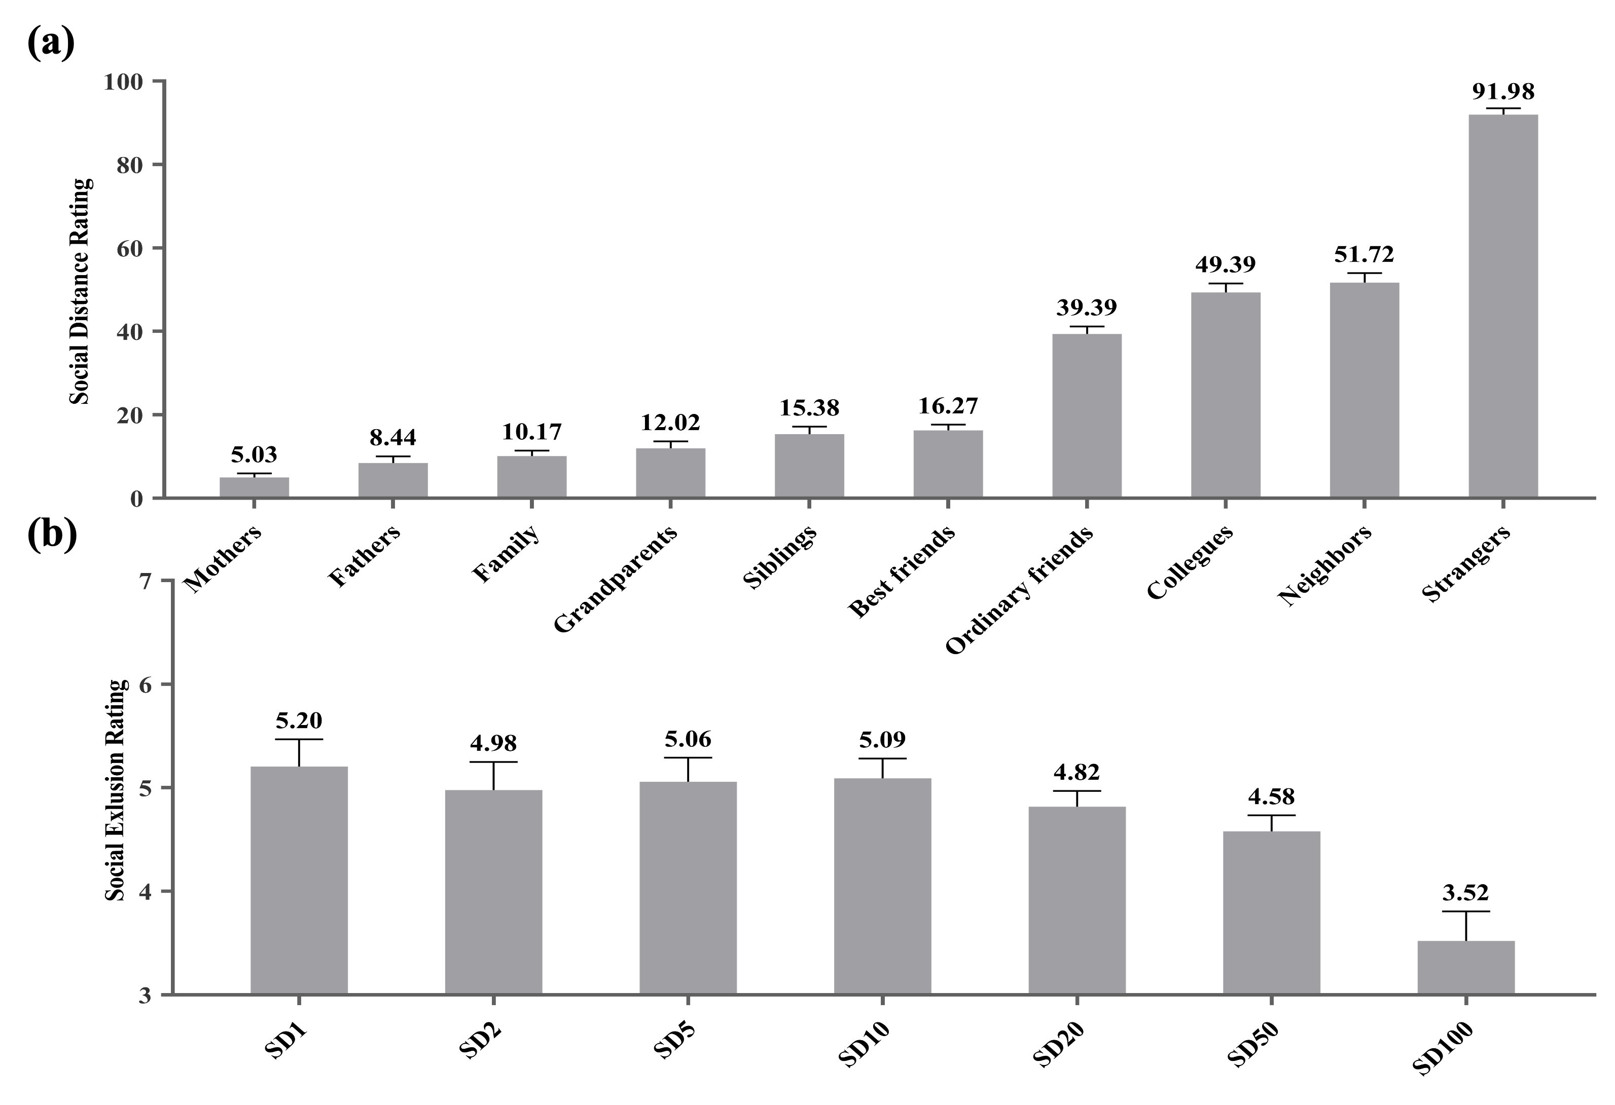
FIGURE A1 Rating results for Study 1. (a) Social distance rating results. (b) Social exclusion rating results. Notes: Error bars = ±1 SE.

APPENDIX B. Measurement Scales for Study 2
Measures of all variables in Study 2 were adapted from previous studies and summarized in Table B1.
TABLE B1 Measurement scales for Study 2.
Construct | Items | Sources
Social distance | Among the following seven pictures, which one best describes your relationship with your friend? | Aron et al. (1991)
Social distance | Please indicate the extent to which you are inclined to describe your relationships as “we”. | Tu et al. (2016)
Gift-selection effort | I think it's important to carefully select and give gifts to the receiver. | Beatty et al. (1991)
Gift-selection effort | I almost always exert considerable effort to select or make special gifts for the receiver. | Beatty et al. (1991)
Gift-selection effort | I almost always invest time and effort into preparing a gift for the receiver. | Hwang and Chu (2019)
Expectations of gift success | I hope that the recipient will like the gift. | Oettingen et al. (2001)
Expectations of gift success | I expect that the recipient will appreciate the gift. | Oettingen et al. (2001)
Expectations of gift success | I have a high expectation that the gift will satisfy the recipient. | Oettingen et al. (2001)
Feelings of social exclusion | After experiencing the gift failure, how excluded do you feel during the experience? | Wan et al. (2014)

APPENDIX C. Pretest, EEG data acquisition, preprocessing and analysis for Study 3

Pretest
One hundred and nineteen participants aged 18-52 (M_{age} = 31.387, SD = 7.383, 38 males, 81 females) were first recruited to pretest the stimuli for Study 3. For the manipulation of social distance, we initially listed 4 types of close and distant relationships according to previous literature, i.e., close friends: intimate friends, confidantes, partners in crime, and childhood friends; distant friends: acquaintances, ordinary colleagues, ordinary classmates, and community members. Then, we asked participants to rate the interpersonal closeness of these relationships by using the Inclusion of Others in the Self scale (IOS scale) (Aron et al., 1991) on a seven-point scale (higher scores mean lower social distance and higher interpersonal closeness). We first averaged the scores for close and distant recipients and found that the scores of the 4 close recipients were significantly higher than those of distant ones (M_{close} = 5.756, SD = 0.829; M_{distant} = 3.506, SD = 0.994; t (118) = 25.821, p < 0.001, d = 2.367; See Table C1).
Gift experience was manipulated into two types: gift failure and gift success. Previous literature has identified several typical types of gift failures, such as gifts are regifted, rejected, stored, and never mentioned (Cruz-Cárdenas et al., 2015, Rucker et al., 1992, Sherry et al., 1993). In contrast, if recipients accept and express their appreciation with the gifts, we recognize these conditions as gift success. Based on these, we listed 5 words representing gift failures and another 5 words for gift success (i.e., gift failure: reject, return, express dislike, indicate unsuitable, indicate unwanted; gift success: readily accept, express like, express appreciation, reward gifts, express gratitude), respectively. Participants were then asked, “To what extent do you think this gift experience is a failure when receiving the following response?” (1 - not at all, 7 - very much). Finally, the paired sample t-test indicated that the manipulation of the gift experience was successful (M_{failure} = 5.792, SD = 1.132; M_{success} = 2.040, SD = 1.118; t (118) = 19.500, p < 0.001, d = 1.788; See Table C2).
TABLE C1 Social distance rating for Study 3 pretest.
Social Distance |  | M | SD | M±SD | t | p | d
Close Friends | partners in crime | 5.830 | 1.237 | 5.756±0.829 | 25.821 | 0.000 | 2.367
Close Friends | intimate friends | 5.940 | 0.985
Close Friends | confidantes | 5.870 | 0.898
Close Friends | childhood friends | 5.380 | 1.221
Distant Friends | community members | 4.000 | 1.496 | 3.506±0.994 | 25.821 | 0.000 | 2.367
Distant Friends | ordinary classmates | 3.140 | 1.271
Distant Friends | acquaintances | 3.580 | 1.458
Distant Friends | ordinary colleagues | 3.300 | 1.350

TABLE C2 The extent of perceived gift failure for Study 3 pretest.
Gift Experience |  | M | SD | M±SD | t | p | d
Gift Success | readily accept | 2.030 | 1.171 | 2.040±1.118 | 19.500 | 0.000 | 1.788
Gift Success | express like | 1.910 | 1.378
Gift Success | express appreciation | 2.170 | 1.258
Gift Success | reward gifts | 1.980 | 1.334
Gift Success | express gratitude | 2.110 | 1.339
Gift Failure | reject | 6.100 | 1.374 | 5.792±1.132 | 19.500 | 0.000 | 1.788
Gift Failure | return | 6.050 | 1.288
Gift Failure | express dislike | 5.650 | 1.394
Gift Failure | indicate unsuitable | 5.280 | 1.255
Gift Failure | indicate unwanted | 5.880 | 1.457

EEG data acquisition
After having a shampoo and blow-dry, participants were comfortably seated in a sound-attenuated room ~100 cm away from a computer screen, which presented the stimuli. Then, they were put on EEG caps and applied conductive paste. In order to ensure the high quality of EEG data, they were asked to try their best to avoid blinks, eye movements, and muscle movements. The formal experiment started after a 5-trial practice.
Electroencephalograms (EEGs) were recorded (band-pass = 0.1-100 Hz, sampling rate = 500 Hz) by using an 32-channel EEG electrode elastic cap (Brain Products GmbH, Gilching, Germany) with Ag/AgCl electrodes placed at each scalp site according to the 10-20 international system (Sharbrough, 1991). The electrode FCz was used for an online EEG reference. Impedances were kept below 10 kΩ throughout the experiment.

EEG data preprocessing
After collecting raw EEG signals, data preprocessing was performed by using the EEGLAB v14.1.1 (Delorme and Makeig, 2004), running on MATLAB R2021b (The Mathworks Inc.). The FCz was used as the reference during recording, and later the average of the left and right mastoids (TP9 and TP10) was calculated as the off-line reference. Next, the continuous EEG signals were digitally filtered with a low-pass filter at 30 Hz. And then EEG recordings in the social distance evaluation stage between -200 and 800 ms time-locked to the onset of S1 were extracted for the analysis of P200, with the prestimulus period corrected as the baseline. For the analysis of SPN in the outcome anticipation stage, differently, EEG data were epochs between 2,200 ms before the S2 onset to 1,100 ms after the S2 appears, with activity from −2,200 to −2,000 ms serving as the baseline. Next, for each subject's EEG data, we manually remove bad epochs through visual observation. There followed the independent component analysis (ICA) to correct artifacts related to eye blinks, eye movements, or muscle potentials, etc. After that, trials containing amplifier clippings, bursts of electromyography activity, or peak-to-peak deflections exceeding ±100 µV were excluded from final analysis to get clean EEG data. After data preprocessing, an average of more than 30 trails were retained for each condition of these two stages, see Table C3.

TABLE C3 The number of trials per subject that entered the final EEG analysis.
Subjects |  | Social Distance  Evaluation Stage |  |  |  | Outcome  Anticipation Stage
Subjects |  | CF | DF | Total |  | CFGF | CFGS | DFGF | DFGS | Total
1 |  | 109 | 104 | 213 |  | 35 | 34 | 31 | 33 | 133
2 |  | 116 | 119 | 235 |  | 39 | 40 | 40 | 40 | 159
3 |  | 119 | 118 | 237 |  | 39 | 36 | 35 | 39 | 149
4 |  | 119 | 116 | 235 |  | 37 | 38 | 37 | 36 | 148
5 |  | 115 | 117 | 232 |  | 38 | 39 | 39 | 39 | 155
6 |  | 117 | 118 | 235 |  | 40 | 40 | 40 | 38 | 158
7 |  | 99 | 111 | 210 |  | 30 | 33 | 34 | 36 | 133
8 |  | 105 | 99 | 204 |  | 39 | 38 | 35 | 37 | 149
9 |  | 118 | 117 | 235 |  | 36 | 32 | 39 | 39 | 146
10 |  | 117 | 118 | 235 |  | 38 | 38 | 38 | 38 | 152
11 |  | 109 | 106 | 215 |  | 38 | 38 | 35 | 35 | 146
12 |  | 106 | 108 | 214 |  | 35 | 36 | 39 | 39 | 149
13 |  | 103 | 98 | 201 |  | 38 | 40 | 40 | 38 | 156
14 |  | 98 | 102 | 200 |  | 44 | 34 | 41 | 36 | 155
15 |  | 103 | 100 | 203 |  | 40 | 40 | 39 | 40 | 159
16 |  | 96 | 102 | 198 |  | 37 | 32 | 39 | 36 | 144
17 |  | 99 | 97 | 196 |  | 35 | 39 | 39 | 39 | 152
18 |  | 98 | 104 | 202 |  | 37 | 39 | 36 | 36 | 148
19 |  | 102 | 99 | 201 |  | 40 | 40 | 40 | 40 | 160
20 |  | 99 | 102 | 201 |  | 38 | 40 | 38 | 35 | 151
21 |  | 104 | 96 | 200 |  | 36 | 39 | 37 | 40 | 152
22 |  | 98 | 99 | 197 |  | 37 | 37 | 39 | 39 | 152
23 |  | 98 | 106 | 204 |  | 34 | 31 | 33 | 31 | 129
24 |  | 94 | 89 | 183 |  | 36 | 33 | 36 | 36 | 141
25 |  | 86 | 90 | 176 |  | 39 | 37 | 36 | 39 | 151
26 |  | 97 | 91 | 188 |  | 39 | 40 | 40 | 40 | 159
27 |  | 102 | 85 | 187 |  | 36 | 37 | 37 | 40 | 150
28 |  | 95 | 93 | 188 |  | 39 | 40 | 40 | 40 | 159
29 |  | 94 | 90 | 184 |  | 36 | 34 | 36 | 36 | 142
30 |  | 102 | 87 | 189 |  | 40 | 39 | 40 | 37 | 156
31 |  | 90 | 86 | 176 |  | 36 | 38 | 36 | 38 | 148
32 |  | 86 | 101 | 187 |  | 38 | 35 | 37 | 36 | 146
33 |  | 97 | 86 | 183 |  | 37 | 38 | 37 | 35 | 147
34 |  | 90 | 95 | 185 |  | 37 | 38 | 39 | 36 | 150
35 |  | 93 | 93 | 186 |  | 39 | 38 | 39 | 39 | 155
36 |  | 91 | 93 | 184 |  | 38 | 37 | 34 | 36 | 145
37 |  | 90 | 87 | 177 |  | 39 | 38 | 38 | 39 | 154
38 |  | 94 | 87 | 181 |  | 40 | 40 | 40 | 40 | 160
39 |  | 94 | 87 | 181 |  | 40 | 39 | 38 | 37 | 154
40 |  | 88 | 92 | 180 |  | 34 | 36 | 38 | 38 | 146
Average |  | 101 | 100 | 200 |  | 38 | 37 | 38 | 38 | 150
Note. CF = close-friend condition; DF = distant-friend condition; CFGF = close-friend * gift-failure condition; CFGS = close-friends * gift-success condition; DFGF = distant-friend * gift-failure condition; DFGS = distant-friend * gift-success condition; Total = total trials of corresponding conditions; Average = average trials of each condition.

EEG data analysis
For the following analysis, EEG data from both the social distance evaluation stage and outcome anticipation stage were averaged into two conditions, i.e., close-friend and distant-friend conditions.
Based on previous ERP studies, according to the visual observation and the guideline proposed by Picton et al. (2000), we analyzed P200 at the social distance evaluation stage, SPN in the outcome anticipation stage. Time windows and electrode pooling were as follows: (1) social distance evaluation stage: P200 from 180 to 240 ms after S1 onset at F3, Fz, F4, FC1, FCz and FC2 (Zinchenko et al., 2017); (2) outcome anticipation stage: SPN from -200 to 0 before S2 onset at C4 and CP6 (Pornpattananangkul and Nusslock, 2015, Zhang et al., 2019, Buodo et al., 2012); Detailed ERP results are shown in Figure C2 to C5.
All statistical testing was performed using SPSS 28.0 (SPSS Inc., Chicago, Illinois, USA). Within-subject repeated-measures ANOVA was carried out on behavioral data and ERPs, respectively. Simple effect analysis was conducted when there was any significant interaction effect among factors. The Greenhouse-Geisser (Greenhouse and Geisser, 1959) correction was applied in all statistical analyses where appropriate.
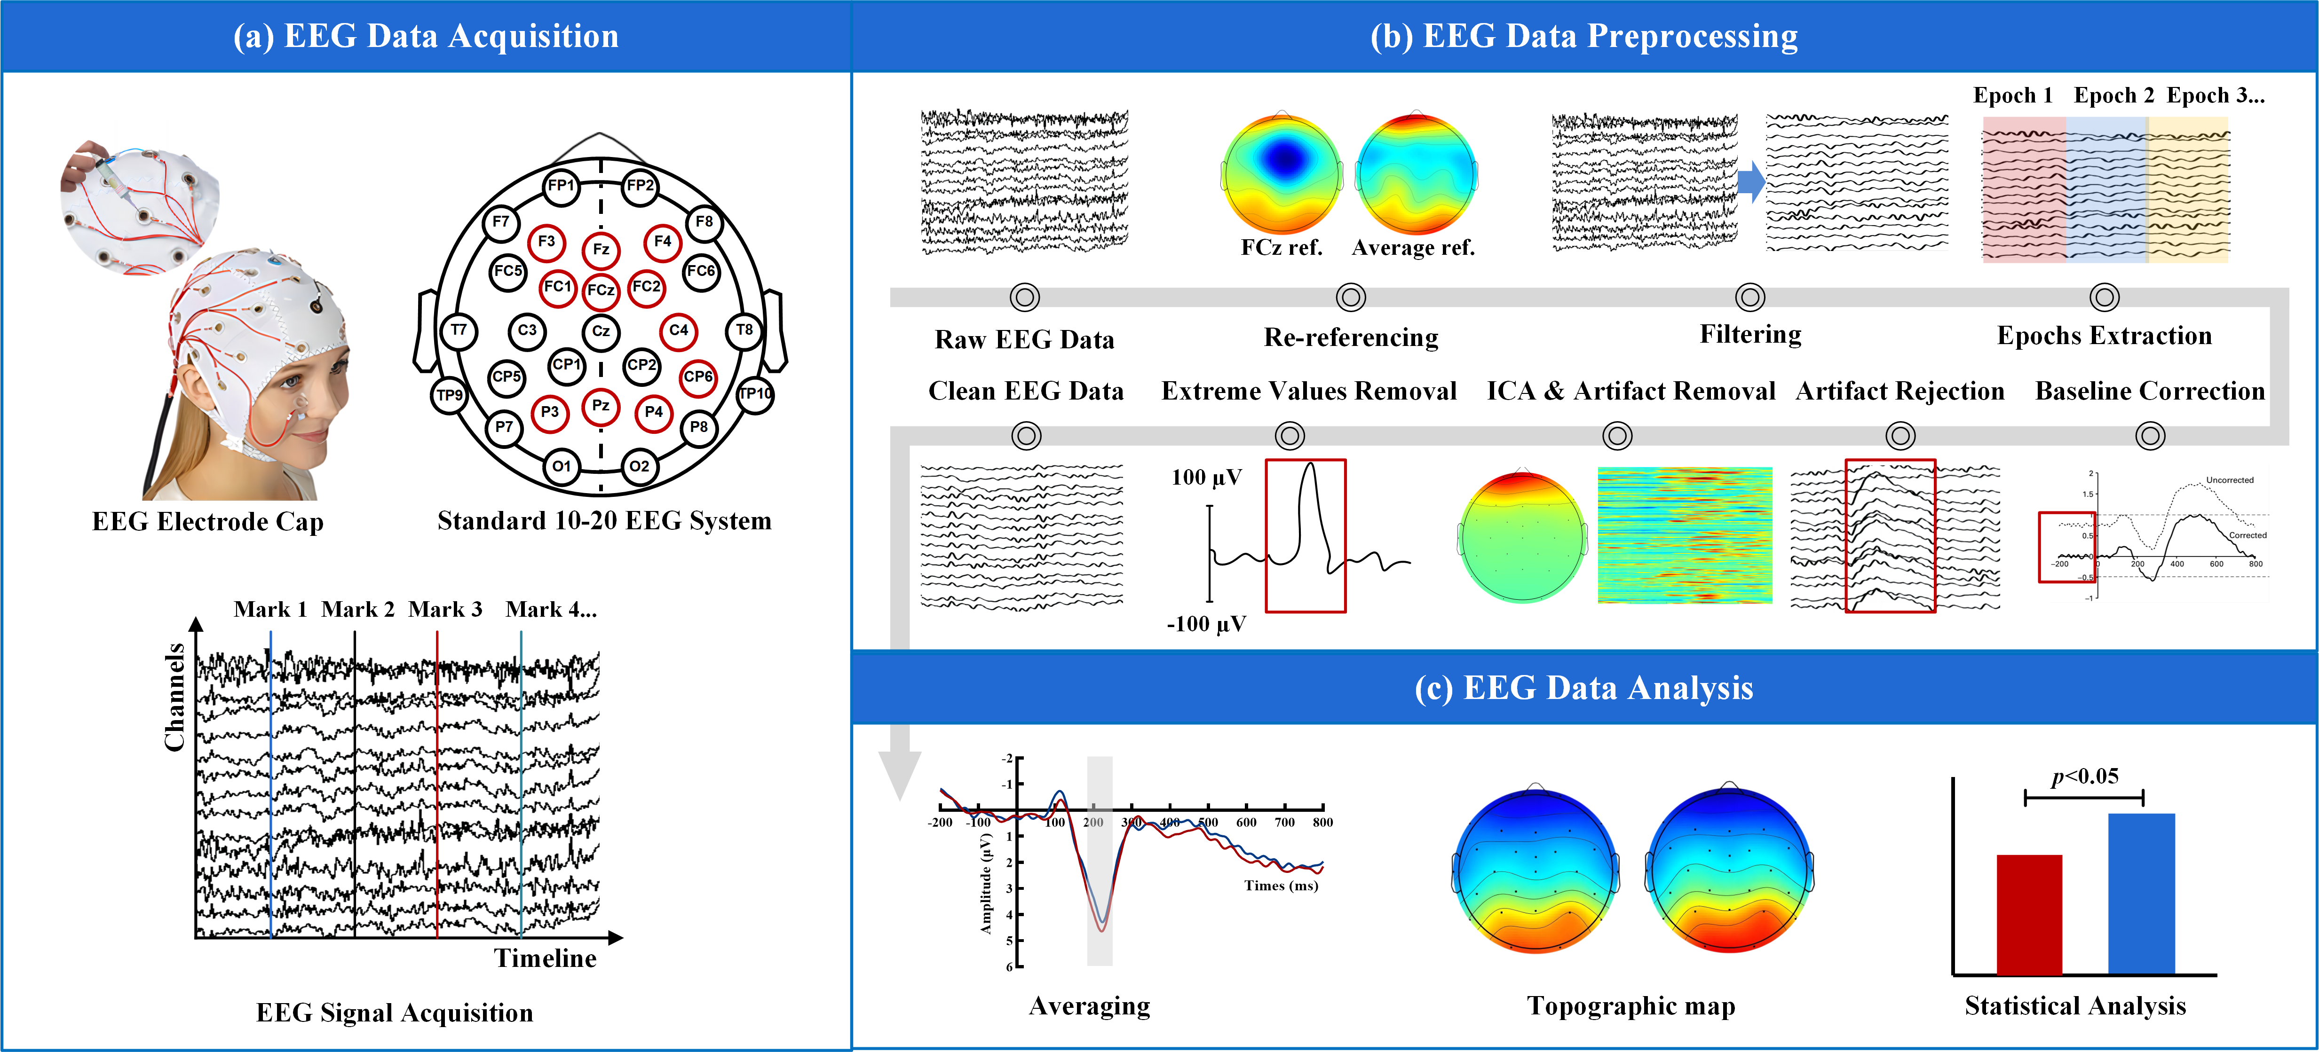
FIGURE C1 Protocol of EEG data acquisition, preprocessing and analysis.

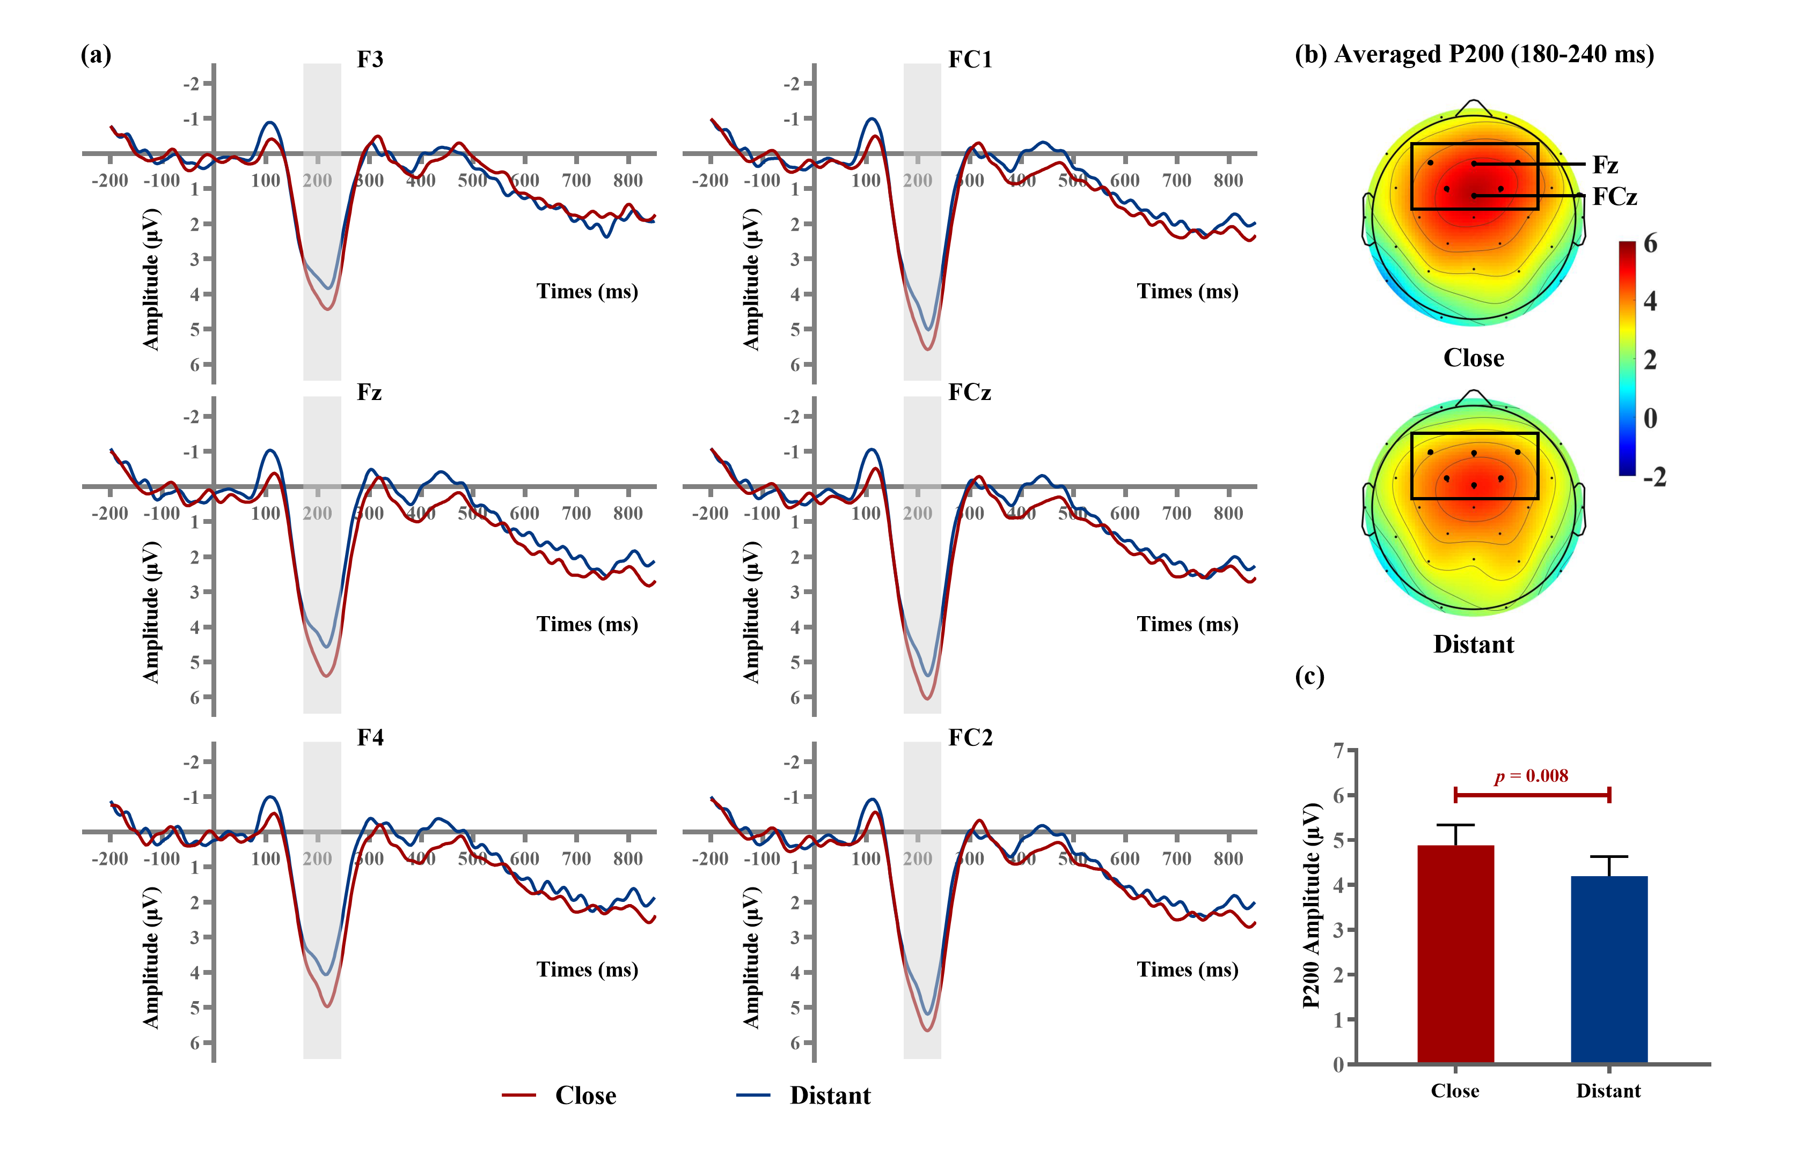
FIGURE C2 P200 results at the social distance evaluation stage. (a) Grand averaged P200 waveforms for close and distant conditions at 6 electrodes (F3, Fz, F4, FC1, FCz, FC2); (b) Topographic maps of P200 for close and distant conditions. The time window of the P200 is 180-240 ms. (c) Averaged P200 amplitudes comparison between close and distant conditions. Notes: Error bars = ±1 SE.
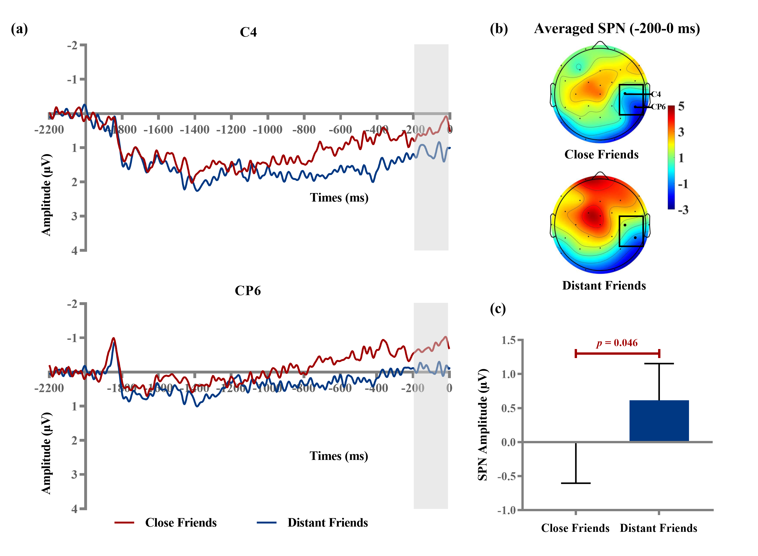
FIGURE C3 SPN results at the outcome anticipation stage. (a) Grand averaged SPN waveforms for close and distant conditions at 2 electrodes (C4 and CP6); (b) Topographic maps of SPN for close and distant conditions. The time window of the SPN is -200-0 ms. (c) Averaged SPN amplitudes comparison between close and distant conditions. Notes: Error bars = ±1 SE.

APPENDIX REFERENCES
ARON, A., ARON, E. N., TUDOR, M. & NELSON, G. 1991. Close relationships as including other in the self. Journal of personality and social psychology, 60, 241-253.
BEATTY, S. E., KAHLE, L. R. & HOMER, P. 1991. Personal values and gift-giving behaviors: A study across cultures. Journal of Business Research, 22, 149-157.
BUODO, G., SARLO, M., POLI, S., GIADA, F., MADALOSSO, M., ROSSI, C. & PALOMBA, D. 2012. Emotional anticipation rather than processing is altered in patients with vasovagal syncope. Clinical Neurophysiology, 123, 1319-1327.
CRUZ-CáRDENAS, J., GONZáLEZ, R. & DEL VAL NúñEZ, M. T. 2015. The use of disliked gifts from a consumer behavior perspective. Journal of Business Research, 68, 1635-1637.
DELORME, A. & MAKEIG, S. 2004. EEGLAB: an open source toolbox for analysis of single-trial EEG dynamics including independent component analysis. Journal of neuroscience methods, 134, 9-21.
GREENHOUSE, S. W. & GEISSER, S. 1959. On methods in the analysis of profile data. Psychometrika, 24, 95-112.
HWANG, J. & CHU, W. J. 2019. The effect of others' outcome valence on spontaneous gift-giving behavior: The role of empathy and self-esteem. European Journal of Marketing, 53, 785-805.
OETTINGEN, G., PAK, H.-J. & SCHNETTER, K. 2001. Self-regulation of goal-setting: Turning free fantasies about the future into binding goals. Journal of personality and social psychology, 80, 736.
PICTON, T. W., BENTIN, S., BERG, P., DONCHIN, E., HILLYARD, S., JOHNSON, R., MILLER, G., RITTER, W., RUCHKIN, D. & RUGG, M. 2000. Guidelines for using human event-related potentials to study cognition: recording standards and publication criteria. Psychophysiology, 37, 127-152.
PORNPATTANANANGKUL, N. & NUSSLOCK, R. 2015. Motivated to win: Relationship between anticipatory and outcome reward-related neural activity. Brain and cognition, 100, 21-40.
RUCKER, M., BALCH, T., HIGHAM, F. & SCHENTER, K. 1992. Thanks But No Thanks: Rejection, Possession and Disposition of the Failed Gift. Advances in consumer research, 19, 488.
SHARBROUGH, F. 1991. American Electroencephalographic Society guidelines for standard electrode position nomenclature. Journal of Clinical Neurophysiology, 8, 200-202.
SHERRY, J. F., MCGRATH, M. A. & LEVY, S. J. 1993. The dark side of the gift. Journal of Business Research, 28, 225-244.
TU, Y., SHAW, A. & FISHBACH, A. 2016. The friendly taking effect: How interpersonal closeness leads to seemingly selfish yet jointly maximizing choice. Journal of Consumer Research, 42, 669-687.
WAN, E. W., XU, J. & DING, Y. 2014. To Be or Not to Be Unique? The Effect of Social Exclusion on Consumer Choice. Journal of Consumer Research, 40, 1109-1122.
ZHANG, J., LAU, E. Y. Y. & HSIAO, J. H.-W. 2019. Using emotion regulation strategies after sleep deprivation: ERP and behavioral findings. Cognitive, Affective, & Behavioral Neuroscience, 19, 283-295.
ZINCHENKO, A., OBERMEIER, C., KANSKE, P., SCHRöGER, E. & KOTZ, S. A. 2017. Positive emotion impedes emotional but not cognitive conflict processing. Cognitive, Affective, & Behavioral Neuroscience, 17, 665-677.

