Enhanced Rock Weathering in Acid Mine Drainage: Carbon Removal Potential and Co-benefits

Online Resources (Supplementary Information)

Contents | Type | Description | Page
Online Resource S1 | Figure | Time needed to achieve 99% ± 5% dissolution efficiency for alkali basalt in the (a–c) cropland and (d–f) suboptimal AMD scenarios. | 2
Online Resource S2 | Figure | Area (ha) of cropland equivalent to the maximum annual dissolution of mass in AMD scenarios. | 3
Online Resource S3 | Figure | Maximum annual dissolution of mass for targeted AMD scenarios with different grain sizes. | 4
Online Resource T1 | Table | Mineral weight fraction and chemical characteristics of alkali basalt. | 5
Online Resource T2 | Table | Rate parameters for selected minerals. | 6

(A)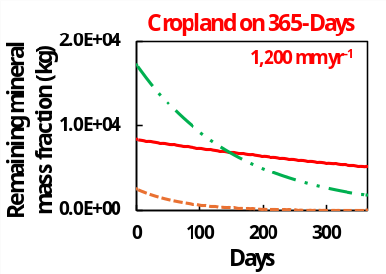(B)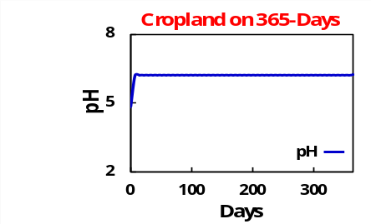(C)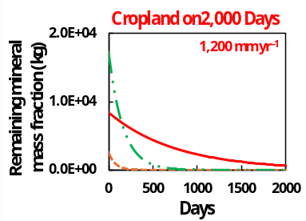
(D) 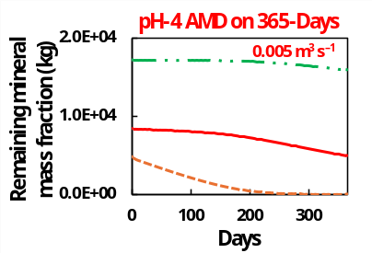 (E) 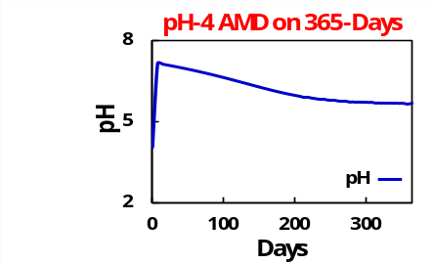 (F) 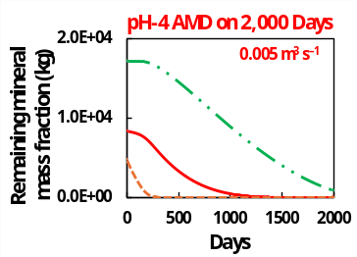
Online Resource S1 | Time needed to achieve 99% ± 5% dissolution efficiency for alkali basalt in the (a–c) cropland and (d–f) suboptimal AMD scenarios. In this simulation, 40 t of alkali basalt including three silicate minerals (labradorite, augite, and forsterite) was applied with a particle size of 10 μm and flow rate of 0.005 m³ s^{–1} for AMD scenarios.

(A)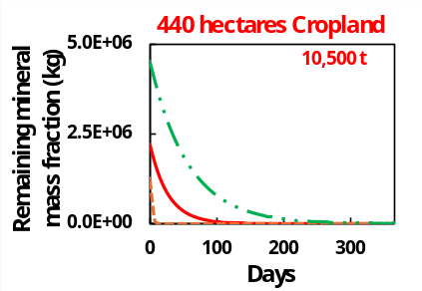(B) 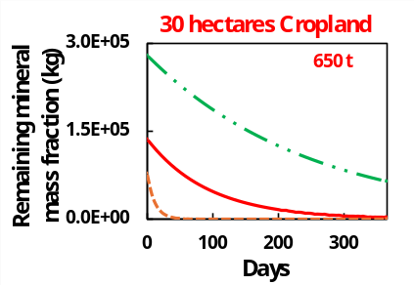 (C) 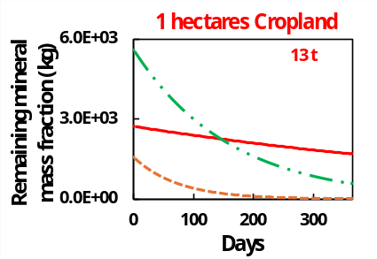
Online Resource S2 | Area (ha) of cropland equivalent to the maximum annual dissolution of mass in AMD scenarios. A flow rate of 1200 mm yr^{–1} and particle size of 10 μm were applied. However, the 99% ± 5% dissolution efficiency of targeted silicate minerals, specifically augite, was not achieved with the assigned cropland area in the latter and here, the geometric-shape-based surface area estimation was acknowledged.

(A) 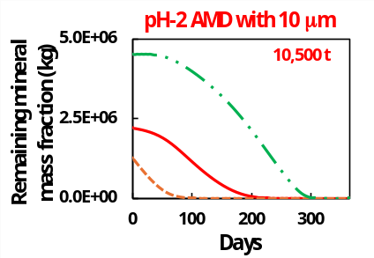(B)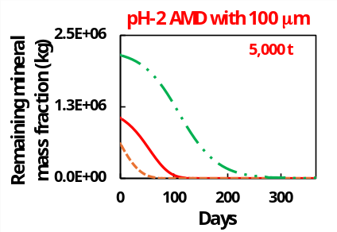 (C) 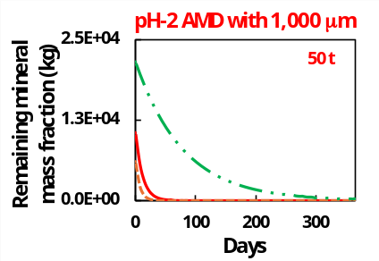
(D) 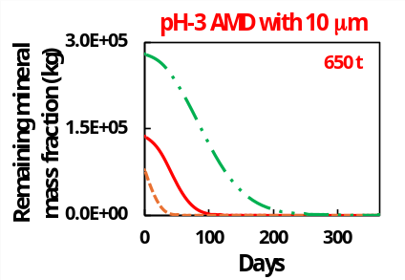(E)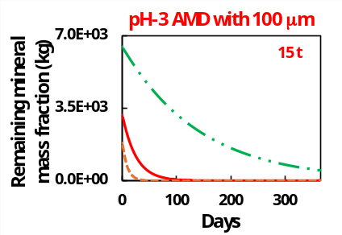 (F) 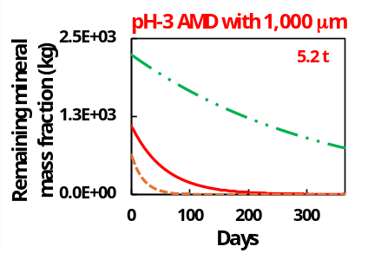
(G) 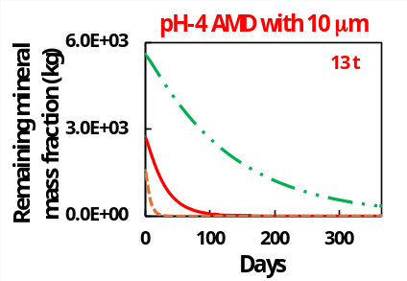(H)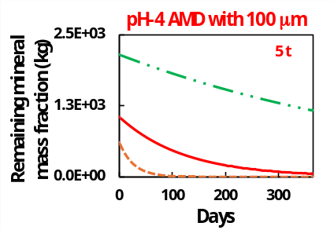 (I) 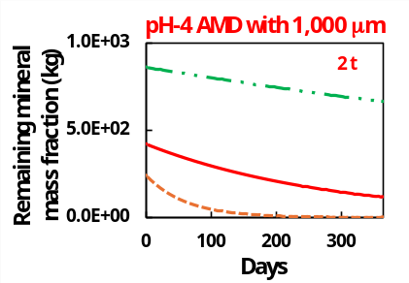
Online Resource S3 | Maximum annual dissolution of mass for targeted AMD scenarios with grain sizes of 10 µm (left), 100 µm (centre), and 1,000 µm (right). All simulations were conducted with a flow rate of 0.5 m³ s^{–1}. However, the 99% ± 5% dissolution efficiency of targeted silicate minerals with 100 μm and 1,000 μm case in pH 3 and pH 4 AMD scenarios was not achieved due to the applied SSA was estimated from the geometric-shape-based.

Online Resource T1 | Mineral weight fractions and chemical characteristics of alkali basal t(Beerling et al. 2020).
Mineral | Chemical formula | Weight fraction | Molecular massª  (g mol^{–1}) | Estimated SSA_{geo} (cm² g^{–1})
Labradorite | Ca_{0.6}Na_{0.4}Al_{1.6}Si_{2.4}O₈ | 0.43 | 271.82 | 10 μm = 80,000  100 μm = 17,000  1000 μm = 7200
Augite | Ca_{0.9}Mg_{0.9}Na_{0.1}Al_{0.4}Fe_{0.2}Si_{1.9}O₆ | 0.21 | 237.66 | 10 μm = 80,000  100 μm = 17,000  1000 μm = 7200
Forsterite | Mg₂SiO₄ | 0.12 | 140.69 | 10 μm = 80,000  100 μm = 17,000  1000 μm = 7200
K-feldspar | KAlSi₃O₈ | 0.06 | 278.33 | 10 μm = 80,000  100 μm = 17,000  1000 μm = 7200
Ilmenite | FeTiO₃ | 0.05 | 151.72 | 10 μm = 80,000  100 μm = 17,000  1000 μm = 7200
Fayalite | Fe₂SiO₄ | 0.05 | 46.39 | 10 μm = 80,000  100 μm = 17,000  1000 μm = 7200
ª Molecular masses of all minerals were calculated on the basis of their chemical composition in the thermodynamic dataset.

Online Resource T2| Rate parameters of selected minerals (Palandri and Kharaka 2004).
Mineral | Acid mechanism |  |  | Neutral mechanism |  |  | Base mechanism
Mineral | Log K | E_{a} | n | Log K | E_{a} | n | Log K | E_{a} | n
Labradorite | –7.87 | 42.1 | 0.626 | –10.91 | 45.2 | - | –15.57 | 71 | –0.57
Augite | –6.82 | 78 | 0.7 | –11.97 | 78 | - | - | - | -
Forsterite | –6.85 | 67.2 | 0.47 | –10.64 | 79 | - | - | - | -
K-feldspar | –10.06 | 51.7 | 0.5 | –12.44 | 38 | - | –21.2 | 94.1 | –0.823
Ilmenite | –8.35 | 37.9 | 0.421 | –11.16 | 37.9 | - | - | - | -
Fayalite | –4.8 | 94.4 | - | –12.8 | 94.4 | - | - | - | -
Log K = rate constant K (mole m^{–2} s^{–1})
E_{a} = Arrhenius activation energy (kJ mol.^{–1})
n = Reaction order with respect to H⁺/OH–
- = N/A

