Space charge drives electromechanical conversion via a piezoelectric-like effect in ion implanted polymers
Andris Šutka,^{1,‡,}* Holger Fiedler,^{2,‡,}* Artis Linarts,¹ Kaspars Mālnieks,¹ Peter C. Sherrell³*
¹ Institute for Materials & Surface Engineering, Faculty of Natural Sciences and Technology, Riga Technical University, Paula Valdena 3/7, Riga, LV-1048 Latvia
² GNS Science, National Isotope Centre, Lower Hutt, New Zealand
³ School of Science, RMIT University, Melbourne 3000, Australia
‡ authors contributed equally to this work

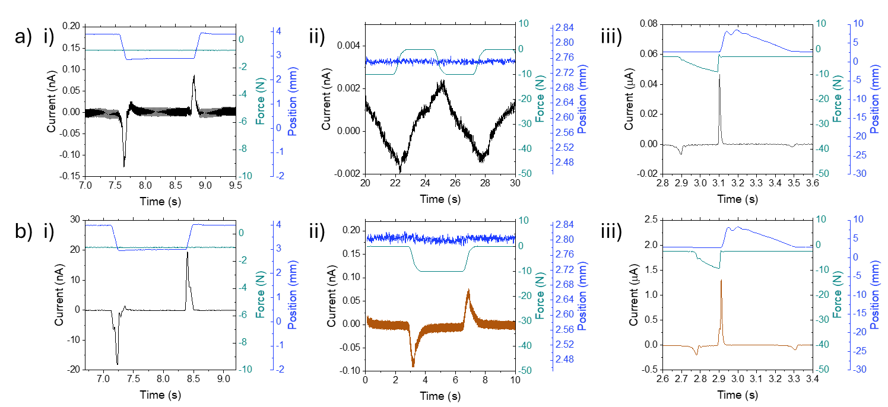
Figure S1. Individual short-circuit and voltage waveforms for a) PTFE, and b) Cu-PTFE in i) non-contact mode; ii) piezoelectric mode; and iii) TENG mode.

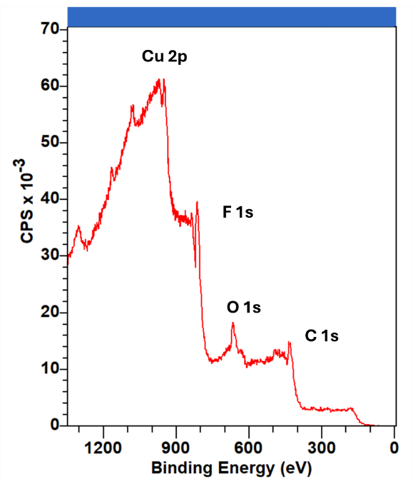
Figure S2. XPS survey spectra of 1 x 10¹⁶ Cu ions cm⁻² PTFE, with peaks shifted by over 150 eV compared to literature values.

