Decomposing socioeconomic inequality in lean diabetes among middle-aged adults and elderly in India

Supplementary Material

Table of contents
Figures S1 Adjusted Odds Ratios of MPCE quintiles, Education, and Social Caste for Diabetes and Lean Diabetes …………………………………………………………………………………………………….1
Figures S2. Decomposition of Erreygers’ concentration index of lean diabetes among middle-aged adults and elderly in India (2017-18) ……………………………………………………………………….….….2
Table S1 Sample Characteristics (Weighted %) …………………………………………………………….3
Table S2 Bivariate distribution of BMI across sociodemographic characteristics………………………….4
Table S3 Unadjusted Lean diabetes prevalence across background characteristics for overall and diabetic sample……………………………………………………………………………………………………….6
Table S4. Multivariate Logistic regression estimates of diabetes and lean diabetes in India…………….…7
Table S5. Erreygers’ Concentration Index for Lean diabetes prevalence by Sociodemographic characteristics ………………………………………………………………………………………………………………9

Figures S1. Adjusted Odds Ratios of a) MPCE quintiles, b) Education, and c) Caste for Diabetes and Lean Diabetes.
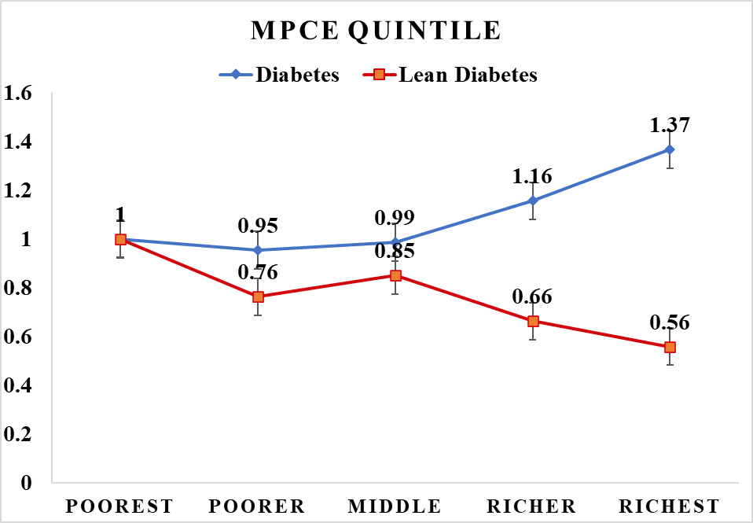
Figure (a)

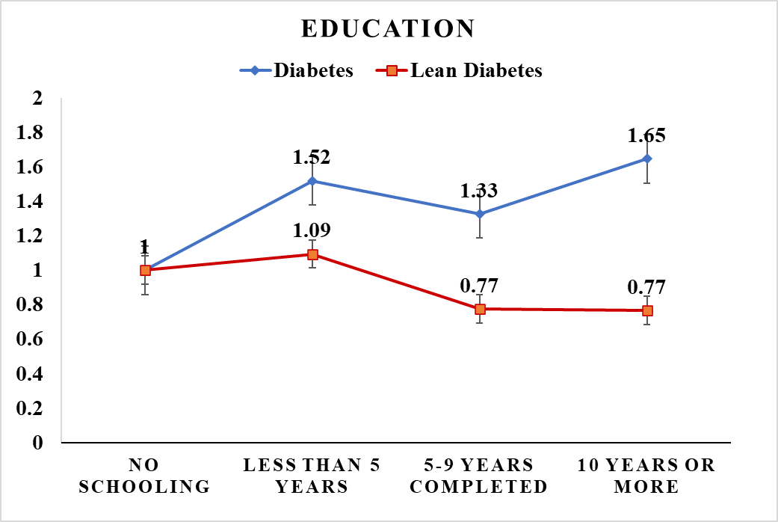
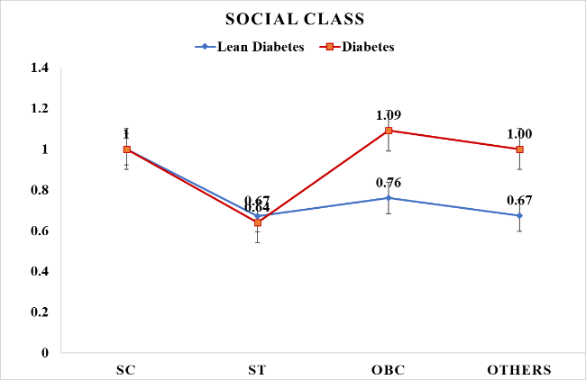
Figure (b)
Figure (c)

Figures S2. Decomposition of Erreygers’ concentration index of lean diabetes among middle-aged adults and elderly in India (2017-18)
Table S1: Sample Characteristics (Weighted %)
Characteristics | Percentage | Sample size (N)
Total | 100 | 58824
MPCE quintile
Poorest | 20.0 | 10192
poor | 20.0 | 10454
Middle | 20.0 | 11294
Richer | 20.0 | 12818
Richest | 20.0 | 14066
Education
No Schooling | 50.9 | 27690
Less than 5 Years | 11.2 | 6833
5-9 years completed | 20.6 | 13487
10 years or more | 17.3 | 10814
Place of Residence
Rural | 70.7 | 38764
Urban | 29.3 | 20060
Social class/Caste
SC | 19.7 | 9864
ST | 8.7 | 10468
OBC | 45.3 | 22363
Others | 26.3 | 16129
Religion
Hindu | 82.5 | 43060
Muslim | 11.1 | 6833
Christian | 2.9 | 5920
Others | 3.5 | 3011
Marital Status
Currently Married | 74.1 | 44108
Widowed | 23.1 | 12807
Others | 2.8 | 1909
Living Arrangement
Living alone | 3.8 | 2084
Living with spouse | 16.4 | 8970
Living with Children | 56.7 | 34343
Living with others | 23.1 | 13427
Work status
currently working | 47.5 | 27353
Previously worked | 26.8 | 15173
Never worked | 25.7 | 16298
Health Insurance
No | 79.5 | 45330
Yes | 20.5 | 13494
BMI
underweight | 21.6 | 10807
Normal weight | 51.8 | 30838
overweight | 19.8 | 12856
obesity | 6.8 | 4323
Diabetes
No | 88.3 | 51374
Yes | 11.7 | 7450
Diabetes (Diagnosed)
No | 90.4 | 52683
Yes | 9.6 | 6141
Lean Diabetes
No | 99.2 | 58405
Yes | 0.8 | 419
Lean Diabetes (Diagnosed)
No | 99.5 | 58546
Yes | 0.5 | 278
Smoke
No | 61.9 | 37195
Yes | 38.1 | 21629
Alcohol usage
No | 84.8 | 48248
Yes | 16.2 | 10576

Table S2: Bivariate distribution of BMI (%) across sociodemographic characteristics among older adults in India, 2017-18
Characteristics | Underweight | 95 % CI | Normal Weight | 95 % CI | Overweight | 95 % CI | Obese | 95 % CI | F stat | P value
Total | 21.6 | (20.8,22.4) | 51.8 | (50.6,53.0) | 19.8 | (18.9,20.8) | 6.7 | (06.1,07.5)
MPCE Quintile
Poorest | 32.2 | (30.6,33.9) | 53.1 | (51.5,54.6) | 12.0 | (10.9,13.1) | 2.8 | (2.3,03.3) | 5011.654 | <0.001
Poorer | 27.0 | (25.3,28.7) | 53.1 | (51.6,54.6) | 15.4 | (14.3,16.6) | 4.5 | (3.6,05.4) |  | <0.001
Middle | 21.6 | (20.3,22.9) | 54.9 | (53.5,56.2) | 17.6 | (16.6,18.7) | 5.9 | (5.0,06.8) |  | <0.001
Richer | 16.8 | (15.4,18.2) | 51.9 | (50.3,53.5) | 23.7 | (22.4,25.0) | 7.6 | (6.8,08.5) |  | <0.001
Richest | 10.4 | (09.1,11.2) | 46.2 | (42.2,50.2) | 30.4 | (28.6,32.3) | 13.0 | (10.9,15.4) |  | <0.001
Education
No schooling | 28.2 | (27.2,29.3) | 52.8 | (51.8,53.8) | 14.7 | (13.9,15.6) | 4.2 | (3.7,04.9) | 4618.614 | <0.001
Less than 5 years | 22.6 | (20.9,24.4) | 53.7 | (51.7,55.6) | 17.8 | (16.2,19.4) | 6.0 | (4.9,07.2) |  | <0.001
5-9 years completed | 15.7 | (14.7,16.8) | 51.8 | (50.4,53.2) | 24.3 | (22.8,25.7) | 8.2 | (7.4,09.0) |  | <0.001
10 years or more | 8.5 | (06.9,10.1) | 47.8 | (43.6,52.) | 30.9 | (28.9,32.9) | 12.9 | (11.1,14.9) |  | <0.001
Diabetes
No | 23.6 | (22.8,24.4) | 52.7 | (51.7,53.7) | 18.2 | (17.3,19.2) | 5.5 | (5.0,06.1) | 2989.453 | <0.001
Yes | 6.8 | (05.6,08.1) | 45.3 | (42.2,48.5) | 32.0 | (30.4,33.7) | 15.9 | (12.6,19.9) |  | <0.001
Smoke
No | 16.9 | (16.1,17.8) | 50.3 | (48.6,52.0) | 23.6 | (22.5,24.9) | 9.2 | (8.2,10.2) | 3178.879 | <0.001
Yes | 29.2 | (28.1,30.0) | 54.3 | (53.3,55.3) | 13.6 | (12.9,14.4) | 2.8 | (2.4,03.3) |  | <0.001
Alcohol Usage
No | 20.6 | (19.7,21.4) | 51.2 | (49.8,52.5) | 20.8 | (19.8,21.8) | 7.5 | (6.7,08.4) | 778.340 | <0.001
Yes | 27.3 | (25.8,28.9) | 55.6 | (54.1,57.1) | 14.7 | (13.5,15.9) | 2.4 | (2.1,02.9) |  | <0.001
Place of Residence
Rural | 26.4 | (25.5,27.3) | 54.4 | (53.7,55.1) | 15.4 | (14.8,16.0) | 3.8 | (3.5,04.2) | 6137.913 | <0.001
Urban | 10.0 | (08.9,11.2) | 45.6 | (42.5,48.7) | 30.6 | (28.8,32.4) | 13.8 | (12.2,15.7) |  | <0.001
Caste
SC | 26.4 | (24.9,28.0) | 53.6 | (52.0,55.3) | 15.5 | (14.5,16.7) | 4.4 | (3.2,5.9) | 2259.263 | <0.001
ST | 35.0 | (32.9,37.3) | 52.8 | (50.8,54.7) | 9.9 | (08.3,11.8) | 2.3 | (1.7,2.9) |  | <0.001
OBC | 20.4 | (19.3,21.6) | 51.5 | (49.3,53.7) | 21.0 | (19.3,22.8) | 7.0 | (5.9,8.3) |  | <0.001
Others | 15.5 | (14.5,16.6) | 50.7 | (49.5,51.9) | 24.3 | (23.2,25.5) | 9.5 | (8.7,10.3) |  | <0.001
Religion
Hindu | 22.1 | (21.1,23.1) | 52.1 | (51.0,53.2) | 19.5 | (18.4,20.6) | 6.3 | (5.7,7.0) | 286.838 | 0.025
Muslim | 18.9 | (16.6,21.3) | 51.5 | (48.3,54.7) | 20.9 | (19.1,22.7) | 8.7 | (6.2,12.3) |  | 0.025
Christians | 24.9 | (14.8,38.6) | 51.1 | (42.7,59.4) | 18.3 | (14.8,22.4) | 5.7 | (4.3,07.6) |  | 0.025
Others | 15.7 | (12.9,18.8) | 47.5 | (44.3,50.8) | 26.1 | (23.0,29.4) | 10.7 | (9.2,12.5) |  | 0.025
Marital status
Married | 19.2 | (18.3,20.2) | 52.9 | (51.8,53.9) | 21.1 | (19.8,22.4) | 6.8 | (6.1,07.5) | 776.866 | <0.001
Widowed | 28.0 | (26.4,29.5) | 48.9 | (47.1,50.7) | 16.6 | (15.5,17.7) | 6.6 | (4.8,9.1) |  | <0.001
Others | 31.6 | (21.3,44.4) | 48.6 | (40.1,57.1) | 13.2 | (10.5,16.5) | 6.6 | (4.7,09.2) |  | <0.001
Living arrangement
Living alone | 28.0 | (24.7,31.5) | 50.8 | (47.1,54.5) | 16.3 | (13.3,19.8) | 4.9 | (3.8,6.4) | 761.565 | <0.001
Living with spouse | 21.6 | (20.0,23.2) | 52.5 | (50.3,54.8) | 19.4 | (17.9,21.0) | 6.5 | (5.4,7.7) |  | <0.001
Living with spouse & children | 18.6 | (17.6,19.7) | 52.9 | (51.5,54.3) | 21.6 | (19.8,23.4) | 6.9 | (6.2,7.6) |  | <0.001
Living with children & others | 27.8 | (26.2,29.6) | 48.9 | (46.5,51.3) | 16.4 | (15.3,17.6) | 6.8 | (5.1,9.1) |  | <0.001
Work status
Currently working | 21.0 | (19.9,22.1) | 56.0 | (54.9,57.2) | 19.0 | (17.6,20.5) | 3.9 | (3.5,4.4) | 2139.299 | <0.001
previously worked | 25.9 | (24.5,27.4) | 50.6 | (49.3,52.0) | 17.3 | (16.3,18.3) | 6.2 | (5.5,6.9) |  | <0.001
Never Worked | 18.2 | (16.8,19.2) | 45.3 | (42.5,48.1) | 24.0 | (22.9,25.1) | 12.5 | (10.5,14.8) |  | <0.001
Health Insurance
No | 21.8 | (20.9,22.70) | 51.8 | (50.6,53.0) | 19.6 | (18.8,20.5) | 6.8 | (6.0,7.6) | 12.467 | 0.495
Yes | 20.7 | (19.5,22.0) | 52.0 | (50.1,53.8) | 20.6 | (18.3,23.1) | 6.7 | (5.9,7.7) |  | 0.495

Table S3 Unadjusted Lean diabetes prevalence (%) across background characteristics for overall and diabetic sample
Background characteristics | Lean diabetes (overall sample) |  |  | Lean diabetes (Among Diabetic sample)
Background characteristics | Yes | 95 % CI | F stat (P value) | Yes | 96 % CI | F stat (P value)
Overall | 0.8 | (0.660,0.939) |  | 6.8 | (5.62, 8.11)
MPCE Quintile
Poorest | 1.2 | (0.775,1.760) | 56.106 (0.004) | 15.4 | (10.6, 22.0) | 2231.29 (<0.001)
Poorer | 0.8 | (0.605,1.140) | 56.106 (0.004) | 9.8 | (7.15, 13.2) | 2231.29 (<0.001)
Middle | 0.9 | (0.663,1.140) | 56.106 (0.004) | 8.8 | (6.72, 11.4) | 2231.29 (<0.001)
Richer | 0.6 | (0.441,0.856) | 56.106 (0.004) | 4.7 | (3.37, 6.47) | 2231.29 (<0.001)
Richest | 0.5 | (0.319,0.638) | 56.106 (0.004) | 2.4 | (1.64, 3.38) | 2231.29 (<0.001)
Education
No Schooling | 0.9 | (0.699,1.120) | 27.381 (0.028) | 11.4 | (9.03, 14.3) | 1590.16 (<0.001)
Less than 5 years | 1.0 | (0.719,1.520) | 27.381 (0.028) | 7.9 | (5.47, 11.3) | 1590.16 (<0.001)
5-9 year | 0.6 | (0.451,0.896) | 27.381 (0.028) | 4.8 | (3.44, 6.74) | 1590.16 (<0.001)
10 years | 0.5 | (0.349,0.775) | 27.381 (0.028) | 2.6 | (1.7, 3.86) | 1590.16 (<0.001)
Place of Residence
Rural | 0.9 | (0.732,1.100) | 27.414 (0.003) | 11.1 | (9.13, 13.30) | 2084.59 (<0.001)
Urban | 0.5 | (0.385,0.708) | 27.414 (0.003) | 2.6 | (1.87, 3.57) | 2084.59 (<0.001)
Caste
SC | 1.1 | (0.757,1.550) | 21.848 (0.064) | 12.8 | (9.08, 17.80) | 988.51 (<0.001)
ST | 0.6 | (0.392,1.020) | 21.848 (0.064) | 13.4 | (8.75, 20.1) | 988.51 (<0.001)
OBC | 0.8 | (0.600,0.954) | 21.848 (0.064) | 5.8 | (4.50, 7.48) | 988.51 (<0.001)
Others | 0.7 | (0.514,0.875) | 21.848 (0.064) | 4.8 | (3.67, 6.23) | 988.51 (<0.001)
Religion
Hindu | 0.8 | (0.609,0.926) | 6.101 (0.535) | 6.6 | (5.32, 8.26) | 13.21 (0.900)
Muslim | 1.0 | (0.676,1.340) | 6.101 (0.535) | 7.3 | (5.11, 10.30) | 13.21 (0.900)
Christian | 0.9 | (0.532,0.590) | 6.101 (0.535) | 6.3 | (3.65, 10.60) | 13.21 (0.900)
Others | 1.0 | (0.463,2.220) | 6.101 (0.535) | 8.0 | (3.66, 16.60) | 13.21 (0.900)
Marital status
Currently married | 0.7 | (0.607,0.861) | 12.848 (0.134) | 6.2 | (5.19, 7.4) | 104,58 (0.161)
Widowed | 1.0 | (0.714,1.400) | 12.848 (0.134) | 8.4 | (5.82, 12.0) | 104,58 (0.161)
Others | 0.7 | (0.313,0.700) | 12.848 (0.134) | 7.7 | (3.62, 15.60) | 104,58 (0.161)
Living arrangement
Living alone | 1.1 | (0.642,1.960) | 28.054 (0.018) | 9.7 | (5.29, 17.0) | 143.61 (0.158)
Living with spouse | 1.0 | (0.765,1.400) | 28.054 (0.018) | 7.5 | (5.47, 10.1) | 143.61 (0.158)
Living with children | 0.6 | (0.520,0.794) | 28.054 (0.018) | 5.8 | (4.68, 7.17) | 143.61 (0.158)
Living with others | 0.9 | (0.665,0.260) | 28.054 (0.018) | 8.0 | (5.58, 11.2) | 143.61 (0.158)
Work status
Currently working | 0.5 | (0.365,0.607) | 152.271 (<0.001) | 5.9 | (4.55, 7.54) | 511.12 (<0.001)
previously worked | 1.4 | (0.060,1.940) | 152.271 (<0.001) | 9.6 | (7.17, 12.70) | 511.12 (<0.001)
Never Worked | 0.7 | (0.541,0.899) | 152.271 (<0.001) | 4.7 | (3.51, 6.25) | 511.12 (<0.001)
Health insurance
No | 0.8 | (0.642,0.978) | 0.086 (0.859) | 6.9 | (5.56, 8.62) | 12.77 (0.473)
Yes | 0.8 | (0.592,0.998) | 0.086 (0.859) | 6.1 | (4.73, 7.93) | 12.77 (0.473)
Smoke
No | 0.6 | (0.509,0.737) | 46.836 (<0.001) | 4.5 | (3.64, 5.49) | 1620.38 (<0.001)
Yes | 1.1 | (0.825,1.390) | 46.836 (<0.001) | 12.8 | (10.10, 16.20) | 1620.38 (<0.001)
Alcohol usage
No | 0.8 | (0.638,0.951) | 0.354 (0.741) | 6.5 | (5.23, 7.93) | 81.87 (0.090)
Yes | 0.8 | (0.591,0.170) | 0.354 (0.741) | 9.0 | (6.49, 12.40) | 81.87 (0.090)

Table S4. Multivariate Logistic regression estimates of diabetes and lean diabetes in India
Characteristics | Diabetes |  | Lean diabetes
Characteristics | OR (95% CI) | p-value | OR (95% CI) | p-value
BMI category
Underweight | ref |  | - | -
Normal weight | 2.55 (2.10, 3.09) | 0.000 | - | -
Overweight | 4.29 (3.55, 5.18) | 0.000 | - | -
Obesity | 5.98 (4.29, 8.34) | 0.000 | - | -
Age Group
45-54 | ref |  | ref
55-64 | 1.84 (1.62, 2.09) | 0.000 | 2.19 (1.45, 3.30) | 0.000
65-74 | 2.17 (1.83, 2.58) | 0.000 | 1.95 (1.24, 3.07) | 0.004
75+ | 1.71 (1.46, 2.00) | 0.000 | 2.56 (1.58, 4.15) | 0.000
Sex
Male | ref |  | ref
Female | 0.70 (0.61, 0.80) | 0.000 | 0.42 (0.27, 0.64) | 0.000
MPCE Quintile
Poorest | ref |  | ref
Poorer | 0.95 (0.79, 1.16) | 0.637 | 0.76 (1.13, 3.09) | 0.269
Middle | 0.99 (0.82, 1.19) | 0.888 | 0.83 (0.56, 1.25) | 0.376
Richer | 1.16 (0.97, 1.37) | 0.100 | 0.64 (0.39, 1.04) | 0.073
Richest | 1.37 (1.12, 1.66) | 0.002 | 0.53 (0.32, 0.88) | 0.014
Education
No Schooling | ref |  | ref
Less Than 5 Years | 1.52 (1.29, 1.79) | 0.000 | 1.10 (0.75, 1.62) | 0.615
5-9 Years Completed | 1.33 (1.12, 1.57) | 0.001 | 0.79 (0.53, 1.19) | 0.259
10 Years or More | 1.65 (1.39, 1.94) | 0.000 | 0.79 (0.51, 1.21) | 0.275
Living Arrangement
Living alone | ref |  | ref
Living with spouse | 1.49 (0.95, 2.34) | 0.085 | 3.31 (0.46, 23.78) | 0.235
Living with spouse & children | 1.40 (0.87, 2.24) | 0.160 | 2.40 (0.34, 16.77) | 0.378
Living with children & others | 1.01 (0.72, 1.41) | 0.955 | 0.77 (0.45, 1.33) | 0.350
Marital Status
Married | ref |  | ref
Widowed | 1.38 (0.91, 2.08) | 0.130 | 3.75 (0.53, 26.38) | 0.184
Others | 1.11 (0.65, 1.89) | 0.708 | 3.61 (0.44, 29.57) | 0.232
Religion
Hindu | ref |  | ref
Muslim | 1.14 (0.96, 1.34) | 0.142 | 1.37 (0.92, 2.03) | 0.122
Christian | 1.29 (1.04, 1.61) | 0.021 | 1.32 (0.67, 2.59) | 0.419
Others | 1.02 (0.84, 1.24) | 0.862 | 1.43 (0.64, 3.20) | 0.385
Caste
SC | ref |  | ref
ST | 0.64 (0.49, 0.83) | 0.001 | 0.66 (0.35, 1.23) | 0.190
OBC | 1.09 (0.95, 1.24) | 0.225 | 0.75 (0.53, 1.06) | 0.107
Others | 1.00 (0.87, 1.16) | 0.989 | 0.68 (0.46, 1.01) | 0.059
Place Of Residence
Rural | ref |  | ref
Urban | 1.52 (1.35, 1.73) | 0.000 | 0.74 (0.51, 1.07) | 0.111
Region
North | ref |  | ref
Central | 1.03 (0.87, 1.22) | 0.716 | 1.47 (0.79, 2.73) | 0.220
East | 1.18 (1.00, 1.40) | 0.050 | 1.19 (0.74, 1.93) | 0.472
North-East | 1.00 (0.80, 1.26) | 0.984 | 0.96 (0.42, 2.19) | 0.929
West | 1.18 (0.99, 1.42) | 0.071 | 0.83 (0.47, 1.45) | 0.508
South | 1.73 (1.50, 1.99) | 0.000 | 1.42 (0.88, 2.29) | 0.151
Work Status
Currently Working | ref |  | ref
Previously Worked | 1.73 (1.53, 1.94) | 0.000 | 2.55 (1.66, 3.92) | 0.000
Never Worked | 1.85 (1.60, 2.14) | 0.000 | 2.52 (1.58, 4.01) | 0.000
Health Insurance
No | ref |  | ref
Yes | 1.10 (0.94, 1.28) | 0.242 | 1.04 (0.75, 1.46) | 0.801
Smoking
No | ref |  | ref
Yes | 0.79 (0.69, 0.90) | 0.000 | 1.35 (0.98, 1.86) | 0.066
Alcohol Use
No | ref |  | ref
Yes | 0.97 (0.84, 1.12) | 0.658 | 0.75 (0.48, 1.16) | 0.194

Table S5. Erreyger’s Concentration Index for Lean diabetes prevalence by Sociodemographic characteristics

Characteristics | Sample size | Index value | Std. error | p-value | 95% CI
MPCE quintile | 38178 | -0.004 | 0.001 | 0.007 | (-0.006, -0.001)
Education | 31134 | -0.005 | 0.002 | 0.001 | (-0.008, -0.002)
cast | 38492 | -0.006 | 0.002 | 0.001 | (-0.009, -0.002)
sex | 31473 | -0.005 | 0.002 | 0.008 | (-0.009, -0.001)
region | 32684 | -0.004 | 0.002 | 0.007 | (-0.007, -0.001)
Residence | 20060 | -0.005 | 0.002 | 0.005 | (-0.009, -0.002)
Work status | 27353 | -0.001 | 0.001 | 0.418 | (-0.004, 0.002)
Religion | 15764 | -0.005 | 0.003 | 0.036 | (-0.010, 0.000)
Marital status | 14716 | -0.007 | 0.004 | 0.075 | (-0.015, 0.001)
Health insurance | 13494 | -0.005 | 0.003 | 0.055 | (-0.010, 0.000)
north region | 10715 | -0.011 | 0.003 | 0.001 | (-0.017, -0.005)
central region | 7904 | -0.007 | 0.007 | 0.350 | (-0.021, 0.007)
east region | 10029 | -0.001 | 0.002 | 0.560 | (-0.006, 0.003)
northeast region | 6642 | -0.001 | 0.003 | 0.818 | (-0.006, 0.005)
west region | 7626 | -0.001 | 0.002 | 0.612 | (-0.005, 0.003)
South | 15908 | -0.005 | 0.003 | 0.054 | (-0.011, 0.000)

