Extended data
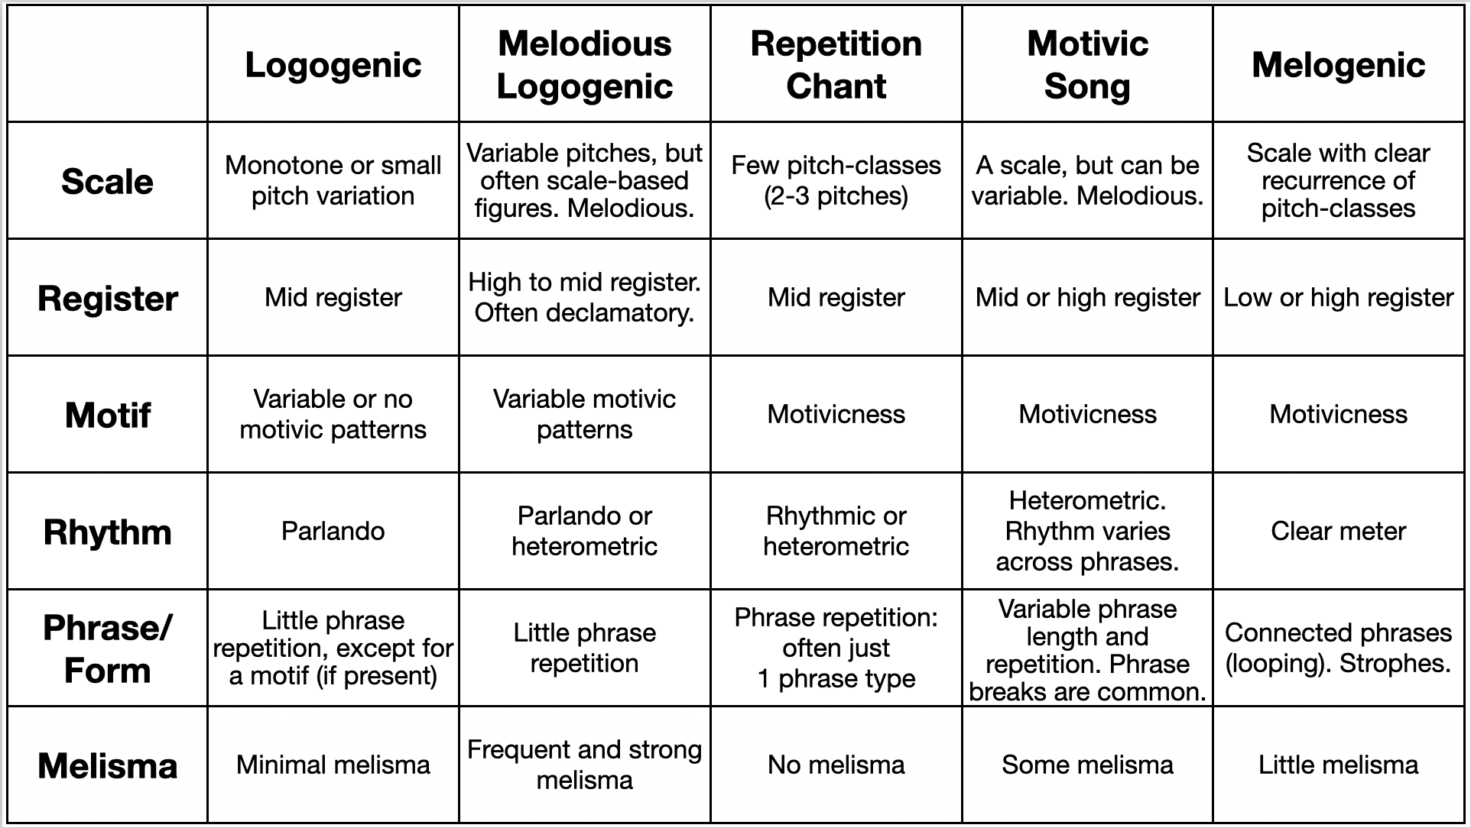Extended Data Table 1: A classification of vocal songs based on a primary distinction between melogenic and logogenic types. See text for details.
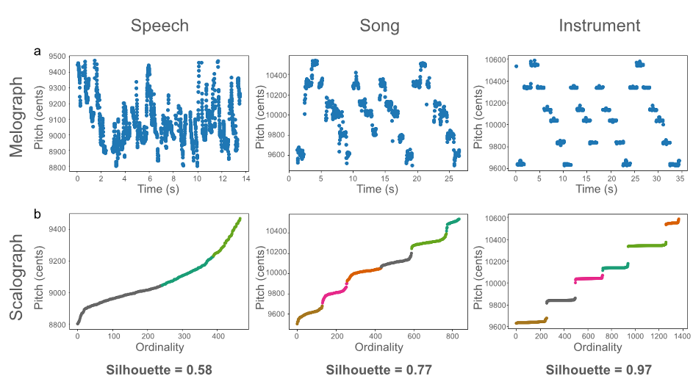
Extended Data Figure 1: (a) Melographs and (b) scalographs for examples of speech (left), song (middle), and instrumental music (right), based on a brief spoken monologue (in English) or the melody Twinkle Twinkle, either sung or played on a piano. The melograph presents the raw time-series of pitches for a sample. The scalograph converts this time-series into an ordinal form of ascending pitches (in cents), independent of time. The automatic k-means clustering solution is indicated by the coloring of the pitch groupings in the scalographs. The silhouette value is shown below each graph. Note how the instrumental sample (right) shows a far more discrete organization of pitch-classes than the two vocal samples, resulting in its high silhouette value, where the maximal value is 1.0.
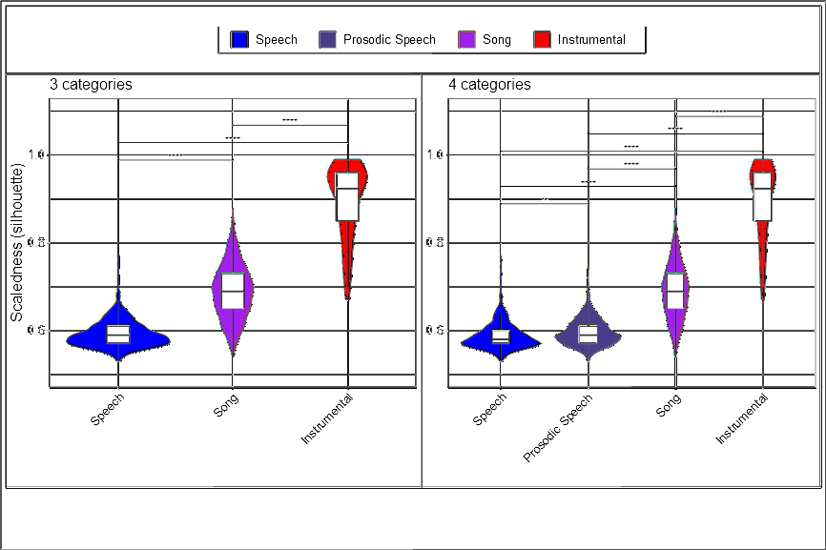
Extended Data Figure 2: Scaledness values across the overall categories of the combined dataset, shown as violin plots. The violin plots are color-coded for overall category as per Figure 1. The outer colored plot presents a mirrored kernel density estimation (a smoothed histogam of the data distribution). The inner boxplot presents the median as a horizontal line, the IQR as a box, and whiskers that extend to the maximum and minimum values (excluding outliers further than 1.5x the IQR from the 25th or 75th percentile). Statistical comparisons are * p<0.05, ** p<0.01, *** p<0.001.

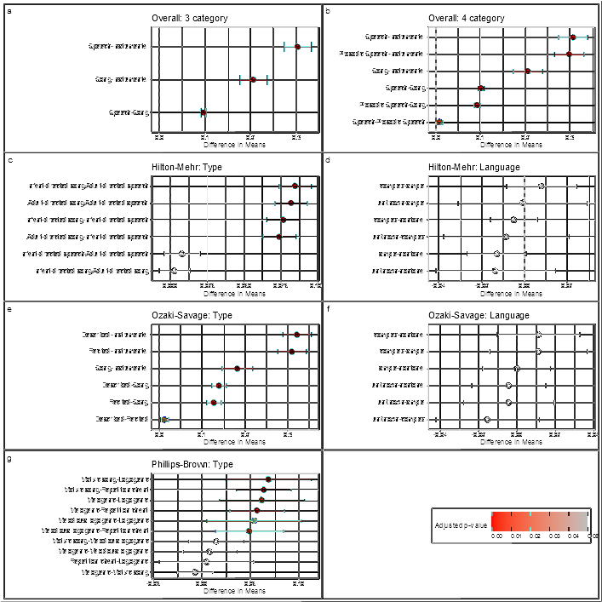
Extended Data Figure 3: Estimated pairwise differences in means with 95% confidence intervals. The top row shows differences for the combined dataset when divided into 3 (a) or 4 (b) categories, the latter including prosodic speech. The second and third rows show differences for the Hilton-Mehr (c-d) and Ozaki-Savage (e-f) datasets respectively, with comparisons according to utterance type on the left and according to language type on the right. The fourth row (g) shows differences for the Phillips-Brown dataset. All comparisons are colour-coded according to the adjusted p-value, with 0.00 in red and >0.05 in grey.
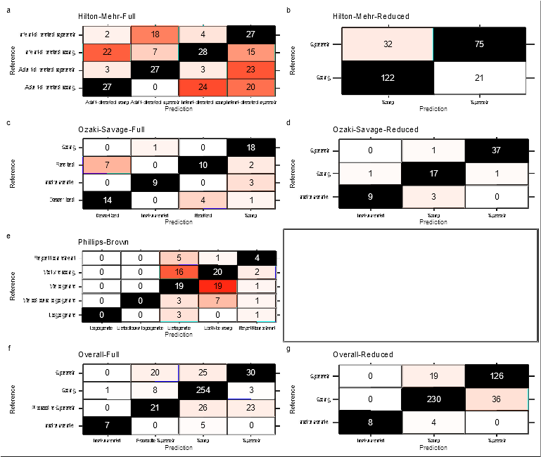
Extended Data Figure 4: Raw predictive analyses results. The confusion matrix for each model gives the predicted classification (columns) against the true classification (rows), with correct predictions highlighted in black and model errors highlighted in a heatmap where red corresponds to more errors.

