Supplementary material

Table S1. List of variables considered for the analysis, indicating whether they were discarded due to excessive NA values and if they were selected in any final model.

Dimension | Variable | Variable NA excess | Selected in MUAC model | Selected in LOS model
Demographics | Caregiver's relationship with the child | No | No | No
Demographics | Age of caregiver | No | No | No
Demographics | Sex of caregiver | No | No | No
Demographics | Years of education of caregiver | Yes | No | No
Demographics | Age mother pregnant | No | Yes | No
Demographics | Number of children less five years | No | No | No
Demographics | Number of younger siblings | Yes | No | No
Demographics | Younger brother's age | Yes | No | No
Demographics | Number of siblings died before the age of five | Yes | No | No
Livelihoods | Type of water supply | No | No | Yes
Livelihoods | Distance to collect water | No | No | Yes
Livelihoods | Time to collect water | No | No | No
Livelihoods | Debugging water | No | No | No
Livelihoods | Type of bathroom sanitation | No | No | No
Livelihoods | Head household work | No | No | No
Livelihoods | Caregiver work | No | No | No
Livelihoods | What is the average income per month generated by the activity of the child's caregiver? | Yes | No | No
Livelihoods | How many hours per day does the child's caregiver spend on this activity? | Yes | No | No
Livelihoods | Number of habitants in the household | No | No | No
Livelihoods | Status of the household | No | No | No
Livelihoods | Type of roof material | No | No | No
Livelihoods | Type of floor material | No | No | No
Livelihoods | Is there an independent kitchenin the household? | No | No | No
Food security and diversity | Receiving breastfeeding now | No | Yes | No
Food security and diversity | Age of stop breastfeeding | Yes | No | No
Food security and diversity | Is the child currently eating other foods besides breast milk? | Yes | No | No
Food security and diversity | How old was the child the first time he/she ate semi-solid, solid or soft foods? | Yes | No | No
Food security and diversity | How old was the child when he/she first drank liquids other than breast milk? | Yes | No | No
Food security and diversity | Source of food | No | No | No
Food security and diversity | Worried about having enough food | No | No | No
Food security and diversity | Reduction in the portion of meals | No | No | No
Food security and diversity | Reduction in the number of meals | No | No | No
Food security and diversity | Go a whole day without eating | No | No | No
Food security and diversity | Cereals and grains frequency in last week | No | Yes | Yes
Food security and diversity | Roots and tubers frequency in last week | No | Yes | Yes
Food security and diversity | Legumes or nuts frequency in last week | No | Yes | Yes
Food security and diversity | Orange-fleshed vegetables (rich in vitamin A) frequency in last week | No | Yes | Yes
Food security and diversity | Green leafy vegetables frequency in last week | No | Yes | Yes
Food security and diversity | Other vegetables frequency in last week | No | Yes | Yes
Food security and diversity | Orange-fleshed fruits (rich in vitamin A) frequency in last week | No | Yes | Yes
Food security and diversity | Other fruits frequency in last week | No | Yes | Yes
Food security and diversity | Meat frequency in last week | No | Yes | Yes
Food security and diversity | Liver, kidney, heart and/or other organs frequency in last week | No | Yes | Yes
Food security and diversity | Fish / Shellfish frequency in last week | No | Yes | Yes
Food security and diversity | Eggs frequency in last week | No | Yes | Yes
Food security and diversity | Dairy products frequency in last week | No | Yes | Yes
Food security and diversity | Fats frequency in last week | No | Yes | Yes
Food security and diversity | Sugar or sweet products frequency in last week | No | Yes | Yes
Food security and diversity | Condiments / Spices frequency in last week | No | Yes | Yes
Healthcare access | Number consultations prenatales | No | No | No
Healthcare access | Mother taking comprimés pregnant | No | No | No
Healthcare access | How to treat a ill child | No | No | No
Healthcare access | Type of transport Health site | No | No | No
Healthcare access | Travel time Health site | No | No | No
Healthcare access | How much did the transportation cost you (round trip)? | Yes | No | No
Healthcare access | Time to admission in Health site visit | No | No | No
Healthcare access | Travel to Health site in one day | No | No | Yes
Healthcare access | If you need to stay overnight, how much does accommodation cost? | Yes | No | No

The variables selected in any of the models appear highlighted in bold

Table S2. WAIC values recorded for different types of random effects combinations for the Week and Travel time (TT) variables.

Country | Dependent variable | Week rw1 & TT rw1 | Week rw1 & TT rw2 | Week rw2 & TT rw1 | Week rw2 & TT rw2
Niger | MUAC | 2617.45 | 2621.42 | 2617.18 | 2621.63
Niger | LOS | 3271.10 | 3269.66 | 3273.84 | 3273.62
Mali | MUAC | 2692.59 | 2691.22 | 2725.75 | 2698.13
Mali | LOS | 2953.37 | 2952.63 | 2952.29 | 2956.31

The optimum values of WAIC appear highlighted in bold

Table S3. Relationships between Travel Time and Week variables with MUAC and LOS for recovery in Niger and Mali. Pearson correlation coefficients between the variables in columns are shown stratified by the variables in rows.

 |  | Travel Time |  | Week
Niger |  | MUAC | LOS | MUAC | LOS
 |  | n = 439 | n = 427 | n = 439 | n = 427
Protocol | CMAM | - | - | - | -
Protocol | iCCM | -0.012 | 0.139 | 0.097 | -0.075
Protocol | Simplified | -0.069 | 0.143** | -0.105 | 0.162**
Sex | Male | -0.093 | 0.195** | -0.005 | 0.066
Sex | Female | -0.025 | 0.105 | -0.109 | 0.281***
Age | 6-24 months | -0.042 | 0.122* | -0.052 | 0.174***
Age | 24-59 months | -0.259 | 0.658 | -0.539 | 0.655
Severity | MAM | -0.098 | 0.112 | -0.136* | 0.322***
Severity | SAM | 0.007 | 0.155 | -0.039 | 0.053
Comorbidities | Yes | -0.298** | 0.153 | -0.242* | 0.303**
Comorbidities | No | 0.030 | 0.135* | -0.034 | 0.175**
Vaccination | Yes | -0.090 | 0.180** | -0.045 | 0.185**
Vaccination | No | 0.009 | 0.06 | -0.096 | 0.215**
Mali |  | MUAC | LOS | MUAC | LOS
 |  | n = 413 | n = 334 | n = 413 | n = 334
Protocol | CMAM | -0.047 | 0.048 | 0.180 | -0.033
Protocol | iCCM | 0.008 | -0.100 | 0.317*** | -0.087
Protocol | Simplified | 0.205 | 0.093 | 0.004 | -0.081
Sex | Male | -0.007 | 0.050 | 0.303*** | -0.044
Sex | Female | 0.044 | -0.037 | 0.218*** | -0.123
Age | 6-24 months | 0.019 | -0.037 | 0.231*** | -0.057
Age | 24-59 months | -0.237 | 0.449* | 0.533** | -0.347
Severity | MAM | 0.118 | 0.048 | 0.238** | -0.107
Severity | SAM | 0.010 | -0.014 | 0.099 | 0.007
Comorbidities | Yes | 0.069 | -0.166 | 0.285 | -0.259
Comorbidities | No | 0.010 | 0.034 | 0.256*** | -0.064
Vaccination | Yes | 0.055 | -0.001 | 0.275*** | -0.130*
Vaccination | No | -0.202 | 0.125 | 0.124 | 0.300

MUAC: Mid-Upper Arm Circumference; LOS: Length of stay; CMAM: Community Management of Acute Malnutrition; iCCM: integrated Community Case Management; MAM: Moderate Acute Malnutrition; SAM: Severe Acute Malnutrition. *: p-value < 0.05; **: p-value < 0.01; ***: p-value < 0.001.

Table S4. Mean effect in Niger of travel time categories on MUAC or LOS depending on presence of comorbidities and child severity.

 |  | No comorbidities |  |  | Comorbidities
 | Time category | Mean | 95% CI lower bound | 95% CI upper bound | Mean | 95% CI lower bound | 95% CI upper bound
MUAC | 1 | -0,55 | -1,98 | 0,79 | 2,65* | 0,51 | 5,14
MUAC | 2 | 0,57 | -0,36 | 1,56 | 1,57* | 0,12 | 3,16
MUAC | 3 | 0,42 | -0,47 | 1,36 | 0,68 | -0,59 | 2,05
MUAC | 4 | -0,60 | -1,98 | 0,56 | -0,35 | -1,92 | 1,11
MUAC | 5 | 0,36 | -1,01 | 2,05 | -0,83 | -2,56 | 0,82
MUAC | 6 | -0,07 | -1,21 | 1,08 | -1,59 | -3,42 | 0,01
MUAC | 7 | -0,13 | -1,90 | 1,63 | -2,13 | -5,00 | 0,18
 | Time category | MAM |  |  | SAM
 | Time category | Mean | 95% CI lower bound | 95% CI upper bound | Mean | 95% CI lower bound | 95% CI upper bound
Length of Stay | 1 | -1,87 | -5,63 | 1,98 | -2,18 | -6,05 | 1,86
Length of Stay | 2 | -1,85 | -4,44 | 0,58 | -2,89 | -5,77 | -0,28
Length of Stay | 3 | -0,55 | -2,70 | 1,64 | -1,74 | -4,23 | 0,59
Length of Stay | 4 | 0,78 | -1,69 | 3,90 | -0,97 | -3,80 | 1,46
Length of Stay | 5 | 0,82 | -2,02 | 3,63 | -0,26 | -4,34 | 2,43
Length of Stay | 6 | 0,96 | -1,97 | 3,61 | 2,25 | -0,48 | 4,90
Length of Stay | 7 | 1,71 | -3,35 | 6,69 | 5,80* | 0,25 | 12,75
 | Time category | No comorbidities |  |  | Comorbidities
 | Time category | Mean | 95% CI lower bound | 95% CI upper bound | Mean | 95% CI lower bound | 95% CI upper bound
Length of Stay | 1 | -2,47 | -5,67 | 1,00 | -0,72 | -5,69 | 4,20
Length of Stay | 2 | -2,65 | -4,97 | -0,59 | -0,62 | -3,94 | 2,43
Length of Stay | 3 | -1,49 | -3,36 | 0,25 | 0,35 | -1,98 | 3,12
Length of Stay | 4 | -0,47 | -2,74 | 1,51 | 0,79 | -1,64 | 4,58
Length of Stay | 5 | 0,65 | -2,25 | 2,76 | -0,10 | -4,00 | 2,64
Length of Stay | 6 | 2,32* | 0,07 | 4,54 | -0,26 | -3,99 | 2,94
Length of Stay | 7 | 4,13* | 0,09 | 8,69 | 0,56 | -5,32 | 7,33

*: p-value < 0.05

Table S5. Mean effect in Niger of Week on MUAC depending on child sex.

 |  | Female |  |  | Male
 | Week | Mean | 95% CI lower bound | 95% CI upper bound | Mean | 95% CI  lower bound | 95% CI upper bound
MUAC | 1 | 0,12 | -1,74 | 1,95 | 1,81 | -0,31 | 4,00
MUAC | 2 | 0,38 | -1,01 | 1,77 | 1,19 | -0,40 | 2,81
MUAC | 3 | 0,64 | -0,68 | 2,00 | 0,60 | -0,81 | 2,08
MUAC | 4 | 0,88 | -0,47 | 2,40 | 0,08 | -1,33 | 1,57
MUAC | 5 | 0,99 | -0,39 | 2,56 | -0,42 | -1,87 | 1,04
MUAC | 6 | 0,87 | -0,46 | 2,34 | -0,87 | -2,35 | 0,51
MUAC | 7 | 0,66 | -0,60 | 2,01 | -1,15 | -2,65 | 0,18
MUAC | 8 | 0,45 | -0,73 | 1,70 | -1,12 | -2,50 | 0,15
MUAC | 9 | 0,19 | -0,96 | 1,40 | -0,87 | -2,16 | 0,33
MUAC | 10 | -0,19 | -1,36 | 0,99 | -0,55 | -1,82 | 0,64
MUAC | 11 | -0,56 | -1,81 | 0,59 | -0,09 | -1,32 | 1,08
MUAC | 12 | -0,78 | -2,02 | 0,36 | 0,46 | -0,68 | 1,66
MUAC | 13 | -0,87 | -2,12 | 0,27 | 0,99 | -0,19 | 2,29
MUAC | 14 | -0,77 | -2,03 | 0,37 | 1,26* | 0,05 | 2,63
MUAC | 15 | -0,51 | -1,67 | 0,58 | 1,26* | 0,11 | 2,51
MUAC | 16 | -0,18 | -1,22 | 0,89 | 1,01 | -0,05 | 2,12
MUAC | 17 | 0,14 | -0,90 | 1,29 | 0,66 | -0,38 | 1,73
MUAC | 18 | 0,33 | -0,88 | 1,76 | 0,24 | -1,00 | 1,46
MUAC | 19 | 0,24 | -1,17 | 1,87 | -0,29 | -1,86 | 1,20
MUAC | 20 | -0,11 | -1,82 | 1,62 | -0,85 | -2,77 | 0,98
MUAC | 21 | -0,65 | -2,97 | 1,56 | -1,40 | -3,76 | 0,89
MUAC | 22 | -1,27 | -4,84 | 1,85 | -1,95 | -5,03 | 1,02

*: p-value < 0.05

Table S6. Mean effect in Mali of Week on MUAC depending on treatment protocol.

 |  | Control Protocol |  |  | Standard Protocol |  |  | Simplified Protocol
 | Week | Mean | 95% CI  lower bound | 95% CI  upper bound | Mean | 95% CI lower bound | 95% CI  upper bound | Mean | 95% CI  lower bound | 95% CI  upper bound
MUAC | 1 | 0,24 | -2,65 | 3,16 | -2,05 | -9,97 | 5,96 | -1,86 | -6,56 | 2,82
MUAC | 2 | -1,35 | -4,48 | 1,75 | -2,01 | -9,14 | 5,20 | -1,47 | -5,79 | 2,86
MUAC | 3 | -2,28 | -5,03 | 0,43 | -1,94 | -8,27 | 4,48 | -0,89 | -5,49 | 3,79
MUAC | 4 | -2,56 | -5,71 | 0,51 | -1,84 | -7,34 | 3,77 | -0,89 | -5,80 | 4,10
MUAC | 5 | -1,27 | -4,69 | 2,23 | -1,69 | -6,28 | 3,00 | -0,97 | -5,84 | 3,99
MUAC | 6 | -1,95 | -5,73 | 1,79 | -1,52 | -4,95 | 2,00 | -1,11 | -5,63 | 3,44
MUAC | 7 | -2,37 | -6,09 | 1,24 | -2,63 | -5,22 | -0,10 | -1,33 | -5,02 | 2,36
MUAC | 8 | -1,64 | -5,04 | 1,76 | -1,08 | -3,47 | 1,35 | -1,86 | -5,68 | 1,88
MUAC | 9 | -1,41 | -5,24 | 2,41 | -0,15 | -2,65 | 2,43 | -1,46 | -5,55 | 2,57
MUAC | 10 | -0,72 | -5,00 | 3,65 | 0,29 | -2,39 | 3,07 | -0,86 | -5,33 | 3,56
MUAC | 11 | 0,00 | -4,31 | 4,49 | 0,17 | -2,84 | 3,31 | -0,34 | -4,68 | 4,00
MUAC | 12 | 0,14 | -4,22 | 4,68 | -1,98 | -5,10 | 0,98 | -0,06 | -4,63 | 4,48
MUAC | 13 | -0,17 | -4,62 | 4,40 | -1,39 | -4,15 | 1,29 | 0,15 | -4,18 | 4,43
MUAC | 14 | -0,40 | -5,04 | 4,35 | 0,14 | -3,14 | 3,45 | 0,67 | -3,26 | 4,57
MUAC | 15 | -0,59 | -5,13 | 4,02 | 1,19 | -2,09 | 4,53 | 1,43 | -1,69 | 4,59
MUAC | 16 | -0,87 | -5,45 | 3,73 | 2,50* | 0,14 | 4,92 | 1,89 | -1,10 | 4,94
MUAC | 17 | -1,12 | -5,39 | 3,14 | 2,69* | 0,10 | 5,35 | 2,20 | -0,39 | 4,83
MUAC | 18 | -1,13 | -5,06 | 2,79 | 3,33* | 0,60 | 6,18 | 1,71 | -1,50 | 4,95
MUAC | 19 | -1,19 | -5,39 | 2,98 | 1,77 | -1,36 | 4,98 | 1,59 | -1,32 | 4,52
MUAC | 20 | -1,23 | -5,16 | 2,69 | 0,96 | -2,56 | 4,58 | 2,07 | -0,94 | 5,15
MUAC | 21 | -0,90 | -4,30 | 2,54 | 0,18 | -2,80 | 3,22 | 1,47 | -2,28 | 5,28
MUAC | 22 | -2,12 | -5,83 | 1,48 | -0,73 | -4,45 | 3,08 | 0,10 | -4,41 | 4,46
MUAC | 23 | -1,78 | -5,87 | 2,19 | -2,50 | -7,02 | 1,96 | 0,07 | -4,98 | 4,97
MUAC | 24 | -1,41 | -5,63 | 2,72 | -4,23 | -9,25 | 0,53 | -0,04 | -5,28 | 5,09
MUAC | 26 | -0,40 | -3,95 | 3,18 | -7,62* | -12,80 | -2,95 | -0,40 | -5,13 | 4,27
MUAC | 27 | -0,19 | -3,60 | 3,26 | -9,29* | -14,08 | -4,91 | -0,49 | -4,85 | 3,84
MUAC | 28 | 0,02 | -3,51 | 3,62 | -8,98* | -12,80 | -5,33 | -0,40 | -4,30 | 3,51
MUAC | 29 | -0,68 | -4,12 | 2,70 | -8,51* | -12,04 | -5,11 | -1,46 | -5,45 | 2,42
MUAC | 30 | -0,93 | -4,89 | 2,88 | -6,61* | -10,29 | -3,06 | -1,53 | -5,59 | 2,43
MUAC | 31 | -0,30 | -4,32 | 3,63 | -5,05* | -8,82 | -1,32 | -1,47 | -5,76 | 2,71
MUAC | 32 | 0,56 | -3,24 | 4,38 | -3,81 | -7,78 | 0,15 | -1,26 | -5,66 | 3,06
MUAC | 33 | 0,83 | -3,25 | 4,92 | -2,58 | -6,57 | 1,43 | -1,38 | -5,93 | 3,04
MUAC | 34 | 1,13 | -2,63 | 4,91 | -1,31 | -4,73 | 2,15 | -1,63 | -6,44 | 2,97
MUAC | 35 | 1,95 | -1,46 | 5,45 | -0,14 | -3,35 | 3,12 | -1,08 | -6,23 | 3,92
MUAC | 36 | 1,88 | -1,55 | 5,39 | 0,67 | -3,11 | 4,52 | -0,61 | -5,92 | 4,64
MUAC | 37 | 1,74 | -1,75 | 5,26 | 1,52 | -2,14 | 5,21 | -0,20 | -5,57 | 5,16
MUAC | 38 | 1,87 | -1,39 | 5,17 | 2,60 | -0,86 | 6,13 | 0,13 | -5,21 | 5,52
MUAC | 39 | 1,13 | -2,42 | 4,60 | 3,76* | 0,37 | 7,25 | 0,40 | -4,85 | 5,72
MUAC | 40 | 1,73 | -1,78 | 5,24 | 5,01* | 2,39 | 7,72 | 0,59 | -4,50 | 5,77
MUAC | 41 | 1,53 | -2,62 | 5,65 | 5,01* | 2,63 | 7,44 | 0,71 | -4,18 | 5,67
MUAC | 42 | 1,51 | -3,26 | 6,21 | 5,46* | 2,71 | 8,29 | 0,92 | -4,18 | 6,13
MUAC | 43 | 1,52 | -3,61 | 6,57 | 5,58* | 2,32 | 8,95 | 1,06 | -4,23 | 6,46
MUAC | 44 | 1,57 | -3,77 | 6,82 | 5,29* | 1,75 | 8,92 | 1,13 | -4,33 | 6,70
MUAC | 45 | 1,65 | -3,78 | 7,00 | 4,48* | 0,81 | 8,11 | 1,12 | -4,50 | 6,84
MUAC | 46 | 1,77 | -3,64 | 7,12 | 3,93* | 0,22 | 7,50 | 1,05 | -4,75 | 6,91
MUAC | 47 | 1,92 | -3,37 | 7,19 | 4,17* | 0,74 | 7,49 | 0,90 | -5,07 | 6,90
MUAC | 48 | 2,11 | -2,95 | 7,18 | 5,88* | 2,63 | 9,18 | 1,12 | -5,58 | 7,88
MUAC | 49 | 2,08 | -3,59 | 7,77 | 6,85* | 3,90 | 9,86 | 1,26 | -6,17 | 8,79
MUAC | 50 | 2,10 | -4,08 | 8,27 | 6,19* | 2,27 | 10,14 | 1,33 | -6,86 | 9,64

*: p-value < 0.05

Table S7. Mean effect in Mali of Week on MUAC depending on child sex.

 |  | Female |  |  | Male
 | Week | Mean | 95% CI  lower bound | 95% CI  upper bound | Mean | 95% CI  lower bound | 95% CI  upper bound
MUAC | 1 | -0,99 | -3,85 | 1,92 | -1,37 | -4,82 | 2,11
MUAC | 2 | -1,65 | -4,58 | 1,22 | -1,34 | -4,49 | 1,88
MUAC | 3 | -2,15 | -5,14 | 0,66 | -1,05 | -3,95 | 2,02
MUAC | 4 | -1,70 | -4,91 | 1,43 | -1,64 | -4,52 | 1,27
MUAC | 5 | -1,25 | -4,32 | 1,97 | -1,35 | -4,25 | 1,79
MUAC | 6 | -1,08 | -3,93 | 1,94 | -2,02 | -4,81 | 0,76
MUAC | 7 | -1,36 | -3,86 | 1,17 | -2,50* | -4,89 | -0,21
MUAC | 8 | -1,63 | -4,00 | 0,68 | -1,59 | -3,81 | 0,73
MUAC | 9 | -1,55 | -4,01 | 0,81 | -1,62 | -4,01 | 0,87
MUAC | 10 | -0,42 | -2,91 | 2,24 | -2,07 | -4,79 | 0,59
MUAC | 11 | -0,07 | -2,65 | 2,72 | -2,01 | -4,83 | 0,77
MUAC | 12 | -0,37 | -3,08 | 2,39 | -2,40 | -5,26 | 0,24
MUAC | 13 | -0,75 | -3,49 | 1,82 | -1,94 | -4,60 | 0,61
MUAC | 14 | 0,09 | -2,60 | 2,81 | -1,49 | -4,35 | 1,31
MUAC | 15 | 0,79 | -1,67 | 3,41 | -0,91 | -3,55 | 1,78
MUAC | 16 | 1,19 | -1,09 | 3,62 | -0,12 | -2,40 | 2,32
MUAC | 17 | 1,05 | -1,25 | 3,47 | -0,08 | -2,29 | 2,24
MUAC | 18 | 0,97 | -1,51 | 3,64 | -0,30 | -2,63 | 2,11
MUAC | 19 | 0,37 | -2,24 | 3,09 | -0,42 | -2,83 | 2,09
MUAC | 20 | 0,20 | -2,41 | 2,99 | -0,63 | -3,17 | 1,99
MUAC | 21 | -0,31 | -2,83 | 2,34 | -1,09 | -3,64 | 1,45
MUAC | 22 | -1,47 | -4,39 | 1,37 | -2,01 | -5,29 | 0,87
MUAC | 23 | -2,23 | -5,58 | 0,93 | -1,78 | -5,37 | 1,41
MUAC | 24 | -2,94 | -6,60 | 0,43 | -1,57 | -5,14 | 1,72
MUAC | 26 | -4,33* | -7,75 | -1,27 | -0,90 | -4,02 | 2,22
MUAC | 27 | -5,37* | -8,76 | -2,43 | -0,60 | -3,58 | 2,48
MUAC | 28 | -5,46* | -8,58 | -2,67 | -0,67 | -3,47 | 2,18
MUAC | 29 | -5,91* | -9,37 | -2,95 | -1,11 | -3,95 | 1,60
MUAC | 30 | -4,61* | -7,80 | -1,77 | -1,38 | -4,61 | 1,53
MUAC | 31 | -3,61* | -6,72 | -0,75 | -1,04 | -4,29 | 1,94
MUAC | 32 | -2,53 | -5,48 | 0,32 | -0,61 | -3,87 | 2,46
MUAC | 33 | -1,88 | -5,05 | 1,15 | -0,26 | -3,42 | 2,73
MUAC | 34 | -1,22 | -4,21 | 1,64 | 0,15 | -2,70 | 2,93
MUAC | 35 | -0,08 | -2,85 | 2,72 | 0,78 | -1,92 | 3,51
MUAC | 36 | 0,75 | -2,18 | 3,77 | 1,04 | -1,84 | 3,91
MUAC | 37 | 1,53 | -1,32 | 4,51 | 1,27 | -1,65 | 4,14
MUAC | 38 | 2,28 | -0,41 | 5,10 | 1,70 | -1,11 | 4,49
MUAC | 39 | 2,91* | 0,28 | 5,67 | 2,23 | -0,62 | 5,11
MUAC | 40 | 3,78* | 1,46 | 6,26 | 3,23* | 0,66 | 6,07
MUAC | 41 | 4,19* | 1,81 | 6,76 | 3,36* | 0,93 | 5,95
MUAC | 42 | 4,34* | 1,65 | 7,30 | 3,83* | 1,19 | 6,81
MUAC | 43 | 4,60* | 1,62 | 8,00 | 3,20* | 0,30 | 6,26
MUAC | 44 | 4,39* | 1,28 | 7,77 | 2,74 | -0,50 | 5,97
MUAC | 45 | 4,12* | 0,78 | 7,61 | 2,27 | -1,06 | 5,41
MUAC | 46 | 3,85* | 0,49 | 7,23 | 2,05 | -1,39 | 5,22
MUAC | 47 | 3,80* | 0,53 | 7,07 | 2,01 | -1,28 | 5,10
MUAC | 48 | 3,97* | 0,92 | 7,07 | 2,95 | -0,33 | 6,28
MUAC | 49 | 3,98* | 0,97 | 7,02 | 3,59* | 0,10 | 7,28
MUAC | 50 | 3,78* | 0,20 | 7,35 | 3,45 | -0,68 | 7,79

*: p-value < 0.05

Table S8. Mean effect in Mali of Week on LOS depending on child severity.

 |  | MAM |  |  | SAM
 | Week | Mean | 95% CI lower bound | 95% CI upper bound | Mean | 95% CI  lower bound | 95% CI upper bound
Length of Stay | 1 | -1,76 | -12,61 | 9,11 | -4,70 | -14,71 | 5,24
Length of Stay | 2 | -1,53 | -10,76 | 7,72 | -4,10 | -12,67 | 4,41
Length of Stay | 3 | -1,28 | -9,29 | 6,75 | -3,44 | -11,01 | 4,05
Length of Stay | 4 | -0,99 | -8,15 | 6,17 | -2,75 | -9,66 | 4,06
Length of Stay | 5 | -0,70 | -7,28 | 5,88 | -2,01 | -8,49 | 4,33
Length of Stay | 6 | -0,42 | -6,59 | 5,77 | -1,20 | -7,39 | 4,81
Length of Stay | 7 | -0,11 | -6,00 | 5,80 | -0,32 | -6,29 | 5,49
Length of Stay | 8 | 0,20 | -5,47 | 5,91 | 0,62 | -5,24 | 6,34
Length of Stay | 9 | 0,53 | -5,01 | 6,13 | 1,62 | -4,19 | 7,37
Length of Stay | 10 | 0,87 | -4,63 | 6,44 | 2,63 | -3,18 | 8,47
Length of Stay | 11 | 1,20 | -4,29 | 6,79 | 3,62 | -2,20 | 9,58
Length of Stay | 12 | 1,54 | -3,94 | 7,16 | 4,55 | -1,27 | 10,63
Length of Stay | 13 | 1,87 | -3,55 | 7,46 | 5,36 | -0,48 | 11,53
Length of Stay | 14 | 2,17 | -3,13 | 7,67 | 5,96* | 0,12 | 12,17
Length of Stay | 15 | 2,44 | -2,70 | 7,76 | 6,38* | 0,55 | 12,56
Length of Stay | 16 | 2,65 | -2,30 | 7,74 | 6,60* | 0,81 | 12,75
Length of Stay | 17 | 2,78 | -2,05 | 7,69 | 6,65* | 0,87 | 12,77
Length of Stay | 18 | 2,89 | -1,92 | 7,72 | 6,46* | 0,69 | 12,57
Length of Stay | 19 | 3,06 | -1,86 | 7,97 | 6,00* | 0,24 | 12,07
Length of Stay | 20 | 3,24 | -1,87 | 8,33 | 5,34 | -0,45 | 11,38
Length of Stay | 21 | 3,38 | -2,05 | 8,71 | 4,46 | -1,41 | 10,50
Length of Stay | 22 | 3,46 | -2,37 | 9,12 | 3,49 | -2,56 | 9,58
Length of Stay | 23 | 3,54 | -2,75 | 9,54 | 2,50 | -3,78 | 8,66
Length of Stay | 24 | 3,61 | -3,12 | 9,92 | 1,53 | -4,96 | 7,75
Length of Stay | 26 | 3,78 | -3,58 | 10,55 | -0,18 | -6,79 | 5,99
Length of Stay | 27 | 3,95 | -3,58 | 10,85 | -0,83 | -7,38 | 5,27
Length of Stay | 28 | 4,17 | -3,44 | 11,16 | -1,30 | -7,74 | 4,72
Length of Stay | 29 | 4,44 | -3,19 | 11,50 | -1,59 | -7,92 | 4,37
Length of Stay | 30 | 4,74 | -2,85 | 11,83 | -1,70 | -7,99 | 4,21
Length of Stay | 31 | 5,03 | -2,42 | 12,10 | -1,65 | -7,89 | 4,25
Length of Stay | 32 | 5,30 | -1,95 | 12,29 | -1,46 | -7,65 | 4,47
Length of Stay | 34 | 5,66 | -0,94 | 12,33 | -0,75 | -6,78 | 5,33
Length of Stay | 35 | 5,69 | -0,54 | 12,13 | -0,38 | -6,35 | 5,82
Length of Stay | 36 | 5,60 | -0,30 | 11,83 | -0,02 | -5,98 | 6,36
Length of Stay | 37 | 5,34 | -0,30 | 11,37 | 0,26 | -5,74 | 6,86
Length of Stay | 38 | 4,83 | -0,63 | 10,69 | 0,37 | -5,73 | 7,18
Length of Stay | 39 | 4,00 | -1,31 | 9,71 | 0,28 | -5,96 | 7,27
Length of Stay | 40 | 2,80 | -2,39 | 8,39 | 0,02 | -6,42 | 7,18
Length of Stay | 41 | 1,22 | -3,90 | 6,77 | -0,44 | -7,16 | 6,88
Length of Stay | 42 | -0,74 | -5,90 | 4,85 | -1,13 | -8,23 | 6,40
Length of Stay | 43 | -2,98 | -8,31 | 2,72 | -2,00 | -9,63 | 5,86
Length of Stay | 44 | -5,43 | -11,06 | 0,40 | -2,99 | -11,35 | 5,43
Length of Stay | 45 | -8,04* | -14,03 | -2,03 | -4,05 | -13,37 | 5,21
Length of Stay | 46 | -10,76* | -17,19 | -4,44 | -5,12 | -15,70 | 5,28
Length of Stay | 47 | -13,56* | -20,53 | -6,70 | -6,18 | -18,33 | 5,69
Length of Stay | 48 | -16,40* | -24,16 | -8,69 | -7,18 | -21,27 | 6,45
Length of Stay | 49 | -19,24* | -28,21 | -10,33 | -8,15 | -24,51 | 7,53
Length of Stay | 50 | -22,05* | -32,76 | -11,55 | -9,09 | -28,07 | 8,90

*: p-value < 0.05

Table S9. Mean effect in Mali of Week on LOS depending on child sex.

 |  | Female |  |  | Male
 | Week | Mean | 95% CI lower bound | 95% CI upper bound | Mean | 95% CI lower bound | 95% CI upper bound
Length of Stay | 1 | 1,48 | -8,13 | 11,04 | -8,82 | -20,52 | 2,74
Length of Stay | 2 | 1,55 | -6,61 | 9,65 | -7,74 | -17,49 | 1,90
Length of Stay | 3 | 1,66 | -5,61 | 8,84 | -6,64 | -14,94 | 1,58
Length of Stay | 4 | 1,81 | -4,99 | 8,47 | -5,53 | -12,82 | 1,71
Length of Stay | 5 | 2,03 | -4,50 | 8,34 | -4,44 | -11,06 | 2,11
Length of Stay | 6 | 2,30 | -3,97 | 8,37 | -3,40 | -9,57 | 2,68
Length of Stay | 7 | 2,65 | -3,37 | 8,52 | -2,35 | -8,24 | 3,43
Length of Stay | 8 | 3,03 | -2,74 | 8,76 | -1,29 | -7,04 | 4,35
Length of Stay | 9 | 3,45 | -2,14 | 9,12 | -0,19 | -5,94 | 5,46
Length of Stay | 10 | 3,83 | -1,68 | 9,55 | 0,94 | -4,88 | 6,71
Length of Stay | 11 | 4,17 | -1,35 | 10,01 | 2,08 | -3,79 | 8,02
Length of Stay | 12 | 4,45 | -1,07 | 10,43 | 3,22 | -2,65 | 9,29
Length of Stay | 13 | 4,60 | -0,90 | 10,66 | 4,30 | -1,51 | 10,46
Length of Stay | 14 | 4,57 | -0,86 | 10,57 | 5,25 | -0,45 | 11,40
Length of Stay | 15 | 4,39 | -0,92 | 10,24 | 6,04 | 0,51 | 12,03
Length of Stay | 16 | 4,08 | -1,10 | 9,74 | 6,65 | 1,33 | 12,39
Length of Stay | 17 | 3,67 | -1,45 | 9,20 | 7,06 | 1,90 | 12,56
Length of Stay | 18 | 3,16 | -1,98 | 8,66 | 7,27 | 2,18 | 12,64
Length of Stay | 19 | 2,58 | -2,67 | 8,13 | 7,37 | 2,22 | 12,75
Length of Stay | 20 | 1,90 | -3,53 | 7,52 | 7,35 | 2,02 | 12,87
Length of Stay | 21 | 1,07 | -4,64 | 6,79 | 7,14 | 1,50 | 12,86
Length of Stay | 22 | 0,15 | -6,02 | 6,03 | 6,85 | 0,78 | 12,83
Length of Stay | 23 | -0,80 | -7,49 | 5,32 | 6,54 | 0,04 | 12,79
Length of Stay | 24 | -1,70 | -8,91 | 4,65 | 6,23 | -0,62 | 12,68
Length of Stay | 26 | -3,18 | -10,99 | 3,58 | 5,66 | -1,39 | 12,24
Length of Stay | 27 | -3,53 | -11,36 | 3,34 | 5,37 | -1,62 | 11,91
Length of Stay | 28 | -3,53 | -11,27 | 3,32 | 5,07 | -1,85 | 11,56
Length of Stay | 29 | -3,20 | -10,79 | 3,52 | 4,77 | -2,12 | 11,25
Length of Stay | 30 | -2,58 | -9,99 | 3,95 | 4,47 | -2,45 | 10,98
Length of Stay | 31 | -1,69 | -8,90 | 4,65 | 4,17 | -2,78 | 10,72
Length of Stay | 32 | -0,63 | -7,59 | 5,63 | 3,88 | -3,05 | 10,46
Length of Stay | 34 | 1,81 | -4,57 | 8,30 | 3,35 | -3,23 | 9,83
Length of Stay | 35 | 2,96 | -3,21 | 9,68 | 3,06 | -3,28 | 9,45
Length of Stay | 36 | 4,00 | -2,19 | 11,00 | 2,77 | -3,35 | 9,14
Length of Stay | 37 | 4,78 | -1,61 | 12,00 | 2,44 | -3,52 | 8,84
Length of Stay | 38 | 5,16 | -1,47 | 12,46 | 1,97 | -3,91 | 8,43
Length of Stay | 39 | 5,07 | -1,70 | 12,30 | 1,31 | -4,56 | 7,85
Length of Stay | 40 | 4,49 | -2,28 | 11,63 | 0,39 | -5,50 | 7,00
Length of Stay | 41 | 3,44 | -3,22 | 10,59 | -0,86 | -6,80 | 5,77
Length of Stay | 42 | 1,85 | -4,63 | 9,01 | -2,41 | -8,48 | 4,26
Length of Stay | 43 | -0,18 | -6,57 | 6,97 | -4,18 | -10,49 | 2,56
Length of Stay | 44 | -2,53 | -9,06 | 4,56 | -6,10 | -12,78 | 0,76
Length of Stay | 45 | -5,10 | -12,01 | 1,97 | -8,11 | -15,27 | -0,99
Length of Stay | 46 | -7,83 | -15,27 | -0,57 | -10,17 | -17,94 | -2,54
Length of Stay | 47 | -10,66 | -18,79 | -2,78 | -12,22 | -20,85 | -3,76
Length of Stay | 48 | -13,51 | -22,65 | -4,53 | -14,23 | -24,11 | -4,56
Length of Stay | 49 | -16,35 | -27,03 | -5,83 | -16,19 | -27,85 | -4,90
Length of Stay | 50 | -19,15 | -32,07 | -6,71 | -18,11 | -32,13 | -4,73

*: p-value < 0.05

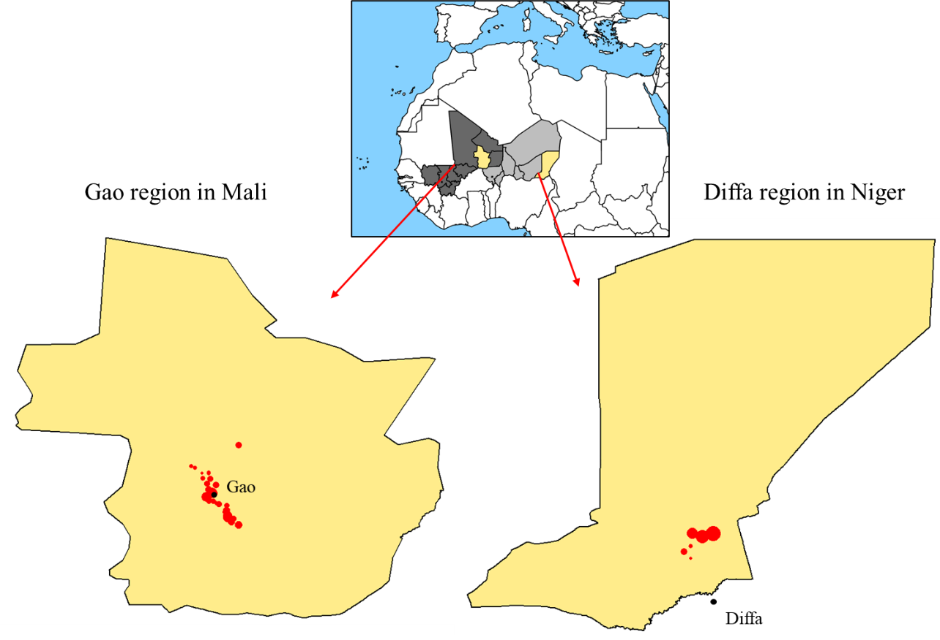

Figure S1. Location of the health sites included in the present study from the regions of Gao in Mali and Diffa in Niger. The size of the points is related to the proportion of children treated in each health site.

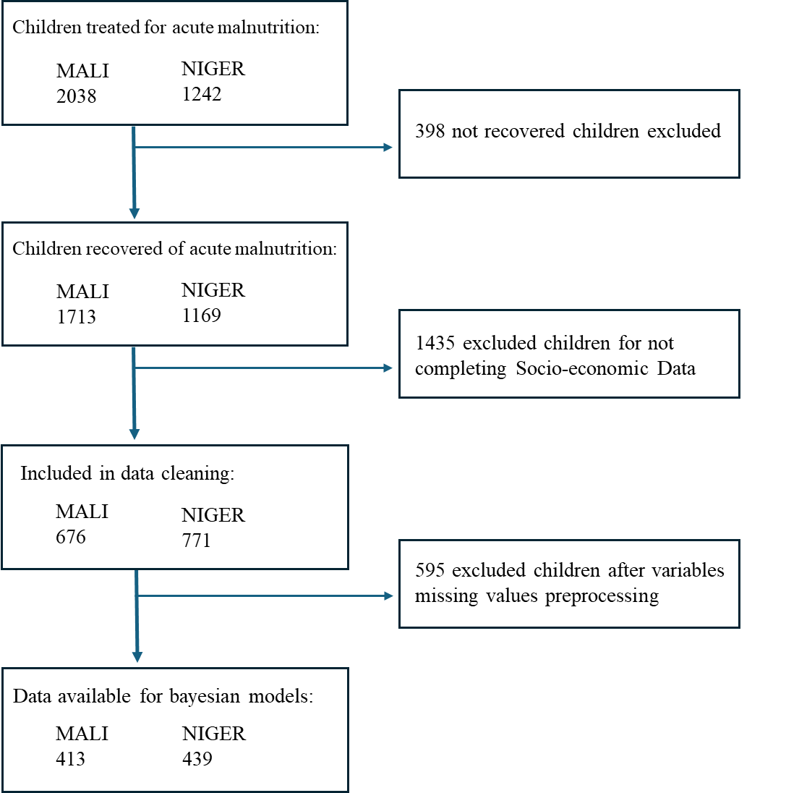

Figure S2. Study participants flow diagram.

MUAC: Mid-Upper Arm Circumference; LOS: Length of Stay.

Figure S3. Posterior distributions of the parameters of the final LOS model in Niger. The 95% credible intervals are indicated in colour, green is used to identify a beneficial change and red a harmful change in terms of LOS.

