Supplementary Material

Supplementary Tables legends
Supplementary Table 1: List of amino acid residues overlapping with paralogous (likely)-pathogenic variants from ClinVar or HGMD databases. For each residue the table displays all conserved missense variants in paralogous genes that have been previously annotated as (likely)-pathogenic in the ClinVar or HGMD database. If for a target residue multiple variant are found they are separated by a semicolon.
Supplementary Table 2: List of patients from literature with 22 distinct phenotypes associated with genetic variants in voltage-gated sodium channels.
Supplementary Figures

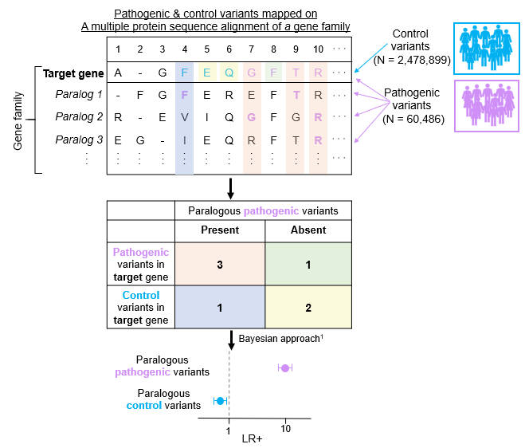
Supplementary Figure 1: Calculation of the likelihood ratio in the presence of pathogenic paralogous variants. Evidence strengths were obtained from Tavtigian et al., 2018 and considered a prior probability of 0.1. 1Approach applied to determine the strength of ACMG criteria in Tavtigian et al. 2018.
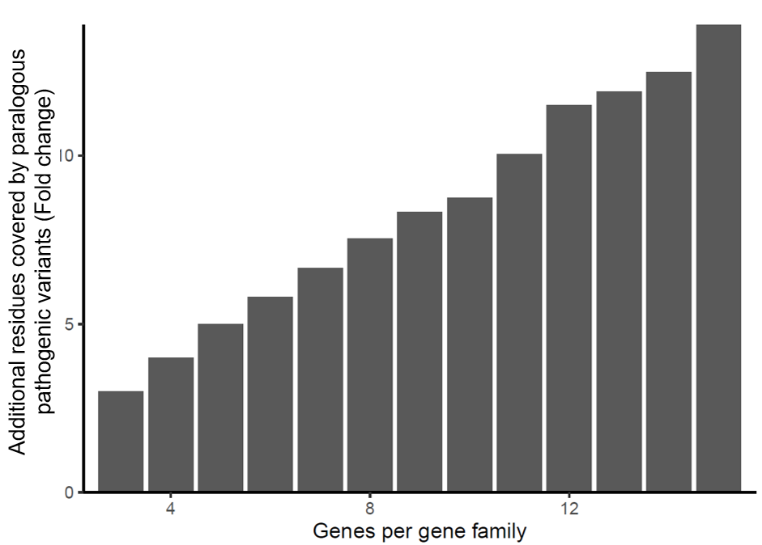
Supplementary Figure 2: The barplot shows a fold-wise increase in pathogenic variant residue coverage with consideration of paralog genes compared to the same gene only. The fold-change is stratified by the number of genes in a gene family.

