Table 1 (supplementary): Summary of CompuSyn simulated CI and DRI values for DOX and Ononin combination in MDA-MB-231 cell line at 70%, 75%, 80%, 85% and 90% growth inhibition.

Fa | CI | DRI DOX
ED₅₀  ED₇₀ | >1  0.76 | 0.139  1.34
ED₇₅  ED₈₀  ED₈₅ | 0.373  0.168  0.06 | 2.68  5.92  15.44
ED₉₀ | 0.018 | 55.10

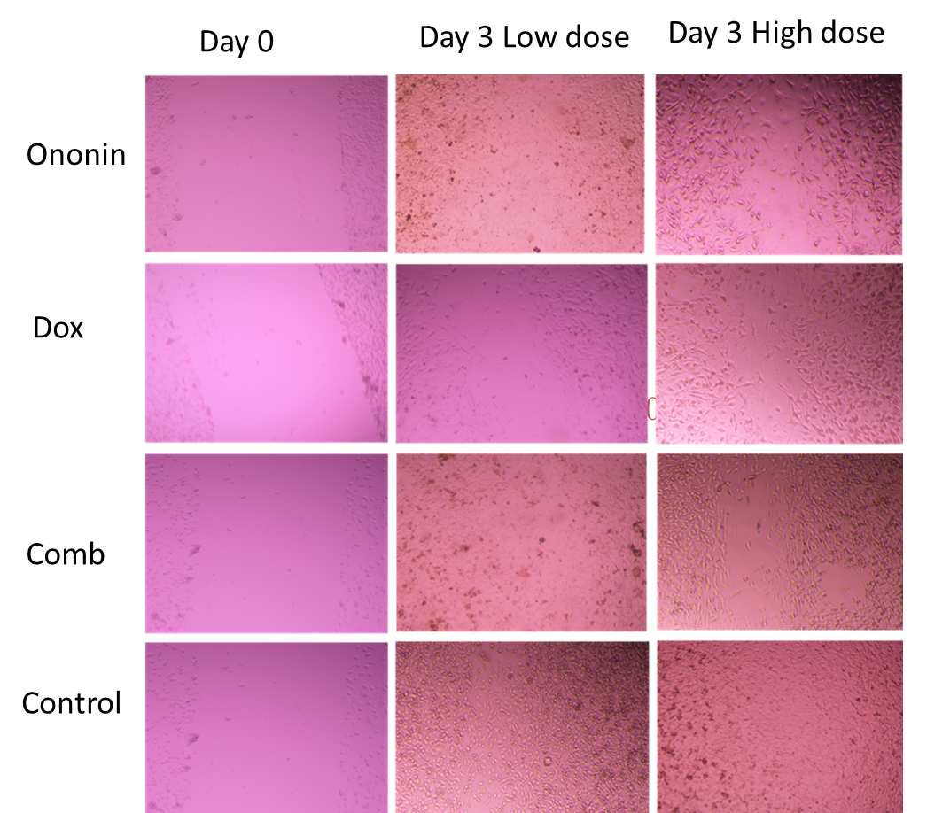

Figure 1 supplemetary: Representative images of the scratch assay in MDA-MB-231 following treatment with Ononin, DOX, or their combination for 72-h.

