Supplementary material

State-of-the-art of FAPI-PET imaging: a systematic review and meta-analysis

Martina Sollini°^{1,2}, Margarita Kirienko°³, Fabrizia Gelardi*^{1,2}, Francesco Fiz², Noemi Gozzi², Arturo Chiti^{1,2}

- Department of Biomedical Sciences, Humanitas University, Via Rita Levi Montalcini 4, 20090 Pieve Emanuele, Milan, Italy
- IRCCS Humanitas Research Hospital, Via Manzoni 56, 20089 Rozzano, Milan, Italy
- Fondazione IRCCS Istituto Nazionale Tumori, Via G. Venezian 1, 20133 Milan, Italy

° MS and MK contributed equally to the present work

*Corresponding Author
Fabrizia Gelardi, M.D.

Department of Biomedical Sciences, Humanitas University
Via Rita Levi Montalcini 4
20090 Pieve Emanuele
Milan, Italy
IRCCS Humanitas Research Hospital
Via Manzoni 56,
20089 Rozzano
Milan, Italy
fabrizia.gelardi@cancercenter.humanitas.it

Chiti: 0000-0002-5806-1856
Fiz: 0000-0003-3932-1330
Gelardi: 0000-0001-7120-333X
Kirienko: 0000-0002-3923-1151
Sollini: 0000-0003-2214-6492
Gozzi: 0000-0003-0126-789

PRISMA checklist

Section and Topic | Item # | Checklist item | Location where item is reported
TITLE
Title | 1 | Identify the report as a systematic review. | 1
ABSTRACT
Abstract | 2 | See the PRISMA 2020 for Abstracts checklist. | 2
INTRODUCTION
Rationale | 3 | Describe the rationale for the review in the context of existing knowledge. | 3
Objectives | 4 | Provide an explicit statement of the objective(s) or question(s) the review addresses. | 3
METHODS
Eligibility criteria | 5 | Specify the inclusion and exclusion criteria for the review and how studies were grouped for the syntheses. | 3-4
Information sources | 6 | Specify all databases, registers, websites, organisations, reference lists and other sources searched or consulted to identify studies. Specify the date when each source was last searched or consulted. | 3
Search strategy | 7 | Present the full search strategies for all databases, registers and websites, including any filters and limits used. | 3-4
Selection process | 8 | Specify the methods used to decide whether a study met the inclusion criteria of the review, including how many reviewers screened each record and each report retrieved, whether they worked independently, and if applicable, details of automation tools used in the process. | 4
Data collection process | 9 | Specify the methods used to collect data from reports, including how many reviewers collected data from each report, whether they worked independently, any processes for obtaining or confirming data from study investigators, and if applicable, details of automation tools used in the process. | 3-4
Data items | 10a | List and define all outcomes for which data were sought. Specify whether all results that were compatible with each outcome domain in each study were sought (e.g. for all measures, time points, analyses), and if not, the methods used to decide which results to collect. | 4-5
Data items | 10b | List and define all other variables for which data were sought (e.g. participant and intervention characteristics, funding sources). Describe any assumptions made about any missing or unclear information. | 4-5
Study risk of bias assessment | 11 | Specify the methods used to assess risk of bias in the included studies, including details of the tool(s) used, how many reviewers assessed each study and whether they worked independently, and if applicable, details of automation tools used in the process. | 4
Effect measures | 12 | Specify for each outcome the effect measure(s) (e.g. risk ratio, mean difference) used in the synthesis or presentation of results. | 5
Synthesis methods | 13a | Describe the processes used to decide which studies were eligible for each synthesis (e.g. tabulating the study intervention characteristics and comparing against the planned groups for each synthesis (item #5)). | 5
Synthesis methods | 13b | Describe any methods required to prepare the data for presentation or synthesis, such as handling of missing summary statistics, or data conversions. | 4
Synthesis methods | 13c | Describe any methods used to tabulate or visually display results of individual studies and syntheses. | 5
Synthesis methods | 13d | Describe any methods used to synthesize results and provide a rationale for the choice(s). If meta-analysis was performed, describe the model(s), method(s) to identify the presence and extent of statistical heterogeneity, and software package(s) used. | 5
Synthesis methods | 13e | Describe any methods used to explore possible causes of heterogeneity among study results (e.g. subgroup analysis, meta-regression). | 5
Synthesis methods | 13f | Describe any sensitivity analyses conducted to assess robustness of the synthesized results. | 5
Reporting bias assessment | 14 | Describe any methods used to assess risk of bias due to missing results in a synthesis (arising from reporting biases). | 4
Certainty assessment | 15 | Describe any methods used to assess certainty (or confidence) in the body of evidence for an outcome. | N/A
RESULTS
Study selection | 16a | Describe the results of the search and selection process, from the number of records identified in the search to the number of studies included in the review, ideally using a flow diagram. | 5-6, Figure 1
Study selection | 16b | Cite studies that might appear to meet the inclusion criteria, but which were excluded, and explain why they were excluded. | 5-6
Study characteristics | 17 | Cite each included study and present its characteristics. | 6-9
Risk of bias in studies | 18 | Present assessments of risk of bias for each included study. | 6, Table S1
Results of individual studies | 19 | For all outcomes, present, for each study: (a) summary statistics for each group (where appropriate) and (b) an effect estimate and its precision (e.g. confidence/credible interval), ideally using structured tables or plots. | Table 1/2
Results of syntheses | 20a | For each synthesis, briefly summarise the characteristics and risk of bias among contributing studies. | 6-9
Results of syntheses | 20b | Present results of all statistical syntheses conducted. If meta-analysis was done, present for each the summary estimate and its precision (e.g. confidence/credible interval) and measures of statistical heterogeneity. If comparing groups, describe the direction of the effect. | 9-10
Results of syntheses | 20c | Present results of all investigations of possible causes of heterogeneity among study results. | 9-10
Results of syntheses | 20d | Present results of all sensitivity analyses conducted to assess the robustness of the synthesized results. | 9-10
Reporting biases | 21 | Present assessments of risk of bias due to missing results (arising from reporting biases) for each synthesis assessed. | N/A
Certainty of evidence | 22 | Present assessments of certainty (or confidence) in the body of evidence for each outcome assessed. | N/A
DISCUSSION
Discussion | 23a | Provide a general interpretation of the results in the context of other evidence. | 10
Discussion | 23b | Discuss any limitations of the evidence included in the review. | 10-12
Discussion | 23c | Discuss any limitations of the review processes used. | 13
Discussion | 23d | Discuss implications of the results for practice, policy, and future research. | 13
OTHER INFORMATION
Registration and protocol | 24a | Provide registration information for the review, including register name and registration number, or state that the review was not registered. | 3
Registration and protocol | 24b | Indicate where the review protocol can be accessed, or state that a protocol was not prepared. | 3
Registration and protocol | 24c | Describe and explain any amendments to information provided at registration or in the protocol. | N/A
Support | 25 | Describe sources of financial or non-financial support for the review, and the role of the funders or sponsors in the review. | 22
Competing interests | 26 | Declare any competing interests of review authors. | 22
Availability of data, code and other materials | 27 | Report which of the following are publicly available and where they can be found: template data collection forms; data extracted from included studies; data used for all analyses; analytic code; any other materials used in the review. | N/A

Supplementary Figure 1. Quality assessment of the included 34 articles according to QUADAS-2 (left panel – bias assessment; right panel applicability assessment).

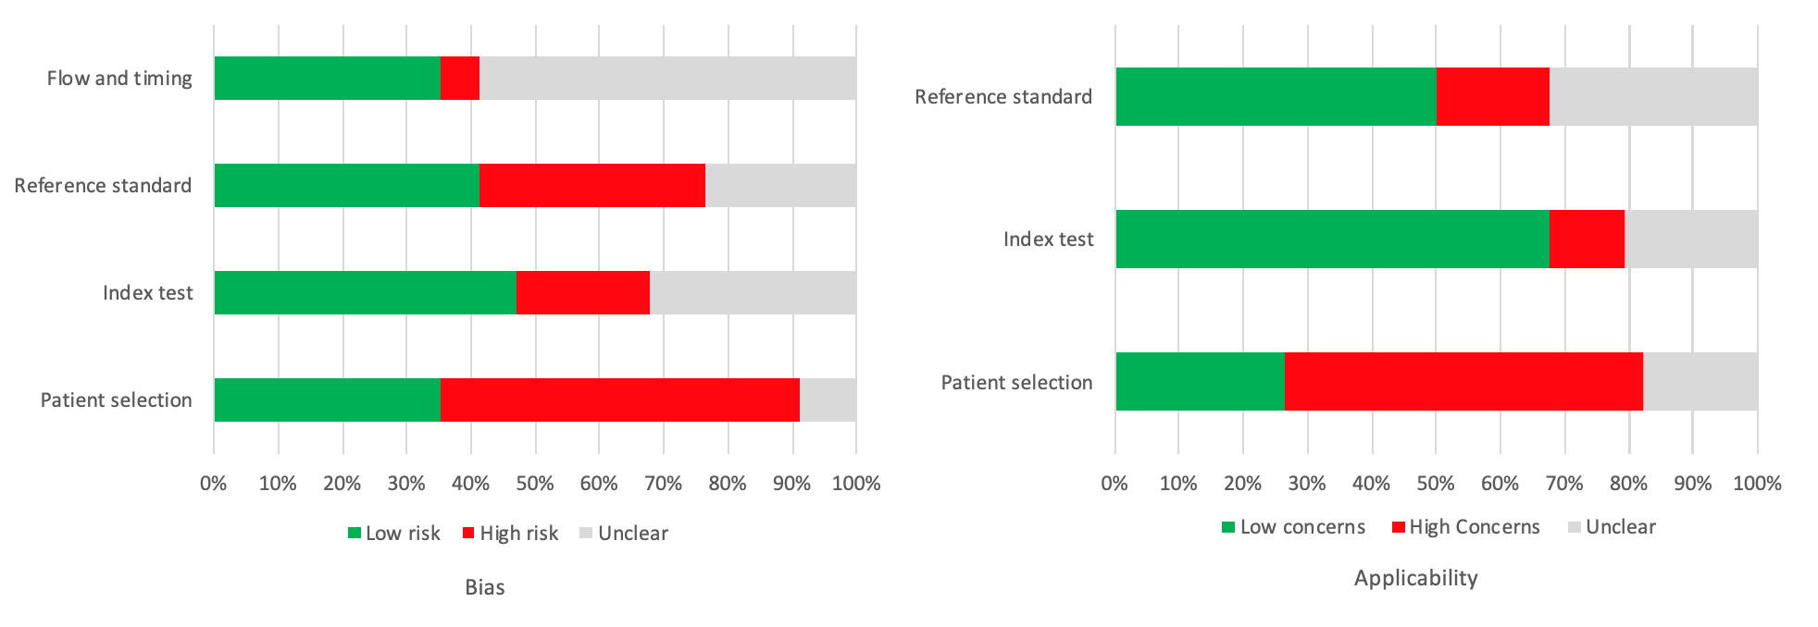

Supplementary Figure 2. Funnel plots for lesion-based [68Ga]Ga-FAPI PET (panel a sensitivity, panel b specificity)

a 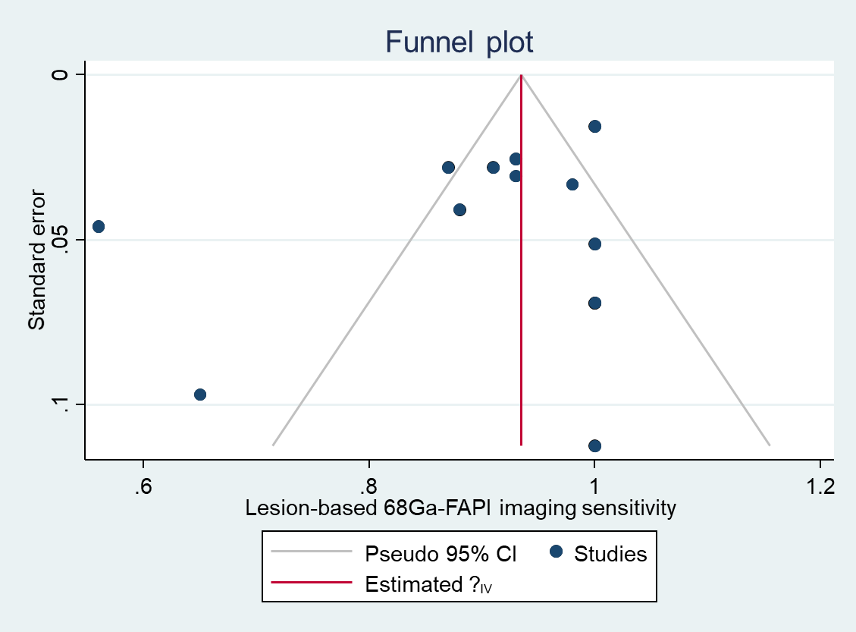
b 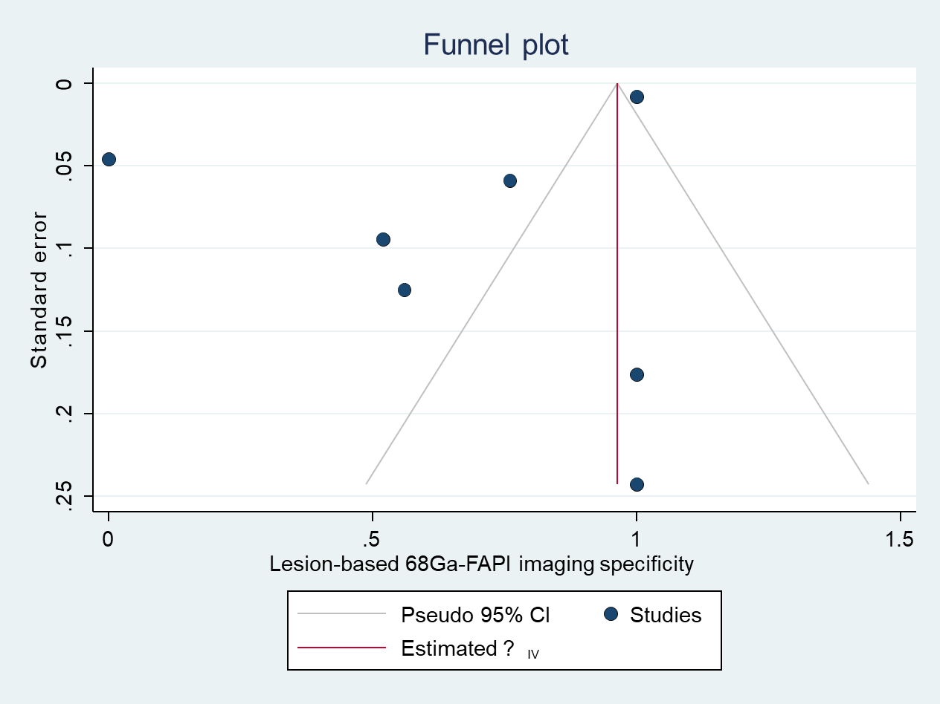

Supplementary Figure 3. Funnel plots for non-primary lesion-based [68Ga]Ga-FAPI PET (panel a sensitivity in lymphnodes and distant metastases; panel b specificity in lymphnodes and distant metastases; panel c sensitivity in lymphnodes, panel d specificity in lymphnodes)

a 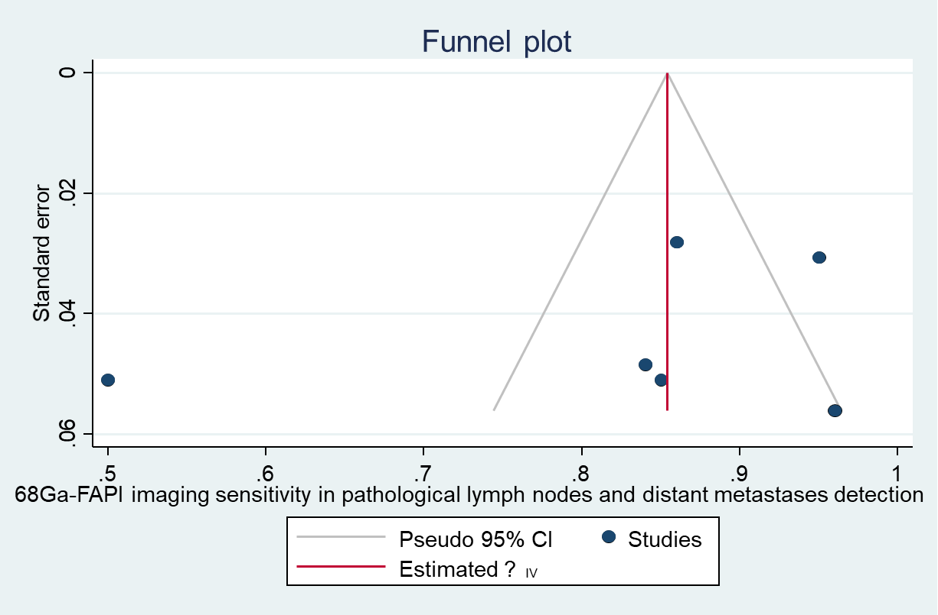
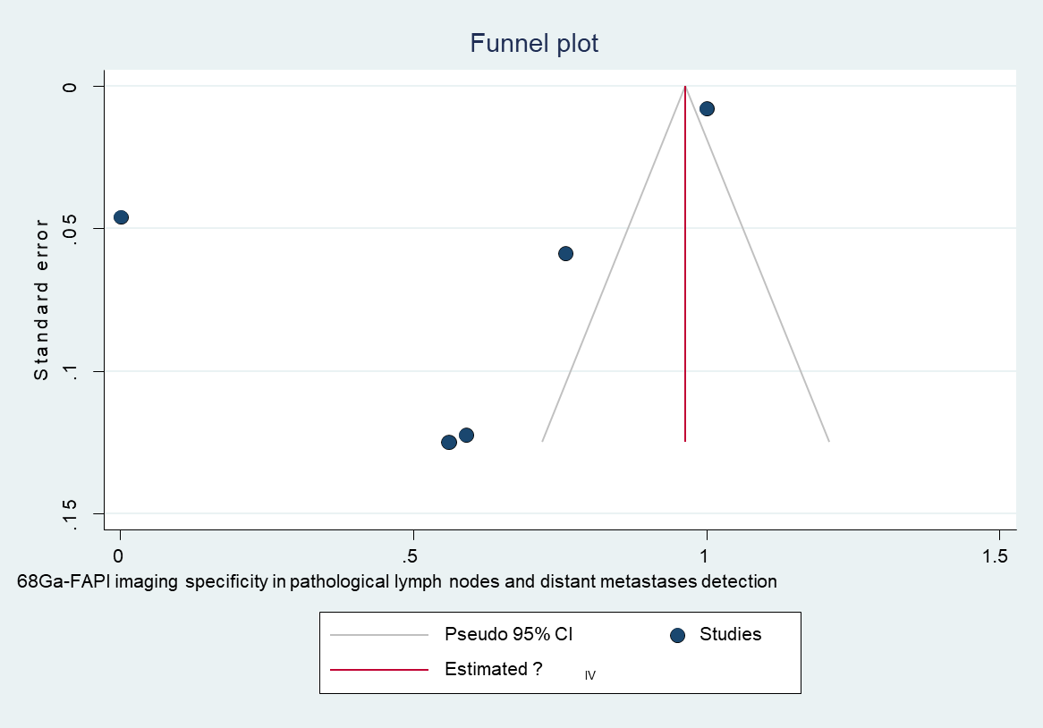
b

c 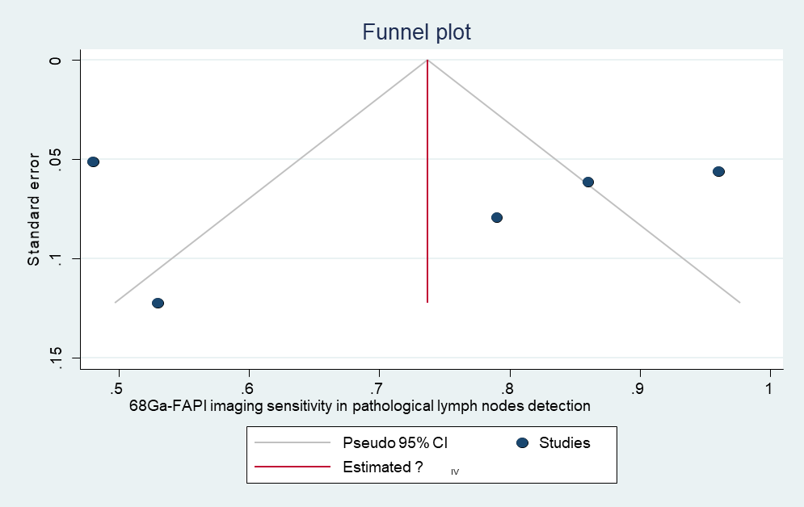

d 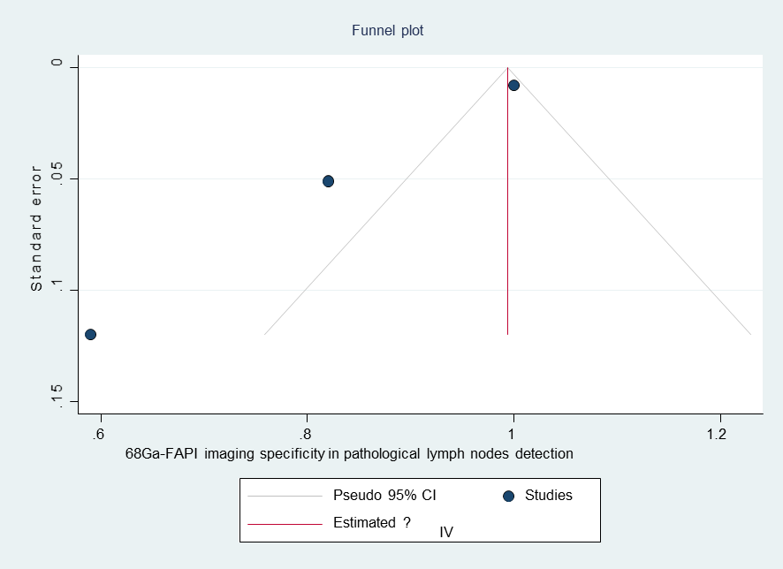

Supplementary Figure 4. Estimated pooled lesion-based sensitivity (panel a) and specificity (panel b) on a per-lesion level in abdominal malignancies

a
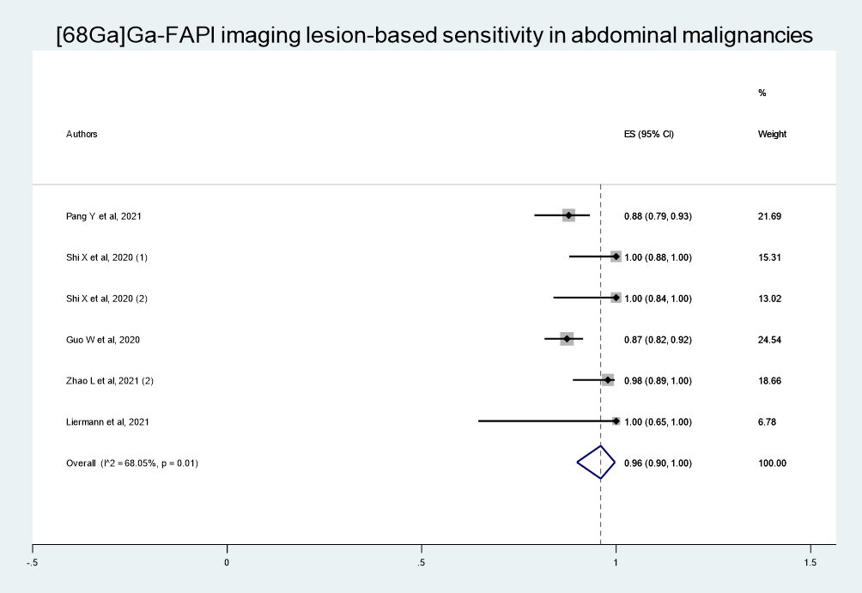

b
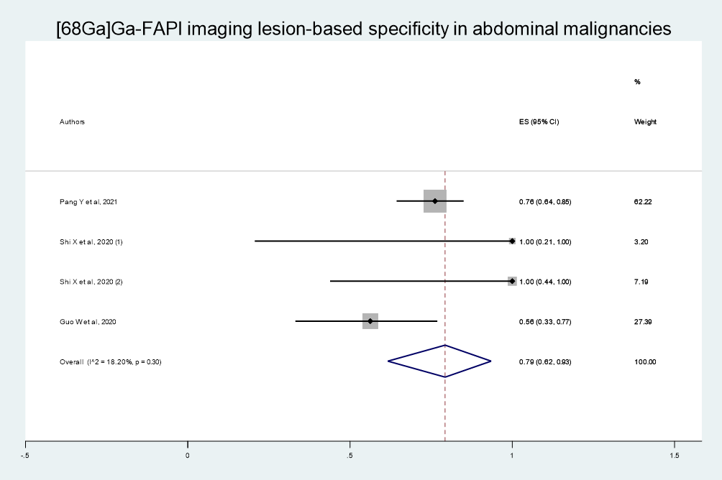

Supplementary Figure 5. Estimated pooled sensitivity for diagnosis of primary tumour in abdominal malignancies
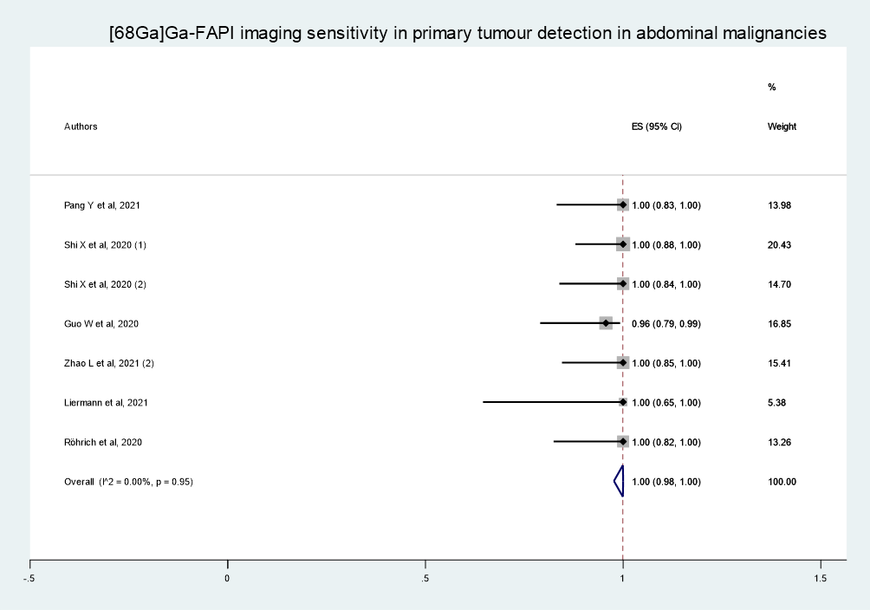

Supplementary Figure 6. Estimated pooled sensitivity for diagnosis of non-primary tumour in abdominal malignancies
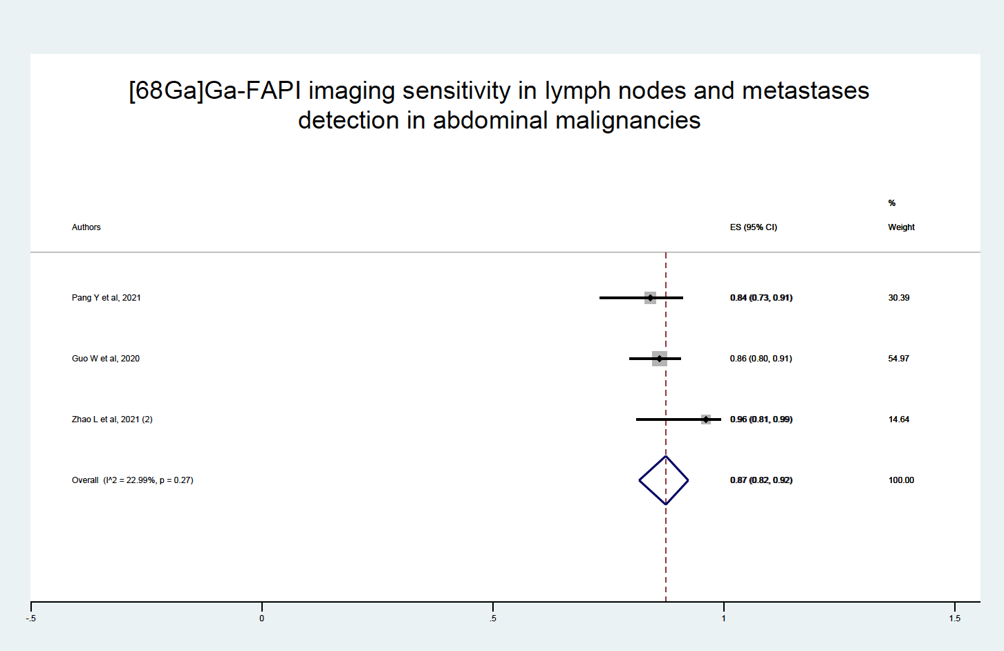

Supplementary Table 1. Main characteristics of articles assessed for quality and included in the systematic review
 | Studies assessed for quality (n=34) | Studies included in the systematic review (n=23)
Year of publication
2018 | 1 | 0
2019 | 3 | 0
2020 | 20 | 15
2021 | 10 | 8
Country
Germany | 16^ | 10
China | 10 | 9
Germany/France | 1 | 0
Germany/US | 1 | 1
Germany/Switzerland | 1 | 1
China/Austria | 2 | 2
US/France | 1^ | 0
India/Germany/Chile | 1 | 0
Germany/France | 1 | 0
Study design
Retrospective | 27 | 16
Prospective | 7 | 7
Clinical setting
Non-oncology | 5 | 5
Cardiology | 3 | 3
Rheumatology | 3 | 3
Oncology | 28 | 17
Brain | 2 | 2
Gastro-entero-pancreatic and liver tumours | 11 | 8
Miscellaneous | 11 | 4
Lung | 1 | 0
Head and neck | 3 | 3
Hybrid imaging
PET/CT | 33 | 22
PET/MRI | 1 | 1
FAPI molecule
FAPI-02 | 1 | 0
FAPI-04 | 18 | 16
FAPI-46 | 2 | 1
FAPI-74 | 1 | 0
FAPI-02 and FAPI-04 | 3 | 2
FAPI-04 and FAPI-46 | 3 | 1
FAPI-21 and FAPI-46 | 1 | 0
FAPI-34 and FAPI-46 | 1 | 0
DOTA.SA.FAPi | 1 | 0
FAPI-04 and others* | 3 | 2
Comparator
MRI | 3 | 2
CT | 5 | 3
FDG | 9 | 7
Miscellaneous | 7 | 6
None | 10 | 5
Reference standard
Pathology | 5 | 5
Imaging | 9 | 8
Pathology, imaging and clinical data | 12 | 10
Not applicable (studies on biodistribution and dosimetry) | 8 | 0
* Others: FAPI-02, FAPI-46, FAPI-21 and FAPI-25
^At least one co-author had multiple affiliations located in different countries

Supplementary Table 2. Details on data availability for each paper for the purpose of meta-analysis
Reference | Patient-based analyses |  | Lesion-based analyses |  | Primary tumour detection | Non-primary tumour evaluation |  | Nodal involvement assessment |  | Distant metastases detection
Reference | Sen | Spec | Sen | Spec | Sen | Sen | Spec | Sens | Spec | Sens
Pang et al. (1)* | Y | N | Y | Y | Y | Y | Y | Y | Y | Y
Shi et al. (2) * | Y | Y | Y | Y | Y | N | N | N | N | N
Shi et al. (2)(3) * | Y | N | Y | Y | Y | N | N | N | N | N
Guo et al. (4)* | Y | Y | Y | Y | Y | Y | Y | N | N | N
Chen et al. (5) | Y | Y | Y | Y | Y | Y | Y | Y | Y | Y
Chen et al. (6) | Y | Y | Y | Y | Y | Y | Y | N | N | N
Serfling S et al, 2020 (7) | Y | N | Y | Y | Y | N | Y | Y | Y | N
Qin C et al, 2021 (8) | Y | N | Y | N | Y | Y | N | Y | N | Y
Zhao et al. (2)(9)* | Y | Y | Y | N | N | N | N | N | N | Y
Zhao et al. (10)* | Y | N | Y | N | Y | N | N | Y | N | N
Syed et al. (11) | Y | N | Y | N | Y | N | N | N | N | N
Windisch et al. (12) | Y | N | Y | N | Y | N | N | N | N | N
Liermann et al. (13)* | Y | N | Y | N | Y | N | N | N | N | N
Röhrich et al. (14)* | Y | Y | N | N | Y | N | N | N | N | N
Y- yes; N - no; Sen - sensitivity; Spec - specificity
*Article exclusively focused on abdominal malignancies

References

1. Pang Y, Zhao L, Luo Z, Hao B, Wu H, Lin Q, et al. Comparison of 68 Ga-FAPI and 18 F-FDG Uptake in Gastric, Duodenal, and Colorectal Cancers. Radiology. 2021 Feb;298(2):393–402.
2. Shi X, Xing H, Yang X, Li F, Yao S, Zhang H, et al. Fibroblast imaging of hepatic carcinoma with 68Ga-FAPI-04 PET/CT: a pilot study in patients with suspected hepatic nodules. Eur J Nucl Med Mol Imaging. 2020 May 29;1–8.
3. Shi X, Xing H, Yang X, Li F, Yao S, Congwei J, et al. Comparison of PET imaging of activated fibroblasts and 18F-FDG for diagnosis of primary hepatic tumours: a prospective pilot study. Eur J Nucl Med Mol Imaging. 2021 May 24;48(5):1593–603.
4. Guo W, Pang Y, Yao L, Zhao L, Fan C, Ke J, et al. Imaging fibroblast activation protein in liver cancer: a single-center post hoc retrospective analysis to compare [68Ga]Ga-FAPI-04 PET/CT versus MRI and [18F]-FDG PET/CT. Eur J Nucl Med Mol Imaging. 2021 May 11;48(5):1604–17.
5. Chen H, Zhao L, Ruan D, Pang Y, Hao B, Dai Y, et al. Usefulness of [68Ga]Ga-DOTA-FAPI-04 PET/CT in patients presenting with inconclusive [18F]FDG PET/CT findings. Eur J Nucl Med Mol Imaging. 2021 Jan;48(1):73–86.
6. Chen H, Pang Y, Wu J, Zhao L, Hao B, Wu J, et al. Comparison of [68Ga]Ga-DOTA-FAPI-04 and [18F] FDG PET/CT for the diagnosis of primary and metastatic lesions in patients with various types of cancer. Eur J Nucl Med Mol Imaging. 2020 Jul 28;47(8):1820–32.
7. Serfling S, Zhi Y, Schirbel A, Lindner T, Meyer T, Gerhard-Hartmann E, et al. Improved cancer detection in Waldeyer’s tonsillar ring by 68Ga-FAPI PET/CT imaging. Eur J Nucl Med Mol Imaging. 2021 Apr 15;48(4):1178–87.
8. Qin C, Liu F, Huang J, Ruan W, Liu Q, Gai Y, et al. A head-to-head comparison of 68Ga-DOTA-FAPI-04 and 18F-FDG PET/MR in patients with nasopharyngeal carcinoma: a prospective study. Eur J Nucl Med Mol Imaging. 2021 Feb 20;
9. Zhao L, Pang Y, Luo Z, Fu K, Yang T, Zhao L, et al. Role of [68Ga]Ga-DOTA-FAPI-04 PET/CT in the evaluation of peritoneal carcinomatosis and comparison with [18F]-FDG PET/CT. Eur J Nucl Med Mol Imaging. 2021 Jun 7;48(6):1944–55.
10. Zhao L, Chen S, Chen S, Pang Y, Dai Y, Hu S, et al. 68Ga-fibroblast activation protein inhibitor PET/CT on gross tumour volume delineation for radiotherapy planning of oesophageal cancer. Radiother Oncol. 2021 May;158:55–61.
11. Syed M, Flechsig P, Liermann J, Windisch P, Staudinger F, Akbaba S, et al. Fibroblast activation protein inhibitor (FAPI) PET for diagnostics and advanced targeted radiotherapy in head and neck cancers. Eur J Nucl Med Mol Imaging. 2020 Nov 23;47(12):2836–45.
12. Windisch P, Röhrich M, Regnery S, Tonndorf-Martini E, Held T, Lang K, et al. Fibroblast Activation Protein (FAP) specific PET for advanced target volume delineation in glioblastoma. Radiother Oncol. 2020;
13. Liermann J, Syed M, Ben-Josef E, Schubert K, Schlampp I, Sprengel SD, et al. Impact of FAPI-PET/CT on Target Volume Definition in Radiation Therapy of Locally Recurrent Pancreatic Cancer. Cancers (Basel). 2021 Feb 14;13(4):796.
14. Röhrich M, Naumann P, Giesel FL, Choyke P, Staudinger F, Wefers A, et al. Impact of 68 Ga-FAPI-PET/CT imaging on the therapeutic management of primary and recurrent pancreatic ductal adenocarcinomas. J Nucl Med. 2020 Oct 23;jnumed.120.253062.

