Supplementary material for:

Optimization of human chaperone BiP production in yeast Pichia pastoris
Eimantas Žitkus¹, Evaldas Čiplys^{1*}, Mantas Žiaunys¹, Andrius Sakalauskas¹, Rimantas Slibinskas^{1*}

¹ Institute of Biotechnology, Life Sciences Center, Vilnius University, Saulėtekio 7, LT-10257 Vilnius, Lithuania

Correspondence*: evaldas.ciplys@bti.vu.lt; rimantas.slibinskas@bti.vu.lt.

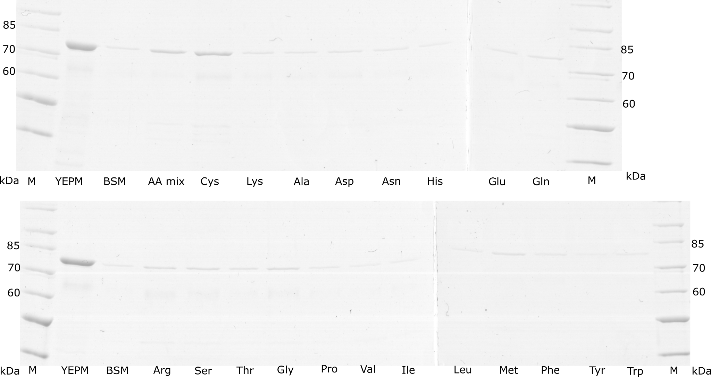

Fig. S1. Effects on rhBiP secretion after addition of amino acids into BSM yeast culture medium. SDS-PAGE analysis of yeast growth media (10x concentrated) after 48 h of induction. rhBiP producing yeast cultures were grown as described in the method section. YEPM - complex media; BSM - basal salt media. Amino acid abbreviations indicate which amino acid was added to the BSM medium at concentration of 4mM. In AAmix all 20 amino acids were added at final concentration of 1 mM. M - unstained protein ladder (ThermoScientific, cat. no. 26614).
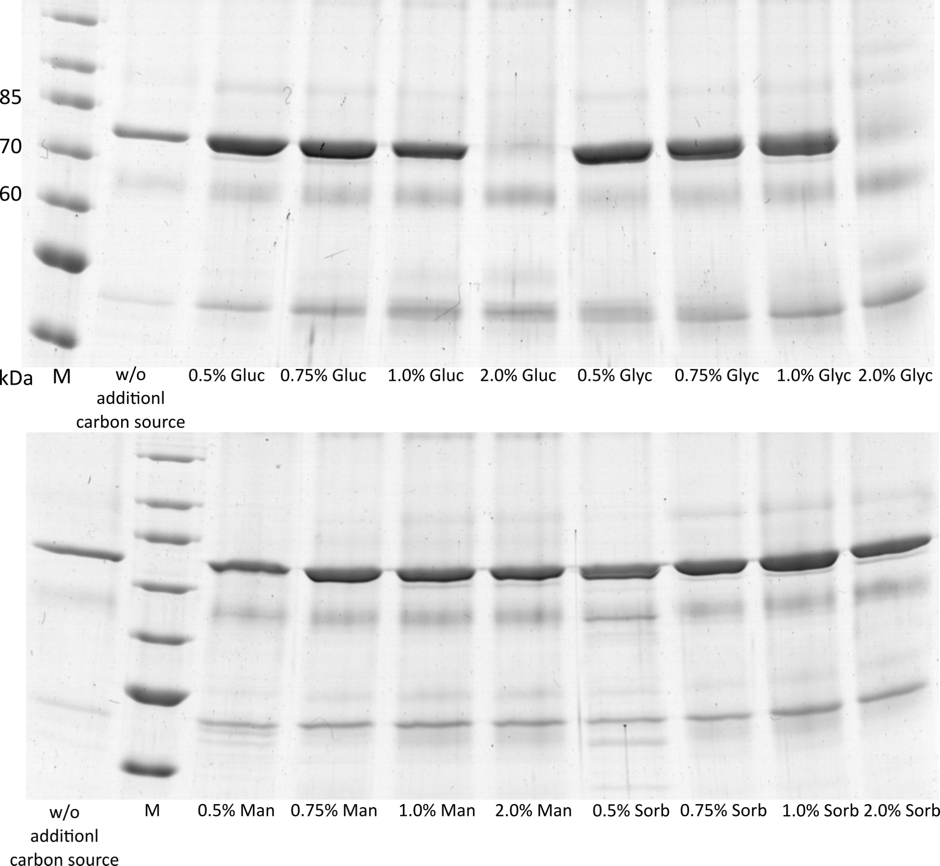

Fig. S2. Effects on rhBiP secretion after addition of different carbon sources to BSM culture medium. SDS-PAGE analysis of yeast growth media (10x concentrated) after 48 h of induction. rhBiP producing yeast cultures were grown as described in the method section. Gluc - glucose; Glyc - glycerol; Man - mannitol; Sorb - sorbitol. All mediums were supplemented with 2mM DTT before induction. Percentage indicates particular carbon source quantity (m/V) in induction media. M - unstained protein ladder (ThermoScientific, cat. no. 26614).

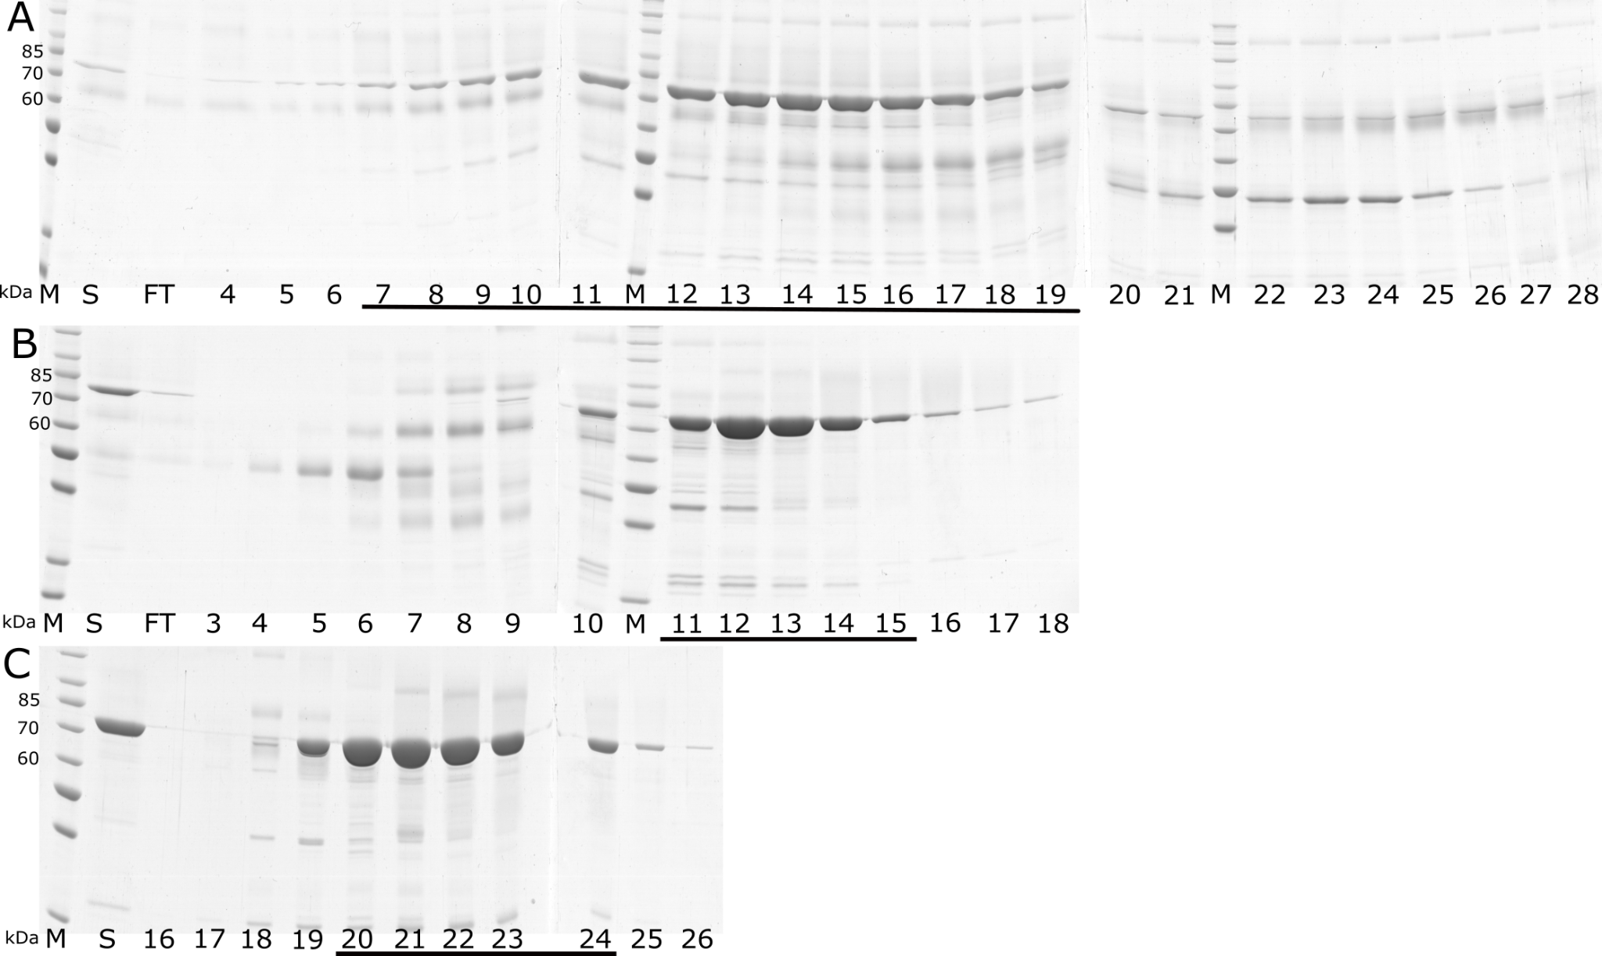

Fig. S3. Purification of rhBiP from yeast culture medium by chromatography. SDS-PAGE analysis of elution fractions from hydrophobic interaction chromatography (A), first anion-exchange chromatography (B) and second anion-exchange chromatography (C). Pooled fractions that were used in the further purification step are underlined. S - sample loaded on chromatography column; FT - flow through fraction; M unstained protein ladder (ThermoScientific, cat. no. 26614).

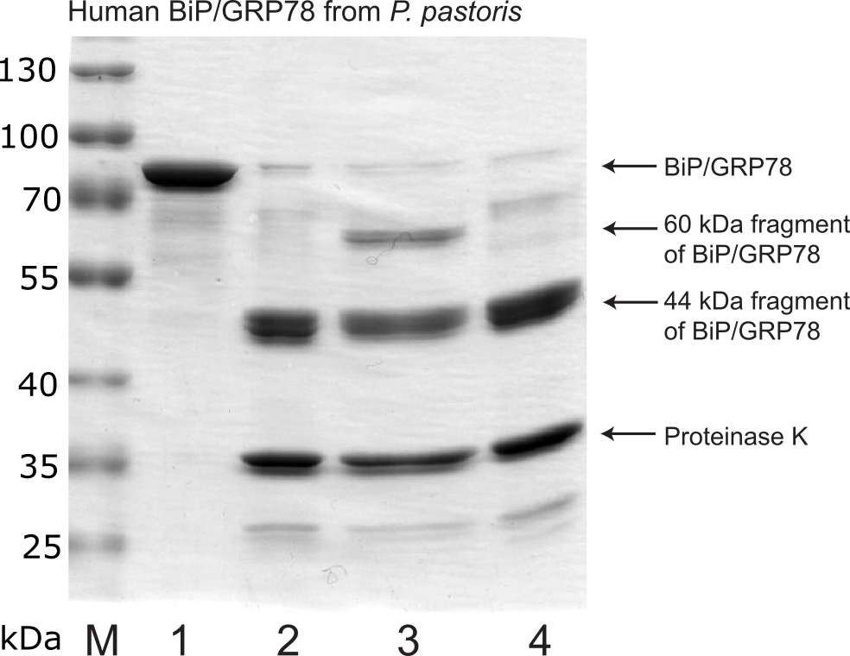

Fig. S4. Partial proteolysis of P. pastoris-secreted rhBiP with proteinase K in the presence of nucleotides. M – prestained protein ladder (ThermoScientific, cat. no. 26616). Undigested rhBiP (A), or digested with proteinase K without nucleotides (B), and in the presence of 100 μM ATP (C) or 100 μM ADP (D).

Table S1. rhBiP secretion in different mineral media compositions.
Growth media | rhBiP yield (titer), mg/L after 42 h induction | WCW, g/L after 42 h induction | Induction medium components
YEPM | 11,8±1.6 | 65,7±3,7 | 2% soy peptone, 1% yeast extract, 0.5% methanol
BSM | 2,2±1.0 | 53,2±6,9 | ¼ BSM salts, 100mM potassium phosphate, 0.5% methanol
BSM + 2% Soy peptone +1% yeast extract | 8,3±0.4 | 64,0±2,8 | ¼ BSM salts, 100mM potassium phosphate, 2% soy peptone, 1%yeast extract, 0.5% methanol
BSM + 2% Soy peptone | 7,3±0.4 | 59,5±2,1 | ¼ BSM salts, 100mM potassium phosphate, 2% soy peptone, 0.5% methanol
BSM + 1% yeast extract | 2,5±0.7 | 56,5±2,1 | ¼ BSM salts, 100mM potassium phosphate, 1% yeast extract, 0.5% methanol
BSM + 2mM DTT | 7,7±2.2 | 56,0±1,4 | ¼ BSM salts, 100mM potassium phosphate, 2mM DTT, 0.5% methanol
BSM + 2mM TCEP | 8,8±1.3 | 56,5±3,5 | ¼ BSM salts, 100mM potassium phosphate, 2mM TCEP, 0.5% methanol
BSM + 2mM DTT + 0,5% Glucose | 16,8±1.3 | 62,6±3,7 | ¼ BSM salts, 100mM potassium phosphate, 2mM DTT, 0.5% glucose, 0.5% methanol
BSM + 2mM DTT + 0,75% Glucose | 17,2±0,7 | 72,4±2,3 | ¼ BSM salts, 100mM potassium phosphate, 2mM DTT, 0.75% glucose, 0.5% methanol
BSM + 2mM DTT + 1,0% Glucose | 14,1±2.1 | 74,4±1,2 | ¼ BSM salts, 100mM potassium phosphate, 2mM DTT, 1.0% glucose, 0.5% methanol
BSM + 2mM DTT + 2,0% Glucose | Nd. | 90,3±1,8 | ¼ BSM salts, 100mM potassium phosphate, 2mM DTT, 2.0% glucose, 0.5% methanol
BSM + 2mM DTT + 0,5% Glycerol | 17,1±1,3 | 71,8±1,8 | ¼ BSM salts, 100mM potassium phosphate, 2mM DTT, 0.5% glycerol, 0.5% methanol
BSM + 2mM DTT + 0,75% Glycerol | 17,2±2.5 | 76,4±1,8 | ¼ BSM salts, 100mM potassium phosphate, 2mM DTT, 0.75% glycerol, 0.5% methanol
BSM + 2mM DTT + 1,0% Glycerol | 16,4±2.5 | 83,7±2,3 | ¼ BSM salts, 100mM potassium phosphate, 2mM DTT, 1.0% glycerol, 0.5% methanol
BSM + 2mM DTT + 2,0% Glycerol | Nd. | 102,2±5,9 | ¼ BSM salts, 100mM potassium phosphate, 2mM DTT, 2.0% glycerol, 0.5% methanol
BSM + 2mM DTT + 0,5% Sorbitol | 9,2±2.5 | 68,3±3,9 | ¼ BSM salts, 100mM potassium phosphate, 2mM DTT, 0.5% sorbitol, 0.5% methanol
BSM + 2mM DTT + 0,75% Sorbitol | 13,0±3.5 | 79,8±5,3 | ¼ BSM salts, 100mM potassium phosphate, 2mM DTT, 0.75% sorbitol, 0.5% methanol
BSM + 2mM DTT + 1,0% Sorbitol | 12,4±3.3 | 88,8±8,8 | ¼ BSM salts, 100mM potassium phosphate, 2mM DTT, 1.0% sorbitol, 0.5% methanol
BSM + 2mM DTT + 2,0% Sorbitol | 13,8±3.6 | 97,8±5,3 | ¼ BSM salts, 100mM potassium phosphate, 2mM DTT, 2.0% sorbitol, 0.5% methanol
BSM + 2mM DTT + 0,5% Mannitol | 12,8±4.0 | 66,9±6,9 | ¼ BSM salts, 100mM potassium phosphate, 2mM DTT, 0.5% mannitol, 0.5% methanol
BSM + 2mM DTT + 0,75% Mannitol | 13,9±4.2 | 79,5±9,2 | ¼ BSM salts, 100mM potassium phosphate, 2mM DTT, 0.75% mannitol, 0.5% methanol
BSM + 2mM DTT + 1,0% Mannitol | 16,5±2.0 | 90,1±5,7 | ¼ BSM salts, 100mM potassium phosphate, 2mM DTT, 1.0% mannitol, 0.5% methanol
BSM + 2mM DTT + 2,0% Mannitol | 13,4±4.1 | 92,9±0,8 | ¼ BSM salts, 100mM potassium phosphate, 2mM DTT, 2.0% mannitol, 0.5% methanol

Table S2. High cell density fermentation conditions for rhBiP secretion in P. pastoris.
Fermentation condition | S1 | S2 | S3 substrate limited induction | S3 oxygen limited induction
T | 28 C | 28 C | 28 C | 28 C
pH | 5 | 7 | 7 | 7
pO2 | 30 % | 30 % | 30% | 0-20%
pO2 maintains | 410 – 740 rpm  O2 enrichment  0-100% | 410 – 740 rpm  O2 enrichment  0-100% | 410-740 rpm  O2 enrichment  0-100% | 410 – 614 rpm  No O2 enrichment
Substrate feeding profile | none | 1 h 50% (v/v) glycerol 20 ml/L/hr.  3 hr. 20 ml/L/hr. to 0 ml/L/hr. | 2 mM DTT addition before induction  Methanol/Glucose mixture feeding at constant 6 ml/L/h rate  Methanol : Glucose (V/W)  25% : 12.5%  12:5% : 6.5%  12.5% : 12.5%  10% : 20%  7.5% 22.5% | 2 mM DTT addition before induction  Glucose (25%) / methanol (12.5%) pulses every 8 hr.

