Table 1 Mechanisms by which changes in human-technology relationships are shaped in space
Industrial Era |  |  |  | Information Era |  |  | AI Era
Human-Technology Cooperation |  |  |  | Human-Technology Interaction |  |  | Human-Technology Integration
Central Agglomeration |  |  |  | Multi-Central Agglomeration |  |  | Decentralization
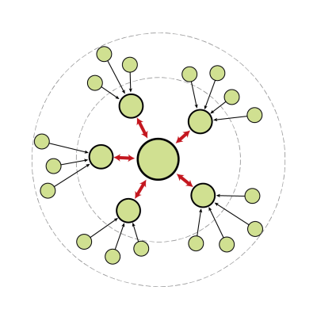 |  |  |  | 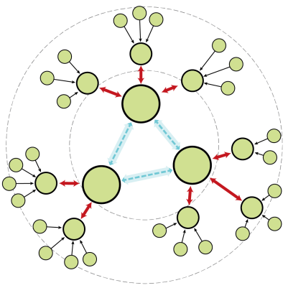 |  |  | 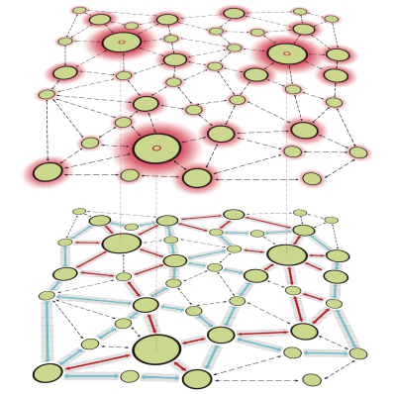
 | Spatial Units |  | Material Resource Flows |  |  | Informational Resource Flows |  | Information Exchange

