Lab On chips for liquid biopsy: a flexible and customized approach through microfabrication
Valeria Garzarelli^{†a,b}, Alessia Foscarini^{†a,b}, Vanessa Indirli^{a,b}, Diego Mangiulloª, Tiziano Verriª, Elisabetta Primiceriª, Annamaria Nigro^{c}, Angelo Quattrini^{c}, Alessandro Romano^{c}, Maria Serena Chiriacòª*, Giuseppe Gigli^{a,b}, Francesco Ferrara*ª
ª CNR NANOTEC – Institute of Nanotechnology, via per Monteroni, 73100, Lecce, Italy
^{b} Department of Experimental Medicine, University of Salento, 73100 Lecce, Italy
^{c} Institute of Experimental Neurology, San Raffaele Scientific Institute, 20132 Milan, Italy
† These authors contributed equally to the work.
*Corresponding author: mariaserena.chiriaco@nanotec.cnr.it; francesco.ferrara@nanotec.cnr.it

Supplementary Information

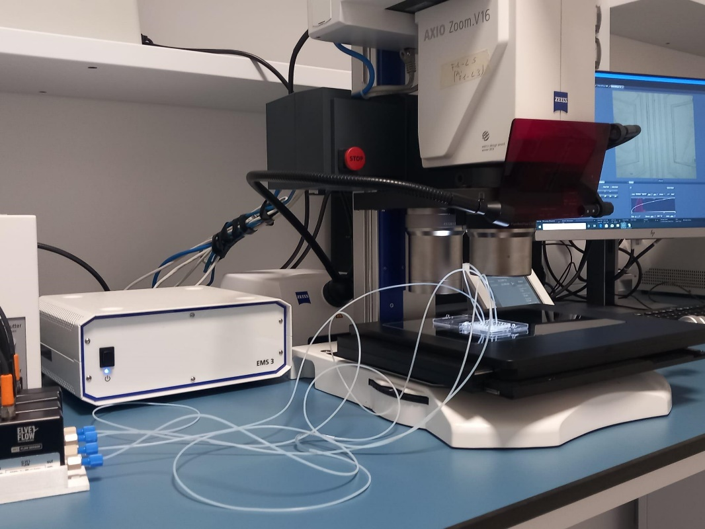

Supplementary Figure 1. Experimental setup consisting of Elveflow micropumping system (Elvesys, France) to deliver fluids into the PMMA transparent device and optical/fluorescence microscope Axio Zoom V16 (Zeiss, Oberkochen Germany) for real-time monitoring of devices.

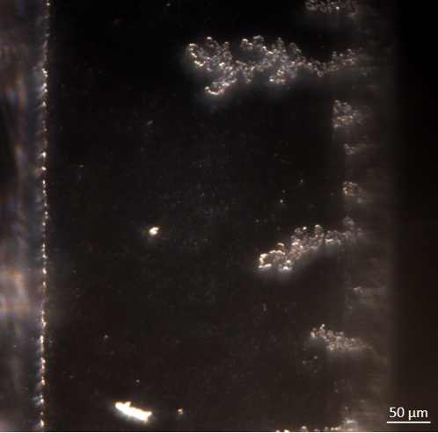

Supplementary Figure 2. Polydopamine ramifications. Ramification debris in the microfluidic channel following polydopamine functionalization.

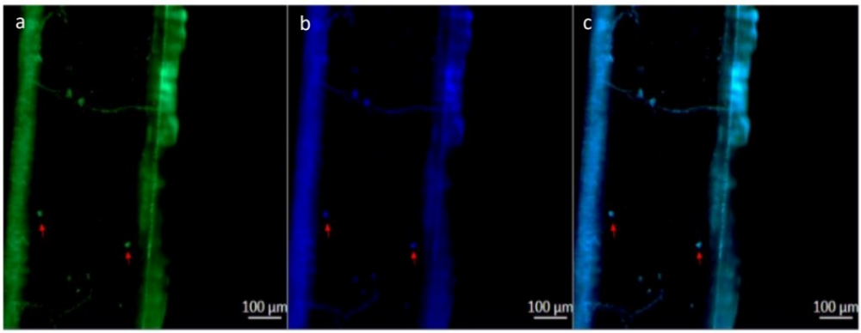

Supplementary Figure 3. Multi-channel testing device functionalization for cell detection. (a) FITC fluorescence signal of OECM-1 cells trapped in the device’s channel and detected by anti-EpCAM primary mouse antibody followed by FITC-conjugated anti-mouse secondary antibody; (b) DAPI staining of OECM-1 nuclei trapped in the functionalized device’s channel; (c) Merge between FITC and DAPI fluorescent signal of the same channel. Rappresentative red arrows indicate the presence of OECM-1 cells. Scale bar: 100 mm.

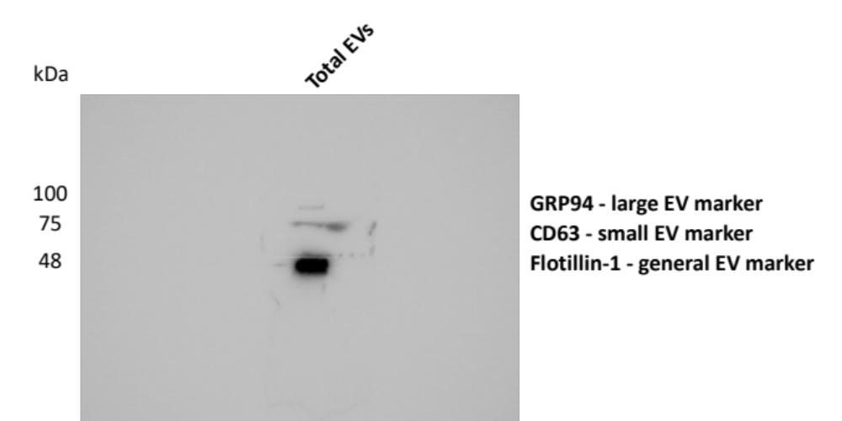

Supplementary Figure 4. Picture of the entire Western Blot (WB) membrane illustrated in Fig. 5a of the manuscript: WB analysis of EVs sample isolated from SH-SY5Y cells showing the expression of three different EVs markers: GRP94 (large EVs), CD63 (small EVs) and Flotilillin-1 (large/small EVs).

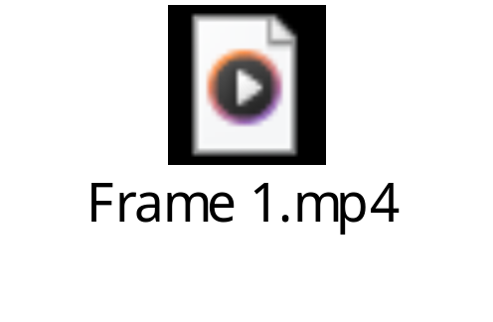

Supplementary Video 1. Fluid mixing. Video of the fluid mixing in the sample-in/answer-out device at different flowrates of a blue and a red solution, simulating saliva and PBS respectively. The pillar in the oval shape promoted the mixing at different flowrates (from 50 mbar to 200 mbar) of the fluids that was monitored by the fluorescence microscope Axio Zoom V16 (Zeiss, Oberkochen Germany).

