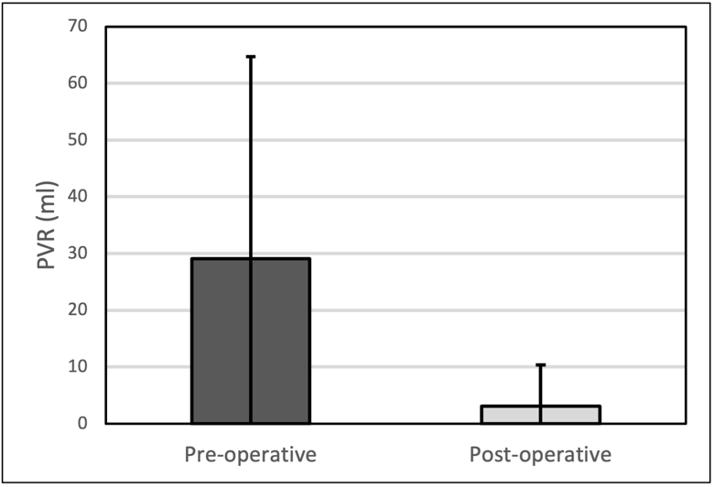
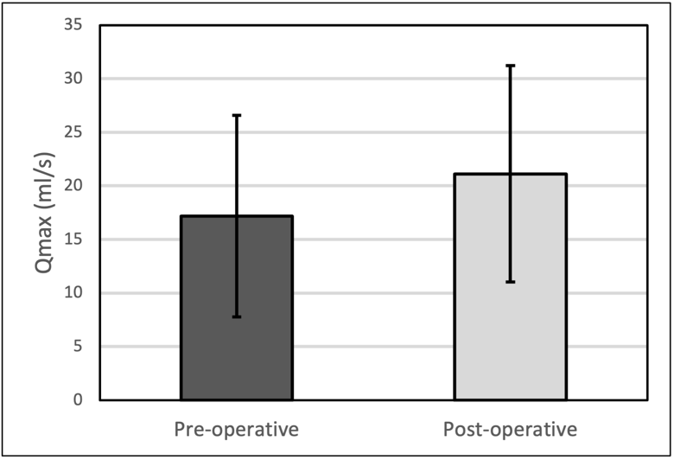
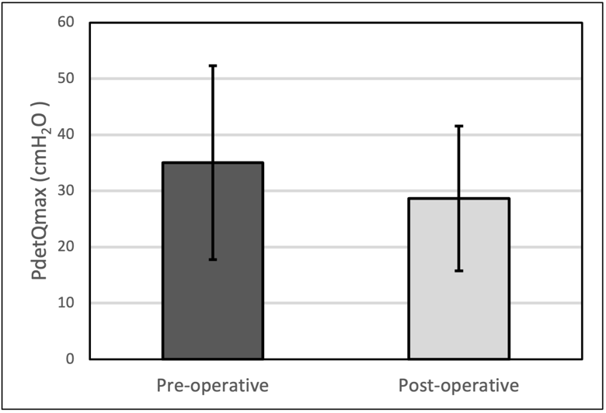
Online Resource 1. Changes in (A) PdetQmax, (B) free Qmax, and (C) postvoid residual (PVR) pre- and post-surgery in pmUD patients
p=0.001
p=0.05
p=0.008
C
A
B

