Supplementary material

Profiling the Nasopharyngeal Microbiome in Patients with Community-Acquired Pneumonia Caused by Streptococcus pneumoniae: Diagnostic Challenges and Ecological Insights
Cristina Zubiria-Barrera^{1,2}*, Linda Yamba Yamba^{3,5}*, Tilman E. Klassert ^{1,2}, Malena Bos ^{1,2}, Jonas Ahl^{3,4}, Lisa Wasserstrom^{3,5}, Hortense Slevogt ^{1,2¶} and Kristian Riesbeck^{3,5 ¶}

* These two authors share the first authorship
¶ These two senior authors share the last authorship
¹Department of Respiratory Medicine and Infectious Diseases, MHH, German Center for Lung Research (DZL), BREATH, Hannover
²Respiratory Infection Dynamics Group, Helmholtz Centre for Infection Research, Braunschweig
³Clinical Microbiology, Department of Translational Medicine, Faculty of Medicine, Lund University, Malmö, Sweden
⁴Infectious Diseases, Department of Translational Medicine, Faculty of Medicine, Lund University, Malmö, Sweden
⁵Clinical Microbiology, Infection Control and Prevention, Laboratory Medicine Skåne, Lund, Sweden

Material and Methods
Patient and controls from the ECAPS cohort
The ECAPS cohort has included 518 patients and 493 seasonally matched asymptomatic controls between September 2016-September 2018 at Malmö University hospital in Skane (Sweden) (1, 2). Inclusion criteria for patients were 2 out of 10 predefined symptoms of pneumonia combined with a radiographic finding. The controls consisted of asymptomatic patients admitted to the Department of Orthopedics during the same period. Patients and controls were sampled with a nasopharyngeal swab at inclusion to the study within 48 hours of admission. Patients were also invited to a follow up visit 10-17 weeks after discharge, where a second nasopharyngeal swab sample post infection was collected to suffice a comparative analysis of the microbiome post-infection. Patients or controls with known immunodeficiency (AIDS/HIV or immunosuppressive therapy) or organ transplantation in the cohort were excluded for the microbiome analysis. Controls included in the present the study were matched by sex, season, and age to patients included.

Microbiological testing of patients and controls

Bacterial cultures and serotyping
Patient nasal swabs, blood and in some cases samples from the lower respiratory tract were used for microbial culture based on clinical indication. All included controls provided a nasopharyngeal swab for culture. Blood and respiratory tract specimens were cultured according to standard methods at Clinical Microbiology Lab at Laboratory Medicine Skåne. Respiratory tract samples were cultured on agar plates at 33-37°C in aerobic, anaerobic and CO₂ conditions. Blood cultures were performed using the automatic BACTEC system (BD diagnostic systems, Sparks, MD). For species identification colony morphology together with standard biochemical tests and MALDI Biotyper analysis (Bruker Daltonics, Bremen, Germany) was used. Serotyping was performed on available pneumococcal isolates collected from culture using multiplex PCR and/or Immulex ™ Pneumotest Kit (Statens Seruminstitut, Copenhagen, Denmark) according to instructions followed by Neufeldt Antisera (Statens Seruminstitut, Copenhagen, Denmark) as described by Uddén et al. or documented from UAD results (3).

BinaxNOW S. pneumoniae® / Urine antigen detection (UAD) and Legionella Urine antigen test
Urine testing BinaxNOW S. pneumoniae® detects pneumococcal polysaccharide antigens in the urine. The UAD tests UAD1 and UAD2 detects 24 pneumococcal serotype-specific polysaccharides (serotypes 1, 3, 5, 6A, 6B, 7F, 9V, 14, 18C, 19A, 19F 23F, 2, 8, 9N, 10A, 11A, 12F, 15B/C, 17F, 20, 22F and 33F). Urine antigen testing as well as the UAD serotype specific urine antigen detection assay was performed on all patients and some of the controls (4-6). Legionella urine antigen test was analyzed based on clinical indication in 32/61 included patients and no controls. Two different tests were used during the study Alere BinaxNOW and later ImmuView that both detect serogroup 1 antigens of Legionella pneumophila.

Bacterial and viral detection by real-time PCR
Available patients and 241 controls were also tested using PCR for detection of respiratory pathogens in the upper respiratory tract.
The nasopharyngeal samples were stored at -80 ºC prior to real-time PCR analysis. MagNA Pure 96 DNA was used for extraction of DNA/RNA from 200 µl of the nasopharyngeal sample without pretreatment. For this the Viral NA Small volume kit (Roche Diagnostics, Basel, Switzerland) with addition of 20 µl poly(A) (Roche Diagnostics, Basel, Switzerland) was used per sample. RT Realtime-PCR amplifications for viral agents were performed on an ABI 7500 real-time PCR system (Applied Biosystems, Waltham, USA) in five multiplex reactions (7, 8). The reactions detect influenza A (H1N1/H3N2), influenza B, respiratory syncytical virus (RSV) A/B, human metapneumovirus (hMPV), parainfluenza virus (PIV) 1 to 3, adenovirus, coronavirus (OC43, NL63, 229E) and rhino-/enterovirus and parechovirus. For all reactions Path-ID Multiplex One-Step RT-PCR Kit (Ambion, Life Technologies, Carlsbad, USA) was used. The PCR program used for all viral reactions were a reverse transcription step at 48 ºC for 10 minutes and a RT-inactivation and initial denaturation step at 95 ºC for 10 minutes followed by 45 cycles of PCR-amplification at 95 ºC for 15 seconds and 55 ºC for 45 seconds.
Real-time PCR amplification for bacterial detection were performed using SensiFAST Probe No-ROX Kit (Bioline, Meridian Bioscience, Cincinnati, USA) and a Bio-Rad CFX96 (Bio-Rad, Hercules, USA). Detection of Haemophilus influenzae (9) and Streptococcus pneumoniae was performed. Detection of lytA in Streptococcus pneumoniae was an in house method developed at the Clinical Microbiology Department (Lund) using forward primer LytA-1-F 5’- GCTGGGTCAAGTACAAGGACACT-3, reverse primer LytA-1-R 5’- GTCCGCTGACTGGATAAAGGCA-3’ and probe Lyt-P 5’- FAM- ACTTAGACGCTAAAGAAGGCGCCATGGTATC-BHQ-1-3’.The PCR program used for H. influenzae and S. pneumoniae was a denaturation step at 95 ºC for 3 minutes followed by 45 cycles of PCR-amplification at 95 ºC for 10 seconds and 60 ºC for 50 seconds.
Also, atypical bacteria were tested, M. pneumoniae, C. pneumoniae, B. pertussis and B. parapertussis using a denaturation step at 95 ºC for 5 minutes followed by 45 cycles of PCR-amplification at 95 ºC for 10 seconds and 60 ºC for 30 seconds (10-12).

Table S1: Primer constructs for Illumina 16S rRNA amplicon sequencing
Forward construct | Components | Sequence
 | 5’ - Illumina Adapter | AATGATACGGCGACCACCGAGATCTACACGCT
 | Golay barcode | NNNNNNNNNNNN
 | Forward primer pad | TATGGTAATT
 | Forward linker | GG
 | Forward primer (F515) | GTGYCAGCMGCCGCGGTAA
Reverse construct | Components | Sequence
 | 3’ - Illumina Adapter | CAAGCAGAAGACGGCATACGAGAT
 | Reverse primer pad | AGTCAGCCAG
 | Reverse linker | CC
 | Reverse primer (R806) | GGACTACNVGGGTWTCTAAT

Table S2. Summary of diagnostic tests performed on nasopharyngeal swab samples from pneumonia patients during infection.

Strep. spp. = Streptococcus spp.; Sp. = Streptococcus pneumonie; FC = feature counts;
dark blue = positive test; grey = negative test;
- = no test performed

Table S3. Serotype distribution of detected serotypes. Among the included patient 45/61 had one or several serotypes detected using urine antigen detection and serotyping of isolates from nasopharyngeal culture and blood culture. Four individuals had 2 different serotypes detected.

Serotype | 3 | 8 | 9N |  | 19A | 4 | 11A | 22F | 5 | 33F | 14 | 37 | 10A | 17F | 18C | 15B | 19F | 23F | 35B | 6A | 12F
% | 27 | 11 | 11 |  | 9 | 7 | 7 | 4 | 4 | 4 | 2 | 2 | 2 | 2 | 2 | 2 | 2 | 2 | 2 | 2 | 2
n | 12 | 5 | 5 |  | 4 | 3 | 3 | 2 | 2 | 2 | 1 | 1 | 1 | 1 | 1 | 1 | 1 | 1 | 1 | 1 | 1

Table S4: Nasopharynx core microbiome

Patients |  | Healthy individuals
Infection | Post-infection
Corynebacterium spp. (mean 22521 FC) | Corynebacterium spp. (mean 15618 FC) | Corynebacterium spp. (mean 20798 FC)
Staphylococcus spp. (mean 13795 FC) | Staphylococcus spp. (mean 10232 FC) | Staphylococcus spp. (mean 14308 FC)
Streptococcus spp. (mean 12916 FC) | Moraxella spp. (mean 5592 FC) | Moraxella spp. (mean 11090 FC)
Moraxella spp. (mean 6902 FC) | Dolosigranulum spp. (mean 5327 FC) | Dolosigranulum spp. (mean 10074 FC)
Dolosigranulum spp. (mean 4232 FC) | Haemophilus spp. (mean 3592 FC) | Prevotella spp. (mean 3461 FC)
Shown are the top 5 main bacterial taxa for each group, ordered by mean feature counts (FC) detected
Table S5: Differentially Abundant Bacterial Taxa between Patient Sampling Time Points and Healthy Controls measured by ANCOMBC

Group1 vs. Group2 | Taxa | p-value | FC_Group1 | FC_Group2 | RA %_Group1 | RA %_Group2
Infection vs. Post-infection | Streptococcus spp. | 0.00004 | 12916.3 | 2011.4 | 14.64 | 3.89
 | Bacillus spp. | 0.023 | 1987.8 | 1037.6 | 2.45 | 0.28
 | Paraclostridium spp. | 0.032 | 644.1 | 106.5 | 0.8 | 0.14
Infection vs. Healthy Controls | Streptococcus spp. | 0.00791 | 12916.3 | 1603.8 | 14.64% | 2.36%
FC = mean feature counts; RA = mean relative abundance

Table S6: Pearson correlation analysis between the relative abundance (RA) of Streptococcus spp. in nasopharynx samples of infected CAP patients and clinical diagnostic test results.

 | Correlations
 |  |  | Streptococcus RA
Pearson | PCR | Correlation coefficient  Sig. (2-tailed)  N | .413  .001**  61
 | UAD | Correlation coefficient  Sig. (2-tailed)  N | -.026  .841  61
 | UAT | Correlation coefficient  Sig. (2-tailed)  N | .113  .385  61
 | Sp. positive blood culture | Correlation coefficient  Sig. (2-tailed)  N | -.109  .417  58
 | NP | Correlation coefficient  Sig. (2-tailed)  N | .139  .284  61
** Correlation is significant at the 0.01 level (2-tailed).
* Correlation is significant at the 0.05 level (2-tailed).

Table S7: Literature review summarizing significant bacterial associations and correlations identified in the nasopharyngeal microbiome in this study.
This study |  |  | Literature
Significant bacterial associations (genus level) | Study details | Study population | Children  /adults | Body site location | Source
Corynebacterium - Staphylococcus (I) / (C) | Corynebacterium pseudodiphtheriticum inhibited S. aureus growth | Healthy individuals | adults | Nasal cavity | (13)
 | Corynebacterium pseudodiphtheriticum mediates contact-independent bactericidal activity against S. aureus | In vitro (clinical isolates) | - | Nasal cavity | (14)
 | Corynebacterium accolens has antimicrobial activity against S. aureus | In vitro (clinical isolates) | adults | Nasal cavity | (15)
 | Corynebacterium abundance negatively correlates with S. aureus | Neonates in ICU (NICU) | infants | Nasal cavity | (16)
Streptococcus – Corynebacterium (I) | Corynebacterium may protect against Streptococcus pneumoniae colonization in young children's nasopharyngeal microbiome | Healthy children | children | Nasopharynx | (17)
 | Corynebacterium accolens cultures in-  hibited S. pneumoniae growth through the lipase LipS1 | in vitro | - | - | (17)
 | Corynebacterium species Inhibit Streptococcus pneumoniae colonization and infection of the mouse airway | Mice | - | Lung | (18)
 | - | - | - | - | -
Staphylococcus – Lawsonella (I) | - | - | - | - | -
Bacillaceae – Anaerococcus (I) | - | - | - | - | -
Bacillaceae – Anoxybacillus (I) | - | - | - | - | -
Peptoniphilus – Lawsonella (I) | Co-ocurrence between Anaerococcus and Peptoniphilus in human chronic wounds | wound cotton swabs from adults | adults | skin | (19)
Anaerococcus – Peptoniphilus (I) / (PI) | - | - | - | - | -
blue: negative correlation; red: positive correlation; (I): infection phase

This study |  |  | Literature
Significant bacterial associations  (genus level) | Study details | Study population | Children  /adults | Body site location | Source
Corynebacterium – Prevotella (PI) | - | - | - | - | -
Corynebacterium – Bacillaceae (PI) | - | - | - | - | -
Anaerococcus – Prevotella (PI) | Co-ocurrence between Anaerococcus and Prevotella in human chronic wounds | wound cotton swabs from adults | adults | skin | (19)
Streptococcus – Veillonella (PI) | Veillonella. tobetsuensis produces signaling molecules that promote the proliferation of Streptococcus gordonii in biofilm formation | in vitro | - | Oral cavity | (20)
 | Significant positive correlation between higher levels of Streptococcus mutans and Veillonella parvula/dispar. | Root caries infection | Elderly adults | Oral cavity | (21)
Streptococcus – Prevotella (PI) | Prevotella species increased S. pneumoniae clearance, such as P. melaninogenica, activating neutrophils in a TLR2-dependent  manner | Mice | - | Lung | (22)
Veillonella – Prevotella (PI) | - | - | - | - | -
Bacillaceae – Geobacillus (PI) | - | - | - | - | -
blue: negative correlation; red: positive correlation; (PI):Post-infection phase

This study |  |  | Literature
Significant bacterial associations  (genus level) | Study details | Study population | Children  /adults | Body site location | Source
Staphylococcus – Moraxella (C) | D. pigrum inhibited S. aureus in vitro. | in vitro | - | Nasal cavity | (23)
Staphylococcus – Dolosigranulum (C) | Dolosigranulum pigrum and S. aureus are inversely correlated in adult nasal microbiota | Healthy subjects | Infants-adults | Nasal cavity | (24)
Corynebacterium – Moraxella (C) | Strong negative correlations between the Corynebacterium and Moraxella | Infants with CF vs. matched healthy controls | infants | Nasopharynx | (25)
Veillonella – Neisseriaceae (C) | Veillonella and Neisseria species showed ability to attach to oral surfaces. | Healthy subjects | adults | Oral cavity | (26)
Bacillaceae – Veillonella (C) | - | - | - | - | -
Streptococcus – Bacillaceae (C) | - | - | - | - | -
blue: negative correlation; red: positive correlation; (C): Healthy Controls

Table S8: Pearson correlation analysis of the relative abundance (RA) of Streptococcus spp. in nasopharyngeal samples from infected CAP patients with clinical data
 | Correlations
 |  |  | Streptococcus RA
Pearson | COPD | Correlation coefficient  Sig. (2-tailed)  N | .224  .083  61
 | Coronary artery disease | Correlation coefficient  Sig. (2-tailed)  N | .140  .357  61
 | Smoker (previously/actually) | Correlation coefficient  Sig. (2-tailed)  N | .119  .623  61
 | Antibiotic treatment (past 14 days) | Correlation coefficient  Sig. (2-tailed)  N | -.181  .162  61
 | Sp. positive blood culture | Correlation coefficient  Sig. (2-tailed)  N | -.109  .417  61
 | Viral co-infection | Correlation coefficient  Sig. (2-tailed)  N | .411  .001**  60
 | PSI score | Correlation coefficient  Sig. (2-tailed)  N | .024  .486  61
 | Shannon index | Correlation coefficient  Sig. (2-tailed)  N | -.034  .793  61
 | Length of stay (LOS) at hospital | Correlation coefficient  Sig. (2-tailed)  N | .059  .793  61
 | Children contact | Correlation coefficient  Sig. (2-tailed)  N | -.048  .713  61
** Correlation is significant at the 0.01 level (2-tailed).
* Correlation is significant at the 0.05 level (2-tailed).

Figure S1. Inclusion of CAP patients diagnosed with Streptococcus pneumoniae from the ECAPS cohort.

Figure S2. Timeline of the sampling of patients and controls. Patients were screened after arrival to the ER for inclusion to the ECAPS cohort. Diagnosis of CAP was defined as a radiographic finding indicating pneumonia and at least 2 out of 10 clinical symptoms of pneumonia. Controls with no respiratory or other infectious symptoms in the previous 14 days were included from the Department of Orthopedics. A nasopharyngeal sample was taken within 48 h of admission from both patients and controls to represent a community acquired microbiome. Patients were sampled a second time 10-17 weeks after discharge. Abbreviations: ECAPS - Etiology of community-acquired pneumonia in Sweden; ER -Emergency room.

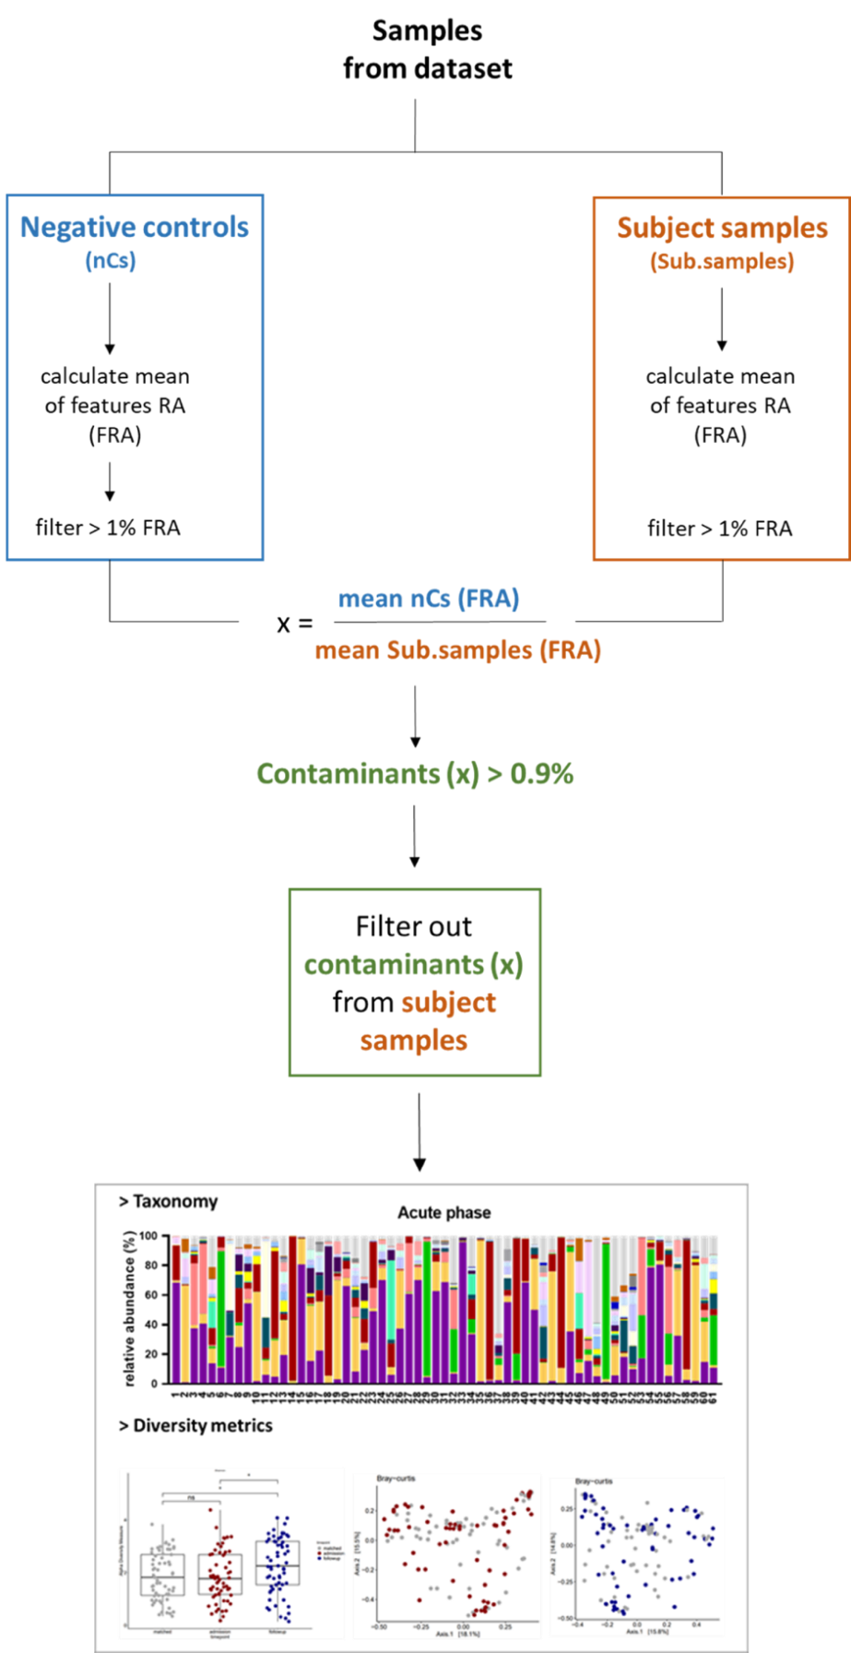

Figure S3: Workflow of our custom-developed contaminant feature-filtering bioinformatics pipeline for 16S rRNA amplicon sequencing data: A custom bioinformatics pipeline was developed in R to eliminate contaminant features detected in negative control samples from patient samples. The dataset was divided into subject and negative control groups. Features with a mean relative abundance (FRA) of less than 1% in both groups were discarded. A ratio was calculated between the mean FRA in negative controls and individual samples. Features with a ratio greater than 0.9 were identified as contaminants and subsequently removed from the subject sample dataset.
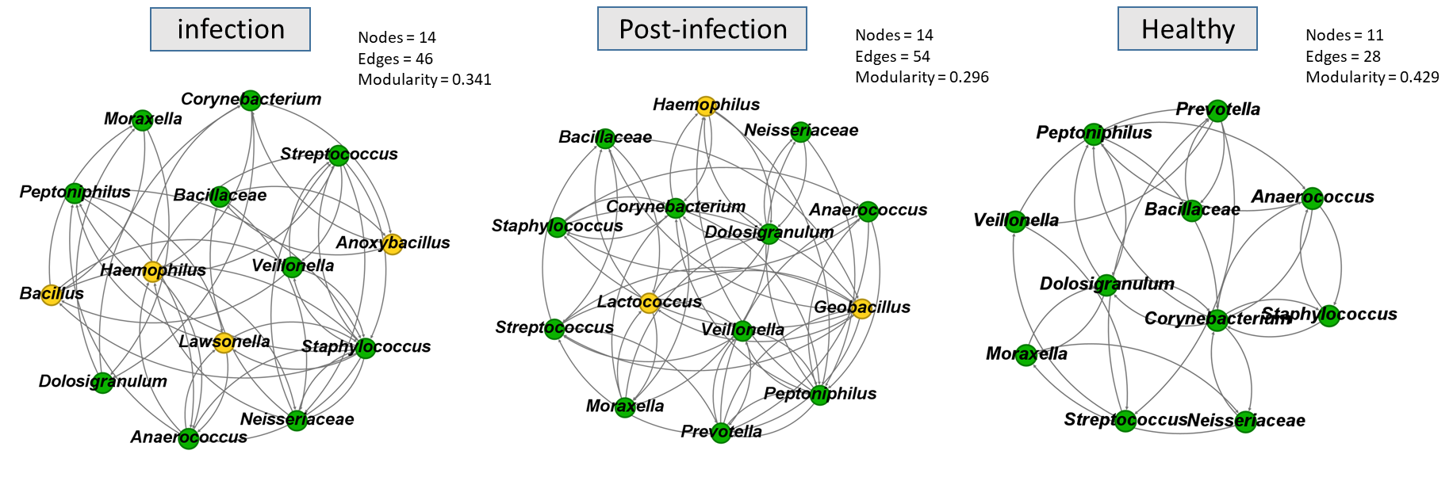
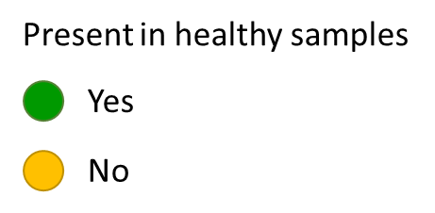

Figure S4: Network analysis of correlation coefficients (calculated using SparCC) from nasopharyngeal microbiome samples. The network diagram represents correlation coefficients greater than 0.1 for bacterial taxa with a mean relative abundance of over 1% in both patient and healthy control samples. Bacterial taxa are represented by nodes, colored green for taxa present in healthy samples, and yellow for those absent. The number of connections (edges), nodes, and the modularity index are indicated for each network.

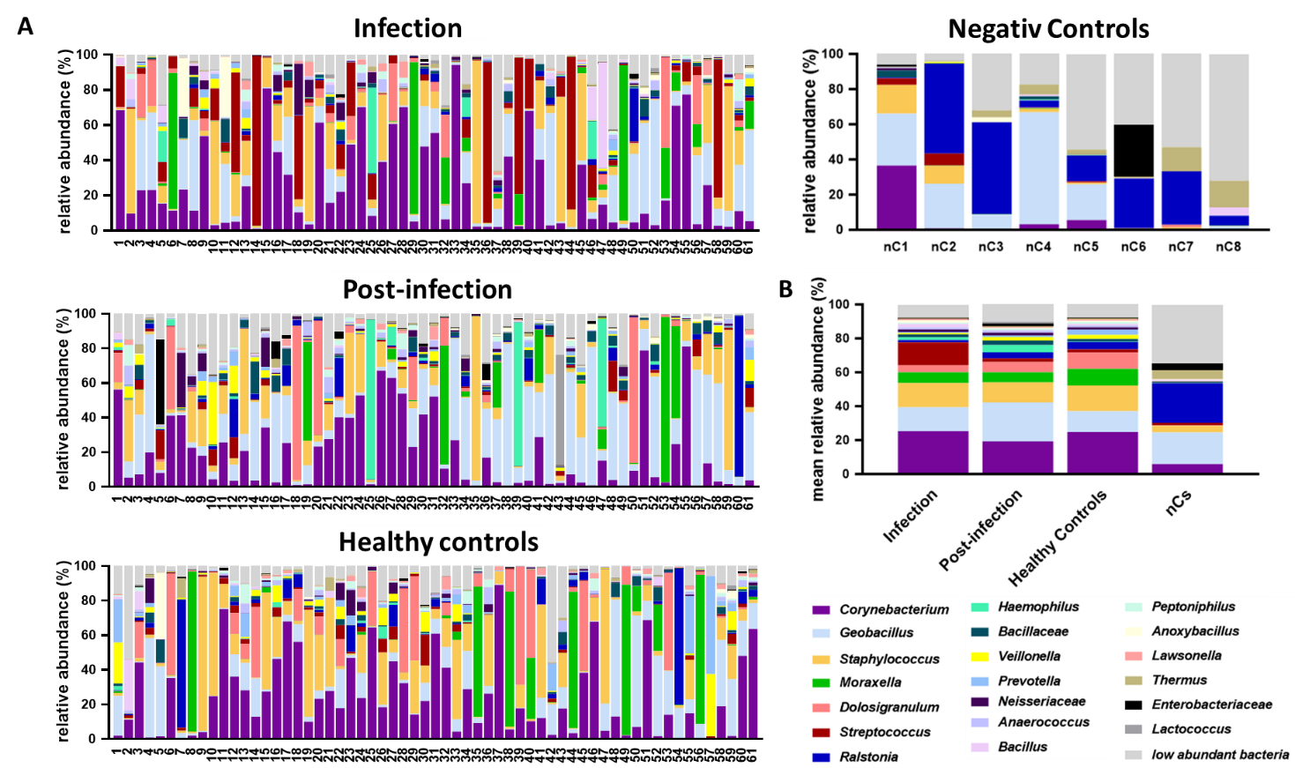

Figure S5. Bacterial taxonomic composition of nasopharyngeal swab samples from CAP patients and wet-lab negative controls. (A) Relative abundance of bacterial taxa at the genus level in CAP patients, matched control samples, and negative controls. (B) Mean relative abundance of bacterial taxa in each group analyzed.

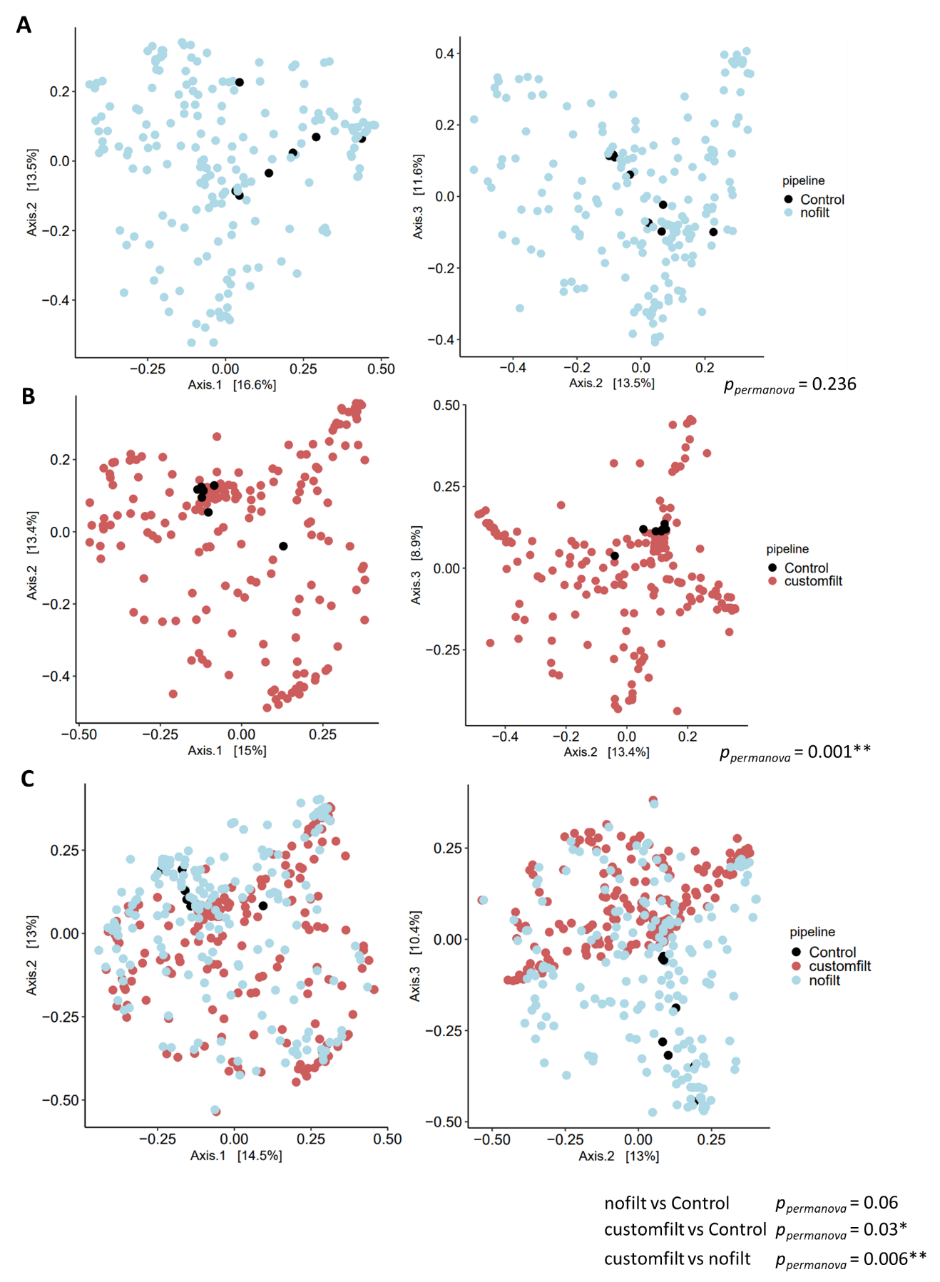

Figure S6. Beta diversity analysis between samples and negative controls. Bioinformatics pipelines comparison. (A) Principal coordinate analysis (PCoA) of the beta diversity using Bray-Curtis distances for samples and negative controls analyzed with a bioinformatics pipeline that does not include any contaminants filtering steps (nofilt) (B) Application of our custom bioinformatics feature-filtering pipeline on the dataset (customfilt). PCoA showing Bray-Curtis distances of negative controls and filtered samples (C) PCoA of Bray-Curtis distances for samples with (customfilt) and without (nofilt) the application of our custom contaminant filtering bioinformatics pipeline, along with negative control samples. P-values correspond to pairwise comparisons using PERMANOVA. * Significant p-values (p < 0.05).
References
1. Hansen K, Yamba Yamba L, Wasserstrom L, Rünow E, Göransson T, Nilsson A, et al. Exploring the microbial landscape: uncovering the pathogens associated with community-acquired pneumonia in hospitalized patients. Frontiers in Public Health. 2023;11.
2. Hansen K, Rünow E, Torisson G, Theilacker C, Palmborg A, Pan K, et al. Radiographically confirmed community-acquired pneumonia in hospitalized adults due to pneumococcal vaccine serotypes in Sweden, 2016–2018—The ECAPS study. Frontiers in Public Health. 2023;11.
3. Uddén F, Rünow E, Slotved HC, Fuursted K, Ahl J, Riesbeck K. Characterization of Streptococcus pneumoniae detected in clinical respiratory tract samples in southern Sweden 2 to 4 years after introduction of PCV13. J Infect. 2021;83(2):190-6.
4. Kalina WV, Souza V, Wu K, Giardina P, McKeen A, Jiang Q, et al. Qualification and Clinical Validation of an Immunodiagnostic Assay for Detecting 11 Additional Streptococcus pneumoniae Serotype-specific Polysaccharides in Human Urine. Clin Infect Dis. 2020;71(9):e430-e8.
5. Pride MW, Huijts SM, Wu K, Souza V, Passador S, Tinder C, et al. Validation of an immunodiagnostic assay for detection of 13 Streptococcus pneumoniae serotype-specific polysaccharides in human urine. Clin Vaccine Immunol. 2012;19(8):1131-41.
6. Hansen K, Rünow E, Torisson G, Theilacker C, Palmborg A, Pan K, et al. Radiographically confirmed community-acquired pneumonia in hospitalized adults due to pneumococcal vaccine serotypes in Sweden, 2016-2018-The ECAPS study. Front Public Health. 2023;11:1086648.
7. Ek P, Böttiger B, Dahlman D, Hansen KB, Nyman M, Nilsson AC. A combination of naso- and oropharyngeal swabs improves the diagnostic yield of respiratory viruses in adult emergency department patients. Infect Dis (Lond). 2019;51(4):241-8.
8. Østby AC, Gubbels S, Baake G, Nielsen LP, Riedel C, Arpi M. Respiratory virology and microbiology in intensive care units: a prospective cohort study. Apmis. 2013;121(11):1097-108.
9. Smith-Vaughan H, Byun R, Nadkarni M, Jacques NA, Hunter N, Halpin S, et al. Measuring nasal bacterial load and its association with otitis media. BMC Ear Nose Throat Disord. 2006;6:10.
10. Hardegger D, Nadal D, Bossart W, Altwegg M, Dutly F. Rapid detection of Mycoplasma pneumoniae in clinical samples by real-time PCR. J Microbiol Methods. 2000;41(1):45-51.
11. Welti M, Jaton K, Altwegg M, Sahli R, Wenger A, Bille J. Development of a multiplex real-time quantitative PCR assay to detect Chlamydia pneumoniae, Legionella pneumophila and Mycoplasma pneumoniae in respiratory tract secretions. Diagn Microbiol Infect Dis. 2003;45(2):85-95.
12. Roorda L, Buitenwerf J, Ossewaarde JM, van der Zee A. A real-time PCR assay with improved specificity for detection and discrimination of all clinically relevant Bordetella species by the presence and distribution of three Insertion Sequence elements. BMC Research Notes. 2011;4(1):11.
13. Yan M, Pamp SJ, Fukuyama J, Hwang PH, Cho D-Y, Holmes S, et al. Nasal microenvironments and interspecific interactions influence nasal microbiota complexity and S. aureus carriage. Cell host & microbe. 2013;14(6):631-40.
14. Hardy BL, Dickey SW, Plaut RD, Riggins DP, Stibitz S, Otto M, et al. Corynebacterium pseudodiphtheriticum exploits Staphylococcus aureus virulence components in a novel polymicrobial defense strategy. MBio. 2019;10(1):10.1128/mbio. 02491-18.
15. Menberu MA, Liu S, Cooksley C, Hayes AJ, Psaltis AJ, Wormald P-J, et al. Corynebacterium accolens has antimicrobial activity against Staphylococcus aureus and methicillin-resistant S. aureus pathogens isolated from the sinonasal niche of chronic rhinosinusitis patients. Pathogens. 2021;10(2):207.
16. Khamash DF, Mongodin EF, White JR, Voskertchian A, Hittle L, Colantuoni E, et al., editors. The association between the developing nasal microbiota of hospitalized neonates and Staphylococcus aureus colonization. Open forum infectious diseases; 2019: Oxford University Press US.
17. Bomar L, Brugger SD, Yost BH, Davies SS, Lemon KP. Corynebacterium accolens releases antipneumococcal free fatty acids from human nostril and skin surface triacylglycerols. MBio. 2016;7(1):10.1128/mbio. 01725-15.
18. Horn KJ, Jaberi Vivar AC, Arenas V, Andani S, Janoff EN, Clark SE. Corynebacterium species inhibit Streptococcus pneumoniae colonization and infection of the mouse airway. Frontiers in Microbiology. 2022;12:804935.
19. Choi Y, Banerjee A, McNish S, Couch KS, Torralba MG, Lucas S, et al. Co-occurrence of anaerobes in human chronic wounds. Microbial ecology. 2019;77:808-20.
20. Mashima I, Nakazawa F. Interaction between Streptococcus spp. and Veillonella tobetsuensis in the early stages of oral biofilm formation. Am Soc Microbiol; 2015.
21. Abram AM, Szewczyk MM, Park SG, Sam SS, Eldana HB, Koria FJ, et al. A co-association of Streptococcus mutans and Veillonella parvula/dispar in root caries patients and in vitro biofilms. Infection and immunity. 2022;90(10):e00355-22.
22. Horn KJ, Schopper MA, Drigot ZG, Clark SE. Airway Prevotella promote TLR2-dependent neutrophil activation and rapid clearance of Streptococcus pneumoniae from the lung. Nature Communications. 2022;13(1):3321.
23. Brugger SD, Eslami SM, Pettigrew MM, Escapa IF, Henke MT, Kong Y, et al. Dolosigranulum pigrum cooperation and competition in human nasal microbiota. Msphere. 2020;5(5):10.1128/msphere. 00852-20.
24. Accorsi EK, Franzosa EA, Hsu T, Joice Cordy R, Maayan-Metzger A, Jaber H, et al. Determinants of Staphylococcus aureus carriage in the developing infant nasal microbiome. Genome biology. 2020;21:1-24.
25. Prevaes SM, De Winter-De Groot KM, Janssens HM, de Steenhuijsen Piters WA, Tramper-Stranders GA, Wyllie AL, et al. Development of the nasopharyngeal microbiota in infants with cystic fibrosis. American journal of respiratory and critical care medicine. 2016;193(5):504-15.
26. Liljemark W, Gibbons R. Ability of Veillonella and Neisseria species to attach to oral surfaces and their proportions present indigenously. Infection and immunity. 1971;4(3):264-8.

