Fig Schedule 1
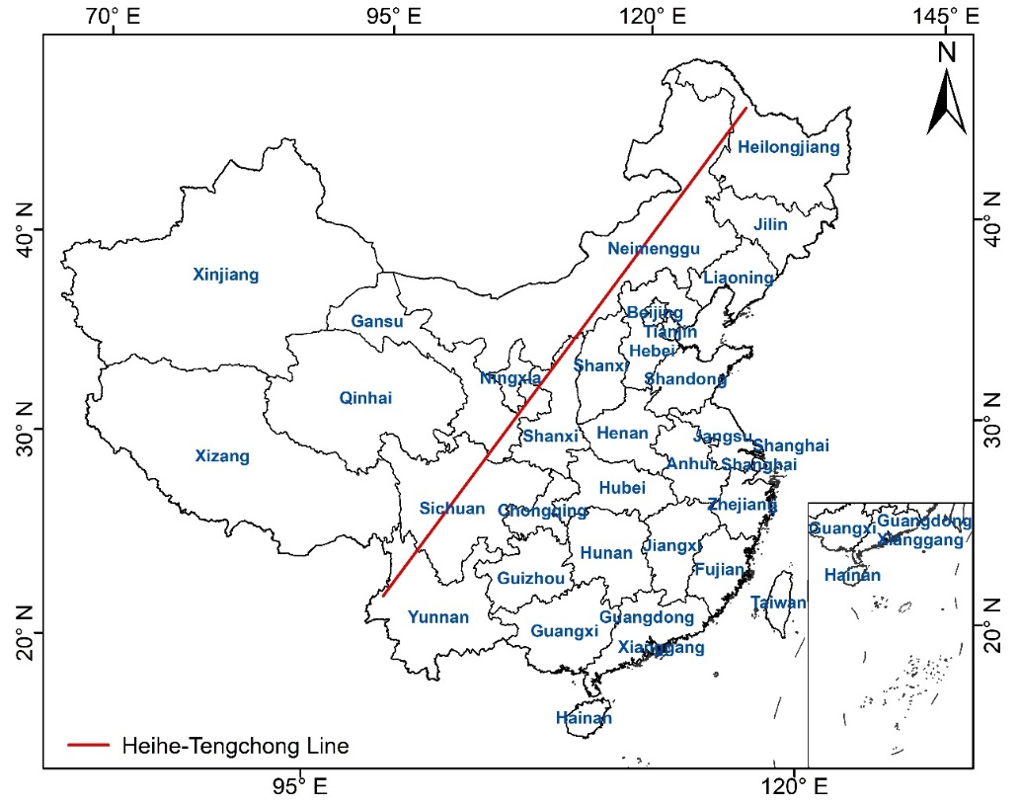
Note: The red line is the Hu Huanyong Line, also known as the Heihe-Tengchong Line. The line is the contrast line proposed by the Chinese geographer Hu Huanyong in 1935 to divide the population density of China.

Table Schedule 1
Gross domestic product (GDP) and food waste resources in 2019 in China
Province | GDP  (billion，$) | Urban and rural food waste  production (10⁴t) | Capital city | GDP  (billion，$) | Urban food waste  production (10⁴t)
Guangdong | 1648.74 | 397.92 | Guangzhou | 361.82 | 161.76
Jiangsu | 1525.63 | 220.35 | Nanjing | 214.84 | 58.62
Shandong | 1088.24 | 231.16 | Jinan | 144.60 | 50.73
Zhejiang | 954.78 | 184.11 | Hangzhou | 235.40 | 117.82
Henan | 830.86 | 164.94 | Zhengzhou | 177.47 | 59.55
Sichuan | 713.82 | 163.01 | Chengdu | 260.51 | 108.87
Hubei | 701.76 | 128.43 | Wuhan | 248.42 | 65.18
Fujian | 649.18 | 118.32 | Fuzhou | 143.82 | 87.83
Hunan | 608.71 | 111.63 | Changsha | 177.23 | 53.25
Shanghai | 584.26 | 85.21 | Shanghai | 584.26 | 82.36
Anhui | 568.32 | 96.09 | Hefei | 144.08 | 50.26
Beijing | 541.63 | 113.95 | Beijing | 541.63 | 128.62
Hebei | 537.55 | 116.87 | Shijiazhuang | 88.97 | 52.65
Shaanxi | 394.96 | 83.76 | Sian | 142.73 | 62.15
Liaoning | 381.43 | 120.84 | Shenyang | 99.08 | 43.27
Jiangxi | 379.11 | 77.37 | Nanchang | 85.69 | 30.63
Chongqing | 361.47 | 75.47 | Chongqing | 361.47 | 199.18
Yunnan | 355.62 | 72.20 | Kunming | 99.16 | 44.08
Guangxi | 325.20 | 76.31 | Nanning | 69.01 | 52.23
Inner Mongolia | 263.57 | 51.70 | Hohhot | 42.74 | 19.61
Shanxi | 260.73 | 68.48 | Taiyang | 61.69 | 23.39
Guizhou | 256.78 | 56.52 | Guiyang | 61.86 | 29.30
Tianjin | 215.98 | 35.36 | Tianjin | 215.98 | 39.49
Heilongjiang | 208.45 | 70.67 | Harbin | 80.38 | 48.96
Xinjiang | 208.21 | 48.75 | Urumqi | 52.83 | 23.71
Jilin | 179.57 | 63.16 | changchun | 90.41 | 39.72
Gansu | 133.50 | 42.88 | Lanzhou | 43.45 | 22.12
Hainan | 81.29 | 31.66 | Haikou | 25.60 | 26.27
Ningxia | 57.40 | 16.85 | Yinchuan | 30.95 | 14.72
Qinghai | 45.42 | 14.45 | Xining | 21.18 | 15.97
Tibet | 26.00 | 9.25 | Lhasa | 9.46 | 6.34
Note: $1.0=6.5305 Chinese Yuan.

