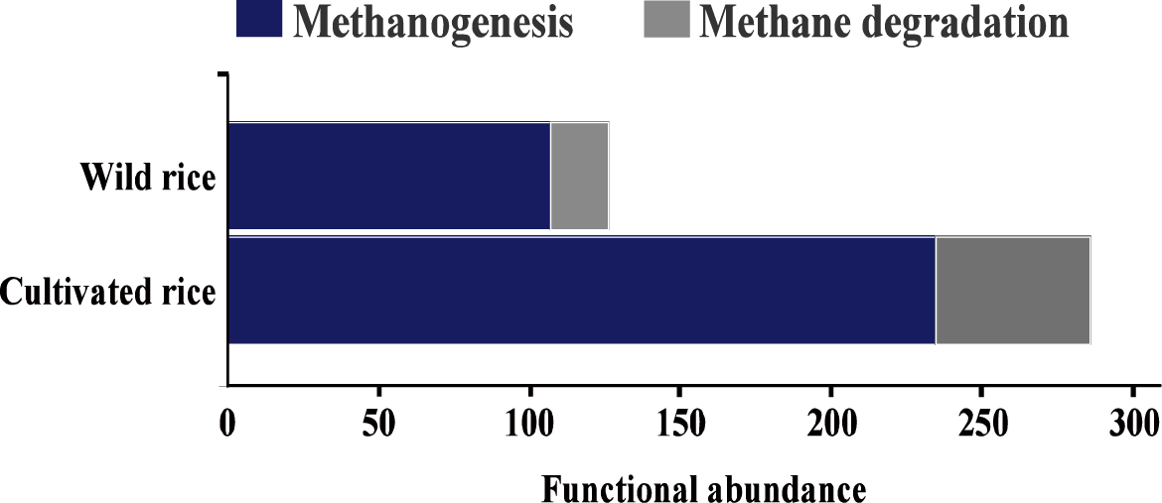

Figure S1 Ratios of rhizosphere methane production to methane degradation functions in cultivated and wild rice.
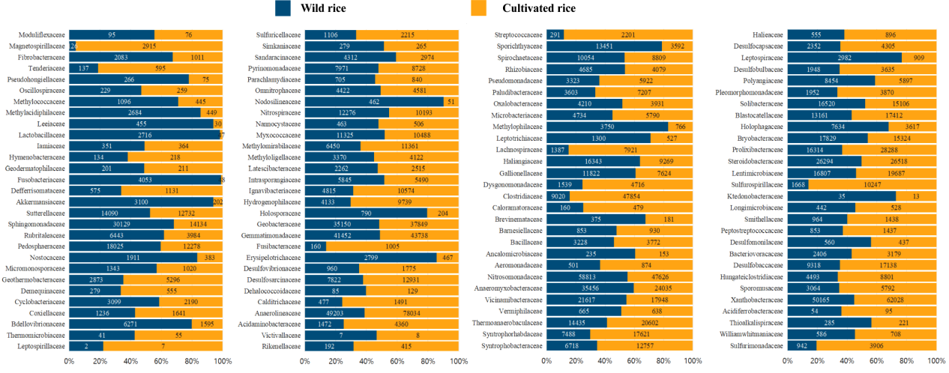+
Figure S2 Abundance ratios of negatively correlated microbial groups in the wild rice and cultivated rice rhizospheres in the field validation experiment.
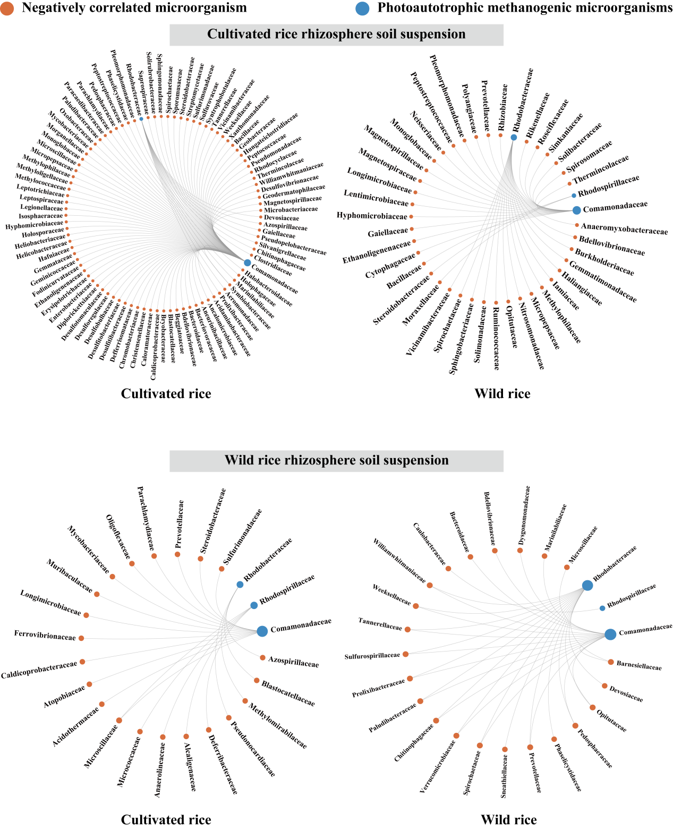

Figure S3 Photoautotrophic methanogenic microbial correlation networks of cultivated rice and wild rice inoculated with the rhizosphere soil suspensions (negative correlations).

