Supplementary Material
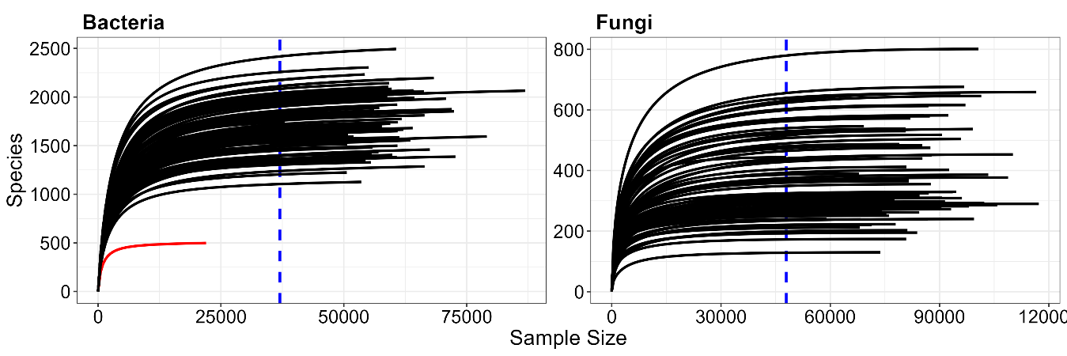
Supplementary Figure S1. Rarefaction curves showing the number of unique ASVs as a function of normalized library size for all samples. Red curves represent samples with small library sizes and thus, excluded from downstream analysis (missing bar in Supplementary Figure S4).
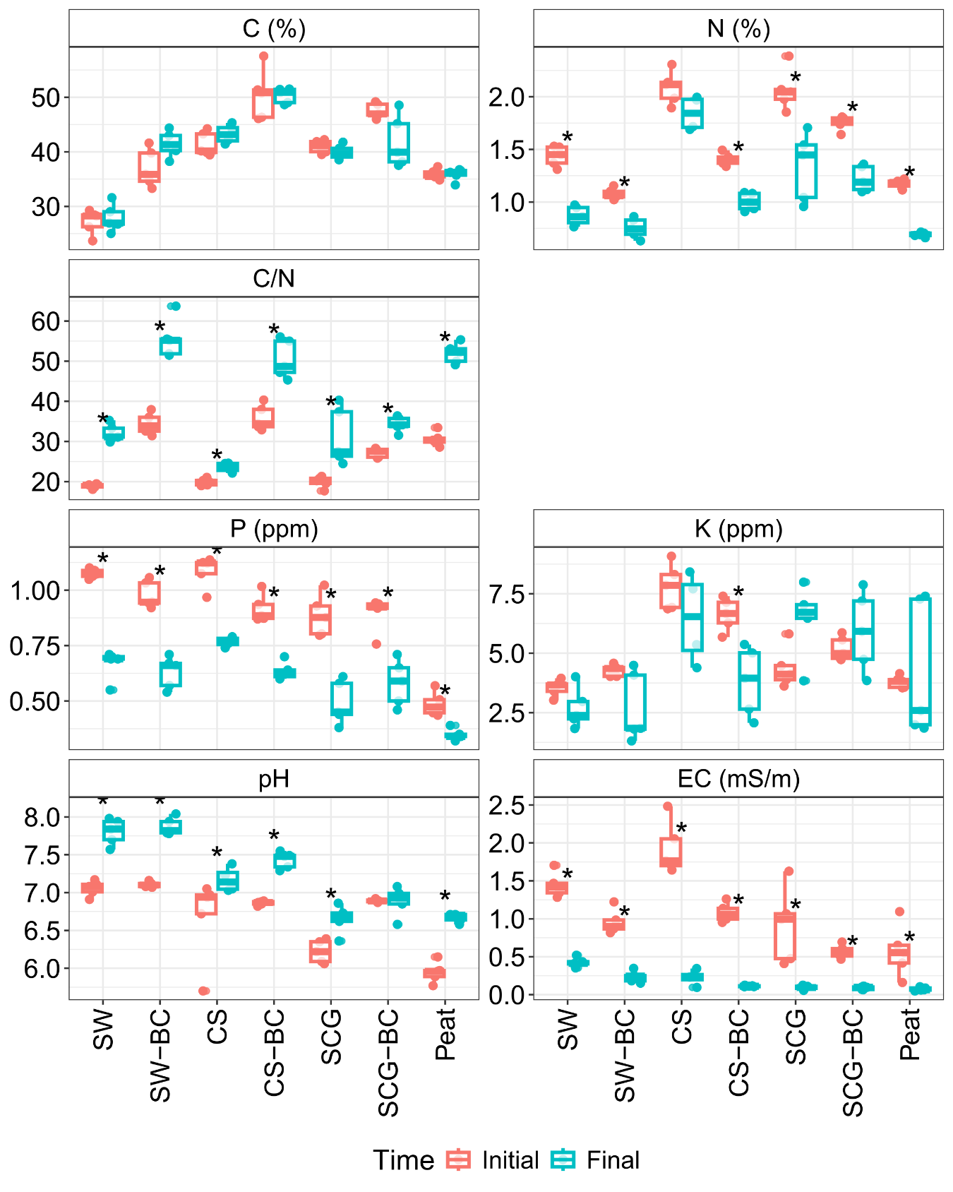
Supplementary Figure S2. Substrate composition and chemical properties after tomato cultivation. Asterisks denote the significance differences between substrate properties before and after tomato cultivation (Wilcoxon, *p < 0.05). SW – Seaweed, CS – Coffee Silverskin, SCG – Spent Coffee Grounds, BC – Biochar was blended during composting. EC – Electric Conductivity, C/N – Carbon/Nitrogen ratio.

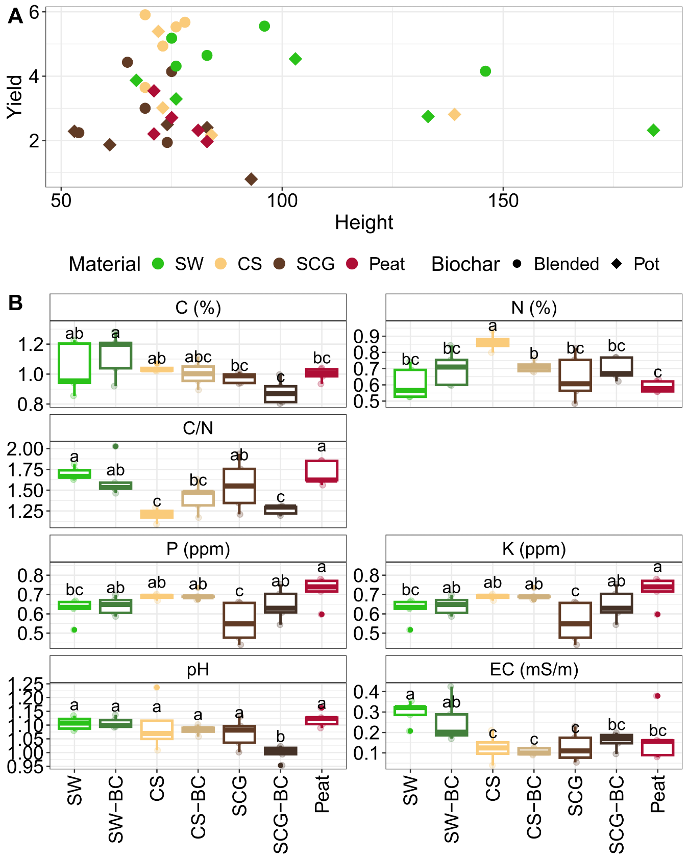
Supplementary Figure S3. A) Scatter plots showing the relationships between tomato yield (kg) and height (cm). B) Changes in substrate composition and chemical properties after tomato cultivation across treatments. SW – Seaweed, CS – Coffee Silverskin, SCG – Spent Coffee Grounds. ANOVA test and LSD (Least Square Difference) test were conducted (a-c indicate significance groups).
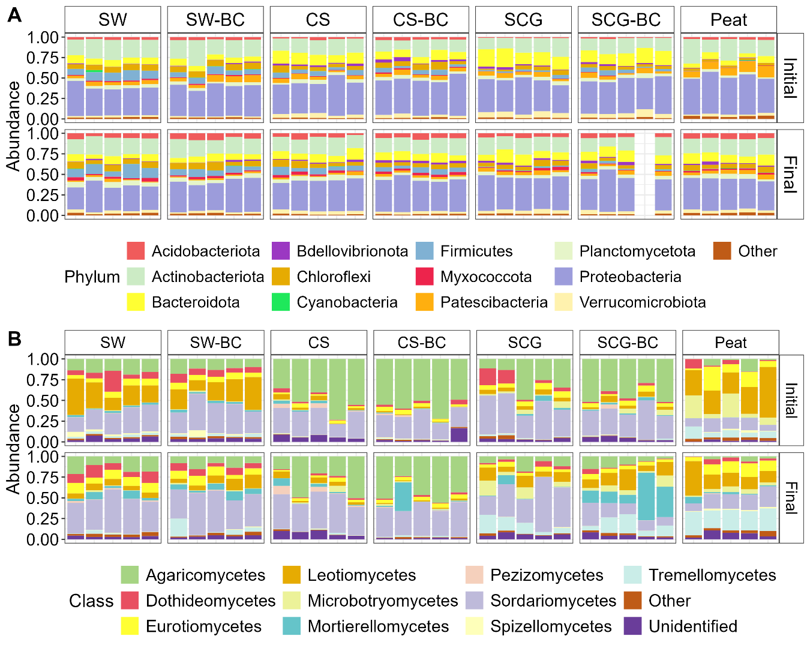
Supplementary Figure S4. Combined effect of compost-biochar on shaping bacterial and fungal community composition. Taxonomic composition of A) prokaryotic communities at the phylum level and B) fungi communities at the class level. “Other” includes minor prokaryotic phylum (relative abundance lower than 2.5%) and fungal class (lower than 5%), and “Unidentified taxonomically unassigned taxa. SW – Seaweed, CS – Coffee Silverskin, SCG – Spent Coffee Grounds, BC – Biochar was blended during composting.

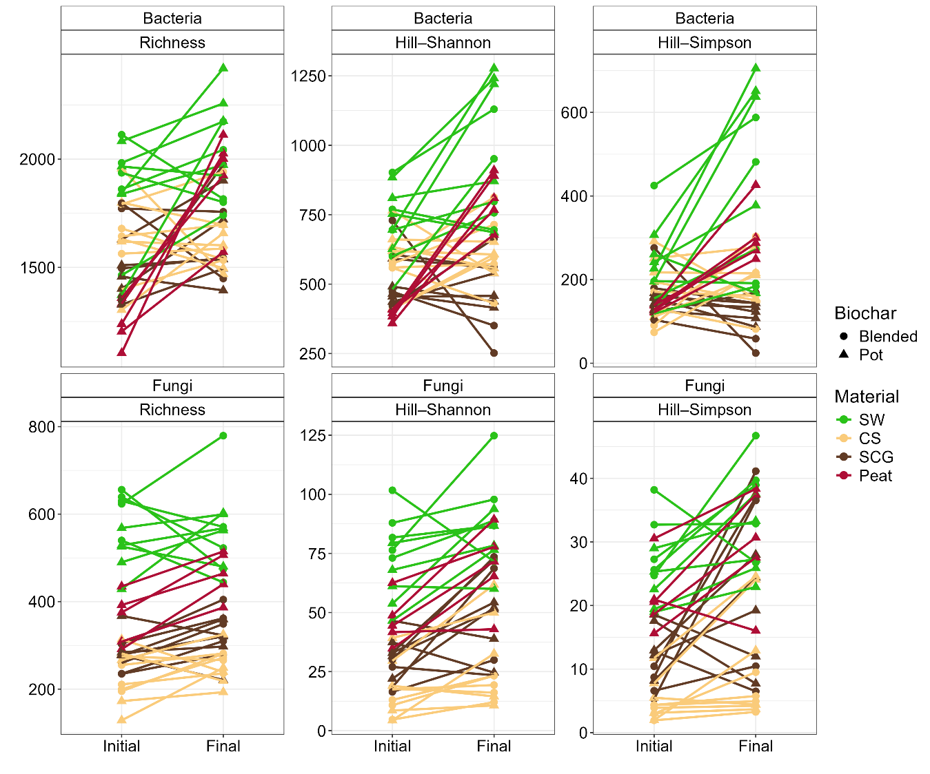
Supplementary Figure S5. Increasing alpha diversity after tomato cultivation is mediated by the combined effect of compost-biochar, that is, treatment. SW – Seaweed, CS – Coffee Silverskin, SCG – Spent Coffee Grounds.

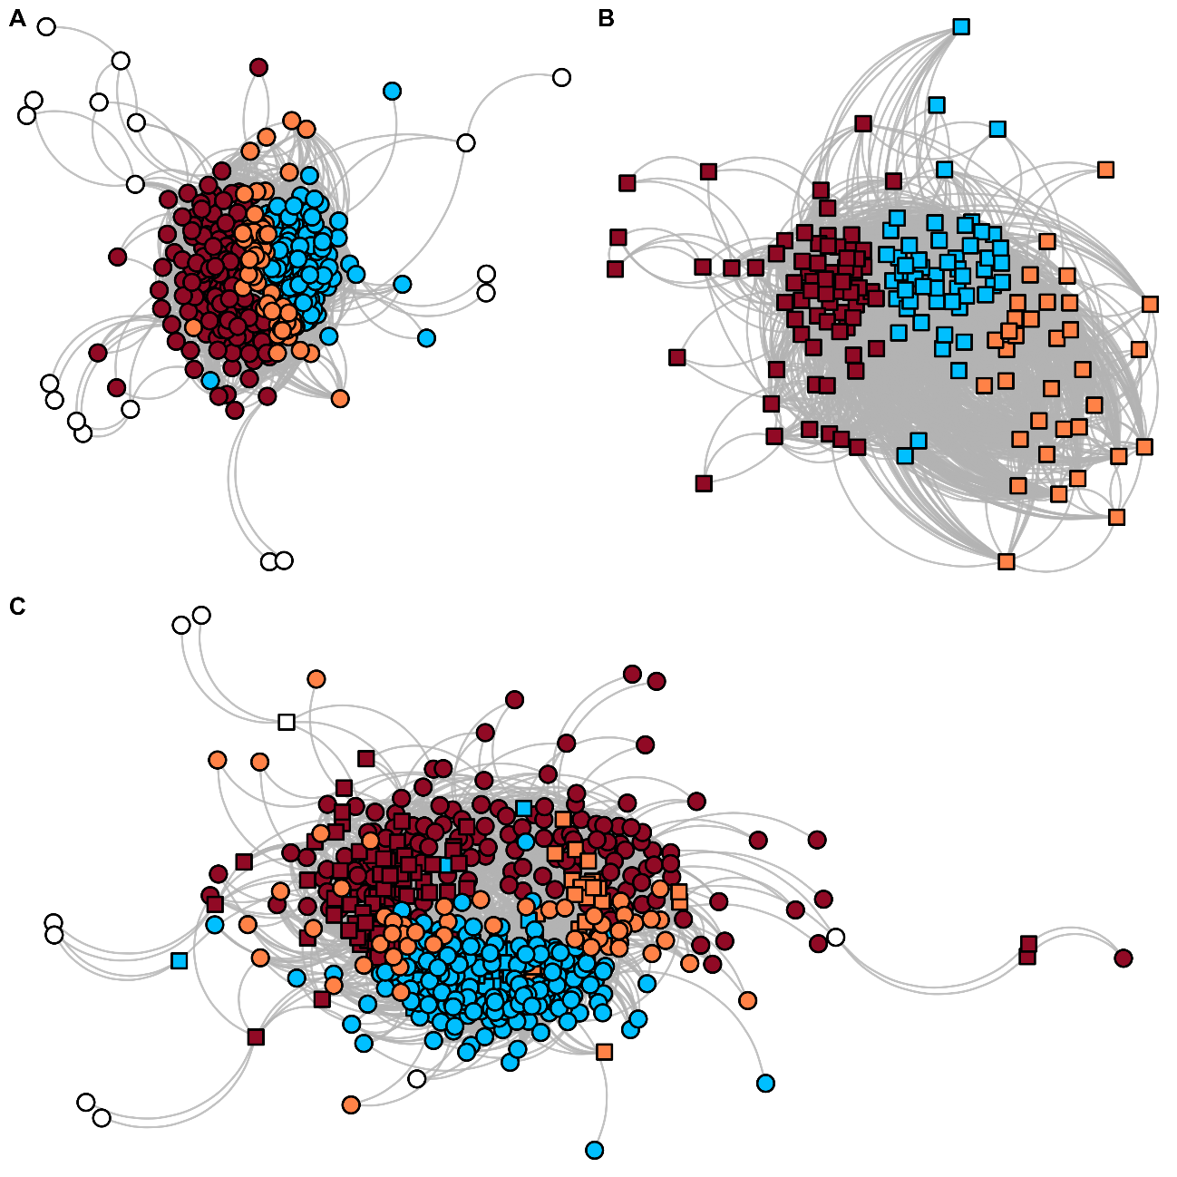
Supplementary Figure S6. Co-occurrence networks revealing A) prokaryotic and B) fungal sub-communities and C) their interaction in a bipartite network. Network nodes represent community members (aggregated at the genus level) and edges significant relationships between nodes (probability of co-occurrence higher than 0.95). Nodes are colored based on their module membership, being the prokaryotic and the fungal networks divided in three different modules (Module Bac-1: red, Module Bac-2: blue and Module Bac-3: orange; and Module Fun-1: red, Module Fun-2: blue and Module Fun-3: orange).

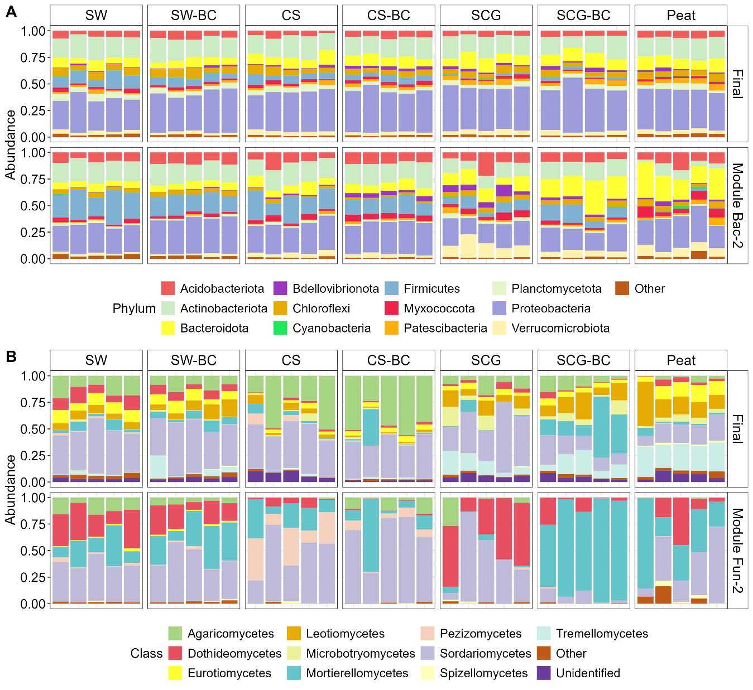
Supplementary Figure S7. Taxonomic composition of the complete prokaryotic and fungal communities and the subset belonging to Module-2 communities after tomato cultivation. A) Prokaryotic communities at the phylum level and B) fungi communities at the class level. “Other” includes minor prokaryotic phylum (relative abundance lower than 2.5%) and fungal class (lower than 5%), and “Unidentified taxonomically unassigned taxa. SW – Seaweed, CS – Coffee Silverskin, SCG – Spent Coffee Grounds, BC – Biochar was blended during composting.

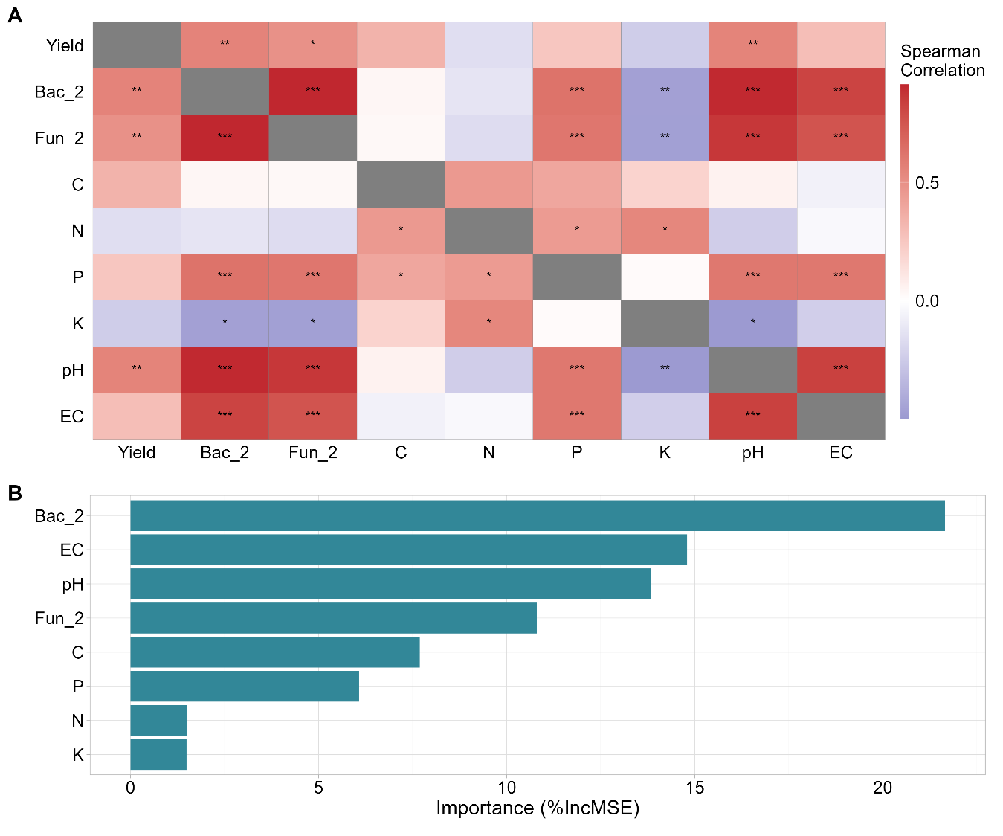
Supplementary Figure S8. Linear and non-linear relationships between tomato yield and substrate chemical and microbial properties. A) Spearman’s rank correlation. Asterisks denote the significance of each pairwise correlation (false discovery rate adjusted, *p < 0.05, **p < 0.01, ***p < 0.001). B) Random forest analysis to identify the relative importance of the different substrate chemical and microbial properties predicting tomato yield. The relative importance is estimated based on the increase in mean-square error (%IncMSE, R² = 0.36 and MSE = 1.159).

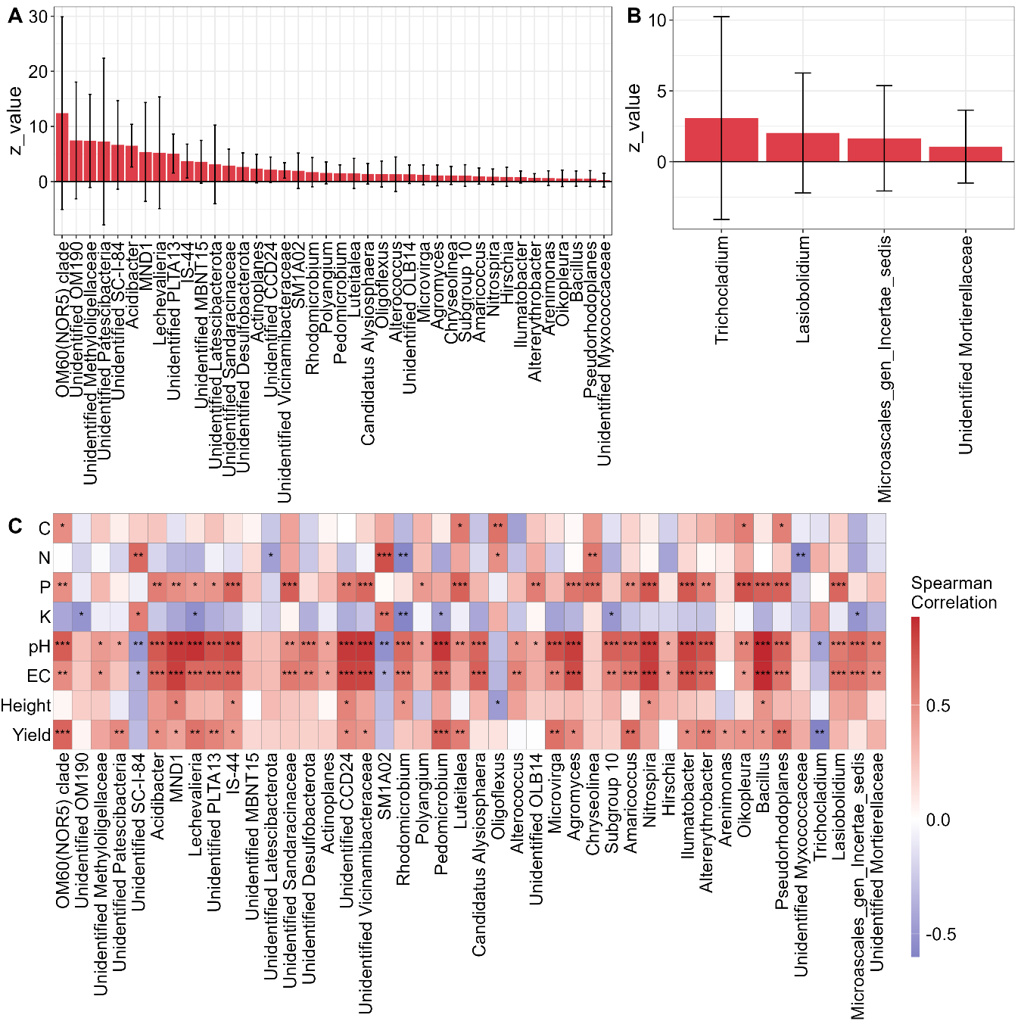
Supplementary Figure S9. Bacterial and fungal belonging to Module-2 with increased abundance after tomato harvest and their relationship with substrate properties and tomato yield and growth.

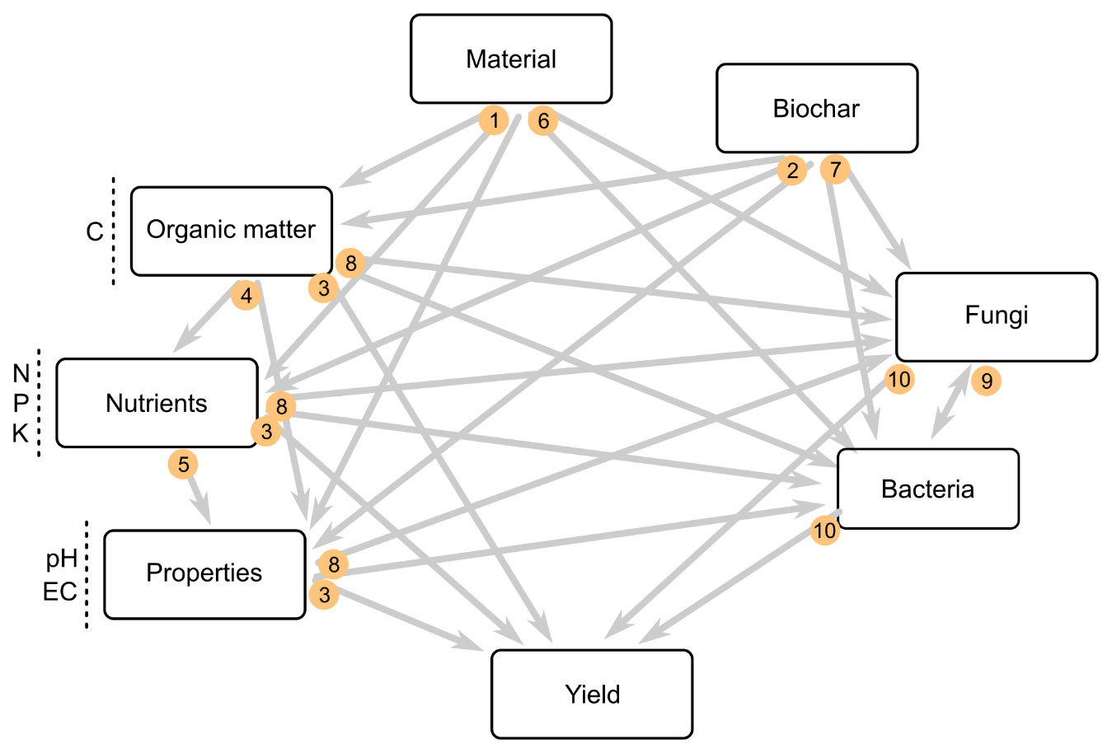
Supplementary Figure S10. A priori structural equation modeling (SEM) metamodel aimed to evaluate the direct and indirect effects of feedstock materials and biochar application on substrate properties, microbial communities, and tomato yield. Numbers indicate the rationale behind each association link explained in Supplementary Table S3.

Supplementary Table S1: PERMANOVA results comparing microbial community differences (bacteria, fungi) among feedstock material (seaweed, coffee silverskin or spent coffee grounds), between biochar application methods (blended during composting or at the bottom of the pot), and between sampling times (before or after harvest) (Supplementary Figure S1).
Community | Source of Variation | R² | F | Pr(>F)
Bacteria | Material | 0.356 | 15.189 | < 0.001 ***
Bacteria | Biochar application | 0.023 | 3.007 | 0.002 **
Bacteria | Interaction | 0.043 | 2.747 | < 0.001 ***
Bacteria | Harvest | 0.100 | 12.864 | < 0.001 ***
Fungi | Material | 0.493 | 25.631 | < 0.001 ***
Fungi | Biochar application | 0.024 | 3.768 | 0.005 **
Fungi | Interaction | 0.044 | 3.441 | < 0.001 ***
Fungi | Harvest | 0.040 | 6.307 | < 0.001 ***

Supplementary Table S2. Standardized direct effects of all significant and non-significant paths considered in the structural equation model (SEM) from Figure 4.
Response | Predictor | Standardized Estimate | P
Yield | Bacteria | 1.477 | 0.004 **
Yield | Fungi | -0.140 | 0.674
Yield | pH | 0.293 | 0.491
Yield | EC | -0.819 | 0.004 **
Yield | C | 0.130 | 0.470
Yield | N | 0.139 | 0.598
Yield | P | -0.468 | 0.153
Yield | K | 0.142 | 0.383
Bacteria | Material | - | 0.006 **
Bacteria | Material = Peat | 0.291 × | < 0.001 ***
Bacteria | Material = SCG | 0.308 × | < 0.001 ***
Bacteria | Material = CS | 0.377 × | < 0.001 ***
Bacteria | Material = SW | 0.401 × | < 0.001 ***
Bacteria | Biochar | - | 0.011 *
Bacteria | Biochar = Pot | 0.324 × | < 0.001 ***
Bacteria | Biochar = Blended | 0.364 × | < 0.001 ***
Bacteria | pH | -0.014 | 0.927
Bacteria | EC | 0.139 | 0.124
Bacteria | C | -0.154 | 0.110
Bacteria | N | 0.009 | 0.944
Bacteria | P | 0.045 | 0.675
Bacteria | K | -0.043 | 0.419
Fungi | Material | -
Fungi | Material = Peat | 0.234 × | 0.130
Fungi | Material = SCG | 0.205 × | < 0.001 ***
Fungi | Material = CS | 0.267 × | < 0.001 ***
Fungi | Material = SW | 0.342 × | < 0.001 ***
Fungi | Biochar | - | < 0.001 ***
Fungi | Biochar = Pot | 0.264 × | 0.921
Fungi | Biochar = Blended | 0.261 × | < 0.001 ***
Fungi | pH | 0.116 | 0.722
Fungi | EC | 0.083 | 0.649
Fungi | C | 0.082 | 0.673
Fungi | N | 0.139 | 0.501
Fungi | P | 0.144 | 0.518
Fungi | K | -0.126 | 0.242
Bacteria | Fungi | 0.520 | 0.0011 **
C | Material | - | < 0.001 ***
C | Material = Peat | 394.441 × | < 0.001 ***
C | Material = SCG | 404.579 × | < 0.001 ***
C | Material = CS | 467.782 × | < 0.001 ***
C | Material = SW | 346.511 × | < 0.001 ***
C | Biochar | - | < 0.001 ***
C | Biochar = Pot | 367.233 × | < 0.001 ***
C | Biochar = Blended | 439.423 × | < 0.001 ***
N | Material | - | < 0.001 ***
N | Material = Peat | 9.513 × | < 0.001 ***
N | Material = SCG | 13.552 × | < 0.001 ***
N | Material = CS | 11.943 × | < 0.001 ***
N | Material = SW | 6.924 × | < 0.001 ***
N | Biochar | - | < 0.001 ***
N | Biochar = Pot | 11.998 × | < 0.001 ***
N | Biochar = Blended | 8.968 × | < 0.001 ***
N | P | 0.638 | < 0.001 ***
P | Material | - | < 0.001 ***
P | Material = Peat | 0.332 × | < 0.001 ***
P | Material = SCG | 0.523 × | < 0.001 ***
P | Material = CS | 0.697 × | < 0.001 ***
P | Material = SW | 0.649 × | < 0.001 ***
P | Biochar | - | 0.284
P | Biochar = Pot | 0.566 × | < 0.001 ***
P | Biochar = Blended | 0.534 × | < 0.001 ***
K | Material | - | < 0.001 ***
K | Material = Peat | 3.768 × | 0.002 **
K | Material = SCG | 6.273 × | < 0.001 ***
K | Material = CS | 5.043 × | < 0.001 ***
K | Material = SW | 2.696 × | < 0.001 ***
K | Biochar | - | 0.199
K | Biochar = Pot | 4.899 × | < 0.001 ***
K | Biochar = Blended | 3.991 × | < 0.001 ***
pH | Material | - | < 0.001 ***
pH | Material = Peat | 6.914 × | < 0.001 ***
pH | Material = SCG | 6.894 × | < 0.001 ***
pH | Material = CS | 7.258 × | < 0.001 ***
pH | Material = SW | 7.662 × | < 0.001 ***
pH | Biochar | - | 0.258
pH | Biochar = Pot | 7.124 × | < 0.001 ***
pH | Biochar = Blended | 7.240 × | < 0.001 ***
pH | C | -0.013 | 0.918
pH | N | -0.201 | 0.115
pH | P | 0.350 | 0.007 **
pH | K | -0.049 | 0.461
EC | Material | - | 0.006 **
EC | Material = Peat | 0.075 × | 0.133
EC | Material = SCG | 0.090 × | 0.006 **
EC | Material = CS | 0.181 × | < 0.001 ***
EC | Material = SW | 0.298 × | < 0.001 ***
EC | Biochar | - | 0.201
EC | Biochar = Pot | 0.191 × | < 0.001 ***
EC | Biochar = Blended | 0.132 × | < 0.001 ***
EC | C | -0.262 | 0.156
EC | N | -0.021 | 0.930
EC | P | 0.240 | 0.264
EC | K | 0.110 | 0.345
Asterisks denote the significance levels (***p < 0.001, **p < 0.01, *p < 0.05 and · p < 0.1).
× Standardized estimates were not calculated for categorical variables.

Supplementary Table S3. Rationale behind each association link proposed for the structural equation modelling (SEM) in Figure 4 and Supplementary Figure S10.
# | Associations | Rationale | References
1 | Material → Substrate properties, organic and nutrient concentrations | Organic substrates from different feedstock materials will have specific properties like texture, nutrient content or composition of organic matter. | (Xie et al. 2023)
2 | Biochar → Substrate properties, organic and nutrient concentrations | Biochar improves substrate properties such as C and nutrient content, pH or water retention capacity. | (Gao et al. 2023; Sánchez-Monedero et al. 2019; Teodoro et al. 2020)
3 | Substrate properties, organic and nutrient concentrations → Tomato Yield | Tomato yield is sensitive to substrate properties, especially those concerning plant nutrition and water content. | (Li et al. 2019; Maynard 1995; Yang et al. 2015)
4 | Organic matter → Nutrients and other properties | The recycling of nutrients from organic matter is a crucial process to maintain fertility. In addition, the concentration of organic ions will alter pH and other properties such as electric conductivity. | (Ritchie & Dolling 1985; Tiessen et al. 1994)
5 | Nutrient concentrations → Other properties | The concentration of certain nutrients has important impact on substrate pH and EC. | (Silber & Bar-Tal 2019)
6 | Material → Microbial communities | The type of organic feedstock used during composting plays a crucial role in shaping microbial communities. | (Bender et al. 2016)
7 | Biochar → Microbial communities | Biochar alter the pH of the mixtures, creates niches within its pore network and could retain nutrients due to entrapment or adsorption on its surface. | (Anderson et al. 2011; Palansooriya et al. 2019)
8 | Substrate properties, organic and nutrient concentrations → Microbial communities | Substrate properties are key determinants of microbial communities. pH is among the strongest selective forces for microbes, together with water availability. | (Barnett et al. 2020; Hou et al. 2022; Liu et al. 2022; Yang et al. 2022)
9 | Fungi ↔ Bacteria | Fungi and bacteria are found together in a wide variety of environments where they assemble into dynamic co-evolving communities. | (Deveau et al. 2018)
10 | Microbial communities → Tomato Yield | Specific microbial communities have shown positive effects on crop productivity in tomato production. | (Anzalone et al. 2022; Sinno et al. 2020; Usero et al. 2021)

