Supplementary Information

Supplementary Table S1. Number of flood events in the attribution dataset by type, decade and country (only those with the highest number of events).
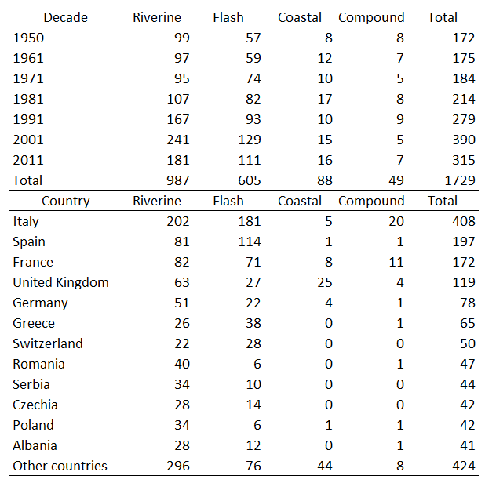

Supplementary Table S2. Reported historical flood events in the HANZE database, detailed whether they were reconstructed in the modeling chain (first column) and whether their impacts were reported in historical sources or were gap-filled with model estimates.
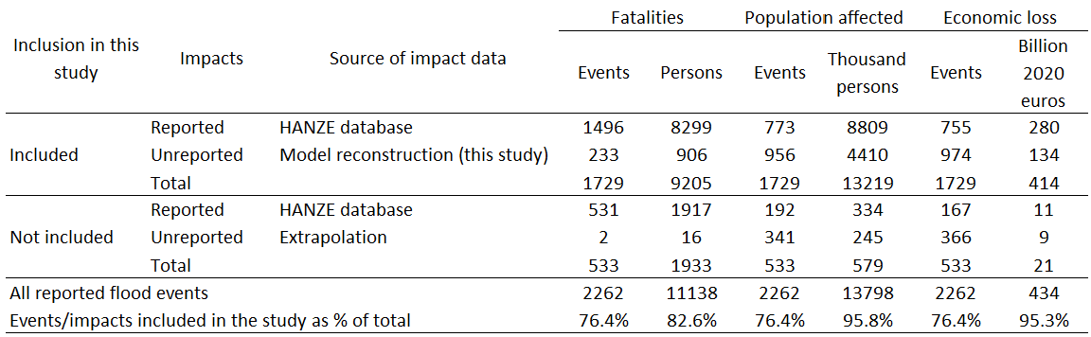

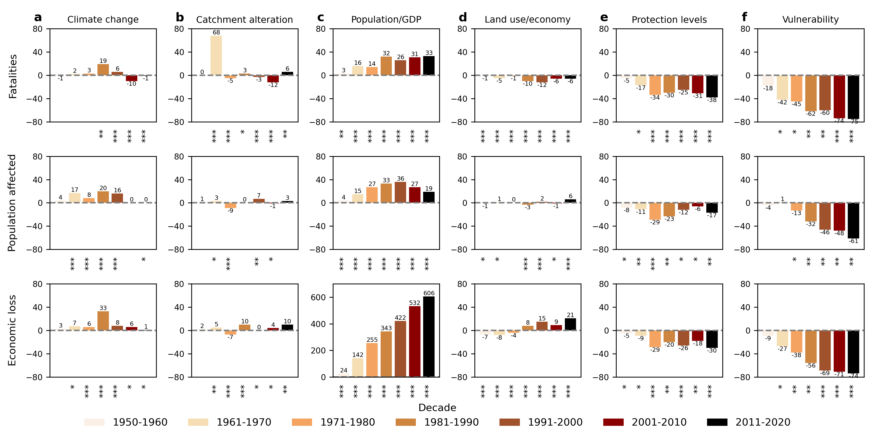
Supplementary Fig. S1. Contribution to impacts (in rows) of different drivers (in columns, panels a-f) by decade, expressed as % change of factual impacts relative to the counterfactual scenario of no change to the individual driver since 1950. Each panel represents one driver of change. Asterixis under each bar represent the likelihood that the difference between factual and counterfactual scenario is larger than the model uncertainty: likely (*), very likely (**) and virtually certain (***).

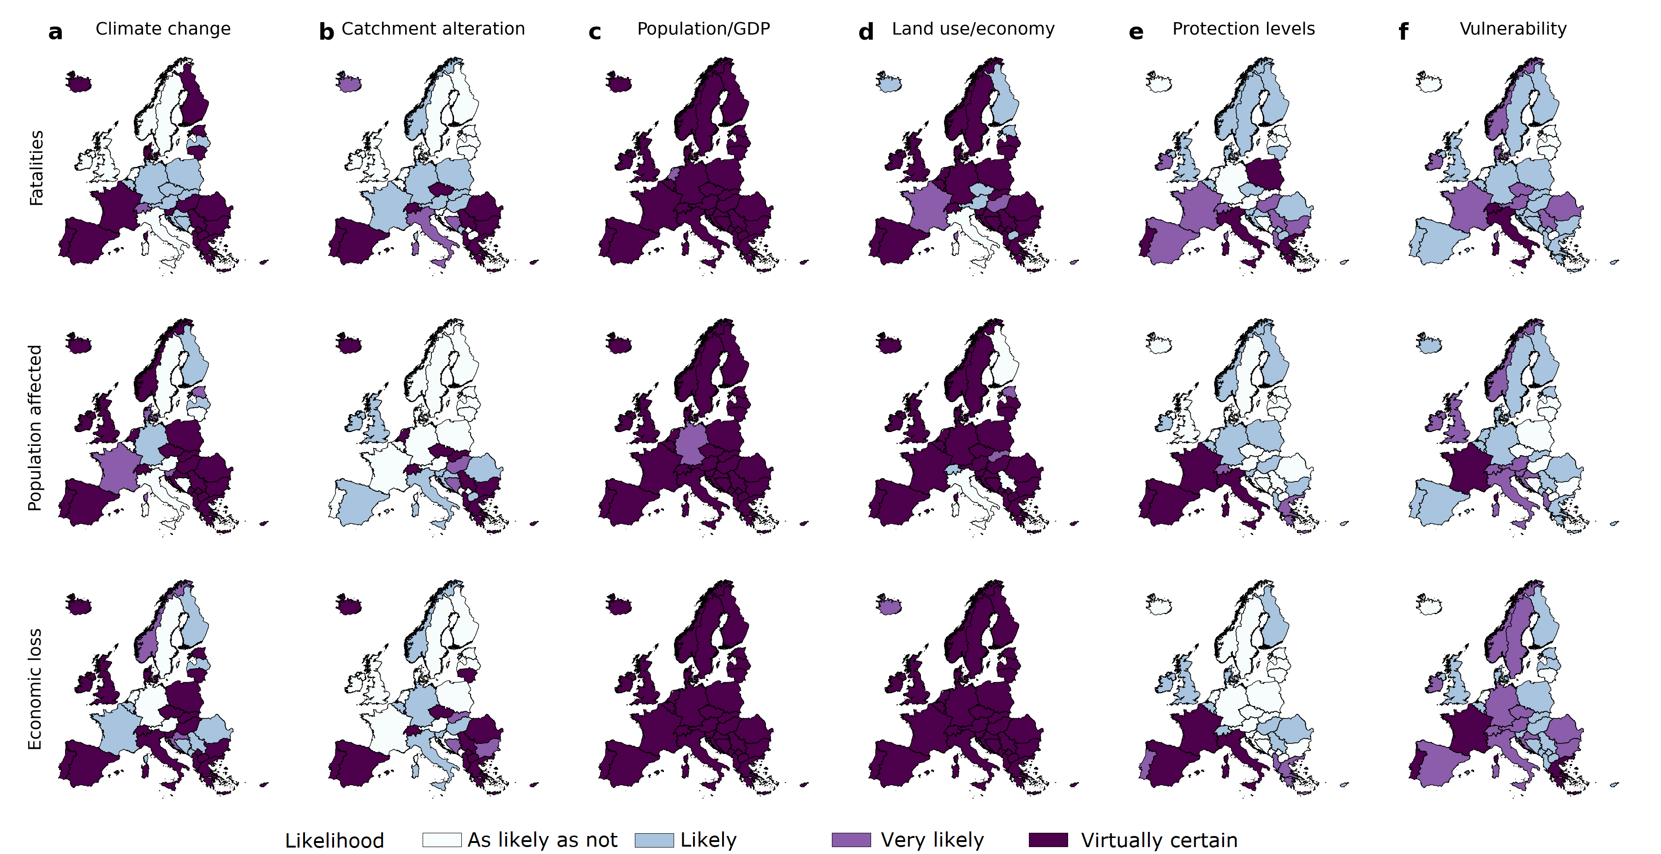
Supplementary Fig. S2. The likelihood that the difference between factual and counterfactual scenarios is larger than the model uncertainty, by country (see Fig. 4): as likely as not (<66%), likely (66-90%), very likely (90-99%), virtually certain (>99%).

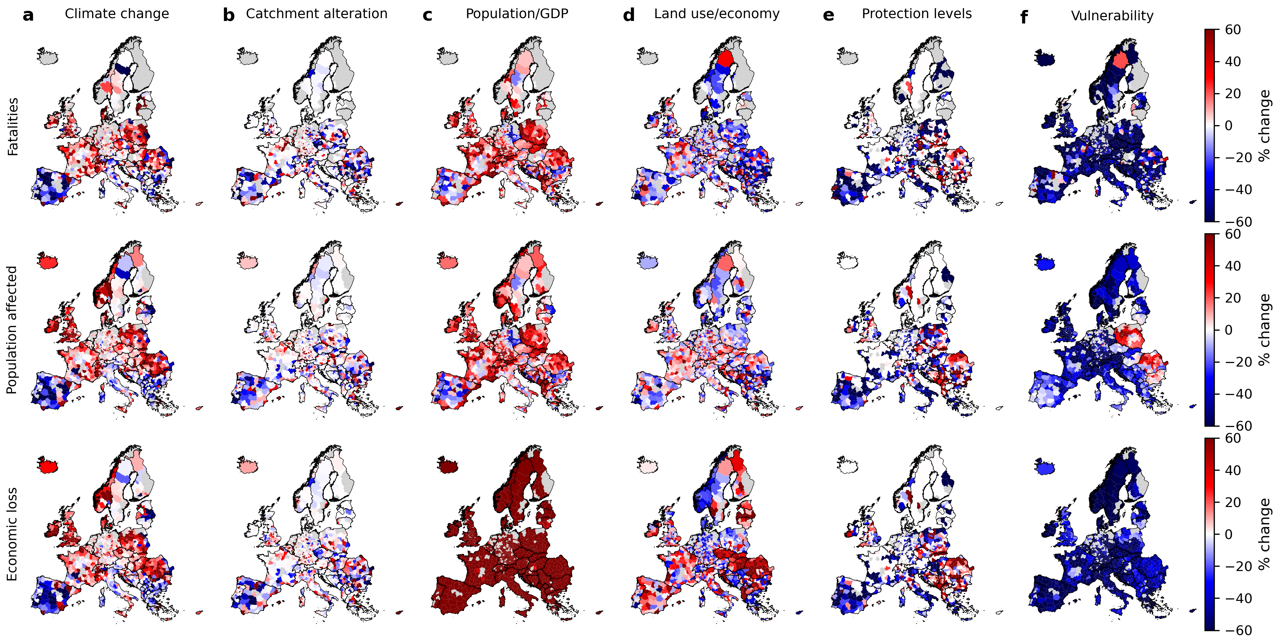
Supplementary Fig. S3. Contribution to impacts (in rows) of different drivers (in columns, panels a-f), by subnational region, expressed as % change of factual impacts relative to the counterfactual scenario of no change in the individual driver since 1950. Each panel represents one driver of change.

