Supplementary Information
Article title: Comparing the efficiency of forest mitigation strategies: climate change and windthrow as overarching drivers
Authors: Cosmin Coșofreț^{1,2}, Laura Bouriaud¹, Costa Maximiliano³, Bouriaud Olivier⁴
Affiliations:
- Forestry Faculty, Stefan cel Mare University of Suceava, 720229 Suceava, Romania
- Applied Ecology Laboratory, Stefan cel Mare University of Suceava, 720229 Suceava, Romania
- ETH Zürich, Department of Environmental Systems Science, Universitätstrasse 16, 8092 Zürich, Switzerland
- Integrated Center for Research, Development, and Innovation in Advanced Materials, Nanotechnologies and Distributed Systems for Fabrication and Control (MANSiD), Stefan cel Mare University of Suceava, 720229 Suceava, Romania
Corresponding author: Bouriaud Olivier (obouriaud@usm.ro)

SI Fig. 1. Evolution of the carbon stocks for the principal tree species across the case study of the Frasin FD.

 | Carbon stock | Potential carbon substitution | Carbon loss
RCP2.6 | 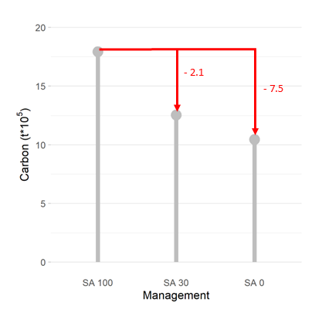  a)  d) | 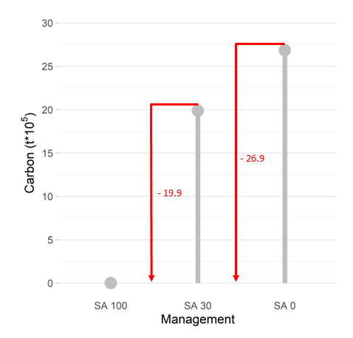  b)  e) | 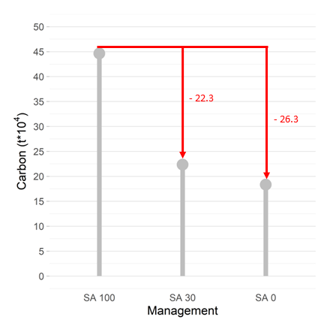  c)  f)
RCP8.5 | 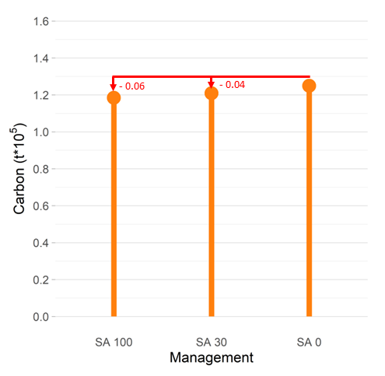 | 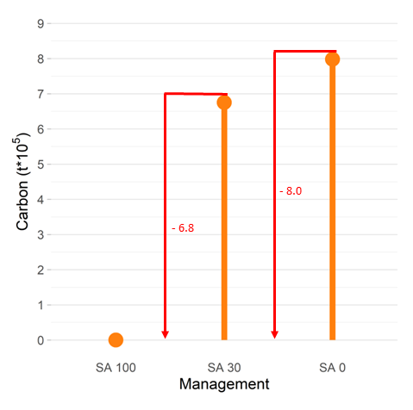 | 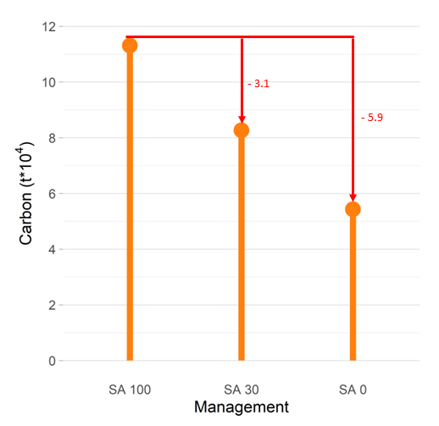
SI Fig. 2. Carbon stock (a,d), Potential carbon substitution (b,e), carbon loss (c,f) under SA0, SA30, and SA100 management type under moderate (RCP2.6 – grey bars) and extreme (RCP8.5 – orange bars) climate scenarios in 2210.

SI Fig. 3. Historic and future wind disturbances effects in mild (RCP2.6) and extreme (RCP8.5) climate scenarios and management strategies.

