Supplementary Information for

Multiple freezing-melting pathways of high-density ice at room temperature

Yun-Hee Lee¹†, Jin Kyun Kim¹†, Yong-Jae Kim^{1,2}†, Minju Kim¹, Yong Chan Cho¹, Rachel J. Husband³, Cornelius Strohm³, Emma Ehrenreich-Petersen³, Torsten Laurus³, Heinz Graafsma³, Robert P. C. Bauer^{3,4}, Felix Lehmkühler^{3,4,5}, Karen Appel⁶, Zuzana Konôpková⁶, Minxue Tang⁶, Anand Prashant Dwivedi⁶, Jolanta Sztuck-Dambietz⁶, Lisa Randolph⁶, Khachiwan Buakor⁶, Oliver Humphries⁶, Carsten Baehtz⁷, Tobias Eklund^{8,9}, Lisa Katharina Mohrbach¹⁰, Anshuman Mondal¹⁰, Hauke Marquardt¹¹, Earl Francis O’Bannon², Katrin Amann-Winkel^{8,9}, Choong-Shik Yoo¹², Ulf Zastrau⁶, Hanns-Peter Liermann³, Hiroki Nada¹³, and Geun Woo Lee^{1,14}*
Corresponding author: gwlee@kriss.re.kr

1. Pressure-time curves of freezing-melting process under dynamic pressurization
Liquid water was compressed and decompressed from 0.6 GPa to 2.0 GPa more than 100-1000 times by using dDAC. Supplementary Fig. 1a,b show a series of P-t curves from the repeating compression and decompression with 1000 cycles. Each cycle of the compression-decompression takes 20 s. Due to the quiescent pressurization, liquid water can be highly over-pressurized up to 1.8-2.0 GPa. The supercompressed water (SW) over 0.96 GPa shows the five representative types of P-t curve due to the freezing-melting process during compression and decompression (Fig. 1, and Supplementary Figs. 1a,b). It should be noted that the five types of P-t curve happen randomly (Supplementary Fig. 1a,b). In addition, the maximum supercompression of SW before crystallization exhibit randomness during the 1000 times operation in Supplementary Fig. 1c. The gasket hole (i.e., sample chamber) maintains almost its initial shape without serious deformation even after the 1000 cycles, although some debris from the gasket wall appear as the number of cycles increases (Supplementary Fig. 1d).

Supplementary Figure 1. Continuous compression and decompression cycles with one dDAC containing H₂O sample. a, 1000 repetitive cycles are plotted with the number of dDAC cycles and elapsed time. b, five types of pressure-time curves appear randomly in the raw data. c, maximum supercompression of SW just before crystallization, assuring the repeatable and reproducible operation of the dDAC. d, Soundness of the gasket hole under the massive accumulation of (de)compression cycles reflects no significant change in the appearance of P-t types during the entire experiments.

2. Time-resolved optical images of two crystallization events in Type 2
In Type 2, supercompressed water rapidly freezes within few milliseconds (see Fig. 2b and Supplementary Fig. 2). The fast crystallization event was monitored with a high-speed camera; the recording rate is 50000 frames per second and each frame corresponds to 20 μs. Optical images reveal two crystallization events during the single pressure-drop upon crystallization in Supplementary Fig. 2. The first crystallization is completed within 40 μs and the second crystallization subsequently starts from the boundary of the gasket (i.e., sample chamber) toward the center.
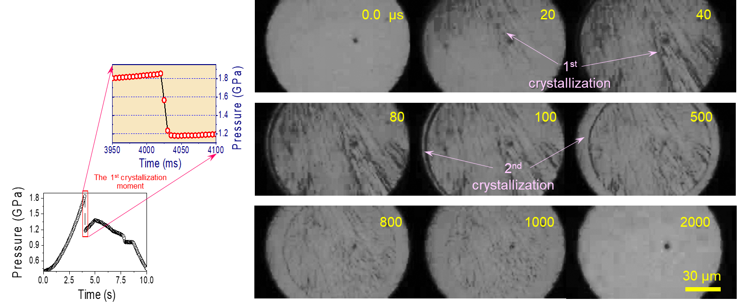

Supplementary Figure 2. Time-resolved micrographs of the crystallization event in Type 2. The recording rate is 50000 frames per second and corresponds to 20 μs for each frame. While the first crystallization is completed within two frames (or ~40 μs) in the downward direction, the second transition proceeds from the rim to the center within ~2000 μs.

3. In-situ synchrotron X-ray scattering experiment along the pressure-time curves
In this study, phases appeared in the P-t curves were identified by X-ray diffraction experiments which were simultaneously performed with pressure measurement during dDAC operation. For this study, we installed the in-line ruby pressure measurement (IRPM) system at the X-ray beamlines (1C-XRS beamline in PAL and P02.2 extreme condition beamline in DESY PETRA III). This method provides simultaneous and precise pressure measurement since ruby fluorescence gives better pressure resolution than metallic pressure markers at low pressure regime³³. X-ray scattering signals were recorded for every 100 ms during the 20 s pressure cycles (Supplementary Fig. 3) and the pressure was simultaneously recorded with the same measuring rate (Supplementary Fig. 3b). From the diffraction patterns, we find that ice VI and metastable ice VII (ms-ice VII) crystals form along the five types of pressure-time curve; in Types 1 and 2, ice VI forms on the crystallization during compression, whereas ms-ice VII is found at 1.6 GPa after crystallization in Types 3 to 5. Moreover, the second crystallization that is indicated by pressure-drop and -jump from 1.6 GPa on decompression shows the formation of ice VI in Types 4 and 5. These results are consistent with the pressure changes in P-t curves. However, we could not resolve the two crystallization events in Type 2 P-t curves in this synchrotron XRD study, due to insufficient X-ray flux and relatively slow detection. Interestingly, we find unidentified peaks that appears just before the formation of the metastable ice VII in the last cycle (marked by a dotted circle). This is the indication of the unknown phase, which is shown in main text and in section 7 in SI (see Fig. 3e,f in the main text).
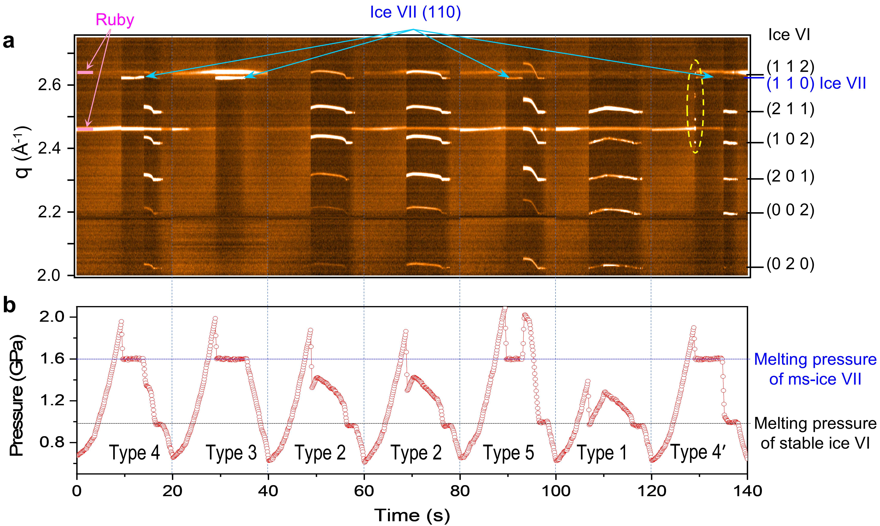

Supplementary Figure 3. X-ray diffraction results recorded simultaneously with pressure. a, In-situ X-ray diffraction patterns are simultaneously measured with b, the pressure-time curves. Despite the occurrence of five complex P-t types, only two crystalline phases, ice VI and ms-ice VII, are identified except for the unidentified transient phase that directly crystalized from SW in the last cycle.

4. In-situ micro-Raman spectroscopic study along the pressure-time curves
We also measured Raman spectra of the phases appeared during crystallization-melting process. We used parallel, split laser beams having the wavelength of 532 nm to excite both ruby particle and sample, which allowed one to simultaneously measure pressure and Raman spectra^{32,33}; each Raman spectrum was recorded for every two seconds, but ruby fluorescence signal for pressure was measured for every five ms. Note that the five types of pressure-time curve occur statistically in a wide range of (de)compression periods (i.e., between tens of milliseconds and hundreds of seconds). We identify all phases which appear along the P-t curves in this study (Supplementary Fig. 4); only ice VI phase on crystallization in Types 1 and 2 and the mixture of metastable ice VII (ms-ice VII) and liquid water formed at 1.6 GPa in Types 3 to 5. In case of Type 3, after the plateau at 1.6 GPa on decompression, only liquid water is shown (Supplementary Fig. 4c), which is consistent with the XRD results (Supplementary Fig. 3). Supplementary Fig. 4d,e show the formation of ice VI from the mixture of ms-ice VII and liquid water at 1.6 GPa on decompression in Types 4 and 5 (i.e., after pressure-drop and -jump from 1.6 GPa). Phase identification along the pressure-time curves is consistent with XRD results in Supplementary Fig. 3. Typical Raman spectra from SW, ice VI and ms-ice VII are compared in Supplementary Fig. 4f.

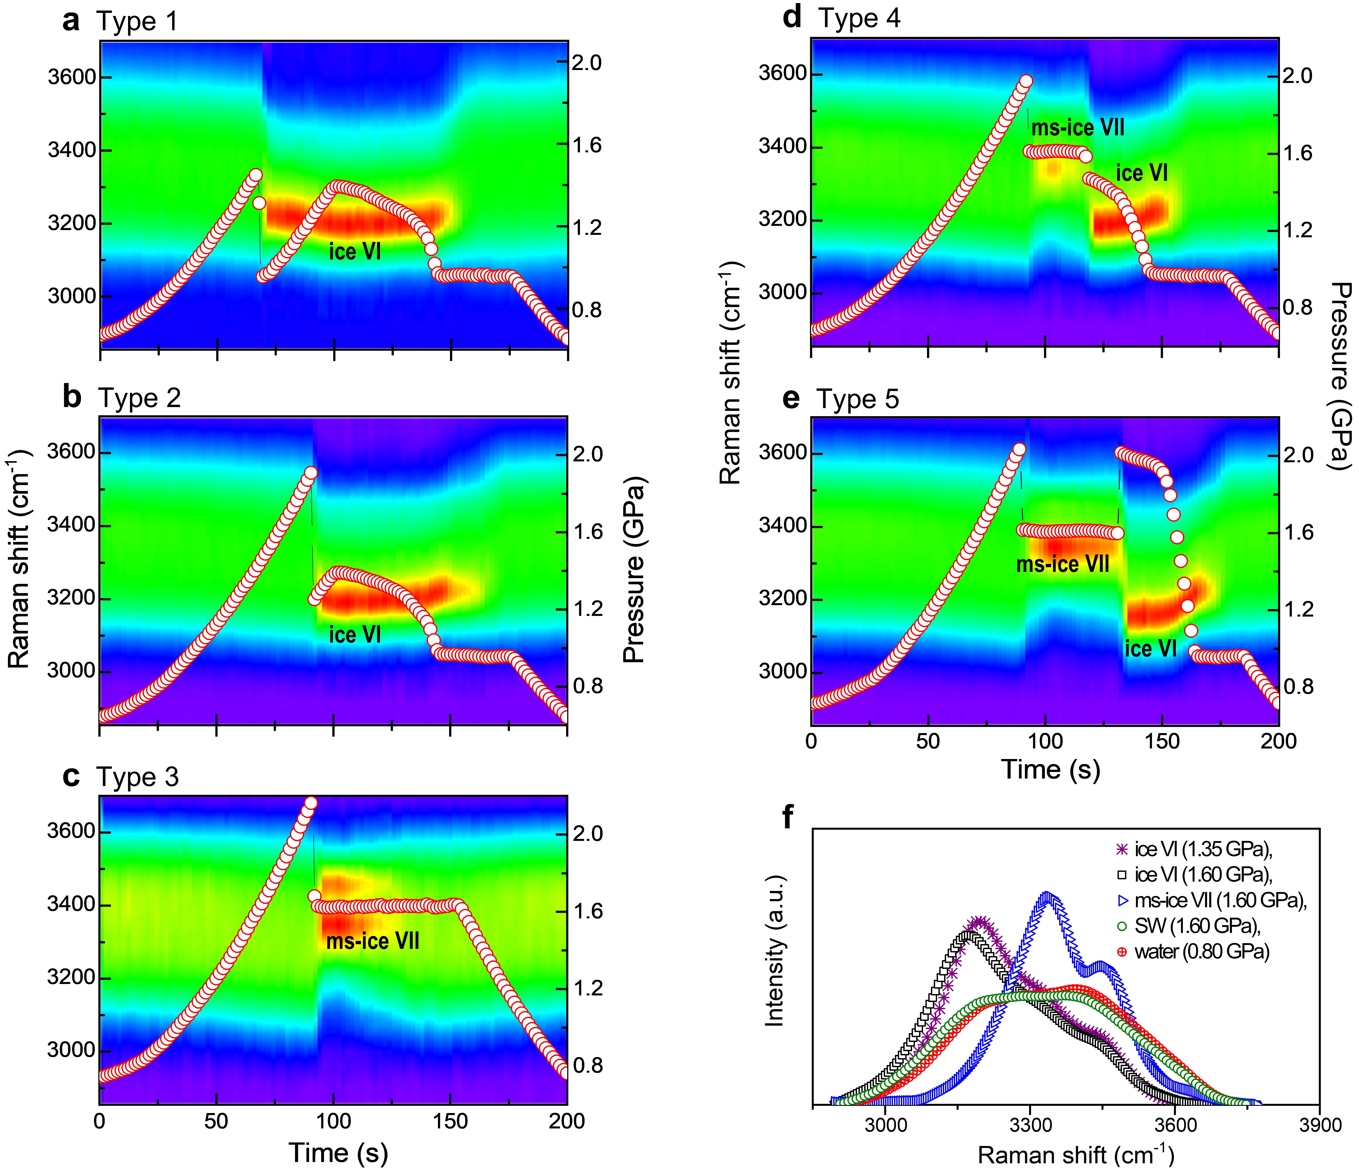

Supplementary Figure 4. Phase identification with Raman spectra along the five types of P-t curve on crystallization-melting process. a-b, show ice VI formation after the pressure drops in Types 1 and 2. In c-e, ms-ice VII appears after the first pressure drops in Types 3 to 5. In d-e, the ms-ice VII and water at 1.6 GPa abruptly changes into ice VI phase on decompression, accompanied by the second pressure-drop and -jump in Types 4 and 5, respectively. f, Representative Raman spectra of ice VI, ms-ice VII, SW, and liquid water. Excitation laser is localized to only ms-ice VII crystal or SW to get their Raman spectra at 1.6 GPa.

5. Synchronization of the X-ray pulse trains and crystallization moment during rapid compression in XFEL experiment
To identify the phases that emerged in Type 2, the crystallization moments must be matched to the injection X-ray pulses train. This is a very challenging task, since crystal nucleation event occurs statistically, depends on the degree of supercompression, and may have different incubation time with the supercompression. Thus, if the X-ray pulse train is not properly synchronized with the compression time, the crystallization events cannot be detected.
In order to predict a time range over which crystallization events occur, we, in advance, tested the dependence of crystallization time on compression rates and the degree of supercompression. Supplementary Figure 5 shows the five types of P-t curve with various (de)compression periods from 0.01 to 10 s. Note that except Type 1, we can observe the all types of P-t curve from slow compression with 20 s cycle and fast compression with 10 ms cycle. This means that the compression rates do not significantly affect the crystallization events in this compression range.We find that the crystallization moment occurs at 8.29±0.15 s for 10 s compression and shifts to 8.69±0.23 ms for 10 ms compression. Although the time for crystallization moment increases a little bit with compression rates, the overall crystallization events can be detected with a narrow time window of 8.5±1.0 ms. Thus, we put the long X-ray pulses train from 7.5 to 9.5 ms with 0.5 ms step for the detection of crystallization moment. Based on this information, we could successfully synchronize the crystallization moment and X-ray pulses train during compression. In this study, we design that decompression takes one second to check the type of P-t curves with the X-ray patterns (Fig. 3a and Supplementary Fig. 5d).

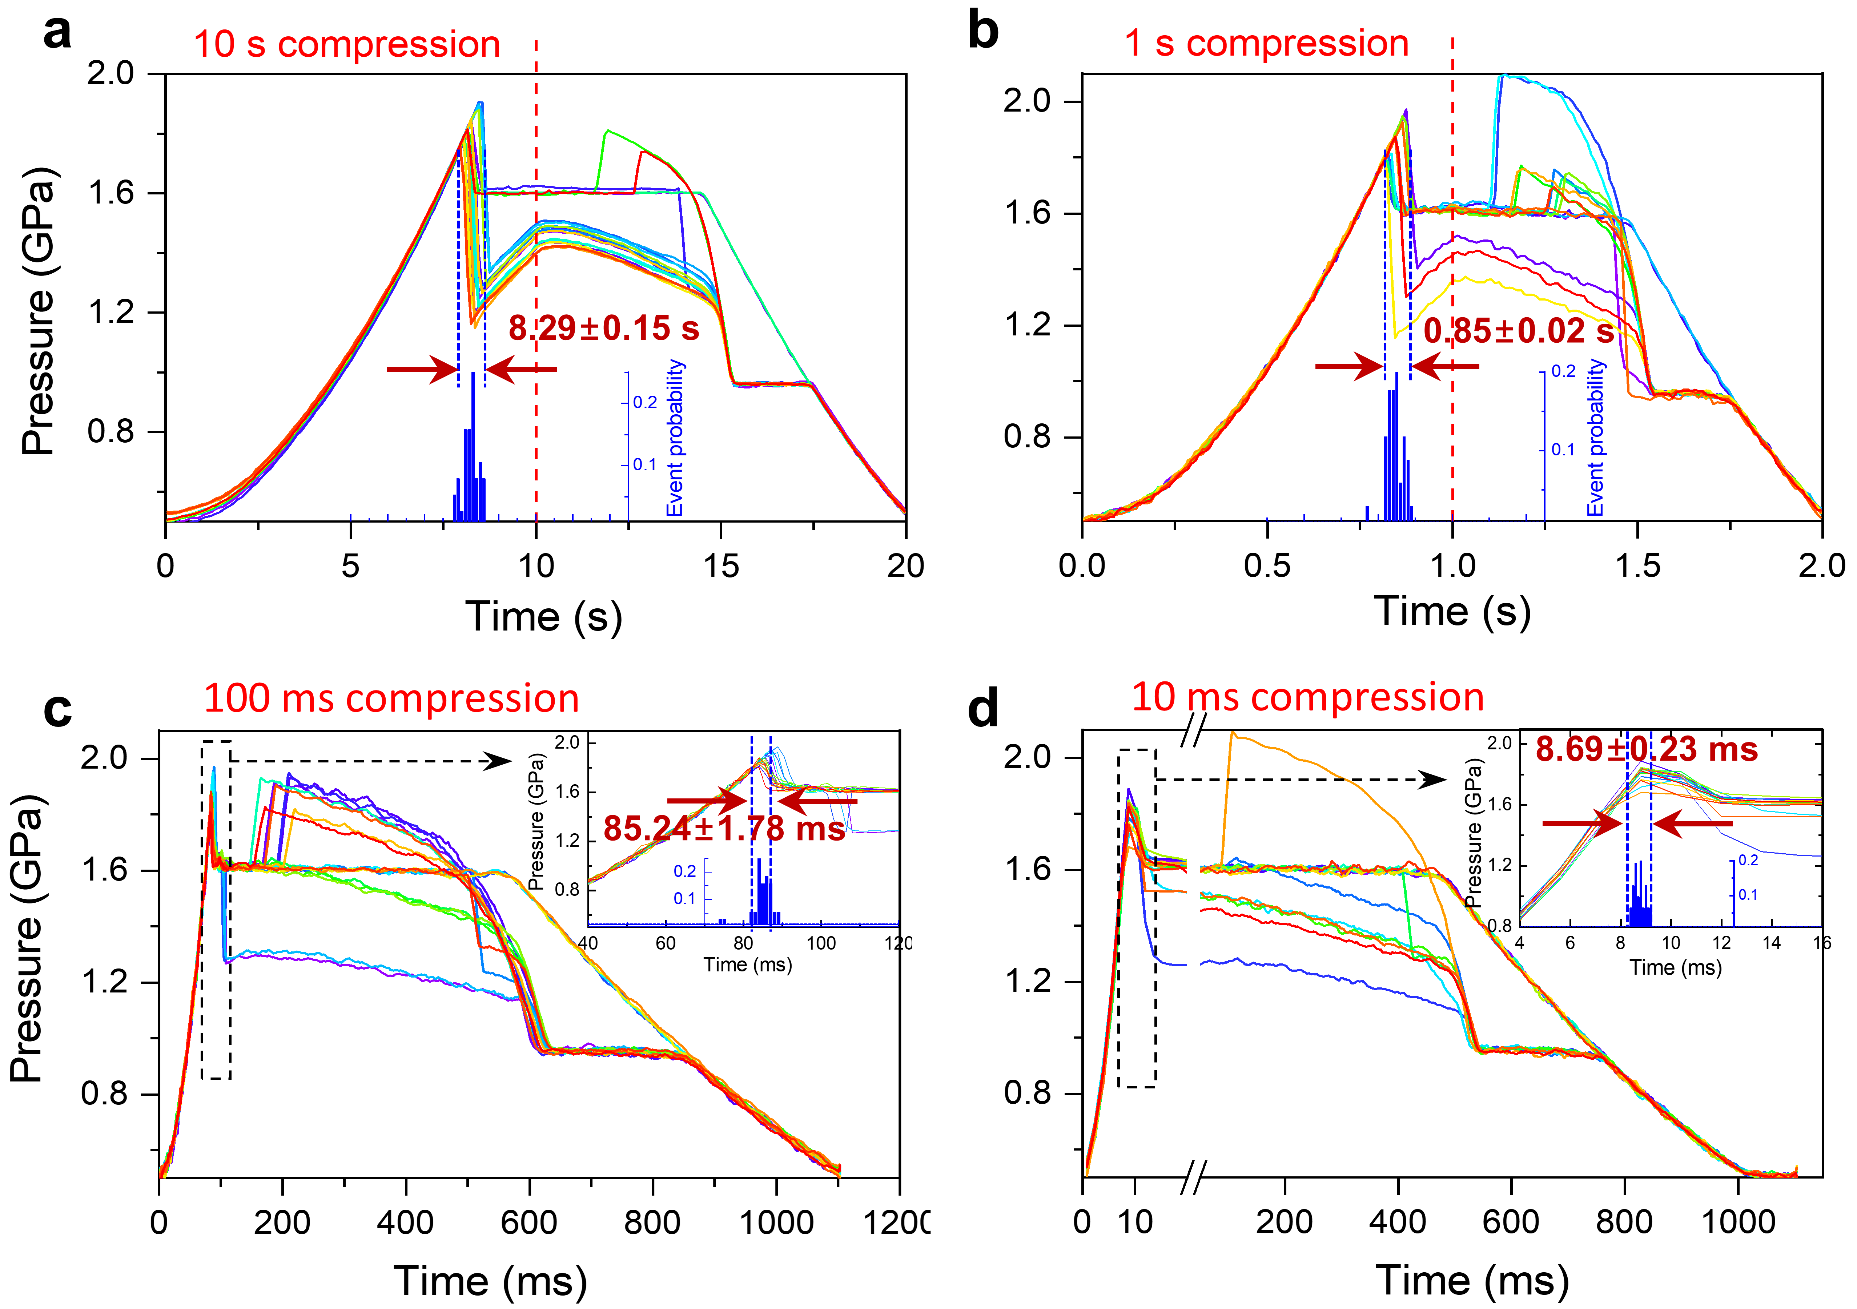

Supplementary Figure 5. Occurrence of crystallization during compression with different cycle periods. Regardless of compression rates and shapes of (de)compression wave function, crystallization happens at similar timescales from 10 s (a) to 10 ms (d) if the crystallization moment is normalized with the compression time. All compression rates show the typical five types of P-t curve.

6. Installation of dDAC in XFEL and event-synchronizing scheme
Three dDACs are placed in a revolver wheel which is installed in the IC2 vacuum chamber (10⁻⁴ mbar, HED beamline at EuXFEL) (Supplementary Fig. 6a) ^{34,35}. X-ray beam and sample gasket hole is aligned by the aid of camera system of the IC2 chamber. Piezo-actuators operating the dDACs are connected via electrical lines to the voltage amplifier and the power supply located outside the chamber. Two detectors of AGIPD and Varex are installed outside of the IC2 chamber (see Supplementary Fig. 6a). For the calibration of X-ray diffraction experiment, Cr₂O₃ powder was used as a reference material for experimental setup and fine alignment. Detailed procedures on calibration can be found in a previous study^{34,35}. A triangular voltage waveform applied to the dDAC for compression and decompression is shifted with respect to the arrival of the 1st X-ray pulses train (See Fig. 3a in the main text).
AGIPD detector with the 0.56 MHz recording rate³⁶ is used to resolve the moment of the first rapid crystallization. Varex detector with the 10 Hz repetition rate is applied for relatively slow transitions of the H₂O phases on decompression. Supplementary Fig. 6b shows XRD patterns which is taken by AGIPD detector during the fast transition. The unknown ice phase formed from SW transforms into ms-ice VII. The two crystalline phases coexist for ~50 μs during the transition. The Varex data shows that the unknown ice changes into ms-ice VII and finally ice VI on decompression. The broad diffused scattering intensity signals liquid water coexisting with the unknown ice and ms-ice VII. Furthermore, the water signal that is still shown before and after transition reflects that the unknown phase only transforms into ms-ice VII and the remained water doesn’t (Supplementary Fig. 6b).

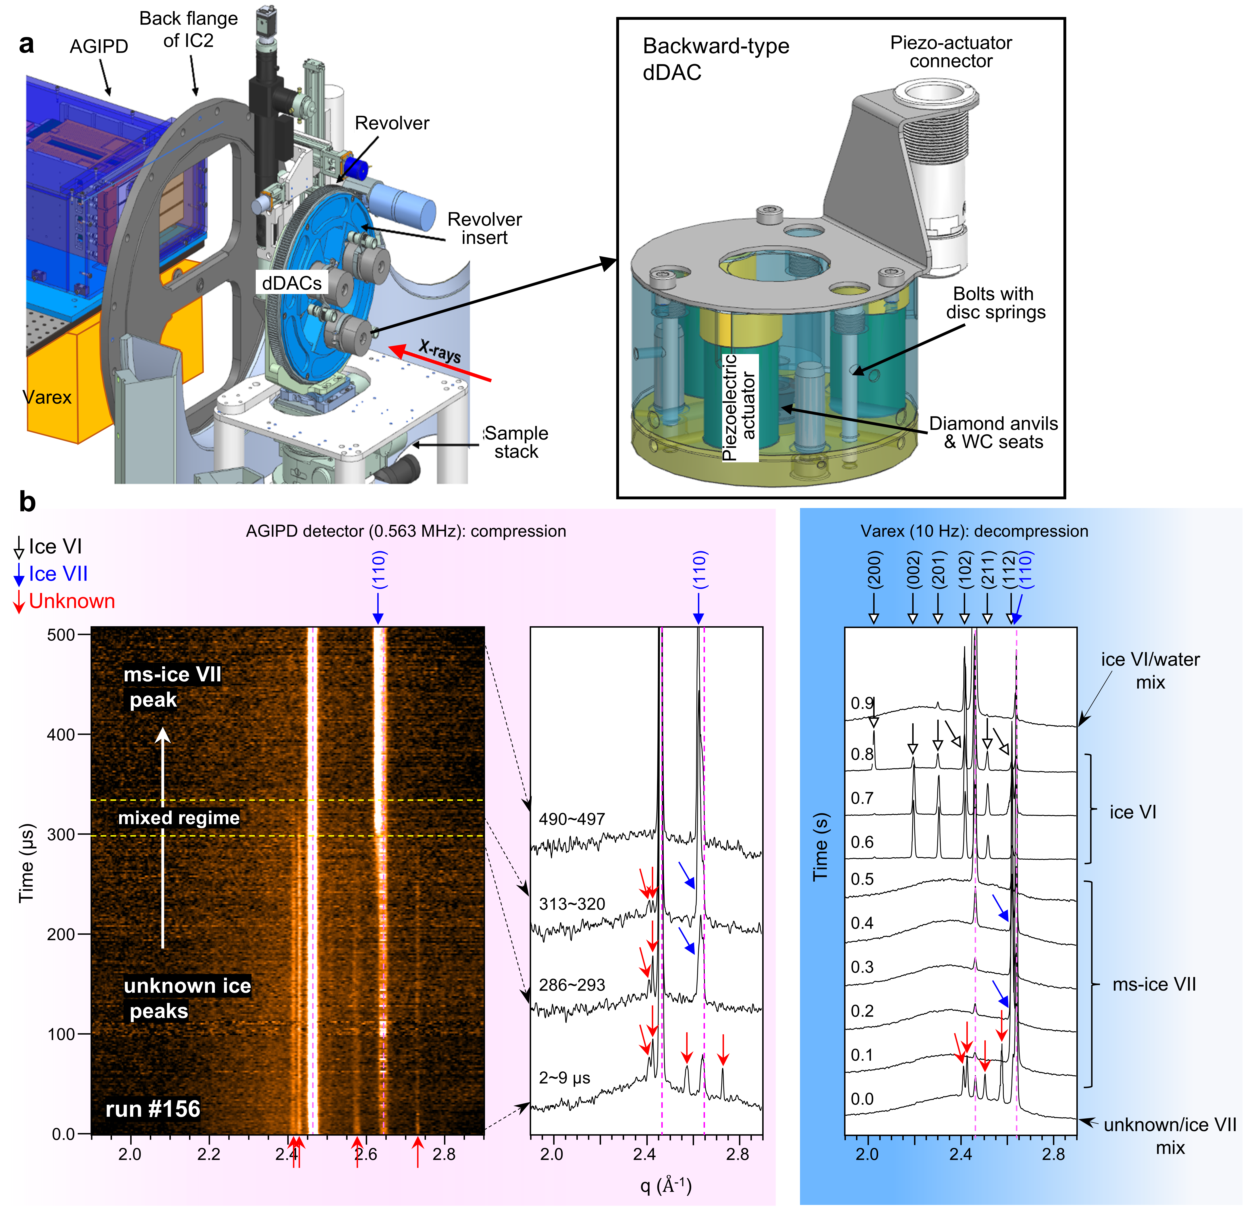

Supplementary Figure 6. dDAC setup for XFEL experiments. a, Schematic diagram for the installation of vacuum-compatible dDACs on the revolver wheel inside of the IC2 at HED beamline. Three LLNL-type dDACs³⁵ are replaced with the backward-type dDACs. Two detectors of AGIPD and Varex are located close to the IC2 chamber. b, Typical data for time-resolved observations for phase formation and transition with both AGIPD and VAREX detectors.

7. Comparison of the unknown ice phase with 23 known ice phases
In this study, we found a new metastable ice phase (i.e., the unknown ice phase), appearing directly from SW on compression (Fig. 3 and Supplementary Fig. 6b). We compare the XRD patterns of the unknown ice crystal with 20 known ice phases in experiment^{2-6,53-68} and theoretically predicted three metastable ices^{24,28,29} (Supplementary Fig. 7); diffraction peaks of both ice VI and VII at 1.6 GPa are based on experimentally measurement in this study or extrapolated EOS information^{59,60}. Ice XVIII is refined based on shock compression data². Ices T and Y are simulated at high pressure of 5-6 GPa^{24,29}. None of the known phases is matched with the new metastable ice phase, although the direct comparison may not be proper to some of XRD patterns due to different pressure and temperature conditions^{53-58,61,63,65-68}. For this comparison, all diffraction profiles are reconstructed assuming the same X-ray wavelength of 0.688 Å.
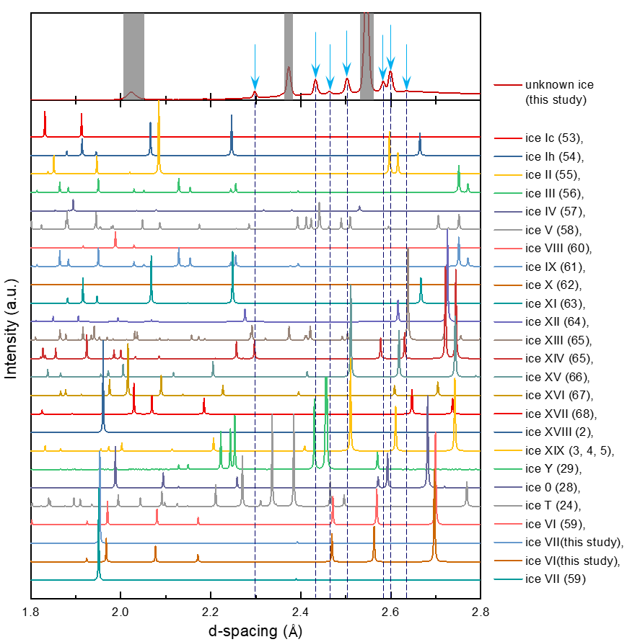

Supplementary Figure 7. Comparison of X-ray diffraction patterns of the unknown ice with 23 stable and metastable ice phases. The diffraction peaks from the unknown ice do not match with the known ice phases. Grey shadow in the diffraction patterns of the unknown ice shows noise signals from ruby and metal gasket.

8. Molecular dynamics simulation study of supercompressed water by TIP4P/ICE
The results of MD simulations with SPCfw model are given in Fig. 4d-f. Here, we show the MD results with TIP4P/Ice model, exhibiting the structural changes of SW with pressure. In Supplementary Fig. 8, all results are qualitatively consistent with SPCfw model in the main text (Fig. 4) and in Supplementary Fig. 9. Potential energy and density of the SW show different slopes at around 2 GPa. Pair distribution function (PDF) exhibits the evolution of the SW from high-density water (HDW) to very-high-density water (VHDW) from 1.0 to 3.2 GPa, which exhibit distinctly enhancing shoulder of the first peak around 3.3 Å and of the second peak around 4.8 Å. The representative angles of HDW is shown in Supplementary Fig. 8e,f. As pressure increases, the second nearest molecules (marked by blue color in Supplementary Fig. 8e) place at the interstitial position between the first nearest molecules in HDW. Thus, the population of the angles with 48° decreases and that for 65° increases with pressure. When pressure increases further, the two angles merge together, which is the characteristics of VHDW. In this case, the water molecules in the second nearest molecules (marked by blue color) lose the hydrogen bonding with the water molecules in the first nearest molecules, resulting in distorted hydrogen bonds. Angle distributions of O′_{1–4}-O-O′′_{5–8} and O-H-O₂^{H} are depicted in Supplementary Fig. 8g,h. O₂^{H} is the O atom of water molecule that does not form a hydrogen-bond with a H atom of central water molecule, and that is included in a sphere with radius of 3.5 Å from the O atom of central molecule.

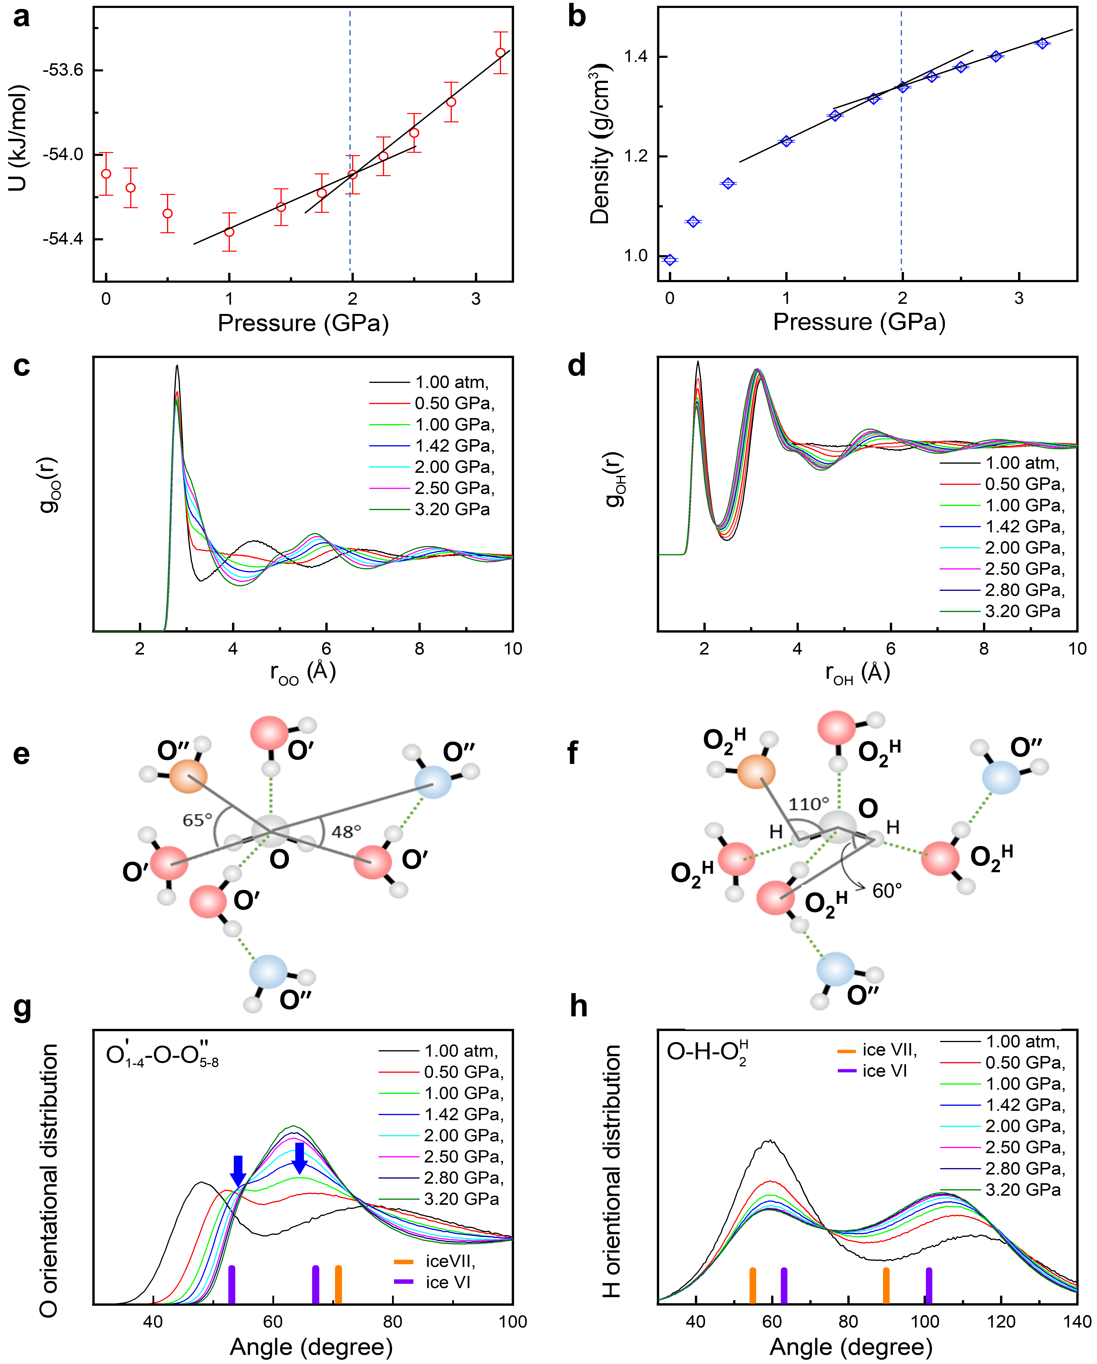

Supplementary Figure 8. Simulation results with TIP4P/ICE model. a, b, show total energy and density with pressure. c, d, show pair distribution functions (PDFs) of oxygen-oxygen and oxygen-hydrogen, respectively. e, f, show schematic diagram for the local order of HDW with the 1st and 2nd nearest neighboring H₂O molecules. Angles of O′_{1–4}-O-O′′_{5–8} and O-H-O₂^{H} are defined in a reference²⁶. Here, O′_{1–4} and O′′_{5–8}, respectively, are defined as the 1st-4th and 5th-8th nearest neighboring O atoms of the O atom of central water molecule. g, Angle distribution of oxygen atoms in nearest and second nearest neighbors. h, Angle distribution function of O-H-O₂^{H}. O₂^{H} is the O atom of a selected water molecule which locates inside of a sphere with radius of 3.5 Å from the O atom of central molecule.

9. Pair distribution functions (PDFs) of O-H pairs and angle distribution functions (ADFs) from SPCfw model
In SPCfw model, PDFs (g(r)) of O-H pairs exhibit relatively small change with pressure over 1.0 GPa, compared with those of O-O pairs. Angle distribution function of O-H-O₂^{H} reflects that the hydrogen bonding resembles somewhat between ice VI-like and ice VII-like structure as pressure increases from 1.0 to 3.2 GPa.

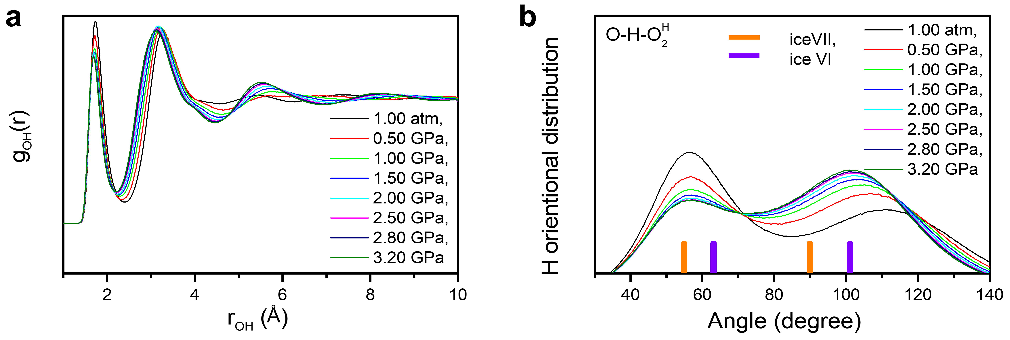

Supplementary Figure 9. Changes in H-O pairs with pressure simulated with SPCfw model. a, b, show g(r) (PDF) of O-H pairs and angle distribution function of O-H-O₂^{H} with pressure, respectively.

Supplementary references
53. Dowell, L. G. & Rinfret, A. P. Rinfret, Low-temperature forms of ice as studied by X-ray diffraction. Nature 188, 1144-1148 (1960).
54. Fortes, A. D. et al. No evidence for large-scale proton ordering in Antarctic ice from powder neutron diffraction. J. Chem. Phys. 120, 11376-11379 (2004).
55. Kamb, B. Ice II. a proton-ordered form of ice. Acta Cryst. 17, 1437-1449 (1964).
56. Kamb, B. & Prakash, A. Structure of ice III. Acta Cryst. B 24, 1317-1327 (1968).
57. Engelhardt, H. & Kamb, B. Structure of ice IV, a metastable high‐pressure phase. J. Chem. Phys. 75, 5887-5899 (1981).
58. Kamb, B., Prakash, A. & Knobler, C. Structure of ice. V. Acta Cryst. 22, 706-715 (1967).
59. Bezacier, L. et al. Equations of state of ice VI and ice VII at high pressure and high temperature. J. Chem. Phys. 141, 104505 (2014).
60. Besson, J. M. et al. Variation of interatomic distances in ice VIII to 10 GPa. Phys. Rev. B 49, 12540 (1994).
61. La Placa, S. J., Hamilton, W. C., Kamb, B. & Prakash, A. On a nearly proton‐ordered structure for ice IX. J. Chem. Phys. 58, 567-580 (1973).
62. Hemley, R. J. et al. Static compression of H₂O-ice to 128 GPa (1.28 Mbar). Nature 330, 737-740 (1987).
63. Leadbetter, A. J. et al. The equilibrium low‐temperature structure of ice. J. Chem. Phys. 82, 424-428 (1985).
64. Lobban, C., Finney, J. L. & Kuhs, W. F. The structure of a new phase of ice. Nature 391, 268-270 (1998).
65. Salzmann, C. G., Radaelli, P. G., Hallbrucker, A., Mayer, E. & Finney, J. L. The preparation and structures of hydrogen ordered phases of ice. Science 311, 1758-1761 (2006).
66. Salzmann, C. G., Radaelli, P. G., Mayer, E. & Finney, J. L. Ice XV: a new thermodynamically stable phase of ice. Phys. Rev. Lett. 103, 105701 (2009).
67. Falenty, A., Hansen, T. C. & Kuhs, W. F. Formation and properties of ice XVI obtained by emptying a type sII clathrate hydrate. Nature 516, 231-233 (2014).
68. Del Rosso, L., Celli, M. & Ulivi, L. New porous water ice metastable at atmospheric pressure obtained by emptying a hydrogen-filled ice. Nat. Commun. 7, 13394 (2016).

