Supplementary Text

Text S1
The reduced upper-limited with the ZEC90, is again due to the ZEC being lower in the UKESM1-0-LL model, showing +0.05 ˚C with CEEMDAN and +0.22˚C for the 20-year averages. While the median ZEC is more negative for the 20-year averages (-0.21˚C) than for CEEMDAN (-0.19˚C), as a result of CEEMDAN shows less cooling for many EMSs compared to when using the 20-year average method after 90 years. However, changes can persist even after 90 years in some models, (Figure S5).
Text S2
Despite most models simulating a cooling of GMST, warming can still be found at the local level in all models, with all models simulating a warming in the Southern Ocean and most models simulating a warming in the Northern Atlantic (Figure S7). A consistent cooling pattern also emerges, with all models simulating cooling over the Eastern Indian Ocean and the Maritime Continent, and parts of Central Africa and South America. The increased confidence in cooling over these regions suggests they may experience some of the most pronounced benefits from achieving net zero.

Supplementary Figures
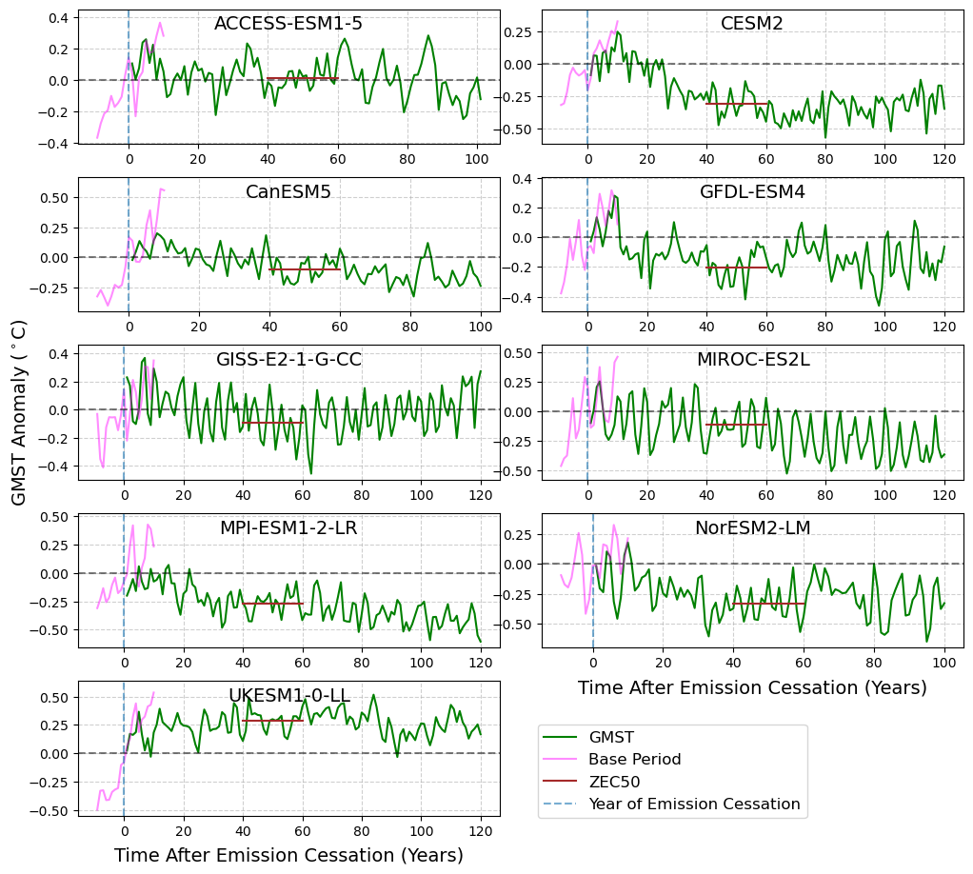
Figure S1: Global Surface Mean Temperature (GSMT) anomalies for the esm-1pct-brch-1000PgC (A1) protocol (green) and the base period from the 1% CO₂ simulations (pink) for nine Earth System Models (ESMs), with temperature anomalies at year 50 indicated in (brown).
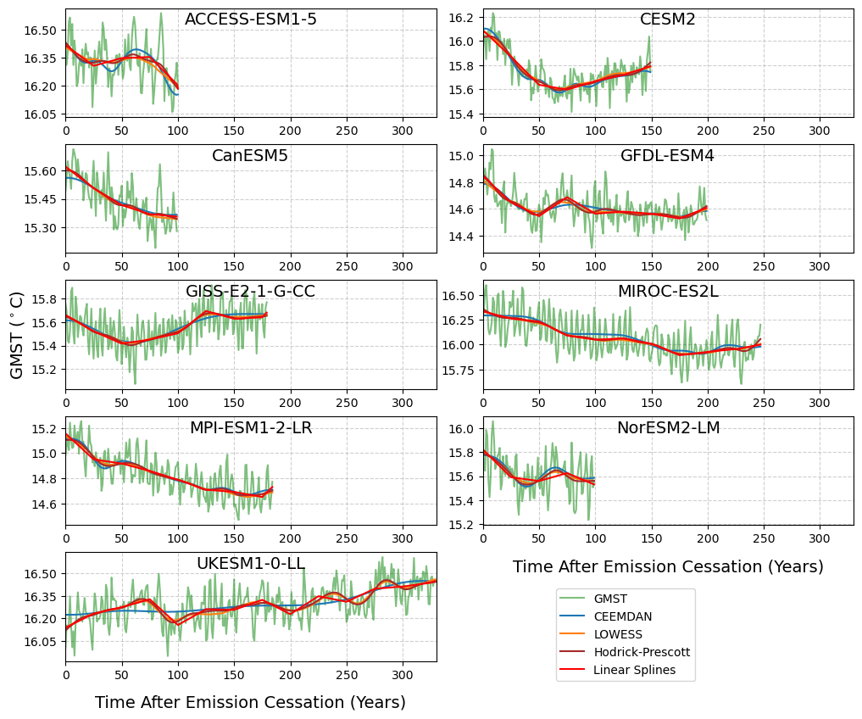Figure S2: Same as Figure 1, with Locally Weighted Scatter Plotted Smoothing (LOWESS) (yellow), Hodrick-Prescott (brown) and linear splines (red) also shown.

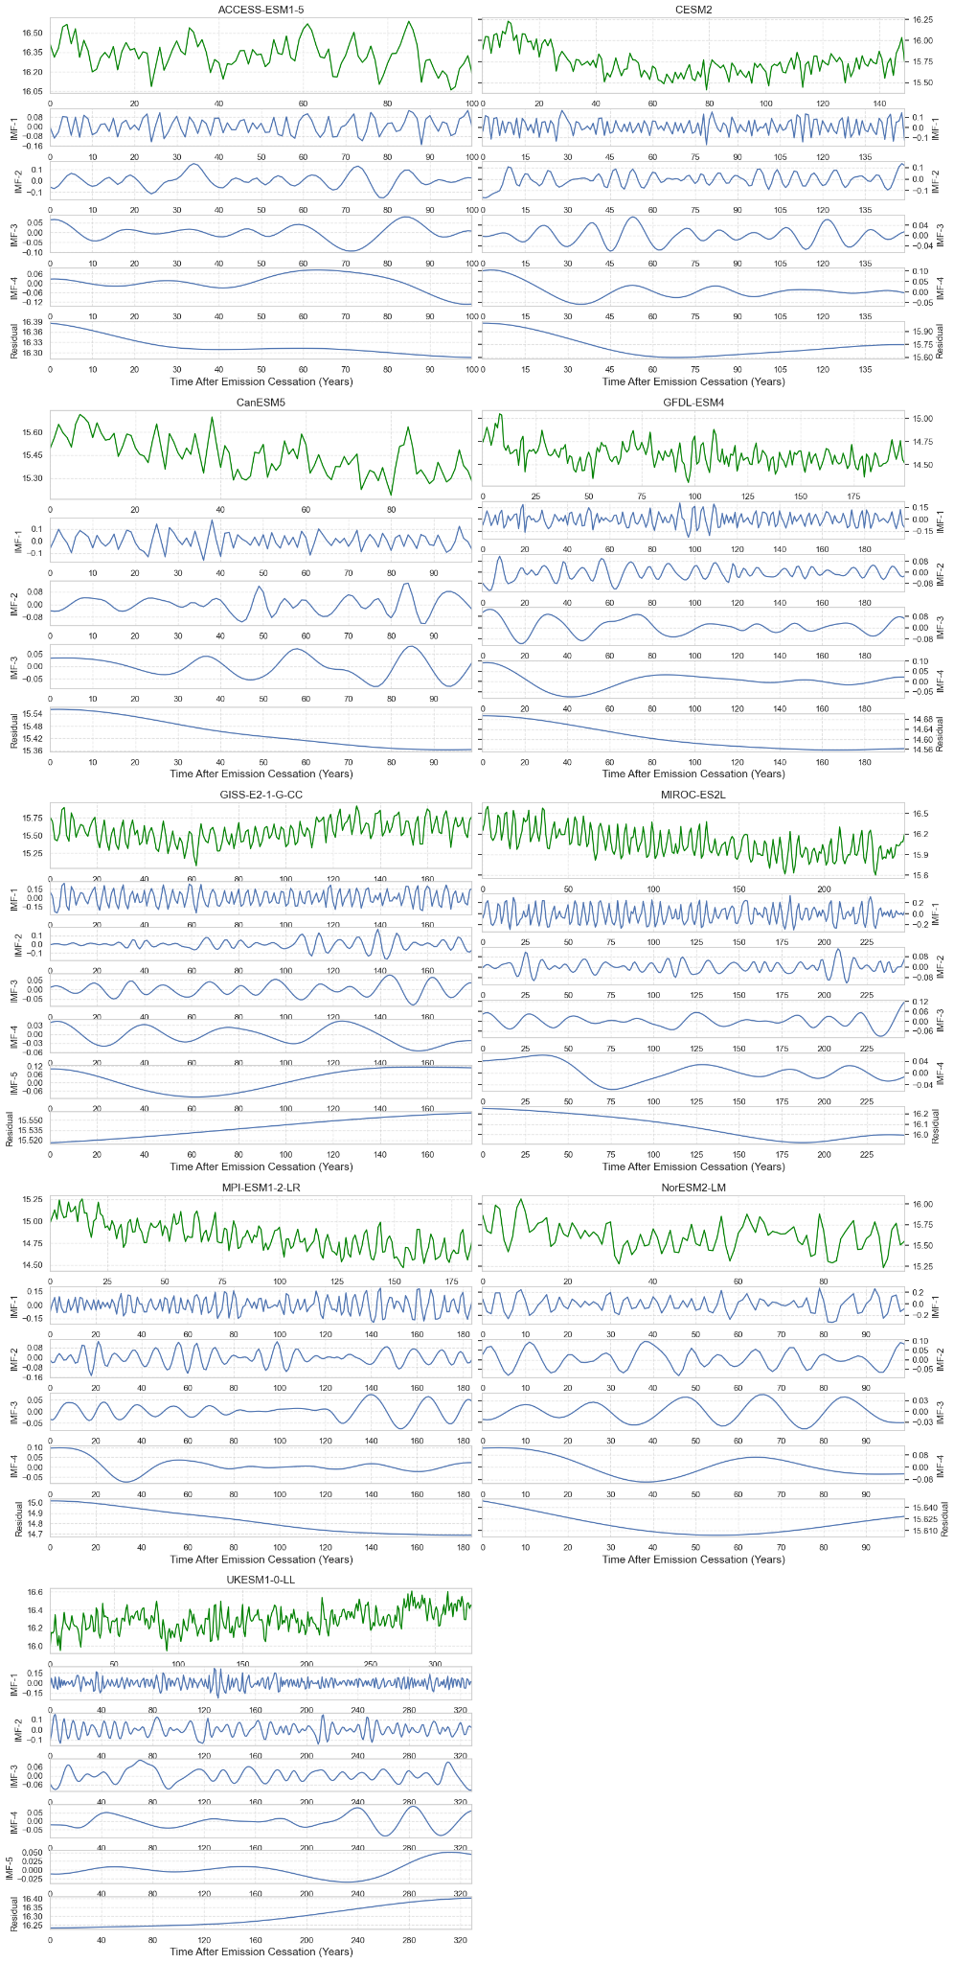
Figure S3: Global Mean Surface temperature (GMST) (top panel), Intrinsic Mode Frequencies (IMFs) and residual for each of the nine Earth System Models (ESMs) that have run Zero Emissions Commitment Model Intercomparison Project (ZECMIP) for the esm-1pct-brch-1000PgC (A1) protocol.
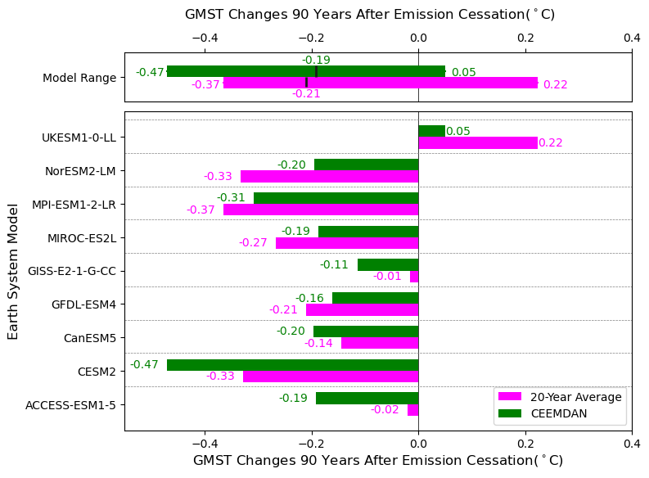
Figure S4: Same as Figure 2, but for 90 years.

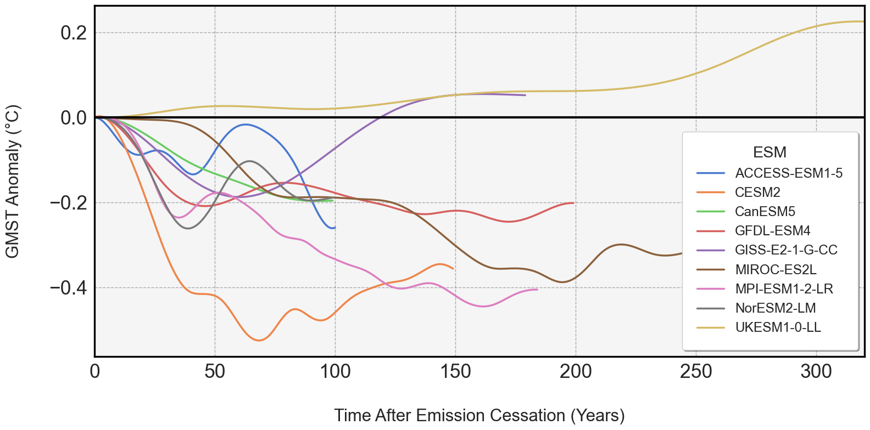Figure S5: GMST anomalies for each ESM calculated using CEEMDAN.

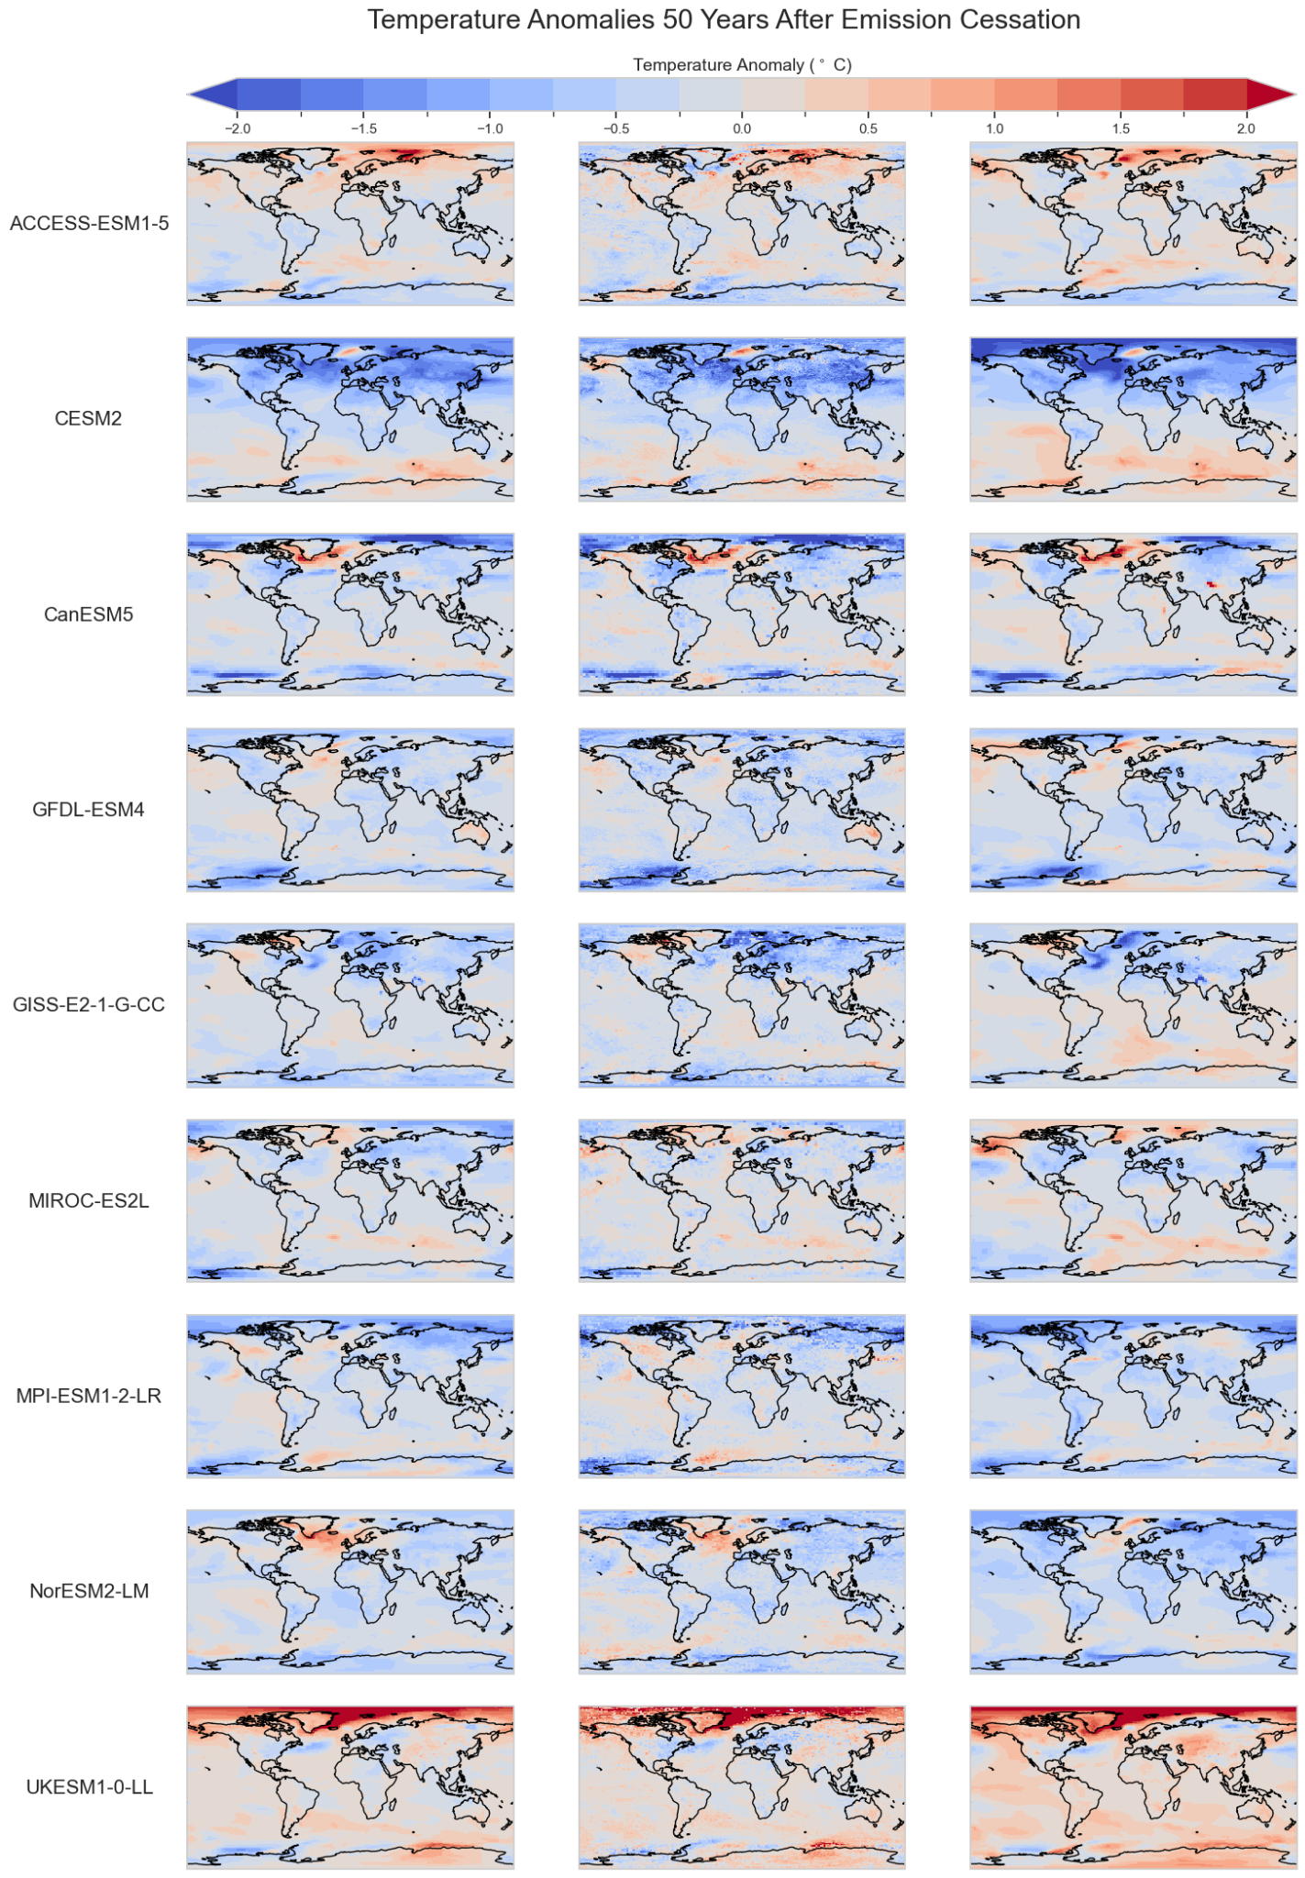
Figure S6: Local temperature estimates using LOWESS (left column), CEEMDAN (middle column) column and 20-year average anomalies when compared to the 20-year base period of the 1%CO2 run (right column) for each ESM (rows).
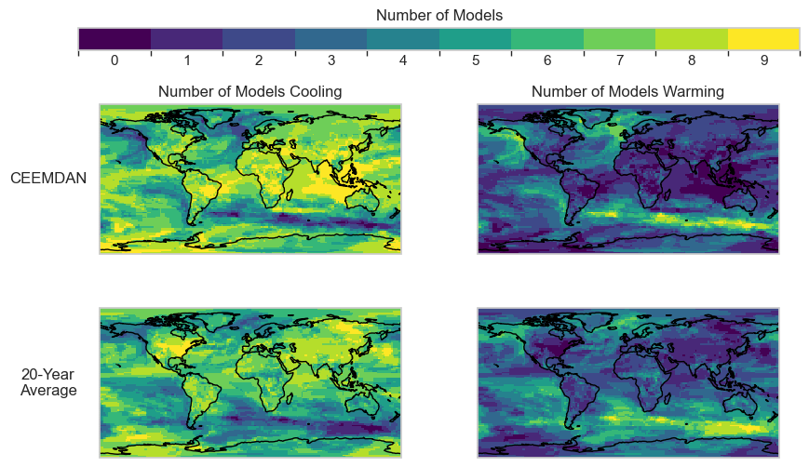Figure S7: The number of models that are cooling (left column) and the number of models that are warming (right column) when using the CEEMDAN (top row) and 20-Year Average methods (bottom row). Each model was re-gridded using a nearest-s2d method to match the MPI-ESM1-2-LR resolution (1.87˚ x 1.88˚ lat x lon).

