Supplementary materials
1. Supplementary information
1.1 CT image acquisition and clinico-radiological information
This study employed various multi-slice CT scanners (detailed equipment information and related parameters can be found in Table S1) to perform enhanced abdominal scans. Non-ionic contrast agents, either Iohexol Injection (350 mg I/ml) or Iomeprol Injection (400 mg I/ml), were administered intravenously via the antecubital vein at a dose of 450 mg I/kg. Arterial phase imaging utilized a threshold-triggering technique, while the venous phase employed a fixed delay of 60-70 seconds. Upon completion of the CT scans, the imaging data were uploaded to the Picture Archiving and Communication System (PACS) workstations, where post-processing was performed, and the data were saved in DICOM format.
Clinical data, including age, sex, blood pressure, and serum potassium levels, were obtained from routine medical records. CT images were extracted from the hospital's Picture Archiving and Communication System (PACS). Radiological parameters included maximum diameter, laterality, CT attenuation values (for plain, arterial, and venous phases), degree of enhancement in the arterial phase (CTa - CTu), degree of enhancement in the venous phase (CTv - CTu), standard deviations of the CT attenuation values across the three phases (Sev-u, Sev-a, Sev-v), as well as shape, margins, and cystic changes. These images were read and assessed by a radiologist with 10 years of experience in urological imaging and another radiologist with 16 years of extensive experience in urological imaging, both of whom were blinded to the histopathological and clinical data. The CT attenuation values were calculated as the mean of three maximum cross-sectional areas (with a measurement range exceeding two-thirds) while avoiding regions of cystic calcification. Low-density areas on unenhanced phase that showed no enhancement on contrast-enhanced scans were classified as cystic changes.
1.2 Region of interest segmentation and feature extraction
A radiologist with 10 years of experience manually segmented all images for regions of interest (ROI), remaining blinded to the clinical history and patient information. During the segmentation process, care was taken to avoid delineating the tumor capsule, adrenal gland, and adjacent tissues. Upon completion of the segmentation, another radiologist with 16 years of experience reviewed each marked ROI individually. In instances of disagreement between the two radiologists, a consensus was reached through discussion with a physician possessing over 20 years of experience in urological imaging to determine the final ROI. Subsequently, features were automatically extracted using the Darwin Intelligent Research Platform (for specific details, please refer to https://arxiv.org/abs/2009.00908).
1.3 Feature selection and model construction
The Intraclass Correlation Coefficient (ICC) was calculated using the formula defined by McGraw and Wong [1]. Initially, the ICC was assessed within each of the two readers, with both readers undergoing a one-month washout period before conducting two separate ICC analyses. Subsequently, the ICC between the two readers was evaluated. Features with an ICC greater than 0.75 in all three analyses were considered robust features and included in the subsequent analyses.
$$\text{ICC=}\frac{{\text{MS}}_{\text{R}}\text{-}{\text{MS}}_{\text{E}}}{{\text{MS}}_{\text{R}}\text{+}\left(\text{k-1}\right){\text{MS}}_{\text{E}}}\text{+}\frac{\text{k}}{\text{n}}\text{×}\left({\text{MS}}_{\text{C}}\text{-}{\text{MS}}_{\text{E}}\right)$$
Next, the "min-max normalization" method was applied to preprocess the features, whereby each feature dimension of all samples was linearly transformed to the range of (0,1).For a given feature X∈ℝ^{N×d}, where N is the total number of samples and d is the feature dimension. Min-max normalization is an operation performed on each column feature X∈ℝ^{N} as follows:
$${\text{x}}_{\text{i}}\text{=}\frac{{\text{x}}_{\text{i}}\text{-}{\text{x}}_{\text{min}}}{{\text{x}}_{\text{max}}\text{-}{\text{x}}_{\text{min}}}$$
where1≤i≤N, and x_{max} and x_{min} are respectively the maximum and minimum element values in x.
Subsequently, a LASSO-based Select From Model algorithm was employed for the initial round of radiomics feature selection. Following this, a second round of feature selection was performed using the Recursive Feature Elimination with Cross-Validation (RFECV) algorithm. The RFECV algorithm evaluates feature importance by iteratively removing the least important features after each training cycle, continuously retraining the classifier until a decline in classification performance is observed or the minimum number of features is reached. This process resulted in the identification of robust final radiomics features, encompassing those from the non-contrast, arterial, venous phases, and their combination. Based on these selected features, Support Vector Machine (SVM) and Logistic Regression (LR) classifier models were developed. The overall workflow of the radiomics analysis is depicted in Fig. S1

- Supplementary tables and figures

Table S1. CT image acquisition parameters
 | Yunnan First People's Hospital (Center I) |  |  | Yunnan Provincial Cancer Hospital (Center II) |  |  |  | The Second Affiliated Hospital of Kunming Medical University (Center III)
Factory owners | SIEMENS | SIEMENS | TOSHIBA | SIEMENS | SIEMENS | TOSHIBA | PHILIPS | PHILIPS | CANON
Manufacturer | SOMATOM Force | SOMATOM Definition | Aquilion ONE | SOMATOM Force | SOMATOM Definition As+ | Aquilion PRIME | Ingenuity CT | Brilliance iCT | Aquilion ONE
Parameters | 192×0.6 | 64×0.6 | 100×0.5 | 192×0.61 | 128 X 0.61 | 80 X 0.61 | 128 X 0.61 | 128×0.625 | 100×0.5
Matrix | 512×512 | 512×512 | 512×512 | 512×512 | 512×512 | 512×512 | 512×512 | 512×512 | 512×512
Rotation time | 0.5s | 0.5s | 0.5s | 0.5s | 0.5s | 0.5s | 0.5s | 0.5s | 0.5s
Tube voltage | 100-120kv | 100-120kv | 120kv | 120kv | 100-120 Kv | 120 Kv | 120 kv | 120kv | 120kv
Tube current | Automatic | Automatic | Automatic | Automatic | Automatic | Automatic | Automatic | 200-250mAs | Automatic
Pitch | 1.0 | 1.0 | 0.8 | 1.0 | 1.0 | 0.8 | 0.9 | 1.0 | 0.8
Slice thickness (mm) | 1-5mm | 1.5-5mm | 1-5mm | 2-8mm | 2-8mm | 2-8mm | 2-10mm | 2mm | 0.9-5mm

Table S2. Diagnostic performance of different algorithmic models in training, validation, and external test cohorts
Model | Cohort | Categories of Machine Learning | AUC (95% CI) | Sensitivity | Specificity | Accuracy | Precision | Cut-off | Delong's test（p）
Clinico-radiological model | Training | SVM | 0.986(0.972-1.000) | 0.948 | 0.925 | 0.937 | 0.932 | 0.572 | 0.01
Clinico-radiological model | Training | LR | 0.951（0.914-0.987） | 0.897 | 0.868 | 0.883 | 0.881 | 0.432 | 0.01
Clinico-radiological model | Validation | SVM | 0.903(0.784-1.000) | 0.867 | 0.769 | 0.821 | 0.813 | 0.696 | 0.773
Clinico-radiological model | Validation | LR | 0.887（0.768-1） | 0.8 | 0.769 | 0.786 | 0.8 | 0.418 | 0.773
Clinico-radiological model | Testing | SVM | 0.912（0.836-0.988） | 0.893 | 0.829 | 0.857 | 0.806 | 0.558 | 0.719
Clinico-radiological model | Testing | LR | 0.897（0.812-0.982） | 0.857 | 0.829 | 0.841 | 0.8 | 0.431 | 0.719
Unenhanced model | Training | SVM | 0.917（0.861-0.972） | 0.81 | 0.943 | 0.874 | 0.94 | 0.609 | 0.063
Unenhanced model | Training | LR | 0.926（0.875-0.978） | 0.793 | 0.943 | 0.865 | 0.939 | 0.58 | 0.063
Unenhanced model | Validation | SVM | 0.913（0.8-1） | 1 | 0.692 | 0.857 | 0.789 | 0.49 | 0.731
Unenhanced model | Validation | LR | 0.918（0.812-1） | 1 | 0.769 | 0.893 | 0.833 | 0.436 | 0.731
Unenhanced model | Testing | SVM | 0.901（0.821-0.981） | 0.929 | 0.771 | 0.841 | 0.765 | 0.286 | 0.278
Unenhanced model | Testing | LR | 0.907（0.829-0.985） | 1 | 0.771 | 0.873 | 0.778 | 0.272 | 0.278
Arterial model | Training | SVM | 0.932（0.886-0.978） | 0.914 | 0.83 | 0.874 | 0.8555 | 0.45 | 0.276
Arterial model | Training | LR | 0.936（0.892-0.98） | 0.862 | 0.868 | 0.865 | 0.877 | 0.539 | 0.276
Arterial model | Validation | SVM | 0.913（0.801-1） | 0.933 | 0.846 | 0.893 | 0.875 | 0.636 | 0.82
Arterial model | Validation | LR | 0.918（0.816-1） | 0.867 | 0.846 | 0.857 | 0.867 | 0.594 | 0.82
Arterial model | Testing | SVM | 0.907（0.828-0.987） | 0.929 | 0.8 | 0.857 | 0.788 | 0.674 | 1
Arterial model | Testing | LR | 0.907（0.828-0.987） | 0.929 | 0.829 | 0.873 | 0.813 | 0.591 | 1
Venous model | Training | SVM | 0.903（0.847-0.96） | 0.897 | 0.792 | 0.847 | 0.825 | 0.5 | 0.271
Venous model | Training | LR | 0.901（0.843-0.958） | 0.897 | 0.774 | 0.838 | 0.813 | 0.527 | 0.271
Venous model | Validation | SVM | 0.903（0.791-1） | 0.867 | 0.846 | 0.857 | 0.867 | 0.473 | 0.48
Venous model | Validation | LR | 0.897（0.782-1） | 0.867 | 0.769 | 0.821 | 0.813 | 0.512 | 0.48
Venous model | Testing | SVM | 0.833（0.729-0.936） | 0.929 | 0.6 | 0.746 | 0.65 | 0.407 | 0.687
Venous model | Testing | LR | 0.832（0.728-0.936） | 0.929 | 0.6 | 0.746 | 0.65 | 0.482 | 0.687
Triphasic model | Training | SVM | 0.987（0.974-1） | 1 | 0.887 | 0.946 | 0.906 | 0.267 | 0.433
Triphasic model | Training | LR | 0.989（0.976-1） | 1 | 0.906 | 0.955 | 0.921 | 0.39 | 0.433
Triphasic model | Validation | SVM | 0.954（0.886-1） | 0.8 | 0.923 | 0.857 | 0.923 | 0.701 | 0.327
Triphasic model | Validation | LR | 0.969（0.913-1） | 0.867 | 0.923 | 0.893 | 0.929 | 0.607 | 0.327
Triphasic model | Testing | SVM | 0.91（0.836-0.984） | 0.786 | 0.914 | 0.857 | 0.88 | 0.95 | 0.755
Triphasic model | Testing | LR | 0.911（0.837-0.985） | 0.786 | 0.886 | 0.841 | 0.846 | 0.815 | 0.755

Table S3. Delong's test for five LR models and two combined nomograms in different cohorts
Types | Models | Cohort | Delong's test (p)
Five LR models | Clinico-radiological model vs Unenhanced model | Training | 0.361
Five LR models | Clinico-radiological model vs Unenhanced model | Validation | 0.624
Five LR models | Clinico-radiological model vs Unenhanced model | Testing | 0.862
Five LR models | Clinico-radiological model vs Arterial model | Training | 0.467
Five LR models | Clinico-radiological model vs Arterial model | Validation | 0.589
Five LR models | Clinico-radiological model vs Arterial model | Testing | 0.850
Five LR models | Clinico-radiological model vs Venous model | Training | 0.115
Five LR models | Clinico-radiological model vs Venous model | Validation | 0.871
Five LR models | Clinico-radiological model vs Venous model | Testing | 0.347
Five LR models | Clinico-radiological model vs Triphasic model | Training | 0.03
Five LR models | Clinico-radiological model vs Triphasic model | Validation | 0.195
Five LR models | Clinico-radiological model vs Triphasic model | Testing | 0.801
Five LR models | Unenhanced model vs Arterial model | Training | 0.692
Five LR models | Unenhanced model vs Arterial model | Validation | 1
Five LR models | Unenhanced model vs Arterial model | Testing | 1
Five LR models | Unenhanced model vs Venous model | Training | 0.465
Five LR models | Unenhanced model vs Venous model | Validation | 0.787
Five LR models | Unenhanced model vs Venous model | Testing | 0.124
Five LR models | Unenhanced model vs Triphasic model | Training | 0.009
Five LR models | Unenhanced model vs Triphasic model | Validation | 0.354
Five LR models | Unenhanced model vs Triphasic model | Testing | 0.887
Five LR models | Arterial model vs Venous model | Training | 0.256
Five LR models | Arterial model vs Venous model | Validation | 0.772
Five LR models | Arterial model vs Venous model | Testing | 0.112
Five LR models | Arterial model vs Triphasic model | Training | 0.006
Five LR models | Arterial model vs Triphasic model | Validation | 0.362
Five LR models | Arterial model vs Triphasic model | Testing | 0.891
Five LR models | Venous model vs Triphasic model | Training | 0.001
Five LR models | Venous model vs Triphasic model | Validation | 0.243
Five LR models | Venous model vs Triphasic model | Testing | 0.015
Two combined nomograms | Unenhanced nomogram vs Triphasic nomogram | Training | 0.049
Two combined nomograms | Unenhanced nomogram vs Triphasic nomogram | Validation | 0.476
Two combined nomograms | Unenhanced nomogram vs Triphasic nomogram | Testing | 0.574

Table S4. HL test for two nomograms in different cohorts
Model | Cohort | Delong's test (p)
Unenhanced nomogram | Training | 0.767
 | Validation | 0.139
 | Testing | 0.733
Triphasic nomogram | Training | 0.993
 | Validation | 0.852
 | Testing | 0.761

Table S5. The mean AUC of two nomograms using five-fold cross-validation in differentiating PHEO from AA.
Fold (training/validation) | 1st fold | 2nd fold | 3rd fold | 4th fold | 5th fold | Mean
Unenhanced radiomics | 0.967/0.959 | 0.963/1 | 0.97/0.964 | 0.969/0.988 | 0.974/0.938 | 0.968/0.961
Triphasic radiomics | 0.993/0.986 | 0.99/1 | 0.994/1 | 0.991/1 | 0.996/0.973 | 0.992/0.987

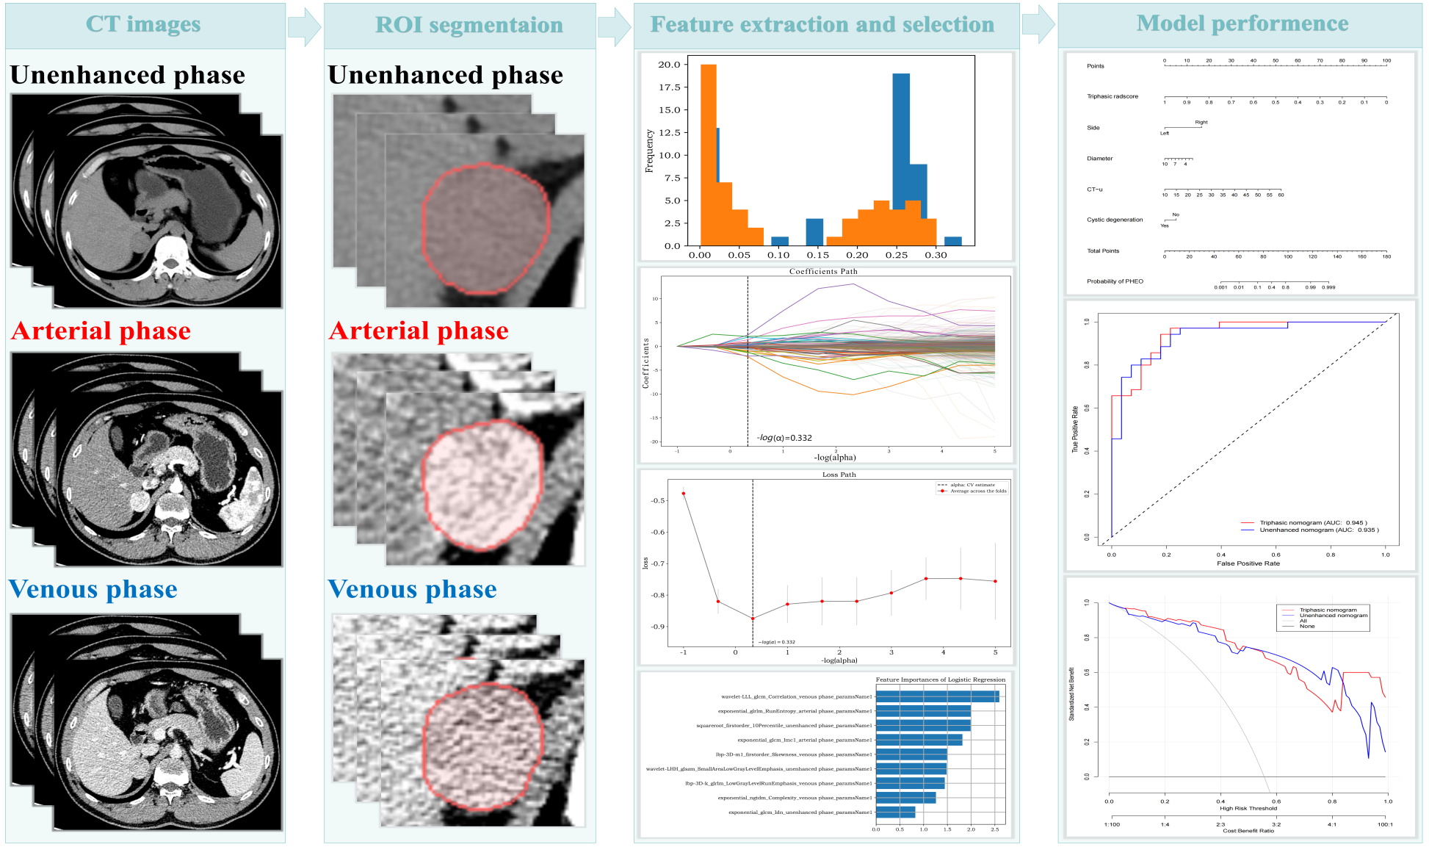
Figure. S1 Flowchart for radiomics analysis.
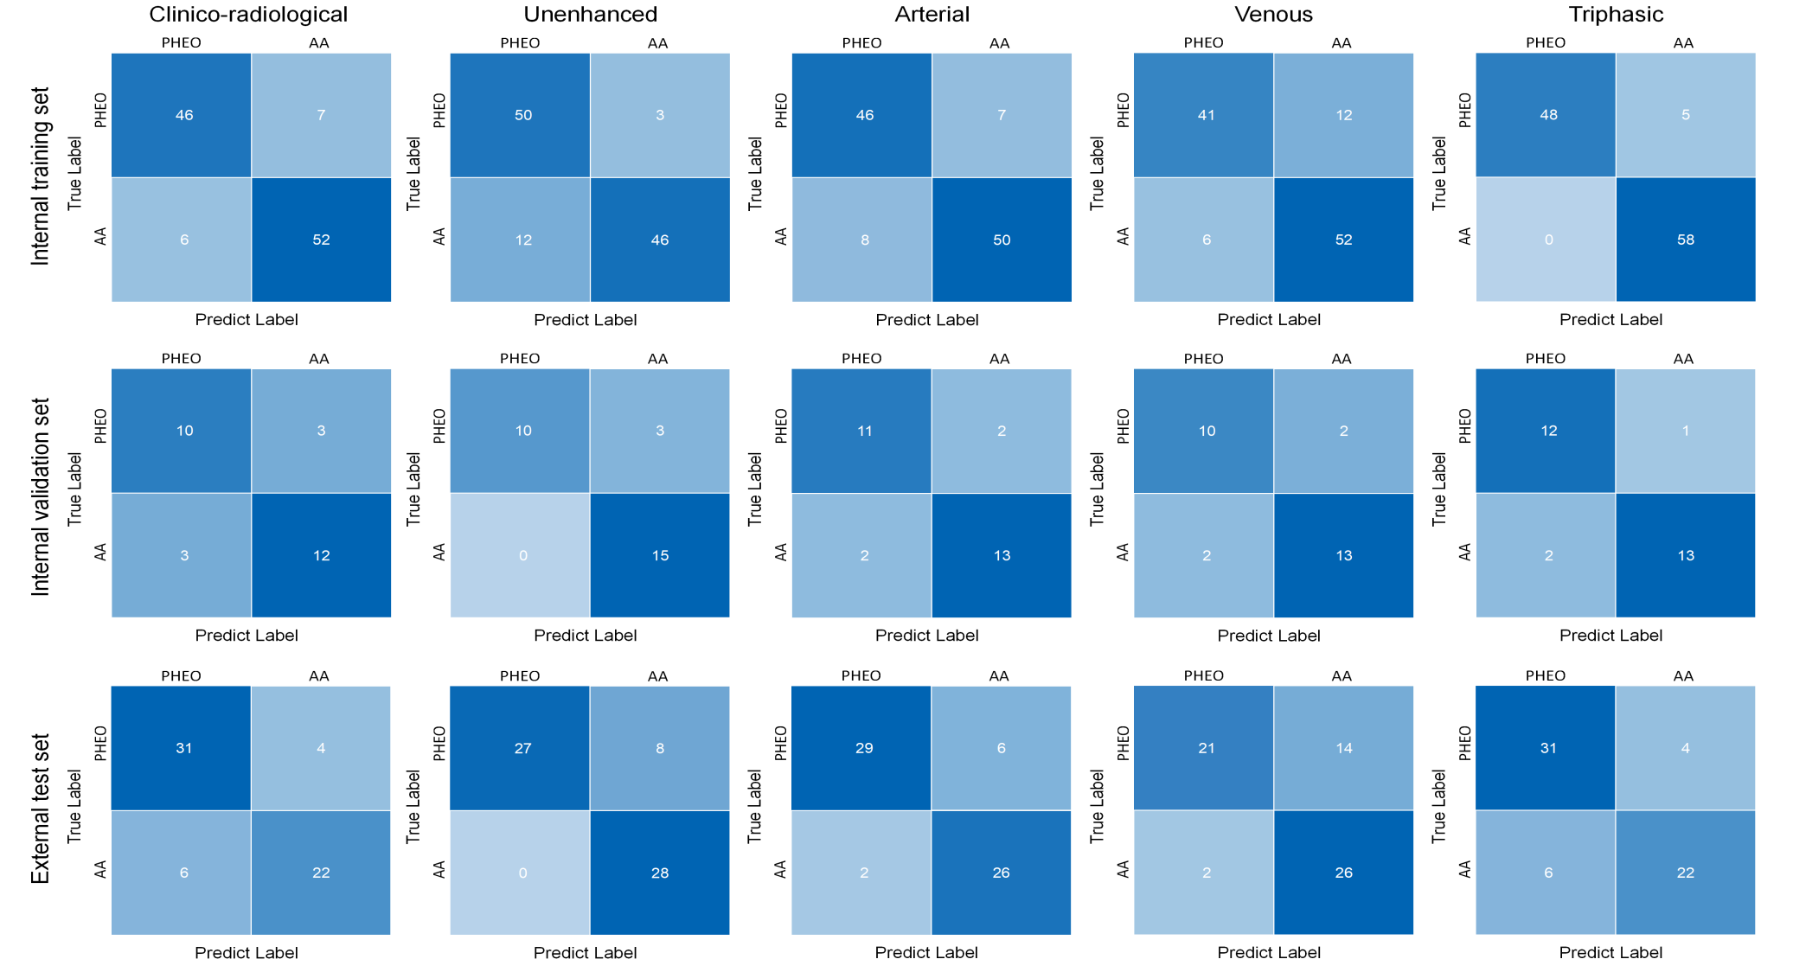
Fig.S2 Confusion matrixes for 5 LR models (Unenhanced, Arterial, Venous, Triphasic , Clinico-radiological) distinguishing LP-AA and PHEO in training, validation, and testing cohorts. X-axis: predictive label; y-axis: true lab
Fig. S3 Mean ROC curves (training: a, validation: b), calibration curves (training: c, validation: d) and decision curves (training: e, validation: f) of two combined nomograms using five-fold cross-validation.
- Wang G, Kang B, Cui J, Deng Y, Zhao Y, Ji C, Wang X: Two nomograms based on radiomics models using triphasic CT for differentiation of adrenal lipid-poor benign lesions and metastases in a cancer population: an exploratory study. Eur Radiol 2023, 33(3):1873-1883.

