Supplementary information
Protonated Phosphonic Acid Electrodes for High Power Heavy-Duty Vehicle Fuel Cells

Katie H. Lim^{1⊥}, Albert S. Lee^{1,2⊥}, Vladimir Atanasov³, Jochen Kerres^{3,4,5}, Santosh Adhikari¹, Sandip Maurya¹, Eun Joo Park¹, Luis Delfin Manriquez¹, Jiyoon Jung², Cy Fujimoto⁶, Ivana Matanovic⁷, Jasna Jankovic⁸, Hongfei Jia⁹, and Yu Seung Kim¹*

¹MPA-11: Materials Synthesis and Integrated Devices Group, Los Alamos National Laboratory, Los Alamos, New Mexico 87545, USA.
²Materials Architecturing Research Center, Korea Institute of Science and Technology, Hwarangno 14gil-5, Seongbuk-gu, Seoul 02792, Republic of Korea.
³Institute of Chemical Process Engineering, University of Stuttgart, Boeblinger Str. 78, 70199 Stuttgart, Germany.
⁴Chemical Resource Beneficiation Faculty of Natural Sciences, North-West University, Potchefstroom 2520, South Africa.
⁵Forschungszentrum Jülich GmbH. Helmholtz Institute Erlangen-Nürnberg for Renewable Energies (IEK-11), Egerlandstr. 3, 91058 Erlangen, Germany.
⁶Organic Materials Science, Sandia National Laboratories, Albuquerque, New Mexico 87185, USA.
⁷Department of Chemical and Biological Engineering, Center for Micro-Engineered Materials (CMEM), The University of New Mexico, Albuquerque, New Mexico 87231, USA; Theoretical Division, Los Alamos National Laboratory, Los Alamos, New Mexico 87545, USA.
⁸Materials Science and Engineering Department, University of Connecticut, Storrs, CT 06269, USA.
⁹Toyota Research Institute of North America, Ann Arbor, Michigan 48105, USA.

⊥ These authors contributed equally to this work.
*Correspondence to: yskim@lanl.gov

This PDF file includes:
Figs. S1 to S15

Figure S1 | DFT calculations on protonation of PFPA. (A) Linear regression fit to deprotonation energies using the difference in DFT calculated electronic energy ($∆$E) of A⁻ and HA. The $∆$E values are calculated using SMD solvation model with water as solvent at the M062X/6-311++G(d,p) level. Equation of line is determined as ${pK}_{a}=0.108*∆E-28.2$ with R² of 0.90 and rms error of 0.2 pK_{a} units. (B) Optimized structure of one fluoroethanesulfonic acid in interaction with three PFPAs.
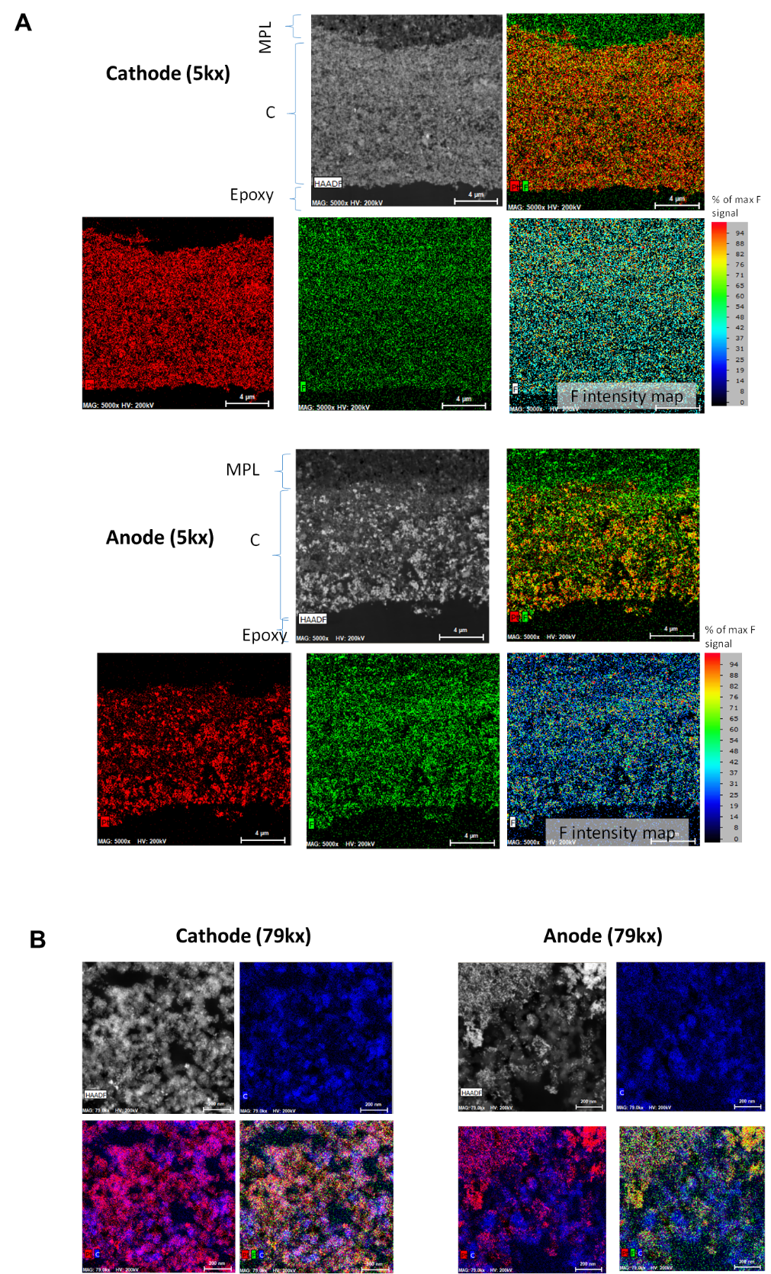
Figure S2 | HAADF-STEM images and corresponding EDS elemental maps (Pt + F + C) of the composite ionomer-bonded electrodes. (A) Cathode and anode gas diffusion electrodes with 5kx magnification (B) Cathode and anode gas diffusion electrodes with 79kx magnification. Composite ionomer: Nafion/PWN-1.8 (Nafion content = 0.5). Pt: Red, F: Green.

Figure S3 | Proton conductivity of Nafion, PWN, and Nafion/PWN mixture in DMSO (solid content: 5 wt%). PWN-0, 0.9, 1.3, 1.8 and 3.0. The Nafion content of the ionomer = 0.5.

Compared to the conductivity in NMP, the conductivity of Nafion, PWN, and Nafion/PWN increased in DMSO. NMP is a weak base that neutralizes acidic protons from Nafion and PWN, while slightly acidic DMSO enhances the proton conduction.

Figure S4 | EIS characterization of MEA using the Nafion/PWN composite ionomer as a function of IEC of PWN. (A) 0.8 V (B) 0.6 V and (C) 2 A cm⁻². Composite ionomers: Nafion/PWN-0.9, Nafion/PWN-1.8 and Nafion/PWN-3.0 (Nafion content = 0.5). The impedance with frequency range from 1 MHz to 0.1 Hz was measured under H₂/O₂ conditions at 160 °C and 170 kPa backpressure.

Figure S5 | EIS characterization of MEA using the Nafion, (1:0), protonated phosphonic acid and non-protonated phosphonic acid ionomers. (A) 0.8 V (B) 0.6 V and (C) 2 A cm⁻². Ionomers: Nafion (Nafion content = 1), protonated phosphonic acid ionomer (Nafion content = 0.4), non-protonated phosphonic acid ionomer (Nafion content = 0). The impedance was measured with frequency range from 1 MHz to 0.1 Hz under H₂/O₂ condition at 160 °C and 170 kPa backpressure.

Figure S6 | H₂/O₂ fuel cell performance of MEAs employing Nafion/PWN-1.8 as a function of Nafion content. MEA component: QAPOH-PA ion-pair membrane, anode (Pt-Ru/C, 0.5 mg_{Pt} cm⁻²), and cathode (Pt/C, 0.7 mg_{Pt} cm⁻²).

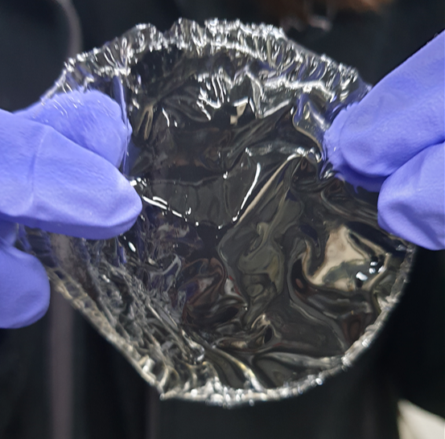
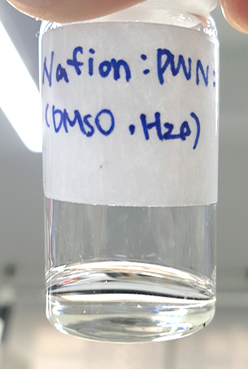
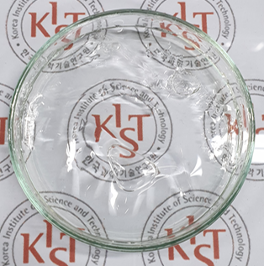

Figure S7 | Solution casting process of PWN/Nafion. (1) Mix of 5 % Nafion dispersion (Nafion D520, 5 wt%) with 5% PWN solution in DMSO (5 wt%), (2) Pour the blended solution on a glass dish and dry at 80 °C (3) Detach the membrane after immersing the membrane cast dish in water.

Figure S8 | HFR of MEAs employing Nafion/PWN-1.8 as a function of temperature. MEA component: QAPOH-PA ion-pair membrane, anode (Pt-Ru/C, 0.5 mg_{Pt} cm⁻²), and cathode (Pt/C, 0.7 mg_{Pt} cm⁻²).

Figure S9 | H₂/air fuel cell performance of Nafion-based LT-PEMFCs at 100 °C as a function of RH. i-V curve, power density and HFR of Nafion LT-PEMFC at 100 °C and 148 kPa (absolute) backpressure and high H₂/air flows (500/500 sccm). Nafion MEA component: Nafion 211 membrane (25 µm thickness), Nafion ionomer, anode and cathode (TEC10E40E, Pt/C, 0.1 mg_{Pt} cm⁻²).

Figure S10 | Effect of cathode catalyst loading on H₂/air fuel cell performance. Cathode catalyst: (A) HiSPEC 9100: Pt 60% on high surface area carbon (Johnson Matthey). (B) TEC10E40E: Pt 40% on high surface area carbon. (C) TEC10E20E: Pt 20% on high surface area carbon. The other MEA components: QAPOH-PA membrane (35 µm thick), anode catalyst (Pt-Ru/C, 0.5 mg_{Pt} cm⁻²), cathode catalyst (Pt/C, 0.1, 0.3, and 0.6 mg_{Pt} cm⁻²), and Nafion/PWN-1.8 ionomer (Nafion content: 0.5). The performance was measured at 160 °C under anhydrous conditions.

Figure S11 | Effect of cathode reactant gas flow rate on H₂/air fuel cell performance. MEA component: QAPOH-PA membrane (35 µm thick), anode catalyst (Pt-Ru/C, 0.5 mg_{Pt} cm⁻²), cathode catalyst (Pt/C, HiSPECTM 0.6 mg_{Pt} cm⁻²), and Nafion/PWN-1.8 ionomer (Nafion content: 0.5).

Figure S12 | Comparison of H₂/air fuel cell performance of different MEAs at 120 °C. Protonated ionomer-bonded MEA: QAPOH-PA membrane (35 µm thickness), Nafion/ PWN-1.8 ionomer (Nafion content: 0.5), anode (Pt-Ru/C, 0.5 mg_{Pt} cm⁻²), and cathode (Pt/C, 0.3 mg_{Pt} cm⁻²). Commercial PA-PBI: PA-PBI membrane (50 µm thickness), PTFE binder, anode (Pt/C, 1.0 mg_{Pt} cm⁻²), and cathode (Pt-alloy, 0.75 mg_{Pt} cm⁻²). Nafion MEA: Nafion 211 membrane (25 µm thickness), Nafion ionomer, anode (Pt/C, 0.2 mg_{Pt} cm⁻²) and cathode (Pt/C, 0.3 mg_{Pt} cm⁻²).

Figure S13 | Fuel cell performance of the ion-pair HT-PEMFC 80 °C. MEA components: QAPOH-PA membrane, anode catalyst (Pt-Ru/C, 0.5 mg_{Pt} cm⁻²), cathode catalyst (Pt/C, 0.6 mg_{Pt} cm⁻²), and Nafion/PWN-1.8 ionomer (Nafion content: 0.5). The performance was measured under anhydrous conditions.

Figure S14 | Performance change during the 2,500-hour durability test. i-V curve, power density and HFR of the ion-pair HT-PEMFC at 100 °C and 148 kPa (absolute) backpressure and high H₂/air flows (500/500 sccm). MEA component: QAPOH-PA ion-pair membrane (40 µm thickness), Nafion/PWN-1.8 composite ionomer Nafion content = 0.5), anode (Pt-Ru/C, 0.5 mg_{Pt} cm⁻²), and cathode (Pt/C 0.6 mg_{Pt} cm⁻²).

Figure S15 | (A) Temperature AST cycling profile (40−160 °C). (B) Temperature cycling durability of PA-PBI HT-PEMFC. The cell current density was measured at a constant cell voltage of 0.5 V under anhydrous conditions. H₂/air were supplied with 148 kPa backpressure and the stoichiometry of 24/10. After the first 7 cycles, the cell was inoperable.

