Supplementary File

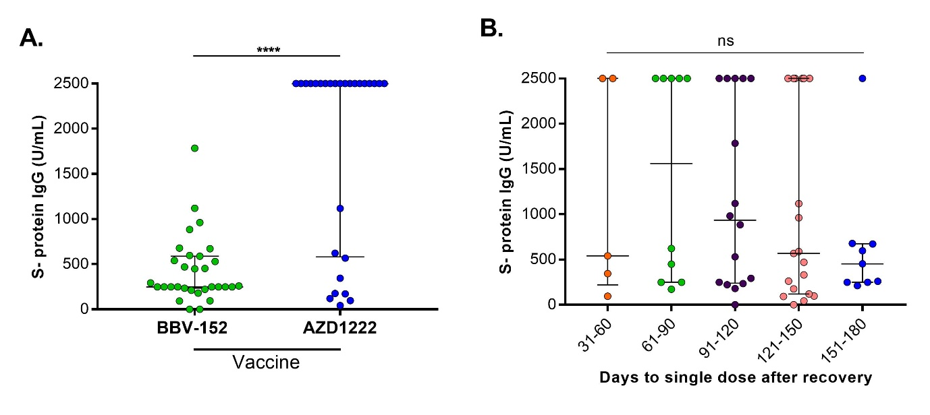
Figure S1. Comparison of IgG antibody response against SARS-CoV-2 S- protein after a single dose of BBV-152 (COVAXIN®) and AZD1222 (COVISHIELDTM) in previously infected HCWs (A). Development of S- protein IgG with different recovery time-period in previously COVID-19 infected HCWs (B). P<0.05 was considered as significant.

