Table 1. Optimization of reaction conditions.^{a,b}
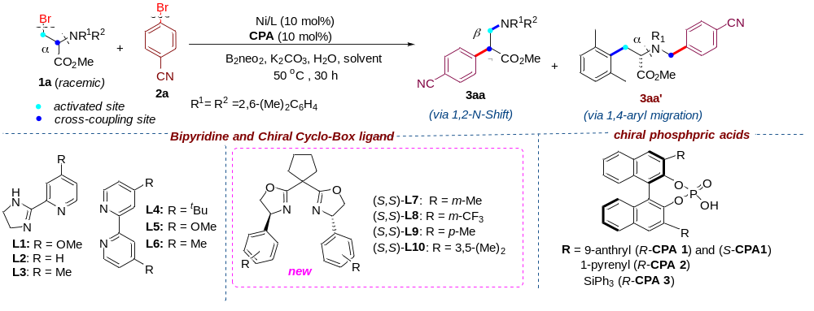
Entry | [Ni]/reductant |  | Ligand | CPA | Yield of 3aa (%)^{b} | Yield 3aa’(%)^{b} | er of  3aa^{c}
1 | NiBr_{2•}dme/Zn |  | L1 | -- | 17 | 61 | --
2 | NiBr_{2•}dme /Mn |  | L1 | -- | <10 | 21 | --
3 | NiBr_{2•}dme /B₂neo₂ |  | L1 | -- | 79(74) | trace | --
4 | NiBr_{2•}dme /B₂pin₂ |  | L1 | -- | <10 | trace | --
5 | NiBr_{2•}dme/B₂cat₂ | L1 |  | -- | <10 | trace | --
6 | NiBr_{2•}dme/B₂neo₂ | L2 |  | -- | 70 | trace | --
7 | NiBr_{2•}dme/B₂neo₂ | L3 |  | -- | 74 | trace | --
8 | NiBr_{2•}dme/B₂neo₂ | L4 |  | -- | 64 | trace | --
9 | NiBr_{2•}dme/B₂neo₂ | L5 |  | -- | 61 | trace | --
10 | NiBr_{2•}dme/B₂neo₂ | L6 |  | -- | 57 | trace | --
11^{d} | NiBr_{2•}dme/B₂neo₂ | (S,S)-L7 |  | -- | 62 | trace | 83:17
12^{d} | NiBr_{2•}dme/B₂neo₂ | (S,S)-L8 |  | -- | <10 | trace | n.d.
13^{d} | NiBr_{2•}dme/B₂neo₂ | (S,S)-L9 |  | -- | 50 | trace | 74:26
14^{d} | NiBr_{2•}dme/B₂neo₂ | (S,S)-L10 |  | -- | 64 | trace | 85:15
15^{d} | NiBr_{2•}dme/B₂neo₂ | (S,S)-L10 |  | (R)-CPA 1 | 62 | trace | 90:10
16^{d} | NiBr_{2•}dme/B₂neo₂ | (S,S)-L10 |  | (R)-CPA 2 | 63(60) | trace | 97:3
17^{d} | NiBr_{2•}dme/B₂neo₂ | (S,S)-L10 |  | (S)-CPA 1 | 59 | trace | 74:26
18^{d} | NiBr_{2•}dme/B₂neo₂ | (S,S)-L10 |  | (R)-CPA 3 | 57 | trace | 89:11
19^{d} | NiCl_{2•}dme/B₂neo₂ | (S,S)-L10 |  | (R)-CPA 2 | 56 | trace | 90:10
ª Standard conditions: 1a (0.2 mmol.), 2a (2 euqiv.), NiBr₂•dme (10 mol%), Ligand (12 mol%), B₂neo₂ (2 equiv), H₂O (2 equiv) K₂CO₃ (2 equiv) and CH₃CN/EtOH (v: v = 1.8: 0.2, 0.1 M) at 50 ºC under Ar atmosphere for 30 h. B₂neo₂ = bis(neopentyl glycolato)diboron, NMP = N-methylpyrrolidone, DMA = dimethyl acetamide, CPA = chiral phosphoric acid, cat = catecholato; pin = pinacolato. n.d. = not detected. ^{b} Yields were determined by gas chromatography (GC) using n-dodecane as an internal standard; isolated yields are reported in parentheses. ^{c} Enantiomeric ratios (e.r.) were determined using chiral HLPC. ^{d} Na₂CO₃ instead of K₂CO₃, on a 0.1 mmol scale at 40 °C for 36 h.

Table 2. Scope of (hetero)aryl bromides and N-benzyl amino acid esters in Ni-catalyzed migratory coupling.^{a,b}
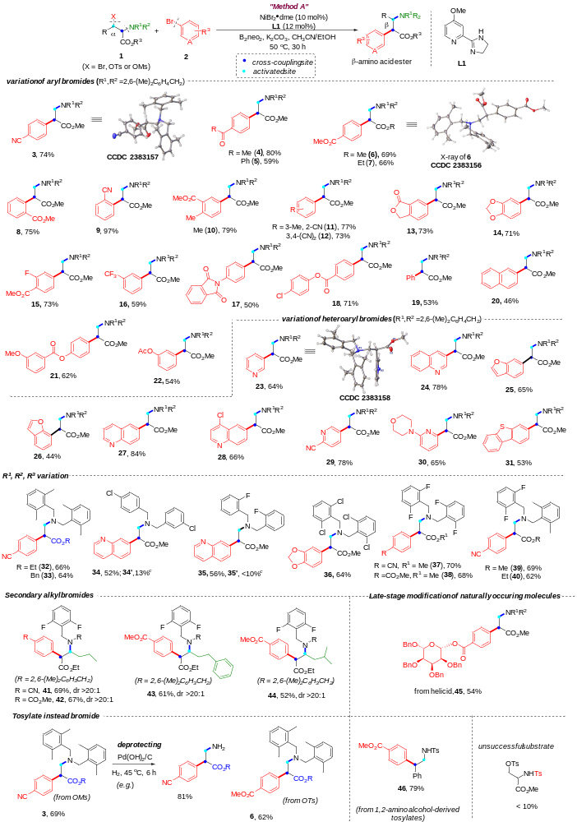
ª Reaction conditions in Method A: alkyl bromide 1 (0.2 mmol), (hetero)aryl bromide 2 (2 equiv), NiBr₂•dme (10 mol%), L1 (12 mol%), B₂neo₂ (2 equiv), H₂O (2 equiv) K₂CO₃ (2 equiv) and CH₃CN/EtOH (v: v = 1.8:0.2, 0.1 M) at 50 °C under Ar atmosphere for 30 h; isolated yields. ^{b} Diastereoselective ratio (dr) was determined by ¹H NMR and/or ¹⁹ F NMR analysis. ^{c} By-products arising from intramolecular C-H cyclization.
Table 3. Ni/CPA-catalyzed enantioselective migratory cross-electrophile coupling by 1,2-N-shift.^{a,b}
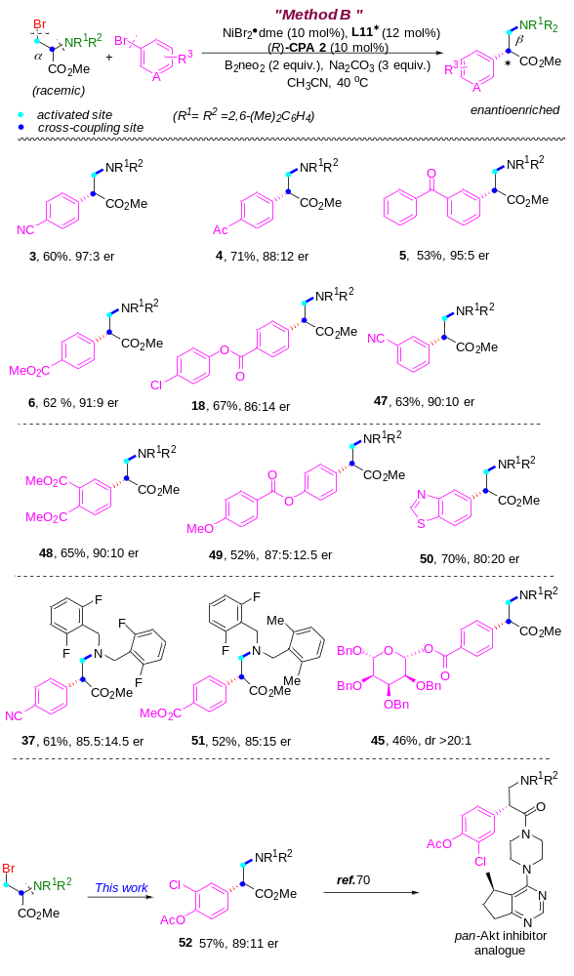
ª Reaction conditions in Method B: alkyl bromide 1 (0.1 mmol), (hetero)aryl bromide 2 (2 equiv.), NiBr_{2•}dme (10 mol%), L10* (12 mol%), (R)-CPA-2 (10 mol%), B₂neo₂ (2 equiv), H₂O (2 equiv) Na₂CO₃ (3 equiv) and CH₃CN (1 mL, 0.1 M) at 40 °C under Ar atmosphere for 36 h. ^{b} Enantiomeric ratios (e.r.) were determined using chiral HLPC; isolated yields.
Table 4. Properties of diverse transition states for the radical addition.
Multiplicity at Ni | Enantioselectivity | Conformation | Free energy barrier (kcal/mol)
Triple  Stateª | S- | R-TS1_{III} | 13.4
Triple  Stateª | S- | R-TS2_{III} | 5.3
Triple  Stateª | S- | R-TS3_{III} | 16.1
Triple  Stateª | R- | S-TS1_{III} | 6.5
Triple  Stateª | R- | S-TS2_{III} | 4.7
Triple  Stateª | R- | S-TS3_{III} | 18.1
Single-stateª | S- | R-TS1_{I} | 8.4
Single-stateª | S- | R-TS2_{I} | 13.7
Single-stateª | S- | R-TS3_{I} | 12.9
Single-stateª | R- | S-TS1_{I} | 7.6
Single-stateª | R- | S-TS2_{I} | 13.7
Single-stateª | R- | S-TS3_{I} | 9.0
- ª Optimized structures are displayed in Fig 2 and Fig 3.

