PackDock is a Flexible Protein-Ligand Docking Approach with Diffusion-Based Side Chain Packing

Supplementary Information
Runze Zhang^{▽,1,2}, Xinyu Jiang^{▽,1,2}, Duanhua Cao^{▽,1,3}, Zhaokun Wang^{▽,1,2}, Jie Yu^{1,4,5}, Mingan Chen^{1,4,6}, Zhehuan Fan^{1,2}, Xiangtai Kong^{1,2}, Jiacheng Xiong^{1,2}, Zimei Zhang^{1,7}, Wei Zhang^{1,2}, Shengkun Ni^{1,2}, Yitian Wang^{1,2}, Minda Liao^{1,2}, Shenghua Gao⁵, Sulin Zhang^{1,2}, Mingyue Zheng^{*,1,2}

¹ Drug Discovery and Design Center, State Key Laboratory of Drug Research, Shanghai Institute of Materia Medica, Chinese Academy of Sciences, 555 Zuchongzhi Road, Shanghai 201203, China
² University of Chinese Academy of Sciences, No. 19A Yuquan Road, Beijing 100049, China
³ Innovation Institute for Artificial Intelligence in Medicine of Zhejiang University, College of Pharmaceutical Sciences, Zhejiang University, Hangzhou, Zhejiang 310058, China
⁴ Lingang Laboratory, Shanghai, 200031, China
⁵ School of Information Science and Technology, ShanghaiTech University, 393 Middle Huaxia Road, Shanghai 201210, China
⁶ School of Physical Science and Technology, Shanghai Tech University, 393 Middle Huaxia Road, Shanghai, 201210, China
⁷ Division of Life Science and Medicine, University of Science and Technology of China, Hefei, Anhui, 230026, China

Table of Contents
S1 Baseline Method
S2 The Definition of Side-chain Torsion Angles
S3 Packing Dataset
S4 Performance of Packing Experiments
S5 Amino Acids Number Statistical in Pocket region
S6 Performance of Re-docking Experiment
S7 Performance of Different Flexible Docking Methods in holo or apo Cross-Docking
S8 Pocket Change Statistical and Experiment Number Statistical in Cross-Docking using holo structures
S9 Visualization of Side-chains in PackDock
S10 Additional Experimental Details on ALDH1B1

S1. Baseline Method

S1.1 Packing Method
SCWRL4[45]. SCWRL4 is a widely-used method for predicting protein side-chain conformations. It employs a graph-based approach, treating side chains as nodes connected by edges representing potential steric clashes. The algorithm searches for the most probable side-chain conformation, minimizing clashes and optimizing energy using a backbone-dependent rotamer library and a statistical potential energy function based on known protein structures.
FASPR[46]. FASPR (Fast and Accurate Side-chain Prediction using Rotamer libraries) efficiently predicts side-chain conformations by utilizing backbone-dependent rotamer libraries and a custom energy function. The method employs Dead-End Elimination (DEE) and tree decomposition to identify the rotamers leading to the Global Minimum Energy Conformation (GMEC).
AttnPacker[47]. AttnPacker is a DL-based method for side-chain conformation prediction that utilizes the attention mechanism, a powerful technique commonly employed in deep learning architectures for tasks involving sequence data. The protocol and settings in notebook protein_learning/examples/inference.ipynb in the AttnPacker repository ( https://github.com/MattMcPartlon/AttnPacker ) were used for packing.
DiffPack[48]. DiffPack is a torsional diffusion model designed for predicting the conformation of protein side-chains based on their backbones. The protocol and settings in script/inference.py in the DiffPack repository ( https://github.com/DeepGraphLearning/DiffPack ) were used for packing.

S1.2 Docking Method
$Autodock$[52] The software versions employed include $Autodock$-GPU, Reduce 3.23.130521, ADFRsuite 1.0, and RDKit 2022.09.1. Ligands are processed into PDBQT files using ADFR prepare_ligand scripts, and RDKit calculates their centroid coordinates and coordinate ranges. Hydrogen atoms are added with Reduce, and PDBQT files are generated using the ADFR prepare_receptor script. The docking box size is set using the co-crystallized ligand's center and its maximum diameters in three directions, plus an additional 4 Å.
$Vina$[34]. The software versions employed include $Vina$1.2.3, Reduce 3.23.130521, ADFRsuite 1.0, and RDKit 2022.09.1. Ligands are processed into PDBQT files using ADFR prepare_ligand scripts, and RDKit calculates their centroid coordinates and coordinate ranges. Hydrogen atoms are added with Reduce, and PDBQT files are generated using the ADFR prepare_receptor script. The docking box size is set using the co-crystallized ligand's center and its maximum diameters in three directions, plus an additional 4 Å.
$Smina$[53]. The software version employed is $Smina$ python API 2021.12.09. The ligand is inputted in SDF format, while the protein is in PDB format. Use the center of the co-crystallized ligand and autobox_add is set to 4 Å.
$Gnina$[54]. The software version employed is $Gnina$ 1.0.3. The ligand is inputted in SDF format, while the protein is in PDB format. Use the center of the co-crystallized ligand and autobox_add is set to 4 Å.
DiffDock[41]. DiffDock is a docking method based on a diffusion-generated model. The protocol and settings in inference.py in the DiffDock repository ( https://github.com/gcorso/DiffDock ). The docking procedures adhere to the default settings of Diffdock.
FlexPose[42]. FlexPose is a framework for AI-based flexible modeling of protein-ligand binding pose. The protocol and settings in demo.py in the FlexPose repository ( https://github.com/tiejundong/FlexPose ) were used for docking.
For all methods, we generated 36 ligand poses and selected the one closest to the ground-truth pose for statistical analysis. To balance the computational complexity and the docking accuracy, following the previous work[51], we defined the flexible amino acids for all conventional docking algorithms as the amino acids within 3.5 Å distance from the ligand.

S2 The Definition of Side-chain Torsion Angles.
Table. S1. Predefined bijective table of side-chain torsion angle with atom
AA names | Tor_1 | Tor_2 | Tor_3 | Tor_4
Gly
Ala
Ser | N-CA-CB-OG
Cys | N-CA-CB-SG
Val | N-CA-CB-CG1
Thr | N-CA-CB-OG1
Pro | N-CA-CB-CG
Ile | N-CA-CB-CG1 | CA-CB-CG1-CD1
Leu | N-CA-CB-CG | CA-CB-CG-CD1
Asp | N-CA-CB-CG | CA-CB-CG-OD1
Asn | N-CA-CB-CG | CA-CB-CG-OD1
His | N-CA-CB-CG | CA-CB-CG-ND1
Phe | N-CA-CB-CG | CA-CB-CG-CD1
Tyr | N-CA-CB-CG | CA-CB-CG-CD1
Trp | N-CA-CB-CG | CA-CB-CG-CD1
Glu | N-CA-CB-CG | CA-CB-CG-CD | CB-CG-CD-OE1
Gln | N-CA-CB-CG | CA-CB-CG-CD | CB-CG-CD-OE1
Met | N-CA-CB-CG | CA-CB-CG-SD | CB-CG-SD-CE
Arg | N-CA-CB-CG | CA-CB-CG-CD | CB-CG-CD-NE | CG-CD-NE-CZ
Lys | N-CA-CB-CG | CA-CB-CG-CD | CB-CG-CD-CE | CG-CD-CE-NZ

S3 Packing Dataset
Table S2. List of targets in Packing dataset.
Dataset | Protein ID
CASP | T0950-D1,T0951-D1,T0953s1-D1,T0953s2,T0954-D1,T0955-D1,T0957s1-D1,T0957s1-D2,T0957s1,T0957s2-D1,T0958-D1,T0960,T0963,T0965-D1,T0966-D1,T0967-D1,T0968s1-D1,T0968s2-D1,T0969-D1,T0970-D1,T0971-D1,T0976,T0980s1-D1,T0984,T0990,T1003-D1,T1005-D1,T1006-D1,T1008-D1,T1009-D1,T1011,T1016-D1,T1018-D1,T1021s1-D1,T1021s2-D1,T1021s3,T1022s1,T1022s2-D1, T1024,T1025-D1,T1026-D1,T1027-D1,T1028-D1,T1029-D1,T1030,T1031-D1,T1032-D1,T1033-D1,T1034-D1,T1035-D1,T1036s1-D1,T1037-D1,T1038,T1039-D1,T1040-D1,T1041-D1,T1042-D1,T1043-D1,T1046s1-D1,T1046s2-D1,T1047s1-D1,T1047s2,T1049-D1,T1050,T1053,T1054-D1,T1056-D1,T1057-D1,T1064-D1,T1065s1-D1,T1065s2-D1,T1067-D1,T1073-D1,T1074-D1,T1079-D1,T1080-D1,T1082-D1,T1090-D1,T1099-D1
PDBbind | 6qqw,6jap,6np2,6qrc,6oio,6jag,6i9a,6jb4,6seo,6jid,5ze6,6pka,6n97,6qtr,6n96,6qzh,6qqz,6k3l,6cjs,6n9l,6ott,6npp,6nsv,6n53,6eeb,6n0m,6ovz,5zcu,6mjq,6efk,6gdy,6kqi,6ueg,6qr7,6g3c,6iql,6qr4,6jib,6qto,6qrd,6e5s,5zlf,6om4,6qqv,6qtq,6os5,6s07,6mjj,6jb0,6uim,6mo0,6cjr,6uii,6sen,6kjf,6qr9,6g9f,6npi,6oip,6miv,6qts,6oi8,6c85,6qsz,6jbb,6np5,6nlj,6n94,6e13,6uil,6n92,6uhv,6q36,6qtx,6rr0,6ufo,6oiq,6qra,6m7h,6ufn,6qr0,6o5u,6ny0,6jan,6ftf,6jon,6cf7,6o9c,6qqu,6mja,6r4k,6h9v,6py0,6jaq,6k2n,6cjj,6a73,6qqt,6qre,6qtw,6np4,6n55,6kjd,6np3,6jbe,6qqq,6j9y,6h7d,6jao,6e7m,6rz6,6qtm,6miy,6jad,6mj4,6qr2,6qxa,6o9b,6ckl,6oir,6oin,6jam,6uhu,6mji,6nt2,6op9,6e4v,6a87,6cjp,6qrf,6j9w,6n93,6nd3,6os6,6dql,6qwi,6npm,6qrg,6nxz,6qr3,6qr1,6o5g,6r7d,6mo2

S4 Performance of Packing experiment
Table. S3. Evaluation of side-chain RMSD of PackPocket and current methods on CASP and PDBBind.
Method | Sample Number | Data Set
Method | Sample Number | CASP(Å) | PDBBind(Å)
SCWRL | 1 | 0.632 | 0.823
FASPR | 1 | 0.625 | 0.876
AttnPacker | 1 | 0.406 | 0.539
DiffPack | 1 | 0.412 | 0.555
PackPocket | 1 | 0.446 | 0.565
DiffPack | 3 | 0.364 | 0.486
PackPocket | 3 | 0.341 | 0.453
DiffPack | 6 | 0.328 | 0.447
PackPocket | 6 | 0.315 | 0.417
DiffPack | 10 | 0.316 | 0.427
PackPocket | 10 | 0.271 | 0.39
DiffPack | 20 | 0.302 | 0.409
PackPocket | 20 | 0.239 | 0.361
DiffPack | 40 | 0.293 | 0.39
PackPocket | 40 | 0.213 | 0.336

S5 Amino Acids Number Statistical in Pocket region
Table. S4. Number of residues repacked using different methods and number of residues in the statistics.
Data Set | Re-packing Number of Residues |  | Statistical Number of Residues
Data Set | Full protein  (Other Methods) | binding pocket region  (PackPocket) | Full protein  (Other Methods) | binding pocket region  (PackPocket)
CASP | 253 | 23 | 23 | 23
PDBBind | 414 | 20 | 20 | 20

S6 Performance of Re-docking Experiment
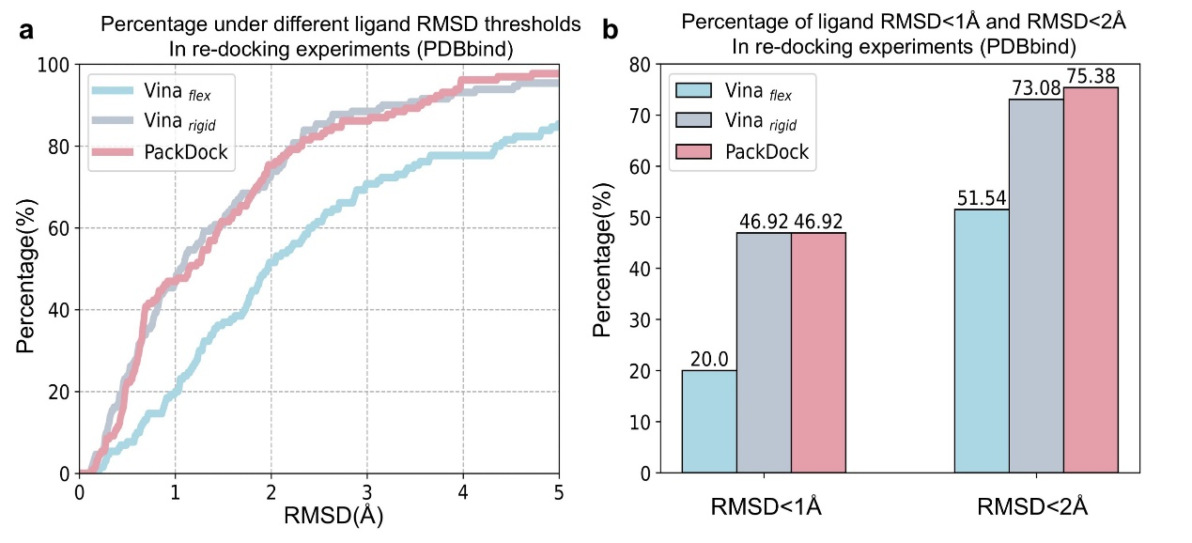
Fig. S1. (a) Proportion for three methods under different ligand RMSD thresholds in re-docking experiment. (b) The percentage of ligand RMSD<1 Å and <2 Å for different methods in re-docking experiment.

S7 Performance of Different Flexible Docking Methods in holo or apo Cross-Docking
Table. S5. Comparing the performance of different methods in Top1 and Best samples. Shown is the percentage of predictions with RMSD < 2Å and RMSD < 1 Å, and the mean RMSD for Cross-Docking using apo.
Method | Best-RMSD |  |  | Top1-RMSD
Method | %<1 Å | %<2 Å | Mean | %<1 Å | %<2 Å | Mean
Diffdock | 2.86 | 30.36 | 3.22 | 1.73 | 10.41 | 6.04
FlexPose | / | / | / | 0.00 | 13.21 | 4.21
Smina_{flex} | 5.00 | 24.29 | 3.58 | 2.71 | 11.52 | 7.19
Gnina_{flex} | 6.43 | 29.64 | 3.41 | 6.74 | 20.22 | 6.39
AutoDock_{flex} | 5.36 | 26.43 | 3.22 | 1.05 | 5.26 | 6.06
AutoDockFR | 0.72 | 9.67 | 4.34 | 0.00 | 0.72 | 10.42
Vina_{flex} | 5.00 | 23.21 | 3.78 | 2.15 | 8.60 | 7.07
PackDock_{Vina} | 14.29 | 48.21 | 2.47 | 6.04 | 23.48 | 4.86
Table. S6. Comparing the performance of different methods in Top1 and Best samples. Shown is the percentage of predictions with RMSD < 2Å and RMSD < 1 Å, and the mean RMSD for Cross-Docking using holo.
Method | Best-RMSD |  |  | Top1-RMSD
Method | %<1 Å | %<2 Å | Mean | %<1 Å | %<2 Å | Mean
Diffdock | 7.41 | 51.87 | 2.85 | 2.59 | 24.73 | 5.83
FlexPose | / | / | / | 4.81 | 35.53 | 3.21
Smina_{flex} | 17.59 | 50.75 | 2.44 | 10.89 | 25.66 | 4.86
Gnina_{flex} | 21.82 | 60.92 | 2.05 | 14.61 | 36.85 | 3.79
AutoDock_{flex} | 14.46 | 45.22 | 2.52 | 4.29 | 18.11 | 4.96
AutoDockFR | 3.40 | 18.34 | 3.59 | 1.05 | 3.94 | 9.59
Vina_{flex} | 15.75 | 44.15 | 2.61 | 9.47 | 22.71 | 4.98
PackDock_{Vina} | 30.67 | 65.23 | 1.96 | 12.16 | 36.32 | 3.78

S8 Pocket Change Statistical and Experiment Number Statistical in Cross-Docking using holo structures
Due to the data processing errors in different docking algorithms, the number of successful docking results varies for each method. We counted the docking test number for each method and analyzed the pocket change between the “source” and “target” proteins used for Cross-Docking tests.
Table. S7. Statistical analysis of the number of test sample points in cross-docking using different methods
Method | Test number in crossdock
PackDock | 7587
$$Vina$$ | 7793
$${Vina}_{flex}$$ | 7441
$$Smina$$ | 7818
$${Smina}_{flex}$$ | 7646
$$Gnina$$ | 7933
$${Gnina}_{flex}$$ | 7927
$$AutoDock$$ | 7968
$${AutoDock}_{flex}$$ | 7468
$$AutoDockFR$$ | 7379
DiffDock | 7648
FlexPose | 6914
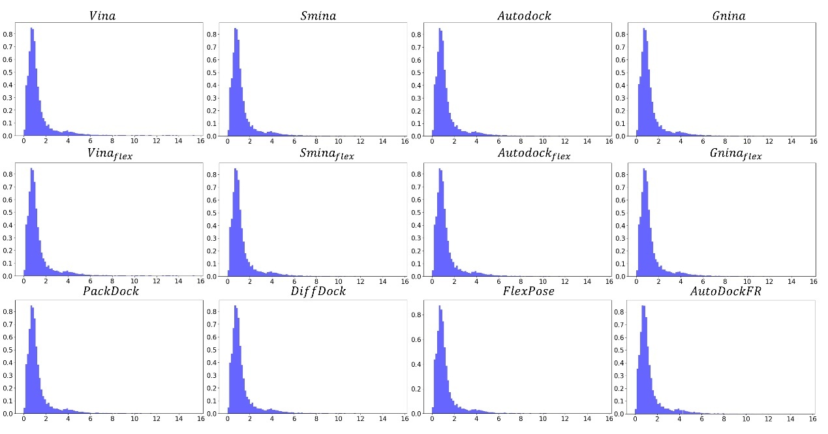
Fig. S2. Pocket change statistical analysis of different methods in Cross-docking testing. X-axis: Pocket change RMSD, Y-axis: Proportion
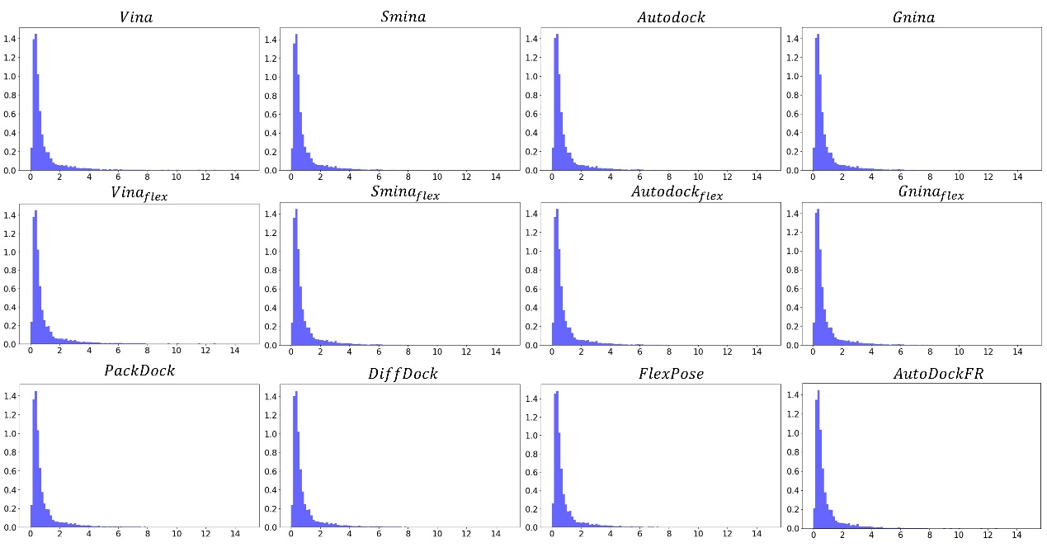
Fig. S3. Backbone change statistical analysis of different methods in Cross-docking testing. X-axis: Backbone change RMSD, Y-axis: Proportion

S9 Visualization of Side-chains in PackDock
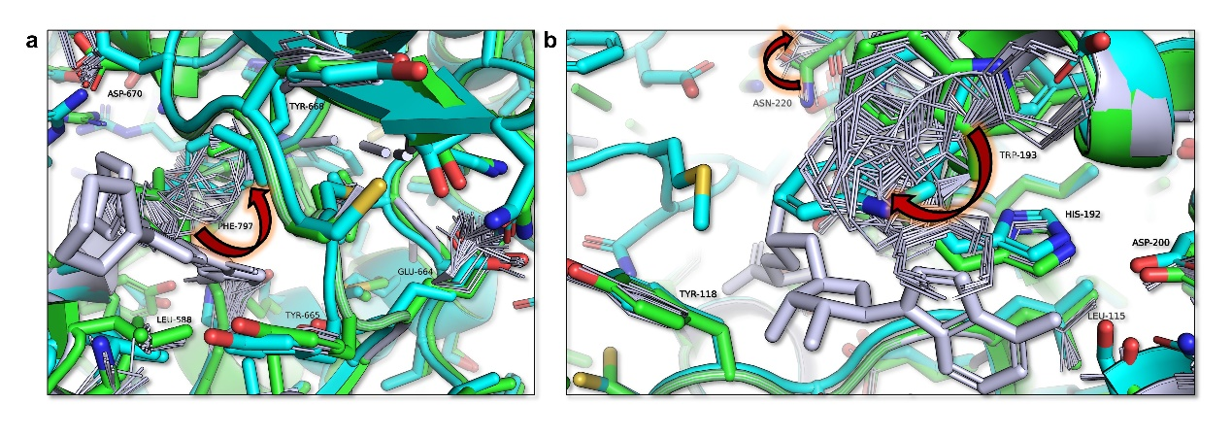
Fig. S4. Visualization of Side-chains in PackDock. (a) In the apo (2ogv, green) - holo (3krj, cyan) structure, F797 exhibits a significant conformational change. (b) In the apo (4pyi, green) - holo (3bmw, cyan) structure, W193 and N220 exhibits a significant conformational change. Other amino acids with smaller conformational differences show a compact unimodal distribution.

S10 Additional Experimental Details on ALDH1B1

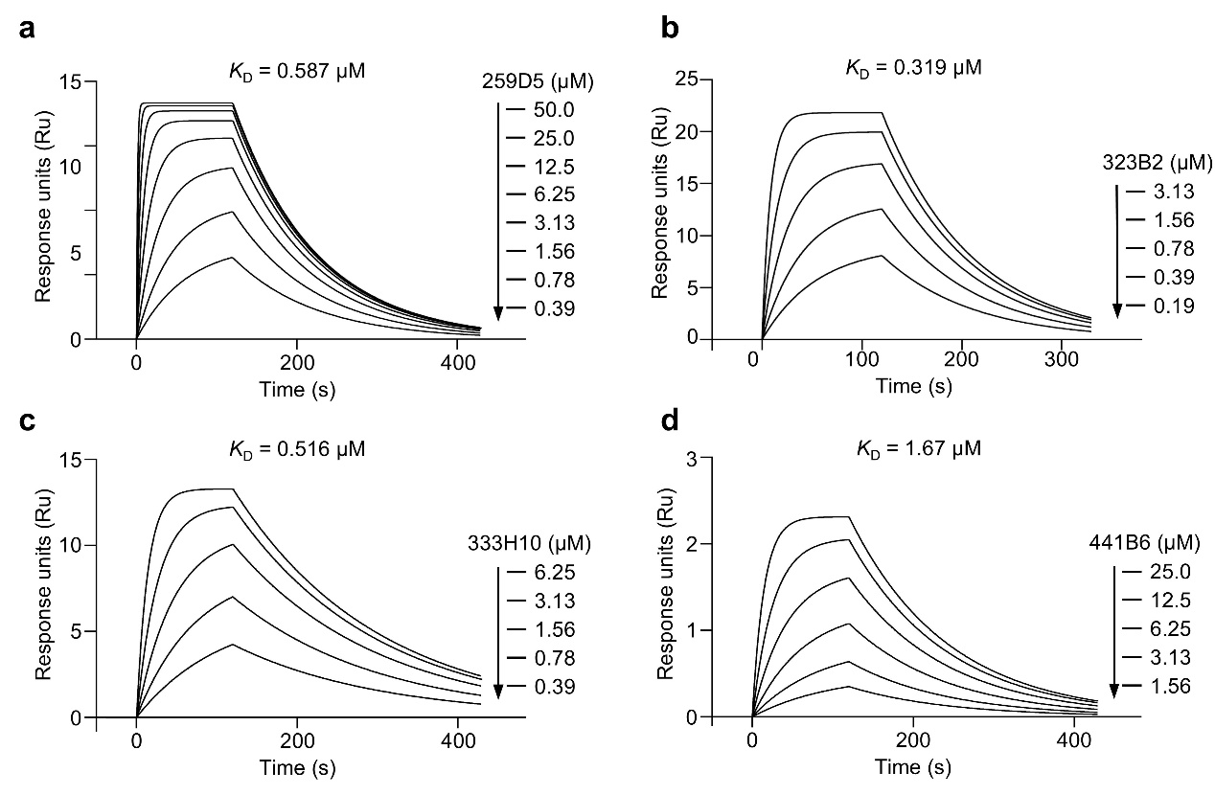
Fig. S5. Supplementary experimental results on the ALDH1B1 target. a-d, Binding affinity measurement of compounds to ALDH1B1 protein using SPR assay. Graphs depicting equilibrium response units versus concentrations of 4 hits were plotted.

